Supporting Information
Scalable Synthesis of biologically active novel Ethyl 1-(4-Alkyl-3-oxo-3,4-dihydro quinoxaline-2-yl)-1H-pyrazole-4-carboxylate derivatives
Vikas S Patilª, Srilakshmi Dhulipalaª, Murali Kopperla^{b}, Somesh Sharma^{b}, S Jagannatha Swamy^{c}, Kondaiah Seku^{d}, Nagaraju Devunuriª*
- Department of Chemistry, School of Applied Sciences & Humanities, Vignan’s Foundation for Science, Technology & Research (VFSTR) Deemed University, Vadlamudi, Guntur - 522 213, Andhra Pradesh, India.
- Aragen Life Sciences Pvt Ltd, Hyderabad, Telangana, India
- Department of Chemistry, Kakatiya University, Warangal, Telangana, India
- Department of Engineering, Civil Section, University of Technology and Applied Sciences-Shinas, Sultanate of Oman

Table of Contents Page
- General Methods and Materials S2
- Procedure for the Synthesis of as Quinoxaline-2,3(1H, 4H)-dione (1b) S2
- Procedure for the Synthesis of 3-hydrazinylquinoxalin-2(1H)-one (1c) S2
- General Procedure for the Synthesis of ethyl 1-(3-oxo-3,4.
-dihydroquinoxalin-2-yl)-1H-pyrazole-4-carboxylate (3) S3
- General Procedure for the Synthesis of Ethyl 1-(4-Alkyl-3-oxo-3,4
-dihydroquinoxalin-2-yl)-1H-pyrazole-4-carboxylate (3a-3s) S3
- Characterization data of Synthesized Compounds (3 and 3a-3s, 6f, 6h) S4-S12
- Copies of ¹HNMR, ¹³CNMR, HRMS and IR spectra (3 and 3a-3s, 6f and 6h) S13-S57

I. General Methods and Materials
Analytical thin layer chromatography was carried out on silica pre-coated alumina plates (Silica gel 60 F254, 0.25 mm thickness) and visualized with UV light at 254 nm. Purification of all the compounds were carried out in Ethyl acetate and n-heptane. 1H and 13C NMR spectra were recorded on SA-Varian 400-MHz. Chemical shifts (δ) are reported in parts per million (ppm) and with reference to tetramethylsilane (TMS) as internal standard. The specifications of the LC/MS instrument are the following: electrospray (+) ionization, mass range of 100-1000 Da, 20V cone voltage, Acquity BEH C-18 column (50 mm x 2.1 mm, 1.7 μm), gradient mobile phase-A: 0.05% formic acid in water and mobile Phase B: 0.05% Formic acid in acetonitrile and a flow rate of 0.5 mL/min. The HRMS spectra recorded using Thermo Scientific Q-exactive orbi-trap HRMS instruments with ESI ion source. The front-end inlet used was UHPLC Dionex Ultimate 3000 instruments which comprises of binary pump, column manger and PDA detector and data was acquired using X-Caliber software. And FT-IR spectra were recorded on Agilent Resolutions Pro FT spectrometer.

II. Procedure for the Synthesis of as Quinoxaline-2,3(1H,4H)-dione (1b):
A solution of orthophenylene diamine (1) (25 g, 1.0 mol eq) and oxalic acid (1a) (1.0 m.eq) in 4 N aqueous hydrochloric acid (10 V) was reflux for 2 h. the progress of reaction was monitored by TLC. After complete consumption of starting material, reaction mixture allows to cooled room temperature and stirred for 30 min. The precipitated product was filtered and washed with excess of water and dried at 45-50°C under reduced pressure to afford the faint brownish solid as quinoxaline-2,3(1H,4H)-dione (1b) with 90% yield.
¹H NMR (400 MHz, DMSO-d⁶): ⸹ 11.9 (s, 2H), 7.27-7.67 (m, 5H), 7.06-7.14 (m, 4H); Mass: 161.14 (M-1); FT-IR (KBr):1669.75 cm⁻¹ -C=O stretching.
III. Procedure for the Synthesis of 3-hydrazinylquinoxalin-2(1H)-one (1c):
The quinoxaline-2,3(1H,4H)-dione (1b) (1.0 mole eq) in 98% hydrazine hydrate solution (30 V) heated mixture at 130-135°C for 2.5-3 h, reaction progress monitored by TLC, after consumption of starting material, reaction mixture allow to cooled at room temperature followed by addition of 2-propanol (50 V) and stirred mixture at 10-15°C for 30 min, The precipitated product was filtered and washed with chilled IPA and dried at 40-45°C under reduced pressure to afford the 3-hydrazinylquinoxalin-2(1H)-one (1c) as yellow solid with 84% yield.
¹H NMR (400 MHz, DMSO-d⁶): ⸹ 12.06 (s, 1H), 8.72 (s, 1H), 7.35-7.37 (d, 1H), 7.10-7.15 (m, 3 H), 4.51 (s, 2 H); LCMS Purity: 97.94%; Mass: 177.19 (M+1); FT-IR (KBr): 3403.45 cm⁻¹ -NH stretching.
IV. General Procedure for the Synthesis of ethyl 1-(3-oxo-3,4-dihydroquinoxalin-2-yl)-1H-pyrazole-4-carboxylate (3):
A solution of 3-hydrazinylquinoxalin-2(1H)-one (1c) (1.0 mole eq) in ethanol (40 V), followed by slow addition of ethyl 2-Formyl-3-oxopropionate (1d) (1.05 mole eq) at 25-30ºC over a period of 30 min then suspension was refluxed for 24 h, the reaction progress monitored by TLC, after consumption of 3-hydrazinylquinoxalin-2(1H)-one (1c) and Hydroxy pyrazole (2) in situ intermediate the suspension was cooled to 25-30°C then filtered and washed with ethanol (2V) sucked dried the solid and dried under reduced pressure at 40-45°C for 1-2 h to afford the orange solid as desired product (3) with 85% yield. (Ethyl 1-(3-oxo-3,4-dihydroquinoxalin-2-yl)-1H-pyrazole-4-carboxylate)
V. General Procedure for the Synthesis of Ethyl 1-(4-Alkyl-3-oxo-3,4-dihydroquinoxalin-2-yl)-1H-pyrazole-4-carboxylate (3a-3s):
To a solution of Ethyl 1-(3-oxo-3,4-dihydroquinoxalin-2-yl)-1H-pyrazole-4-carboxylate (3) (1.0 mole eq) in DMF (5 V), added cesium carbonate (1.2 mole, eq) at 25-30°C then stirred mixture for 15 min then slowly added alkyl halides (1.1 mole eq) and stirred suspension for 5-10 h, the reaction progress monitored by TLC, after consumption of starting material the suspension was quenched with water (60 V) and extracted with two times with ethyl acetate then washed combine ethyl acetate layer with sat. brine and dried the ethyl acetate extract over anhydrous sodium sulphate then evaporated under reduced pressure below 45°C to afford the crude product which was further triturated with ethyl acetate and n-hexane to afford the ethyl 1-(1,2-dihydro-1-methyl-2-oxoquinoxalin-3-yl)-1H-pyrazole-4-carboxylate (3a) with 88% yield.
Note: The compound 3c, 3e, 3f, 3g, 4h and 3i was purified by column chromatography on 60-120 mesh silica gel by using ethyl acetate and n-Hexane as gradient.

VI. Characterization data of Synthesized Compounds (3 and 3a-3s):
Ethyl 1-(3-oxo-3,4-dihydroquinoxalin-2-yl)-1H-pyrazole-4-carboxylate (3)
Yield: 12 g (85%), orange solid; m.p.: 252-254⁰C; FT-IR (KBr):1675.67 cm⁻¹ -C=O stretching (amide), 1707.20 cm⁻¹ -C=O stretching (ester), 3113.00 cm⁻¹: -C-H stretching (aromatic); ¹H NMR (400 MHz, DMSO-d⁶): ⸹ 13.08 (s, 1H), 9.33- (s, 1H), 8.22 (s, 1H), 7.81-7.83 (d, 2H, J = 8 Hz). 7.58-7.62 (dd 1H, J = 1.2Hz, J = 8.4 Hz); 7.37-7.41 (m, 2H, J = 7.6 Hz), 4.26-4.32 (q, 2H), 1.30-1.33 (t, 3H); ¹³C NMR (100 MHz, DMSO-d⁶): ⸹ 161.83, 150.67, 143.16, 142.16, 136.01, 131.88, 130.51, 130.13, 128.34, 124.07, 115.73, 115.36, 60.18 & 14.21; HRMS: ESI m/z 285.0963 (M+H)⁺, [M.F: C₁₄H₁₃N₄O₃ requires 285.0943].
Ethyl 1-(4-methyl-3-oxo-3,4-dihydroquinoxalin-2-yl)-1H-pyrazole-4-carboxylate (3a):
Yield: 923 mg (88%), light brown solid; m.p.: 195-199⁰C; FT-IR (KBr):1648.51 cm⁻¹ -N-C=O stretching, 1715.44 cm⁻¹: -C=O stretching of ester; ¹H NMR (400 MHz, CDCl₃) ⸹ ⸹ 9.57 (s, 1H), 8.26 (s, 1H), 8.04-8.07 (d, 1H, J = 7.6 Hz), 7.62-7.66 (t, 1H, J = 8.4 Hz, 1.6 Hz) & 7.40-7.47 (m, 2H, 7.2 Hz), 4.32-4.38 (q, 2H), 3.86 (t, 1H) 1.37-1.40 (t, 3H); ¹³C NMR (100 MHz, CDCl₃): ⸹ 162.30, 150.13, 143.43, 141.65, 136.29, 132.60, 130.74, 130.70, 130.17, 124.63, 117.18, 113.66, 60.43, 29.81 & 14.20; HRMS: ESI m/z 299.1118 (M+H)⁺, [M.F: C₁₅H₁₅N₄O₃ requires 299.1099].
Ethyl 1-(4-methyl-d³)-3-oxo-3,4-dihydroquinoxalin-2-yl)-1H-pyrazole-4-carboxylate (3b):
Yield: 300 mg (81%), light brown solid; m.p.: >186-187⁰C; FT-IR (KBr):1646.00 cm⁻¹ -N-C=O stretching, 1715.85 cm⁻¹: -C=O stretching of ester; ¹H NMR (400 MHz, DMSO-d⁶) ⸹ ⸹ 9.27 (s, 1H), 8.23 (s, 1H), 7.87-7.89 (d, 1H, J = 7.6 Hz), 7.67-7.73 (m, 2H) & 7.48-7.50 (t, 1H, J = 1.2 Hz, J = 8 Hz), 4.26-4.32 (q, 2H), 1.30-1.33 (t, 3H); ¹³C NMR (100 MHz, DMSO-d⁶): ⸹ 161.82, 150.40, 142.44, 142.12, 136.12, 133.09, 130.91, 130.27, 129.20, 124.34, 115.72, 115.02, 60.19 & 14.20; HRMS: ESI m/z 302.1308 (M+H)⁺, [M.F: C₁₅H₁₂D₃N₄O₃ requires 302.1288].
Ethyl 1-(4-ethyl-3-oxo-3,4-dihydroquinoxalin-2-yl)-1H-pyrazole-4-carboxylate (3c):
Yield: 196 mg (60%), light yellow solid; m.p.: 149-152⁰C; FT-IR (KBr):1653.34 cm⁻¹ -N-C=O stretching, 1707.52 cm⁻¹: -C=O stretching of ester; ¹H NMR (400 MHz, CDCl₃) ⸹ ⸹ 9.59 (s, 1H), 8.26 (s, 1H), 8.06-8.08 (d, 1H, J = 8Hz), 7.62-7.66 (t, 1H, J = 8.8 Hz), 7.42-7.46 (m, 2H, J = 8 Hz), 4.44-4.50 (q, 2H), 4.32-4.38 (q, 2H), 1.45-1.48 (t, 3H) 1.36-1.40 (t, 3H); ¹³C NMR (100 MHz, CDCl₃): ⸹ 162.44, 149.83, 143.57, 141.83, 136.43, 131.72, 131.23, 130.85, 130.66, 124.60, 117.31, 113.57, 60.51, 38.41, 14.29 & 12.31; HRMS: ESI m/z 313.1275 (M+H)⁺, [M.F: C₁₆H₁₇N₄O₃ requires 313.1256].
Ethyl 1-(3-oxo-4-propyl-3,4-dihydroquinoxalin-2-yl)-1H-pyrazole-4-carboxylate (3d):
Yield: 205 mg (51%), light orange solid; m.p.: 133⁰C; FT-IR (KBr):1653.13 cm⁻¹ -N-C=O stretching, 1711.58 cm⁻¹: -C=O stretching of ester; ¹H NMR (400 MHz, CDCl₃) ⸹ ⸹ 9.59 (s, 1H), 8.26 (s, 1H), 8.05-8.08 (d, 1H, J = 8Hz), 7.61-7.65 (t, 1H, J=1.6 Hz, J = 8.8 Hz), 7.39-7.45 (m, 2H, J = 7.2 Hz), 4.32-4.38 (m, 4H), 1.85-1.91 (q, 2H), 1.19-1.36 (t, 3H),1.09-1.12 (t, 3H); ¹³C NMR (100 MHz, CDCl₃): ⸹ 162.48, 150.10, 143.61, 141.87, 136.47, 132.00, 131.21, 130.79, 130.66, 124.61, 117.33, 113.77, 60.53, 44.79, 20.65, 14.31 & 11.31; HRMS: ESI m/z 327.1431 (M+H)⁺, [M.F: C₁₇H₁₉N₄O₃ requires 327.1412].
Ethyl 1-(4-butyl-3-oxo-3,4-dihydroquinoxalin-2-yl)-1H-pyrazole-4-carboxylate (3e):
Yield: 269 mg (75%), light orange solid; m.p.: 123-126⁰C; FT-IR (KBr):1650.91 cm⁻¹ -N-C=O stretching, 1713.92 cm⁻¹: -C=O stretching of ester; ¹H NMR (400 MHz, CDCl₃) ⸹ ⸹ 9.59 (s, 1H), 8.26 (s, 1H), 8.06-8.08 (d, 1H, J = 8Hz), 7.61-7.65 (t, 1H, J=1.6 Hz, J = 7.6 Hz), 7.40-7.46 (m, 2H, J = 8.4 Hz), 4.32-4.41 (m, 4H), 1.78-1.86 (q, 2H), 1.51-1.58 (q, 2H), 1.36-1.40 (t, 3H),1.02-1.05 (t, 3H); ¹³C NMR (100 MHz, CDCl₃): ⸹ 162.48, 150.07, 143.62, 141.86, 136.46, 131.99, 131.23, 130.80, 130.66, 124.60, 117.32, 113.75, 60.53, 43.17, 29.26, 20.23, 14.31 & 13.69; HRMS: ESI m/z 341.1586 (M+H)⁺, [M.F: C₁₈H₂₁N₄O₃ requires 341.1569].
Ethyl 1-(3-oxo-4-pentyl-3,4-dihydroquinoxalin-2-yl)-1H-pyrazole-4-carboxylate (3f):
Yield: 327 mg (75%), light yellow solid; m.p.: 98-100⁰C; FT-IR (KBr):1647.84 cm⁻¹ -N-C=O stretching, 1711.68 cm⁻¹: -C=O stretching of ester; ¹H NMR (400 MHz, CDCl₃): ⸹ 9.59 (s, 1H), 8.26 (s, 1H), 8.05-8.08 (d, 1H, J = 8.4 Hz), 7.61-7.65 (t, 1H, J =8.4 Hz, ), 7.39-7.45 (m, 2H), 4.32-4.40 (m, 4H), 1.80-1.87 (m, 2H), 1.42-1.53 (m. 4H), 1.36-1.40 (t, 3H) & 0.93-0.97 (t, 3H); ¹³C NMR (100 MHz, CDCl₃): ⸹ 162.48, 150.05, 143.61, 141.86, 136.47, 131.99, 131.23, 130.80, 130.66, 124.60, 117.32, 113.74, 60.53, 43.38, 29.02, 26.95, 22.31, 14.31 & 13.87; HRMS: ESI m/z 355.1743 (M+H)⁺, [M.F: C₁₉H₂₃N₄O₃ requires 355.1725].
Ethyl 1-(2-(pentyloxy)quinoxalin-3-yl)-1H-pyrazole-4-carboxylate (6f):
Yield: 22 mg (5%), off white solid; m.p.: 75-76⁰C; FT-IR (KBr): 1722.37 cm⁻¹: -C=O stretching of ester; ¹H NMR (400 MHz, CDCl₃): ⸹ 9.02 (s, 1H), 8.26 (s, 1H), 8.11-8.13 (d, 1H, J = 8.0 Hz), 7.86-7.89 (d, 1H, J =8.4 Hz, ), 7.68-7.72 (t, 1H), 7.60-7.64 (t, 1H), 4.65-4.68 (t, 2H), 4.34-4.39 (t, 2H), 1.90-1.97 (m, 2H), 1.41-1.67 (m, 7H) & 0.94-0.98 (t, 3H); ¹³C NMR (100 MHz, CDCl₃): ⸹ 162.58, 149.63, 143.31, 139.76, 137.10, 136.74, 135.21, 130.39, 128.87, 127.80, 126.60, 117.26, 68.17, 60.61, 28.31, 28.25, 22.36, 14.38 & 13.99; LCMS Purity: 100% Mass: m/z 355.66 (M+H)⁺.
Ethyl 1-(4-hexyl-3-oxo-3,4-dihydroquinoxalin-2-yl)-1H-pyrazole-4-carboxylate (3g):
Yield: 233 mg (60%), Light yellow solid; m.p.: 82-86⁰C; FT-IR (KBr):1648.38 cm⁻¹ -N-C=O stretching, 1711.74 cm⁻¹: -C=O stretching of ester; ¹H NMR (400 MHz, CDCl₃): ⸹ 9.59 (s, 1H), 8.26 (s, 1H), 8.05-8.08 (d, 1H, J = 8.4 Hz), 7.61-7.65 (t, 1H, J =8.8 Hz, ), 7.39-7.45 (m, 2H, J = 3.2 Hz, J = 9.6 Hz), 4.32-4.40 (m, 4H), 1.81-1.84 (m, 2H), 1.49-1.52 (m, 2H), 1.33-1.41 (m. 7H), & 0.89-0.93 (t, 3H); ¹³C NMR (100 MHz, CDCl₃): ⸹ 162.47, 150.04, 143.61, 141.84, 136.46, 131.98, 131.21, 130.79, 130.65, 124.59, 117.31, 113.74, 60.53, 43.42, 31.35, 27.20, 26.61, 22.45, 14.30 & 13.92; HRMS: ESI m/z 369.1897 (M+H)⁺, [M.F: C₂₀H₂₅N₄O₃ requires 369.1882].
Ethyl 1-(4-(3-(benzyloxy)propyl)-3-oxo-3,4-dihydroquinoxalin-2-yl)-1H-pyrazole-4-
carboxylate (3h):
Yield: 395 mg (65%), faint yellow solid; m.p.: >80-82⁰C; FT-IR (KBr):1663.95 cm⁻¹ -N-C=O stretching, 1709.42 cm⁻¹: -C=O stretching of ester;¹H NMR (400 MHz, CDCl₃): ⸹ 9.57 (s, 1H), 8.26 (s, 1H), 8.04-8.06 (d, 1H, J = 7.6 Hz), 7.54-7.58 (m, 2H), 7.31-7.44 (m, 6H), 4.52-4.54 (m, 2H), 4.55 (s, 2H), 4.32-4.37 (q, 2H), 3.62-3.65 (t, 2H), 2.12-2.16 (q, 2H), & 1.36-1.40 (t, 3H); ¹³C NMR (100 MHz, CDCl₃): ⸹ 162.45, 150.17, 143.58, 141.76, 137.97, 136.42, 132.18, 131.15, 130.86, 130.52, 128.42, 127.72, 127.56, 124.64, 117.30, 113.98, 73.14, 67.18, 60.52, 41.08, 27.61 & 14.30 HRMS: ESI m/z 433.1846 (M+H)⁺, [M.F: C₂₄H₂₅N₄O4 requires 433.1831].
Ethyl 1-(2-(3-(benzyloxy)propoxy)quinoxalin-3-yl)-1H-pyrazole-4-carboxylate (6h)

Yield: 91 mg (15%), pale yellow solid; m.p.: 64-66⁰C; FT-IR (KBr): 1718.06 cm⁻¹: -C=O stretching of ester;¹H NMR (400 MHz, CDCl₃): ⸹ 8.93 (s, 1H), 8.23 (s, 1H, J = 8.4 Hz), 7.69-7.73 (t, 1H, J = 1.2 Hz), 7.61-7.65 (t, 1H, J = 7.2 Hz), 7.23-7.31 (m, 5H), 4.78-4.81 (t, 2H), 4.54 (s, 2H), 4.33-4.38 (q, 2H), 3.68-3.71 (t, 2H), 2.19-2.26 (q, 2H), & 1.37-1.40 (t, 3H); ¹³C NMR (100 MHz, CDCl₃): ⸹ 162.56, 149.56, 143.27, 139.75, 138.20, 137.13, 136.75, 135.16, 130.44, 128.85, 128.34, 127.87, 127.64, 117.23, 66.57, 65.28, 60.60, 29.06 & 14.42 , LCMS purity: 98.07%, Mass, m/z 433.62 (M+H)⁺,

Ethyl 1-(4-(cyclopropylmethyl)-3-oxo-3,4-dihydroquinoxalin-2-yl)-1H-pyrazole-4-carboxylate (3i):
Yield: 230 mg (64%), light orange solid; m.p.:145-147⁰C ; FT-IR (KBr):1654.95 cm⁻¹ -N-C=O stretching, 1706.47 cm⁻¹: -C=O stretching of ester; ¹H NMR (400 MHz, CDCl₃) ⸹ ⸹ 9.56 (s, 1H), 8.26 (s, 1H), 8.06-8.08 (dd, 1H, J = 8Hz, J= 1.2 H), 7.62-7.66 (m, 1H, J = 8.4 Hz, J=1.2 Hz), 7.52-7.54 (d, 1H, J= 8 Hz), 7.42-7.46 (t, 1H, J= 8 Hz, J=1.2 Hz), 4.32-4.38 (m, 4H), 1.37-1.40 (t, 3H) 1.27-1.29 (m, 1H) & 0.58-0.62 (m, 4H); ¹³C NMR (100 MHz, CDCl₃): ⸹ 162.50, 150.44, 143.65, 142.06, 136.46, 133.29, 133.23, 131.19, 130.86, 124.70, 117.30, 113.70, 60.55, 47.13, 31.45, 14.32, 9.58 & 4.17; HRMS: ESI m/z 339.1430 (M+H)⁺, [M.F: C₁₈H₁₉N₄O₃ requires 339.1412].
Ethyl 1-(3-oxo-4-(prop-2-yn-1-yl)-3,4-dihydroquinoxalin-2-yl)-1H-pyrazole-4-carboxylate (3j):
Yield: 272 mg (80%), faint brown solid; m.p.:131⁰C; FT-IR (KBr):1653.86 cm⁻¹ -N-C=O stretching, 1722.24 cm⁻¹: -C=O stretching of ester; ¹H NMR (400 MHz, DMSO-d⁶): ⸹ 9.23 (s, 1H), 8.24 (s, 1H), 7.90-7.91 (d, 1H, J = 7.6Hz), 7.72-7.77 (m, 2H, J = 7.6 Hz,), 7.50-7.53 (t, 1H, J= 7.6 Hz), 5.21 (s, 2H), 4.26-4.32 (q, 2H), 3.42 (s, 1H) & 1.30-1.33 (t, 3H); ¹³C NMR (100 MHz, DMSO-d⁶): ⸹ 161.79, 149.72, 142.53, 142.23, 136.19, 131.56, 131.01, 130.48, 129.44, 124.77, 115.83, 115.21, 77.51, 75.70, 60.22, 32.22, & 14.20; HRMS: ESI m/z 323.1118 (M+H)⁺, [M.F: C₁₇H₁₅N₄O₃ requires 323.1099].
Ethyl 1-(4-benzyl-3-oxo-3,4-dihydroquinoxalin-2-yl)-1H-pyrazole-4-carboxylate (3k):
Yield:277 mg (70%), light yellow solid; m.p.: 160-163⁰C; FT-IR (KBr):1630.56 cm⁻¹ -N-C=O stretching, 1731.87 cm⁻¹: -C=O stretching of ester; ¹H NMR (400 MHz, CDCl₃): ⸹ 9.62 (s, 1H), 8.28 (s, 1H), 8.06-8.09 (dd, 1H, J = 8.4 Hz, 1.6 Hz), 7.51-7.55 (m, 1H, J = 8.8 Hz, J = 1.2 Hz)), 7.29-7.43 (m, 7H), 5.64 (s, 2H), 4.32-4.38 (q, 2H), & 1.36-1.34 (t, 3H); ¹³C NMR (100 MHz, CDCl₃): ⸹ 162.43, 150.52, 143.72, 141.96, 136.55, 134.36, 132.21, 131.20, 130.89, 130.53, 129.07, 128.01, 126.75, 124.86, 117.44, 114.50, 60.56, 46.77 & 14.30; HRMS: ESI m/z 375.1427 (M+H)⁺, [M.F: C₂₁H₁₉N₄O₃ requires 375.1412].
Ethyl 1-(4-(4-chlorobenzyl)-3-oxo-3,4-dihydroquinoxalin-2-yl)-1H-pyrazole-4-carboxylate (3l):
Yield:327 mg (65%), faint yellow solid; m.p.: 154⁰C; FT-IR (KBr):1670.98 cm⁻¹ -N-C=O stretching, 1739.52 cm⁻¹: -C=O stretching of ester; ¹H NMR (400 MHz, DMSO-d⁶): ⸹ 9.31 (s, 1H), 8.25 (s, 1H), 7.88-7.90 (dd, 1H, J = 8 Hz, 1.2 Hz), 7.59-7.63 (m, 1H, J = 8.8 Hz, J = 1.2 Hz), 7.37-7.51 (m, 6H), 5.60 (s, 2H), 4.26-4.32 (q, 2H), & 1.30-1.33 (t, 3H); ¹³C NMR (100 MHz, DMSO-d⁶): ⸹ 161.83, 150.77, 142.85, 142.18, 136.34, 134.44, 132.18, 132.075, 130.85, 130.68, 129.47, 129.01, 128.56, 124.53, 115.73, 115.21, 60.20, 45.25, & 14.20; HRMS: ESI m/z 409.1036 (M+H)⁺, [M.F: C₂₁H₁₈ClN₄O₃ requires 409.1023].
Ethyl 1-(4-(4-cyanobenzyl)-3-oxo-3,4-dihydroquinoxalin-2-yl)-1H-pyrazole-4-carboxylate (3m):
Yield: 300 mg (61%), off white solid; m.p.: 191-193⁰C; FT-IR (KBr):1659.08 cm⁻¹ -N-C=O stretching, 1725.78 cm⁻¹: -C=O stretching of ester and 2226.99 cm⁻¹ -CN stretching; ¹H NMR (400 MHz, DMSO-d⁶): ⸹ 9.30 (s, 1H), 8.26 (s, 1H), 7.90-7.99 (d, 1H, J = 7.6 Hz), 7.80-7.82 (d, 2H, J = 8.4 Hz) 7.58-7.62 (m, 3H, J = 8 Hz, J = 1.2 Hz), 7.43-7.47 (m, 2H, J = 8 Hz), 5.70 (s, 2H), 4.26-4.32 (q, 2H), & 1.29-1.33 (t, 3H); ¹³C NMR (100 MHz, DMSO-d⁶): ⸹ 161.83, 150.84, 142.91, 142.19, 141.20, 136.34, 132.52, 132.19, 130.87, 130.72, 129.50, 127.94, 124.60, 118.64, 115.73, 115.10, 110.27, 60.21, 45.69 & 14.20; HRMS: ESI m/z 400.1378 (M+H)⁺, [M.F: C₂₁H₁₈N₅O₃ requires 400.1365].
Ethyl 1-(4-(2-(methoxycarbonyl)-6-nitrobenzyl)-3-oxo-3,4-dihydroquinoxalin-2-yl)-1H-pyrazole-4-carboxylate (3n):
Yield:394 mg (67%), light yellow solid; m.p.: 145-148⁰C; FT-IR (KBr):1747.45 cm⁻¹ -C=O stretching Ar-ester, 1722.61 cm⁻¹: -C=O stretching of ester; ¹H NMR (400 MHz, DMSO-d⁶): ⸹ 8.83 (s, 1H), 8.22 (s, 1H), 8.15-8.18 (dd, 1H, J = 8.4 Hz, J = 1.2 Hz), 8.01-8.07 (m, 2H, J = 8 Hz) 7.81-7.87 (m, 2H), 7.71-7.76 (m, 2H), 6.06 (s, 2H), 4.25-4.31 (q, 2H), 3.82 (s, 3H) & 1.28-1.32 (t, 3H); ¹³C NMR (100 MHz, DMSO-d⁶): ⸹ 166.20, 161.75, 151.30, 149.22, 142.36, 138.81, 136.83, 136.65, 135.29, 133.97, 133.48, 131.11, 130.25, 129.21, 128.41, 128.29, 127.24, 126.09, 116.12, 61.44, 60.15, 52.87 & 14.17; HRMS: ESI m/z 478.1325 (M+H)⁺, [M.F: C₂₃H₂₀N₅O7 requires 478.1318].
Ethyl 1-(4-(2-methoxy-2-oxoethyl)-3-oxo-3,4-dihydroquinoxalin-2-yl)-1H-pyrazole-4-carboxylate (3o):
Yield:300 mg (68%), off white solid; m.p.: 178-179⁰C; FT-IR (KBr):1669.07 cm⁻¹ -N-C=O stretching, 1709.71 cm⁻¹: -C=O stretching of ester and 1746.50 cm⁻¹ -C=O stretching of Alkyl-ester; ¹H NMR (400 MHz, DMSO-d⁶): ⸹ 9.21 (s, 1H), 8.25 (s, 1H), 7.92-7.94 (d, 1H, J = 8 Hz), 7.68-7.73 (m, 2H), 7.49-7.53 (m, 1H, J = 8 Hz, J = 2 Hz), 5.26 (s, 2H), 4.26-4.31 (q, 2H), 3.73 (s, 3H) & 1.29-1.3 (t, 3H); ¹³C NMR (100 MHz, DMSO-d⁶): ⸹ 167.60, 161.75, 150.29, 142.39, 142.21, 136.08, 132.42, 131.22, 130.31, 129.52, 124.84, 116.00, 114.96, 60.24, 52.59, 44.48 & 14.18; HRMS: ESI m/z 357.1170 (M+H)⁺, [M.F: C₁₇H₁₇O₅N₄ requires 357.1154].
Ethyl 1-(4-(2-amino-2-oxoethyl)-3-oxo-3,4-dihydroquinoxalin-2-yl)-1H-pyrazole-4-carboxylate (3p):
Yield: 295 mg (70%), off white solid; m.p.: 269-273⁰C; FT-IR (KBr):1648.05 cm⁻¹ -N-C=O stretching, 1708.06 cm⁻¹: -C=O stretching of ester and 1691.56 cm⁻¹ -C=O stretching of primary amide, 3321.71 and 3278.28 cm⁻¹ -NH bending; ¹H NMR (400 MHz, DMSO-d⁶): ⸹ 9.24 (s, 1H), 8.25 (s, 1H), 7.89-7.91 (d, 1H, J = 7.6 Hz), 7.68-7.70 (m, 2H), 7.46-7.50 (m, 2H, J = 7.6 Hz), 7.39 (s, 1H), 4.97 (s, 2H), 4.26-4.32 (q, 2H), & 1.30-1.33 (t, 3H); ¹³C NMR (100 MHz, DMSO-d⁶): ⸹ 167.49, 161.80, 150.48, 142.51, 142.28, 136.04, 132.77, 130.99, 130.41, 129.35, 124.52, 115.89, 114.84, 60.24, 45.55 & 14.20; HRMS: ESI m/z 342.1174 (M+H)⁺, [M.F: C₁₆H₁₆O₄N₅ requires 342.1158].
Ethyl 1-(3-oxo-4-(2-oxo-2-phenylethyl)-3,4-dihydroquinoxalin-2-yl)-1H-pyrazole-4-carboxylate (3q):
Yield: 251 mg (59%), off white solid; m.p.: 175-176⁰C; FT-IR (KBr):1662.28 cm⁻¹ -N-C=O stretching, 1718.95 cm⁻¹: -C=O stretching of ester and 1691.56 cm⁻¹ -C=O stretching of acetophenone; ¹H NMR (400 MHz, CDCl₃): ⸹ 9.52 (s, 1H), 8.27 (s, 1H), 8.09-8.12 (m, 3H), 7.70-7.74 (t, 1H, J = 7.6 Hz), 7.51-7.61 (m, 3H, J = 8 Hz, J = 1.2 Hz), 7.42-7.45 (t, 1H, J = 7.6 Hz), 7.05-7.07 (d, 1H, J=8 Hz), 5.86 (s, 2H), 4.30-4.36 (q, 2H), & 1.34-1.38 (t, 3H); ¹³C NMR (100 MHz, CDCl₃): ⸹ 190.16, 162.38, 150.21, 143.67, 141.61, 136.42, 134.57, 134.16, 132.25, 131.07, 130.92, 130.58, 129.11, 128.11, 124.90, 117.40, 113.55, 60.52, 49.17 & 14.27; HRMS: ESI m/z 403.1374 (M+H)⁺, [M.F: C₂₂H₁₉O₄N₄ requires 403.1362].
Ethyl 1-(4-(2-(4-fluorophenyl)-2-oxoethyl)-3-oxo-3,4-dihydroquinoxalin-2-yl)-1H-pyrazole-4-carboxylate (3r):
Yield:230 mg (52%), light brown solid; m.p.: 195-197⁰C; FT-IR (KBr): 1650.97 cm⁻¹ -N-C=O stretching, 1716.37 cm⁻¹: -C=O stretching of ester and 1691.59 cm⁻¹ -C=O stretching of acetophenone; ¹H NMR (400 MHz, CDCl₃): ⸹ 9.51 (s, 1H), 8.27 (s, 1H), 8.09-8.17 (m, 3H, J = 8 Hz, J = 1.2 Hz), 7.53-7.57 (t, 1H, J = 8.8 Hz, J = 1.2 Hz), 7.42-7.47 (m, 1H, J = 8.4 Hz, J = 1.2 Hz), 7.26-7.29 (m, 2H), 7.04-7.06 (d, 1H, J=8 Hz), 5.83 (s, 2H), 4.31-4.36 (q, 2H), & 1.34-1.38 (t, 3H); ¹³C NMR (100 MHz, CDCl₃): ⸹ 188.68, 167.83, 165.26, 162.41, 150.24, 143.75, 141.67, 136.42, 132.26, 131.15, 131.01, 130.98, 130.91, 130.72, 125.01, 117.50, 116.58, 116.35, 113.49, 60.58, 49.03 & 14.30; HRMS: ESI m/z 421.1278 (M+H)⁺, [M.F: C₂₂H₁₈O₄N₄F requires 421.1267].
Ethyl 1-(3-oxo-4-(2-oxo-2-(4-(trifluoromethyl)phenylethyl)-3,4-dihydroquinoxalin-2-yl)-1H-pyrazole-4-carboxylate (3s):
Yield: 400 mg (69%), light yellow solid; m.p.:182-184⁰C; FT-IR (KBr):1654.95 cm⁻¹ -N-C=O stretching, 1715.97 cm⁻¹: -C=O stretching of ester and 1697.58 cm⁻¹ -C=O stretching of acetophenone; ¹H NMR (400 MHz, CDCl₃): ⸹ 9.50 (s, 1H), 8.28 (s, 1H), 8.22-8.24 (d, 2H, J= 8.4 Hz), 8.11-8.13 (m, 1H, J = 8 Hz, J = 1.2 Hz), 7.86-7.88 (d, 2H, J = 8.4 Hz), 7.54-7.58 (m, 1H, J = 8.4 Hz, J = 1.2 Hz), 7.44-7.48 (m, 1H, J = 8 Hz), 7.04-7.06 (d, 1H, J=8 Hz), 5.86 (s, 2H), 4.31-4.36 (q, 2H), & 1.35-1.38 (t, 3H); ¹³C NMR (100 MHz, CDCl₃): ⸹ 189.65, 162.37, 150.20, 143.78, 141.63, 136.84, 136.37, 135.95, 135.62, 132.13, 131.15, 131.04, 130.77, 128.59, 126.26, 126.23, 125.12, 124.62, 121.90, 117.55, 113.36, 60.60, 49.30 & 14.28; HRMS: ESI m/z 471.1246 (M+H)⁺, [M.F: C₂₃H₁₈O₄N₄F₃ requires 471.1235].

- Copies of ¹HNMR, ¹³CNMR, HRMS and IR spectra (3, 6f, 6h and 3a-3s)
3
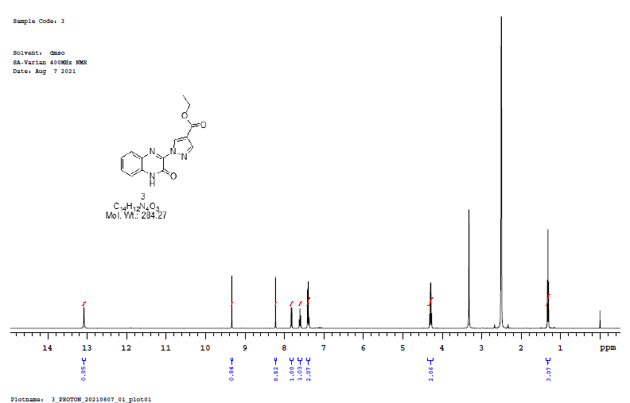

3
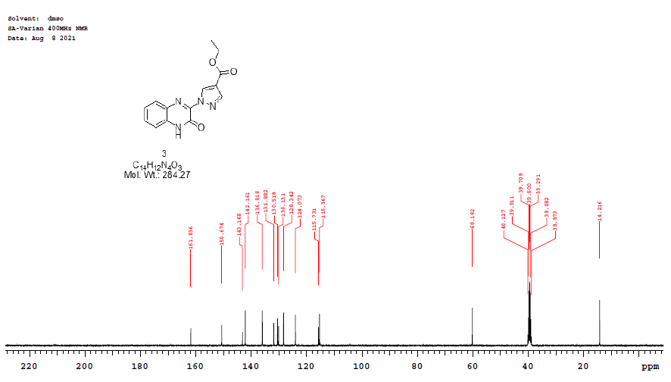

3
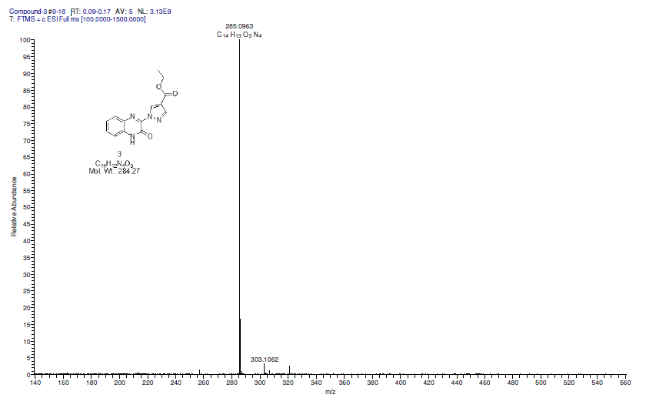

3
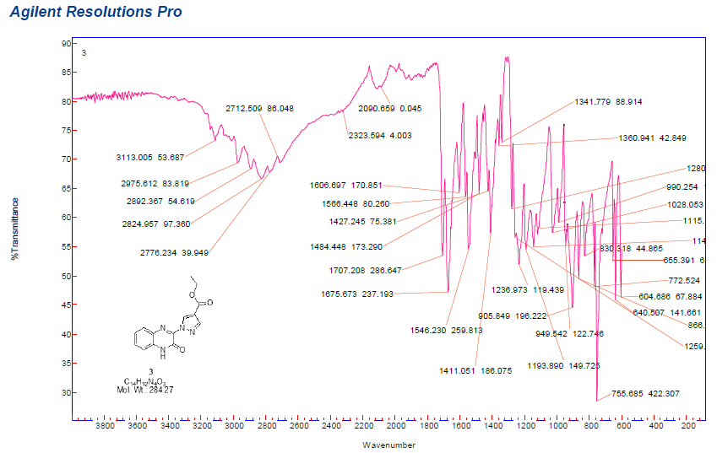

3a
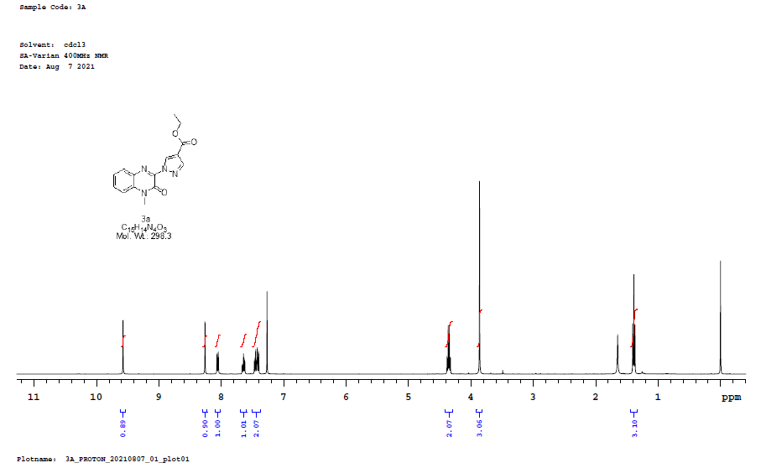

3a
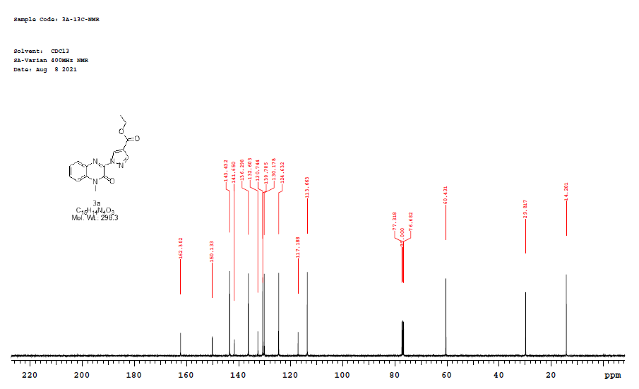
3a
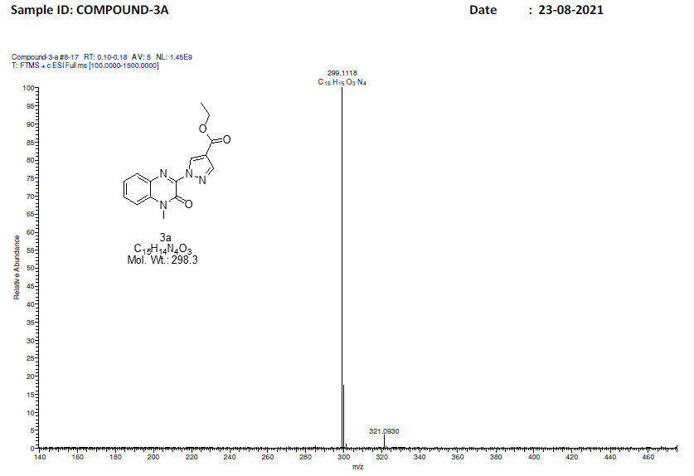

3a
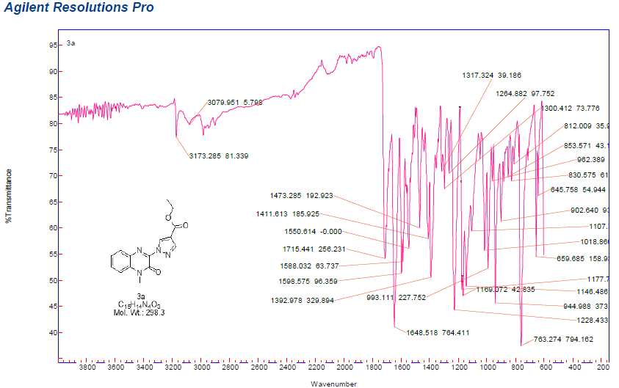

3b
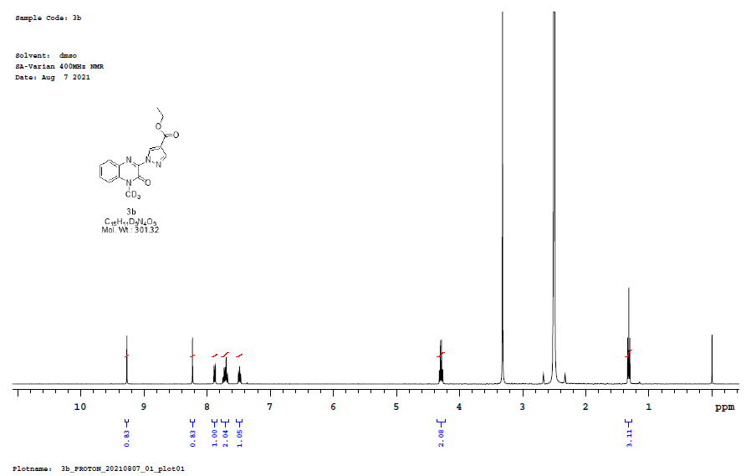

3b
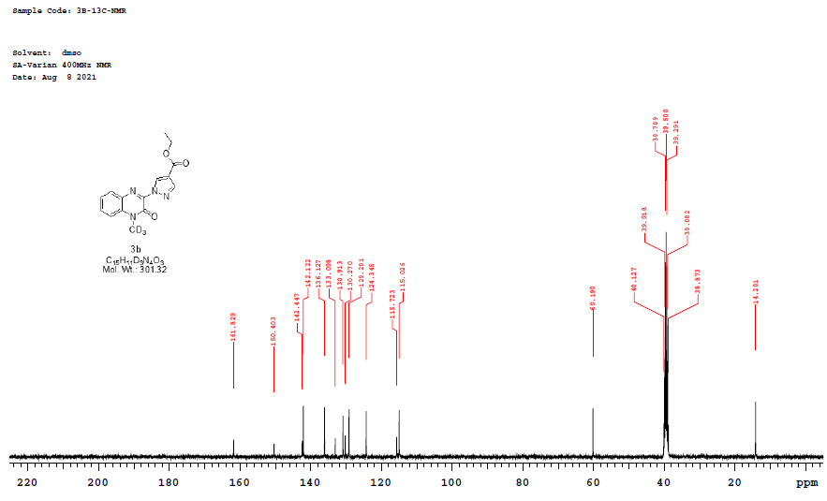

3b
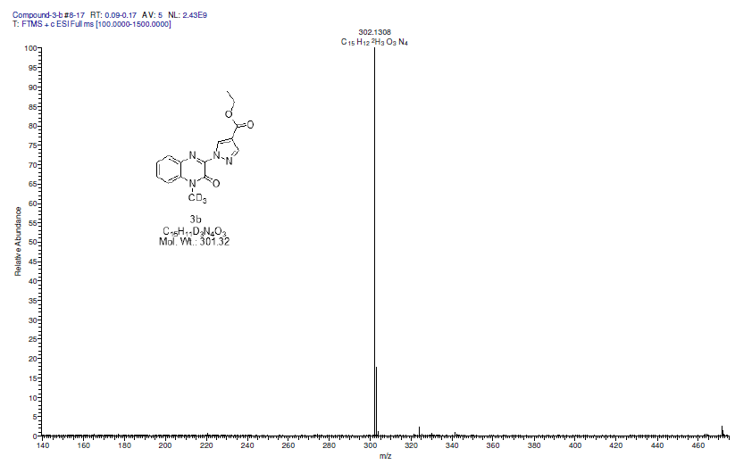

3b
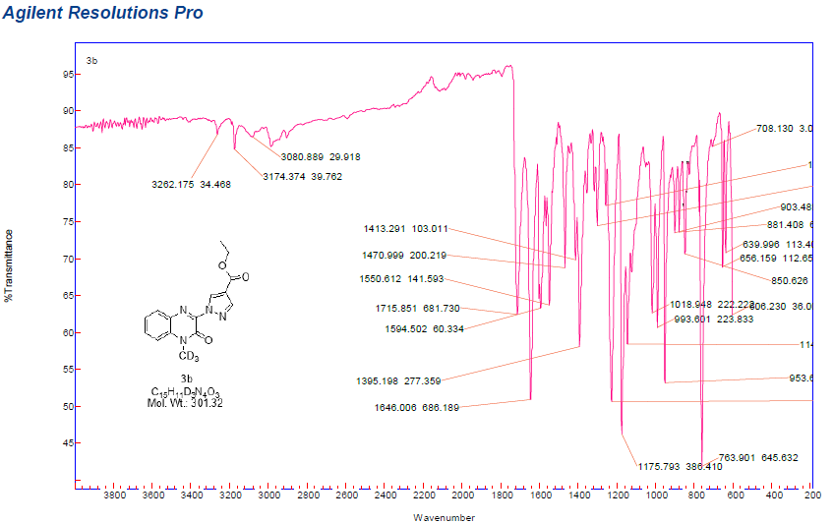

3c
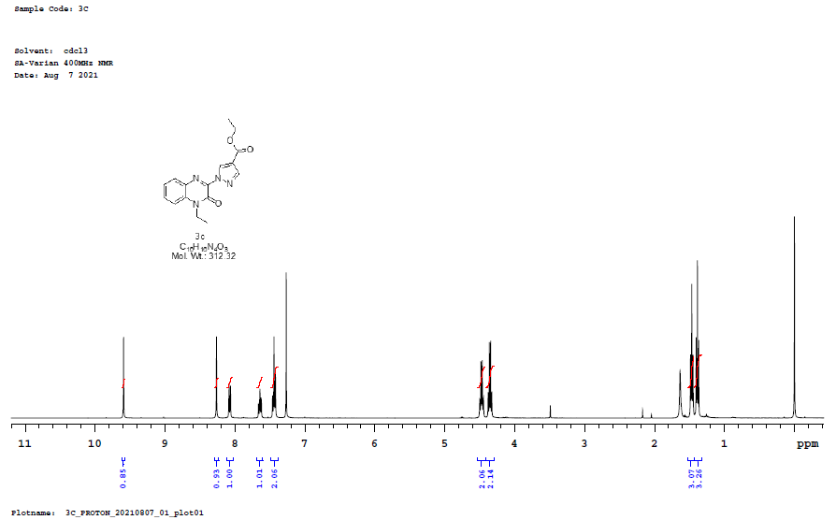

3c
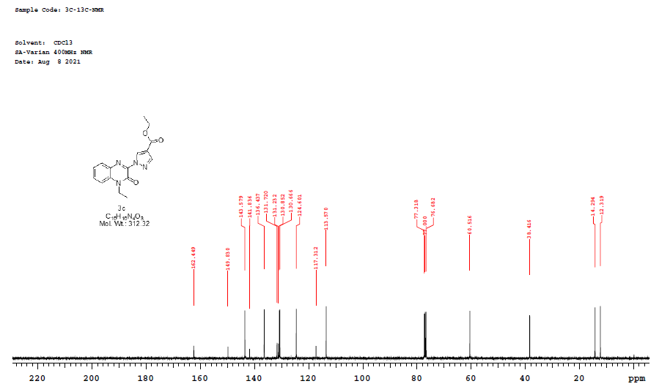

3c
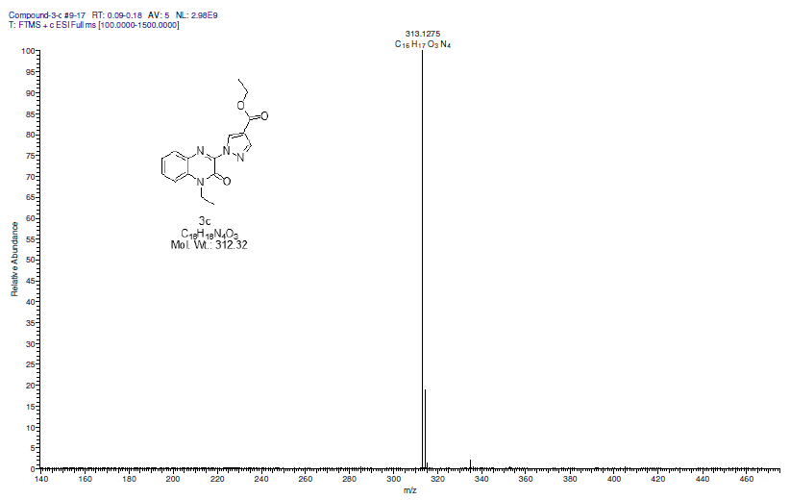

3c
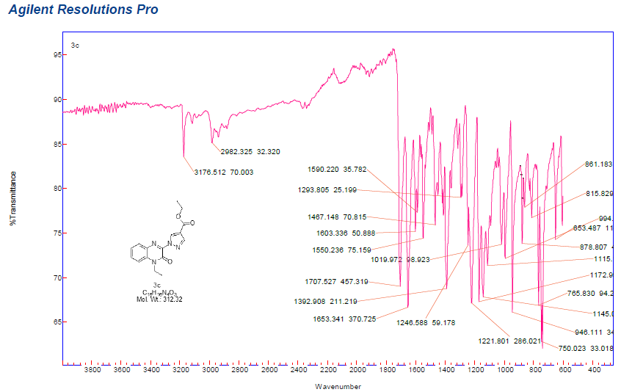

3d
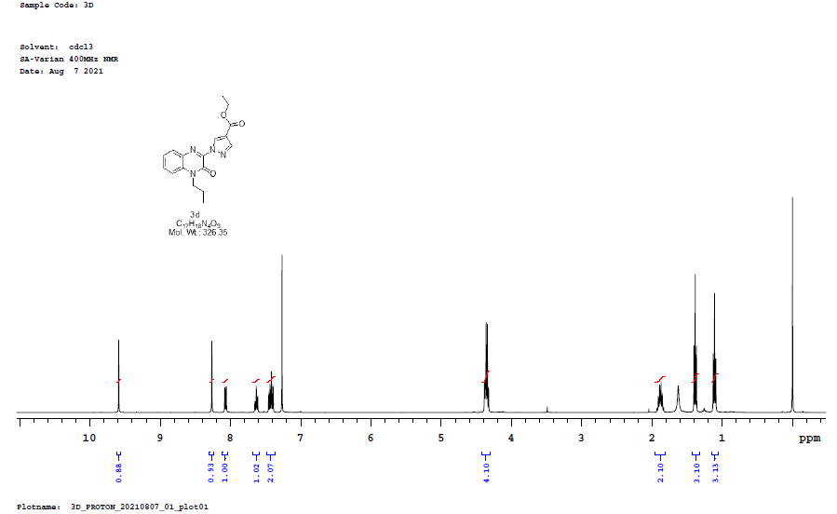

3d
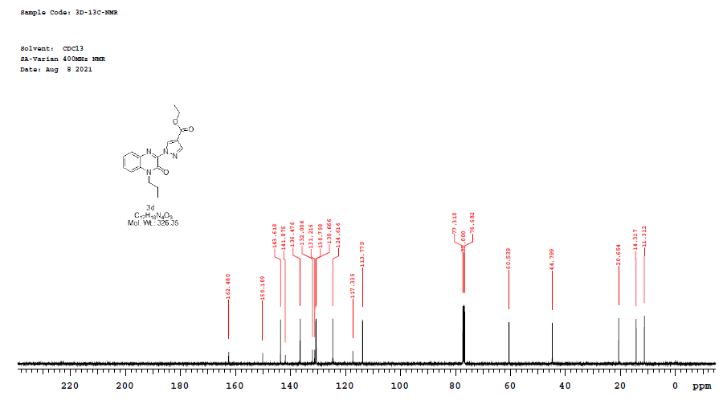

3d
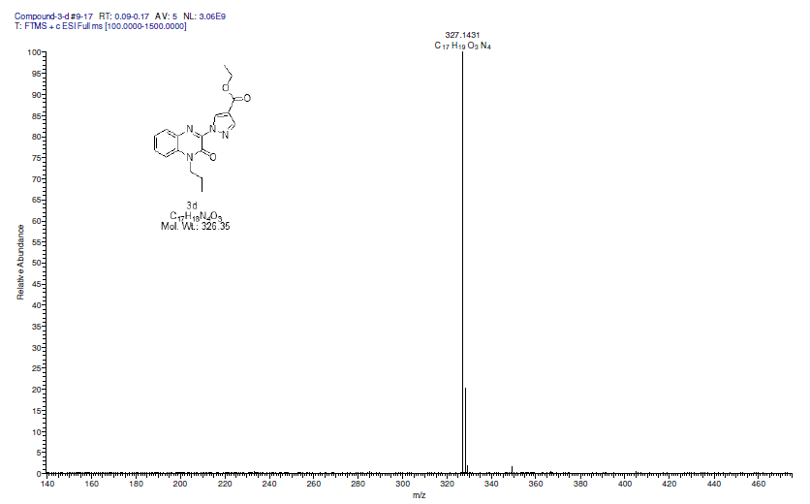

3d
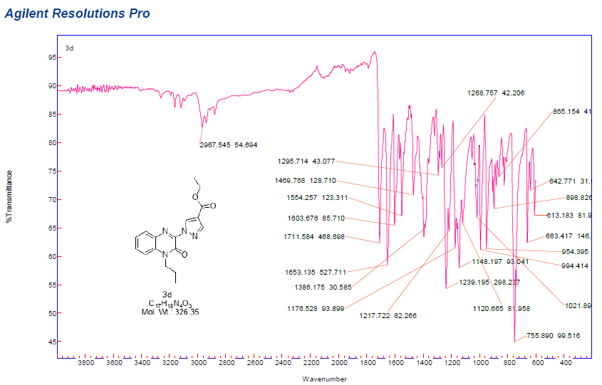

3e
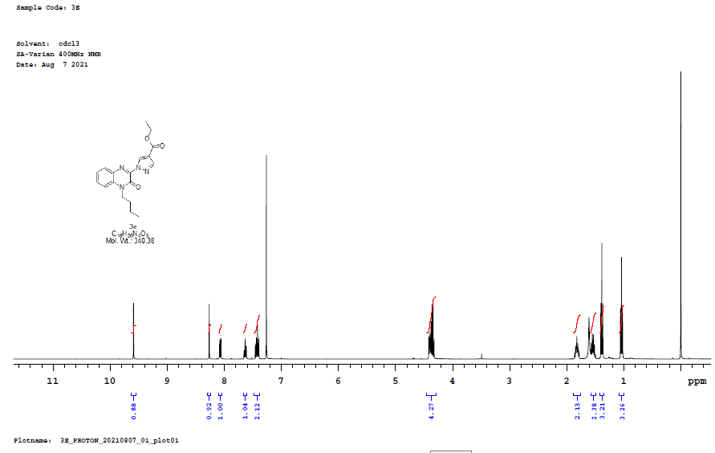

3e
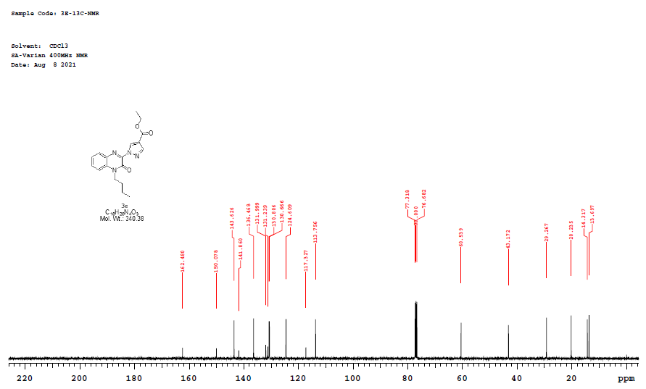

3e
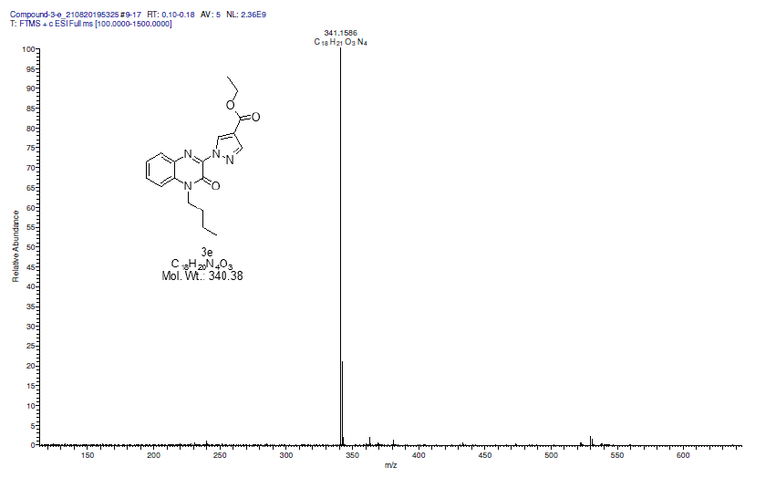

3e

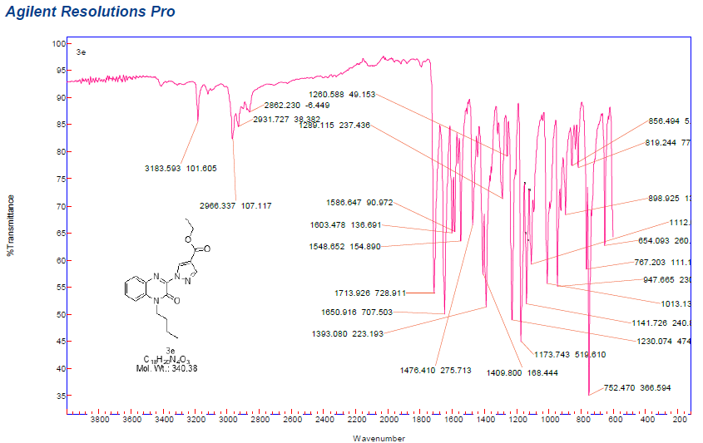

3f
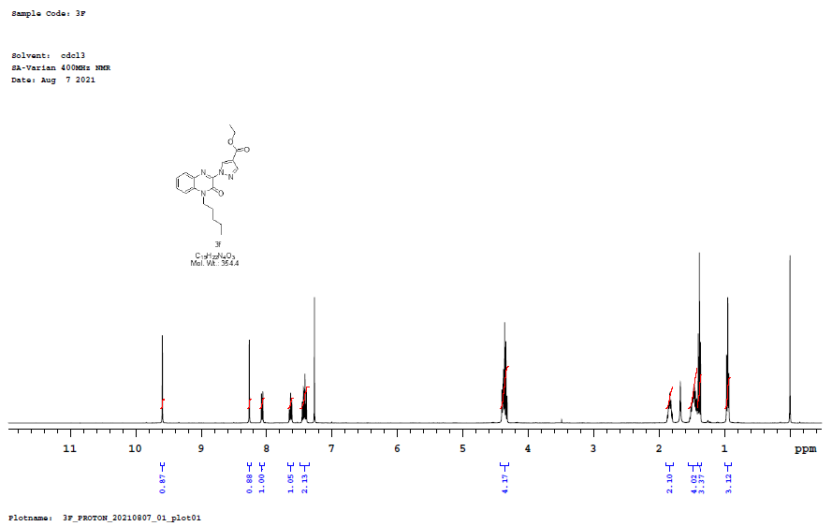
3f

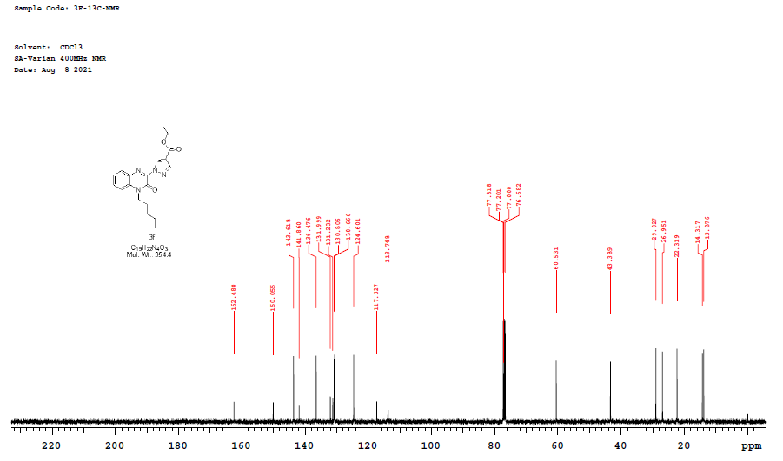

3f
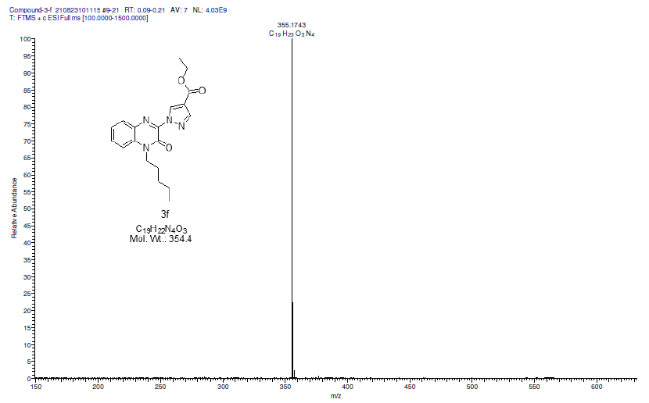

3f
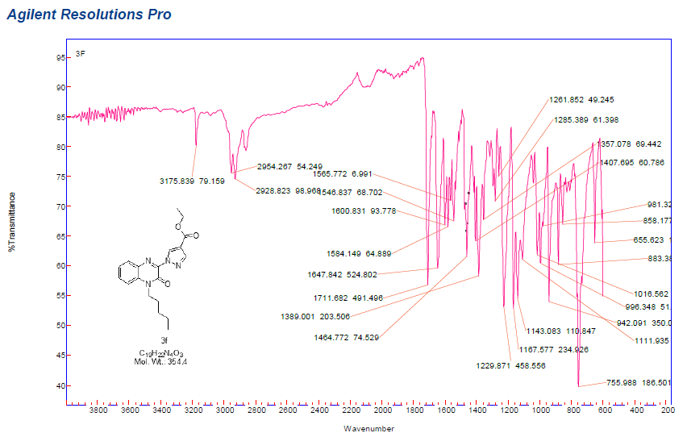

6f
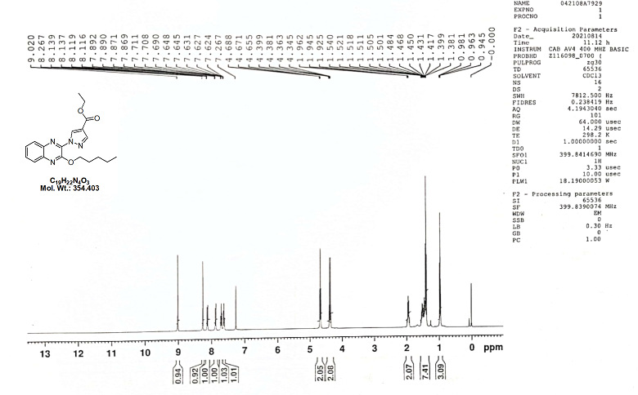
6f
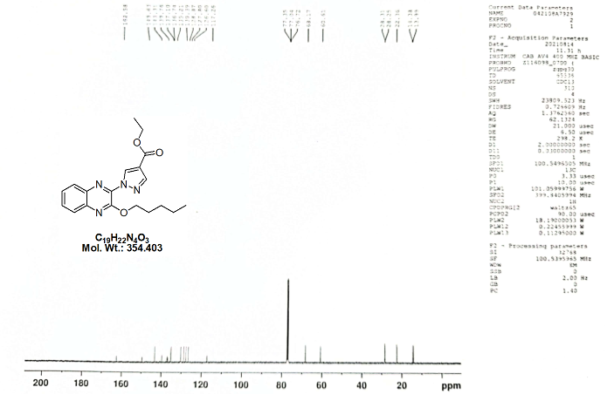

6f
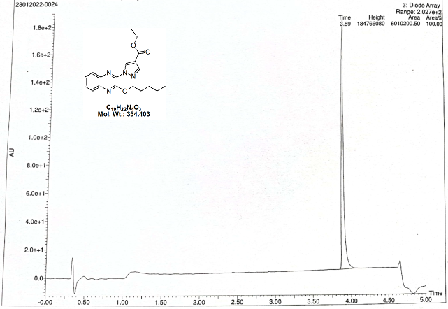

6f
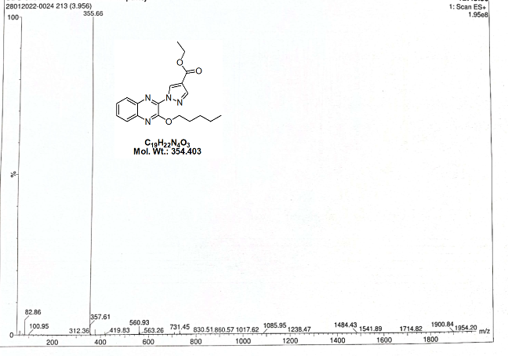

6f
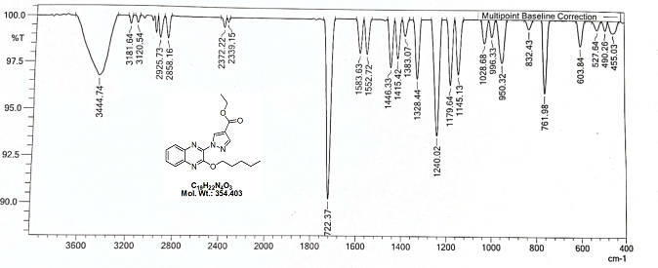

3g

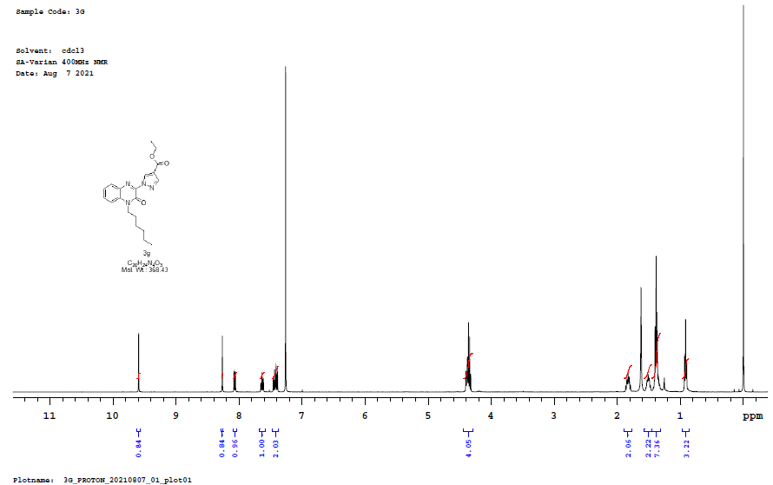

3g

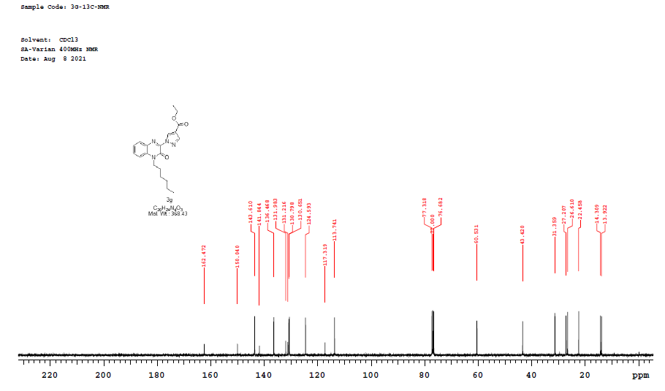
3g
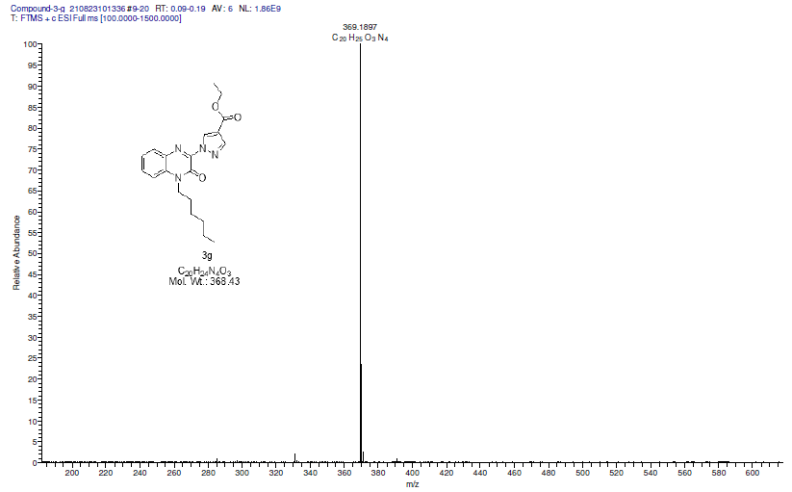

3g
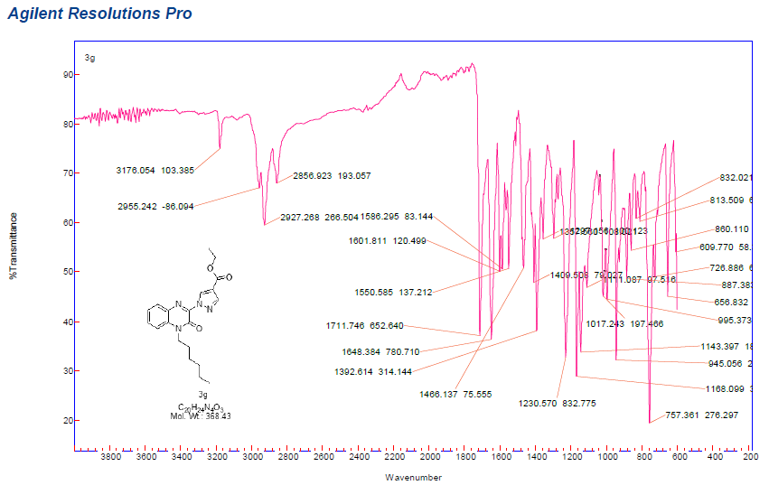

3h
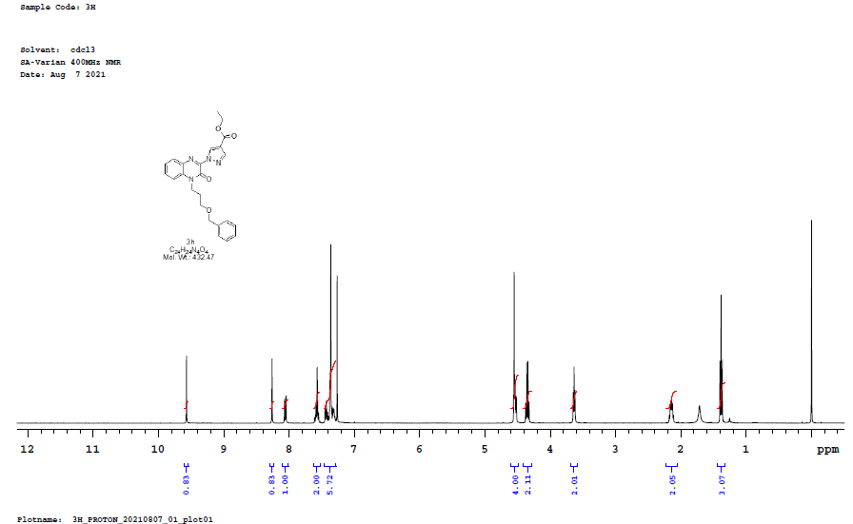

3h
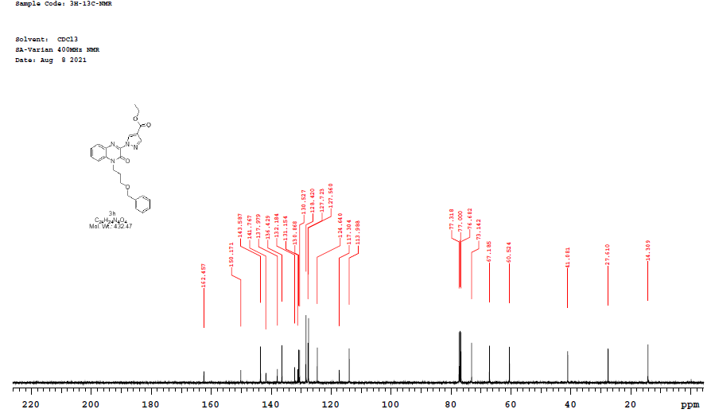

3h
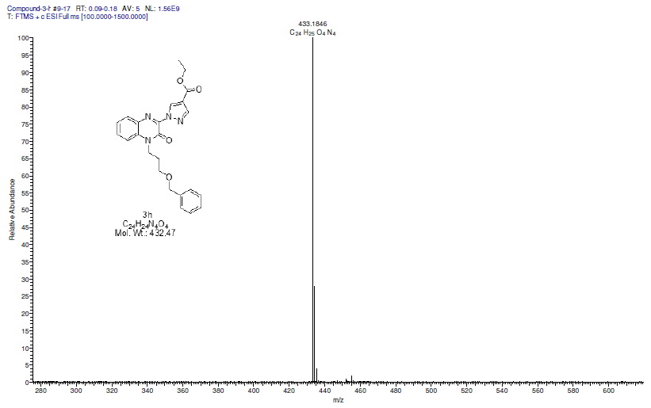

3h
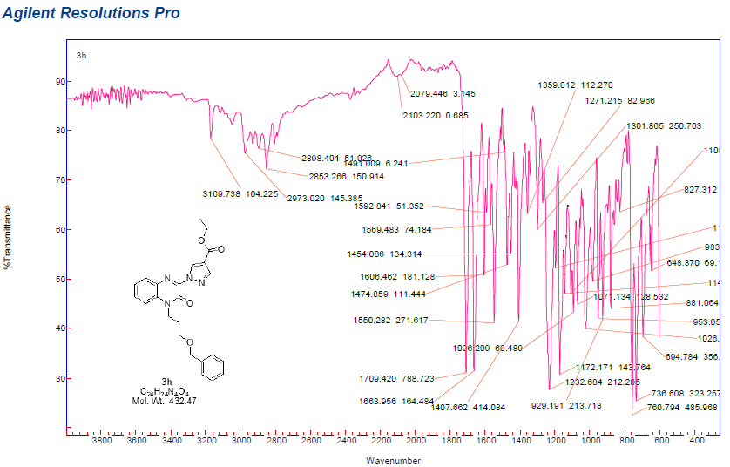

6h
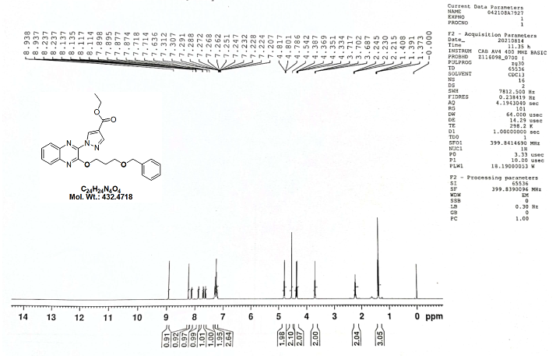

6h
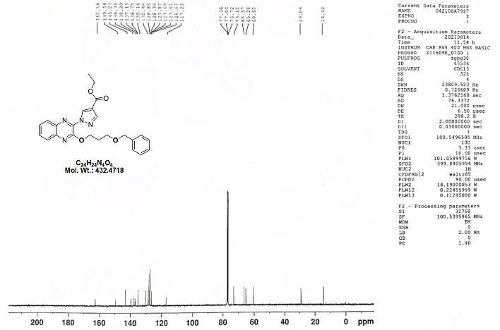

6h
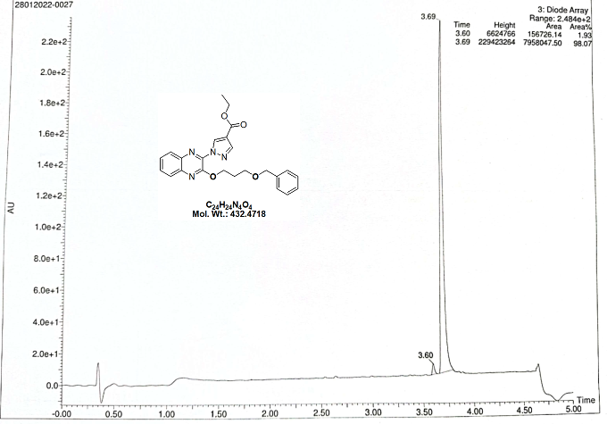

6h
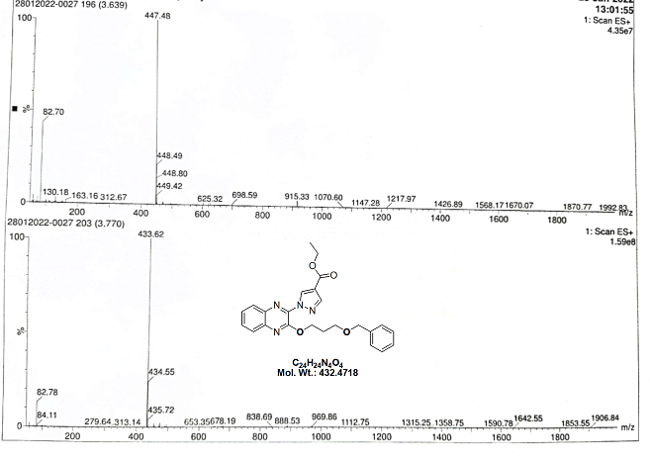

6h
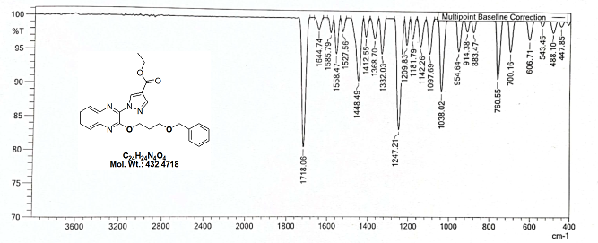

3i
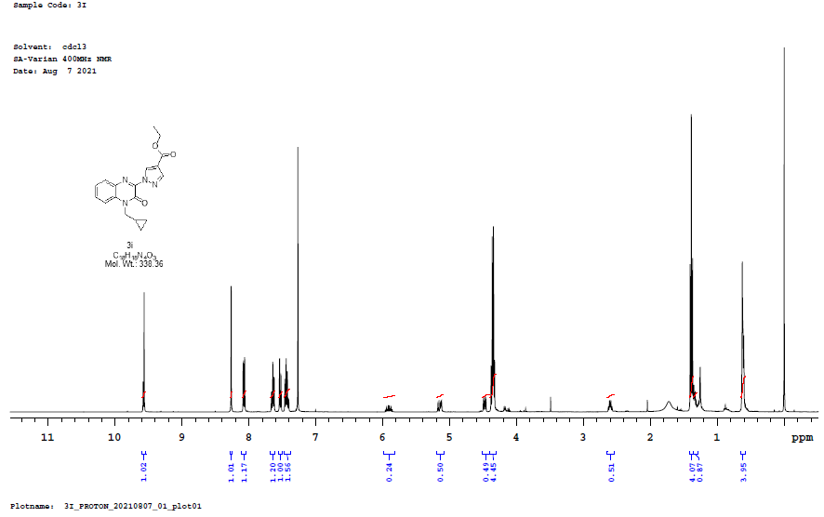

3i
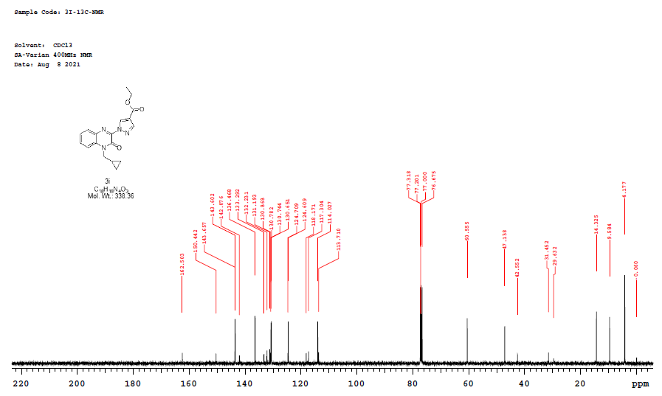

3i
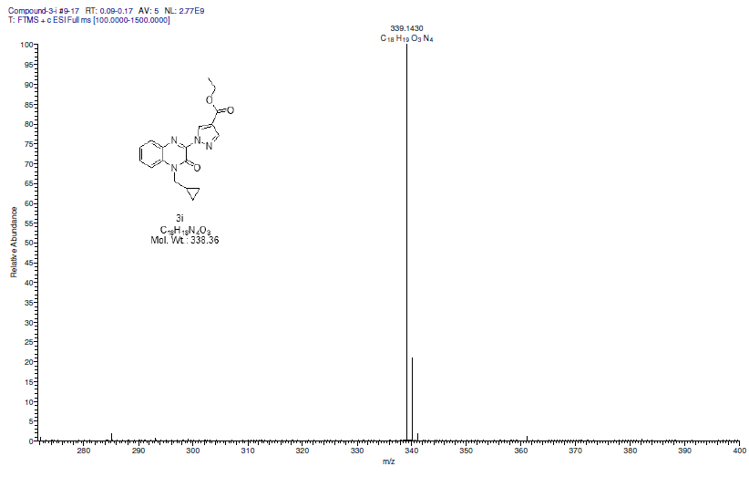

3i
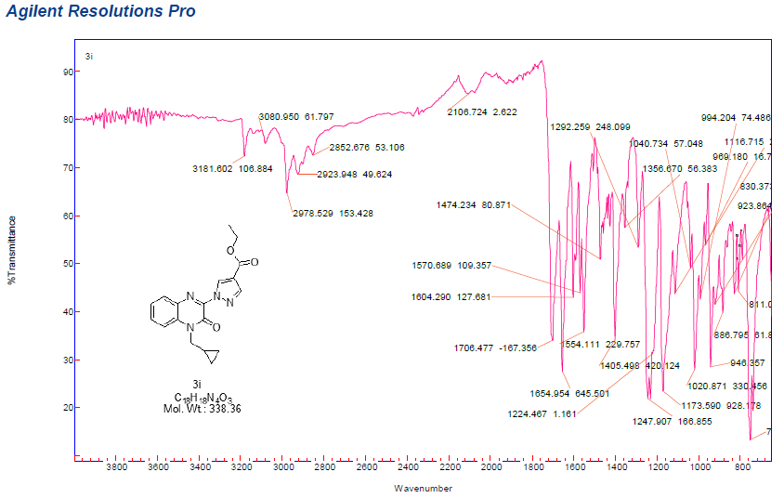

3j
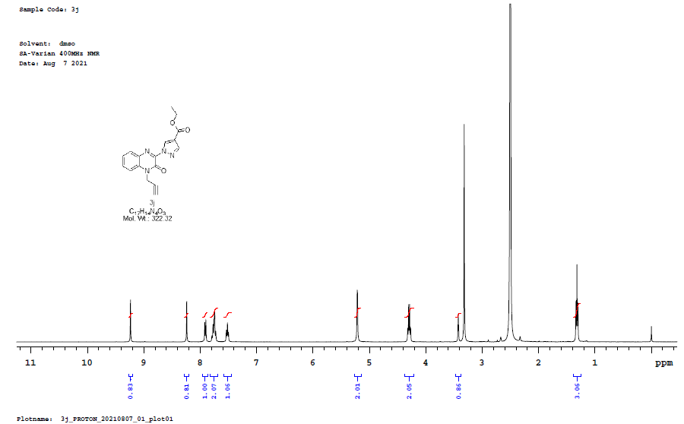

3j
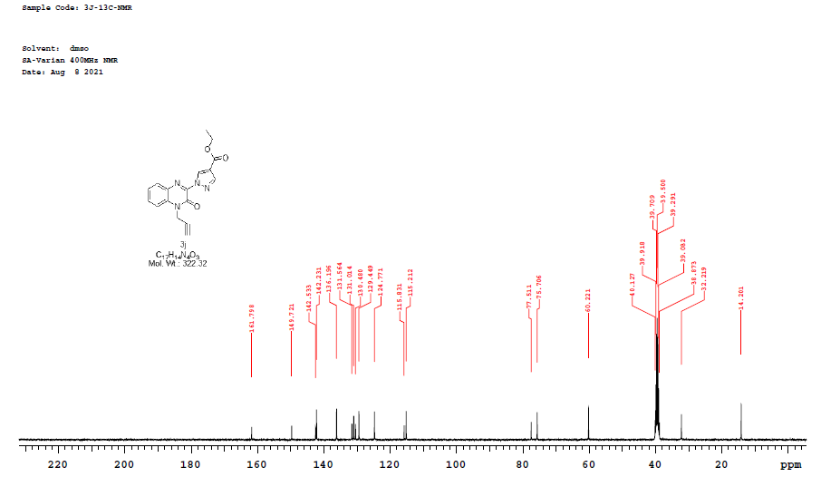

3j
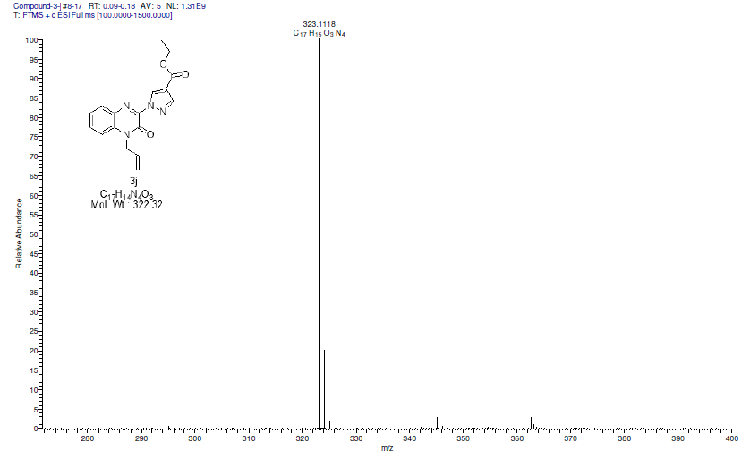

3j
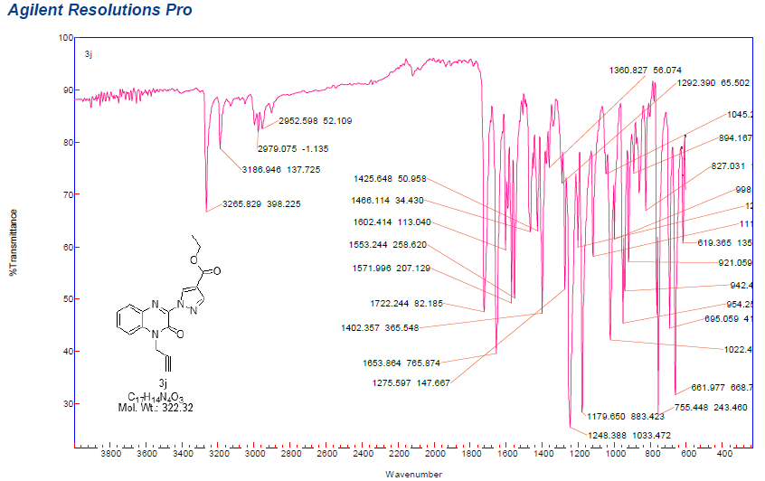

3k
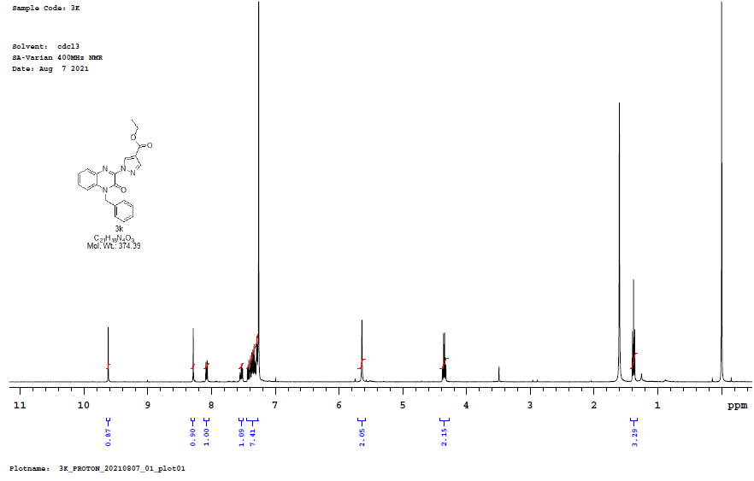

3k
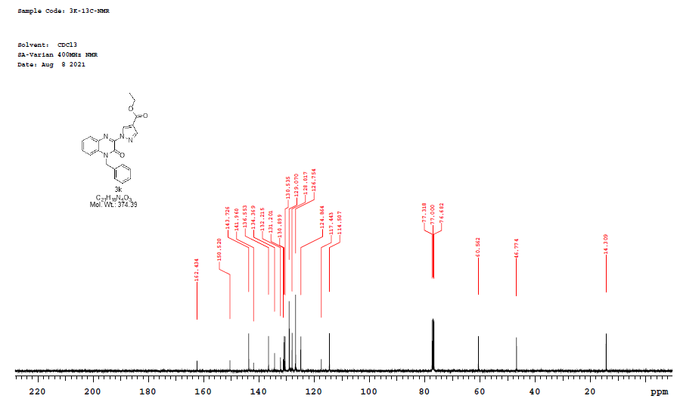

3k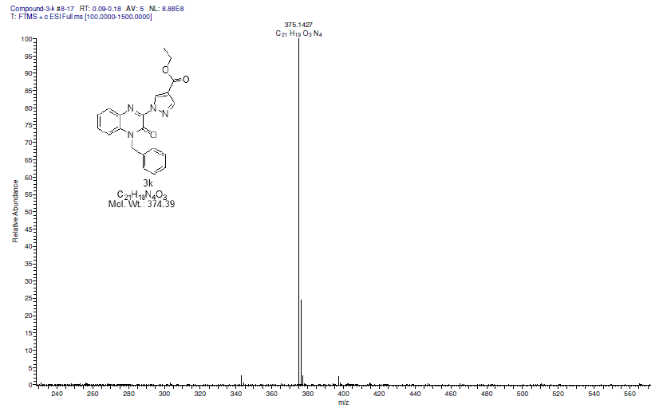

3k
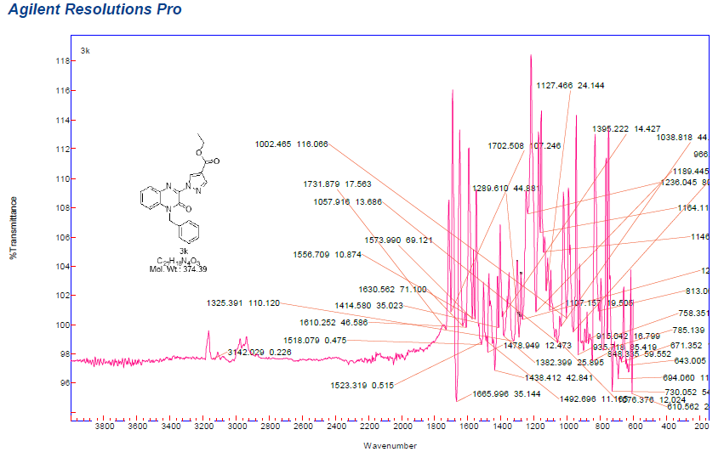

3l
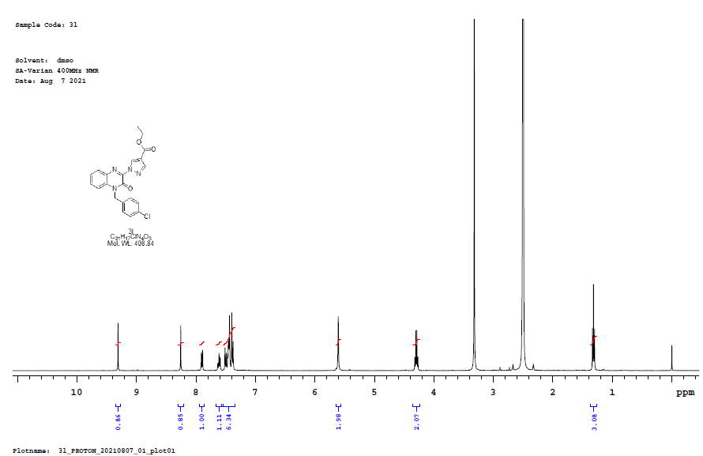

3l
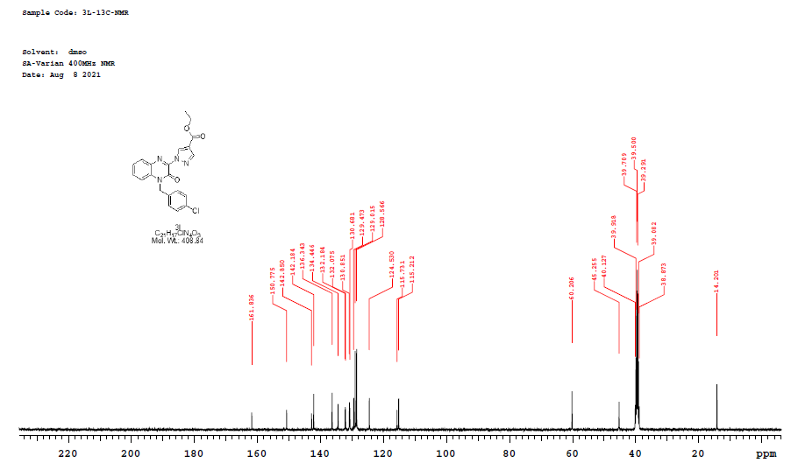

3l
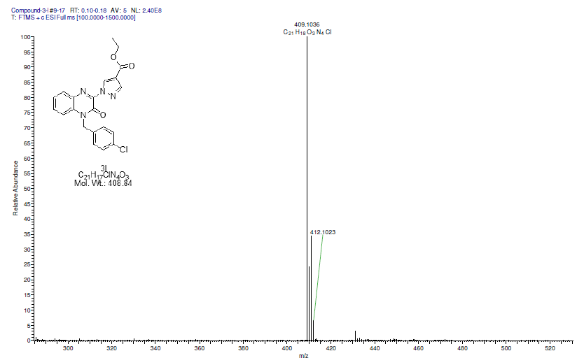

3l
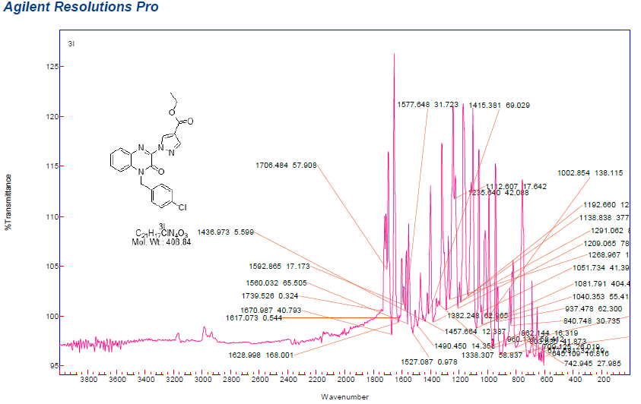
3m
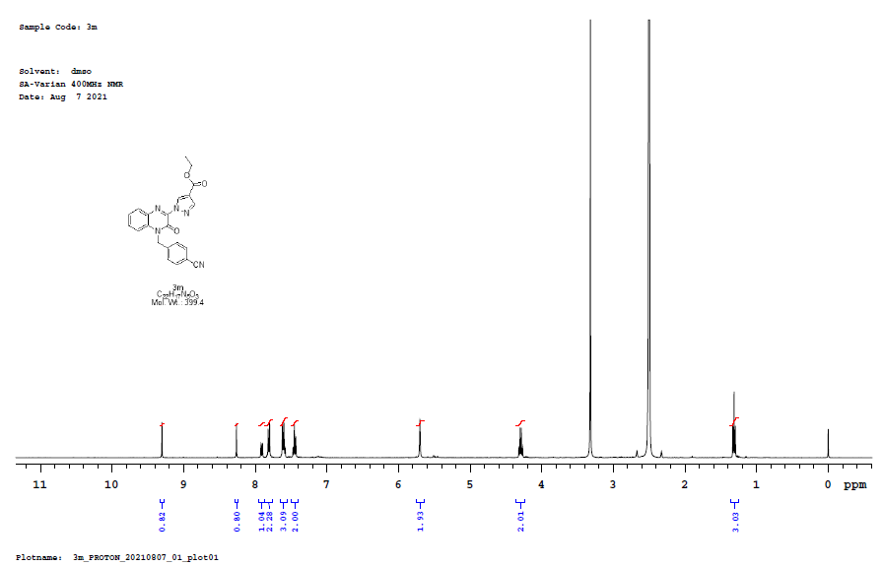

3m
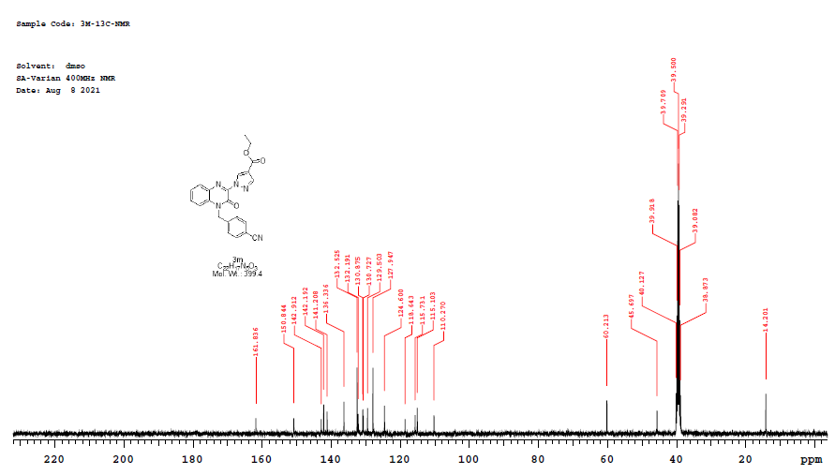

3m
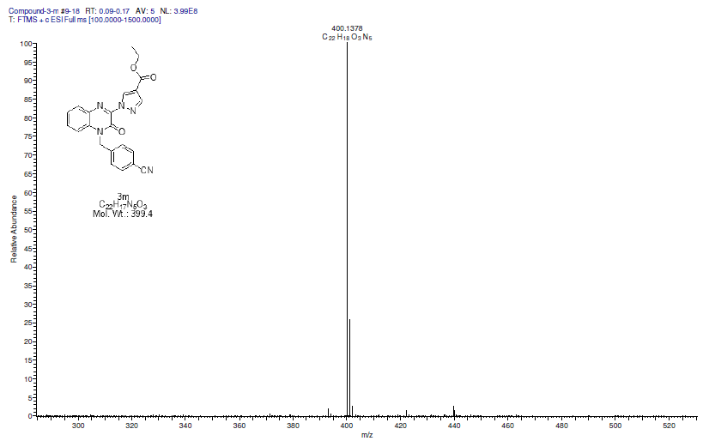

3m
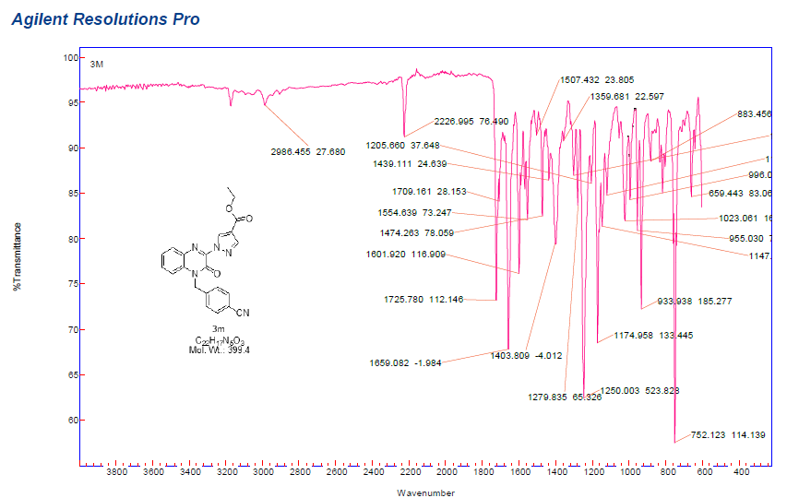

3n
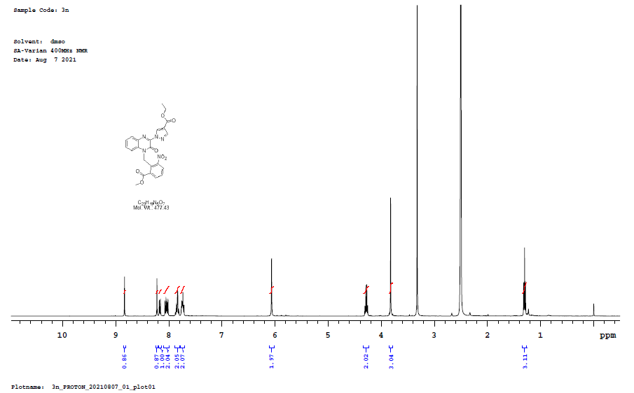

3n
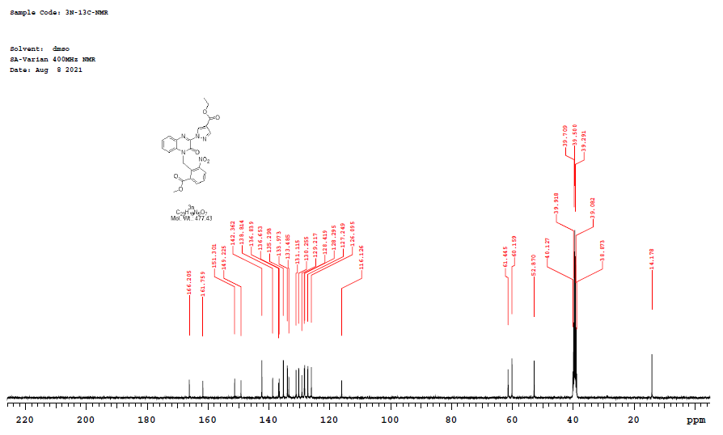

3n

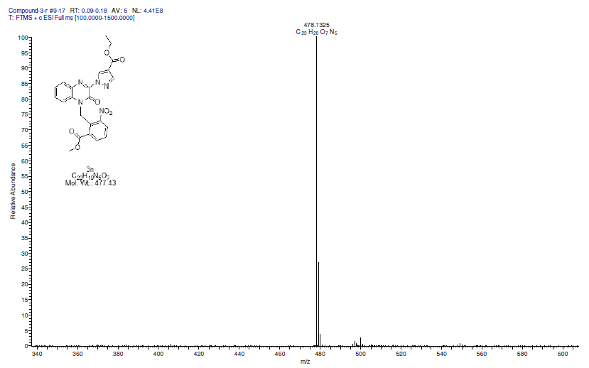

3n
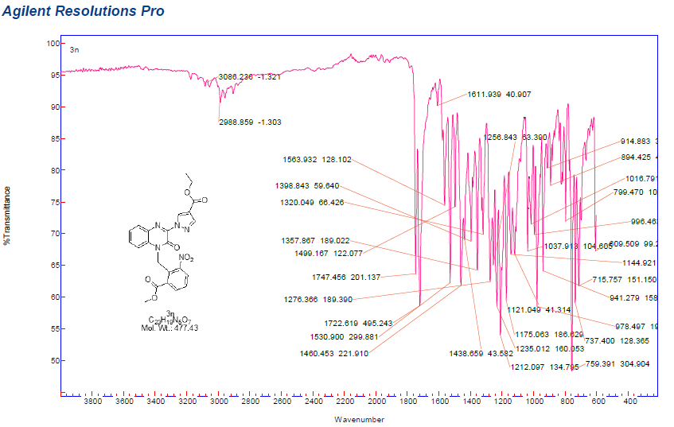
3o
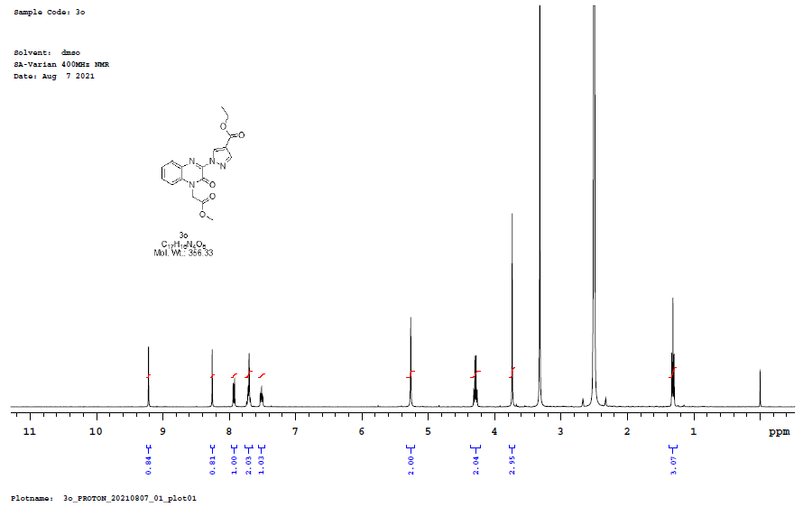

3o
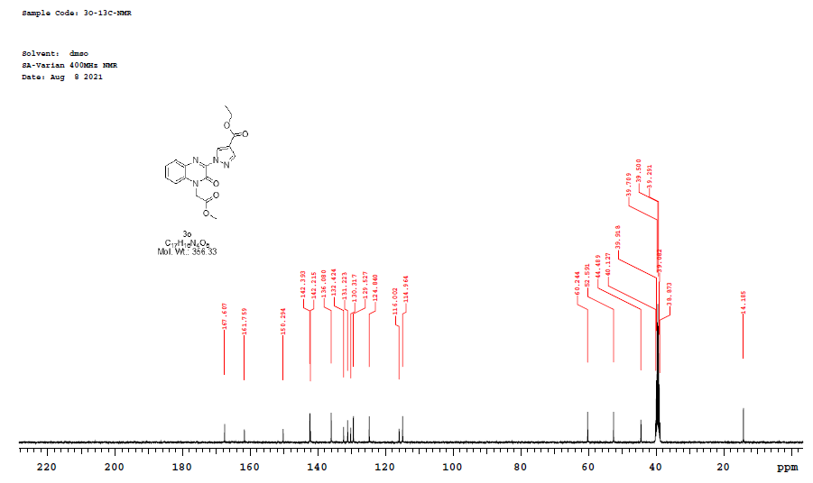

3o
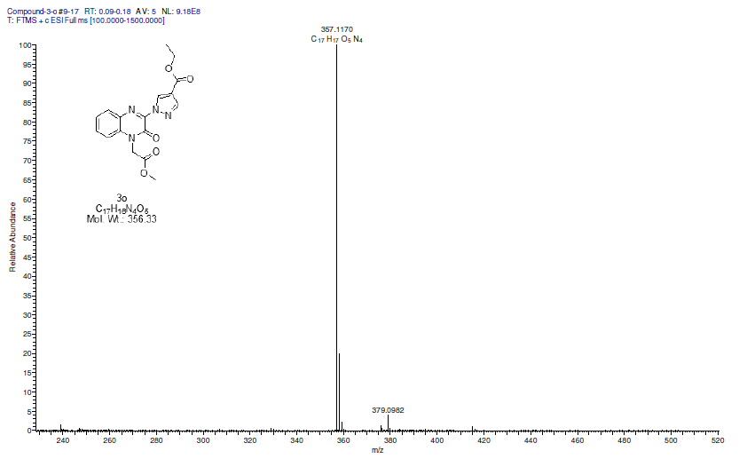

3o
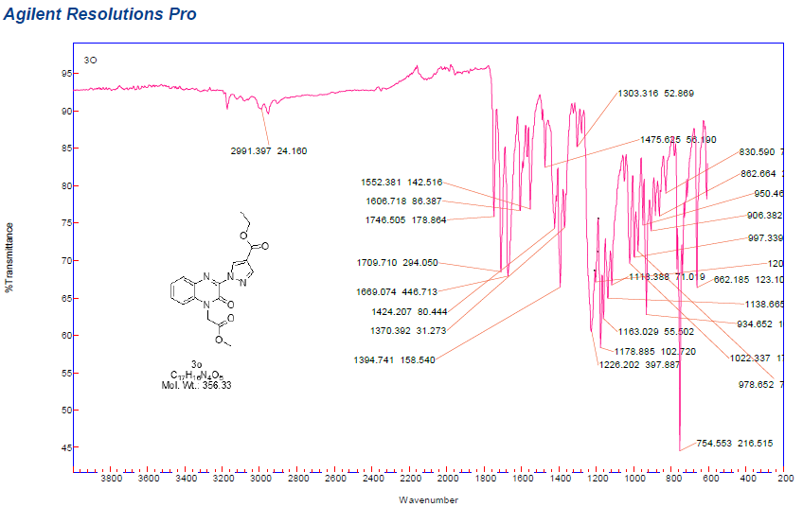

3p
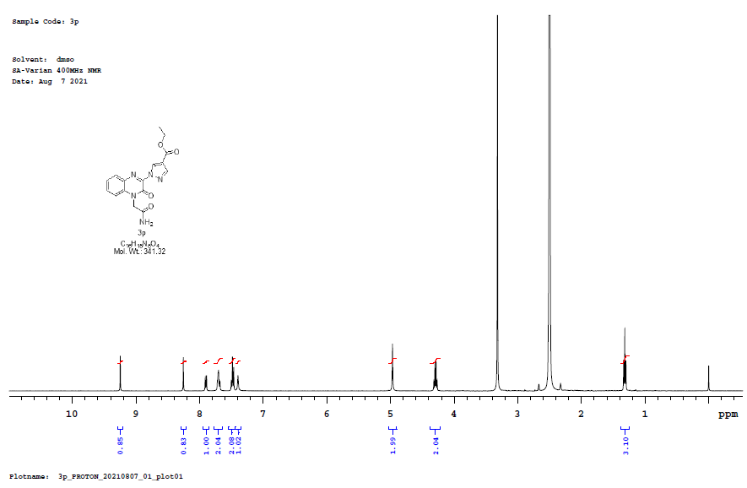

3p
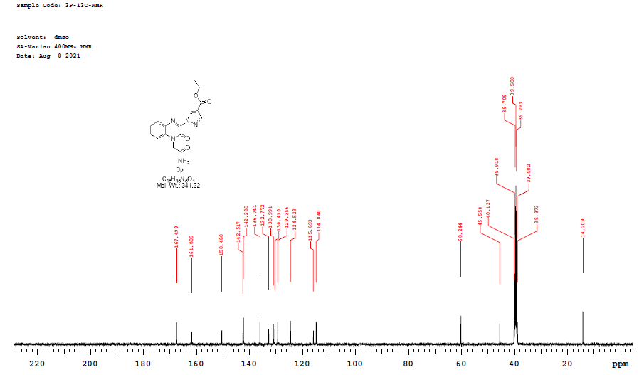

3p
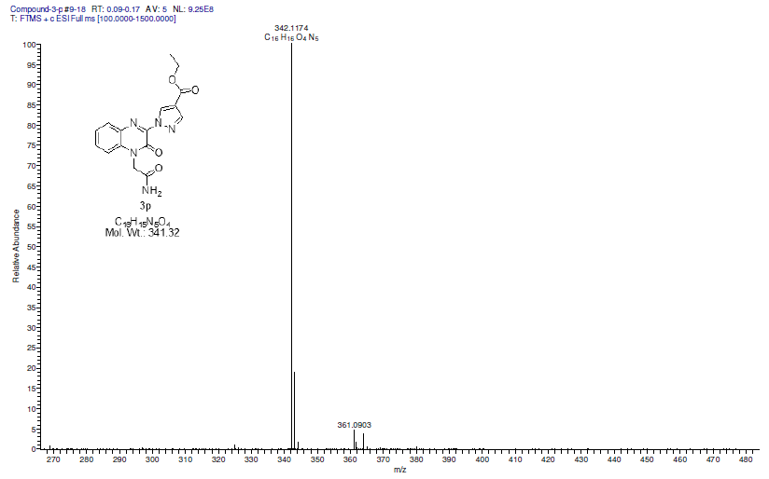

3p
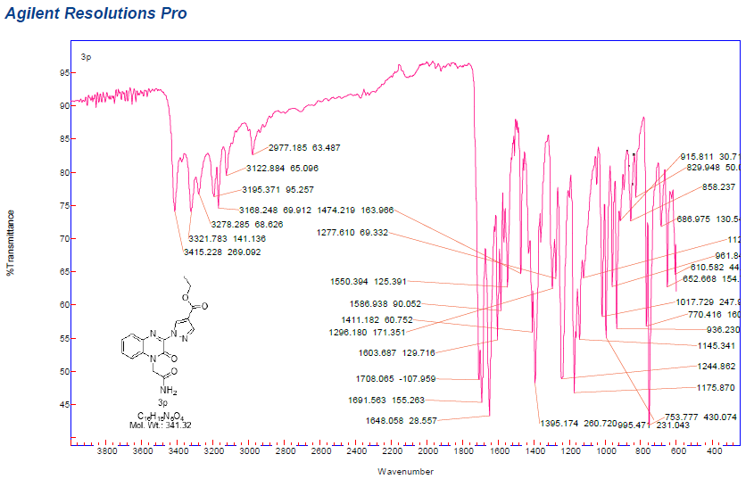

3q
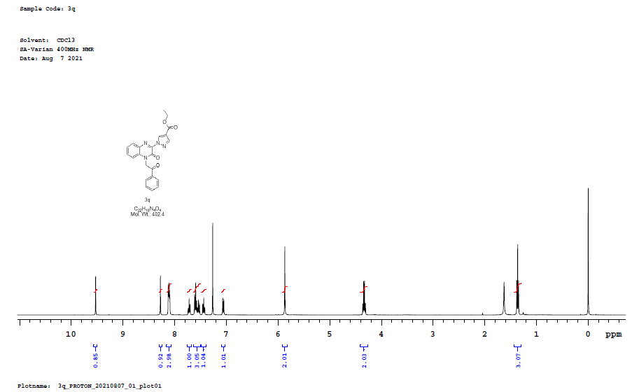

3q
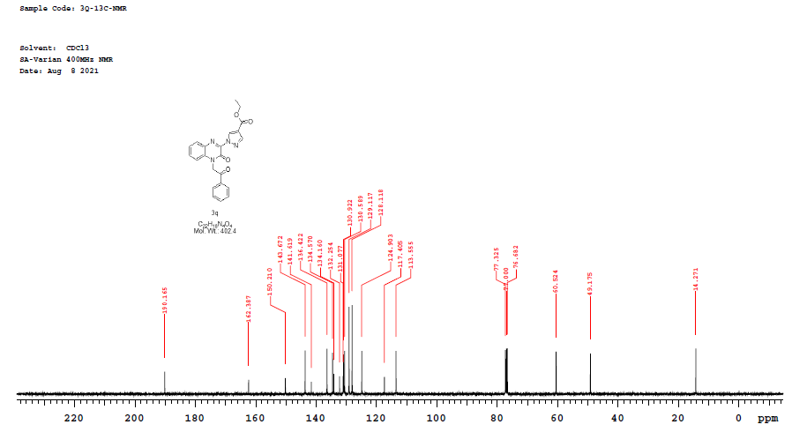

3q
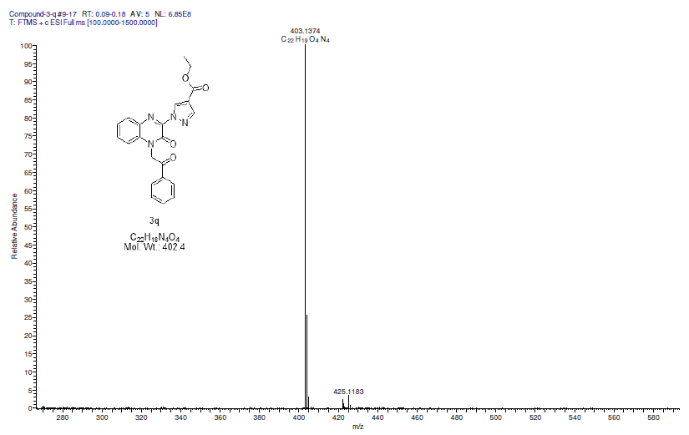

3q
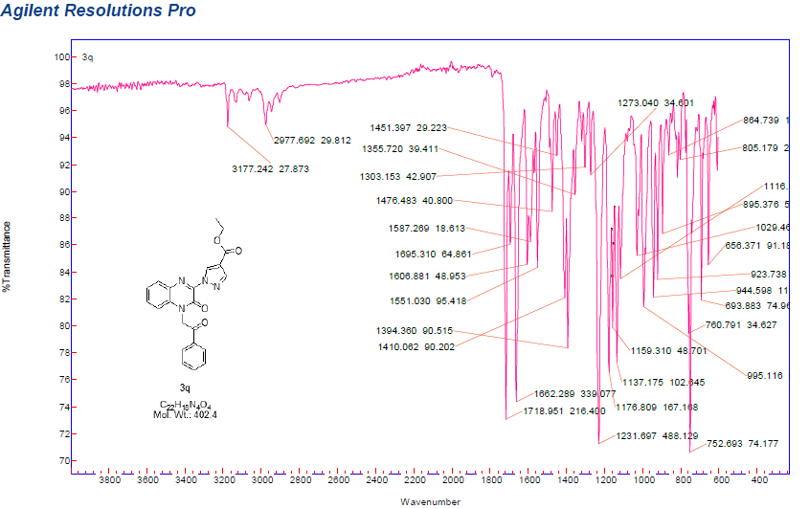

3r
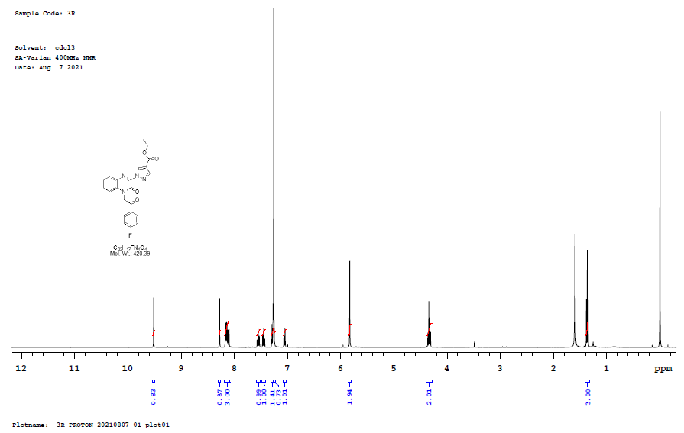

3r
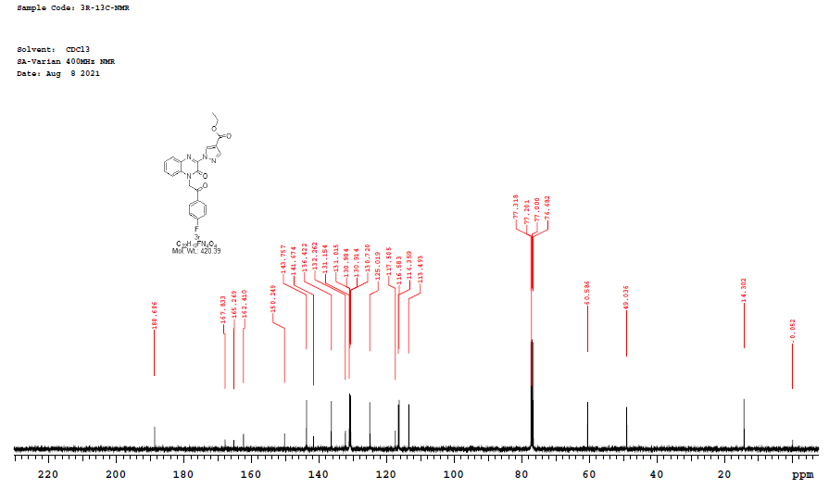

3r
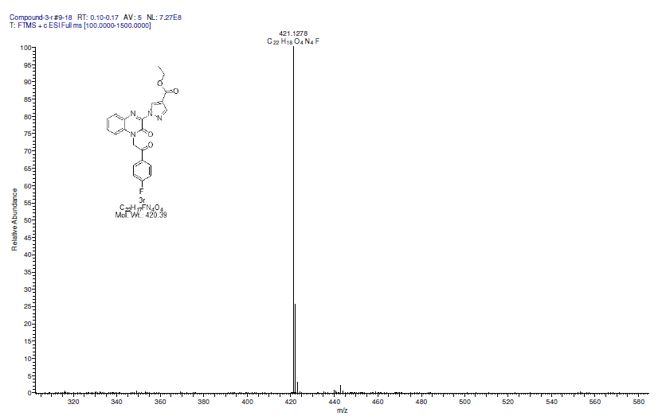

3r
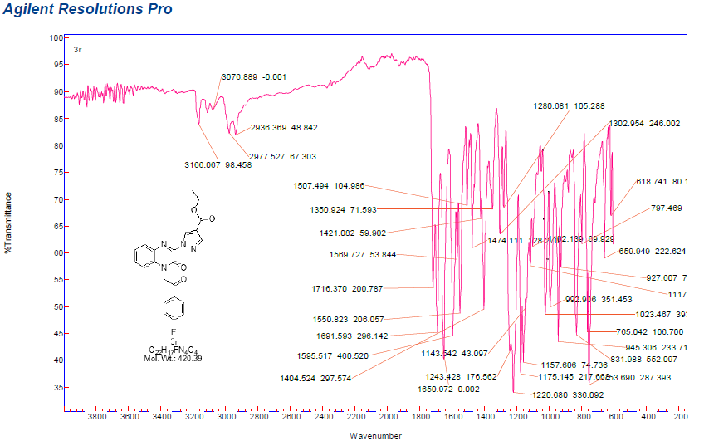

3s
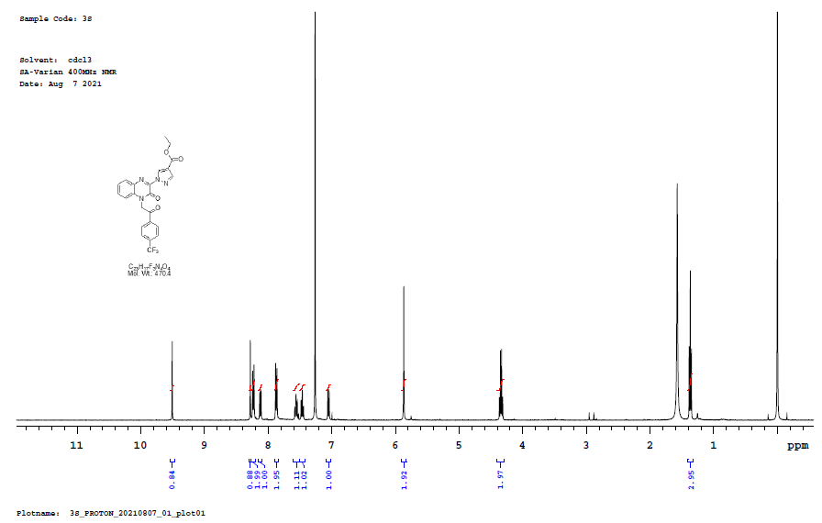

3s
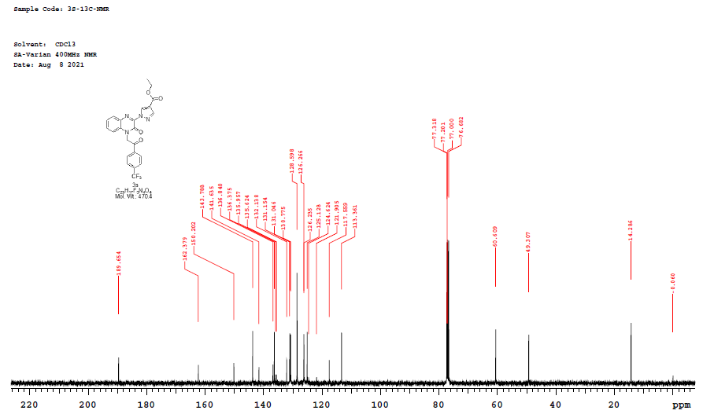

3s
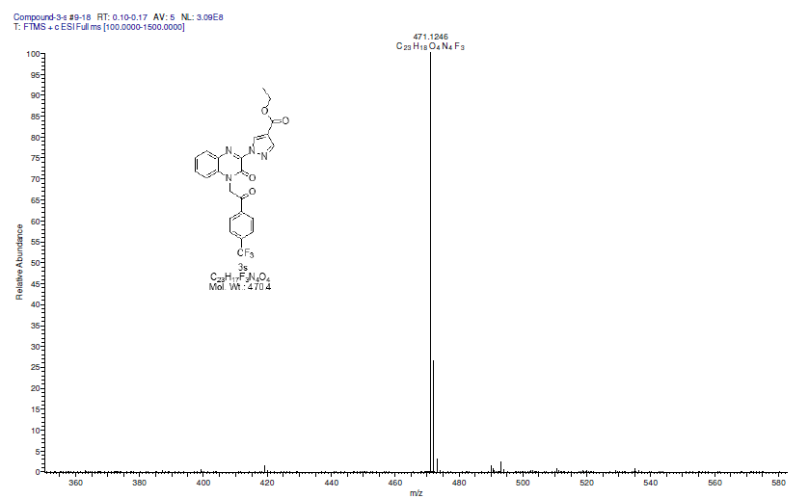

3s
