Supporting Information for
Uncertainty propagation in a global biogeochemical model driven by leaf area data
Chenyu Bian^{1,2} & Jianyang Xia^{1,2,*}
- Zhejiang Tiantong Forest Ecosystem National Observation and Research Station, State Key Laboratory of Estuarine and Coastal Research, School of Ecological and Environmental Sciences, East China Normal University, Shanghai 200241, China
- Research Center for Global Change and Complex Ecosystems, East China Normal University, Shanghai 200241, China
*Correspondence to: Jianyang Xia ( jyxia@des.ecnu.edu.cn )
This file includes:
Figure S1. Biome distribution of the CABLE model used in this study. The abbreviations of biomes are: ENF, Evergreen Needleleaf Forest; EBF, Evergreen Broadleaf Forest; DNF, Deciduous Needleleaf Forest; DBF, Deciduous Broadleaf Forest; Shrub, Shrub land; C3G, C3 Grassland; C4G, C4 Grassland.
Figure S2. The decomposition of NPP among different biomes. NPP can be decomposed into GPP and CUE. The abbreviations of biomes are given in Figure S1.
Figure S3. Residence time can be decomposed into the baseline residence time and environmental scalars among eight biomes. Each point represents an ensemble results from three simulations. The abbreviations of biomes are given in Figure S1.
Figure S4. Bar plot of the C, N, and P allocation coefficients of leaf, woody, and root in eight biomes. The abbreviations of biomes are given in Figure S1.
Table S1. Summary of CABLE simulation experiments used in this study.
Table S2. Table of CABLE simulation results for each biome. The abbreviations of biomes are given in Figure S1.

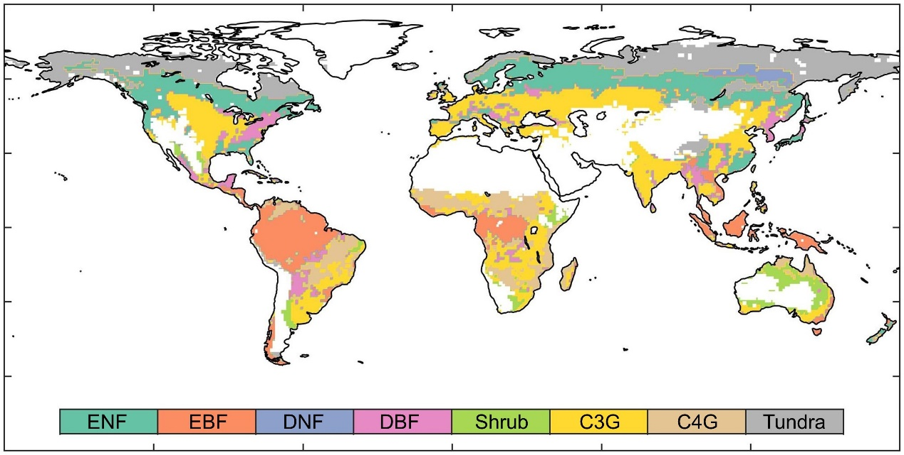
Figure S1. Biome distribution of the CABLE model used in this study. The abbreviations of biomes are: ENF, Evergreen Needleleaf Forest; EBF, Evergreen Broadleaf Forest; DNF, Deciduous Needleleaf Forest; DBF, Deciduous Broadleaf Forest; Shrub, Shrub land; C3G, C3 Grassland; C4G, C4 Grassland.

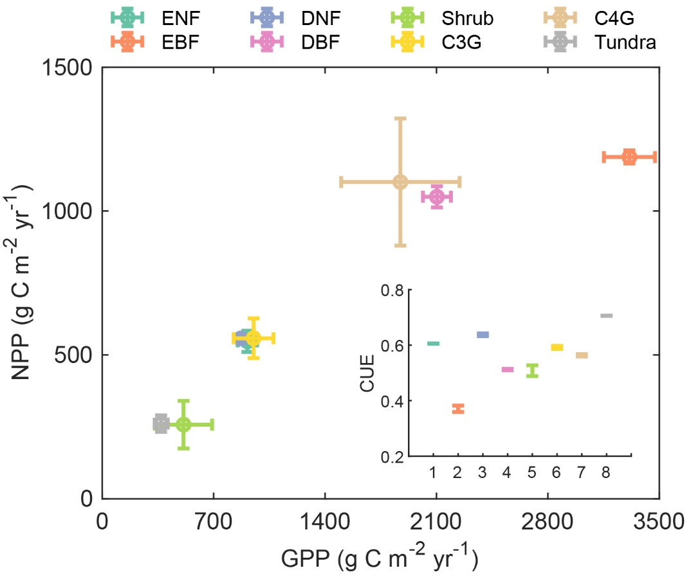
Figure S2. The decomposition of NPP among different biomes. NPP can be decomposed into GPP and CUE. The abbreviations of biomes are given in Figure S1.

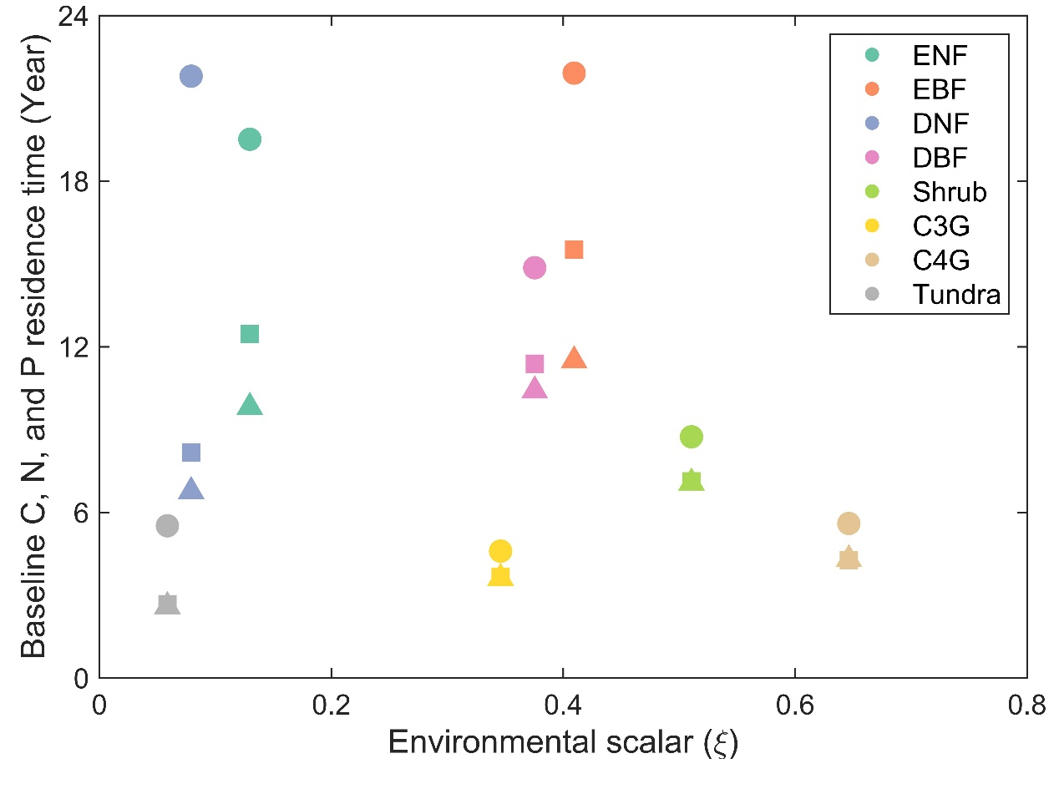
Figure S3. Residence time can be decomposed into the baseline residence time and environmental scalars among eight biomes. Each point represents an ensemble results from three simulations. The abbreviations of biomes are given in Figure S1.

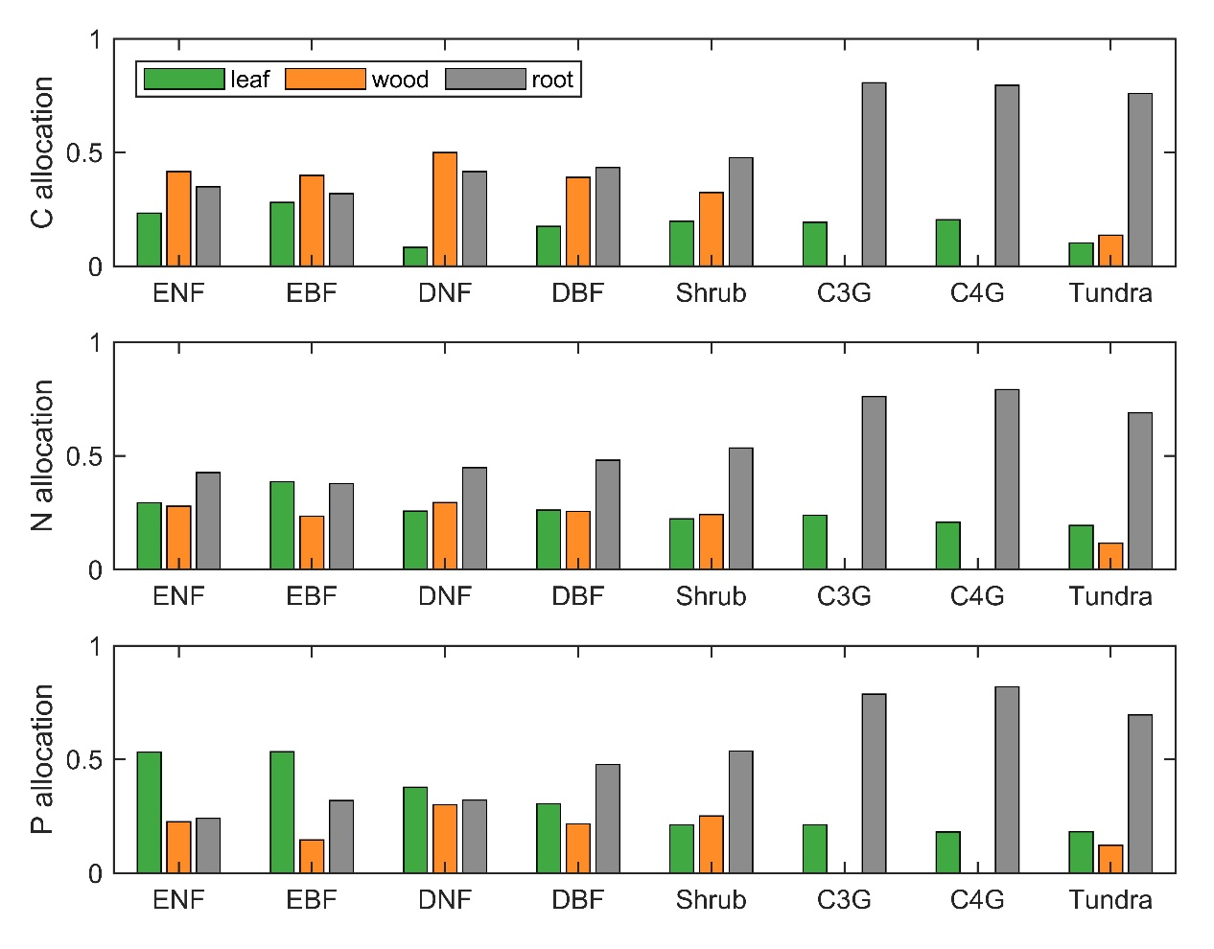
Figure S4. Bar plot of the C, N, and P allocation coefficients of leaf, woody, and root in eight biomes. The abbreviations of biomes are given in Figure S1.

Table S1. Summary of CABLE simulation experiments used in this study.
Simulation name | LAI datasets | Climate | CO₂ | Time Period
S-GIMMS | GIMMS LAI3g | Recycled (1982-2011) | Time varied | 1982-2011
S-GLASS | GLASS | Recycled (1982-2011) | Time varied | 1982-2011
S-GLOBMAP | GLOBMAP | Recycled (1982-2011) | Time varied | 1982-2011

Table S2. Table of CABLE simulation results for each biome. The abbreviations of biomes are given in Figure S1.
Components | Biome | S-GIMMS | S-GLASS | S-GLOBMAP | Mean | Standard Deviation
$τ_{C}$(year) | ENF | 64.937 | 64.262 | 63.621 | 64.273 | 0.658
 | EBF | 26.314 | 26.540 | 29.709 | 27.521 | 1.898
 | DNF | 156.098 | 151.689 | 155.128 | 154.305 | 2.317
 | DBF | 27.683 | 27.627 | 27.937 | 27.749 | 0.165
 | Shrub | 43.164 | 43.180 | 37.945 | 41.429 | 3.018
 | C3G | 30.970 | 30.597 | 30.556 | 30.708 | 0.228
 | C4G | 17.884 | 17.872 | 17.549 | 17.769 | 0.190
 | Tundra | 127.375 | 125.924 | 125.999 | 126.433 | 0.817
$τ_{N}$(year) | ENF | 48.047 | 51.152 | 52.075 | 50.425 | 2.110
 | EBF | 26.847 | 26.857 | 26.590 | 26.765 | 0.152
 | DNF | 73.681 | 86.292 | 75.220 | 78.398 | 6.880
 | DBF | 25.582 | 25.725 | 25.411 | 25.573 | 0.157
 | Shrub | 33.995 | 34.095 | 32.346 | 33.479 | 0.982
 | C3G | 24.394 | 24.526 | 23.550 | 24.157 | 0.529
 | C4G | 14.592 | 14.623 | 14.066 | 14.427 | 0.313
 | Tundra | 43.915 | 61.322 | 53.872 | 53.036 | 8.733
$τ_{P}$(year) | ENF | 40.624 | 43.189 | 43.861 | 42.558 | 1.708
 | EBF | 23.485 | 23.490 | 23.234 | 23.403 | 0.146
 | DNF | 61.757 | 70.968 | 63.665 | 65.463 | 4.862
 | DBF | 24.587 | 24.819 | 24.440 | 24.615 | 0.191
 | Shrub | 33.466 | 33.607 | 31.755 | 32.943 | 1.031
 | C3G | 23.917 | 24.023 | 22.868 | 23.603 | 0.639
 | C4G | 14.578 | 14.633 | 14.039 | 14.417 | 0.328
 | Tundra | 43.306 | 56.978 | 52.416 | 50.900 | 6.961
NPP  (gC m⁻² yr⁻¹) | ENF | 508.094 | 552.231 | 581.506 | 547.277 | 36.956
 | EBF | 1166.975 | 1211.963 | 1184.513 | 1187.817 | 22.676
 | DNF | 568.906 | 561.388 | 541.794 | 557.363 | 13.997
 | DBF | 1046.090 | 1088.207 | 1014.802 | 1049.700 | 36.835
 | Shrub | 316.036 | 294.013 | 162.873 | 257.641 | 82.806
 | C3G | 585.842 | 608.929 | 479.293 | 558.021 | 69.151
 | C4G | 1212.286 | 1243.608 | 846.230 | 1100.708 | 220.940
 | Tundra | 271.593 | 283.403 | 228.760 | 261.252 | 28.752
N uptake  (gN m⁻² yr⁻¹) | ENF | 2.849 | 3.132 | 3.192 | 3.058 | 0.183
 | EBF | 9.504 | 9.956 | 10.169 | 9.876 | 0.340
 | DNF | 5.548 | 5.418 | 5.270 | 5.412 | 0.139
 | DBF | 9.899 | 10.468 | 9.749 | 10.039 | 0.379
 | Shrub | 1.592 | 1.541 | 0.990 | 1.374 | 0.334
 | C3G | 7.204 | 7.572 | 6.300 | 7.025 | 0.654
 | C4G | 4.297 | 4.287 | 4.129 | 4.237 | 0.094
 | Tundra | 0.315 | 0.316 | 0.301 | 0.311 | 0.009
P uptake  (gP m⁻² yr⁻¹) | ENF | 0.141 | 0.155 | 0.158 | 0.151 | 0.009
 | EBF | 0.393 | 0.412 | 0.423 | 0.409 | 0.015
 | DNF | 0.383 | 0.369 | 0.364 | 0.372 | 0.010
 | DBF | 0.502 | 0.534 | 0.498 | 0.512 | 0.020
 | Shrub | 0.141 | 0.137 | 0.088 | 0.122 | 0.030
 | C3G | 0.608 | 0.641 | 0.525 | 0.592 | 0.060
 | C4G | 0.370 | 0.369 | 0.352 | 0.364 | 0.010
 | Tundra | 0.028 | 0.028 | 0.027 | 0.028 | 0.001
$τ_{C}^{'}$(year) | ENF | 19.478 | 19.473 | 19.600 | 19.517 | 0.072
 | EBF | 21.903 | 21.890 | 21.948 | 21.914 | 0.030
 | DNF | 21.782 | 22.014 | 21.612 | 21.803 | 0.202
 | DBF | 14.854 | 14.849 | 14.887 | 14.863 | 0.020
 | Shrub | 8.717 | 8.738 | 8.765 | 8.740 | 0.024
 | C3G | 4.597 | 4.600 | 4.600 | 4.599 | 0.001
 | C4G | 5.573 | 5.592 | 5.633 | 5.599 | 0.031
 | Tundra | 5.560 | 5.455 | 5.538 | 5.518 | 0.055
$τ_{N}^{'}$(year) | ENF | 11.720 | 12.638 | 13.052 | 12.470 | 0.682
 | EBF | 15.572 | 15.570 | 15.451 | 15.531 | 0.069
 | DNF | 7.254 | 9.516 | 7.750 | 8.173 | 1.189
 | DBF | 11.394 | 11.429 | 11.331 | 11.385 | 0.050
 | Shrub | 7.095 | 7.171 | 7.116 | 7.127 | 0.039
 | C3G | 3.657 | 3.702 | 3.638 | 3.666 | 0.033
 | C4G | 4.347 | 4.337 | 4.143 | 4.276 | 0.115
 | Tundra | 2.254 | 3.051 | 2.726 | 2.677 | 0.400
$τ_{P}^{'}$(year) | ENF | 9.159 | 9.966 | 10.316 | 9.814 | 0.593
 | EBF | 11.538 | 11.535 | 11.433 | 11.502 | 0.059
 | DNF | 6.017 | 7.749 | 6.519 | 6.762 | 0.891
 | DBF | 10.397 | 10.472 | 10.354 | 10.408 | 0.060
 | Shrub | 7.043 | 7.124 | 7.047 | 7.071 | 0.046
 | C3G | 3.617 | 3.662 | 3.581 | 3.620 | 0.040
 | C4G | 4.375 | 4.370 | 4.155 | 4.300 | 0.125
 | Tundra | 2.236 | 2.881 | 2.668 | 2.595 | 0.329
CUE | ENF | 0.606 | 0.606 | 0.605 | 0.605 | 0.000
 | EBF | 0.380 | 0.373 | 0.358 | 0.370 | 0.012
 | DNF | 0.641 | 0.632 | 0.639 | 0.637 | 0.005
 | DBF | 0.511 | 0.510 | 0.515 | 0.512 | 0.002
 | Shrub | 0.492 | 0.501 | 0.530 | 0.508 | 0.020
 | C3G | 0.589 | 0.589 | 0.598 | 0.592 | 0.006
 | C4G | 0.563 | 0.568 | 0.559 | 0.563 | 0.004
 | Tundra | 0.706 | 0.705 | 0.707 | 0.706 | 0.001
GPP  (gC m⁻² yr⁻¹) | ENF | 847.031 | 922.739 | 967.978 | 912.583 | 61.109
 | EBF | 3140.719 | 3337.545 | 3458.310 | 3312.191 | 160.307
 | DNF | 884.808 | 884.283 | 844.616 | 871.236 | 23.055
 | DBF | 2101.882 | 2191.532 | 2015.989 | 2103.134 | 87.778
 | Shrub | 639.165 | 588.518 | 306.983 | 511.555 | 178.965
 | C3G | 1002.676 | 1042.429 | 808.870 | 951.325 | 124.960
 | C4G | 2068.782 | 2106.729 | 1444.605 | 1873.372 | 371.808
 | Tundra | 385.735 | 402.278 | 324.281 | 370.765 | 41.097
$$ξ_{T}$$ | ENF | 0.171 | 0.173 | 0.174 | 0.173 | 0.001
 | EBF | 0.599 | 0.603 | 0.599 | 0.601 | 0.002
 | DNF | 0.088 | 0.090 | 0.090 | 0.089 | 0.001
 | DBF | 0.417 | 0.417 | 0.415 | 0.416 | 0.001
 | Shrub | 0.565 | 0.564 | 0.569 | 0.566 | 0.002
 | C3G | 0.377 | 0.377 | 0.374 | 0.376 | 0.002
 | C4G | 0.706 | 0.706 | 0.696 | 0.703 | 0.005
 | Tundra | 0.098 | 0.098 | 0.099 | 0.098 | 0.000
$$ξ_{W}$$ | ENF | 0.728 | 0.719 | 0.725 | 0.724 | 0.004
 | EBF | 0.698 | 0.696 | 0.699 | 0.698 | 0.002
 | DNF | 0.878 | 0.918 | 0.879 | 0.891 | 0.023
 | DBF | 0.896 | 0.899 | 0.901 | 0.899 | 0.003
 | Shrub | 0.888 | 0.895 | 0.922 | 0.901 | 0.018
 | C3G | 0.904 | 0.904 | 0.908 | 0.905 | 0.002
 | C4G | 0.916 | 0.918 | 0.923 | 0.919 | 0.003
 | Tundra | 0.587 | 0.605 | 0.602 | 0.598 | 0.010
$$ξ$$ | ENF | 0.129 | 0.129 | 0.131 | 0.130 | 0.001
 | EBF | 0.409 | 0.410 | 0.409 | 0.409 | 0.001
 | DNF | 0.077 | 0.082 | 0.078 | 0.079 | 0.003
 | DBF | 0.375 | 0.376 | 0.375 | 0.375 | 0.001
 | Shrub | 0.501 | 0.506 | 0.525 | 0.511 | 0.012
 | C3G | 0.346 | 0.346 | 0.345 | 0.346 | 0.000
 | C4G | 0.647 | 0.649 | 0.643 | 0.646 | 0.003
 | Tundra | 0.057 | 0.059 | 0.059 | 0.059 | 0.001

