Supplementary Material

Supplementary Tables

Supplementary Table 1
Environmental data registered at the time of animal collection in West Antarctic Peninsula (WAP) and Southern South America (SSA): depth, bottom salinity and temperature, total organic carbon (TOC) and total sulphur (TS) of sediment, and TOC: TS ratio.
 | Depth (m) | Salinity | Temperature (°C) | TOC (%) | TS (%) | TOC: TS
WAP | 5.88 | 33.80 | 1.67 | 0.79 | 0.25 | 3.16
SSA | 1.50 | 32.00 | 7.00 | 0.95 | 0.27 | 3.52

Supplementary Table 2
Complete list of GO enriched terms resulting from each pairwise comparisons in West Antarctic Peninsula (WAP) and southern South America (SSA) experiments. The first column indicates the treatment in which the corresponding GO term resulted enriched. The column ‘numDEInCat’ indicates the number of differentially expressed genes in the category.
WAP experiment
T_{in}Ox_{hip} vs. T_{in}Ox_{n}
Enrich. in treatment: | category | numDEInCat | term
T_{in}Ox_{hip} | GO:0005739 | 4 | mitochondrion
T_{in}Ox_{hip} | GO:0006357 | 3 | regulation of transcription by RNA polymerase II
T_{in}Ox_{hip} | GO:0042025 | 3 | host cell nucleus
T_{in}Ox_{n} | GO:0005856 | 1 | cytoskeleton
T_{in}Ox_{hip} vs. T_{w}Ox_{hip}
Enrich. in treatment: | category | numDEInCat | term
T_{in}Ox_{hip} | GO:0046982 | 2 | protein heterodimerization activity
T_{in}Ox_{hip} | GO:0003197 | 1 | endocardial cushion development
T_{in}Ox_{hip} | GO:0007162 | 1 | negative regulation of cell adhesion
T_{in}Ox_{hip} | GO:0007422 | 1 | peripheral nervous system development
T_{in}Ox_{hip} | GO:0009968 | 1 | negative regulation of signal transduction
T_{in}Ox_{hip} | GO:0014037 | 1 | Schwann cell differentiation
T_{in}Ox_{hip} | GO:0014065 | 1 | phosphatidylinositol 3-kinase signaling
T_{in}Ox_{hip} | GO:0016328 | 1 | lateral plasma membrane
T_{in}Ox_{hip} | GO:0019838 | 1 | growth factor binding
T_{in}Ox_{hip} | GO:0021545 | 1 | cranial nerve development
T_{w}Ox_{hip} | GO:0007160 | 2 | cell-matrix adhesion
T_{w}Ox_{hip} | GO:0005112 | 1 | Notch binding
T_{w}Ox_{hip} | GO:0005576 | 2 | extracellular region
T_{w}Ox_{hip} | GO:0003180 | 1 | aortic valve morphogenesis
T_{w}Ox_{hip} | GO:0005581 | 1 | collagen trimer
T_{w}Ox_{hip} | GO:0010629 | 1 | negative regulation of gene expression
T_{w}Ox_{hip} | GO:0010811 | 1 | positive regulation of cell-substrate adhesion
T_{w}Ox_{hip} | GO:0032966 | 1 | negative regulation of collagen biosynthetic process
T_{w}Ox_{hip} | GO:0034668 | 1 | integrin alpha4-beta1 complex
T_{w}Ox_{hip} | GO:0050866 | 1 | negative regulation of cell activation
T_{in}Ox_{n} vs. T_{w}Ox_{n}
Enrich. in treatment: | category | numDEInCat | term
T_{w}Ox_{n} | GO:0002281 | 1 | macrophage activation involved in immune response
T_{w}Ox_{n} | GO:0003823 | 1 | antigen binding
T_{w}Ox_{n} | GO:0030277 | 1 | maintenance of gastrointestinal epithelium
T_{w}Ox_{n} | GO:0030299 | 1 | intestinal cholesterol absorption
T_{w}Ox_{n} | GO:0030308 | 1 | negative regulation of cell growth
T_{w}Ox_{n} | GO:0042632 | 1 | cholesterol homeostasis
T_{w}Ox_{n} | GO:0046790 | 1 | virion binding
T_{w}Ox_{n} | GO:0099512 | 1 | supramolecular fiber
T_{w}Ox_{n} | GO:0043231 | 1 | intracellular membrane-bounded organelle
T_{w}Ox_{hip} vs. T_{w}Ox_{n}
Enrich. in treatment: | category | numDEInCat | term
T_{w}Ox_{hip} | GO:0046872 | 5 | metal ion binding
T_{w}Ox_{hip} | GO:0004222 | 2 | metalloendopeptidase activity
T_{w}Ox_{hip} | GO:0003677 | 4 | DNA binding
T_{w}Ox_{n} | GO:0000977 | 1 | RNA polymerase II regulatory region DNA binding
T_{w}Ox_{n} | GO:0002376 | 1 | immune system process
T_{w}Ox_{n} | GO:0005925 | 1 | focal adhesion
T_{w}Ox_{n} | GO:0006355 | 1 | regulation of transcription, DNA-templated
T_{w}Ox_{n} | GO:0007596 | 1 | blood coagulation
T_{w}Ox_{n} | GO:0051607 | 1 | defense response to virus
T_{w}Ox_{n} | GO:0060333 | 1 | interferon-gamma-mediated signaling pathway
T_{w}Ox_{n} | GO:0060337 | 1 | type I interferon signaling pathway
SSA experiment
T_{c}Ox_{hip} vs. T_{c}Ox_{n}
Enrich. in treatment: | category | numDEInCat | term
T_{c}Ox_{hip} | GO:0000122 | 4 | negative regulation of transcription by RNA polymerase II
T_{c}Ox_{hip} | GO:0031398 | 3 | positive regulation of protein ubiquitination
T_{c}Ox_{hip} | GO:0043027 | 3 | endopeptidase inhibitor activity involved in apoptotic process
T_{c}Ox_{hip} | GO:0043154 | 3 | negative regulation of endopeptidase involved in apoptotic process
T_{c}Ox_{hip} | GO:0061630 | 3 | ubiquitin protein ligase activity
T_{c}Ox_{hip} | GO:1990001 | 3 | inhibition of endopeptidase activity involved in apoptotic process
T_{c}Ox_{hip} | GO:0043066 | 4 | negative regulation of apoptotic process
T_{c}Ox_{hip} | GO:0005634 | 8 | nucleus
T_{in}Ox_{n} vs. T_{c}Ox_{hip}
Enrich. in treatment: | category | numDEInCat | term
T_{c}Ox_{hip} | GO:0045944 | 4 | positive regulation of transcription by RNA polymerase II
T_{c}Ox_{hip} | GO:0000122 | 4 | negative regulation of transcription by RNA polymerase II
T_{c}Ox_{hip} | GO:0005667 | 3 | transcription factor complex
T_{in}Ox_{n} | GO:0016021 | 3 | integral component of membrane
T_{in}Ox_{h} vs. T_{c}Ox_{n}
Enrich. in treatment: | category | numDEInCat | term
T_{c}Ox_{n} | GO:0006313 | 2 | transposition, DNA-mediated
T_{c}Ox_{n} | GO:0016324 | 2 | apical plasma membrane
T_{in}Ox_{h} | GO:0031398 | 3 | positive regulation of protein ubiquitination
T_{in}Ox_{h} | GO:0043027 | 3 | endopeptidase inhibitor activity involved in apoptotic process
T_{in}Ox_{h} | GO:0043154 | 3 | negative regulation of endopeptidase involved in apoptotic process
T_{in}Ox_{h} | GO:0061630 | 3 | ubiquitin protein ligase activity
T_{in}Ox_{h} | GO:1990001 | 3 | inhibition of endopeptidase involved in apoptotic process
T_{in}Ox_{h} | GO:0019899 | 3 | enzyme binding
T_{in}Ox_{n} vs. T_{c}Ox_{n}
Enrich. in treatment: | category | numDEInCat | term
T_{c}Ox_{n} | GO:0001674 | 1 | female germ cell nucleus
T_{c}Ox_{n} | GO:0005534 | 1 | galactose binding
T_{c}Ox_{n} | GO:0005623 | 1 | cell
T_{c}Ox_{n} | GO:0033296 | 1 | rhamnose binding
T_{c}Ox_{n} | GO:0042564 | 1 | NLS-dependent protein nuclear import complex
T_{c}Ox_{n} | GO:0060473 | 1 | cortical granule
T_{c}Ox_{n} | GO:1903777 | 1 | melibiose binding
T_{c}Ox_{n} | GO:0042803 | 1 | protein homodimerization activity
T_{c}Ox_{n} | GO:0005524 | 1 | ATP binding
T_{in}Ox_{n} | GO:0005506 | 1 | iron ion binding
T_{in}Ox_{n} | GO:0045329 | 1 | carnitine biosynthetic process
T_{in}Ox_{n} vs. T_{c}Ox_{hip}
Enrich. in treatment: | category | numDEInCat | term
T_{c}Ox_{hip} | GO:0031398 | 3 | positive regulation of protein ubiquitination
T_{c}Ox_{hip} | GO:0043027 | 3 | endopeptidase inhibitor activity involved in apoptotic process
T_{c}Ox_{hip} | GO:0043154 | 3 | negative regulation of endopeptidase involved in apoptotic process
T_{c}Ox_{hip} | GO:0061630 | 3 | ubiquitin protein ligase activity
T_{c}Ox_{hip} | GO:1990001 | 3 | inhibition of endopeptidase activity involved in apoptotic process
T_{c}Ox_{hip} | GO:0043066 | 4 | negative regulation of apoptotic process
T_{in}Ox_{n} | GO:0003924 | 2 | GTPase activity

Supplementary Table 3
List of differentially expressed genes (DEG) supporting the most significant enriched GO terms in hypoxia vs. Normoxia treatments at in situ and warming conditions in the experiment performed in West Antarctic Peninsula
T_{is}Ox_{n} vs. T_{is}Ox_{hyp}

GO: Mitochondrion
ETS domain-containing protein Elk-1
Haloacid dehalogenase-like hydrolase domain-containing 5
Alternative oxidase, mitochondrial
AAC-rich mRNA clone AAC4 protein
T_{w}Ox_{n} vs. T_{w}Ox_{hyp}

GO: metal ion binding
Elastase
Cytochrome b
Transcription initiation factor TFIID subunit 3
Neprilysin-1
GO: metal ion binding
Elastase
Neprilysin-1

Supplementary Figures

Supplementary Figure 1
Map showing the regions where the experiments were conducted: Southern South America (SSA) and West Antarctic Peninsula (WAP).

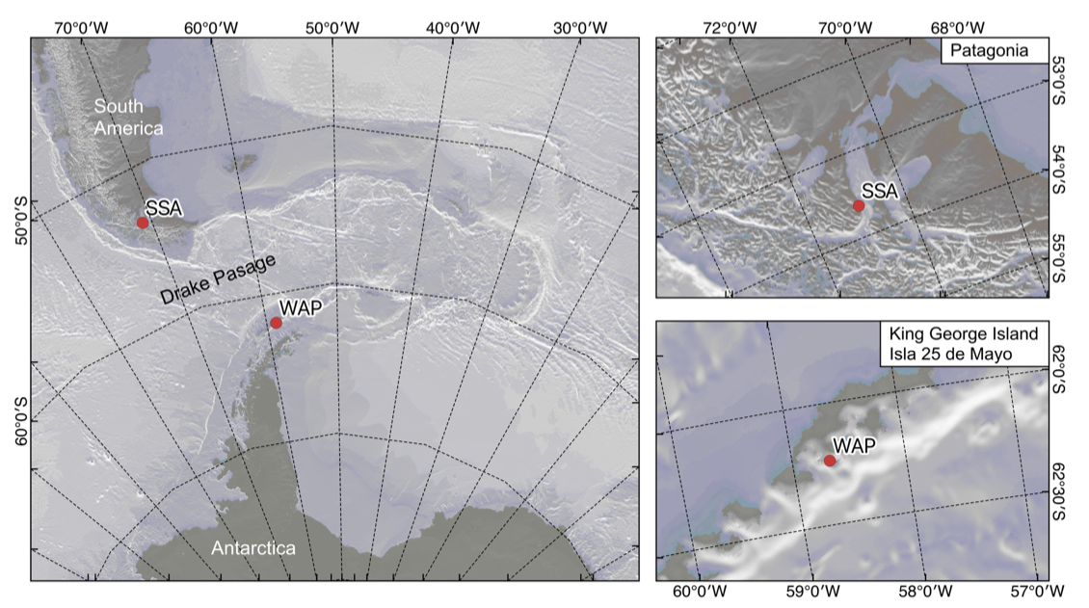

Supplementary Figure 2
Experimental design carried out in Southern South America (SSA) and West Antarctic Peninsula (WAP). In both regions the experimental organisms were acclimatized for 10 days. The experimental phase involved the exposure of 4 replicates (jars) containing five animals for 18 days to the following conditions: in SSA: in situ (7 °C) and South migration future scenario (4 °C) in combination with normoxia and hypoxia; in WAP: in situ (1.5 °C) and warming (4 °C) in combination with normoxia and hypoxia. In the experiment in SSA, an additional step was conducted on day 18, by further decreasing the temperature from 4 °C down to 2 °C under conditions of normoxia.

