Supplementary Material

Supplementary Figures

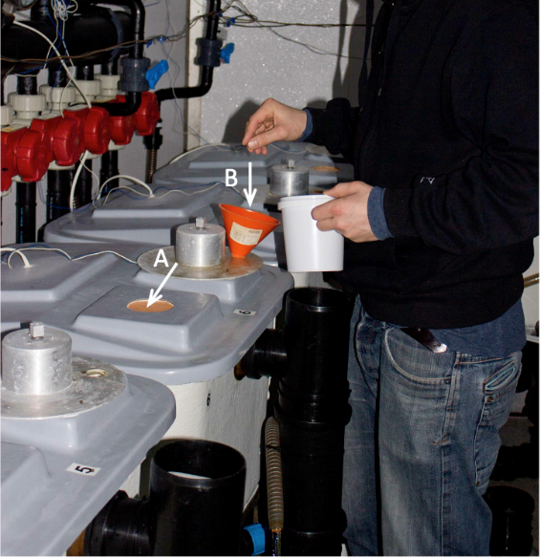
Supplementary Figure 1. For all three experimental trials a solitary tank-based system was used for analyses of individual feed intake. The experimental rig consisted of individual indoor tanks (0.5 x 0.5 x 0.4 m) with 85 L flow-through water volume. The tanks permitted visual observations of the fish (A) while they were hand-fed (B) without disturbing them. The tanks had waste feed collectors and any uneaten food was collected 10 min after the meal was terminated without disturbing the fish.
Supplementary Figure 2. Pellets consumed in relationship to the number of pellets provided. Lines and shaded areas show effect and 95% confidence intervals of each variable predicted by a linear mixed effect model, dots represent individual fish measurements of a meal for each feed deprivation time (2 h in purple blue and 18h in green).

Supplementary Figure 3. Random intercepts and 95% confidence intervals of individual fish (A) and trial (B) estimated in the linear mixed effect model.

Supplementary Tables

Supplementary Table 1. Model selection table listing tested models in backward selection from full model, removing one explanatory variable each. Models are sorted by quality of fit (top to bottom) based on the Akaike information criterion with a correction for small sample sizes (AICc). Values shown are number of parameters, AICc, AICc deviation from best model, model likelihood, AICc weights and log-likelihood.
Models | Parameters | AICc | Delta AICc | Model likelihood | AICc weight | Loglikelihood
Full | 10 | 12933 | 0 | 1 | 1 | -6457
-Trial | 9 | 12949 | 15 | 0 | 1 | -6465
-Prior consumption | 8 | 12949 | 16 | 0 | 1 | -6466
-Fish weight change | 9 | 12955 | 21 | 0 | 1 | -6468
-Day | 9 | 13070 | 137 | 0 | 1 | -6526
- Feed deprivation time | 8 | 13447 | 514 | 0 | 1 | -6716

Supplementary Table 2. Parameter estimates and associated standard errors (SE), z-value, and p-value (values rounded to two digits).
Parameter | Estimate | SE | z-value | p-value
Feed deprivation time 2h | 3.02 | 0.10 | 30.04 | <0.001
Feed deprivation time 18h | 3.51 | 0.10 | 34.70 | <0.001
Pellets provided | 0.20 | 0.01 | 27.53 | <0.001
Day | 0.10 | 0.01 | 11.90 | <0.001
Fish weight change | 0.19 | 0.03 | 5.66 | <0.001
Feed deprivation time 2h: Prior consumption | -0.01 | 0.01 | -1.27 | 0.202
Feed deprivation time 18h: Prior consumption | -0.04 | 0.01 | -4.27 | <0.001

