Supplemental Materials
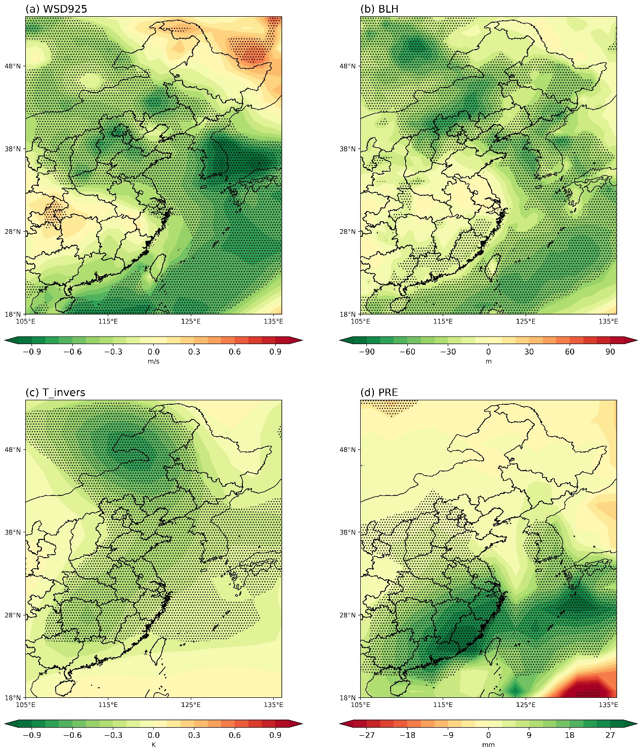
Figure S1. Anomalies for (a) wind speed at 925 hPa (WSD925), (b) boundary layer height (BLH), (c) vertical differences of air temperature between 850 and 925 hPa (T_invers), (d) precipitation (PRE) obtained by regression upon the normalized PC2. Stippling regions indicate the significance at the 90% confidence level.

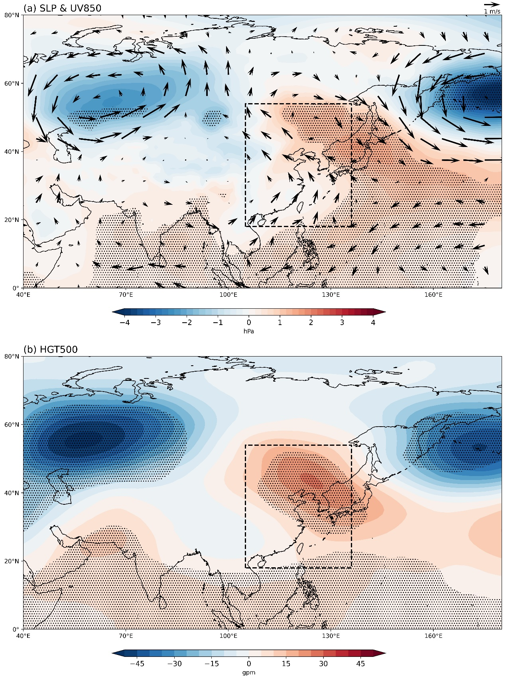
Figure. S2. As in Fig. S1, but for (a) sea level pressure (SLP, shading) and 850-hPa winds (UV850, vectors), (b) geopotential height at 500hPa (HGT500). Stippling regions indicate the significance at the 90% confidence level.

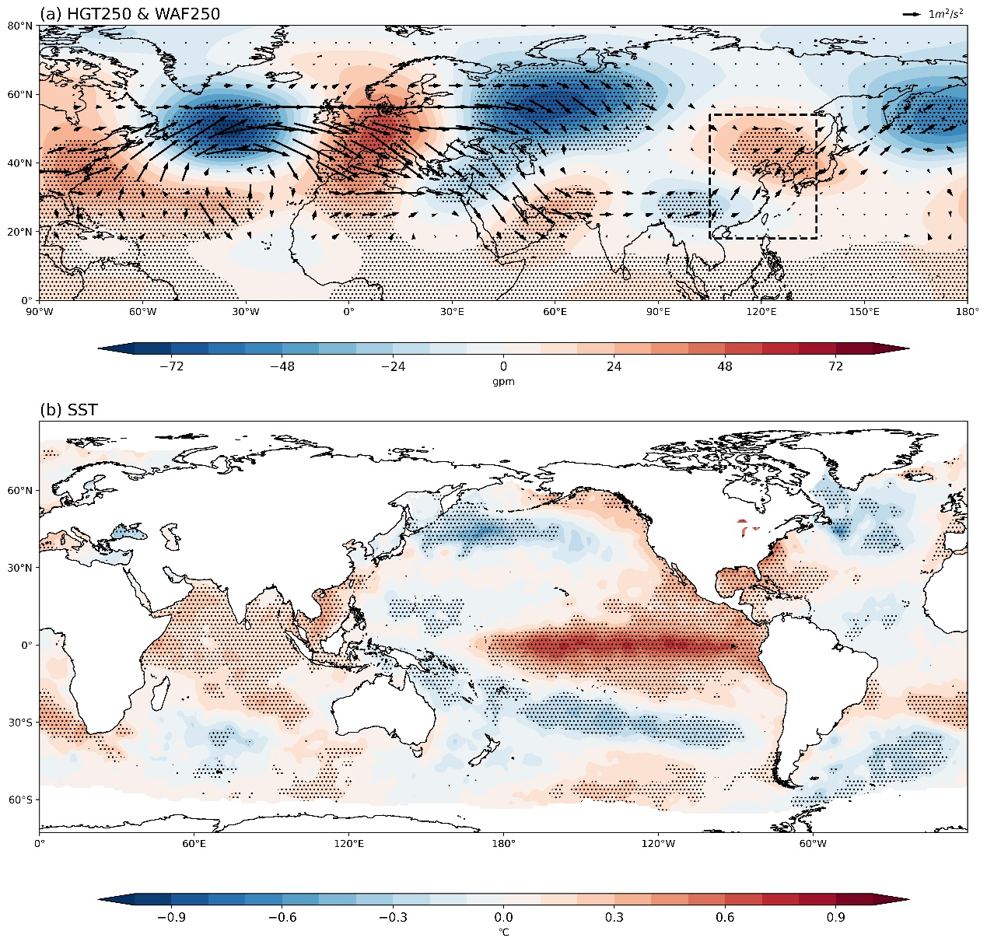
Figure S3. As in Fig. S1, but for (a) geopotential height at 250hpa (HGT250, shading) and corresponding wave activity flux (WAF250, vectors), (b) sea surface temperature (SST). Stippling regions indicate the significance at the 90% confidence level.

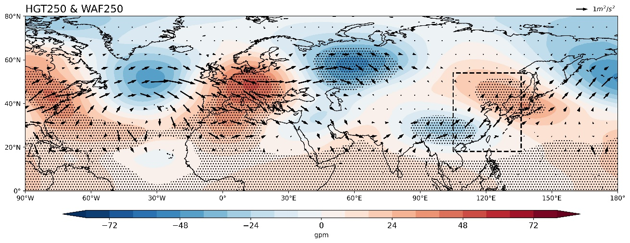
Figure S4. As in Figure S3a, but for Nino-3.4 index. Stippling regions indicate the significance at the 90% confidence level.

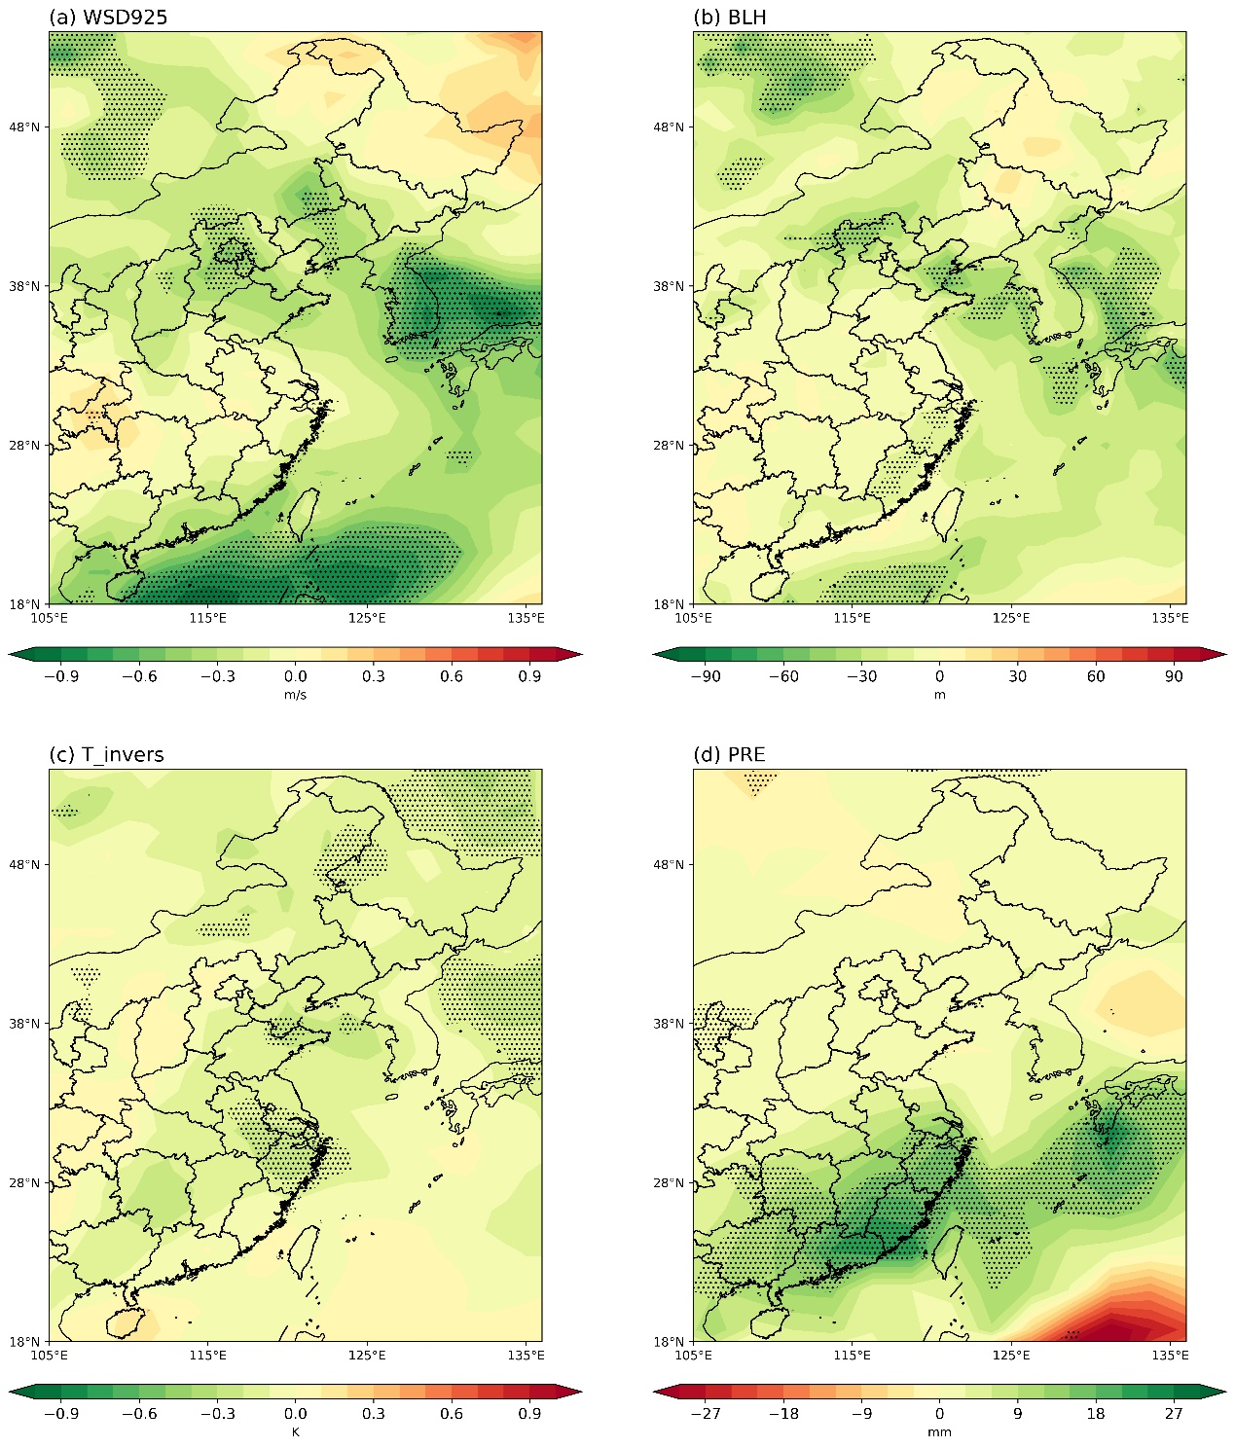
Figure S5. As in Figure S1, but for Nino-3.4 index. Stippling regions indicate the significance at the 90% confidence level.

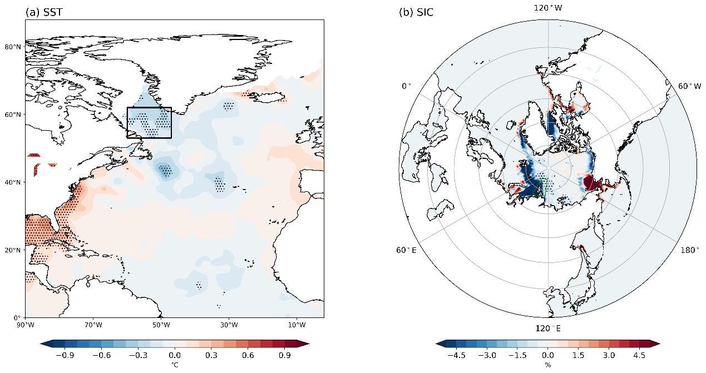
Figure S6. Regression maps of (a) SST in the North Atlantic in December and (b) sea ice concentration (SIC) in November onto the PC2 time series after removing ENSO signal. Stippling regions indicate the significance at the 90% confidence level.

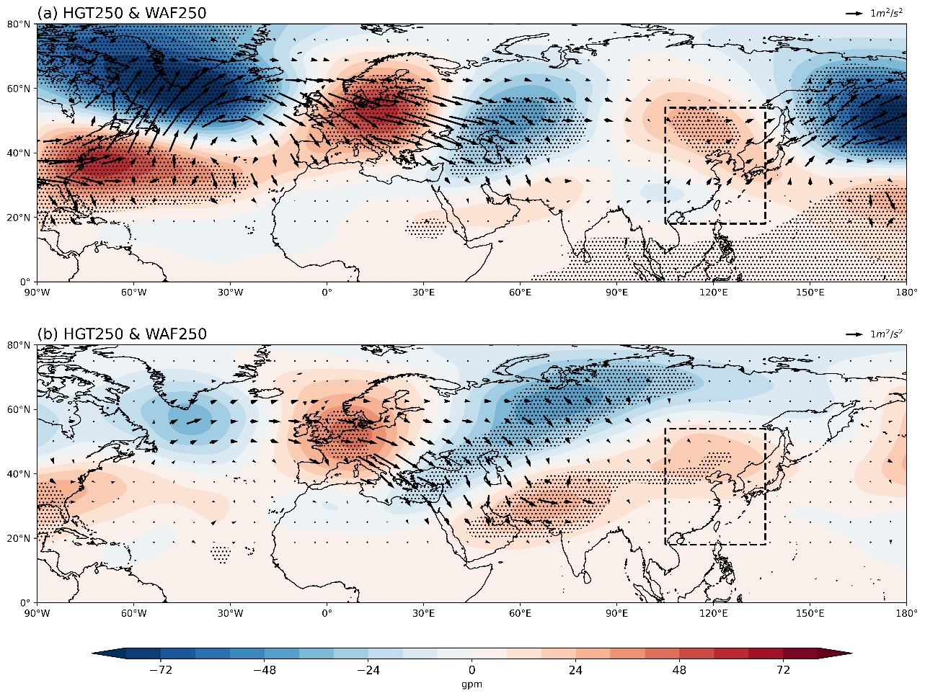
Figure S7. As in Figure S4, but for (a) LSI index and (b) KSI index, respectively. Stippling regions indicate the significance at the 90% confidence level.
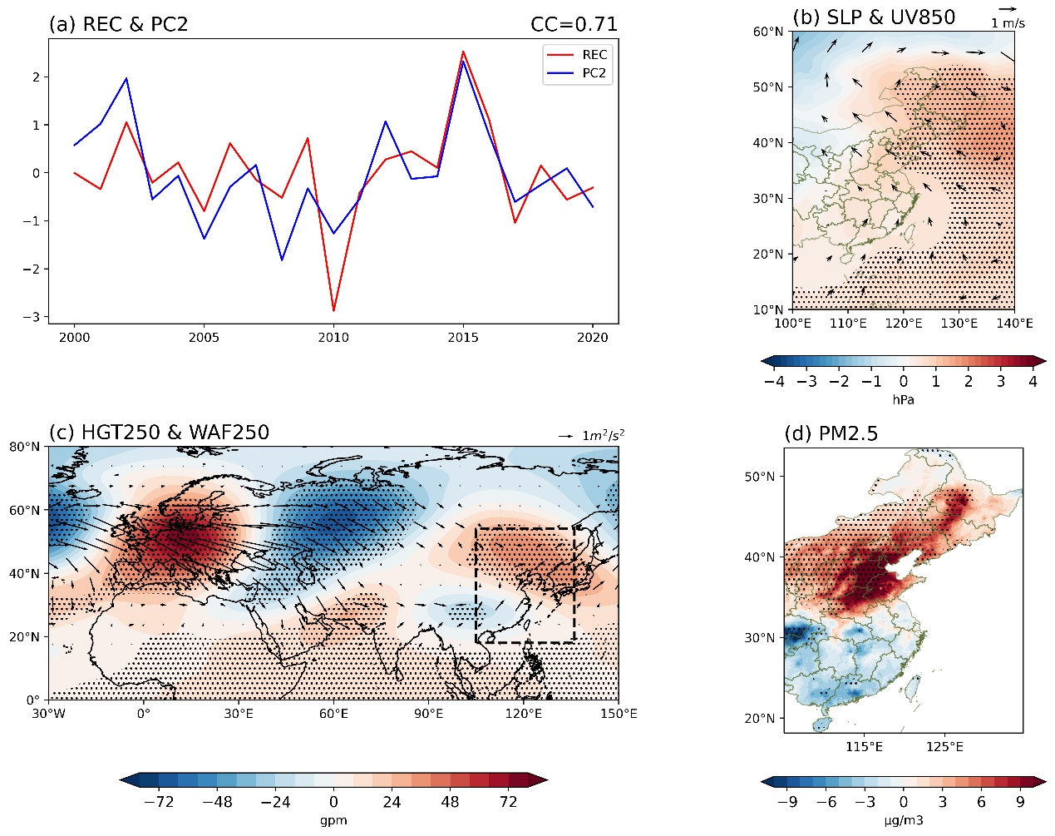
Figure S8. (a) Time series of reconstructed index (REC) based on multiple climate factors (red line) and PC2 (blue line) during 2000-2020. (b) Anomalies of SLP and 850-hPa winds (UV850) obtained by regression upon the REC. (c)-(d) As in (b), but for HGT and WAF at 250hPa, and PM_{2.5} in Eastern China, respectively. Stippling regions in (b-d) indicate the significance at the 90% confidence level.

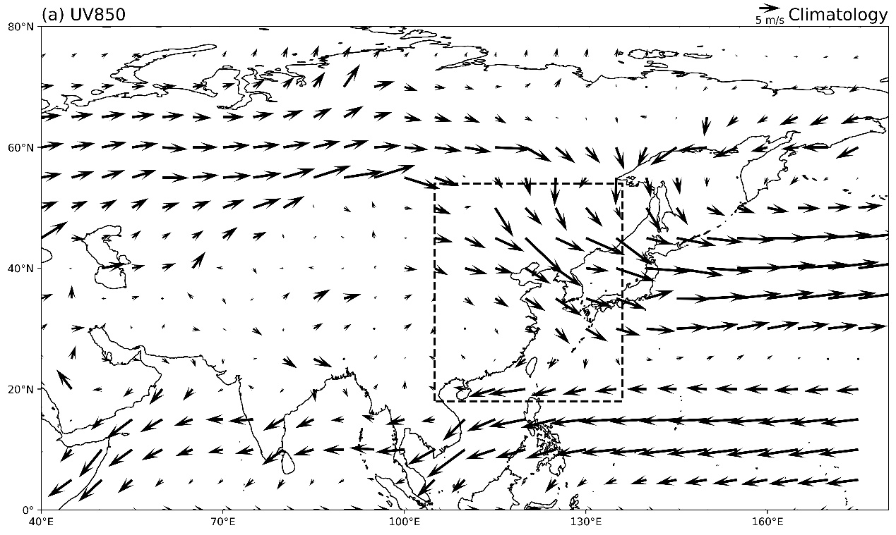
Figure S9. The climatological mean 850-hPa winds (UV850) during 2000-2020.

