Appendix 1: Detailed Materials and methods.
Behaviour Identification and Video Tagging
Accelerometer traces (XYZ force data; training and wild roaming) were exported from the devices as raw .CSV files using the OMGUI software package (V1.0.0.43, Axivity). Videos with specific activities were split from the original videos in 10-60 second chunks. The behaviours recorded during the training data collection were Climbing, Resting/Lying, Sitting, Vigilance, Standing Vigilance, Vigilant Walking, Walking, Turning, Galloping, Bounding, Jumping and Scurrying (Supp. Table S1). Lying/Resting data was collected from within these enclosures but also when the animals were resting in their individual calico bags in air-conditioned facilities before release in the late afternoon. General behaviours, such as eating, drinking and any intraspecific interactions, were unattainable due the unfamiliarity of the lab conditions discouraging these behaviours and the restrictions for placing multiple northern quolls in the same enclosures.
These videos were imported into a customised MATLAB GUI along with the accelerometer traces. The timestamp of the video was determined using Mediainfo (version 18.08, 2018) and then adjusted for the difference between the starting time of the split video and the starting time of the original from which it was split. To synchronise the accelerometer trace and behaviour videos the taps described above were used, aligning the obvious peaks in the trace, with the timing of the taps. Synchronisation could also be manually adjusted using characteristic actions that show obvious triaxial signatures in the accelerometer traces (i.e. the animal rearing up onto their back legs displayed an obvious peak in the Z-axis). Once synchronized the trace was given a score of 1-12 specific to the behaviour and exported.
Data Processing and Analysis
The video alignment, behavioural identification, data processing, Self-Organising Map (SOM) creation, and behaviour prediction follows the methods from Galea et al. (2021), and only a brief description is given here (see supplementary material, Appendix 1). SOMs are artificial neural networks that are often used for extraction and prediction of large data sets by identifying patterns in multi-dimensional data. The SOM creation process involved a large data set of 1 second epochs associated with a number of behaviours (12) that are identified by predictor variables (25) and splitting this dataset into training data (80%) and testing (20%). These predictor variables were chosen based on a sensitivity analysis described in Tatler, Cassey et al. (2018), and were Means, Standard Deviations, Signal Magnitude Area, Overall Body Accelerations (OBA), Vectorial Body Accelerations (VBAs), Skews, and Axes Correlations and are described further in the Supplementary materials (Supp. Table S2). The dataset used for this training/testing process contained 274,695, 1 second observations of our 25 predictors (≈ 76 hrs) of 19 northern quolls (8F:11M) and a SOM model with the grid shape of 7 by 10 was created.
A model for all behaviours was created from the training data set using a SOM with the package kohonen in Rstudio (Ver. 3.0.10)(Wehrens and Buydens 2007, Wehrens and Kruisselbrink 2018). The accuracy of SOM prediction model was tested using a confusion matrix, extracting the standard accuracy measures, specificity, precision, sensitivity, and overall accuracy (Supp. Table S3). The ‘predict‘ function from the kohonen package was used the SOM algorithm to predict the behaviours in the wild roaming northern quolls.
Building and Testing the Self-Organising Map
Behaviours were predicted using a Self-Organising Map (SOM) model created using the package kohonen in Rstudio (Ver. 3.0.10)(Wehrens and Buydens 2007, Wehrens and Kruisselbrink 2018). We used four statistical measures to test the accuracy of the SOM; Sensitivity, Specificity, Precision and overall Accuracy (see Supplementary Materials). The Self-Organising Map is an artificial neural network that organises unique signatures into a grid shaped map characterising the specified data. To determine the optimal shape of the SOM grid the overall accuracy was compared for each shape while incrementally increasing the width and height of the map; from a 5 by 5 to a 10 by 10 grid. A 7 by 10 grid gave the most accurate representation of the northern quoll training data (Fig S3).
To increase the accuracy of our SOM we created a competitive algorithm that compared a newly created SOM, with a previously saved original SOM, saving the most accurate of the pair. The two SOMs were compared with the four accuracy measures, firstly discarding either SOM that was predicting behaviours at <80%, <90%, and <95%, with greater frequency. Next the accuracy measures were compared between the two and the new SOM was saved in place of the original SOM if the new SOM showed improvement. If there was no improvement, the old SOM was retained. This process was repeated between 10 to 300 times, showing minimal improvement after 20 times, this study chose to run the competitive SOM 200 times.
Scurries and Climbing behaviour
The absence of Scurries and Climbing from the wild roaming data could result from the nature of both behaviours and how they were recorded for training. Training data for climbing was recorded on a thin pole which may be a rare behaviour within the habitats where these quolls were caught, unless they were using the extremities of the canopies. Scurries were considered short bursts of fast locomotion, less than a full locomotor stride. The described nature of this behaviour is probably quite rare in the wild; if they are foraging, the individual would move at a slower rate with multiple stops (Vigilant walking) while fast locomotion would minimise the intermittent nature inherit in the tagged scurry-like behaviour. Alternatively, scurries could be an observer influenced behaviour or could be absorbed into many of the other high energy behaviours, for example bounds.

Appendix 2: Additional Figures and Tables.

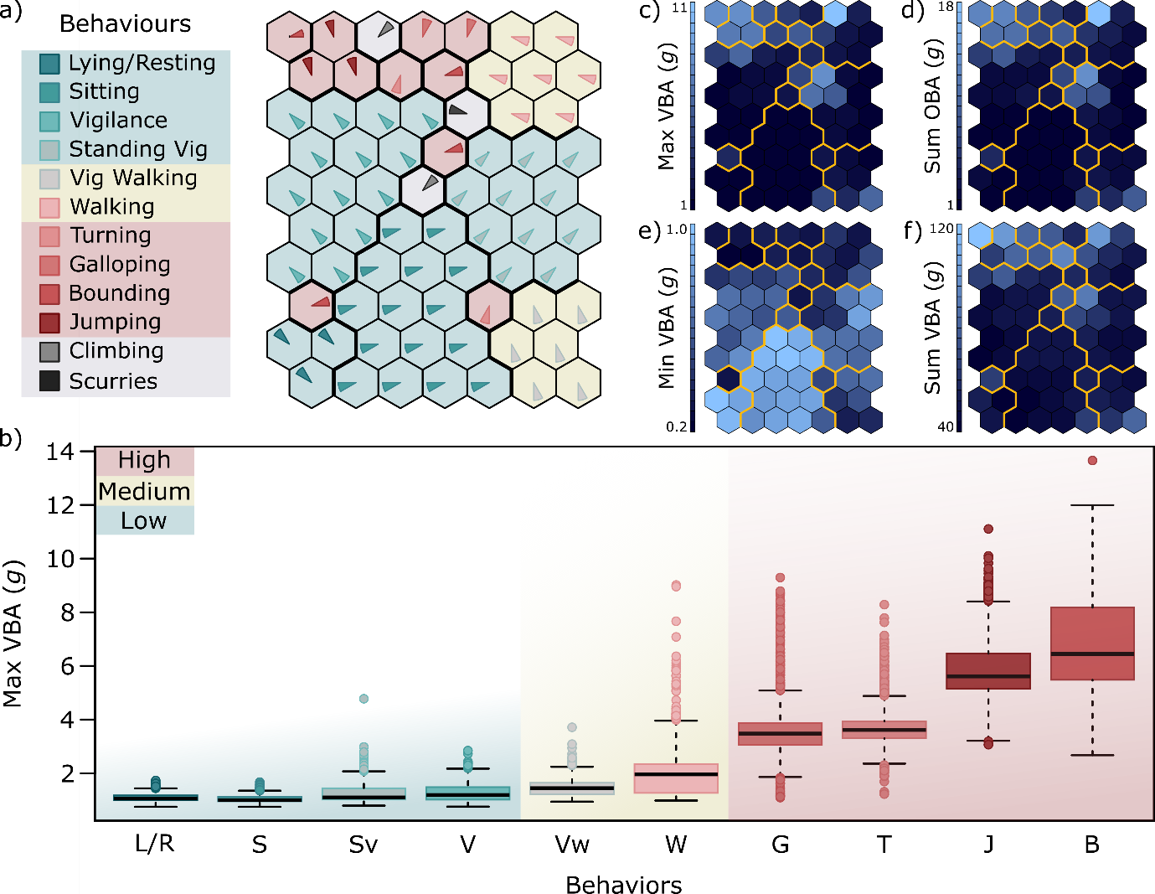
Figure S1: The output from the 10 by 7 Self Organising Map (SOM) created using kohonen (ver. 3.0.10) on the Northern Quoll training data set of 219,754 observations and tested on 54,941 observations (80:20). a) Represents the organization of unique identifiers that predict each behaviour with low (green), medium (yellow) and high (pink) energy behaviours. Behaviours in grey shading were not predicted in the wild roaming data collected. The thick black lines signify the distinction between different behaviours and are also represented as yellow outline in c) – f). b) Boxplot of the energy expenditure of the behaviours recorded for Northern Quolls in situ. c, e, f) Range of the variable of Max, Min and Sum, Vectorial Body Acceleration (g) used for prediction in the SOM (respectively), the yellow outline represents the separate behavioural clades as in a). d) Range of the Max Overall Body Acceleration used for prediction in the SOM.

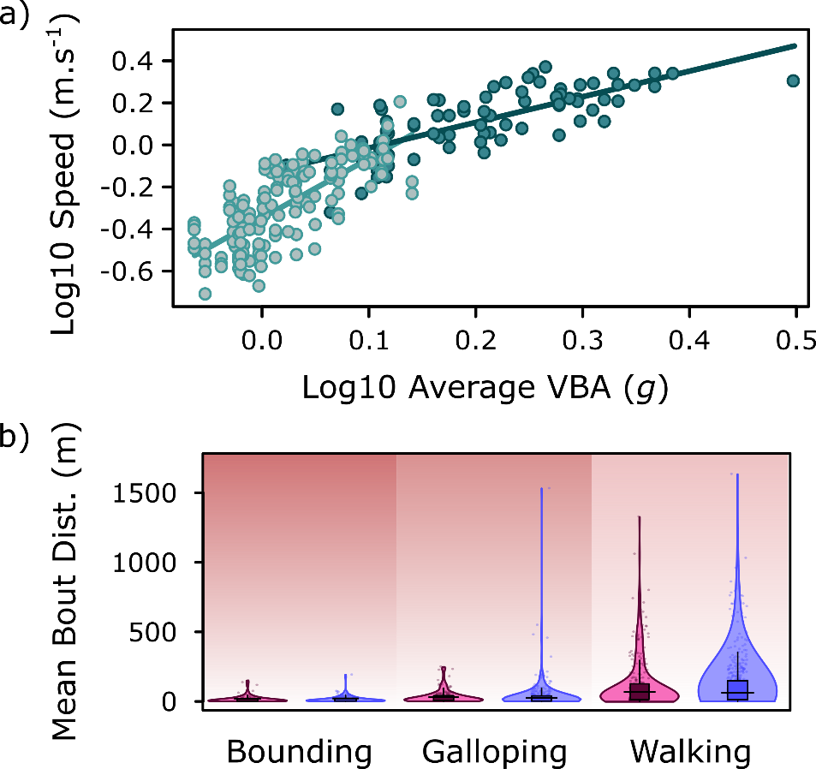
Figure S2: The speed and distance travelled in wild roaming and video training northern quolls. a) The Log₁₀ Speed (m.s⁻¹) and Log₁₀ Average VBA (g) of strides in walking (light) and bounding (dark) locomotor gaits from training videos. b) The difference in distance travelled per bout of locomotion (m) in wild roaming male (blue) and female (maroon) northern quolls for each locomotor behaviour.

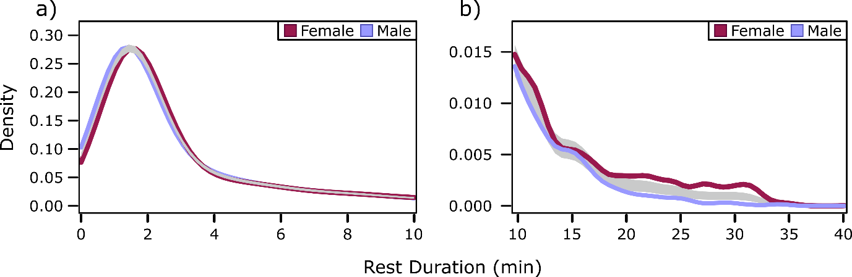
Figure S3: The density of resting bouts in Male (blue) and Female (maroon) northern quolls. a) Density of resting bout lengths from 0min to 10min. b) Density of resting bouts from 10min to 40min (right). The light grey area represents upper and lower limits of the reference band for the equality of male and female resting densities.
Table S1: The name and description of all 12 behaviours identified in videos and used to create the prediction algorithm (7 by 10 SOM; Self Organising Map). Red shading is for high energy behaviours, yellow for medium, and green for low. Gray shaded behaviours were not predicted in wild roaming northern quolls.
Behaviour | Energetic Expenditure | Description of Movement
Lying/Resting | Low | Quoll in a stationary position; lying on either side or back.
Sitting | Low | Quoll in a stationary position; sitting on all feet planted on the ground.
Vigilance | Low | Quoll in a stationary position (Hind legs planted); clearly moving head or other parts of the body, resulting in accelerometer movement.
Standing Vigilance | Low | Quoll in a stationary position (Hind legs planted); reared up to be standing on only two hind feet.
Vigilant Walking | Medium | Quoll moving (all feet moving through a stride); but with intermittent pausing for purpose of vigilance (i.e. sniffing, looking, scratching).
Walking | Medium | Quoll moving (all feet moving through a stride); without intermittent pausing and clearly no visible aerial phase.
Turning | High | Quoll making swift turns around an obstacle or in a tight circle.
Galloping | High | Quoll moving (all feet moving through a stride); without intermittent pausing, clear amble-style gait moving at visibly higher speeds than walking.
Bounding | High | Quoll moving (all feet moving through a stride); without intermittent pausing, hindfeet clearly striking the ground at the same time.
Jumping | High | Quoll leaping off the ground for an extended period of time; usually vertical, but always singular behaviour with some recovery afterwards.
Climbing | NA | Quoll climbing upwards, in any gait, on substrate provided.
Scurries | NA | Small, fast intermittent movement in any direction.

Table S2: Descriptions of the 25 Predictor variables used to identify and predict behaviours. These variables were calculated over a rolling epoch of 50Hz (1 second) for both training data and wild roaming data.
Predictor Variable | Description
Axes (X, Y, Z) | The value of first observation in the epoch for each axis (X+ posterior, Y+ right lateral, Z+ ventral).
Mean (X, Y, Z) | The mean value of the rolling epoch for each axis.
SD (X, Y, Z) | The standard deviation of the rolling epoch for each axis.
Signal Magnitude Area | The magnitude of single epoch where (N) is the duration of that epoch.  $$SMA= \frac{1}{N}(∑_{i=1}^{N}x_{i}+∑_{i=1}^{N}y_{i}+∑_{i=1}^{N}z_{i})$$
Overall Body Acceleration (OBA)  (Max, Min, Sum) | The Maximum, Minimum and Summation of OBA from the rolling epoch. OBA is calculated using the following formula.  $$ODBA=\left|x\right|+\left|y\right|+\left|z\right|$$
Vectorial Body Acceleration (VBA)  (Max, Min, Sum) | The Maximum, Minimum and Summation of VBA from the rolling epoch. VBA is calculated using the following formula.  $$VDBA= \sqrt{x^{2}+y^{2}+z^{2}}$$
Skew (X,Y, Z) | Measure of symmetry in the distribution of each axis
Correlation (XY, XZ, ZY) | Measure of Correlation between pairs of axes.

Table S3: Four statistical measures used in the sensitivity analysis to calculate the accuracy of the machine learning algorithm (SOM; Self Organising Map). TP = True positives, TN = True negatives, FP = False positives, FN = False negatives.
Statistical Measure | Equation
Sensitivity | $$\frac{TP}{(TP+FN)}$$
Precision | $$\frac{TP}{(TP+FP)}$$
Specificity | $$\frac{TN}{(TN+FP)}$$
Overall Accuracy | $$\frac{(TN+TP)}{(TN+TP+FN+FP)}$$

Table S4: Sensitivity, Precision, Specificity, and overall Accuracy of the SOM predictions based on the 7 by 10 map and 80-20% training/testing dataset. Green, yellow, and pink shading represents low, medium, and high energy behaviours. Gray shading represents behaviours that were not recorded in situ. Bold text signifies 100% accuracy (n=27), italicised text represent data below 99.9% accuracy (n = 6).
 | Lying/Resting | Sitting | Standing Vig | Vigilance | Climbing | Scurry
Sensitivity | 1.000 | 1.000 | 1.000 | 1.000 | 0.9887 | 0.9810
Precision | 1.000 | 1.000 | 0.9998 | 1.000 | 1.000 | 1.000
Specificity | 1.000 | 1.000 | 0.9999 | 1.000 | 1.000 | 1.000
Accuracy | 1.000 | 1.000 | 0.9999 | 1.000 | 0.9998 | 0.9999
 | Vig Walking | Walking | Turning | Galloping | Jumping | Bounding
Sensitivity | 1.000 | 1.000 | 0.9882 | 0.9866 | 0.9979 | 1.000
Precision | 1.000 | 0.9998 | 1.000 | 1.000 | 0.9834 | 0.9786
Specificity | 1.000 | 0.9999 | 1.000 | 1.000 | 0.9997 | 0.9994
Accuracy | 1.000 | 0.9999 | 0.9998 | 0.9996 | 0.9997 | 0.9994

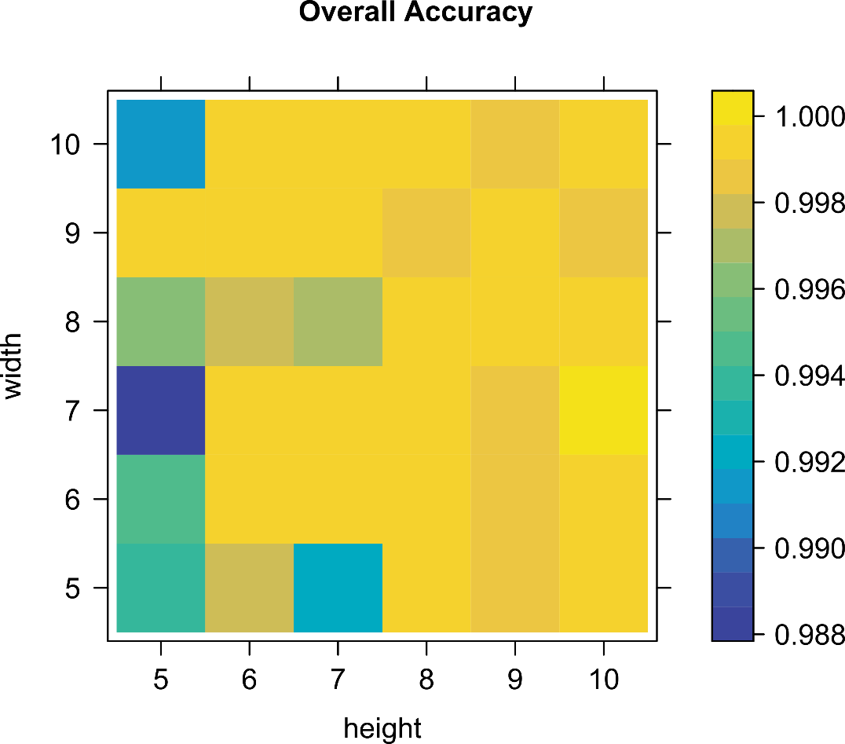
Figure S4: The shape analysis figure showing overall accuracy dependant on the shape of the SOM created.

Table S5: Models, Coefficients, Numerator Degrees of Freedom, Denominator Degrees of Freedom, F-value, and P-value of all models used in this paper. Calculated using lme from the package ‘nlme’ (Ver. 3.1-157). The variables used in these models in order of appearance were VBA_{max} (Maximum Vectorial Body Acceleration over 1 sec), hour (hour of the day 0:23), day (the date of collection), Count (specific behaviour used over 1 sec), energy (high, medium, low energy behaviours), locomotion (continuous bouts of walking, vig walking, bounding, galloping), LogSpeed (Log₁₀ speed from recorded locomotor bouts), LogAvVBA (Log₁₀ of the average Vectorial Body Acceleration of a single bout), PredictedSpeed (Speed predicted from accelerometer bouts), and >10min (inactive bouts greater than 10 minutes).
Model: Coefficients | NumDf | DenDf | F-value | p-value
Model 1: glmer -- Count ~ sex * energy + (1|subject), family = ‘poisson’
sex (M: F) | 1 | 22 | 6.93 | 0.015
energy (Low: Mid: High) | 2 | 16421 | 2.19e⁰⁷ | <0.0001
energy: sex | 2 | 16421 | 3.46e⁰⁵ | <0.0001
Model 2: glmer -- Count ~ sex * locomotion + (1|subject), family = ‘poisson’
sex (M: F) | 1 | 22 | 5.24 | 0.032
locomotion (move:still) | 1 | 16423 | 2.06e⁰⁷ | <0.0001
sex: locomotion | 1 | 16423 | 7.72e⁰⁵ | <0.0001
Model 3: lme -- Count ~ sex * behaviours * hour, random = ~1|subject
(Intercept) | 1 | 27716 | 569.34 | <0.0001
sex | 1 | 22 | 3.00 | 0.109
behaviours | 9 | 27716 | 1092.06 | <0.0001
hours | 23 | 27716 | 1.20 | 0.231
behaviours: hours | 207 | 27716 | 4.55 | <0.0001
sex: behaviours | 9 | 27716 | 85.65 | <0.0001
sex: hours | 23 | 27716 | 0.46 | 0.986
sex: behaviours: hours | 207 | 27716 | 1.14 | 0.075
Model 4: glmer -- Count ~ sex * behaviours + (1|subject), family = ‘poisson’
sex (M: F) | 1 | 22 | 1.76 | 0.198
behaviours (1:10) | 9 | 16407 | 8.02e⁰⁶ | <0.0001
sex: behaviours | 9 | 16407 | 8.68e⁰⁵ | <0.0001
Model 5: lme -- VBA_{max} ~ sex * hour, random = ~1|day/subject
(Intercept) | 1 | 460 | 2256.87 | <0.0001
sex (M: F) | 1 | 448 | 28.88 | <0.0001
hour | 1 | 460 | 12.32 | <0.0001
sex: hour | 1 | 448 | 0.33 | 0.999
Model 6 lme -- LogSpeed ~ LogAvVBA * behaviours, random = ~1|subject
(Intercept) | 1 | 205 | 63.54 | <0.0001
LogAvVBA | 1 | 205 | 943.58 | <0.0001
behaviours | 1 | 205 | 15.54 | 0.0001
LogAvVBA: behaviours | 1 | 205 | 61.47 | <0.0001
Model 7: lme -- PredictedSpeed ~ sex, random = ~1|subject
(Intercept) | 1 | 72705 | 2049.18 | <0.0001
sex | 1 | 11 | 2.05 | 0.18
Model 8: lme – distance ~ sex * behaviours, random = ~1|day/hour/subject
(Intercept) | 1 | 71930 | 35.38 | <0.0001
sex | 1 | 345 | 0.001 | 0.973
behaviours | 2 | 71930 | 15.37 | <0.0001
sex: behaviours | 2 | 71930 | 0.32 | 0.726
Model 9: lme -- Rest>10min ~ sex, random = ~1|hour/subject
(Intercept) | 1 | 403 | 2946.01 | <0.0001
sex | 1 | 179 | 15.39 | <0.0001
Model 10: lme – Rest-all~ sex, random = ~1|hour/subject
(Intercept) | 1 | 7783 | 265.45 | <0.0001
sex | 1 | 262 | 15.26 | <0.0001

Table S6: The Tukey post hoc comparisons of models from Table 5. Calculated using the ‘emmeans’ package in R (Ver. 1.7.4-1). The variables used in these models in order of appearance were; energy (high, medium, low energy behaviours), locomotion (continuous bouts of walking, vig walking, bounding, galloping).
 | contrast | estimate | SE | df | z.ratio | p.value
Model 1: emmeans -- specs = pairwise ~ sex*energy, adjust = "tukey"
 | Female High - Male High | -0.05 | 0.06 | INF | -0.77 | 0.274
 | Female Low - Male Low | 0.17 | 0.06 | INF | 2.80 | 0.058
 | Female Medium - Male Medium | -0.22 | 0.06 | INF | -3.60 | 0.004
Model 2: emmeans -- specs = pairwise ~ sex*locomotion, adjust = "tukey"
 | Female Locomotion - Male Locomotion | -0.2076 | 0.06 | INF | -3.38 | 0.004
 | Female Stationary - Male Stationary | 0.1892 | 0.06 | INF | 3.08 | 0.011
Model 3: emmeans -- specs = pairwise ~ behaviors*hours*sex, adjust = "tukey" T-value
 | Lying.Resting hours2 Female - Lying.Resting hours2 Male | 16828.38 | 2413.61 | 12 | 6.97 | 0.034
 | Lying.Resting hours12 Female - Lying.Resting hours12 Male | 20559.19 | 3041 | 12 | 6.76 | 0.043
 | Lying.Resting hours13 Female - Lying.Resting hours13 Male | 26621.83 | 3016.78 | 12 | 8.82 | 0.004
 | Lying.Resting hours16 Female - Lying.Resting hours16 Male | 21011.52 | 2657.17 | 12 | 7.91 | 0.012
Model 4: emmeans -- specs = pairwise ~ sex*behaviours, adjust = "tukey"
 | Bounds Female - Bounds Male | -0.18 | 0.06 | INF | -2.78 | 0.373
 | Gallop Female - Gallop Male | -0.09 | 0.06 | INF | -1.49 | 0.996
 | Jumping Female - Jumping Male | 0.23 | 0.06 | INF | 3.53 | 0.052
 | Lying.Resting Female - Lying.Resting Male | 1.25 | 0.06 | INF | 19.58 | <0.001
 | Sitting Female - Sitting Male | -0.08 | 0.06 | INF | -1.21 | 1
 | Standing Vig Female - Standing Vig Male | -0.26 | 0.06 | INF | -4.01 | 0.009
 | Turning Female - Turning Male | -0.05 | 0.06 | INF | -0.80 | 1
 | Vig Walking Female - Vig Walking Male | -0.19 | 0.06 | INF | -2.99 | 0.235
 | Vigilance Female - Vigilance Male | 0.26 | 0.06 | INF | 4.13 | 0.006
 | Walking Female - Walking Male | -0.30 | 0.06 | INF | -4.65 | <0.001

References
Tatler, J., et al. (2018). "High accuracy at low frequency: detailed behavioural classification from accelerometer data." 221(23): jeb184085.

Wehrens, R. and L. M. Buydens (2007). "Self-and super-organizing maps in R: the Kohonen package." Journal of Statistical Software 21(5): 1-19.

Wehrens, R. and J. Kruisselbrink (2018). "Flexible self-organizing maps in kohonen 3.0." Journal of Statistical Software 87(1): 1-18.

