Supplementary material
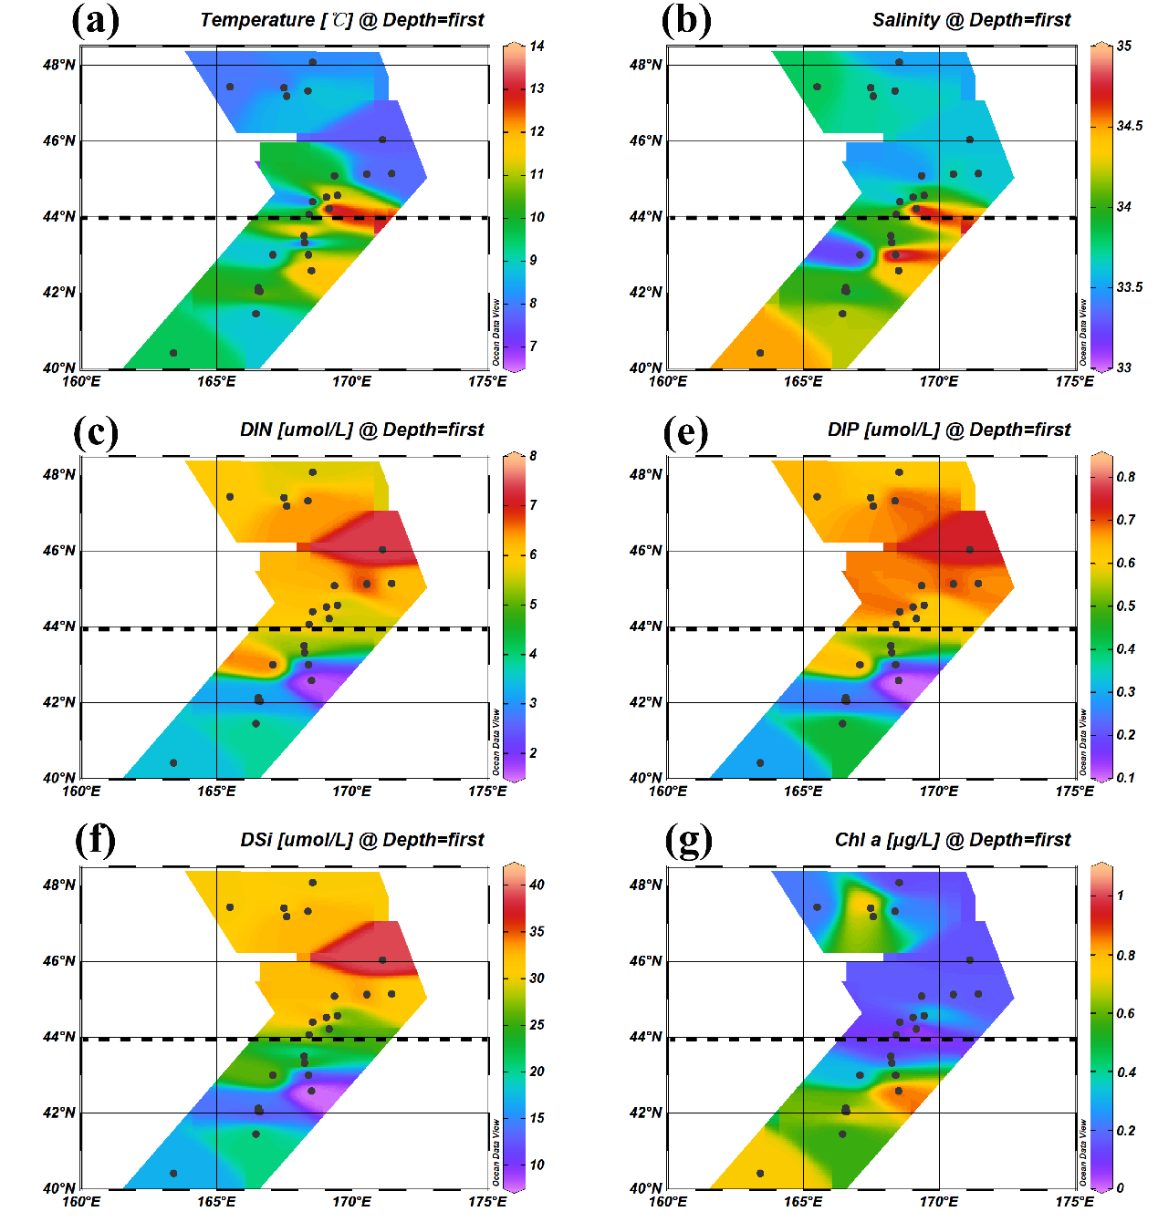
Figure S1. Distribution of temperature (a), salinity (b), DIN (c), DIP (e), DSi (f) and Chl a (g) in the summer in the Northwest Pacific Ocean.

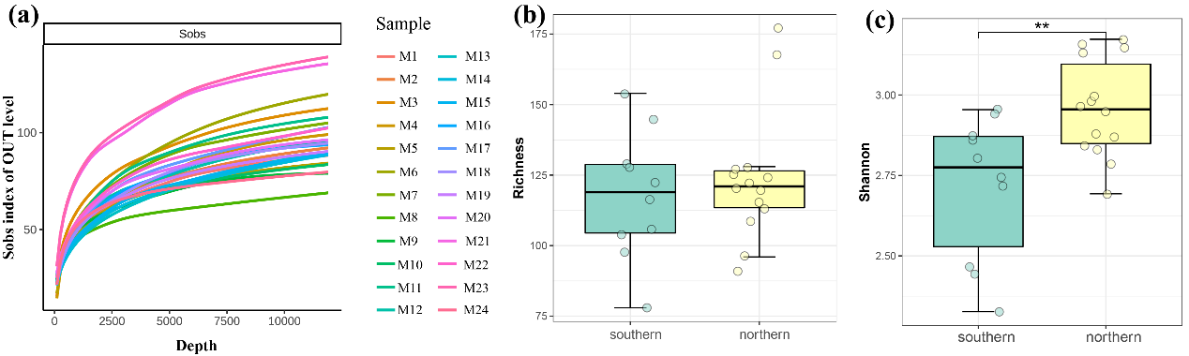
Figure S2. Rarefaction curve index for each sample (a), alpha-diversity estimates including OTU Richness (b), Shannon indexes (c) by metabarcoding method in the summer in the Northwest Pacific Ocean.

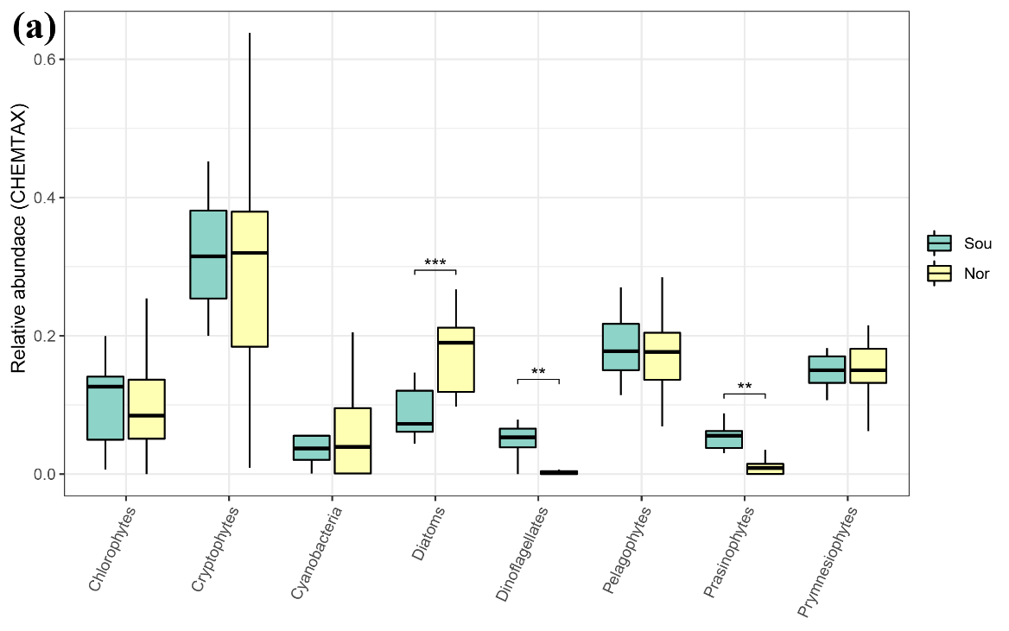
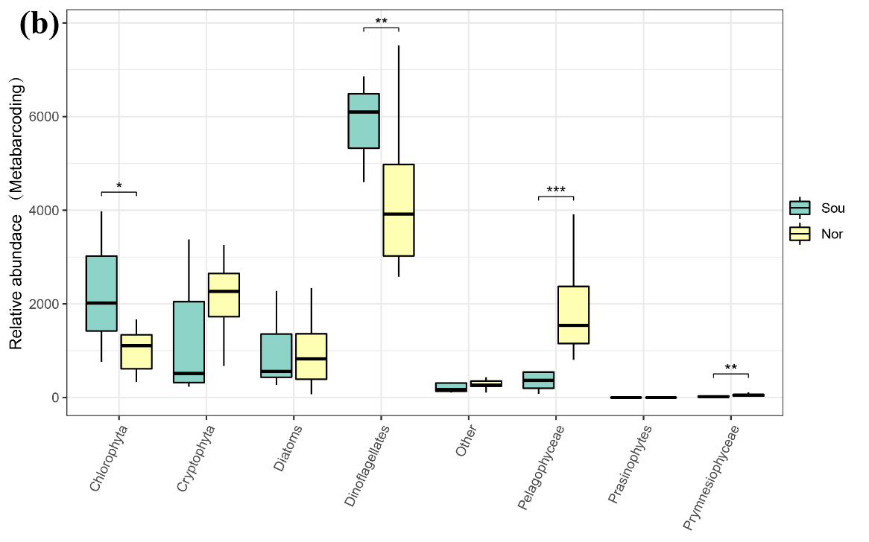
Figure S3. Wilcoxon test were analyzed to test the relative phytoplankton abundance differences between southern and northern regions based on the results of CHEMTAX (a) and metabarcoding (b) analysis.

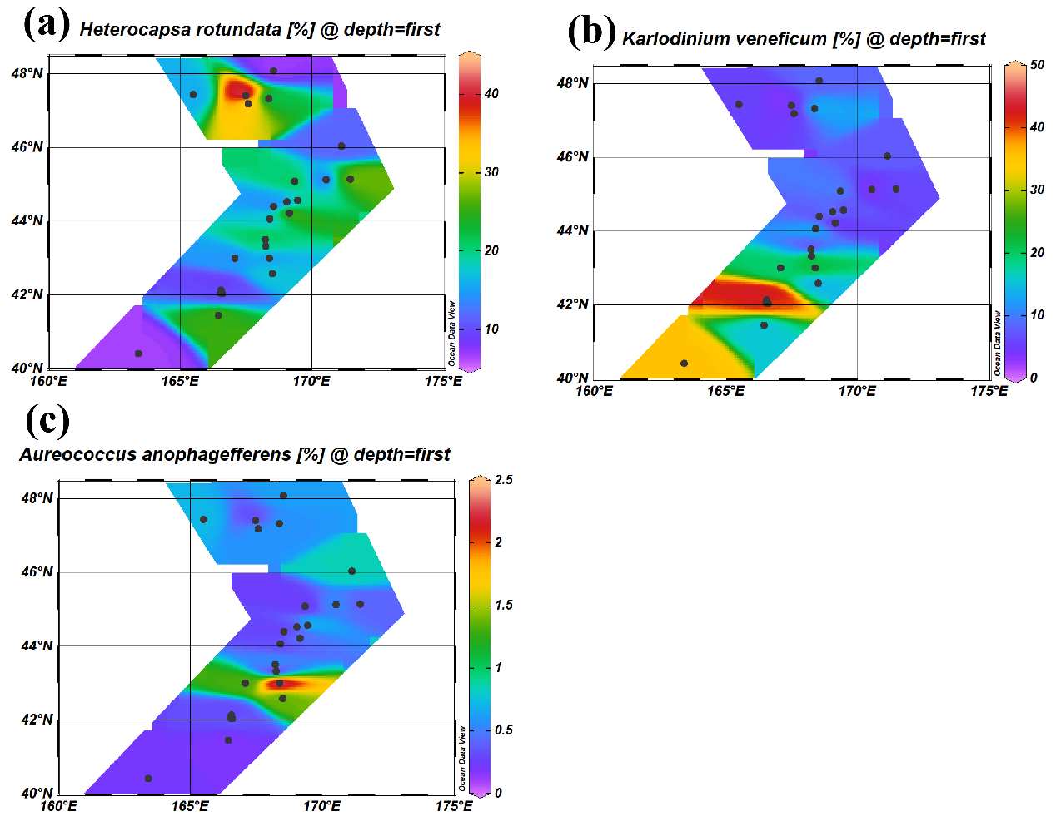
Figure S4. Distribution of the relative abundance of harmful algae: Heterocapsa rotundata (a), Karlodinium veneficum (b) and Aureococcus anophagefferens (c) based on the results of metabarcoding analysis.

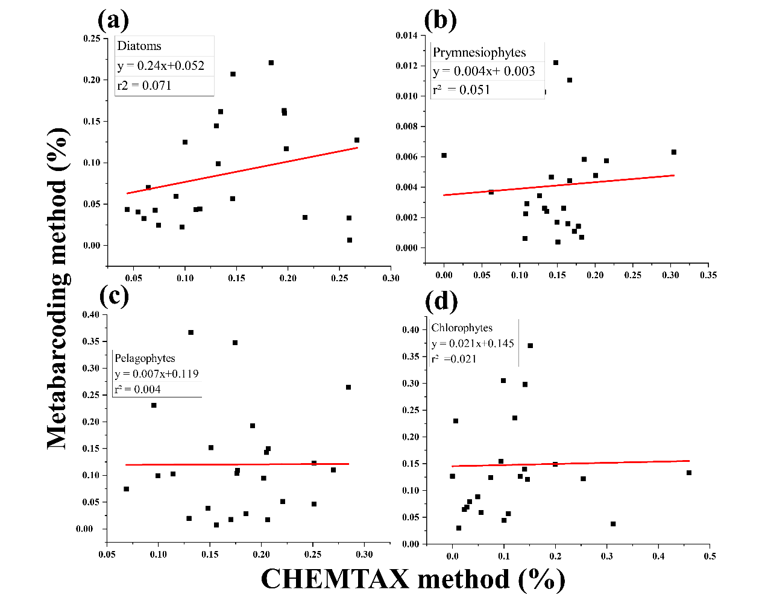
Figure S5. Pairwise comparison of CHEMTAX and metabarcoding in determining phytoplankton taxonomic composition: diatoms (a), prymnesiophytes (b), pelagophytes (c), chorophytes (d).
Table S1. Physiochemical characteristics for each sampling sites.
station | date | Latitude (N) | Longitude (E) | Temperature (°C) | salinity | DIN (μmol/L) | DIP (μmol/L) | DSi (μmol/L) | Chl a (μg/L)
M1 | 0523 | 40.42 | 163.4 | 9.598 | 34.50 | 3.457 | 0.294 | 16.931 | 0.732
M2 | 0525 | 41.45 | 166.43 | 8.872 | 34.22 | 3.825 | 0.439 | 20.530 | 0.560
M3 | 0529 | 42.04 | 166.58 | 11.227 | 33.61 | 2.838 | 0.186 | 11.621 | 1.044
M4 | 0602 | 42.05 | 166.51 | 10.086 | 34.26 | 3.409 | 0.256 | 13.448 | 0.364
M5 | 0607 | 42.14 | 166.54 | 9.462 | 34.05 | 3.339 | 0.299 | 15.738 | 0.545
M6 | 0612 | 42.59 | 168.49 | 11.796 | 34.38 | 1.636 | 0.100 | 7.518 | 0.864
M7 | 0615 | 43 | 168.38 | 11.301 | 34.88 | 2.239 | 0.181 | 11.685 | 0.579
M8 | 0617 | 43 | 167.06 | 8.853 | 33.22 | 6.548 | 0.643 | 26.351 | 0.323
M9 | 0624 | 43.33 | 168.24 | 6.970 | 33.95 | 5.250 | 0.570 | 26.976 | 0.232
M10 | 0701 | 43.51 | 168.21 | 12.410 | 34.03 | 5.441 | 0.509 | 19.833 | 0.111
M11 | 0627 | 44.07 | 168.39 | 9.890 | 34.02 | 5.905 | 0.649 | 27.970 | 0.084
M12 | 0702 | 44.22 | 169.14 | 13.710 | 34.92 | 5.473 | 0.584 | 24.222 | 0.041
M13 | 0628 | 44.4 | 168.53 | 7.032 | 33.52 | 6.120 | 0.695 | 31.823 | 0.133
M14 | 0630 | 44.53 | 169.03 | 12.154 | 33.65 | 6.405 | 0.713 | 35.724 | 0.158
M15 | 0703 | 44.57 | 169.44 | 11.010 | 34.06 | 5.430 | 0.593 | 25.260 | 0.378
M16 | 0704 | 45.09 | 169.33 | 9.890 | 33.49 | 6.275 | 0.679 | 32.391 | 0.161
M17 | 0705 | 45.13 | 170.52 | 7.818 | 33.69 | 6.788 | 0.703 | 33.565 | 0.172
M18 | 0706 | 45.14 | 171.44 | 7.816 | 33.63 | 6.161 | 0.677 | 31.087 | 0.164
M19 | 0707 | 46.04 | 171.12 | 7.708 | 33.61 | 7.384 | 0.749 | 39.020 | 0.157
M20 | 0712 | 47.19 | 167.56 | 8.718 | 33.72 | 6.552 | 0.676 | 32.859 | 0.666
M21 | 0713 | 47.33 | 168.36 | 8.817 | 33.66 | 6.471 | 0.697 | 32.792 | 0.201
M22 | 0715 | 47.42 | 167.47 | 7.852 | 33.71 | 5.545 | 0.622 | 30.607 | 0.789
M23 | 0709 | 47.44 | 165.48 | 7.961 | 33.81 | 5.986 | 0.651 | 30.659 | 0.215
M24 | 0717 | 48.08 | 168.52 | 8.186 | 33.52 | 5.664 | 0.618 | 30.451 | 0.147

Table S2. Comparison of phytoplankton community composition in the Northwest Pacific Ocean.
 | Summer, 1999 (n=3)ª  (Liu et al, 2004)^{b} | September- October 2005 (n=3)  (Fujiki et al, 2009) | October 2010  (Fujiki et al, 2014) ^{c} | June-July 2021 (n=28)  (this study)
Diatoms | 14.5 ± 4.3 | 8.2 ± 2.4 | 0.2 | 13
Prymnesiophytes | 12.6 ± 2.4 | 29.2 ± 5.6 | 26.6 | 16
Pelagophytes | 6.6 ± 0.5 | 19.2 ± 1.5 | 18.3 | 17
Chlorophytes | 6.4 ± 3.3 | 2.4 ± 1.2 | 35.7 | 13
Prasinophytes | 30.9 ± 2.3 | 9.3 ± 1.2 | 7.5 | 5
Cryptophytes | 14.0 ± 1.8 | 8.0 ± 1.4 | 8.1 | 25
Dinoflagellates | 4.1 ± 2.2 | 5.0 ± 1.0 | 3.1 | 5
Cyanobacteria | 10.9 ± 4.2 | 18.8 ± 3.9 | 0.7 | 6
ª n is the number of sampling stations
.^{b} The data are from Suzuki et al. (2002), which are recalculated by Liu et al. (2004).
^{c} The data are from Table 2. of Suzuki et al. (2002), which are the average of phytoplankton group composition on 26 and 29 October, 2010. SE was not given due to lack of sampling stations.

