Supplementary Material

Biomarker evidence of the water mass structure and primary productivity changes in the Chukchi Sea over the past 70 years

Chao Gao^{1, 2, 3}, Xiaoyan Ruan⁴, Yi Ge Zhang³, Huan Yang², Xiaotong Xiao⁵, Xiaoxia Lü², Yi Yang^{2*}, Hongmei Wang², Xiaoguo Yu^{6*}

¹School of Earth Sciences, China University of Geosciences, Wuhan 430074, China
²State Key Laboratory of Biogeology and Environmental Geology, China University of Geosciences, Wuhan 430074, China
³Department of Oceanography, Texas A&M University, College Station, TX 77843, USA
⁴Key Laboratory of Tectonics and Petroleum Resources of Ministry of Education, China University of Geosciences, Wuhan 430074, China
⁵Frontiers Science Center for Deep Ocean Multispheres and Earth System, and Key Laboratory of Marine Chemistry Theory and Technology, Ministry of Education, Ocean University of China, Qingdao 266100, China
⁶Second Institute of Oceanography, Ministry of Natural Resources, Hangzhou 310012, China
* Correspondence:
Yi Yang, yiyang@cug.edu.cn; Xiaoguo Yu, yuxiaoguo@sio.org.cn

Summary
This supporting information provides additional text and figures to help understanding the article.

1. Methods
  - Dating
Sedimentation rates and the chronology framework were determined for Core R07 by analyzing ²¹⁰Pb activity in selected horizons (Figure S1) and has been published by Zhang et al. (2018). Briefly, ²¹⁰Pb measurements were performed using ORTEC HPGe detectors (GEM, Lo-Ax and GMX) at the Nanjing Institute of Geography and Limnology in Nanjing, China. IAEA-133A, IAEA-327, and IAEA-375 were used as international standard reference materials to determine the energy, efficiency, and mass calibration of each detector. Constant ²¹⁰Pb activities in the lower portion of the core are assumed to represent the ‘supported’ 210Pb activity, and this value was subtracted from total activity to yield excess ²¹⁰Pb activity (²¹⁰Pb_{ex}). ²¹⁰ Pb_{ex} profile did not show an ideal exponential distribution (Figure S1), which may indicate a zone of bioturbation and sediment mixing. However, according to the sediment color, sediment core R07 can be divided into two section. The grayish yellow upper section (0-1 cm) may be the oxidized layer, while the lower section (1-27 cm) is ash black (Zhang et al., 2018). The presence of oxidized layer indicates that the sediment core was collected intact and the lower section was not affected by bio-disturbance. Besides, previous studies have showed that the sedimentation appeared to be more important than bioturbation for the Chukchi Shelf cores collected from depth > 45m (water depth of 73m for R07) (Cooper and Grebmeier, 2018). In the sampling area, there is seasonal sea ice cover in winter and marginal sea ice or open water in summer (Figure S2). It has been proposed that the presence of sea ice also has an effect on the concentration of ²¹⁰Pb reaching the sediment interface (Baskaran and Naidu, 1995). Given the dramatic change in sea ice in this area over the past decades (Figure 4), the non-decaying change of ²¹⁰Pb_{ex} concentration in sediment core (0-8 cm) may be the result of the dramatic changes of sea ice since ca. 2000, which caused the change of initial concentration of ²¹⁰Pb. A sedimentation rate of 0.41 cm yr–1 was calculated using the constant initial concentration (CIC) model (Oldfield et al., 1978) for Core R07, which is similar to the sedimentation rate reported from an adjacent station (71.49°N, 167.78°W, 0.37 cm yr^{–1}, Cooper and Grebmeier, 2018)) and also within the estimated range of 0.2–0.7 cm yr^{–1} sedimentation rate of the Chukchi Sea shelf (Huh et al., 1997). In addition, based on this sedimentation rate, there is significant correlations between the temperature proxies in this core and the satellite-observed temperature (Gao et al., 2021), which supports the reasonableness of this age model.

  - Sea ice concentration construction
Construction of sea ice concentration before 1979 was based on SST. The correlation analysis shows that there is a significant correlation between SIC and SST during 1979 to 2020 (r² = 0.75, n = 42, p < 0.0001), especially when the SST<1℃ (r² = 0.83, n = 38, p < 0.0001) (Figure S3), which is in agreement with climate modeling results that Arctic surface warming is caused by sea ice decline and associated sea-surface temperatures (Screen et al., 2012).Given there was no SST was above 1℃ before 2000 (Figure 4) , the calibration models (SIC = –34.85 * SST + 45.43, r² = 0.83, n = 38, p < 0.0001) was used to get SIC data before 1979 (Figure 4).

2. Supplementary Figures and Tables
2.1 Figures

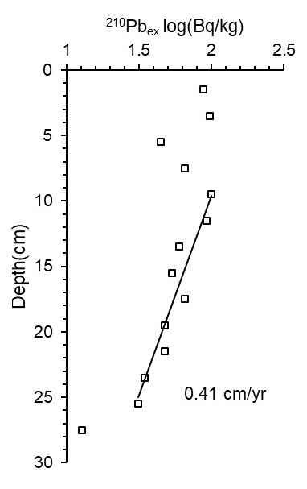
Figure S1. ²¹⁰Pb_{ex} profiles for core R07. Modified from Zhang et al. (2018).

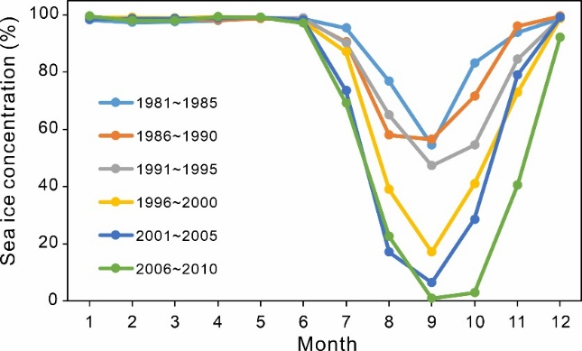
Figure S2. Time series of the monthly SIC for the area of R07 core.

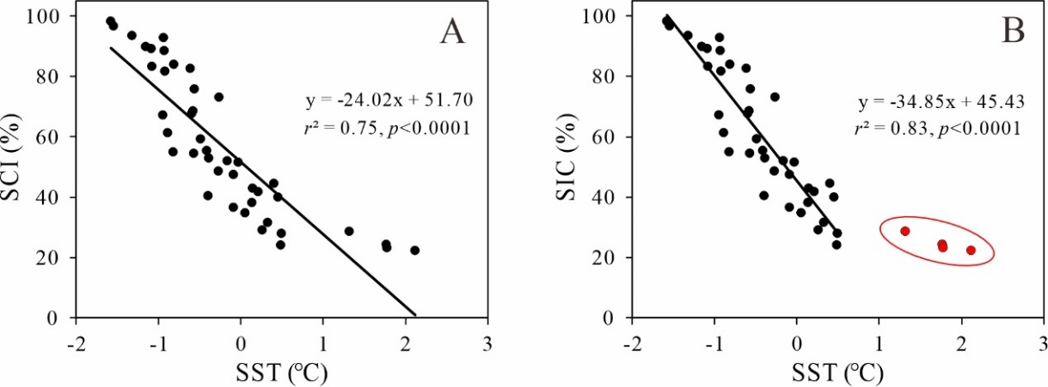
Figure S3. Cross plot showing linear relationship between SST and SIC from 1979 to 2020. A) Original data, B) Data without SST > 1℃ (red dots in the cycle).

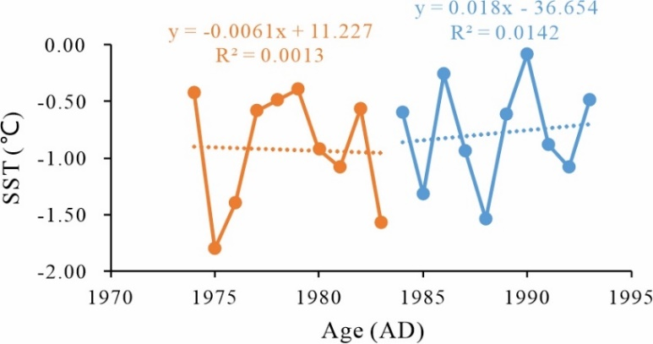
Figure S4. SST records and trends for 1974-983 (orange dots and line) and 1984-1993 (blue dots and line).

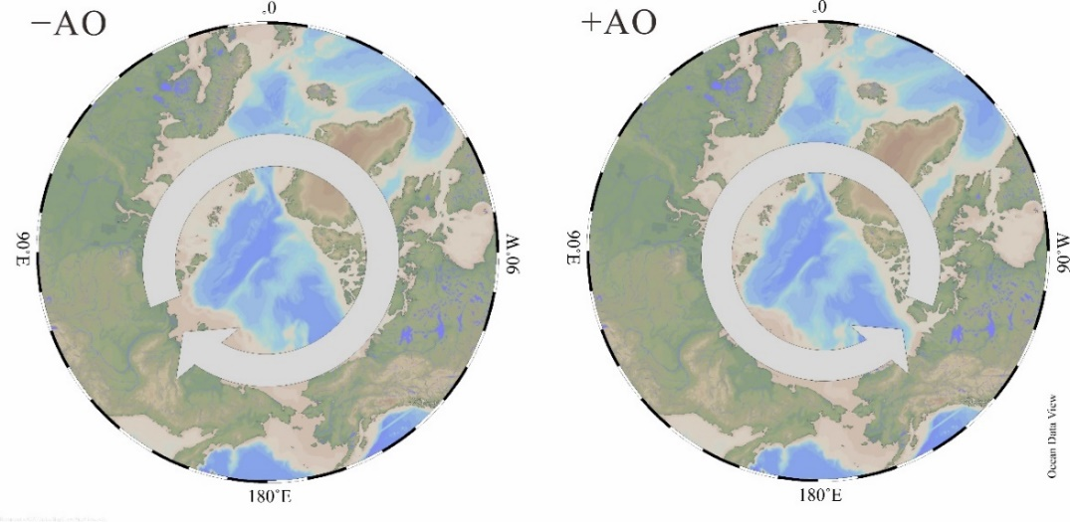
Figure S5. The anticyclonic wind anomaly during the –AO phase and the cyclonic wind anomaly during the +AO phase. Modified from Wang et al. (2014).

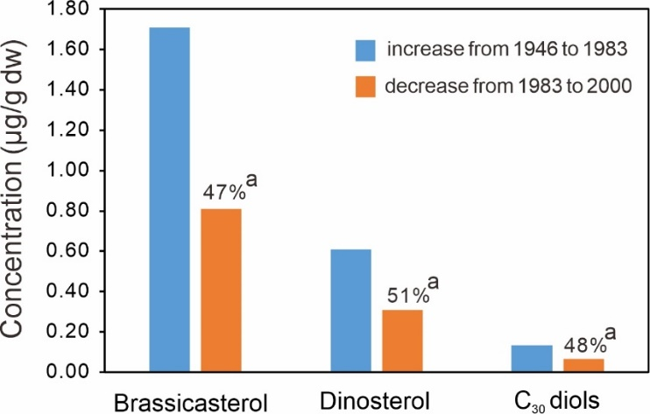
Figure S6. The changes in biomarker concentrations. a) The decrease amount from 1983 to 2000 as a percentage of the increase amount from 1946 to 1983 (black number).
2.2 Tables
Table S1. TOC, concentrations of biomarkers, and B/D ratios in Core R07.

Depth  (cm) | Age  (ca. AD) | TOCª | C₂₅₋₃₃  n-alkanes^{b} | C₂₄₋₃₀  n-alkanoic acids^{b} | C₂₄₋₃₀  n-alkanols^{b} | C₃₂ 1,15-diol^{c} | Brassicasterol^{b} | Dinosterol^{b} | C₃₀ diols^{c} | B/D ratio
1-2 | 2010 | 1.96 | 3.00 | 7.03 | 8.00 | 120.48 | 1.71 | 1.10 | 324.87 | 1.56
2-3 | 2008 | 1.83 | 3.63 | 7.56 | 7.16 | 120.19 | 1.42 | 0.91 | 303.19 | 1.57
3-4 | 2005 | 1.71 | 3.45 | 7.77 | 8.27 | 122.99 | 1.66 | 0.99 | 288.68 | 1.68
4-5 | 2003 | 1.69 | 3.78 | 7.33 | 7.72 | 128.94 | 1.78 | 0.99 | 307.56 | 1.80
5-6 | 2000 | 1.80 | 3.92 | 9.13 | 8.09 | 113.91 | 1.33 | 0.88 | 260.01 | 1.51
6-7 | 1998 | 1.69 | 3.75 | 8.08 | 7.87 | 124.82 | 1.24 | 1.03 | 310.73 | 1.21
7-8 | 1995 | 1.87 | 3.97 | 7.13 | 8.84 | 138.68 | 1.33 | 1.12 | 331.03 | 1.18
8-9 | 1993 | 1.82 | 3.50 | 8.27 | 8.72 | 131.43 | 1.50 | 0.98 | 288.75 | 1.52
9-10 | 1991 | 2.06 | 4.20 | 7.34 | 9.65 | 131.29 | 1.99 | 1.14 | 320.44 | 1.75
10-11 | 1988 | 1.80 | 3.92 | 8.70 | 9.80 | 125.88 | 1.69 | 1.15 | 305.44 | 1.47
11-12 | 1986 | 1.64 | 4.21 | 7.42 | 9.28 | 137.40 | 1.60 | 1.17 | 291.35 | 1.37
12-13 | 1983 | 1.60 | 4.28 | 9.49 | 10.95 | 150.00 | 2.14 | 1.19 | 324.62 | 1.79
13-14 | 1981 | 1.69 | 4.18 | 8.71 | 9.72 | 126.07 | 1.16 | 1.02 | 274.17 | 1.14
14-15 | 1978 | 1.85 | 3.74 | 8.30 | 10.10 | 133.70 | 0.84 | 1.03 | 271.24 | 0.81
15-16 | 1976 | 1.67 | 4.10 | 7.27 | 7.85 | 115.61 | 1.22 | 1.05 | 250.95 | 1.17
16-17 | 1973 | 1.72 | 4.25 | 8.48 | 7.71 | 120.24 | 0.87 | 0.87 | 260.52 | 1.00
17-18 | 1971 | 1.65 | 4.22 | 7.22 | 6.87 | 117.15 | 0.82 | 0.95 | 241.65 | 0.86
18-19 | 1969 | 1.53 | 3.70 | 8.29 | 9.65 | 135.99 | 1.15 | 1.01 | 284.98 | 1.14
19-20 | 1966 | 1.56 | 3.90 | 6.58 | 8.75 | 134.94 | 1.16 | 0.80 | 250.02 | 1.45
20-21 | 1964 | 1.38 | 3.45 | 6.80 | 7.46 | 118.99 | 0.70 | 0.77 | 223.81 | 0.90
21-22 | 1961 | 1.62 | 3.61 | 7.53 | 6.99 | 104.68 | 0.57 | 0.68 | 189.24 | 0.84
22-23 | 1959 | 1.34 | 3.81 | 7.12 | 9.56 | 111.61 | 0.71 | 0.64 | 206.46 | 1.12
23-24 | 1956 | 1.22 | 3.25 | 5.60 | 7.64 | 101.96 | 0.62 | 0.73 | 198.81 | 0.85
24-25 | 1954 | 1.22 | 3.76 | 7.07 | 7.55 | 112.30 | 0.48 | 0.60 | 188.78 | 0.81
25-26 | 1951 | 1.17 | 3.63 | 6.58 | 7.63 | 118.14 | 0.61 | 0.50 | 185.88 | 1.22
26-27 | 1948 | 1.01 | 3.48 | 7.10 | 6.37 | 94.40 | 0.36 | 0.46 | 162.96 | 0.78
27-28 | 1946 | 1.15 | 3.57 | 6.88 | 8.16 | 124.97 | 0.43 | 0.58 | 188.04 | 0.74
a. Data from Zhang et al. (2018).
b. In μg/g dry sediment.
c. In ng/g dry sediment.

Reference
Baskaran, M., Naidu, A.S., 1995. 210Pb-derived chronology and the fluxes of 210Pb and 137Cs isotopes into continental shelf sediments, East Chukchi Sea, Alaskan Arctic. Geochimica et Cosmochimica Acta 59 (21), 4435-4448.
Cooper, L.W., Grebmeier, J.M., 2018. Deposition patterns on the Chukchi shelf using radionuclide inventories in relation to surface sediment characteristics. Deep Sea Research Part II: Topical Studies in Oceanography 152, 48-66.
Gao, C., Yang, Y., Yang, H., Zhang, Y.G., Lü, X., Wang, H., Yu, X., Ruan, X., 2021. Different temperature dependence of marine-derived brGDGT isomers in a sediment core from the Chukchi Sea shelf. Organic Geochemistry 152, 104169.
Oldfield, F., Appleby, P.G., Battarbee, R.W., 1978. Alternative 210Pb dating: results from the New Guinea Highlands and Lough Erne. Nature 271 (5643), 339-342.
Screen, J.A., Deser, C., Simmonds, I., 2012. Local and remote controls on observed Arctic warming. Geophysical Research Letters 39 (10)
Wang, J., Eicken, H., Yu, Y., Bai, X., Zhang, J., Hu, H., Wang, D.-R., Ikeda, M., Mizobata, K., Overland, J.E., 2014. Abrupt climate changes and emerging ice-ocean processes in the Pacific Arctic Region and the Bering Sea. In: J.M. Grebmeier, W.M. (Eds.), The Pacific Arctic Region: Ecosystem Status and Trends in a Rapidly Changing Environment. Springer Dordrecht, pp. 65-99.
Zhang, W., Yu, X., Wang, W., Liu, Y., Ye, L., Bian, Y., Xu, D., Yang, H., Yao, X., 2018. Records of organic carbon and total nitrogen for environmental change in the chukchi sea during the past 100 years. Marine Geology & Quaternary Geology 38 (2), 13-24 (in Chinese with English abstract).

