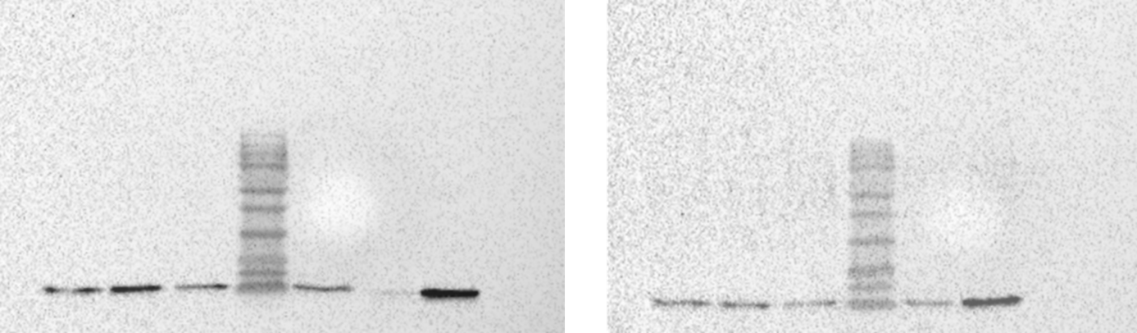
B
A
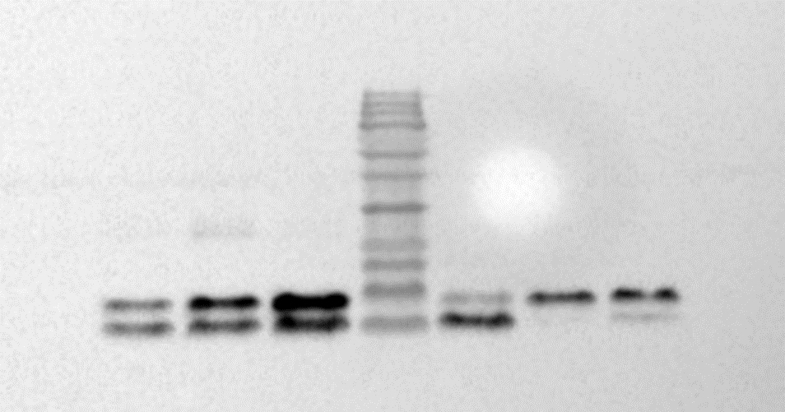  C | D | 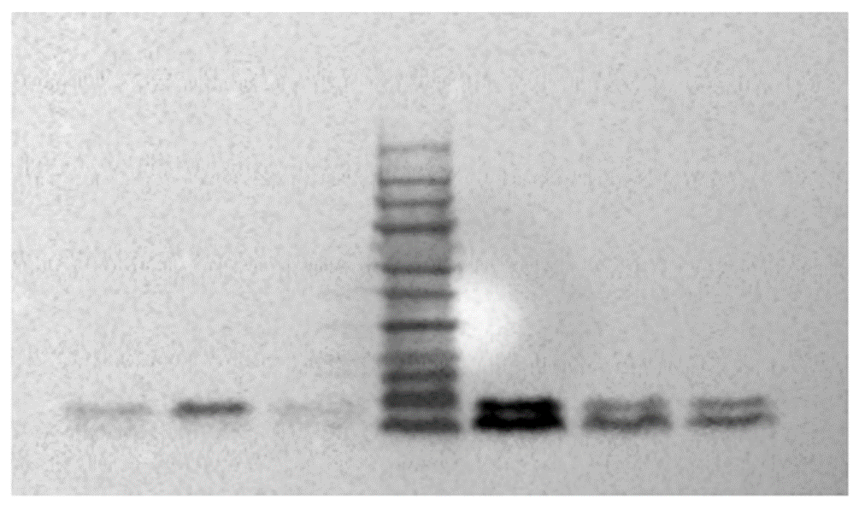  E
Supporting Information
Investigation of the molecular mechanisms which contribute to the survival of the polychaete Platynereis spp. under ocean acidification conditions in the CO₂ vent system of Ischia Island

Fig S1 Images obtained from the Western blot analysis and elaborated with ImageJ software of the individuals of Platynereis spp. sampled in the Ctrl and in the Vent site (A. H2B, B. H2BK16AC, C. H3, D. H3K27AC, E. H3K4Me2).

Table S1 PERMANOVA results of epigenetics analysis carried out in individuals of Platynereis spp. sampled in the Ctrl and in the Vent site.
Histone modification | Factor
H2B AC/H2B | site | p_{(MC)}= 0.4999
 |  | F_{(1,11)}= 1.0263
 | period | p_{(MC)}= 0.1117
 |  | F_{(1,11)}= 3.1896
 | site x period | p_{(MC)}= 0.0214 *
 |  | F_{(1,11)}= 8.3567
H3 AC/H3 | site | p_{(MC)}= 0.4266
 |  | F_{(1,11)}= 15.551
 | period | p_{(MC)}= 0.0648
 |  | F_{(1,11)}= 44.451
 | site x period | p_{(MC)}= 0.3079
 |  | F_{(1,11)}= 1.179
H3 Me2/H3 | site | p_{(MC)}= 0.8589
 |  | F_{(1,11)}= 48.27
 | period | p_{(MC)}= 0.665
 |  | F_{(1,11)}= 0.1957
 | site x period | p_{(MC)}= 0.3181
 |  | F_{(1,11)}= 11.371

