Figure S1 from Seasonal habitat preference and foraging behaviour of Weddell seals in the western Ross Sea
H_SUMMER | H_FALL
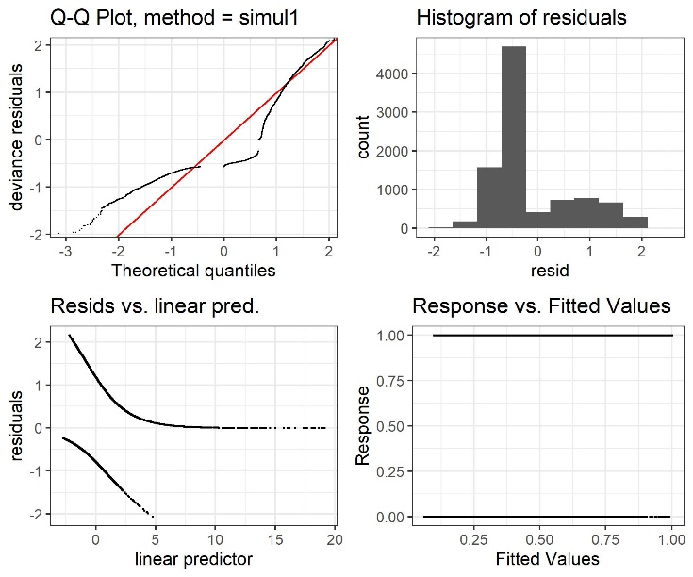 | 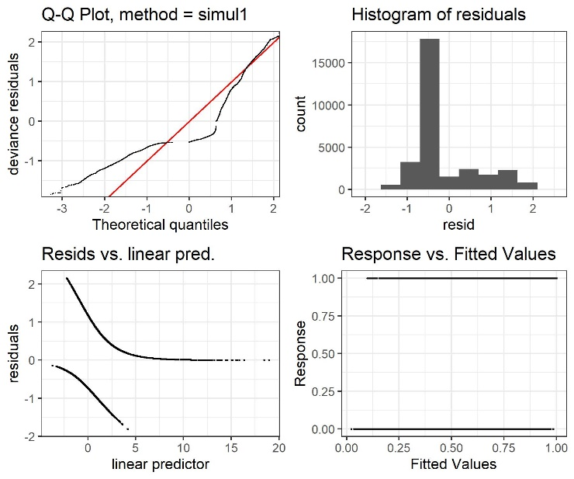
H_WINTER | H_SPRING
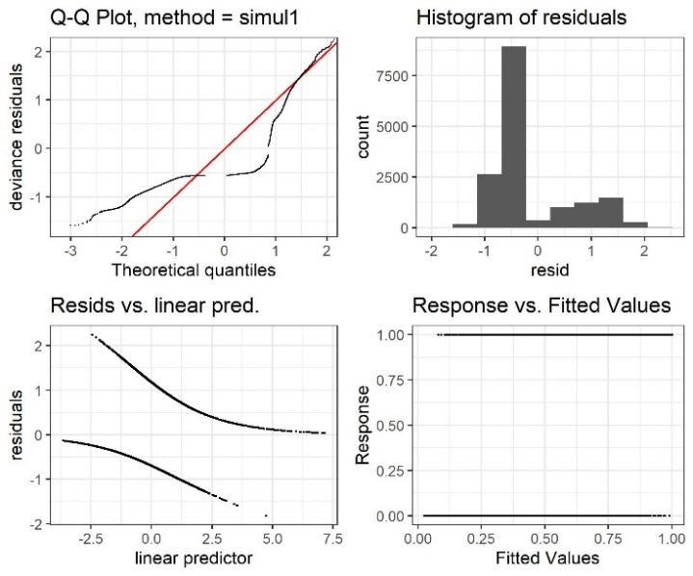 | 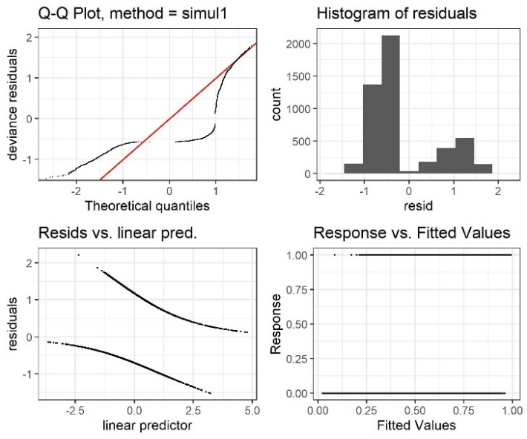
F_HORZ_SUMMER | F_HORZ_FALL
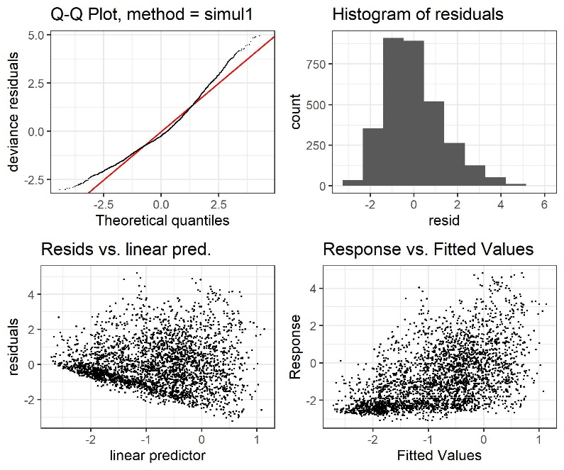 | 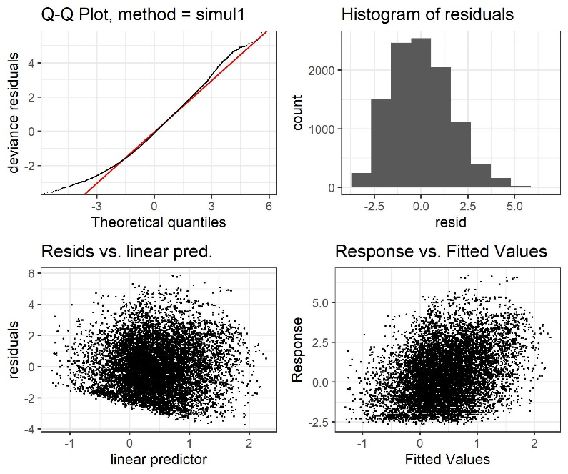
F_HORZ_WINTER | F_HORZ_SPRING
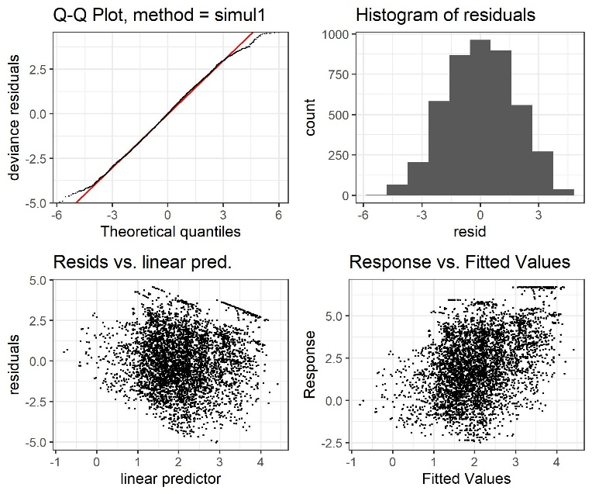 | 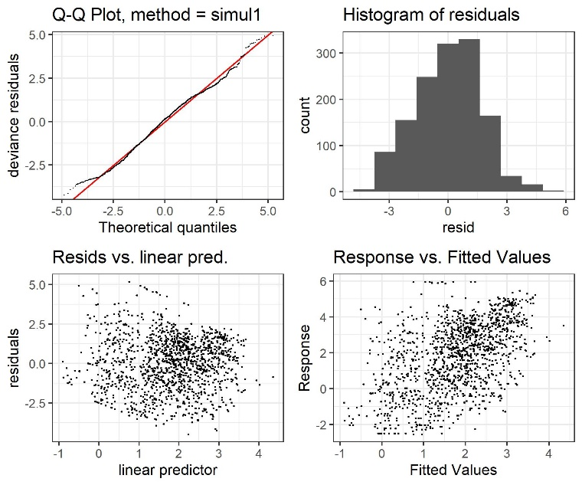
F_VERT_SUMMER | F_VERT_ALL
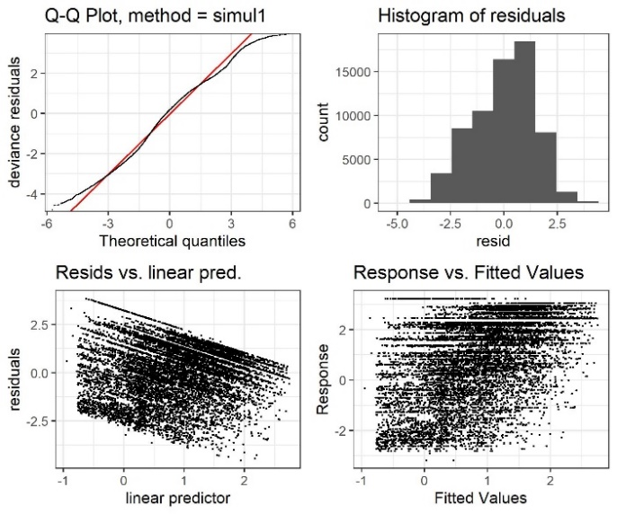 | 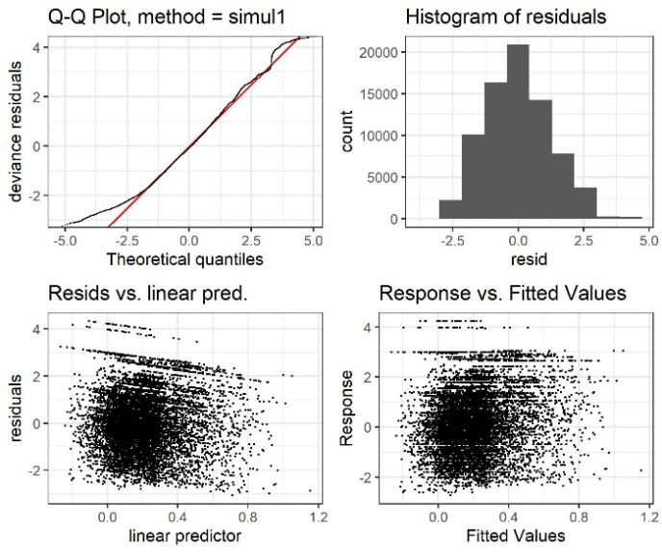
F_VERT_WINTER | F_VERT_SPRING
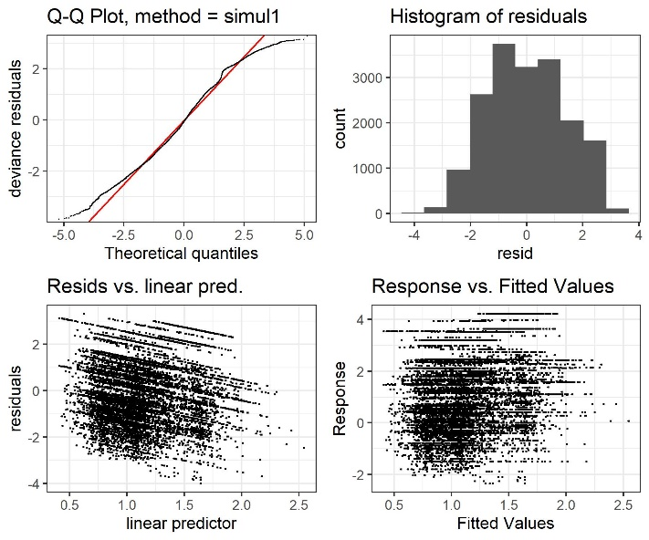 | 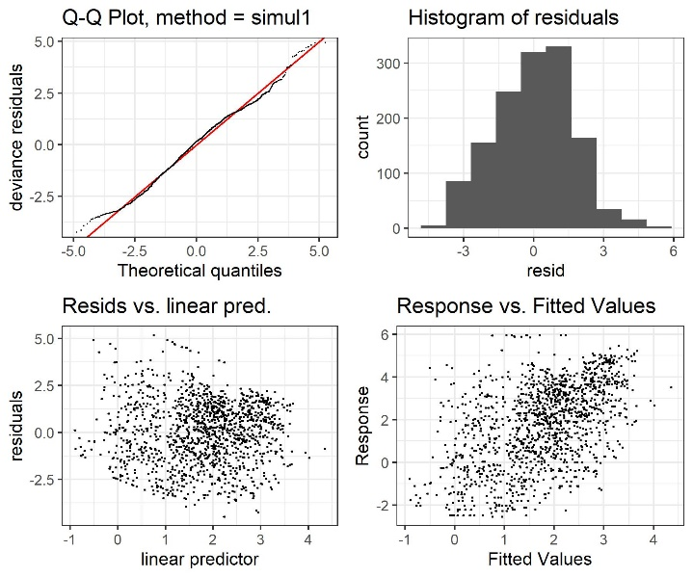
Figure S1: Four residual plots showing diagnostic information about the fitting procedure and results for all final seasonal models. Model labels are indicated at the top of each 4-panel plot with H and F distinguishing between habitat and foraging models and HORIZ and VERT distinguishing between horizontal and vertical foraging models.

