A symbiotic bacterium of Antarctic fish reveals environmental adaptability mechanisms and biosynthetic potential towards antibacterial and cytotoxic activities

Yu Xiao¹, Fangfang Yan¹, Yukun Cui¹, Jiangtao Du¹, Guangzhao Hu¹, Wanying Zhai², Rulong Liu¹, Zhizhen Zhang³, Jiasong Fang¹, Liangbiao Chen^{2*} and Xi Yu^{1*}

running head: Antarctic bacteria genomic and metabolites

Address: ¹Shanghai Engineering Research Center of Hadal Science and Technology, College of Marine Sciences, Shanghai Ocean University, Shanghai, 201306, China
² International Research Center for Marine Biosciences, Ministry of Science and Technology, Shanghai Ocean University, Shanghai, 201306, China
³Ocean College, Zhoushan Campus, Zhejiang University, Zhoushan, 316021, China

*corresponding author: XY (xyu@shou.edu.cn, +8615332036650);

LC (lbchen@shou.edu.cn, +8615618063251).

Key words: Antarctic fish, symbiotic bacteria, Serratia, genome, bioactive metabolites
Figure S1
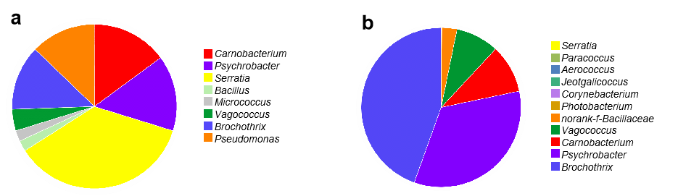
Supplementary Figure S1 Identification of fish symbiotic bacteria. a, Composition and relative abundance of symbiotic bacteria of TB-I. Serratia (36.2%) (Serratia myotis)，Carnobacterium (14.9%) (Carnobacterium maltaromaticum, Carnobacterium divergens, Carnobacterium Mobile, Carnobacterium funditum, Carnobacterium antarcticm), Psychrobacter (14.9%) (Psychrobacter maritimus), Pseudomonas (12.8%) (Pseudomonas paracarnis, Pseudomonas fildesensis, Pseudomonas kitaguniensis), Brochothrix (12.8%) (Brochothrix themosphacta), Vagococcus (4.3%) (Vagococcus salmoninarum), Micrococcus (2.1%) (Micrococcus luteus) and Bacillus (2.1%) (Bacillus proteolyticus). b, Composition and relative abundance of symbiotic bacteria of TB-S. Brochothrix (44.5%), Psychrobacter (33.8%), Carnobacterium (9.8%), Vagococcus (8.7%), norank-f-Bacillaceae (3.1%), Photobacterium (0.04%), Corynebacterium (0.03%), Jeotgalicoccus (0.02%), Aerococcus (0.02%), Serratia (0.02%) and Paracoccus (0.003%) Origin 2022.

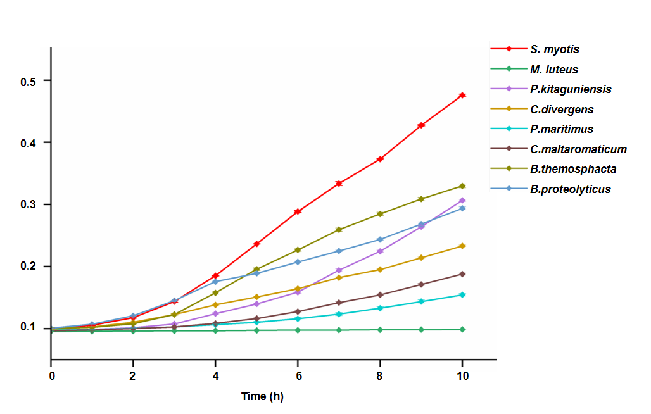
Figure S2

Supplementary Figure S2 Growth curves of nine symbiotic bacteria from Antarctic fish under minimal nutrient media. Nine symbiotic bacteria: Serratia myotis, Micrococcus luteus, Pseudomonas kitaguniensis, Carnobacterium divergens, Psychrobacter maritimus, Carnobacterium maltaromaticum, Brochothrix themosphacta, Bacillus proteolyticus. Origin 2022

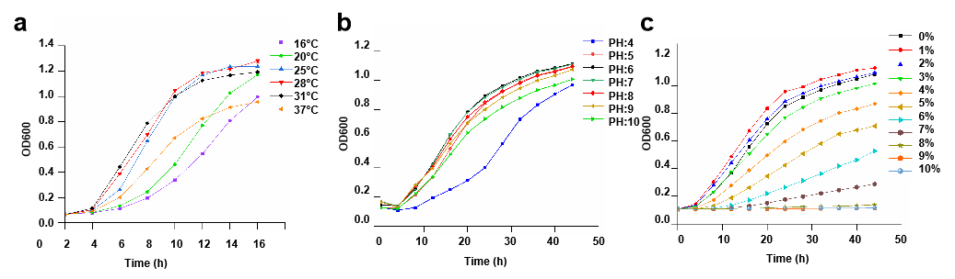
Figure S3

Supplementary Figure S3 Growth curves of S. myotis L7-1 under different growth conditions. a, Different temperature (16℃, 20℃, 25℃, 28℃, 31℃, 37℃). b, Different pH values (4-10, interval 1). c, Different salinity (w/v (0-10%, interval 1%). Three parallel groups were set up for each group. Origin 2022

Figure S4
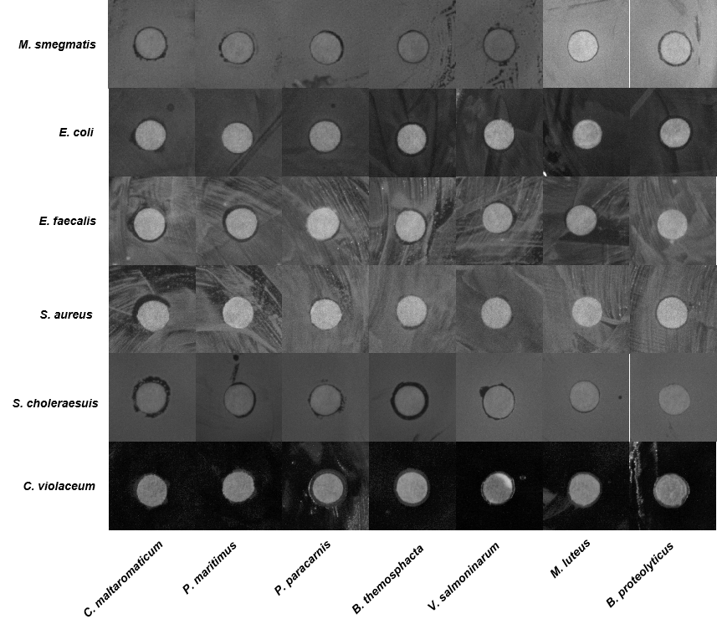
Supplementary Figure S4 The antibacterial activity of secondary metabolites of symbiotic bacteria. Zone of inhibition of the metabolites produced by seven symbiotic bacteria isolated from T. bernacchii.

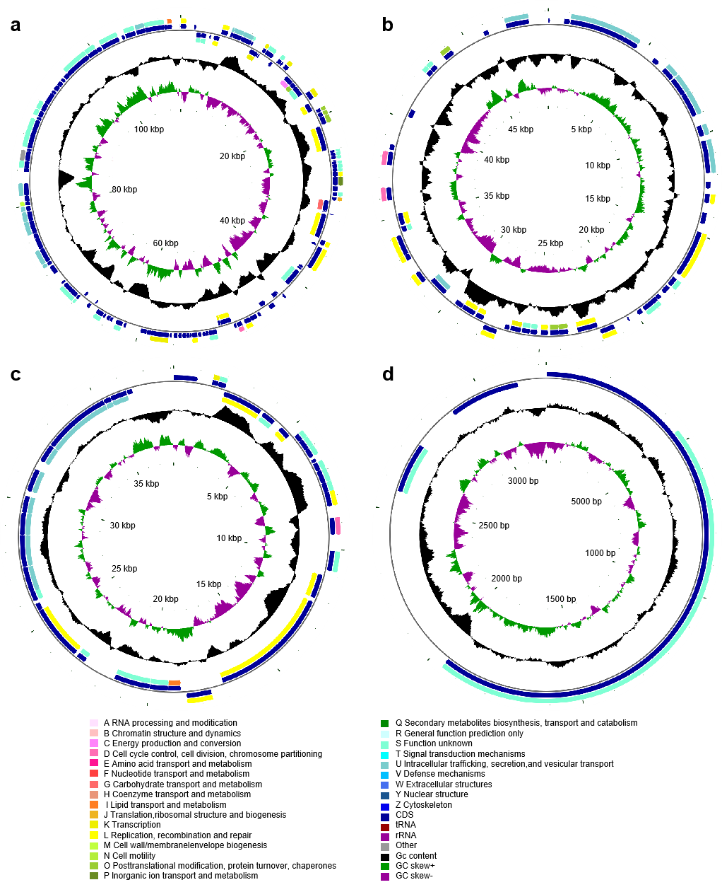
Figure S5

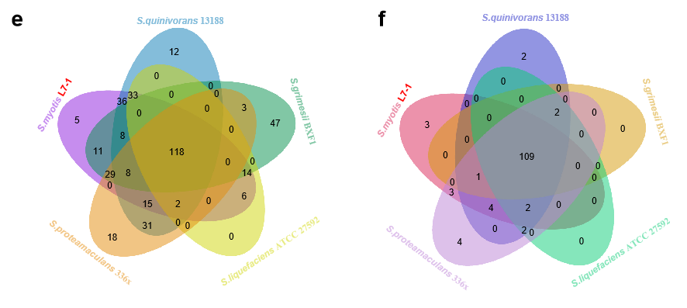

Supplementary Figure S5 Comparative genomics indicates the specific adaptability mechanisms. Circular map of plasmid of S. myotis L7-1. a, Plasmid A. 110,419 bp (pA), with a GC content of 55.10%, and 125 genes with coding sequences. A total of 0 tRNA, 0 rRNA and 1 sRNA were detected. A total of 127 genes were predicted to have COG functional annotation. b, Plasmid B. 49,145 bp (pB), with a GC content of 44.83%, and 48 genes with coding sequences. A total of 0 tRNA, 0 rRNA and 2 sRNA were detected. A total of 50 genes were predicted to have COG functional annotation. c, Plasmid C. 38,106 (pC), with a GC content of 50.14%, and 36 genes with coding sequences. A total of 0 tRNA, 0 rRNA and 1 sRNA were detected. A total of 37 genes were predicted to have COG functional annotation. d, Plasmid D. 3,223 bp (pD), with a GC content of 56.28%, and 4 genes with coding sequences. A total of 0 tRNA, 0 rRNA and 1 sRNA were detected. A total of 4 genes were predicted to have COG functional annotation. From outside to inside Ring 1 and 4 depicts CDS in the positive strand and negative strand, different colors indicate different COG functional classifications. Ring 2 and 3 depicts CDS, tRNA and rRNA in the positive strand and negative strand. Ring 5 and 6 represents GC content and GC skew, respectively.cloud.majorbio.com e, Venn diagram showing the distribution of secondary metabolic synthesis gene cluster genes in the genomes of S. myotis L7-1 and the four reference Serratia strains. A total of 118 secondary metabolic synthesis gene cluster genes were common to the five Serratia genomes. The unique gene cluster gene in S. myotis L7-1 included betalactone, RiPP-like and arylpolyene, siderophore, associated with SM production. f, Venn diagram showing the distribution of CAZyme genes in the genomes of S. myotis L7-1 and the four reference Serratia strains. A total of 109 CAZyme genes were common to the five Serratia genomes. The unique CAZyme gene in S. myotis L7-1 included glycosyl transferases and polysaccharide lyases. www.ehbio.com/test/venn.

Figure S6
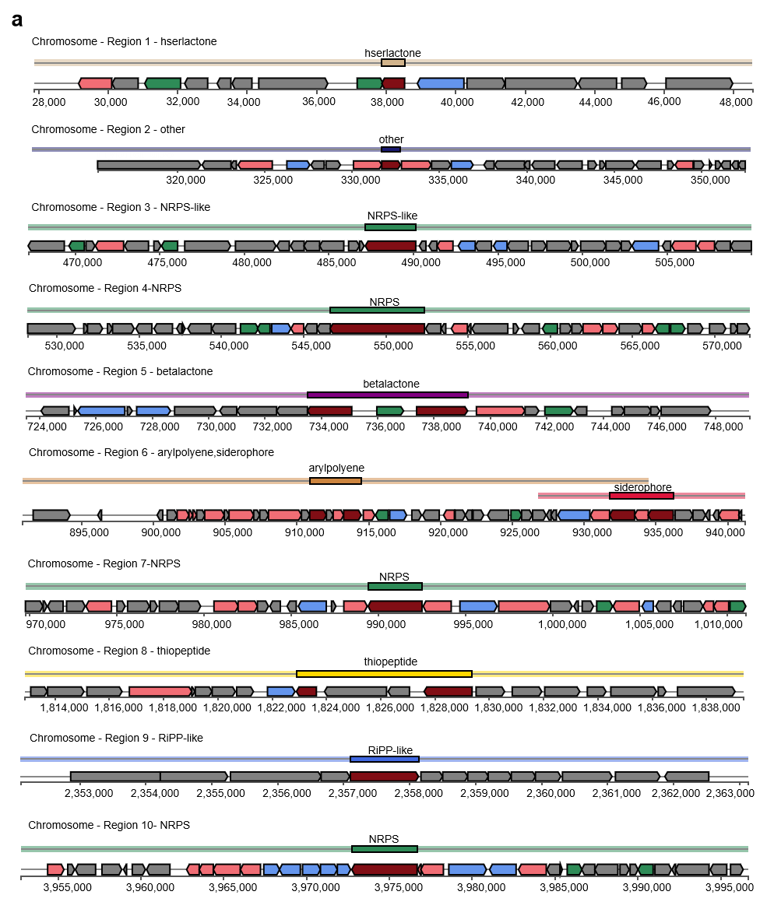

Supplementary Figure S6 Genomic annotation and BGCs prediction of S. myotis L7-1. 10 secondary metabolic gene clusters of S. myotis L7-1. antismash. secondarymetabolites.org

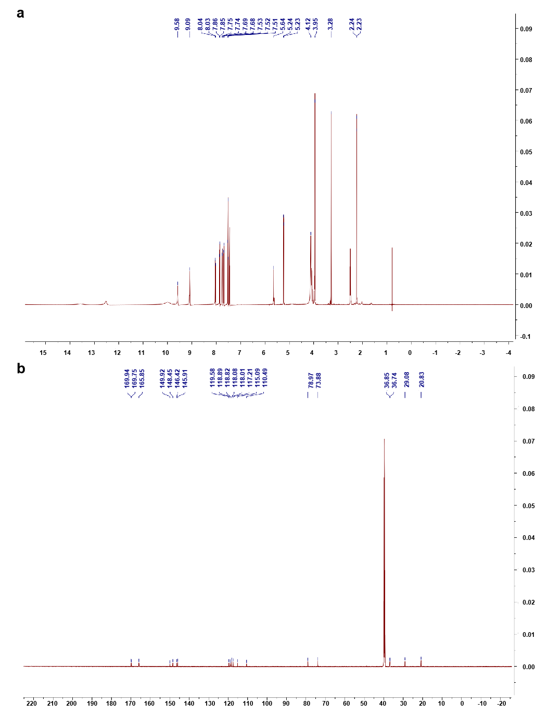
Figure S7

Supplementary Figure S7 Identification of the bioactive compound serranticin. a, ¹H-NMR spectrum of srranticin in DMSO-d₆. b, ¹³C-NMR spectrum of serranticin in DMSO-d₆.
Figure S8
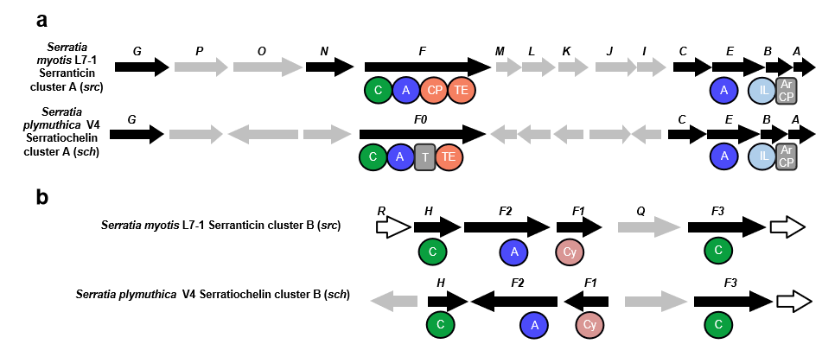
Supplementary Figure S8 Serranticin gene clusters. a, Comparison of serranticin cluster A with the Serratia plymuthica V4 serratiochelin cluster A. The sequences and syntenies of these two clusters are highly homologous. b, Comparison of serranticin cluster B with the Serratia plymuthica V4 serratiochelin cluster B. The sequences and syntenies of these two clusters are highly homologous.

Supplementary Table S1 Isolation of fish symbiotic bacteria. Separation medium formulation.
Medium | Formulation | PH
LB agar | yeast extract 5 g, NaCl 5 g, pepptone 10 g, agar 15 g | natural PH
NA | trypeptone 10 g, NaCl 5 g, beef extract 3 g, agar 15 g | natural PH
TSA | FeSO₄.7H₂O 0.01 g, MgSO₄.7H₂O 0.2 g, K₂HPO₄ 0.5 g, beef extract 2 g, yeast extract 2 g, ammonium acetate 3 g, peptone 6 g，glucose 40 g, agar 15 g | PH 6.5
RCM | L-Cysteine hydrochloride 0.5 g, solublestarch 1 g, Sodium acetate 3 g, NaCl 3 g, yeast extract 3 g, glucose 5 g, beef extract 10 g, peptone 10 g, 15 g agar | PH 8.5
MASM | KH₂PO₄ 0.1 g, NH₄Cl 0.3 g, KCl 0.5 g, Trace element 1 mL, Vitamin mixture 1 mL, Vitamin B1 1 mL, Vitamin B12 1 mL, CaCl₂.2H₂O 1.4 g, N-acetylglucosamine 2 g, Na₂SO₄ 4 g, MgCl.6H₂O 5 g, glucose 5.2 g, NaHCO₃ 20 mM 20 mL, NaCl 26 g, agar 15 g | PH 7-8
PDA | glucose 20 g, potato 200g, agar 15 g | natural PH
YMG | yeast extract 4 g, malt extract 10 g, glucose 20 g, agar 15 g | natural PH
MM | FeSO₄.7H₂O 0.01 g, MgSO₄.7H₂O 0.2 g, K₂HPO₄ 0.5 g, (NH₄)₂SO₄ 1g, glucose 10 g, agar 15 g | natural PH
MN | Na₂HPO₄ 5.96g, K₂HPO₄ 3 g, NH₄Cl 1 g, NaCl 0.5 g, MgSO₄ 0.058 g, glucose 5 g | PH 7

Supplementary Table S2 Identification of Serratia strains. 17 strains of S. myotis 16S rDNA similarity, interspecies similarity and isolation medium.
Name | Top-hit taxon | Top-hit taxon | Isolation medium | Interspecific similarity (%)
L7-1 | S. myotis | 99.71 | LB | 99.70-100
E7 | S. myotis | 99.78 | LB | 99.70-100
F7S | S. myotis | 99.57 | LB | 99.40-100
F7Z1 | S. myotis | 99.57 | LB | 99.70-100
FLS7 | S. myotis | 99.78 | LB | 99.70-100
L7-2 | S. myotis | 99.50 | LB | 99.40-99.70
LD7 | S. myotis | 99.71 | LB | 99.70-100
LM7-1 | S. myotis | 99.64 | MASM | 99.70-100
LM7-3 | S. myotis | 99.57 | MASM | 99.70-100
M7-1- | S. myotis | 99.64 | MM | 99.70-100
N7-1 | S. myotis | 99.71 | NA | 99.70-100
P7 | S. myotis | 99.78 | PDA | 99.70-100
PE7 | S. myotis | 99.86 | PDA | 99.70-100
RC7-1 | S. myotis | 99.78 | RCM | 99.70-100
RC7 | S. myotis | 99.78 | RCM | 99.70-100
SE7 | S. myotis | 99.78 | TSA | 99.70-100
TS7-1 | S. myotis | 99.71 | TSA | 99.70-100

Supplementary Table S3 Composition and number of other antibiotic resistance genes of S. myotis L7-1.
Antibiotics | N
acridine dye | 9
aminoglycoside antibiotic | 32
antibacterial free fatty acids | 2
benzalkonium chloride | 1
bicyclomycin | 1
diaminopyrimidine antibiotic | 15
elfamycin antibiotic | 1
fosfomycin | 8
glycopeptide antibiotic | 19
glycylcycline | 17
lincosamide antibiotic | 21
monobactam | 24
mupirocin | 2
nitrofuran antibiotic | 2
nitroimidazole antibiotic | 12
nucleoside antibiotic | 4
oxazolidinone antibiotic | 13
penem | 26
phenicol antibiotic | 52
pleuromutilin antibiotic | 19
rhodamine | 1
rifamycin antibiotic | 27
streptogramin antibiotic | 16
sulfonamide antibiotic | 11
triclosan | 18
Supplementary Table S4 Unique KEGG genes of S. myotis L7-1 compared to the four reference strains (S. quinivorans 13188, S. grimesii BXF1, S. liquefaciens ATCC 27592, and S. proteamaculans 336x).
KEGG | KO Description
K03366 | butA, budC; meso-butanediol dehydrogenase (S, S)-butanediol dehydrogenase / diacetyl reductase [EC:1.1.1.- 1.1.1.76 1.1.1.304]
K12203 | dotB, traJ; defect in organelle trafficking protein DotB [EC:7.2.4.8]
K12204 | dotC, traI; defect in organelle trafficking protein DotC
K12205 | dotD, traH; defect in organelle trafficking protein DotD
K05275 | E1.1.1.65; pyridoxine 4-dehydrogenase [EC:1.1.1.65]
K07026 | E3.1.3.70; mannosyl-3-phosphoglycerate phosphatase [EC:3.1.3.70]
K17204 | eryE; erythritol transport system ATP-binding protein
K11202 | fryB; fructose-like PTS system EIIB component [EC:2.7.1.-]
K11203 | fryC, frvB; fructose-like PTS system EIIC or EIIBC or EIIABC component
K06048 | gshA, ybdK; glutamate---cysteine ligase / carboxylate-amine ligase [EC:6.3.2.2 6.3.-.-]
K11004 | hlyB, cyaB; ATP-binding cassette, subfamily B, bacterial HlyB/CyaB
K11003 | hlyD, cyaD; membrane fusion protein, hemolysin D
K12206 | icmB, dotO; intracellular multiplication protein IcmB [EC:7.2.4.8]
K12209 | icmE, dotG; intracellular multiplication protein IcmE
K12211 | icmG, dotF; intracellular multiplication protein IcmG
K12212 | icmJ, dotN; intracellular multiplication protein IcmJ
K12213 | icmK, traN, dotH; intracellular multiplication protein IcmK
K12214 | icmL, traM, dotI; intracellular multiplication protein IcmL
K12217 | icmO, trbC, dotL; intracellular multiplication protein IcmO [EC:7.2.4.8]
K12218 | icmP, trbA; intracellular multiplication protein IcmP
K12222 | icmT, traK; intracellular multiplication protein IcmT
K01182 | IMA, malL; oligo-1,6-glucosidase [EC:3.2.1.10]
K07045 | K07045; uncharacterized protein
K07498 | K07498; putative transposase
K12227 | K12227, traL; TraL protein
K17202 | K17202, eryG; erythritol transport system substrate-binding protein
K17203 | K17203, eryF; erythritol transport system permease protein
K18991 | mtrA; AraC family transcriptional regulator, activator of mtrCDE
K01788 | nanE; N-acylglucosamine-6-phosphate 2-epimerase [EC:5.1.3.9]
K01174 | nuc; micrococcal nuclease [EC:3.1.31.1]
K18640 | parM, stbA; plasmid segregation protein ParM
K23991 | ptsA, fryA; multiphosphoryl transfer protein [EC:2.7.3.9 2.7.1.-]
K02856 | rhaT; L-rhamnose-H+ transport protein
K08172 | shiA; MFS transporter, MHS family, shikimate and dehydroshikimate transport protein
K03465 | thyX, thy1; thymidylate synthase (FAD) [EC:2.1.1.148]
K12228 | trbB; TrbB protein
K20531 | trbF; type IV secretion system protein TrbF
K20532 | trbG; type IV secretion system protein TrbG
K20533 | trbI; type IV secretion system protein TrbI
K03194 | virB1; type IV secretion system protein VirB1
K03195 | virB10, lvhB10; type IV secretion system protein VirB10
K03196 | virB11, lvhB11; type IV secretion system protein VirB11 [EC:7.4.2.8]
K03197 | virB2, lvhB2; type IV secretion system protein VirB2
K03199 | virB4, lvhB4; type IV secretion system protein VirB4 [EC:7.4.2.8]
K03200 | virB5, lvhB5; type IV secretion system protein VirB5
K03201 | virB6, lvhB6; type IV secretion system protein VirB6
K03203 | virB8, lvhB8; type IV secretion system protein VirB8
K03204 | virB9, lvhB9; type IV secretion system protein VirB9
K03205 | virD4, lvhD4; type IV secretion system protein VirD4 [EC:7.4.2.8]
K16695 | wzxC; lipopolysaccharide exporter
K03829 | yedL; putative acetyltransferase [EC:2.3.1.-]

Supplementary Table S5 Unique COG genes of S. myotis L7-1 compared to the four reference strains (S. quinivorans 13188, S. grimesii BXF1, S. liquefaciens ATCC 27592, and S. proteamaculans 336x).
COG | COG Description
COG3253 | Coproheme decarboxylase/chlorite dismutase
COG3415 | CRISPR-associated protein Csa3, CARF domain
COG2390 | DNA-binding transcriptional regulator LsrR, DeoR family
COG1479 | DNAse/DNA nickase specific for phosphorothioated or glycosylated phage DNA, GmrSD/DndB/SspE family, contains DUF262 and HNH nuclease domains
COG1525 | Endonuclease YncB, thermonuclease family
COG5039 | Exopolysaccharide biosynthesis protein EpsI, predicted pyruvyl transferase
COG3401 | Fibronectin type 3 domain
COG2170 | Gamma-glutamyl:cysteine ligase YbdK, ATP-grasp superfamily
COG3306 | Glycosyltransferase involved in LPS biosynthesis, GR25 family
COG3385 | IS4 transposase InsG
COG3769 | Mannosyl-3-phosphoglycerate phosphatase YedP/MpgP, HAD superfamily
COG5520 | O-Glycosyl hydrolase
COG3409 | Peptidoglycan-binding (PGRP) domain of peptidoglycan hydrolases
COG4938 | Predicted ATPase
COG4889 | Predicted helicase
COG5618 | Predicted periplasmic lipoprotein
COG3010 | Putative N-acetylmannosamine-6-phosphate epimerase
COG0535 | Radical SAM superfamily maturase, SkfB/NifB/PqqE family
COG1715 | Restriction endonuclease Mrr
COG3587 | Restriction endonuclease, type III RM system
COG1351 | Thymidylate synthase ThyX, FAD-dependent family
COG3958 | Transketolase, C-terminal subunit
COG3959 | Transketolase, N-terminal subunit
COG3547 | Transposase
COG4753 | Two-component response regulator, YesN/AraC family, consists of REC and AraC-type DNA-binding domains
COG3170 | Type IV pilus assembly protein FimV
COG0630 | Type IV secretory pathway ATPase VirB11/Archaellum biosynthesis ATPase ArlI/FlaI
COG3736 | Type IV secretory pathway, component VirB8
COG3701 | Type IV secretory pathway, TrbF component
COG2948 | Type IV secretory pathway, VirB10 component
COG3838 | Type IV secretory pathway, VirB2 component (pilin)
COG3702 | Type IV secretory pathway, VirB3 component
COG3451 | Type IV secretory pathway, VirB4 component
COG3704 | Type IV secretory pathway, VirB6 component
COG3504 | Type IV secretory pathway, VirB9 components
COG3843 | Type IV secretory pathway, VirD2 component (relaxase)
COG3505 | Type IV secretory pathway, VirD4 component, TraG/TraD family ATPase
COG4925 | Uncharacterized conserved protein
COG4249 | Uncharacterized conserved protein, contains caspase domain
COG5470 | Uncharacterized conserved protein, DUF1330 family
COG5639 | Uncharacterized conserved protein, DUF2274 domain
COG4541 | Uncharacterized membrane protein
COG4694 | Wobble nucleotide-excising tRNase

Supplementary Table S6 Identification of the bioactive compound serranticin. Optical rotation for serranticin in acetone.
N | Average | Standard Deviation | Relative standard deviation (%) | Max | Min | T (C°)
5 | -26.40 | 2.97 | -11.25 | -22 | -30 | 20

Supplementary Table S7 Identification of the bioactive compound serranticin. ¹H-NMR (600 MHz) and ¹³C-NMR (150 MHz) spectroscopic data for serranticin in DMSO-d₆.
Position | 1H-NMR (J in Hz) | 13C-NMR
1 |  | 110.49
2 | 12.52 (s) | 148.45
3 |  | 145.91
4 | 7.68 (dd, J = 7.9, 1.4) | 118.01
5 | 7.52 (t, J = 7.9) | 118.82
6 | 7.85 (dd, J = 7.9, 1.4) | 119.58
7 |  | 165.85
9 | 5.24 (d, J = 7.4) | 73.88
10 | 5.64 (m) | 78.97
12 | 2.23 (3H, d, J = 6.4) | 20.83
1' |  | 169.75
2' (NH) | 9.09 (t, J = 6.0)
3' | 4.08 (2H, m) | 36.85
4' | 3.28 (2H, m) | 29.08
5' | 3.97 (2H, m) | 36.74
6' (NH) | 9.58 (t, J = 5.9)
7' |  | 169.94
1'' |  | 115.09
2'' | 13.54 (s) | 149.92
3'' | 10.00 (2H, s, 3) | 146.42
4'' | 7.75 (dd, J = 7.9, 1.4) | 118.89
5'' | 7.45 (t, J = 8.0) | 118.08
6'' | 8.04 (dd, J = 8.0, 1.4) | 117.21

Supplementary Table S8 Serranticin gene clusters. Annotation of the serranticin biosynthetic cluster A.
Gene | AA length | Predicted Function | Strain | Identity (%) | Similarity (%)
srcA | 252 | 2,3-dihydro-2,3-dihydroxybenzoate dehydrogenase | Serratia plymuthica V4 | 85 | 100
srcB | 284 | Isochorismatase | Serratia plymuthica V4 | 88 | 99
srcC | 402 | Isochorismate synthase | Serratia plymuthica V4 | 86 | 100
srcE | 542 | Enterobactin synthase component E | Serratia plymuthica V4 | 87 | 100
srcF | 1314 | Enterobactin synthase subunit F | Serratia plymuthica V4 | 86 | 100
srcG | 561 | Acetolactate synthase | Serratia plymuthica V4 | 88 | 100
srcI | 319 | Iron-enterobactin transporter periplasmic binding protein | Serratia plymuthica V4 | 84 | 100
srcJ | 422 | Enterobactin transporter EntS | Serratia plymuthica V4 | 86 | 100
srcK | 357 | Ferric enterobactin transport system permease protein | Serratia plymuthica V4 | 87 | 100
srcL | 341 | Iron-enterobactin ABC transporter permease | Serratia plymuthica V4 | 87 | 100
srcM | 267 | Ferric enterobactin transport ATP-binding protein | Serratia plymuthica V4 | 88 | 98
srcN | 759 | TonB-dependent siderophore receptor | Serratia plymuthica V4 | 87 | 99
srcO | 456 | Enterochelin esterase | Serratia plymuthica V4 | 84 | 100
srcP | 535 | ABC transporter substrate-binding protein | Serratia plymuthica V4 | 88 | 98

Supplementary Table S9 Serranticin gene clusters. Annotation of the serranticin biosynthetic cluster B.
Gene | AA length | Predicted Function | Strain | Identity (%) | Similarity (%)
srcF1 | 533 | Glutamate racemase | Serratia plymuthica V4 | 80 | 99
srcF2 | 1031 | Non-ribosomal peptide synthetase | Serratia plymuthica V4 | 84 | 100
srcF3 | 974 | Condensation domain | Serratia plymuthica V4 | 81 | 100
srcH | 448 | Condensation domain | Serratia plymuthica V4 | 81 | 100
srcQ | 707 | TonB-dependent receptor | Serratia plymuthica V4 | 89 | 100
srcR | 532 | ABC transporter substrate-binding protein | Serratia plymuthica V4 | 88 | 99

