Supplementary Material

Supplementary Methods

Vertebrate community definition
We defined the vertebrate community at the species level with both standardized and non-standardized observations. We used annual records of vertebrates by field observations during the bird incubation period from late June to mid-July from 2010 to 2019. The observations were made from 500m linear transects (n= 145 to 295 per year), where all vertebrates were recorded within 150m of each side (Lamarre et al., 2017; Duchesne et al., 2021). We also used non-standardized daily incidental observations of vertebrates made by a single or a group of researchers from late May to late August each year from 2007 to 2019. Each species observed incidentally during field days was recorded. We apply the following criteria to each data set to exclude occasional visitors: i) species without confirmed breeding cases on the study site, ii) species observed only in a single year, and iii) species typically breeding and foraging in nearby marine or coastal habitats. After applying those criteria, we obtained 32 species with the standardized data and 35 with the daily incidental observations. We retained the largest number of species from these two lists (Table S1).

Non-breeding range delimitation

Range maps
The non-breeding range of most migratory species (22 of 28) was derived from species range maps defined by either a collection of diverse data sources, models of species occurrence based on amateur bird watching observations, or a combination of both.
Birdlife range maps (Migratory species)
We used the non-breeding range maps defined by BirdLife International and Handbook of the Birds of the World (2019) (hereafter Birdlife). The Birdlife range maps are based on a combination of individual localizations from scientific collections, field observations, published and unpublished literature, range maps and expert knowledge. All maps were reviewed between 2014 to 2017. Birdlife range maps include the intercontinental distribution of species in terrestrial, coastal and marine habitats. However, the precision and accuracy seem to vary between species, probably depending on the quality of the available data.
eBird range maps (Migratory species)
We used range maps defined by Fink et al. (2020a; hereafter eBird) based on models of species occurrence built with amateur birdwatching observations and 79 environmental predictors, where 76 were derived from 19 land cover variables (Fink et al., 2020b). Species range maps defined by eBird have a high resolution (2.8 × 2.8 km) and are defined based on recent observations but are, for the moment, restricted to the Americas only. The eBird ranges do not extend to marine habitats since most observations are on land.

Tracking devices
Snowy owls
Snowy owls were captured at the study site and tracked for up to three consecutive years with ARGOS satellite transmitters in 2007 (n=9) and 2014 (n=3) (Therrien et al., 2012; Robillard et al., 2018). The non-breeding period was defined for each individual and year based on the daily distance traveled (Robillard et al., 2018). The non-breeding range of snowy owls was defined with a 95 % kernel density function of pooled non-breeding locations using the R package adehabitatHR (Calenge, 2006). The kernel was based on a bivariate normal kernel distribution with a fixed smoothing term, an automatic bandwidth selection with the ad hoc method, and the default software grid resolution.
Common-ringed plovers
Common-ringed plovers were captured at the study site and tracked from 2014 to 2016 (n= 14) with geolocators (Léandri-Breton et al., 2019). The non-breeding period was defined for each individual by considering the period where no apparent migration movement was observed for more than sixty days. The non-breeding range was defined with a 95 % kernel density function of pooled non-breeding locations using the R package adehabitatHR (Calenge, 2006). The kernel was based on a bivariate normal kernel distribution with a fixed smoothing term, bandwidth selection was done with a least-square cross-validation method (LSCV) because we did not observe convergence with the ad hoc method, and we used the default software grid resolution. We removed the marine part of the defined non-breeding range polygon since common-ringed plovers are associated to terrestrial and coastal habitats during the non-breeding period based on Billerman et al. (2021). The presence of a marine portion in the raw non-breeding range defined with geolocators could be explained by the uncertainty of the tracking devices, which located coastal individuals in the nearby marine environment.
Snow Geese
Snow geese were captured during migration at a staging site at Île-aux-Oies (St-Lawrence River, Québec, Canada) and equipped with GPS-GSM collars from 2019 to 2021 (Legagneux et al., unpublished data; Létourneux et al., 2021). We selected only locations from geese that have bred on Bylot (n= 12) and filtered to keep only locations during January and February to represent the non-breeding range. We defined the non-breeding period for snow geese as January and February, based on a visual inspection of the individual movement to identify the longest period where individuals are relatively stationary. The non-breeding range of snow goose was also defined with a 95 % kernel density function of pooled non-breeding locations using the R package adehabitatHR (Calenge, 2006). The kernel was based on a bivariate normal kernel distribution with a fixed smoothing term, an automatic bandwidth selection with the ad hoc method, and the default software grid resolution. We removed the marine part of the defined non-breeding range polygon since snow geese are associated to terrestrial and coastal habitats during the non-breeding period based on Billerman et al. (2021). The presence of a marine portion in the raw non-breeding range defined with GPS could be explained by the uncertainty of the tracking devices, which located coastal individuals in the nearby marine environment. We compared the non-breeding range of snow geese defined with tracking devices to the non-breeding range defined with winter band recovery from individuals banded from Bylot Island (n= 7 156) and observed a highly similar range. The non-breeding of snow goose encompassed the boundaries of six ecoregions when defined with tracking devices and seven ecoregions when defined with banding data. The further analyses were performed with the tracking data.
Long-tailed jaegers
Long-tailed jaegers were captured in 2008 and from 2014 to 2019, equipped with geolocators or satellite transmitter devices, and tracked year-round (Seyer et al., 2021). Most individuals were tracked from Bylot Island (n= 50); however, two individuals were tracked from a site located around 400 km south of the study site (Seyer et al., 2021). The non-breeding range of long-tailed jaegers was also defined with a 95 % kernel density function of pooled non-breeding locations using the R package adeadehabitatHR (Calenge, 2006). The kernel was based on a bivariate normal kernel distribution and the least-square cross-validation method (LSCV) to select the smoothing parameters (Seyer et al., 2021).
American golden-plovers
American golden-plovers were captured at the study site from 2009 to 2015 and equipped with geolocators (Lamarre et al., 2021). Individuals were recaptured on Bylot 1 to 4 years after the first capture; we used the tracks of 19 individuals. The non-breeding locations were defined as the southernmost cluster of locations. The non-breeding range was defined with a 95 % kernel density estimation of pooled non-breeding locations using the kde function in the R package ks (Duong et al., 2007). We removed the marine part of the defined non-breeding range polygon since American golden-plovers are associated to terrestrial and coastal habitats during the non-breeding period based on Billerman et al. (2021). The presence of a marine portion in the raw non-breeding range defined with geolocators could be explained by the uncertainty of the tracking devices, which located coastal individuals in the nearby marine environment.
King eiders
King eiders were captured at East Bay in the Eastern Canadian subarctic around 1 000 km south of the study site (n= 6; Gilchrist et al., 2004). Subarctic and High-Arctic king eiders from the Canadian Eastern Arctic mixed on the same non-breeding grounds on the West coast of Greenland (Salomonsen, 1968). We defined the stationary non-breeding period for king eiders from November to March, based on a visual inspection of the individual movement to identify the longest period where individuals are relatively stationary. We filtered to keep only stationary non-breeding locations. The non-breeding range of king eiders was defined with a 95 % kernel density function of pooled non-breeding locations using the R package adehabitatHR (Calenge, 2006). The kernel was based on a bivariate normal kernel distribution with a fixed smoothing term, an automatic bandwidth selection with the ad hoc method, and the default software grid resolution. We removed the terrestrial portion of the defined non-breeding range polygon since king eiders are associated to coastal and marine habitats during the non-breeding period based on Billerman et al. (2021). The presence of a terrestrial portion in the raw non-breeding range could be explained by the uncertainty of the tracking devices, which located coastal individuals in the nearby terrestrial environment.

Buffer zones (Partially migratory species)
The non-breeding range of the partially migratory Arctic fox was delimited with a 500 km buffer around the study site based on the extent of the foraging trips documented by Lai et al. (2016). The non-breeding range of the partially migratory common raven was delimited with a 100 km buffer centered on the study site. We selected a 100 km radius around the study site which allow to encompass the nearest town and the nearby marine environment where ravens could scavenge on seals; based on winter foraging behavior documented by Temple (1974).

Selecting range data for each migratory species
We used the non-breeding ranges defined with tracking devices in priority if available. Otherwise, Birdlife range maps, eBird range maps, or the overlap between eBird and Birdlife range maps were used (Table S1). Birdlife range maps were selected over eBird range maps for species associated with marine habitats during the non-breeding season (6 species). Birdlife range maps were also prioritized for migratory species associated with the East Atlantic Flyway connecting the Canadian Arctic with European and African regions since eBird range maps are restricted to the Americas. Ebird range maps were chosen over Birdlife when the eBird range boundaries of a species fell inside the Birdlife range because the resolution of eBird was higher (2.8 km × 2.8 km; 3 species). In other cases, a visual inspection of the correspondence between the Birdlife, eBird and the overlap between Birdlife and eBird non-breeding range maps with the non-breeding density defined by Fink et al., (2020b) was realized to select the most representative range data (11 species; Figure S1.A).

Refining non-breeding range with species flyways
The non-breeding ranges of species were refined with the specific flyways used by the population or subspecies at the study site. The subspecies of polytypic migratory species were identified using the subspecies breeding range (Billerman et al., 2021). Populations of monotypic species with distinct geographic populations were identified with the literature available: research articles, unpublished tracking programs and animal movement database (Wikelski et al., 2021; Seaturtle, 2021). It allowed us to identify a single or multiple flyways encompassing the entire non-breeding range of each subspecies or population present at the study site (Table S2). We used the spatial extent of the major flyways of the world obtained from Wetlands International (2022). For each species, the area of the non-breeding range falling outside the boundaries of the identified flyway(s) was removed (Figure S1.B). It allowed us to retain only areas of the non-breeding range where individuals from the study site have a higher occurrence probability.

Association between species non-breeding range and biogeographic ecoregions

Biogeographic ecoregions of the world
We used worldwide classifications of terrestrial, marine and coastal ecoregions (Figure S2) to determine the ecoregions where each migratory species is found during the non-breeding period. We used the well-known classifications of terrestrial ecoregions made by Olson et al. (2001) and marine ecoregions made by Spalding et al. (2007). An ecoregion represents a relatively homogeneous species assemblage at the regional scale (e.g., Bylot Island is located in the “High Arctic Tundra Ecoregion” and New York is located in the “Northeastern Coastal Forests Ecoregion”). The ecological relevance of terrestrial ecoregion boundaries has been shown for vertebrate and plant species assemblages (Smith et al., 2018). Ecoregion boundaries are caused by environmental conditions, topography and biogeographic history (Olson et al., 2001; Spalding et al., 2007). The absence of a worldwide classification of coastal ecoregions leads us to implement a classification consisting of narrow biogeographic regions along the coastline of the world. We refer to coastal regions as a region under the influence of the tide, so we defined a buffer of less than three km width on both sides of the coastline of the world. We delineated and named coastal ecoregions based on the adjacent marine ecoregions (Spalding et al., 2007). We removed the continental and coastal portions of the marine ecoregions since we defined a unique classification for coastal ecoregions. We decided to change the classification of mangroves from terrestrial to coastal ecoregion since tides influence them. Finally, large bodies of water were not assigned to specific ecoregions in the classification of terrestrial ecoregions (Olson et al., 2001), thus we assigned freshwater ecoregions to large inland bodies of water from the classification of freshwater ecoregions of the world (Abell et al., 2008).

Filtering selected ecoregions based on species’ non-breeding habitats
We filtered the ecoregions associated with each species during the non-breeding period based on the main type(s) of non-breeding habitat (terrestrial, marine or coastal). It allowed us to avoid the inclusion of edges that would represent weak ecological interaction between a species and an ecoregion. Single or multiple habitat types (terrestrial, marine and coastal) were assigned to each species based on the typical non-breeding habitat described in Billerman et al. (2021; Table S3). Terrestrial habitats were defined as continental, including freshwater, but excluding coastal environments. Coastal habitats were defined as 3 km from both sides of the coastline to represent tidal environment and marine habitats were defined as the oceanic area located more than 3km from the coastline. We removed the ecoregions associated with unassigned habitat types for each species. Using habitat type(s) as an ecological filter prevents the consideration of ecologically irrelevant associations between species and ecoregions during the geoprocessing based on a minor spatial overlap.
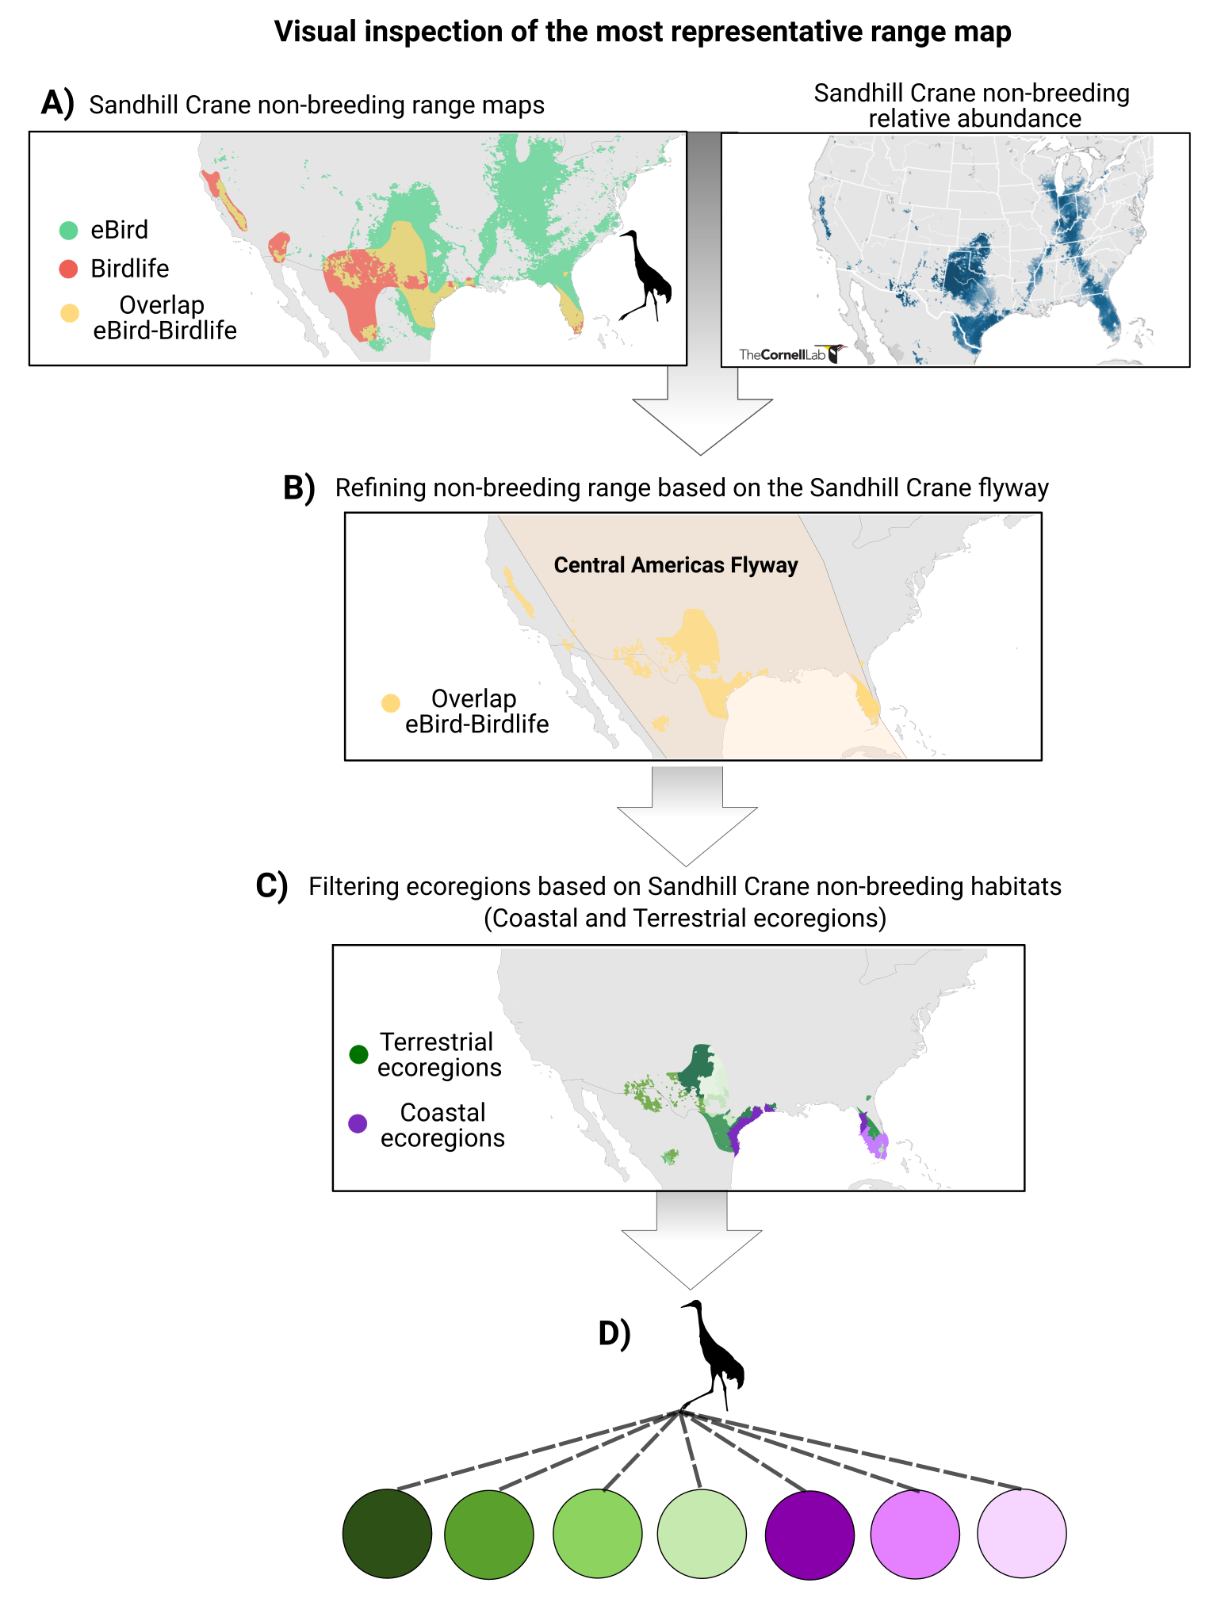
Figure S1. (A) Example of the visual inspection criteria to select the most representative non-breeding range data for sandhill crane. (B) Refinement of the selected non-breeding range map with the flyway used by sandhill crane from the study site population (i.e., Central Americas Flyway). (C) Refinement of the list of ecoregions associated with the sandhill crane population based on non-breeding habitat type. Based on the literature, we have assigned both terrestrial and coastal habitats to the sandhill crane population, which precludes association with marine ecoregions. (D) Bipartite representation of the migratory connections between the sandhill crane species node (crane icon) and the connected terrestrial ecoregions (green circles) and the coastal ecoregions (purple circles) used as non-breeding ground.

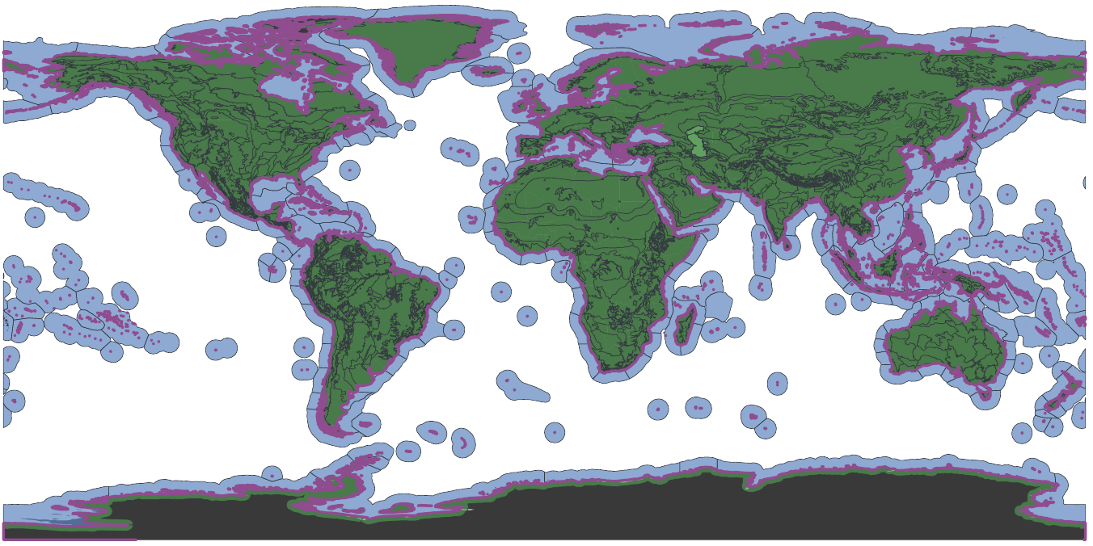
Figure S2. Map of the ecoregions of the world delineated by dark gray lines and colored by type: terrestrial ecoregions in green (adapted from Olson et al., 2001), marine ecoregions in blue (adapted from Spalding et al., 2007) and coastal ecoregions in purple (adapted from Spalding et al., 2007). Since coastal ecoregions are extremely narrow, the delineation between ecoregions is not showed on the map, but the delineation between coastal ecoregions was based on the marine ecoregions.

Validation of the non-breeding range refinement with the flyways(s) and the non-breeding habitat type(s)
To validate our non-breeding ranges refinement and filtering methods, we performed a preliminary validation analysis based on the highly specific tracking programs available as reference (n=6). We compared the proportion of ecoregions filtered from general range maps using the non-breeding range defined with tracking data (Figure S3).
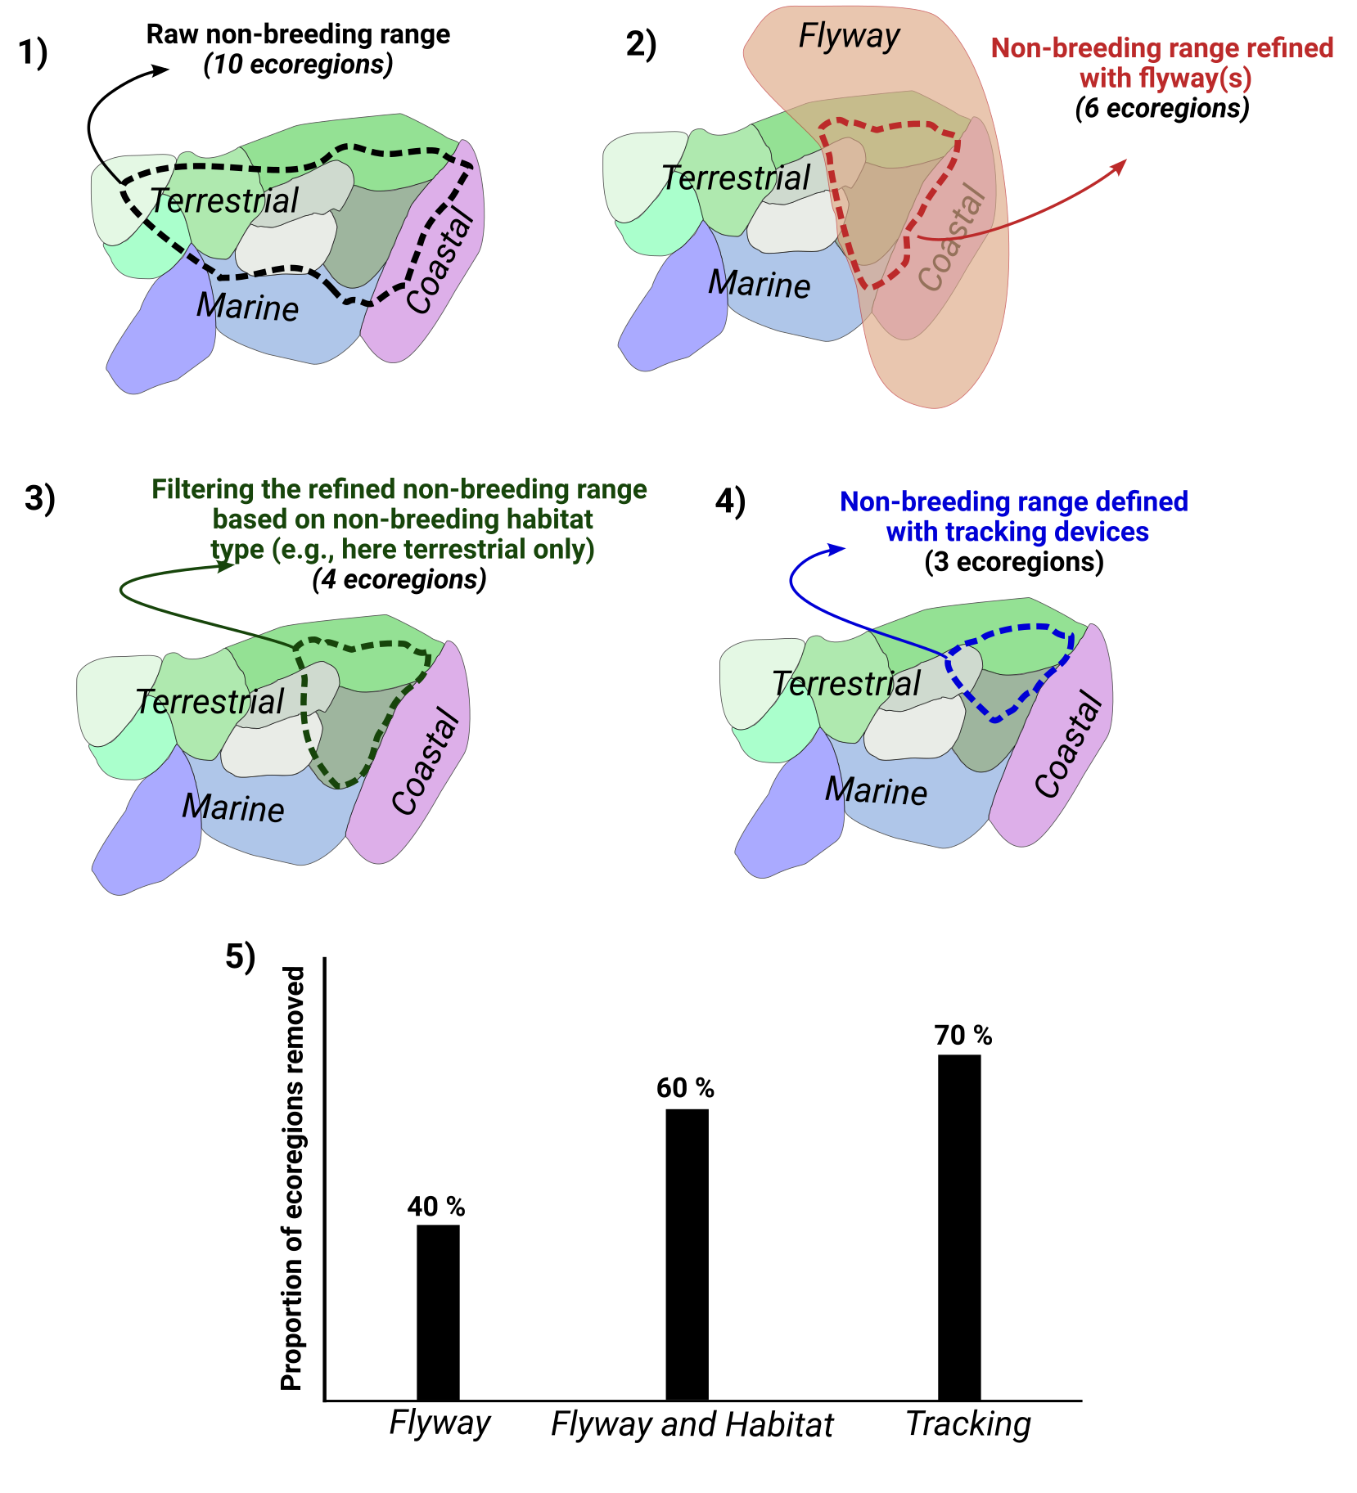
Figure S3. Fictive example of the refinement of a non-breeding range with flyway(s) and filtering with habitat type(s) to illustrate the method employed to calculate the proportion of ecoregions removed. (1) Number of ecoregions overlapping with the raw species non-breeding range maps. (2) Number of ecoregions associated with the non-breeding range map refined with the flyway(s) used by the individuals from the study site. (3) Number of ecoregions associated with the non-breeding range map refined with the flyway(s) used by the individuals from the study site and their habitat type(s). (4) Number of ecoregions associated with the non-breeding range map defined with accurate and specific tracking data. (5) Comparison of the efficiency of each type of filter (Flyway(s), Habitat and Flyway(s) and Tracking data) measured by the proportion of removed ecoregions from the raw non-breeding range.

Despite the relatively low sample size of our reference data set (n=6 species; American golden-plover, common-ringed plover, snowy owl, long-tailed jaeger, snow goose and king eider), the validation analysis suggests that the use of flyway(s) and non-breeding habitat type(s) allow the removal of a considerable number of ecoregions, but still tend to overestimate the number of associated ecoregions (Figure S4). The eBird sample size is smaller than the Birdlife sample size because species with Old World ranges are not part of the eBird data set. The use of flyway(s) was more effective in refining Birdlife range maps than eBird range maps because it allows the removal of areas in the Old World which are not included in eBird range maps. Flyway(s) and habitat type(s) appear to have an additive effect on the removal of irrelevant species-ecoregion association (higher proportion of ecoregions removed with flyway+habitat than flyway only or habitat only). The wide variation observed in the proportion of ecoregions removed by flyway(s) and habitat type(s) suggests that the effectiveness of ecological filters in refining species range maps depends on the species involved. This means that for some species, filters have removed a large proportion of ecoregions (often species with intercontinental or global distributions) and for other species, filters have practically no effect (species with more localized ranges). The high proportion of ecoregions removed by using specific data (tracking) highlights the need to consider ecological filters to refine non-breeding ranges when focusing on a local or regional community. Note that the higher sample size with Birdlife range maps is explained by the presence of some species only outside of the Americas, thus for which eBird data are not available yet.

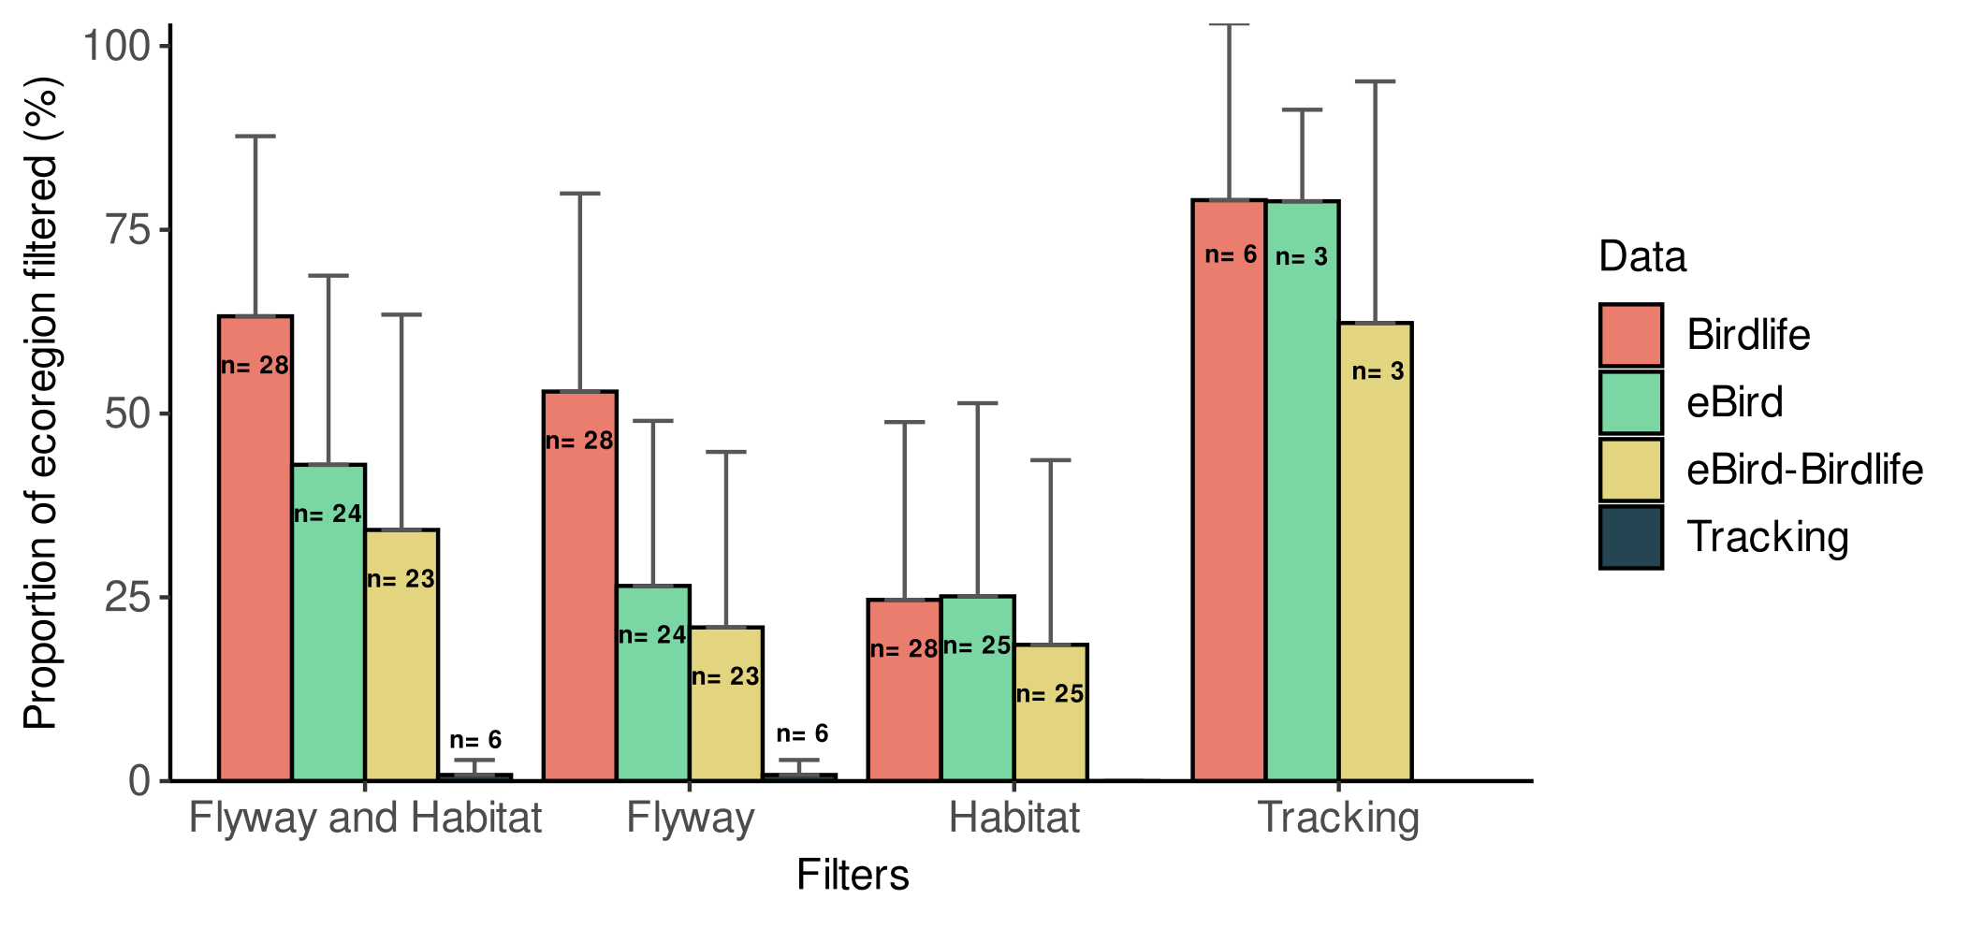
Figure S4. Mean proportion of ecoregion removed from the raw non-breeding range maps by the refinement with flyway(s) and the filtering with habitat type(s), the refinement with the flyway(s) only, the filtering with habitat type(s) only and the filtering with non-breeding ranges defined with tracking data. Error bars represent standard deviation and the sample size represents the number of species considered.

Table S1. Species of Bylot Island tundra food web and the non-breeding range map selected for migratory and partially migratory species based on the selection criteria used to retain the most representative non-breeding range data available.
Functional group | Species | Non-breeding  strategy | Range selected | Selection criteria
lemmings | collared lemming  (Dicrostonyx groenlandicus) | Resident | - | -
lemmings | brown lemming  (Lemmus trimucronatus) | Resident | - | -
hares | Arctic hare  (Lepus arcticus) | Resident | - | -
ptarmigans | rock ptarmigan  (Lagopus muta) | Resident | - | -
geese and swans | snow goose  (Anser caerulescens) | Migrant | Tracking | Legagneux et al., unpublished data
geese and swans | cackling goose  (Branta hutchinsii) | Migrant | eBird-Birdlife | Visual inspection of the overlap with the Ebird relative abundance map
geese and swans | tundra swan  (Cygnus columbianus) | Migrant | Birdlife | Visual inspection of the overlap with the Ebird relative abundance map
passerines | lapland longspur  (Calcarius lapponicus) | Migrant | eBird-Birdlife | Visual inspection of the overlap with the Ebird relative abundance map
passerines | horned lark  (Eremophila alpestris) | Migrant | eBird | Visual inspection of the overlap with the Ebird relative abundance map
passerines | snow bunting  (Plectrophenax nivalis) | Migrant | eBird-Birdlife | Visual inspection of the overlap with the Ebird relative abundance map
passerines | American pipit  (Anthus rubescens) | Migrant | eBird-Birdlife | Visual inspection of the overlap with the Ebird relative abundance map
shorebirds | American golden-plover  (Pluvialis dominica) | Migrant | Tracking | Lamarre, J. F., Gauthier, G., Lanctot, R. B., Saalfeld, S. T., Love, O. P., Reed, E., et al., (2021). Timing of Breeding Site Availability Across the North American Arctic Partly Determines Spring Migration Schedule in a Long-Distance Neotropical Migrant. Front. Ecol. Evol. 9, 710007. https://doi.org/10.3389/fevo.2021.710007
shorebirds | black-bellied plover  (Pluvialis squatarola) | Migrant | eBird | Ebird range falls inside the boundary of the Birdlife range
shorebirds | common-ringed plover  (Charadrius hiaticula) | Migrant | Tracking | Léandri-Breton, D.-J., Lamarre, J.-F., and Bêty, J. (2019). Seasonal variation in migration strategies used to cross ecological barriers in a nearctic migrant wintering in Africa. J. Avian Biol. 50, e02101. https://doi.org/10.1111/jav.02101
shorebirds | ruddy turnstone  (Arenaria interpres) | Migrant | Birdlife | Birdlife range encompass palearctic distribution
shorebirds | red phalarope  (Phalaropus fulicarius) | Migrant | Birdlife | Species found mostly in marine habitats during non-breeding
shorebirds | red knot  (Calidris canutus) | Migrant | Birdlife | Birdlife range encompass palearctic distribution
shorebirds | white-rumped sandpiper  (Calidris fuscicollis) | Migrant | eBird | Visual inspection of the overlap with the Ebird relative abundance map
shorebirds | buff-breasted sandpiper  (Calidris subruficollis) | Migrant | eBird | Visual inspection of the overlap with the Ebird relative abundance map
shorebirds | Baird's sandpiper  (Calidris bairdii) | Migrant | eBird | Ebird range falls inside the boundary of the Birdlife range
shorebirds | pectoral sandpiper  (Calidris melanotos) | Migrant | eBird | Ebird range falls inside the boundary of the Birdlife range
ducks and loons | king eider  (Somateria spectabilis) | Migrant | Tracking | Gilchrist, G., Mosbech, A., and Sonne, C. (2004). Data available on movebank.org, study name “Common/King Eiders; East Bay Island, Nunavut; Gilchrist/Mosbech/Sonne 2001 and 2003”, study ID 43747715).
ducks and loons | long-tailed duck  (Clangula hyemalis) | Migrant | Birdlife | Species found mostly in marine habitats during non-breeding
ducks and loons | pacific loon  (Gavia pacifica) | Migrant | Birdlife | Species found mostly in marine habitats during non-breeding
ducks and loons | red-throated loon  (Gavia stellata) | Migrant | Birdlife | Species found mostly in marine habitats during non-breeding
ermines | ermine  (Mustela erminea) | Resident | - | -
cranes | sandhill crane  (Antigone canadensis) | Migrant | eBird-Birdlife | Visual inspection of the overlap with the Ebird relative abundance map
jaegers | long-tailed jaeger  (Stercorarius longicaudus) | Migrant | Tracking | Seyer, Y., Gauthier, G., Bêty, J., Therrien, J.-F., and Lecomte, N. (2021). Seasonal variations in migration strategy of a long-distance Arctic-breeding seabird. Mar. Ecol. Prog. Ser. 677, 1-16. https://doi.org/10.3354/meps13905
jaegers | parasitic jaeger  (Stercorarius parasiticus) | Migrant | Birdlife | Species found mostly in marine habitats during non-breeding
gulls | glaucous gull  (Larus hyperboreus) | Migrant | Birdlife | Species found mostly in marine habitats during non-breeding
ravens | common raven  (Corvus corax) | Partial migrant | 100 km buffer | Approximate distance from the nearest landfill: Temple, S. A. (1974). Winter food habits of ravens on the Arctic Slope of Alaska. Arctic 27 41-46. https://doi.org/10.14430/arctic2851
raptors | peregrine falcon  (Falco peregrinus) | Migrant | eBird | Visual inspection of the overlap with the Ebird relative abundance map
raptors | rough-legged hawk  (Buteo lagopus) | Migrant | eBird | Visual inspection of the overlap with the Ebird relative abundance map
raptors | snowy owl  (Bubo scandiacus) | Migrant | Tracking and eBird | Robillard, A., Gauthier, G., Therrien, J.-F., and Bêty, J. (2018). Wintering space use and site fidelity in a nomadic species, the snowy owl. J. Avian Biol. 49, jav–01707. https://doi.org/10.1111/jav.01707
foxes | Arctic fox  (Vulpes lagopus) | Partial migrant | 500 km buffer | Lai, S., Bêty, J., and Berteaux, D. (2017). Movement tactics of a mobile predator in a meta‐ecosystem with fluctuating resources: the arctic fox in the High Arctic. Oikos 126, 937-947. https://doi.org/10.1111/oik.03948

Table S2. Seasonal migratory species of Bylot Island with their assigned global avian flyway(s) (geographical grouping of annual ranges of avian migratory species). The assignment of flyway(s) was based on the available literature.
Species | Subspecies | Flyway | Justification | Reference
American golden-plover | NA | Central Americas  Atlantic Americas | Individuals tracked from study site (n=19) | Lamarre, J. F., Gauthier, G., Lanctot, R. B., Saalfeld, S. T., Love, O. P., Reed, E., et al., (2021). Timing of Breeding Site Availability Across the North American Arctic Partly Determines Spring Migration Schedule in a Long-Distance Neotropical Migrant. Front. Ecol. Evol. 9, 710007. https://doi.org/10.3389/fevo.2021.710007
American pipit | A. r. rubescens | Central Americas  Atlantic Americas | Subspecies non-breeding range: "se. United States and ne. Mexico, with records south to Guatemala" | Hendricks, P., and Verbeek, N. A. (2020). "American Pipit (Anthus rubescens), version 1.0", in Birds of the World, ed. Billerman, S. M. Cornell Lab of Ornithology, Ithaca, NY, USA. https://doi.org/10.2173/bow.amepip.01 [Accessed July 2020]
Baird's sandpiper | NA | Central Americas  Pacific Americas | Annual range map | BirdLife International (2020). "Species factsheet: Calidris bairdii", in BirdLife Data Zone. http://datazone.birdlife.org [Accessed July 2020]
black-bellied plover | NA | Atlantic Americas | Indivuals tracked from the Eastern Arctic | Canadian Wildlife Service (2020). "Black-bellied Plover Tracking (Canada)", in Seaturtle.org Satellite Tracking Data Repository. http://www.seaturtle.org/tracking/?project_id=1020 [Accessed July 2020]
buff-breasted sandpiper | NA | Central Americas | Annual range map | Lanctot, R. B., Aldabe, J., Almeida, J. B., Blanco, D., Jorgensen, J., Rocca, P., et al. (2010). Conservation plan for the Buff-breasted Sandpiper (Tryngites subruficollis) Version 1.1. Manomet Center for Conservation Science, Manomet, Massachusetts, and U.S. Fish & Wildlife Service, Anchorage, Alaska.
cackling goose | B. h. hutchinsii | Central Americas | Subspecies non-breeding range: "south-central United States (chiefly Oklahoma and Texas) and south and northeastern Mexico (chiefly Tamaulipas)" | Mowbray, T. B., Ely, C. R., Sedinger J. S., and Trost, R. E. (2020). "Cackling Goose (Branta hutchinsii), version 1.0", in Birds of the World, ed. Rodewald, P. G., and Keeney, B. G. Cornell Lab of Ornithology, Ithaca, NY, USA. https://doi.org/10.2173/bow.cacgoo1.01 [Accessed July 2020]
common-ringed plover | NA | East Atlantic | Individuals tracked from study site (n=14) | Léandri-Breton, D.-J., Lamarre, J.-F., and Bêty, J. (2019). Seasonal variation in migration strategies used to cross ecological barriers in a nearctic migrant wintering in Africa. J. Avian Biol. 50, e02101. https://doi.org/10.1111/jav.02101
glaucous gull | L. h. leuceretes | Atlantic Americas | "winters south to the ne. United States, with some reaching south to Florida, east to Bermuda, and west to the Great Plains, e. New Mexico, and s. Texas" | Weiser, E. and Gilchrist, H. G. (2020). "Glaucous Gull (Larus hyperboreus), version 1.0" in Birds of the World, ed. Billerman, S. M. Cornell Lab of Ornithology, Ithaca, NY, USA. https://doi.org/10.2173/bow.glagul.01 [Accessed July 2020]
horned lark | E. a. hoyti | Central Americas  Atlantic Americas | "Subspecies non-breeding range: "Nevada to Michigan" | Beason, R. C. (2020). "Horned Lark (Eremophila alpestris), version 1.0" in Birds of the World, ed. Billerman, S. M. Cornell Lab of Ornithology, Ithaca, NY, USA. https://doi.org/10.2173/bow.horlar.01 [Accessed July 2020]
king eider | NA | East Atlantic | Individuals tracked from a subarctic Eastern Canadian Arctic breeding site (n=6) | Gilchrist, G., Mosbech, A., and Sonne, C. (2004). Data available on movebank.org, study name “Common/King Eiders; East Bay Island, Nunavut; Gilchrist/Mosbech/Sonne 2001 and 2003”, study ID 43747715).  Mosbech, A., and Boertmann, D. (1999). Distribution, relative abundance and reaction to aerial surveys of post-breeding king eiders (Somateria spectabilis) in western Greenland. Arctic 52, 188-203. https://doi.org/10.14430/arctic922
lapland longspur | C. l. subcalcaratus | Central Americas  Atlantic Americas | Subspecies non-breeding range: "e. North America west to Nebraska, Colorado, Oklahoma, and Texas" | Hussell, D. J. T., and Montgomerie, R. (2020). "Lapland Longspur (Calcarius lapponicus), version 1.0", in Birds of the World, ed. Billerman S. M., Keeney, B. K., Rodewald, P. G., and Schulenberg, T. S. Cornell Lab of Ornithology, Ithaca, NY, USA. https://doi.org/10.2173/bow.laplon.01 [Accessed July 2020]
long-tailed duck | NA | Atlantic Americas | Tracks of individuals from non-breeding sites | Sea Duck Joint Venture (2015). Atlantic and Great Lakes sea duck migration study: progress report June 2015.
long-tailed jaeger | S. l. pallescens | Atlantic Americas  East Atlantic | Individuals tracked from study site (n=50) | Seyer, Y., Gauthier, G., Bêty, J., Therrien, J.-F., and Lecomte, N. (2021). Seasonal variations in migration strategy of a long-distance Arctic-breeding seabird. Mar. Ecol. Prog. Ser. 677, 1-16. https://doi.org/10.3354/meps13905
pacific loon | NA | Pacific Americas | Species non-breeding range | Russell, R. W. (2020). "Pacific Loon (Gavia pacifica), version 1.0" in Birds of the World, ed. Rodewald, P. G. Cornell Lab of Ornithology, Ithaca, NY, USA. https://doi.org/10.2173/bow.pacloo.01 [Accessed July 2020]
parasitic jaeger | NA | Atlantic Americas  East Atlantic | "Widely distributed off both coasts of South America...Common near coasts of s. Africa from late Oct to early May, especially around the Benguela Current" | McCarty, J. P., L. L. Wolfenbarger, C. D. Laredo, P. Pyle, and R. B. Lanctot (2020). Buff-breasted Sandpiper (Calidris subruficollis), version 1.0. In Birds of the World (P. G. Rodewald, Editor). Cornell Lab of Ornithology, Ithaca, NY, USA. https://doi.org/10.2173/bow.bubsan.01
pectoral sandpiper | NA | Central Americas  Atlantic Americas  Pacific Americas | Annual range map | BirdLife International (2020). "Species factsheet: Calidris melanotos", in BirdLife Data Zone. http://www.birdlife.org [Accessed July 2020]
peregrine falcon | F. p. tundrius | Central Americas  Atlantic Americas  Pacific Americas | Individuals tracked from western Greenland | Burnham, K. K., Burnham, W.A., Newton, I., Johnson, J. A., and Gosler, A.G. (2012). The history and range expansion of peregrine falcons in the Thule Area, Northwest Greenland. Monographs on Greenland Bioscience. Museum Tusculanum Press
red knot | C. c. islandica  C. c. rufa | Atlantic Americas  East Atlantic | Study site is located in an overlap zone between the Atlantic Americas population and the East Atlantic population | Environment and Climate Change Canada (2017). Recovery Strategy and Management Plan for the Red Knot (Calidris canutus) in Canada. Ottawa.
red phalarope | NA | East Atlantic | "Most birds nesting in e. Canadian Arctic thought to winter off w. and sw. Africa (Brown 1986)" | Tracy, D. M., Schamel, D., and Dale, J. (2020). "Red Phalarope (Phalaropus fulicarius), version 1.0", in Birds of the World, ed. Billerman, S. M. Cornell Lab of Ornithology, Ithaca, NY, USA. https://doi.org/10.2173/bow.redpha1.01 [Accessed July 2020]
red-throated loon | NA | Atlantic Americas | Individuals tracked from non-breeding sites (n=31) | Spiegel, C.S., Berlin, A. M., Gilbert, A. T., Gray, C. O., Montevecchi, W.A., Stenhouse, I. J., et al. (2017). Determining Fine- scale Use and Movement Patterns of Diving Bird Species in Federal Waters of the Mid-Atlantic United States Using Satellite Telemetry. U.S. Department of the Interior, Bureau of Ocean Energy Management . OCS Study BOEM 2017-069.
rough-legged hawk | B. l. sanctijohannis | Central Americas  Atlantic Americas | Individuals tracked from study site (n=2) and other Arctic breeding sites | Paprocki, N. (n.d.). Year-round GPS movements of 77 Rough-legged Hawks .Idaho Cooperative Fish and Wildlife Research Unit. https://www.usgs.gov/media/images/year-round-gps-movements-77-rough-legged-hawks [Accessed July 2020]
ruddy turnstone | A. i. morinella  A. i. interpres | Atlantic Americas  East Atlantic | A. i. morinella: "Canadian arctic populations mainly migrate to and winter in Old World"  A. i. interpres: "Winters mainly from s. U.S. along Atlantic and Gulf coasts south around Caribbean Sea, West Indies, and along both coasts of South America" | Nettleship, D. N. (2020). "Ruddy Turnstone (Arenaria interpres), version 1.0", in Birds of the World, ed. Billerman, S. M. Cornell Lab of Ornithology, Ithaca, NY, USA. https://doi.org/10.2173/bow.rudtur.01 [Accessed July 2020]
sandhill crane | A. c. canadensis | Central Americas | Individuals tracked from non-breeding sites | Krapu, G. L., Brandt, D. A., Jones, K. L., and Johnson, D. H. (2011). Geographic distribution of the mid‐continent population of sandhill cranes and related management applications. Wildl. Monogr. 175, 1-38. https://doi.org/10.1002/wmon.1
snow bunting | P. n. nivalis | Central Americas  Atlantic Americas | Low Canadian Arctic populations are associated to the Central Americas Flyway and the populations from western Greenland are associated to the Altantic Americas Flyway | Macdonald, C. A., Fraser, K. C., Gilchrist, H. G., Kyser, T. K., Fox, J. W., and Love, O. P. (2012). Strong migratory connectivity in a declining Arctic passerine. Anim. Migr. 1, 23-30. https://doi.org/10.2478/ami-2012-0003
snow goose | A. c. atlanticus | Atlantic Americas | Individuals tracked from study site (n=12) | Legagneux et al., unpublished data
snowy owl | NA | Central Americas  Atlantic Americas | Individuals tracked from study site (n=12) | Robillard, A., Gauthier, G., Therrien, J.-F., and Bêty, J. (2018). Wintering space use and site fidelity in a nomadic species, the snowy owl. J. Avian Biol. 49, jav–01707. https://doi.org/10.1111/jav.01707
tundra swan | C. c. columbianus | Atlantic Americas | Individuals banded and encountered across North America | Ely, C. R., Sladen, W. J., Wilson, H. M., Savage, S. E., Sowl, K. M., Henry, B., et al. (2014). Delineation of Tundra Swan Cygnus c. columbianus populations in North America: geographic boundaries and interchange. Wildfowl 64, 132-147.
white-rumped sandpiper | NA | Central Americas  Atlantic Americas | Annual range map | BirdLife International (2020). "Species factsheet: Calidris fuscicollis", in BirdLife Data Zone. http://www.birdlife.org [Accessed July 2020]

Table S3. Seasonal and partially migratory species of Bylot Island with their assigned primary non-breeding habitat type(s). The assignment of the non-breeding habitat type(s) was based on the available literature.
Species | Habitat type | Justification | Reference
Arctic fox | Terrestrial  Marine  Coastal | Loop migration of several hundreads of kilometres in adjacent habitats | Lai, S., Bêty, J., and Berteaux, D. (2017). Movement tactics of a mobile predator in a meta‐ecosystem with fluctuating resources: the arctic fox in the High Arctic. Oikos 126, 937-947. https://doi.org/10.1111/oik.03948
rock ptarmigan | Terrestrial | "Shrubby areas and margins of lakes and rivers" | Montgomerie, R., and Holder, K. (2020). "Rock Ptarmigan (Lagopus muta), version 1.0", in Birds of the World, ed. Billerman, S. M., Keeney, B. K., Rodewald, P. G., and Schulenberg, T. S. Cornell Lab of Ornithology, Ithaca, NY, USA. https://doi.org/10.2173/bow.rocpta1.01
cackling goose | Terrestrial  Coastal | "Coastal areas, mudflats, shallow tidal waters, salt-water marshes, wet grasslands, freshwater marshes, lakes, reservoirs, rivers and agricultural fields" | Mowbray, T. B., Ely, C. R., Sedinger, J. S., and Trost, R. E. (2020). "Cackling Goose (Branta hutchinsii), version 1.0", in Birds of the World, ed. Rodewald, P G., and Keeney, B. K. Cornell Lab of Ornithology, Ithaca, NY, USA. https://doi.org/10.2173/bow.cacgoo1.01
snow goose | Terrestrial  Coastal | "Coastal areas, estuarine marshes, inlets, bays, shallow tidal waters, coastal freshwater, brackish marshes, wet grasslands, freshwater marshes, coastal prairies and cultivated fields" | Mowbray, T. B., Cooke, F., and Ganter, B. (2020). "Snow Goose (Anser caerulescens), version 1.0", in Birds of the World, ed. Rodewald, P. G. Cornell Lab of Ornithology, Ithaca, NY, USA. https://doi.org/10.2173/bow.snogoo.01
tundra swan | Terrestrial  Coastal | "Shallow estuarine tidal areas, freshwater lakes, ponds, rivers, agricultural fields and flooded pastures" | Limpert, R. J., Earnst, S. L., Carboneras, C., and Kirwan, G. M. (2020). "Tundra Swan (Cygnus columbianus), version 1.0", in Birds of the World, ed. Billerman, S. M. Cornell Lab of Ornithology, Ithaca, NY, USA. https://doi.org/10.2173/bow.tunswa.01
king eider | Marine  Coastal | "Southern edge of sea ice, polynyas in sea ice, coastal areas, shallow open waters, offshore waters" | Gerber, B. D., Dwyer, J. F., Nesbitt, S. A., Drewien, R. C., Littlefield, R. C., Tacha, T. C., and Vohs, P. A. (2020). "Sandhill Crane (Antigone canadensis), version 1.0", in Birds of the World, ed. Poole, A. F. Cornell Lab of Ornithology, Ithaca, NY, USA. https://doi.org/10.2173/bow.sancra.01
long-tailed duck | Terrestrial  Marine  Coastal | "Coastal marine waters, large freshwater lakes, with extensive sea ice, will use recurring polynyas and floe edges" | Robertson, G. J., and Savard, J.-P. L. (2020). "Long-tailed Duck (Clangula hyemalis), version 1.0", in Birds of the World, ed. Billerman, S. M. Cornell Lab of Ornithology, Ithaca, NY, USA. https://doi.org/10.2173/bow.lotduc.01
pacific loon | Marine | "Coastal water; nearshore open ocean, bays and estuaries" | Russell, R. W. (2020). "Pacific Loon (Gavia pacifica), version 1.0", in Birds of the World, ed. Rodewald, P G. Cornell Lab of Ornithology, Ithaca, NY, USA. https://doi.org/10.2173/bow.pacloo.01
red-throated loon | Terrestrial  Marine  Coastal | "Coastal upwellig, coastal estuaries, occasionally on large freshwater lakes and slow-moving rivers" | Rizzolo, D. J., Gray, C. E., Schmutz, J. A., Barr, J. F., Eberl, C., and McIntyre, J. W. (2020). "Red-throated Loon (Gavia stellata), version 2.0", in Birds of the World, ed. Rodewald, P. G., and Keeney, B. K. Cornell Lab of Ornithology, Ithaca, NY, USA. https://doi.org/10.2173/bow.retloo.02
snowy owl | Terrestrial  Marine  Coastal | "Snow-covered tundra, open water within the ice pack, rangelands, farmlands, coast lines, marshes, large forest clearings and cities and towns" | Holt, D. W., Larson, M. D., Smith, N., Evans, D. L., and Parmelee, D. F. (2020). "Snowy Owl (Bubo scandiacus), version 1.0", in Birds of the World, ed. Billerman, S. M. Cornell Lab of Ornithology, Ithaca, NY, USA. https://doi.org/10.2173/bow.snoowl1.01
rough-legged hawk | Terrestrial  Coastal | "Prairies, shrub-steppes, semideserts, open fields, marshlands, bogs, dunes and coastal areas" | Bechard, M. J., Swem, T. R., Orta, J., Boesman, P. F. D., Garcia, E. F. J., and Marks, J. S. (2020). "Rough-legged Hawk (Buteo lagopus), version 1.0", in Birds of the World, ed. Billerman, S. M. Cornell Lab of Ornithology, Ithaca, NY, USA. https://doi.org/10.2173/bow.rolhaw.01
peregrine falcon | Terrestrial  Coastal | "Extreme habitat variability: Open-relief, mangrove, coastal or wetland areas, major river valleys, lake shores, pasture lands and urban areas" | White, C. M., Clum, N. J., Cade, T. J., and Hunt, W. G. (2020). "Peregrine Falcon (Falco peregrinus), version 1.0", in Birds of the World, ed. Billerman, S. M. Cornell Lab of Ornithology, Ithaca, NY, USA. https://doi.org/10.2173/bow.perfal.01
parasitic jaeger | Marine  Coastal | "Near shore to beyond the edge of the continental shelf and in estuaries" | Wiley, R. H., and Lee, D. S. (2020). "Parasitic Jaeger (Stercorarius parasiticus), version 1.0", in Birds of the World, ed. Billerman, S. M. Cornell Lab of Ornithology, Ithaca, NY, USA. https://doi.org/10.2173/bow.parjae.01
long-tailed jaeger | Marine | "Pelagic" | Wiley, R. H., and Lee, D. S. (2020). "Long-tailed Jaeger (Stercorarius longicaudus), version 1.0", in Birds of the World, ed. Billerman, S. M. Cornell Lab of Ornithology, Ithaca, NY, USA. https://doi.org/10.2173/bow.lotjae.01
glaucous gull | Terrestrial  Marine  Coastal | "Maritime coasts, freshwater lakes, agricultural fields, urban areas, garbage dumps, polynyas and open water" | Weiser, E., and Gilchrist, H. G. (2020). "Glaucous Gull (Larus hyperboreus), version 1.0", in Birds of the World, ed. Billerman, S. M. Cornell Lab of Ornithology, Ithaca, NY, USA. https://doi.org/10.2173/bow.glagul.01
common raven | Terrestrial  Marine  Coastal | "Extreme habitat generalist: forested and open coastal, steppe, mountain, desert, tundra, Arctic ice floes, mountains and cliff" | Boarman, W. I., and Heinrich, B. (2020). "Common Raven (Corvus corax), version 1.0", in Birds of the World, ed. Billerman, S. M. Cornell Lab of Ornithology, Ithaca, NY, USA. https://doi.org/10.2173/bow.comrav.01
sandhill crane | Terrestrial  Coastal | "Shallow open water marshes, estuarine intertidal areas, wetland areas, croplands and pastures" | Gerber, B. D., Dwyer, J. F., Nesbitt, S. A., Drewien, R. C., Littlefield, C. D., Tacha, T. C., and Vohs, P. A. (2020). "Sandhill Crane (Antigone canadensis), version 1.0", in Birds of the World, ed. Poole, A. F. Cornell Lab of Ornithology, Ithaca, NY, USA. https://doi.org/10.2173/bow.sancra.01
American pipit | Terrestrial  Coastal | "Coastal beaches and marshes, stubble fields, recently-plowed fields, mud flats and river courses" | Hendricks, P., and Verbeek, N. A. (2020). "American Pipit (Anthus rubescens), version 1.0", in Birds of the World, ed. Billerman, S. M. Cornell Lab of Ornithology, Ithaca, NY, USA. https://doi.org/10.2173/bow.amepip.01
horned lark | Terrestrial  Coastal | "Open barren country, shortgrass prairies, deserts, brushy flats, alpine habitats, shrubsteppes, sandy beaches, sand dunes, steppes, agricultural areas, areas grazed by livestock" | Beason, R. C. (2020). "Horned Lark (Eremophila alpestris), version 1.0", in Birds of the World, ed. Billerman, S. M. Cornell Lab of Ornithology, Ithaca, NY, USA. https://doi.org/10.2173/bow.horlar.01
lapland longspur | Terrestrial | "Prairies, open weedy and grassy fields, grain stubbles, shores" | Hussell, D. J. T., and Montgomerie, R. (2020). "Lapland Longspur (Calcarius lapponicus), version 1.0", in Birds of the World, ed. Billerman, S. M., Keeney, B. K., Rodewald, P. G., and Schulenberg, T. S. Cornell Lab of Ornithology, Ithaca, NY, USA. https://doi.org/10.2173/bow.laplon.01
snow bunting | Terrestrial  Coastal | "Open weedy and grassy fields, grain stubbles, shores of lakes and rivers, farmyards, shingle beaches, salt marshes, sand dunes, tidelines, coastal lowlands" | Montgomerie, R., and Lyon, B. (2020). "Snow Bunting (Plectrophenax nivalis), version 1.0", in Birds of the World, ed. Billerman, S. M., Keeney, B. K., Rodewald, P. G., and Schulenberg, T. S. Cornell Lab of Ornithology, Ithaca, NY, USA. https://doi.org/10.2173/bow.snobun.01
American golden-plover | Terrestrial  Coastal | "Grasslands, coastal wetlands and tidal areas" | Johnson, O. W., Connors, P. G., and Pyle, P. (2021). "American Golden-Plover (Pluvialis dominica), version 1.1", in Birds of the World, ed. Rodewald, P. G., Keeney, B. K., and Billerman, S. M. Cornell Lab of Ornithology, Ithaca, NY, USA. https://doi.org/10.2173/bow.amgplo.01.1
black-bellied plover | Coastal | "Coastal beaches and estuaries, flooded pastures and agricultural land near sea and bays, salt marshes, mangrove" | Poole, A. F., Pyle, P., Patten, M. A., and Paulson, D. R. (2020). "Black-bellied Plover (Pluvialis squatarola), version 1.0", in Birds of the World, ed. Billerman, S. M. Cornell Lab of Ornithology, Ithaca, NY, USA. https://doi.org/10.2173/bow.bkbplo.01
common-ringed plover | Coastal  Terrestrial | "Beaches, sandbanks, mudflats, estuaries, rivers, lakes, lagoons, saltmarshes, grassland, flooded fields and artificial habitats (gravel pits, reservoirs, farmland and playing fields)" | Wiersma, P., Kirwan, G. M., and Boesman, P. F. D. (2020). "Common Ringed Plover (Charadrius hiaticula), version 1.0", in Birds of the World, ed. del Hoyo, J., Elliott, A., Sargatal, J., Christie, D. A., and de Juana, E. Cornell Lab of Ornithology, Ithaca, NY, USA. https://doi.org/10.2173/bow.corplo.01
ruddy turnstone | Coastal | "Almost exclusively coastal, shorelines, mudflats, sandflats and delta" | Nettleship, D. N. (2020). "Ruddy Turnstone (Arenaria interpres), version 1.0", in Birds of the World, ed. Billerman, S. M. Cornell Lab of Ornithology, Ithaca, NY, USA. https://doi.org/10.2173/bow.rudtur.01
red phalarope | Marine | "Pelagic" | Tracy, D. M., Schamel, D., and Dale, J. (2020). "Red Phalarope (Phalaropus fulicarius), version 1.0", in Birds of the World, ed. Billerman, S. M. Cornell Lab of Ornithology, Ithaca, NY, USA. https://doi.org/10.2173/bow.redpha1.01
red knot | Coastal | "Sandy beaches, peat banks, salt marshes, brackish lagoons, tidal mudflats, mangroves, sandflats" | Baker, A., Gonzalez, P., Morrison, R. I. G., and Harrington, B. A. (2020). "Red Knot (Calidris canutus), version 1.0", in Birds of the World, ed. Billerman, S. M. Cornell Lab of Ornithology, Ithaca, NY, USA. https://doi.org/10.2173/bow.redkno.01
white-rumped sandpiper | Terrestrial  Coastal | "Beaches, river banks, open fields, marshes, intertidal areas, saltmarsh/slough, stream and canal, pond/lagoon edge, flooded field" | Parmelee, D. F. (2020). "White-rumped Sandpiper (Calidris fuscicollis), version 1.0", in Birds of the World, Poole, A. F., Stettenheim, P. R., and Gill, F. B. Cornell Lab of Ornithology, Ithaca, NY, USA. https://doi.org/10.2173/bow.whrsan.01
buff-breasted sandpiper | Terrestrial  Coastal | "Grasslands in the coastal portions of the Río de La Plata Grasslands, the eastern portion of the Flooding Pampa of Argentina, and areas adjacent to lagoon complexes" | McCarty, J. P., Wolfenbarger, L. L., Laredo, C. D., Pyle, P., and Lanctot, R. B. (2020). "Buff-breasted Sandpiper (Calidris subruficollis), version 1.0", in Birds of the World, ed. Rodewald, P. G. Cornell Lab of Ornithology, Ithaca, NY, USA. https://doi.org/10.2173/bow.bubsan.01
Baird's sandpiper | Terrestrial | "Habitats about 2,550-4,500 m elevation, dry areas with short vegetation, strongly grazed shore meadows with muddy, partly dry ponds, short-grass plains and slopes" | Moskoff, W., and Montgomerie, R. (2020). "Baird's Sandpiper (Calidris bairdii), version 1.0", in Birds of the World, ed. Poole, A. F., and Gill, F. B. Cornell Lab of Ornithology, Ithaca, NY, USA. https://doi.org/10.2173/bow.baisan.01
pectoral sandpiper | Terrestrial | "Grasslands, marshy areas and wetlands, rarely tidal" | Farmer, A., Holmes, R. T., and Pitelka, F. A. (2020). "Pectoral Sandpiper (Calidris melanotos), version 1.0", in Birds of the World, ed. Billerman, S. Cornell Lab of Ornithology, Ithaca, NY, USA. https://doi.org/10.2173/bow.pecsan.012.

Network analysis

Modularity analysis
The modularity analysis was performed with the package infomapecology based on network flow (Farage et al., 2021), representing the flow of migratory individuals between the focal community and non-breeding regions. The infomap algorithm is based on an iterative process of random walks (paths from node to node) to optimize the partition of nodes into groups (modules) with the minimum amount of information possible (Farage et al., 2021). A partition represents a specific organization of nodes into sub-groups (modules). At each iteration, the nodes are partitioned into modules, then the algorithm goes from node to node and applies an information cost and an additional cost for changing modules. Afterward, it calculates an index of the quality of the partition based on an objective function. In the next iteration, the algorithm proposes a slightly different partition and repeats the same walk, and so on, until reaching the optimal partition (i.e., the minimum index value).

Supplementary Results
Figure S5. Degree distributions (i.e., number of links) of the nodes representing species in the Bylot Island community (A) and the nodes representing ecoregions used as non-breeding grounds by the migratory and partially migratory species from Bylot Island (B).
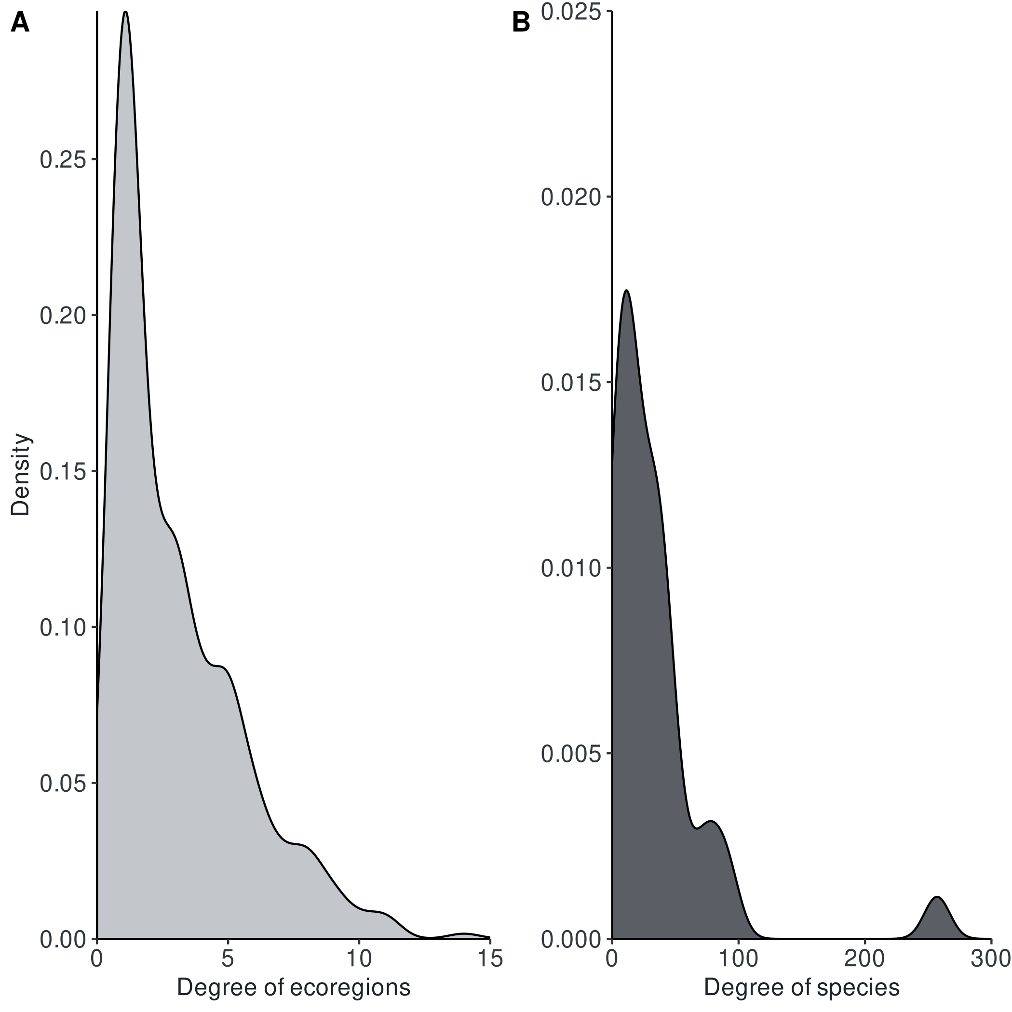

Table S4. List of the 393 ecoregions used as non-breeding grounds by the migratory and partially migratory species from Bylot Island and their assigned module in the community migration network determined by the infomap algorithm.
Ecoregions | Type | Module
Coastal Baffin Bay - Davis Strait | coastal | 1
Coastal High Arctic Archipelago | coastal | 1
Coastal Lancaster Sound | coastal | 1
Baffin Bay - Davis Strait | marine | 1
High Arctic Archipelago | marine | 1
Lancaster Sound | marine | 1
Baffin coastal tundra | terrestrial | 1
Davis Highlands tundra | terrestrial | 1
High Arctic tundra | terrestrial | 1
Rock and Ice | terrestrial | 1
Coastal Carolinian | coastal | 2
Coastal Gulf of Alaska | coastal | 2
Coastal Gulf of Maine/Bay of Fundy | coastal | 2
Coastal Gulf of St. Lawrence - Eastern Scotian Shelf | coastal | 2
Coastal Hudson Complex | coastal | 2
Coastal Northern Grand Banks - Southern Labrador | coastal | 2
Coastal Oregon, Washington, Vancouver Coast and Shelf | coastal | 2
Coastal Puget Trough/Georgia Basin | coastal | 2
Coastal Scotian Shelf | coastal | 2
Coastal Southern Grand Banks - South Newfoundland | coastal | 2
Coastal Southern Gulf of Mexico | coastal | 2
Coastal Virginian | coastal | 2
Mesoamerican Gulf-Caribbean mangroves | coastal | 2
Bahamian | marine | 2
Carolinian | marine | 2
Floridian | marine | 2
Gulf of Maine/Bay of Fundy | marine | 2
Gulf of St. Lawrence - Eastern Scotian Shelf | marine | 2
Hudson Complex | marine | 2
North Greenland | marine | 2
Northern Grand Banks - Southern Labrador | marine | 2
Scotian Shelf | marine | 2
Southern Grand Banks - South Newfoundland | marine | 2
Virginian | marine | 2
Alaska-St. Elias Range tundra | terrestrial | 2
Alberta Mountain forests | terrestrial | 2
Alberta-British Columbia foothills forests | terrestrial | 2
Allegheny Highlands forests | terrestrial | 2
Appalachian mixed mesophytic forests | terrestrial | 2
Appalachian-Blue Ridge forests | terrestrial | 2
Arizona Mountains forests | terrestrial | 2
Atlantic coastal pine barrens | terrestrial | 2
Bajío dry forests | terrestrial | 2
Balsas dry forests | terrestrial | 2
Blue Mountains forests | terrestrial | 2
British Columbia mainland coastal forests | terrestrial | 2
Canadian Aspen forests and parklands | terrestrial | 2
Cascade Mountains leeward forests | terrestrial | 2
Central and Southern Cascades forests | terrestrial | 2
Central and Southern mixed grasslands | terrestrial | 2
Central British Columbia Mountain forests | terrestrial | 2
Central Canadian Shield forests | terrestrial | 2
Central forest-grasslands transition | terrestrial | 2
Central Mexican matorral | terrestrial | 2
Central Pacific coastal forests | terrestrial | 2
Central tall grasslands | terrestrial | 2
Central U.S. hardwood forests | terrestrial | 2
Chihuahuan desert | terrestrial | 2
Colorado Plateau shrublands | terrestrial | 2
Colorado Rockies forests | terrestrial | 2
East Central Texas forests | terrestrial | 2
Eastern Canadian forests | terrestrial | 2
Eastern Canadian Shield taiga | terrestrial | 2
Eastern Cascades forests | terrestrial | 2
Eastern forest-boreal transition | terrestrial | 2
Eastern Great Lakes lowland forests | terrestrial | 2
Edwards Plateau savanna | terrestrial | 2
English - Winnipeg Lakes | terrestrial | 2
Everglades | terrestrial | 2
Flint Hills tall grasslands | terrestrial | 2
Florida sand pine scrub | terrestrial | 2
Fraser Plateau and Basin complex | terrestrial | 2
Great Basin montane forests | terrestrial | 2
Great Basin shrub steppe | terrestrial | 2
Gulf of St. Lawrence lowland forests | terrestrial | 2
Lake | terrestrial | 2
Laurentian Great Lakes | terrestrial | 2
Low Arctic tundra | terrestrial | 2
Meseta Central matorral | terrestrial | 2
Mid-Continental Canadian forests | terrestrial | 2
Middle Arctic tundra | terrestrial | 2
Middle Atlantic coastal forests | terrestrial | 2
Midwestern Canadian Shield forests | terrestrial | 2
Mississippi lowland forests | terrestrial | 2
Mojave desert | terrestrial | 2
Montana Valley and Foothill grasslands | terrestrial | 2
Muskwa-Slave Lake forests | terrestrial | 2
Nebraska Sand Hills mixed grasslands | terrestrial | 2
New England-Acadian forests | terrestrial | 2
Newfoundland Highland forests | terrestrial | 2
North Central Rockies forests | terrestrial | 2
Northeastern coastal forests | terrestrial | 2
Northern Canadian Shield taiga | terrestrial | 2
Northern Cordillera forests | terrestrial | 2
Northern mixed grasslands | terrestrial | 2
Northern Pacific coastal forests | terrestrial | 2
Northern short grasslands | terrestrial | 2
Northern tall grasslands | terrestrial | 2
Northern transitional alpine forests | terrestrial | 2
Okanagan dry forests | terrestrial | 2
Ozark Mountain forests | terrestrial | 2
Pacific Coastal Mountain icefields and tundra | terrestrial | 2
Palouse grasslands | terrestrial | 2
Piney Woods forests | terrestrial | 2
Puget lowland forests | terrestrial | 2
Sierra Madre de Oaxaca pine-oak forests | terrestrial | 2
Sierra Madre del Sur pine-oak forests | terrestrial | 2
Sierra Madre Occidental pine-oak forests | terrestrial | 2
Sierra Madre Oriental pine-oak forests | terrestrial | 2
Snake-Columbia shrub steppe | terrestrial | 2
Sonoran desert | terrestrial | 2
Sonoran-Sinaloan transition subtropical dry forest | terrestrial | 2
South Avalon-Burin oceanic barrens | terrestrial | 2
South Central Rockies forests | terrestrial | 2
South Florida rocklands | terrestrial | 2
Southeastern conifer forests | terrestrial | 2
Southeastern mixed forests | terrestrial | 2
Southern Great Lakes forests | terrestrial | 2
Southern Hudson Bay | terrestrial | 2
Southern Hudson Bay taiga | terrestrial | 2
St.Lawrence | terrestrial | 2
Tamaulipan matorral | terrestrial | 2
Tamaulipan mezquital | terrestrial | 2
Tehuacán Valley matorral | terrestrial | 2
Texas blackland prairies | terrestrial | 2
Torngat Mountain tundra | terrestrial | 2
Trans-Mexican Volcanic Belt pine-oak forests | terrestrial | 2
Upper Midwest forest-savanna transition | terrestrial | 2
Veracruz moist forests | terrestrial | 2
Wasatch and Uinta montane forests | terrestrial | 2
Western Great Lakes forests | terrestrial | 2
Western Gulf coastal grasslands | terrestrial | 2
Western short grasslands | terrestrial | 2
Willamette Valley forests | terrestrial | 2
Wyoming Basin shrub steppe | terrestrial | 2
Yukon Interior dry forests | terrestrial | 2
Coastal Araucanian | coastal | 3
Coastal Central Chile | coastal | 3
Coastal Central Peru | coastal | 3
Coastal Chiapas-Nicaragua | coastal | 3
Coastal Chiloense | coastal | 3
Coastal Cortezian | coastal | 3
Coastal Guayaquil | coastal | 3
Coastal Humboldtian | coastal | 3
Coastal Magdalena Transition | coastal | 3
Coastal Mexican Tropical Pacific | coastal | 3
Coastal Nicoya | coastal | 3
Coastal North American Pacific Fijordland | coastal | 3
Coastal Northern California | coastal | 3
Coastal Panama Bight | coastal | 3
Coastal Southern California Bight | coastal | 3
Coastal Southwestern Caribbean | coastal | 3
Coastal Western Caribbean | coastal | 3
Northern Mesoamerican Pacific mangroves | coastal | 3
South American Pacific mangroves | coastal | 3
Southern Mesoamerican Pacific mangroves | coastal | 3
Apure-Villavicencio dry forests | terrestrial | 3
Araya and Paria xeric scrub | terrestrial | 3
Atlantic dry forests | terrestrial | 3
Bahamian pine mosaic | terrestrial | 3
Bahia interior forests | terrestrial | 3
Baja California desert | terrestrial | 3
Belizian pine forests | terrestrial | 3
California Central Valley grasslands | terrestrial | 3
California coastal sage and chaparral | terrestrial | 3
California interior chaparral and woodlands | terrestrial | 3
California montane chaparral and woodlands | terrestrial | 3
Campos Rupestres montane savanna | terrestrial | 3
Catatumbo moist forests | terrestrial | 3
Cauca Valley dry forests | terrestrial | 3
Cauca Valley montane forests | terrestrial | 3
Central American Atlantic moist forests | terrestrial | 3
Central American dry forests | terrestrial | 3
Central American montane forests | terrestrial | 3
Central American pine-oak forests | terrestrial | 3
Chiapas Depression dry forests | terrestrial | 3
Chiapas montane forests | terrestrial | 3
Chimalapas montane forests | terrestrial | 3
Chocó-Darién moist forests | terrestrial | 3
Cordillera La Costa montane forests | terrestrial | 3
Cordillera Oriental montane forests | terrestrial | 3
Costa Rican seasonal moist forests | terrestrial | 3
Cuban cactus scrub | terrestrial | 3
Cuban dry forests | terrestrial | 3
Cuban moist forests | terrestrial | 3
Cuban pine forests | terrestrial | 3
Cuban wetlands | terrestrial | 3
Eastern Panamanian montane forests | terrestrial | 3
Enriquillo wetlands | terrestrial | 3
Guajira-Barranquilla xeric scrub | terrestrial | 3
Guayaquil flooded grasslands | terrestrial | 3
Guianan freshwater swamp forests | terrestrial | 3
Guianan Highlands moist forests | terrestrial | 3
Guianan moist forests | terrestrial | 3
Guianan piedmont and lowland moist forests | terrestrial | 3
Guianan savanna | terrestrial | 3
Gulf of California xeric scrub | terrestrial | 3
Gurupa varzeá | terrestrial | 3
Hispaniolan dry forests | terrestrial | 3
Hispaniolan moist forests | terrestrial | 3
Hispaniolan pine forests | terrestrial | 3
Iquitos varzeá | terrestrial | 3
Isthmian-Atlantic moist forests | terrestrial | 3
Isthmian-Pacific moist forests | terrestrial | 3
Jalisco dry forests | terrestrial | 3
Jamaican dry forests | terrestrial | 3
Jamaican moist forests | terrestrial | 3
Klamath-Siskiyou forests | terrestrial | 3
La Costa xeric shrublands | terrestrial | 3
Lara-Falcón dry forests | terrestrial | 3
Leeward Islands moist forests | terrestrial | 3
Lesser Antillean dry forests | terrestrial | 3
Llanos | terrestrial | 3
Magdalena Valley dry forests | terrestrial | 3
Magdalena Valley montane forests | terrestrial | 3
Magdalena-Urabá moist forests | terrestrial | 3
Maracaibo dry forests | terrestrial | 3
Marajó varzeá | terrestrial | 3
Maranhão Babaçu forests | terrestrial | 3
Miskito pine forests | terrestrial | 3
Motagua Valley thornscrub | terrestrial | 3
Napo moist forests | terrestrial | 3
Northeastern Brazil restingas | terrestrial | 3
Northern California coastal forests | terrestrial | 3
Oaxacan montane forests | terrestrial | 3
Orinoco Delta swamp forests | terrestrial | 3
Orinoco wetlands | terrestrial | 3
Panamanian dry forests | terrestrial | 3
Pantanos de Centla | terrestrial | 3
Paraguana xeric scrub | terrestrial | 3
Petén-Veracruz moist forests | terrestrial | 3
Puerto Rican dry forests | terrestrial | 3
Puerto Rican moist forests | terrestrial | 3
Purus varzeá | terrestrial | 3
Rio Negro campinarana | terrestrial | 3
San Lucan xeric scrub | terrestrial | 3
Santa Marta montane forests | terrestrial | 3
Sierra de la Laguna dry forests | terrestrial | 3
Sierra de la Laguna pine-oak forests | terrestrial | 3
Sierra de los Tuxtlas | terrestrial | 3
Sierra Madre de Chiapas moist forests | terrestrial | 3
Sierra Nevada forests | terrestrial | 3
Sinaloan dry forests | terrestrial | 3
Sinú Valley dry forests | terrestrial | 3
Solimões-Japurá moist forests | terrestrial | 3
Southern Pacific dry forests | terrestrial | 3
Talamancan montane forests | terrestrial | 3
Tapajós-Xingu moist forests | terrestrial | 3
Tocantins/Pindare moist forests | terrestrial | 3
Trinidad and Tobago moist forests | terrestrial | 3
Tumbes-Piura dry forests | terrestrial | 3
Uatuma-Trombetas moist forests | terrestrial | 3
Veracruz dry forests | terrestrial | 3
Veracruz montane forests | terrestrial | 3
Xingu-Tocantins-Araguaia moist forests | terrestrial | 3
Yucatán dry forests | terrestrial | 3
Yucatán moist forests | terrestrial | 3
Amazon-Orinoco-Southern Caribbean mangroves | coastal | 4
Bahamian-Antillean mangroves | coastal | 4
Central African mangroves | coastal | 4
Coastal Agulhas Bank | coastal | 4
Coastal Alboran Sea | coastal | 4
Coastal Amazonia | coastal | 4
Coastal Angolan | coastal | 4
Coastal Azores Canaries Madeira | coastal | 4
Coastal Bahamian | coastal | 4
Coastal Cape Verde | coastal | 4
Coastal Celtic Seas | coastal | 4
Coastal Channels and Fjords of Southern Chile | coastal | 4
Coastal Eastern Brazil | coastal | 4
Coastal Eastern Caribbean | coastal | 4
Coastal Faroe Plateau | coastal | 4
Coastal Floridian | coastal | 4
Coastal Greater Antilles | coastal | 4
Coastal Guianan | coastal | 4
Coastal Gulf of Guinea Central | coastal | 4
Coastal Gulf of Guinea Islands | coastal | 4
Coastal Gulf of Guinea South | coastal | 4
Coastal Gulf of Guinea Upwelling | coastal | 4
Coastal Gulf of Guinea West | coastal | 4
Coastal Namaqua | coastal | 4
Coastal Namib | coastal | 4
Coastal North and East Iceland | coastal | 4
Coastal North Patagonian Gulfs | coastal | 4
Coastal North Sea | coastal | 4
Coastal Northeastern Brazil | coastal | 4
Coastal Northern Gulf of Mexico | coastal | 4
Coastal Patagonian Shelf | coastal | 4
Coastal Rio de la Plata | coastal | 4
Coastal Saharan Upwelling | coastal | 4
Coastal Sahelian Upwelling | coastal | 4
Coastal South and West Iceland | coastal | 4
Coastal South European Atlantic Shelf | coastal | 4
Coastal Southeastern Brazil | coastal | 4
Coastal Southern Caribbean | coastal | 4
Coastal Southern Norway | coastal | 4
Coastal Uruguay-Buenos Aires Shelf | coastal | 4
Guinean mangroves | coastal | 4
Southern Atlantic mangroves | coastal | 4
Channels and Fjords of Southern Chile | marine | 4
Malvinas/Falklands | marine | 4
North Patagonian Gulfs | marine | 4
Northeastern Brazil | marine | 4
Patagonian Shelf | marine | 4
Rio de la Plata | marine | 4
Southern Caribbean | marine | 4
Coastal Malvinas/Falklands | coastal | 5
Coastal Rio Grande | coastal | 5
Alto Paraná Atlantic forests | terrestrial | 5
Araucaria moist forests | terrestrial | 5
Atacama desert | terrestrial | 5
Atlantic Coast restingas | terrestrial | 5
Beni savanna | terrestrial | 5
Bolivian montane dry forests | terrestrial | 5
Bolivian Yungas | terrestrial | 5
Caribbean shrublands | terrestrial | 5
Central Andean dry puna | terrestrial | 5
Central Andean puna | terrestrial | 5
Central Andean wet puna | terrestrial | 5
Cerrado | terrestrial | 5
Chilean matorral | terrestrial | 5
Chiquitano dry forests | terrestrial | 5
Dry Chaco | terrestrial | 5
Eastern Cordillera real montane forests | terrestrial | 5
Ecuadorian dry forests | terrestrial | 5
Espinal | terrestrial | 5
High Monte | terrestrial | 5
Humid Chaco | terrestrial | 5
Humid Pampas | terrestrial | 5
Low Monte | terrestrial | 5
Madeira-Tapajós moist forests | terrestrial | 5
Magellanic subpolar forests | terrestrial | 5
Northern Andean páramo | terrestrial | 5
Northwestern Andean montane forests | terrestrial | 5
Pantanal | terrestrial | 5
Paraná flooded savanna | terrestrial | 5
Patagonian steppe | terrestrial | 5
Peruvian Yungas | terrestrial | 5
Sechura desert | terrestrial | 5
Serra do Mar coastal forests | terrestrial | 5
Southern Andean steppe | terrestrial | 5
Southern Andean Yungas | terrestrial | 5
Southern Cone Mesopotamian savanna | terrestrial | 5
Southwest Amazon moist forests | terrestrial | 5
Titicaca | terrestrial | 5
Uruguayan savanna | terrestrial | 5
Valdivian temperate forests | terrestrial | 5
Western Ecuador moist forests | terrestrial | 5
Agulhas Bank | marine | 6
Amazonia | marine | 6
Angolan | marine | 6
Azores Canaries Madeira | marine | 6
Cape Verde | marine | 6
Guianan | marine | 6
Gulf of Guinea Central | marine | 6
Gulf of Guinea Islands | marine | 6
Gulf of Guinea South | marine | 6
Gulf of Guinea Upwelling | marine | 6
Gulf of Guinea West | marine | 6
Namaqua | marine | 6
Namib | marine | 6
Natal | marine | 6
Rio Grande | marine | 6
Saharan Upwelling | marine | 6
Sahelian Upwelling | marine | 6
Sao Pedro and Sao Paulo Islands | marine | 6
Southeastern Brazil | marine | 6
Uruguay-Buenos Aires Shelf | marine | 6
Atlantic coastal desert | terrestrial | 7
Guinean forest-savanna mosaic | terrestrial | 7
Mediterranean acacia-argania dry woodlands and succulent thickets | terrestrial | 7
Mediterranean conifer and mixed forests | terrestrial | 7
Mediterranean dry woodlands and steppe | terrestrial | 7
Mediterranean High Atlas juniper steppe | terrestrial | 7
Mediterranean woodlands and forests | terrestrial | 7
North Saharan steppe and woodlands | terrestrial | 7
Saharan halophytics | terrestrial | 7
Sahelian Acacia savanna | terrestrial | 7
West Sudanian savanna | terrestrial | 7
Coastal East Greenland Shelf | coastal | 8
Coastal Northern Labrador | coastal | 8
Coastal West Greenland Shelf | coastal | 8
East Greenland Shelf | marine | 8
Northern Labrador | marine | 8
West Greenland Shelf | marine | 8
Cortezian | marine | 9
Gulf of Alaska | marine | 9
Magdalena Transition | marine | 9
North American Pacific Fijordland | marine | 9
Northern California | marine | 9
Oregon, Washington, Vancouver Coast and Shelf | marine | 9
Puget Trough/Georgia Basin | marine | 9
Southern California Bight | marine | 9

References
Abell, R., Thieme, M., Revenga, C., Bryer, M., Kottelat, M., Bogutskaya, N. et al., (2008). Freshwater ecoregions of the world: A new map of biogeographic units for freshwater biodiversity conservation. BioScience 58, 403-414. https://doi.org/10.1641/B580507
Billerman, S. M., Keeney, B. K., Rodewald, P. G., and Schulenberg, T. S. (2021). Birds of the World. Cornell Laboratory of Ornithology, Ithaca, NY, USA. https://birdsoftheworld.org/bow/home [Accessed August 2021].
Calenge, C. (2006). The package adehabitat for the R software: a tool for the analysis of space and habitat use by animals. Ecol. Model. 197, 516-519. https://doi.org/10.1016/j.ecolmodel.2006.03.017
Duchesne, É., Lamarre, J-F., Gauthier, G., Berteaux, D., Gravel, D., and Bêty, J. (2021). Variable strength of predator-mediated effects on species occurrence in an arctic terrestrial vertebrate community. Ecography 44, 1236-1248. https://doi.org/10.1111/ecog.05760
Duong, T. (2007). ks: Kernel density estimation and kernel discriminant analysis for multivariate data in R. J. Stat. Softw. 21, 1-16. https://doi.org/10.18637/jss.v021.i07
Farage, C., Edler, D., Eklöf, A., Rosvall, M., and Pilosof, S. (2021). Identifying flow modules in ecological networks using infomap. Methods Ecol. Evol. 12, 778–786. https://doi.org/10.1111/2041-210X.13569
Fink, D., Auer, T., Johnston, A., Ruiz‐Gutierrez, V., Hochachka, W. M., and Kelling, S. (2020b). Modeling avian full annual cycle distribution and population trends with citizen science data. Ecol. Appl. 30, e02056. https://doi.org/10.1002/eap.2056
Fink, D., Auer, T., Johnston, A., Strimas-Mackey, M., Robinson, O., Ligocki, S., et al. Data from: eBird Status and Trends, Data Version: 2019; Released: 2020. Cornell Lab of Ornithology, Ithaca, New York. (2020a) https://doi.org/10.2173/ebirdst.2020
Gilchrist, G., Mosbech, A., and Sonne, C. (2004). Data available on movebank.org, study name “Common/King Eiders; East Bay Island, Nunavut; Gilchrist/Mosbech/Sonne 2001 and 2003”, study ID 43747715).
Lai, S., Bêty, J., and Berteaux, D. (2017). Movement tactics of a mobile predator in a meta‐ecosystem with fluctuating resources: the arctic fox in the High Arctic. Oikos 126, 937-947. https://doi.org/10.1111/oik.03948
Lamarre, J. F., Gauthier, G., Lanctot, R. B., Saalfeld, S. T., Love, O. P., Reed, E., et al., (2021). Timing of Breeding Site Availability Across the North American Arctic Partly Determines Spring Migration Schedule in a Long-Distance Neotropical Migrant. Front. Ecol. Evol. 9, 710007. https://doi.org/10.3389/fevo.2021.710007
Lamarre, J. F., Legagneux, P., Gauthier, G., Reed, E. T., and Bêty, J. (2017). Predator-mediated ne- gative effects of overabundant snow geese on arctic-nesting shorebirds. Ecosphere 8, e01788. https://doi.org/10.1002/ecs2.1788
Léandri-Breton, D.-J., Lamarre, J.-F., and Bêty, J. (2019). Seasonal variation in migration strategies used to cross ecological barriers in a nearctic migrant wintering in Africa. J. Avian Biol. 50, e02101. https://doi.org/10.1111/jav.02101
LeTourneux, F., Grandmont, T., Dulude-de Broin, F., Martin, M.-C., Lefebvre, J., Kato, A., et al., (2021). COVID19-induced reduction in human disturbance enhances fattening of an overabundant goose species. Biol. Conserv. 255, 108968. https://doi.org/10.1016/j.biocon.2021.108968
Olson, D. M., Dinerstein, E., Wikramanayake, E. D., Burgess, N. D., Powell, G. V., Underwood, E. C., et al. (2001) Terrestrial ecoregions of the world: A new map of life on earth: new global map of terrestrial ecoregions provides an innovative tool for conserving biodiversity. BioScience 51, 933–938. https://doi.org/10.1641/0006-3568(2001)051[0933:TEOTWA]2.0.CO;2
Robillard, A., Gauthier, G., Therrien, J.-F., and Bêty, J. (2018). Wintering space use and site fidelity in a nomadic species, the snowy owl. J. Avian Biol. 49, jav–01707. https://doi.org/10.1111/jav.01707
Salomonsen, F. (1968). The moult migration. Wildfowl 19, 5-24.
Seaturtle (2021). Satellite Tracking. http://www.seaturtle.org/tracking/ [Accessed August 2021].
Seyer, Y., Gauthier, G., Bêty, J., Therrien, J.-F., and Lecomte, N. (2021). Seasonal variations in migration strategy of a long-distance Arctic-breeding seabird. Mar. Ecol. Prog. Ser. 677, 1-16. https://doi.org/10.3354/meps13905
Smith, J. R., Letten, A. D., Ke, P. J., Anderson, C. B., Hendershot, J. N., Dhami, M. K., et al. (2018). A global test of ecoregions. Nat. Ecol. Evol. 2, 1889-1896. https://doi.org/10.1038/s41559-018-0709-x
Spalding, M. D., Fox, H. E., Allen, G. R., Davidson, N., Ferdaña, Z. A., Finlayson, M., et al. (2007). Marine ecoregions of the world: a bioregionalization of coastal and shelf areas. BioScience 57, 573–583. https://doi.org/10.1641/B570707
Temple, S. A. (1974). Winter food habits of ravens on the Arctic Slope of Alaska. Arctic 27 41-46. https://doi.org/10.14430/arctic2851
Therrien, J.-F., Gauthier, G., and Bêty, J. (2012). Survival and reproduction of adult snowy owls tracked by satellite. J. Wildl. Manage. 76, 1562-1567. https://doi.org/10.1002/jwmg.414
Wetlands International (2022). What are Flyways. https://wpp.wetlands.org/background/WAF [Accessed September 6, 2022]. Data available at: https://wpp.wetlands.org/downloads/downloads
Wikelski, M., Davidson, S. C., and Kays, R. (2021). Movebank: archive, analysis and sharing of animal movement data. Max Planck Institute of Animal Behavior. www.movebank.org [Accessed August 2021].

