Supplementary Material

Results for the two best-fitting CJS models
Here, we present the full results of the two best-fitting CJS models (Table S1). The second-best fitting CJS model had a very similar AICc to the best model (ΔAICc = 0.6) and consisted of transient and time-varying apparent survival (both Φ₀ and Φ₁₊); and detection probability (p) varying with effort. The only difference between the two models is that Φ₁₊ is constant in the best-fitting model and time-varying in the second model. The second model produced very similar estimates of detection, survival, transient rate and abundance, compared with the final model (Table S1, Figure S1).
Table S1. Parameter maximum likelihood estimates (MLE) and 95% confidence intervals (CI) for the two best-fitting CJS models: p.effort, Φ.time:transient (p varies with effort, transient Φ, time-varying Φ₀, constant Φ₁₊) and p.effort, Φ.time+transient (as before but Φ₁₊ is time-varying). p denotes detection probability; Φ₀ denotes survival following the first sighting; Φ₁₊ denotes survival following subsequent sightings; N_{R} denotes the number of non-transient animals; N_{T} denotes the number of transient animals; and N_{tot} denotes the total number of animals. Parameter types are separated by dashed lines and season-specific values are given for time-varying parameters.
Parameter | Season | p.effort, Φ.time:transient |  |  | p.effort, Φ.time+transient
 |  | MLE | Lower CI | Upper CI | MLE | Lower CI | Upper CI
p | 2011 | 0.12 | 0.09 | 0.16 | 0.11 | 0.08 | 0.15
p | 2012 | 0.16 | 0.13 | 0.22 | 0.16 | 0.11 | 0.21
p | 2013 | 0.15 | 0.12 | 0.21 | 0.15 | 0.11 | 0.2
p | 2014 | 0.1 | 0.08 | 0.14 | 0.1 | 0.07 | 0.13
p | 2015 | 0.15 | 0.12 | 0.21 | 0.15 | 0.11 | 0.2
p | 2016 | 0.11 | 0.09 | 0.15 | 0.11 | 0.08 | 0.14
p | 2017 | 0.12 | 0.1 | 0.17 | 0.12 | 0.09 | 0.16
p | 2018 | 0.11 | 0.08 | 0.14 | 0.11 | 0.08 | 0.14
p | 2019 | 0.2 | 0.15 | 0.28 | 0.2 | 0.14 | 0.28
p | 2020 | 0.05 | 0.03 | 0.08 | 0.05 | 0.03 | 0.07
Φ₀ | 2010 | 0.5 | 0.35 | 0.7 | 0.47 | 0.33 | 0.65
Φ₀ | 2011 | 0.46 | 0.32 | 0.64 | 0.45 | 0.31 | 0.62
Φ₀ | 2012 | 0.33 | 0.22 | 0.47 | 0.33 | 0.22 | 0.47
Φ₀ | 2013 | 0.32 | 0.21 | 0.47 | 0.31 | 0.2 | 0.47
Φ₀ | 2014 | 0.35 | 0.19 | 0.53 | 0.34 | 0.18 | 0.54
Φ₀ | 2015 | 0.25 | 0.13 | 0.38 | 0.25 | 0.13 | 0.4
Φ₀ | 2016 | 0.26 | 0.1 | 0.47 | 0.27 | 0.1 | 0.5
Φ₀ | 2017 | 0.2 | 0.06 | 0.38 | 0.21 | 0.06 | 0.43
Φ₀ | 2018 | 0.07 | 0.03 | 0.17 | 0.08 | 0 | 0.18
Φ₀ | 2019 | 0.72 | 0.18 | 0.9 | 0.75 | 0.23 | 1
Φ₁₊ | constant | 0.97 | 0.91 | 0.98 | - | - | -
Φ₁₊ | 2011 | - | - | - | 0.99 | 0.97 | 1
Φ₁₊ | 2012 | - | - | - | 0.98 | 0.95 | 1
Φ₁₊ | 2013 | - | - | - | 0.98 | 0.95 | 1
Φ₁₊ | 2014 | - | - | - | 0.99 | 0.94 | 1
Φ₁₊ | 2015 | - | - | - | 0.98 | 0.91 | 1
Φ₁₊ | 2016 | - | - | - | 0.98 | 0.92 | 1
Φ₁₊ | 2017 | - | - | - | 0.97 | 0.88 | 1
Φ₁₊ | 2018 | - | - | - | 0.92 | 0.76 | 1
Φ₁₊ | 2019 | - | - | - | 1 | 0.97 | 1
T | 2011 | 0.5 | 0.31 | 0.64 | 0.53 | 0.37 | 0.66
T | 2012 | 0.6 | 0.44 | 0.69 | 0.6 | 0.48 | 0.7
T | 2013 | 0.56 | 0.4 | 0.65 | 0.57 | 0.44 | 0.67
T | 2014 | 0.53 | 0.34 | 0.65 | 0.52 | 0.37 | 0.66
T | 2015 | 0.64 | 0.5 | 0.74 | 0.64 | 0.51 | 0.75
T | 2016 | 0.58 | 0.39 | 0.72 | 0.57 | 0.38 | 0.72
T | 2017 | 0.61 | 0.45 | 0.73 | 0.6 | 0.44 | 0.73
T | 2018 | 0.8 | 0.69 | 0.86 | 0.78 | 0.69 | 0.87
T | 2019 | 0.2 | 0.04 | 0.64 | 0.19 | 0 | 0.6
N_{R} | 2011 | 443 | 276 | 719 | 427 | 264 | 708
N_{R} | 2012 | 409 | 260 | 646 | 408 | 266 | 674
N_{R} | 2013 | 457 | 300 | 695 | 450 | 302 | 750
N_{R} | 2014 | 479 | 290 | 760 | 489 | 302 | 809
N_{R} | 2015 | 426 | 248 | 670 | 424 | 258 | 726
N_{R} | 2016 | 330 | 183 | 543 | 345 | 208 | 579
N_{R} | 2017 | 387 | 227 | 605 | 397 | 246 | 682
N_{R} | 2018 | 284 | 169 | 471 | 310 | 178 | 504
N_{R} | 2019 | 864 | 347 | 1092 | 872 | 407 | 1460
N_{T} | 2011 | 449 | 278 | 547 | 478 | 347 | 639
N_{T} | 2012 | 620 | 432 | 730 | 624 | 460 | 841
N_{T} | 2013 | 573 | 406 | 698 | 585 | 431 | 793
N_{T} | 2014 | 529 | 348 | 670 | 539 | 384 | 730
N_{T} | 2015 | 746 | 549 | 909 | 753 | 567 | 1008
N_{T} | 2016 | 456 | 293 | 571 | 454 | 311 | 634
N_{T} | 2017 | 601 | 424 | 746 | 603 | 435 | 815
N_{T} | 2018 | 1100 | 802 | 1330 | 1099 | 846 | 1512
N_{T} | 2019 | 216 | 35 | 704 | 204 | 0 | 720
N_{tot} | 2011 | 892 | 675 | 1118 | 906 | 711 | 1257
N_{tot} | 2012 | 1028 | 779 | 1317 | 1032 | 788 | 1433
N_{tot} | 2013 | 1030 | 772 | 1290 | 1035 | 801 | 1429
N_{tot} | 2014 | 1008 | 751 | 1268 | 1028 | 802 | 1415
N_{tot} | 2015 | 1171 | 878 | 1483 | 1177 | 904 | 1619
N_{tot} | 2016 | 786 | 593 | 964 | 799 | 625 | 1063
N_{tot} | 2017 | 988 | 738 | 1219 | 1001 | 781 | 1365
N_{tot} | 2018 | 1384 | 1040 | 1710 | 1409 | 1109 | 1961
N_{tot} | 2019 | 1081 | 777 | 1388 | 1076 | 784 | 1539
N_{tot} | 2020 | 1434 | 924 | 1908 | 1501 | 1031 | 2244

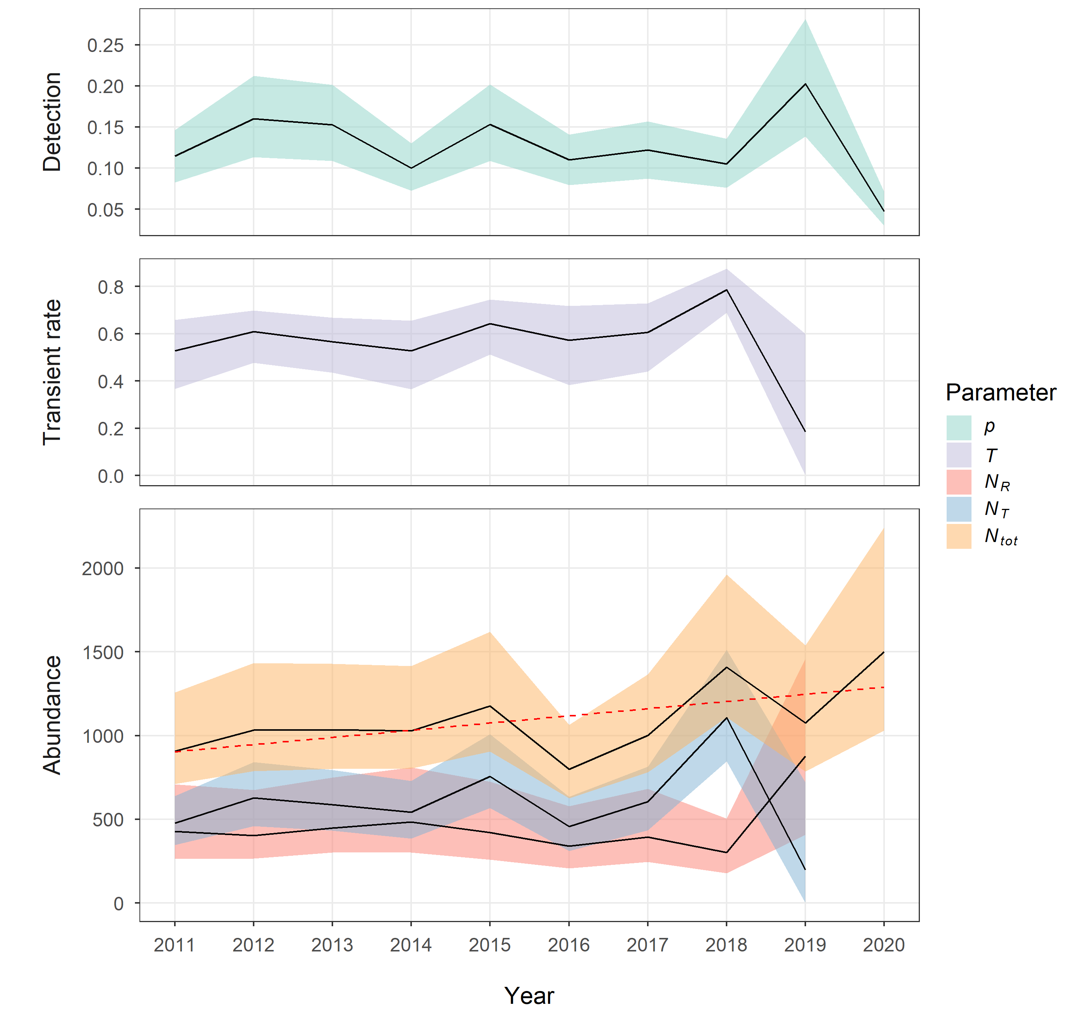
Figure S1. Seasonal estimates for detection probability (p), transient rate (T), abundance of non-transients (N_{R}), abundance of transients (N_{T}), and total abundance (N_{tot}), with 95% confidence intervals (CI, shaded regions) derived from a stratified bootstrap (1000 replicates), for the second best-fitting model (effort-dependent p, transient Φ, time-dependent Φ₀ and Φ₁₊). The weighted linear trend (non-significant) for total abundance is denoted by the dashed red line.

Sensitivity analysis of p specification
Although it was considered reasonable in this study to modify effort by long-term intra-seasonal sighting rates, there were reservations about using the data twice in model fitting, in terms of capture-recapture data and applying an availability weighting to the catch-effort covariate. Therefore, we conducted a sensitivity analysis by visually comparing abundance estimates from CJS models with three different specifications of p: time-varying; linked to unmodified effort (number of survey days); and linked to modified effort (survey days corrected for intra-seasonal variability in sighting rates). Figure S2 demonstrates that, despite some differences in estimates and inter-seasonal variability, all specifications show similar trends and 95% confidence intervals (CI) are largely overlapping.

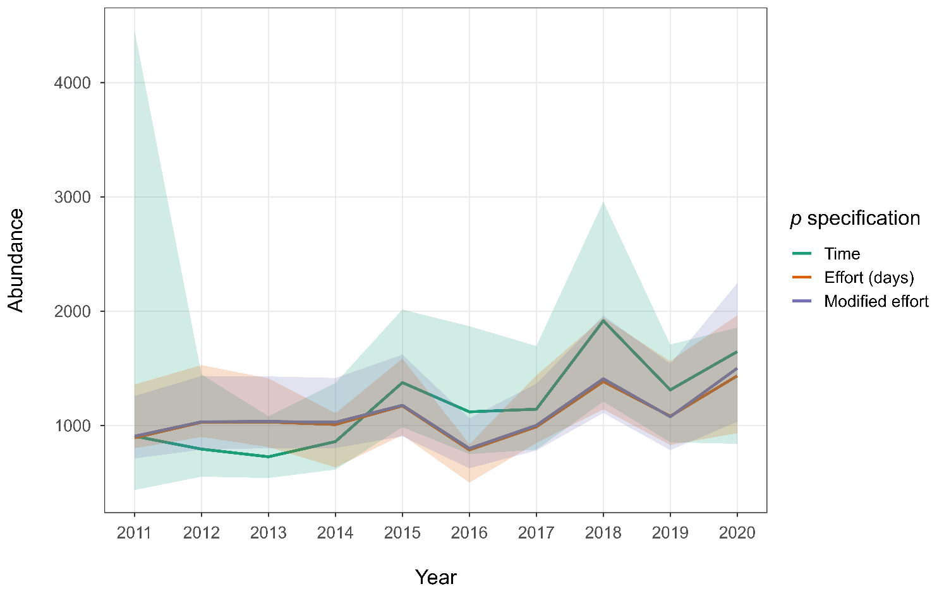
Figure S2. A comparison of seasonal abundance estimates from CJS models with three different specifications of detection (p): time-varying; linked to unmodified effort (number of survey days); and linked to modified effort (survey days corrected for intra-seasonal variability in sighting rates). In each case, in line with the best-fitting CJS model, we specified transient Φ, in which Φ₀ was time-varying and Φ₁₊ was constant. Lines denote abundance estimates from the full model and shading denotes 95% confidence intervals (CI) derived from a stratified bootstrap (1000 replicates).

Results for candidate JSSA model
Initially, we considered both Jolly-Seber-Schwarz-Arnason (JSSA) and Cormack-Jolly-Seber (CJS) model frameworks. CJS was selected because there were identifiability issues with time-varying JSSA models (primarily identified through inspection of beta estimates). Nevertheless, the range of estimates given by JSSA models was comparable to CJS and encouraging. Here, we provide model outputs for the best-fitting JSSA model without identifiability issues, with transient apparent survival (Φ), detection (p) linked to effort, and constant probability of entry (pent; Table S2, Figure S3). This JSSA model yielded two survival estimates: survival following the first sighting (Φ₀) and survival following subsequent sightings (Φ₁₊). Due to the way in which seasonal abundance is derived from the super-population abundance parameter estimate, transience rates and the separate numbers of transients and non-transients could not be provided (Félix et al. 2011, Schleimer et al. 2019). The model was fit as a POPAN model in RMark.
Table S2. Parameter maximum likelihood estimates (MLE) and 95% confidence intervals (CI) for a candidate JSSA model (effort-dependent p, transient Φ, constant pent). p denotes detection probability; Φ₀ denotes survival following the first sighting; Φ₁₊ denotes survival following subsequent sightings; pent denotes probability of entry; N_{super} denotes super-population abundance (the total number of animals present across all occasions); and N_{year} denotes derived seasonal abundance. Season-specific values are given for time-varying parameters.
Parameter | Season | MLE | Lower CI | Upper CI
p | 2010 | 0.07 | 0.05 | 0.09
p | 2011 | 0.11 | 0.08 | 0.14
p | 2012 | 0.14 | 0.10 | 0.18
p | 2013 | 0.14 | 0.10 | 0.18
p | 2014 | 0.10 | 0.07 | 0.13
p | 2015 | 0.14 | 0.10 | 0.18
p | 2016 | 0.10 | 0.07 | 0.14
p | 2017 | 0.11 | 0.08 | 0.15
p | 2018 | 0.10 | 0.07 | 0.13
p | 2019 | 0.17 | 0.12 | 0.22
p | 2020 | 0.05 | 0.04 | 0.07
Φ₁₊ | constant | 0.99 | 0.94 | 1
Φ₀ | constant | 0.34 | 0.29 | 0.46
pent | constant | 0.05 | 0.04 | 0.06
N_{super} | constant | 2140 | 1932 | 2673
N_{year} | 2010 | 979 | 751 | 1411
N_{year} | 2011 | 1085 | 854 | 1519
N_{year} | 2012 | 1188 | 951 | 1617
N_{year} | 2013 | 1287 | 1034 | 1716
N_{year} | 2014 | 1386 | 1112 | 1817
N_{year} | 2015 | 1487 | 1181 | 1924
N_{year} | 2016 | 1580 | 1232 | 2032
N_{year} | 2017 | 1680 | 1307 | 2140
N_{year} | 2018 | 1777 | 1367 | 2247
N_{year} | 2019 | 1870 | 1412 | 2355
N_{year} | 2020 | 1956 | 1435 | 2451

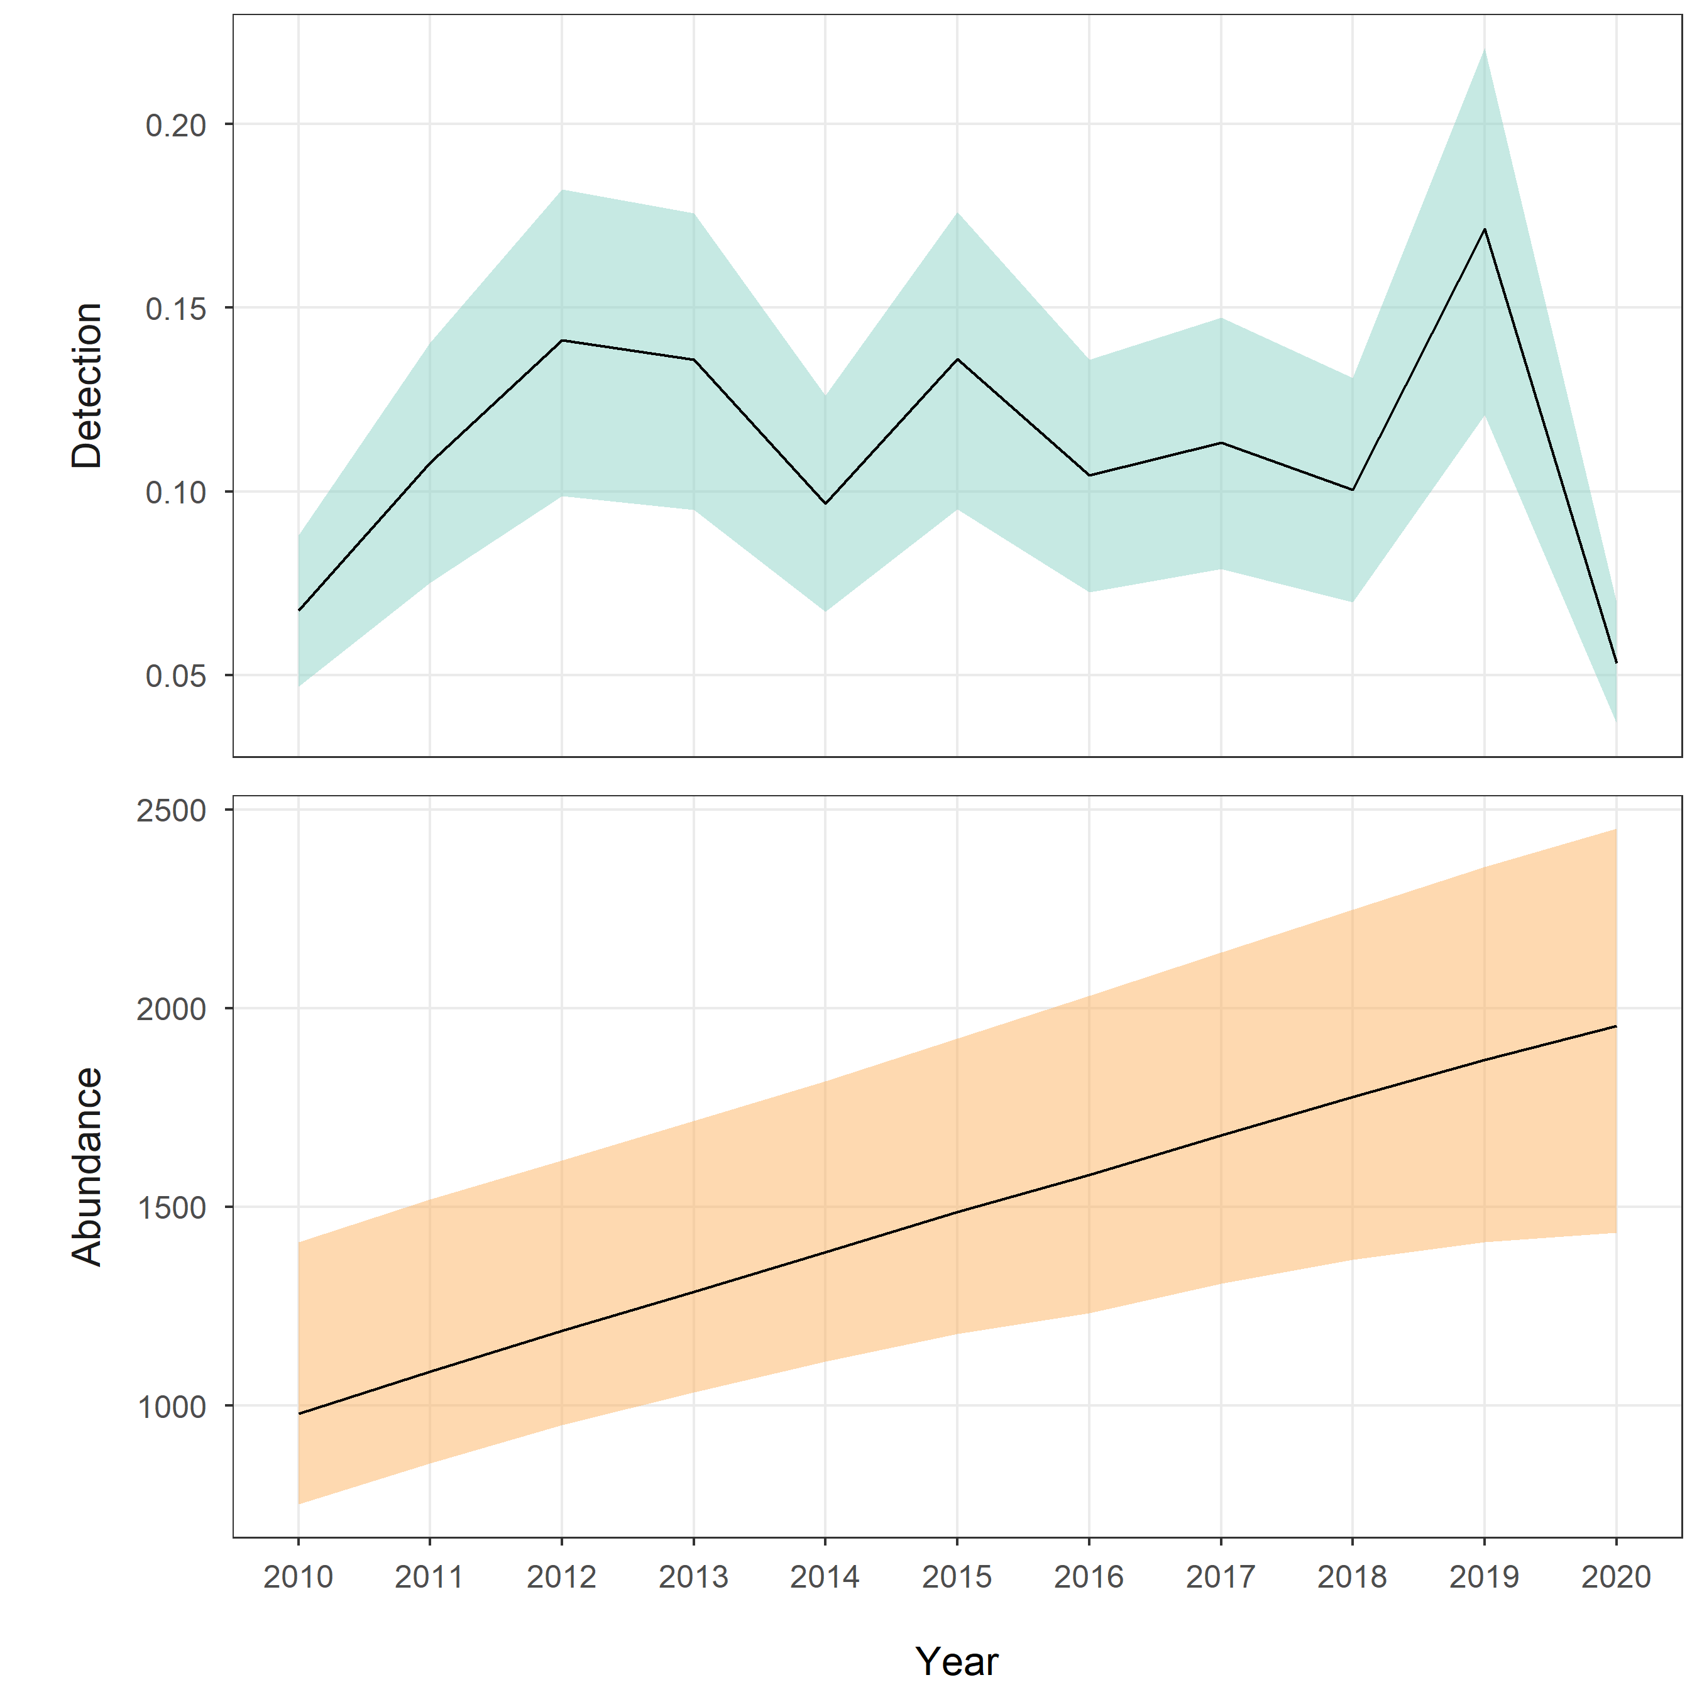
Figure S3. Seasonal estimates (black lines) and 95% confidence intervals (shaded areas), derived from a stratified bootstrap (1000 replicates), for detection probability (p) and derived abundance (N_{year}) for a candidate JSSA (POPAN) model (effort-dependent p, transient Φ, constant pent).

