Supplementary Material

Supplementary Tables
Table S1. Information of the tested microorganisms.
Category | Species | Preservation number | Culture medium
Bacteria | Pseudomonas putida | CCTCC AB2014017 | NA
 | Pseudomonas aeruginosa | CCTCC AB93066 | NA
 | Erwinia oleae | CCTCC AB2014255 | NA
 | Erwinia tasmaniensis | CCTCC AB2014256 | NA
 | Escherichia coli | CCTCC AB204033 | LB
Yeast | Candida albicans | CCTCC AY2022003 | LB
Filamentous fungi | Penicillium commune | CCTCC AF93302 | PDA
 | Penicillium expansum | CCTCC S2022025 | PDA
 | Penicillium polonicum | CCTCC S2022026 | PDA
 | Mucor racemosus | CCTCC AF93267 | PDA
 | Aspergillus fumigatus | CCTCC AF93048 | PDA
 | Aspergillus sp. | CCTCC AF2019015 | PDA
 | Fusarium sp. | CCTCC AF93230 | PDA
 | Trichoderma sp. | CCTCC AF2018015 | PDA
Note: CCTCC (China Center for Type Culture Collection; Wuhan, Hubei, China); NA, Nutrient agar.

Table S2. Inhibition rates of yeast VOCs to microbial growth.
Yeast  strain | Inhibition rate (%, Mean±SD)
 | E. coli | C. albicans | P. commune | P. expansum | P. polonicum | Aspergillus sp. | A. fumigatus | M. racemosus | Fusarium sp.
A29 | 48.15±12.83^{b} | 53.33±5.77^{d} | 25.00±6.61ª | 65.69±2.12ª | 54.36±7.48ª | 65.71±33.52ª | 93.52±11.23^{b} | 26.23±13.98ª | 20.00±17.33ª
A211 | 70.37±6.42^{b} | 40.00±0.00^{c} | 59.17±13.77ª | 77.33±19.66^{b} | 68.19±25.77ª | 91.23±11.05^{b} | 90.97±12.77^{b} | 54.64±7.35^{b} | 74.67±19.91^{b}
A37 | 70.37±6.42^{b} | 46.67±5.77^{d} | 73.33±5.20^{b} | 76.72±20.16^{b} | 67.50±5.22ª | 72.89±22.23ª | 93.98±10.42^{b} | 58.47±7.35^{b} | 30.22±10.01ª
A38 | 66.67±11.11^{b} | 13.33±5.77ª | 59.17±12.33ª | 60.78±7.65ª | 55.74±3.17ª | 55.34±5.52ª | 99.54±0.80^{b} | 45.08±15.36ª | 19.11±6.01ª
C21 | 48.15±6.42^{b} | 10.00±0.00ª | 41.67±22.41ª | 43.63±9.43ª | 66.11±17.89ª | 72.89±23.48ª | 52.78±5.89ª | 41.26±9.57ª | 55.11±19.79ª
C23 | 33.33±11.11ª | 10.00±0.00ª | 41.67±13.77ª | 35.05±10.45ª | 34.99±4.32ª | 43.78±11.84ª | 90.74±8.14^{b} | 48.36±10.66ª | 33.78±22.36ª
C31 | 14.81±6.42ª | 10.00±0.00ª | 41.67±6.29ª | 38.11±2.81ª | 46.06±2.07ª | 53.75±1.38ª | 82.41±16.22^{b} | 32.51±3.10ª | 20.89±7.81ª
D13 | 51.85±6.42^{b} | 13.33±5.77ª | 23.33±1.44ª | 44.85±17.54ª | 70.26±23.32ª | 68.90±25.20ª | 98.61±2.41^{b} | 36.34±4.21ª | 47.11±18.10ª
D24 | 51.85±6.42^{b} | 20.00±0.00^{b} | 45.00±13.23ª | 57.72±5.51ª | 62.66±14.52ª | 68.10±1.38ª | 84.72±18.16^{b} | 50.55±8.69ª | 33.33±6.11ª
D27 | 40.74±6.42ª | 3.33±0.00ª | 31.67±2.89ª | 39.34±9.55ª | 65.42±29.14ª | 62.52±9.96ª | 100.00±0.00^{b} | 45.63±8.05ª | 44.44±2.04ª
D41 | 51.85±6.42^{b} | 10.00±0.00ª | 39.17±19.42ª | 59.56±7.35ª | 43.29±7.85ª | 56.94±35.24ª | 100.00±0.00^{b} | 34.97±10.38ª | 49.78±29.70ª
E24 | 48.15±12.83^{b} | 43.33±5.77^{c} | 45.00±20.46ª | 24.02±1.06ª | 62.66±14.52ª | 35.41±7.18ª | 95.14±6.87^{b} | 44.54±0.47ª | 24.89±15.91ª
731 | 48.15±6.42^{b} | 46.67±5.77^{d} | 52.50±5.00ª | 52.82±14.04ª | 61.96±9.58ª | 85.65±6.33ª | 93.75±8.84^{b} | 29.51±3.57ª | 19.33±6.60ª
MR | 66.67±11.11^{b} | 33.33±5.77^{c} | 36.67±35.91ª | 49.75±14.97ª | 75.10±17.97ª | 45.77±7.31ª | 100.00±0.00^{b} | 32.79±7.51ª | 47.56±33.32ª
Note: Different lowercase letters indicate significant differences within a column according to Tukey-Kramer test (p < 0.05).
Table S3. Influence of VOC of yeasts to the growth of A. thaliana at 20℃.
 | Yeast strain | Chlorophyll content (mg/g) |  |  | Fresh weight (mg) |  |  | Shoot height  (cm) | Leaf numbers | Blossomed  flowers
 |  | Chlorophyll  a  content | Chlorophyll  b  content | Total  chlorophyll  content | Total  fresh  weight | Root weight | Shoot weight
Experiment  1 | CK | 0.16±0.04 | 0.07±0.01 | 0.22±0.06 | 111.00±63.14 | 22.83±15.43 | 88.17±48.38 | 7.15±1.23 | 18.50±2.88 | 1.83±0.75
 | A29 | 0.19±0.10 | 0.07±0.03 | 0.26±0.15 | 361.75±88.83** | 102.00±32.07** | 259.75±59.30** | 6.53±0.74 | 37.75±10.31** | 2.75±1.50
 | A211 | 0.12±0.06 | 0.05±0.02 | 0.17±0.08 | 176.25±40.34 | 61.75±20.19 | 114.50±37.55 | 6.89±0.80 | 19.00±2.16 | 3.25±1.26
 | A38 | 0.16±0.08 | 0.07±0.02 | 0.23±0.12 | 209.75±84.79 | 67.25±36.93 | 142.50±52.11 | 5.83±0.75 | 20.25±1.50 | 2.00±0.82
 | C21 | 0.20±0.05 | 0.08±0.02 | 0.28±0.08 | 206.80±54.15 | 52.80±29.18 | 154.00±56.47 | 6.51±1.17 | 20.20±2.28 | 2.40±2.30
 | C23 | 0.18±0.04 | 0.07±0.01 | 0.24±0.06 | 247.00±88.19* | 79.80±46.69* | 167.20±46.59* | 6.74±1.02 | 24.60±2.88 | 3.60±2.88
 | MR | 0.14±0.02 | 0.06±0.01 | 0.19±0.03 | 60.80±13.85 | 22.20±8.93 | 38.60±14.72 | 3.82±1.28** | 13.40±2.41 | 0.00±0.00
Experiment  2 | CK | 0.10±0.02 | 0.07±0.02 | 0.17±0.02 | 141.00±70.00 | 12.58±8.78 | 128.58±63.17 | 4.11±1.39 | 25.25±7.35 | 1.75±1.54
 | A37 | 0.02±0.01 | 0.03±0.01** | 0.04±0.02 | 41.00±17.88** | 4.40±3.47 | 36.40±15.85** | 0.31±0.09** | 13.30±2.67** | 0.00±0.00
 | C31 | 0.27±0.10* | 0.08±0.03 | 0.35±0.15** | 161.00±47.43 | 20.27±9.14 | 139.82±41.70 | 6.50±1.30** | 28.91±7.23 | 4.91±1.92**
 | D13 | 0.17±0.03 | 0.05±0.01 | 0.22±0.05 | 261.00±70.84** | 28.64±7.03* | 232.36±65.07** | 7.85±2.15** | 32.55±6.89* | 8.55±3.62**
 | D24 | 0.21±0.03 | 0.07±0.01 | 0.27±0.05 | 239.55±77.77** | 33.18±14.23** | 206.36±65.70** | 5.75±1.06* | 31.27±7.10 | 5.18±1.08**
 | D27 | 0.11±0.05 | 0.04±0.01 | 0.15±0.06 | 258.08±48.80** | 31.25±10.62** | 226.83±40.55** | 5.79±1.53* | 34.75±7.29** | 3.33±0.98
 | D41 | 0.27±0.04* | 0.08±0.01 | 0.36±0.06** | 296.17±88.03** | 55.00±24.46** | 244.50±70.11** | 6.57±1.97** | 32.92±6.73* | 6.75±2.96**
 | E24 | 0.18±0.08 | 0.06±0.02 | 0.24±0.11 | 241.73±48.59** | 27.45±6.27* | 214.36±46.64** | 6.59±1.13** | 32.09±4.85 | 4.91±1.64**
 | 731 | 0.40±0.17** | 0.00±0.00** | 0.33±0.14** | 10.25±7.76** | 1.88±2.10 | 8.38±5.76** | 0.43±0.29** | 9.75±1.16** | 0.00±0.00
Note: The test was carried out in two times, and the control (CK) was set twice; '*' indicates P < 0.05, compared with control using Dunnett’s test; '**' indicates P < 0.01, compared with control using Dunnett’s test.
Table S4. Influence of VOC of yeasts to the growth of A. thaliana at 10℃.
Yeast strain | Chlorophyll content (mg/g) |  |  | Fresh weight (mg) |  |  | Shoot height  (cm) | Leaf numbers | Blossomed  flowers
 | Chlorophyll  a  content | Chlorophyll  b  content | Total  chlorophyll  content | Total  fresh  weight | Root weight | Shoot weight |  |  |  | Unblossomed  flowers
Control | 0.06±0.01 | 0.04±0.00 | 0.10±0.01 | 331.00±128.83 | 33.30±26.00 | 297.67±108.18 | 3.21±1.49 | 35.67±4.61 | 0.11±0.33 | 7.78±6.96
A29 | 0.05±0.01 | 0.04±0.02 | 0.09±0.03 | 544.50±131.44** | 79.67±76.11* | 454.88±97.74** | 1.36±0.40** | 53.25±8.40** | 0.00±0.00 | 0.00±0.00
A211 | 0.02±0.00 | 0.03±0.00 | 0.04±0.01 | 292.10±85.93 | 63.70±46.50 | 228.40±48.69 | 1.13±0.13** | 23.00±4.29** | 0.00±0.00 | 0.00±0.00
A37 | 0.02±0.00 | 0.03±0.00 | 0.04±0.01 | 423.60±69.48 | 163.00±42.52** | 260.60±37.99 | 1.17±0.12** | 20.70±3.20** | 0.00±0.00 | 0.00±0.00
A38 | 0.09±0.02 | 0.05±0.00 | 0.14±0.03 | 673.11±138.32** | 84.56±27.68* | 588.56±120.47** | 2.46±1.04 | 56.78±9.58** | 0.00±0.00 | 6.22±11.72
C21 | 0.12±0.03 | 0.05±0.01 | 0.17±0.04 | 800.11±80.04** | 114.11±34.56** | 686.00±95.07** | 2.83±0.57 | 47.56±12.19** | 0.00±0.00 | 0.00±0.00
C23 | 0.12±0.05 | 0.05±0.01 | 0.17±0.07 | 437.67±87.18 | 51.56±16.82 | 386.11±82.26 | 1.71±0.27** | 32.11±5.13 | 0.00±0.00 | 0.00±0.00
C31 | 0.15±0.06** | 0.06±0.02* | 0.22±0.08** | 338.33±47.77 | 41.44±13.50 | 296.89±49.69 | 1.34±0.38** | 37.33±7.14 | 0.00±0.00 | 0.00±0.00
D13 | 0.13±0.03* | 0.06±0.01 | 0.19±0.04* | 639.22±128.35** | 96.78±32.58** | 542.44±101.86** | 1.83±0.21** | 50.33±12.05** | 0.00±0.00 | 0.56±1.67
D27 | 0.21±0.06** | 0.08±0.02** | 0.30±0.09** | 609.78±69.14** | 66.00±25.10 | 543.78±48.18** | 2.30±0.41 | 43.11±7.88 | 0.00±0.00 | 1.89±3.95
D41 | 0.11±0.01 | 0.05±0.00 | 0.16±0.01 | 445.67±102.87 | 33.22±15.09 | 412.44±95.50** | 7.37±1.60** | 51.44±7.47** | 1.22±1.64 | 26.33±11.00**
731 | 0.01±0.00 | 0.02±0.00 | 0.04±0.00 | 6.00±1.41** | 2.11±0.78 | 3.89±1.27** | 0.31±0.03** | 3.89±0.78** | 0.00±0.00 | 0.00±0.00
MR | 0.01±0.00 | 0.03±0.00 | 0.04±0.01 | 354.90±58.91 | 118.90±48.78** | 236.00±23.53 | 1.31±0.09** | 17.00±1.94** | 0.00±0.00 | 0.00±0.00
D24 | ND | ND | ND | ND | ND | ND | ND | ND | ND | ND
E24 | - | - | - | - | - | - | - | - | - | -
Note: “ND” means the plant was too small to measure; “-” means data was lacked due to contamination; '*' indicates P < 0.05, compared with control using Dunnett’s test; '**' indicates P < 0.01, compared with control using Dunnett’s test.
Table S5. Detected new VOCs in yeast- A. thaliana co-culture system.
 | New VOC |  |  |  |  |  |  |  | Peak Area (unit, ×10⁶)，Mean±SD
Classic |  |  | Name | CAS  number |  | RI  (min) | Chemical  formula | MW | Strain  731 | Strain  D13 | Strain  D41
Alcohol |  | 1-Hexanol |  |  | 111-27-3 | 7.738 | C₆H₁₄O | 102 | 298.1±14.7 | - | -
 |  | 2-Hexyl-1-octanol |  |  | 19780-79-1 | 15.665 | C₁₄H₃₀O | 214 | - | 2.5±0.1 | -
Organic acid |  | Isobutyric acid |  |  | 79-31-2 | 5.572 | C₄H₈O₂ | 88 | - | - | 18.1±10.1
Alkane |  | 2-Methyl butane |  |  | 78-78-4 | 10.152 | C₅H₁₂ | 72 | - | 7.2±0.1 | -
 |  | Decane |  |  | 124-18-5 | 12.506 | C₁₀H₂₂ | 142 | - | - | 1.6±0.2
 |  | Hendecane |  |  | 1120-21-4 | 12.602 | C₁₁H₂₄ | 156 | - | 1.4±0.0 | 1.7±0.4
 |  | 2,6-Dimethyl undecane |  |  | 17301-23-4 | 14.354 | C₁₃H₂₈ | 184 | - | 2.2±0.1 | -
 |  | 2,3,4-Trimethyl decane |  |  | 62238-15-7 | 14.490 | C₁₃H₂₈ | 184 | - | 3.8±0.1 | -
 |  | n-Tridecane |  |  | 629-50-5 | 14.951 | C₁₃H₂₈ | 184 | 1.4±0.5 | 15.4±0.2 | -
 |  | Tetradecane |  |  | 629-59-4 | 15.269 | C₁₄H₃₀ | 198 | - | 2.1±0.3 | 6.8±0.8
 |  | 2,6,10-Trimethyl tetradecane |  |  | 14905-56-7 | 14.166 | C₁₇H₃₆ | 240 | - | 3.1±0.3 | -
 |  | n-Heptadecane |  |  | 629-78-7 | 15.399 | C₁₇H₃₆ | 240 | - | 11.4±5.0 | -
 |  | Octadecane |  |  | 593-45-3 | 18.114 | C₁₈H₃₈ | 254 | - | 3.6±0.4 | -
 |  | 2,6-Dimethyl heptadecane |  |  | 54105-67-8 | 14.951 | C₁₉H₄₀ | 268 | - | 3.5±0.5 | -
Terpene |  | (+)-Aromadendrene |  |  | 489-39-4 | 17.464 | C₁₅H₂₄ | 204 | - | - | 2.2±1.3
 |  | γ-Muurolene |  |  | 30021-74-0 | 17.641 | C₁₅H₂₄ | 204 | 15.6±13.6 | - | -
 |  | (-)-Thujopsen |  |  | 470-40-6 | 17.771 | C₁₅H₂₄ | 204 | - | - | 1.2±0.1
Note: MW, molecular weight; RI, Retention time; -, not detected.

Supplementary Figures

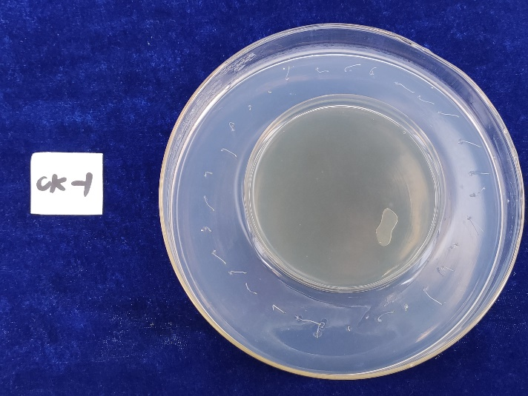
Artificial nectar and yeast
Plant culture medium

Seed of A. thaliana
Figure S1. Inside space in the experiment of the effect of mVOCs on seed germination.
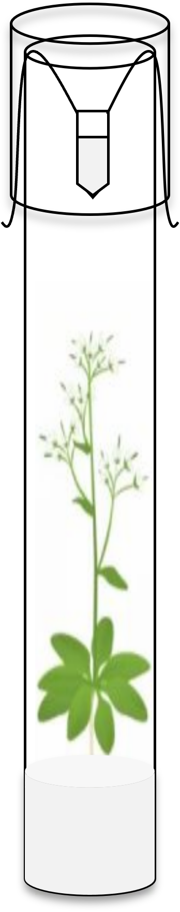
Artificial nectar and yeast
A. thaliana
Plant culture medium

Lid-moved EP tube (1.5 mL)
Figure S2. Mode pattern of mVOC- A. thaliana co-culture system.
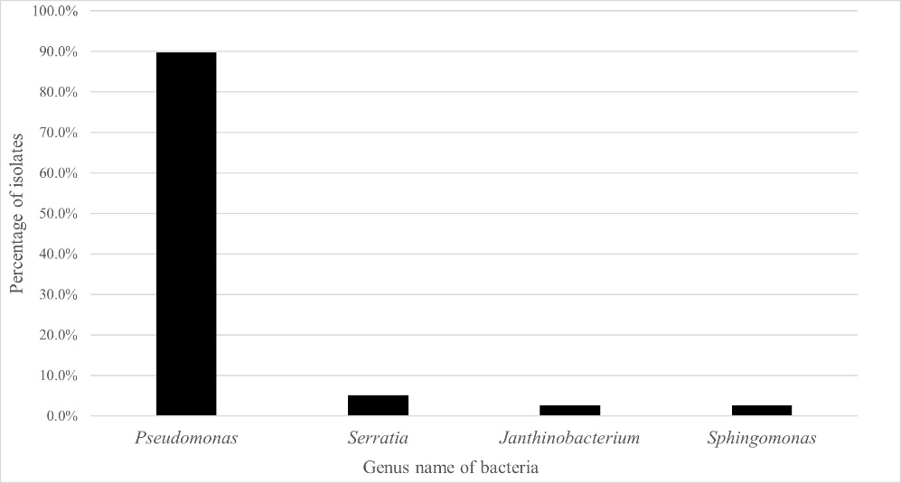
Figure S3. Genera distribution of all isolated yeasts from Arctic flowers.
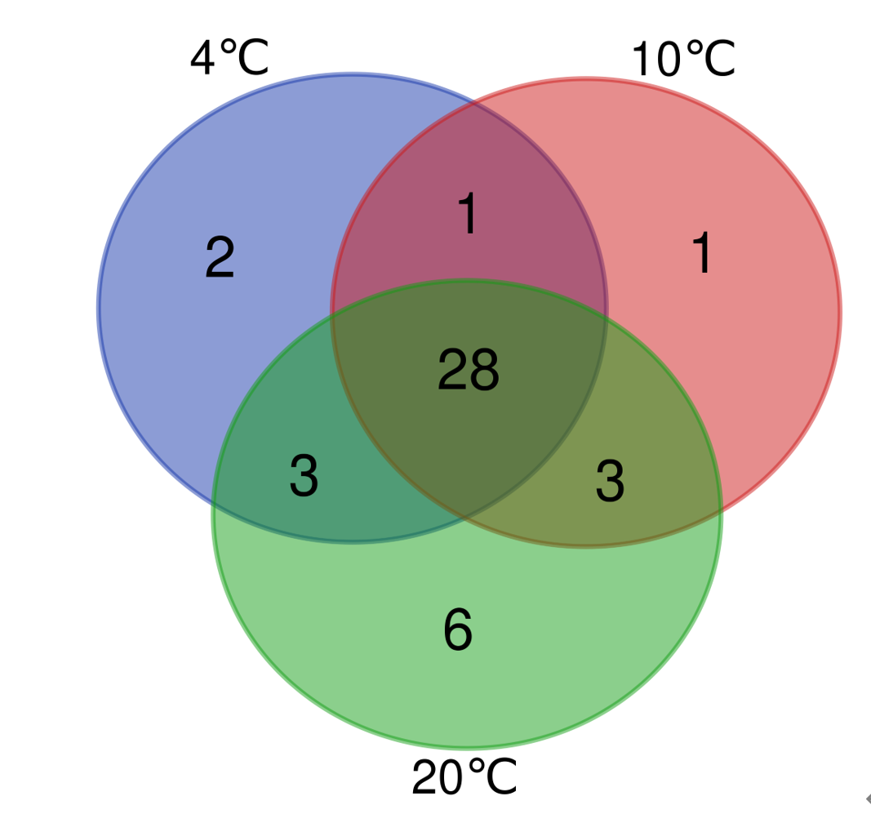
Figure S4. Venn diagram of the mVOC components at varying incubation temperatures.
a
b
c
d
e
f
g
h
i
j
k
l
m
n
o
p
q
Figure S5. Inhibitory effect of selected VOCs on the growth of Arabidopsis. a: sterile water; b: ethanol; c: 10 µg hendecane; d: 100 µg hendecane; e: 500 µg hendecane; f: 1000 µg hendecane; g: 2000 µg hendecane; h: 10 µg tetradecane; i: 100 µg tetradecane; j: 500 µg tetradecane; k: 1000 µg tetradecane; l: 2000 µg tetradecane; m: 10 µg 1-hexanol; n: 100 µg 1-hexanol; o: 1-500 µg 1-hexanol; p: 1000 µg 1-hexanol; q: 2000 µg 1-hexanol.

