Supplemental materials
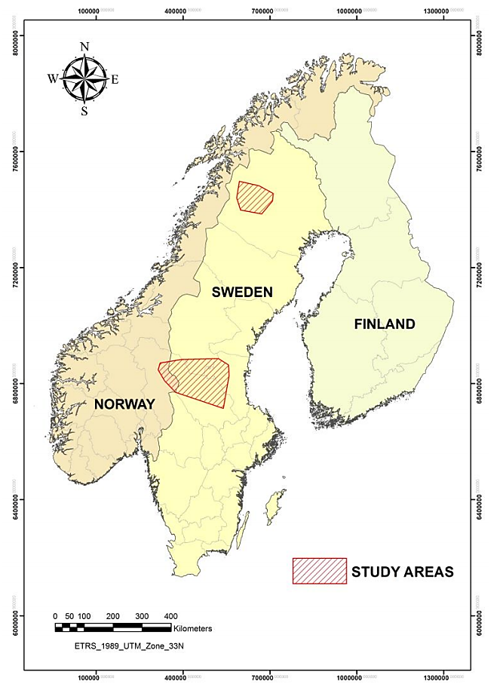
Figure S1: Locations of the study areas in Scandinavia (red hatched areas). Bears were captured in spring from 2011 to 2018 in a northern (N=5) and southern (N=26) study area about 600 km apart. Reprinted from “Short and long-term physiological effects of capture and handling on free-ranging brown bears (Ursus arctos)”, by Esteruelas N. F., Doctoral thesis, Inland Norway University of Applied Science (2017), p. 24.

Figure S2: Reproductive success of female Scandinavian brown bears (N=24) from the southern study area during 2012-2018 along the gradient of bilberry abundance in late summer. Observed values are colored according to the interaction between age category and bilberry abundance during hyperphagia the previous summer: adults are shown in blue regardless of berry abundance (N=11), young adults with high berry index (> 0.5) are shown in dark green (N=6) and young adults with low berry index (< 0.5) in light green (N=7).

B
A
Figure S3: Den exit date (A) and time spent in the den after parturition (days) (B) in female Scandinavian brown bears (N=23) from the southern study area whose cubs were observed (N=18) or not (N=5) in spring during 2012-2018. Observed values are colored according to the interaction between age category and bilberry abundance during hyperphagia the previous summer: adults are shown in blue regardless of berry abundance (N=11), young adults with high berry index (> 0.5) are shown in dark green (N=5) and young adults with low berry index (< 0.5) in light green (N=7).
Figure S4: Den exit date along the gradient of parturition dates in female Scandinavian brown bears from the southern area whose cubs were observed in spring during 2012-2018 (N=18), and associated linear model predictions (yellow line). The yellow area represents the 95% confidence interval. The significance of this tendency was not tested as the investigation of this side result was beyond the scope of this paper.
Table S1: Results of the model selection on all candidate models evaluating the factors influencing the timing of gestation and the reproductive success of Scandinavian brown bear females. The model(s) for which ΔAICc with the lowest ranked model was less than 2 was considered as the best model and is highlighted in bold.
Response variable | Candidate models | ∆AICc | AICc weight
CL reactivation | Area  T_{a} at den entry  1  Start of hibernation  Den entry  Day length at den entry | 0  1.49  11.69  15.16  15.44  15.73 | 0.68  0.32  0  0  0  0
Parturition | Age category x Berry index  Age category + Berry index  Age category  Age category + Primiparity  Age category + Year  Age category x Year  Berry index  1  Primiparity  Year  Berry index + Primiparity  Berry index + Year  Berry index x Primiparity  Primiparity + Year  Berry index x Year  Primiparity x Year | 0  5.71  7.23  9.52  9.73  12.83  14.10  14.64  16.27  16.32  16.43  16.88  17.06  18.85  20.07  21.96 | 0.90  0.05  0.02  0.01  0.01  0  0  0  0  0  0  0  0  0  0  0
Reproductive success  (Young adults) | Berry index  1  Parturition  Primiparity | 0  2.69  4.22  5.40 | 0.69  0.18  0.08  0.05

