Survival ability, metabolic activity recovery and ultrastructural damages of Antarctic black fungus in perchlorates media

Cassaro A.¹, Pacelli C.^{1,2,*}, Onofri S.¹
¹Department of Ecological and Biological Sciences, University of Tuscia, Largo dell’Università snc, Viterbo, Italy
² Human Spaceflight and Scientific Research Unit, Italian Space Agency, via del Politecnico, Rome, Italy

Supplementary Material

Growth tolerance to Mars-relevant perchlorate salts
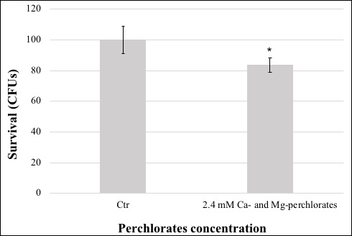

Figure S1. Survival ability of C. antarcticus colonies after growth on 2.4 mM (0.4 wt% of Mg(ClO₄)₂ and 0.6 wt% of Ca(ClO₄)₂) cultivation medium. Significant differences were calculated by t test with * = p < 0.05 and ** = p < 0.001.

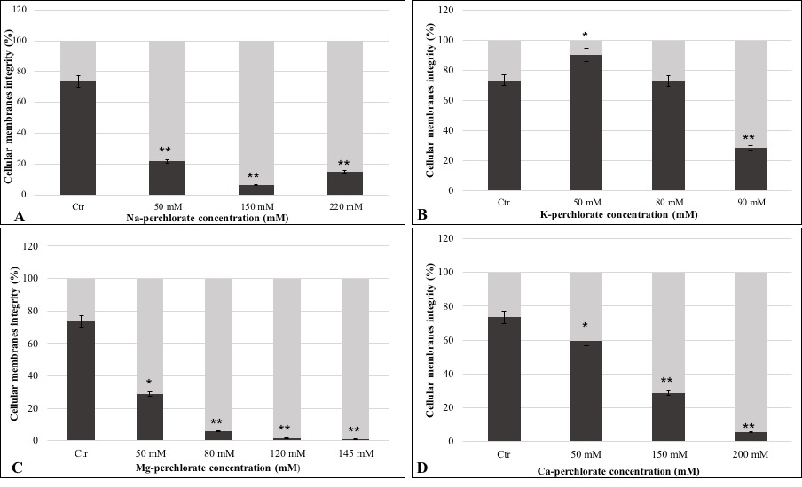
Cellular membranes integrity assessment (PMA assay)

Figure S2. Percentage of undamaged and damaged cellular membranes measured with PMA assay coupled with qPCR of C. antarcticus colonies grown on different perchlorates concentrations. A) Na-, B) K-, C) Mg-, and D) Ca-perchlorates. All concentrations are expressed in mM. Significant differences were calculated by t test with * = p < 0.05 and ** = p < 0.001.

Ultrastructural investigation: TEM observations
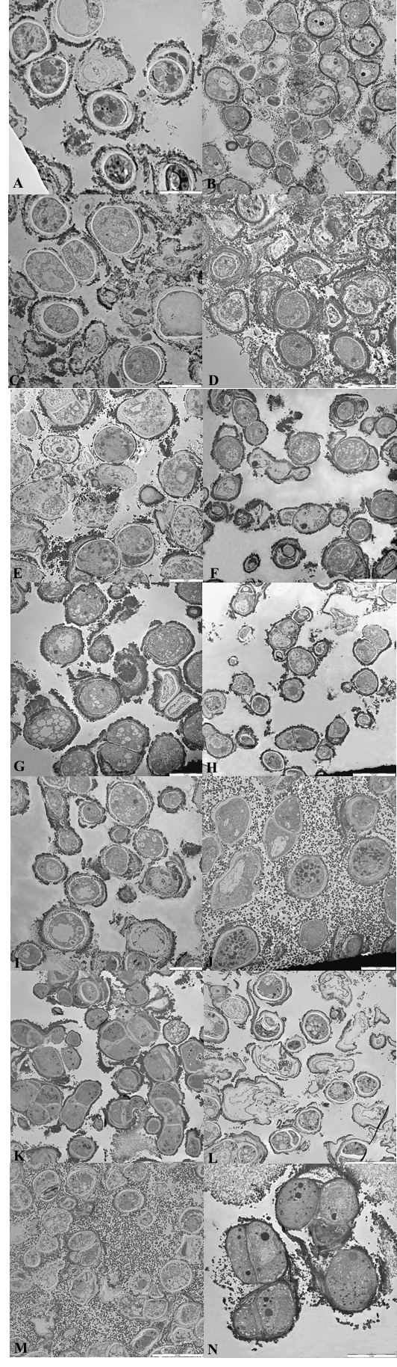

Figure S3. TEM images of C. antarcticus cells grown on A, B) MEA (no salts, controls), C) 50 mM, D) 150 mM and E) 220 mM of Na-perchlorate; F) 50 mM, G) 80 mM and H) 90 mM of K-perchlorate; I) 50 mM, J) 120 mM and K) 145 mM of Mg-perchlorate; L) 50 mM, M) 150 mM and N) 200 mM of Ca-perchlorate.

