Supplementary material
Table S1 Main abbreviations
Abbreviation | Explanation
TWC | Tsushima Warm Current
TSI | Temperature suitability index
ESTSI | Average temperature suitability index of the coastal waters of China seas
JSTSI | Average temperature suitability index of the southern part of the Sea of Japan
NSTSI | Average temperature suitability index of the Pacific coast of Japan
EOF | Empirical orthogonal function
GF | Gradient forest
GAM | Generalized additive models
TGAM | Threshold generalized additive models

Table S2 Information on fisheries data used in this study
Country or region | Period | Fishing area | Data resource
China | 1950-2017 | ECS and Yellow Sea | Chinese fishery statistics and FAO
Japan | 1950-2017 | East China Sea, Sea of Japan, and the waters off Central and Northern Japan | FAO
Korea | 1950-2017 | The South Sea of South Korea | FAO
Chinese Taipei | 1950-2017 | East China Sea | FAO
TWC | 1973-2017 | East China Sea and Sea of Japan | Japanese stock assessment report
Pacific | 1970-2017 | The waters off central and northern Japan, high seas of the northwestern Pacific Ocean | Japanese stock assessment report

Table S3 Descriptions for climatic indices
Climate indices | Descriptions | Sources | Temporal resolutions
Pacific Decadal Oscillation  (PDO) | The PDO index is defined as the leading principal component of North Pacific monthly sea surface temperature variability. | https://www.ncdc.noaa.gov/teleconnections/pdo/ | 1970-2017, winter average
Southern Oscillation Index  (SOI) | The SOI is a standardized index based on the observed sea level pressure differences between Tahiti and Darwin, Australia. | https://www.esrl.noaa.gov/psd/enso/dashboard.html | 1970-2017, previous May to April average
Arctic Oscillation Index  (AOI) | The AOI is a climate pattern characterized by winds circulating counterclockwise around the Arctic at around 55°N latitude. | https://www.ncdc.noaa.gov/teleconnections/ao/ | 1970-2017, winter average
East Asian Monsoon  (MOI) | The MOI is the difference in the zonal wind speed (field at 300hPa) between 27.5°N-37.5°N, 110°E-170°E and 50°N-60°N, 80°E-140°E. | http://www.esrl.noaa.gov/psd/data/  time-series/ | 1970-2017, winter average
North Pacific Index  (NPI) | The NPI is the area-weighted sea level pressure over the region 30°N-65°N, 160°E-140°W. | https://climatedataguide.ucar.edu/climate-data/north-pacific-np-index-trenberth-and-hurrell-monthly-and-winter | 1970-2017, winter average
Siberian High Index  (SHI) | The SHI is the mean sea level pressure over the region 40°N-60°N, 70°E-120°E. | http://rda.ucar.edu/datasets/ds010.1/ | 1970-2017, winter average
North Pacific Gyre Oscillation (NPGO) | The NPGO is a climate pattern that emerges as the second dominant mode of sea surface height variability in the Northeast Pacific. | http://o3d.org/npgo/ | 1970-2017, winter average

Table S4 Correlation coefficients between large-scale climate indices and regional TSIs and other EOFs. Single and double asterisks (* and **) represent significant levels at P < 0.05 and P < 0.01, respectively.
 | PDO | SOI | AOI | MOI | NPI | SHI | NPGO
EOF1 | 0.10 | -0.44 | 0.13 | -0.38** | -0.15 | -0.23 | 0.00
EOF2 | 0.23 | -0.26 | -0.05 | -0.11 | -0.28 | -0.26 | -0.10
EOF3 | -0.35* | 0.08 | 0.26 | -0.32* | 0.36* | -0.06 | -0.18
EOF4 | 0.02 | 0.04 | 0.31* | -0.04 | 0.12 | 0.04 | -0.30*
ESTSI | 0.08 | -0.02 | 0.26 | -0.39** | 0.10 | -0.17 | -0.11
JSTSI | -0.11 | -0.10 | 0.31* | -0.34* | 0.11 | -0.06 | -0.26
NSTSI | -0.27 | 0.33* | -0.06 | 0.03 | 0.26 | 0.14 | -0.01

Table S5 Correlation coefficients between chub mackerel abundance and climate indices/ regional TSI/EOFs with 1- and 2-year lags. Single and double asterisks (* and **) represent significance levels at P < 0.05 and P < 0.01, respectively. (CC: Chinese catch; TC: TWC catch; TB: TWC biomass; TR: TWC recruitment; PC: Pacific catch; PB: Pacific biomass; PR: Pacific recruitment). Suffixes lag1 and lag2 represent time lags of 1 and 2 years, respectively
 | China | TC | TB | TR | PC | PB | PR
PDO | -0.13 | 0.15 | 0.26 | 0.16 | 0.13 | 0.04 | -0.01
SOI | 0.00 | 0.02 | -0.18 | -0.19 | 0.01 | 0.06 | 0.05
AOI | 0.00 | -0.05 | -0.07 | -0.11 | -0.25 | -0.12 | -0.11
MOI | 0.02 | 0.11 | 0.06 | 0.05 | 0.11 | 0.10 | 0.20
NPI | -0.01 | -0.01 | -0.13 | -0.17 | -0.03 | 0.06 | 0.01
NPGO | 0.15 | -0.25 | -0.33* | -0.29 | -0.13 | -0.07 | 0.07
SHI | -0.40** | 0.07 | 0.25 | 0.08 | 0.39** | 0.36* | 0.34*
EOF1 | -0.08 | -0.23 | -0.02 | 0.01 | 0.04 | 0.17 | 0.20
EOF2 | 0.05 | 0.11 | 0.11 | 0.11 | -0.32* | -0.56** | -0.59**
EOF3 | -0.05 | 0.02 | 0.11 | 0.09 | -0.04 | 0.02 | -0.07
EOF4 | -0.05 | 0.12 | 0.12 | 0.09 | 0.00 | 0.07 | 0.10
ESTSI | -0.36* | 0.21 | 0.34* | 0.24 | 0.14 | -0.05 | -0.19
JSTSI | -0.29* | 0.29* | 0.40** | 0.32* | 0.16 | 0.14 | 0.03
NSTSI | -0.15 | 0.09 | 0.14 | 0.11 | 0.20 | 0.01 | -0.17
PDOlag1 | -0.09 | 0.07 | 0.25 | 0.17 | 0.08 | -0.05 | -0.04
SOIlag1 | -0.07 | -0.24 | -0.25 | -0.18 | 0.00 | 0.08 | 0.13
AOIlag1 | -0.06 | 0.10 | -0.02 | -0.03 | -0.20 | -0.07 | 0.15
MOIlag1 | -0.06 | 0.00 | 0.03 | 0.08 | 0.19 | 0.20 | 0.24
NPIlag1 | -0.09 | -0.11 | -0.17 | -0.16 | -0.09 | 0.02 | 0.04
NPGOlag1 | 0.18 | -0.36* | -0.45** | -0.46** | 0.02 | 0.03 | -0.01
SHIlag1 | -0.44** | 0.04 | 0.27 | 0.17 | 0.47** | 0.46** | 0.38**
EOF1lag1 | -0.07 | -0.06 | 0.01 | -0.10 | 0.15 | 0.25 | 0.27
EOF2lag1 | 0.11 | 0.21 | 0.07 | 0.01 | -0.32* | -0.61** | -0.59**
EOF3lag1 | 0.02 | 0.16 | 0.07 | -0.01 | -0.05 | -0.04 | -0.15
EOF4lag1 | -0.04 | 0.08 | 0.09 | 0.13 | -0.03 | 0.15 | 0.30
ESTSIlag1 | -0.33* | 0.23 | 0.24 | 0.08 | 0.00 | -0.13 | -0.12
JSTSIlag1 | -0.22 | 0.37* | 0.40** | 0.31* | 0.22 | 0.11 | 0.04
NSTSIlag1 | -0.11 | 0.16 | 0.11 | 0.08 | 0.04 | -0.12 | -0.27
PDOlag2 | -0.20 | 0.14 | 0.19 | -0.01 | -0.02 | -0.15 | -0.23
SOIlag2 | 0.12 | -0.21 | -0.15 | -0.04 | 0.15 | 0.27 | 0.29*
AOIlag2 | 0.07 | 0.01 | 0.00 | 0.14 | -0.10 | -0.04 | 0.04
MOIlag2 | 0.01 | 0.02 | 0.09 | 0.06 | 0.25 | 0.21 | 0.10
NPIlag2 | 0.05 | -0.03 | -0.03 | 0.17 | 0.02 | 0.17 | 0.25
NPGOlag2 | 0.16 | -0.47** | -0.48** | -0.46** | 0.03 | 0.02 | -0.07
SHIlag2 | -0.45** | 0.09 | 0.41** | 0.31* | 0.49** | 0.40** | 0.19
EOF1lag2 | -0.16 | 0.07 | 0.10 | 0.12 | 0.10 | 0.07 | -0.09
EOF2lag2 | 0.19 | 0.01 | -0.06 | -0.03 | -0.46** | -0.61** | -0.41**
EOF3lag2 | 0.00 | 0.10 | 0.13 | 0.26 | -0.06 | 0.00 | 0.11
EOF4lag2 | -0.06 | 0.05 | 0.10 | 0.10 | 0.07 | 0.19 | 0.16
ESTSIlag2 | -0.27 | -0.01 | 0.17 | 0.11 | -0.01 | -0.04 | -0.04
JSTSIlag2 | -0.22 | 0.37* | 0.40** | 0.42** | 0.17 | 0.07 | 0.01
NSTSIlag2 | -0.13 | 0.01 | 0.07 | 0.03 | 0.06 | 0.05 | 0.15

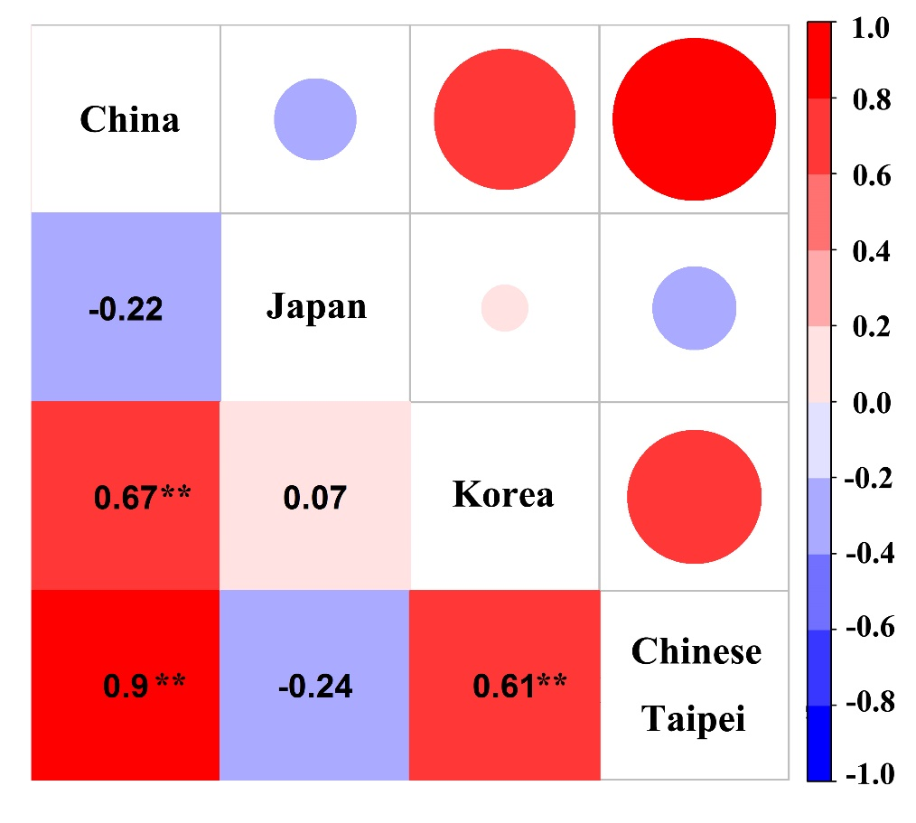
Fig. S1 Correlation analysis among the Chinese catch, Japanese catch, Korean catch, and Taiwanese catch. Single and double asterisks represent significance at P < 0.05 and P < 0.01, respectively.
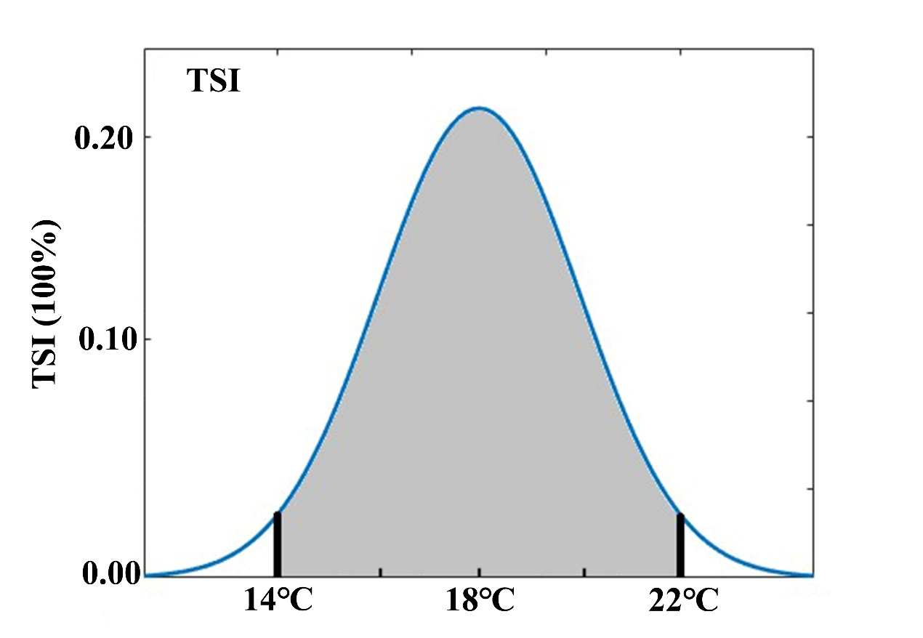
Fig. S2 The function distribution of TSI.
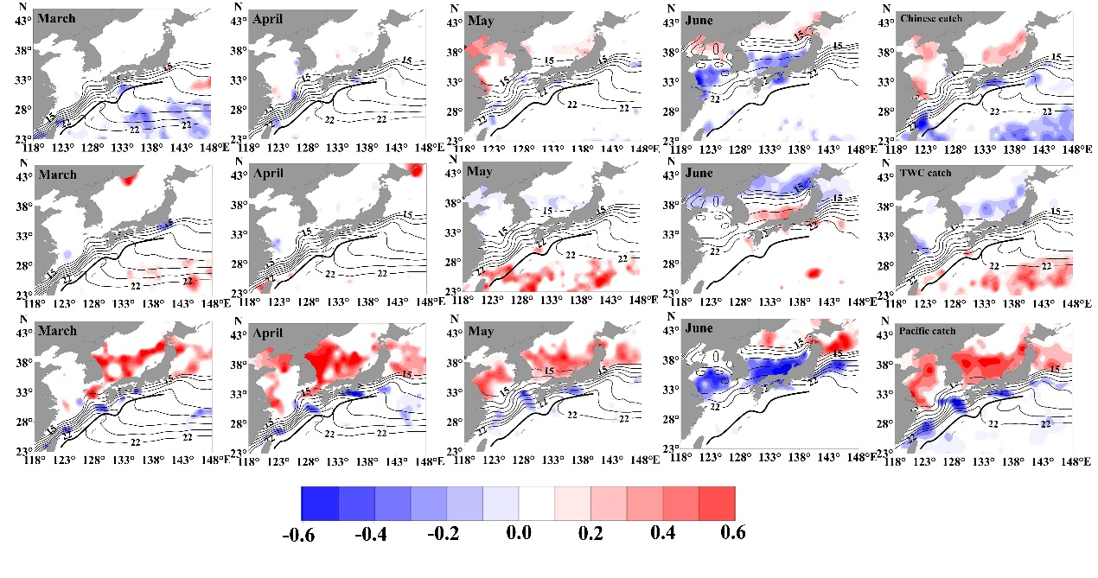
Fig. S3 Correlations between the annual Chinese catch, TWC catch, Pacific catch, and the monthly/average TSI during the spawning period (March to June) in 1970–2017. From the first row to the third row,Chinese catch, TWC catch and Pacific catch are in order. Fine lines are the average monthly 15°C and 22°C isotherms, that represent the suitable spawning temperature for chub mackerel. The thick line is the mean position of the Kuroshio Current. axis.
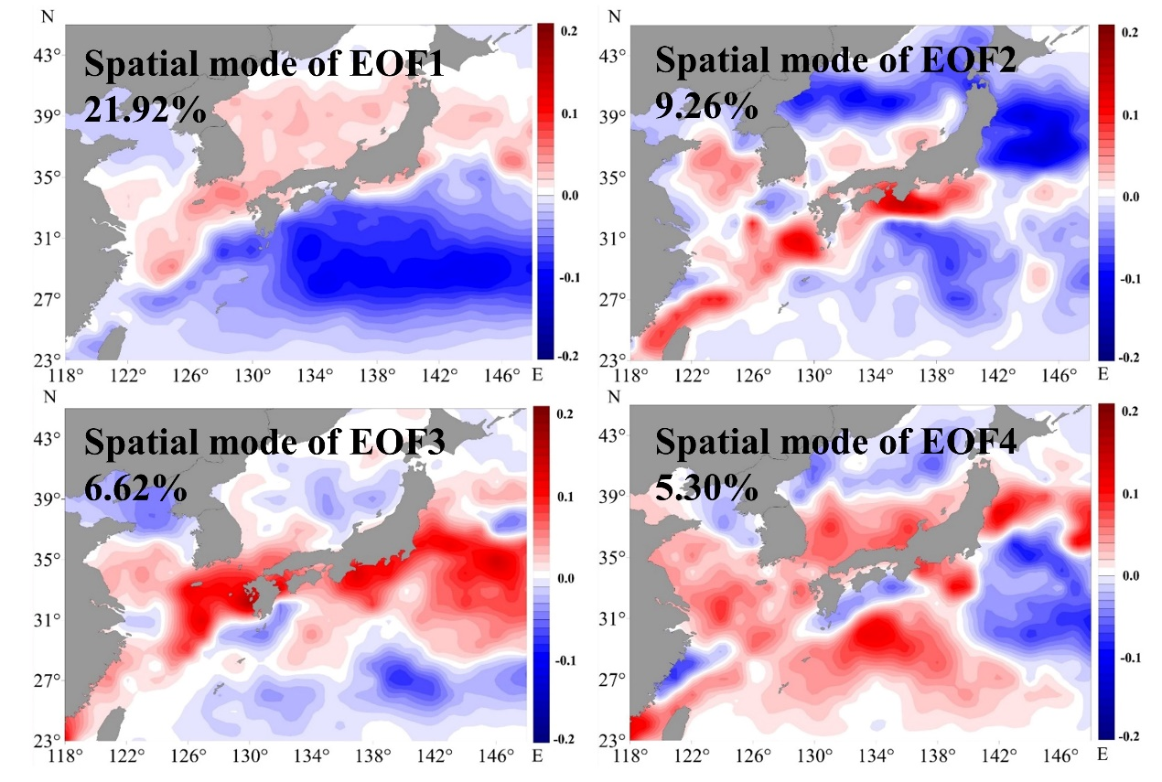
Fig. S4 Spatial modes of EOFs. Colors from blue to red represent negative to positive loadings on EOFs.

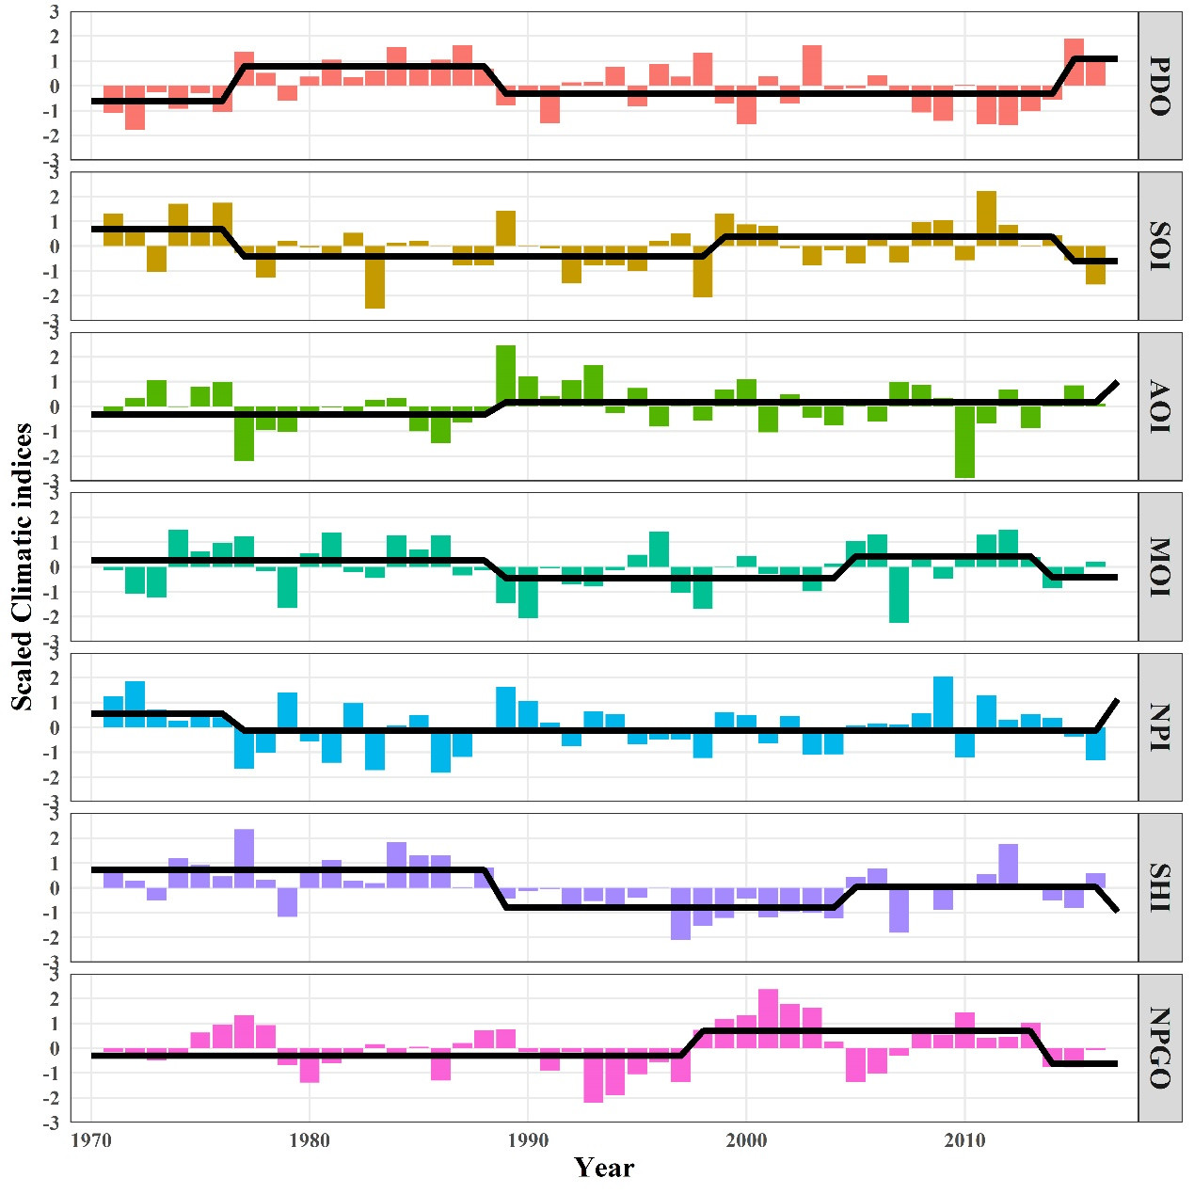
Fig. S5 Trajectories of the climatic indices (CIs). Black lines represent regime means calculated by STARS.
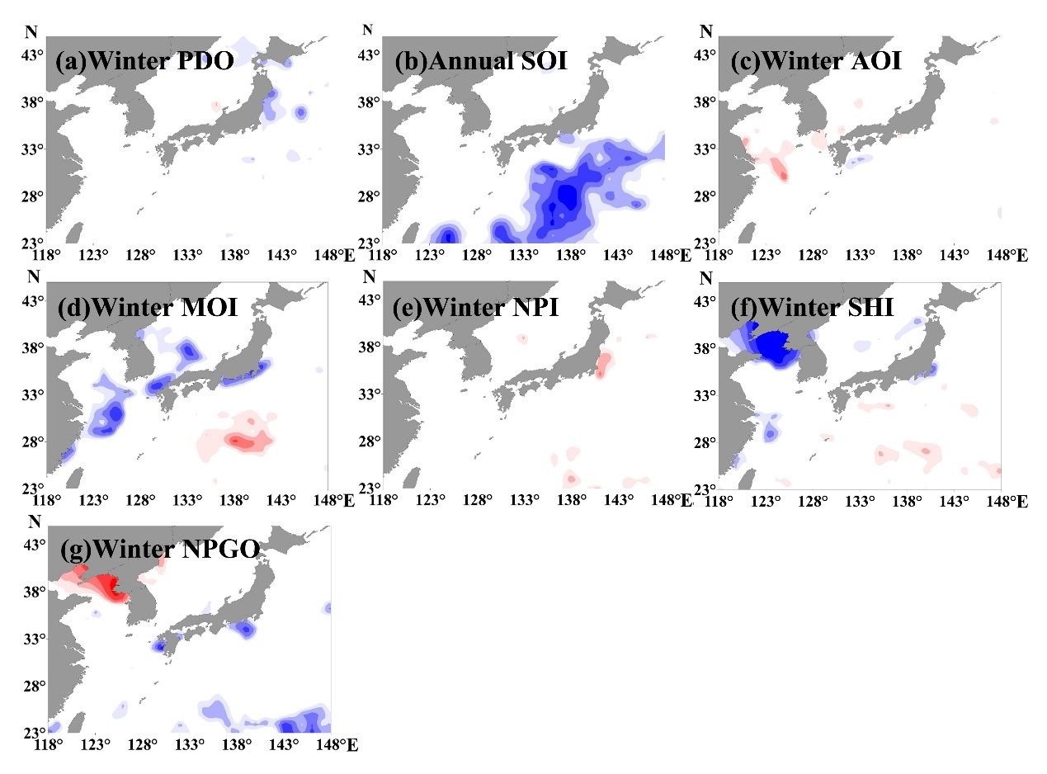
Fig. S6 Maps showing correlations of TSI with climate indices during the spawning seasons. a) The winter PDO; b) the annual SOI; c) the winter AOI; d) the winter MOI; e) the winter NPI; f) the winter SHI; g) the winter NPGO. The correlation map for annual SOI was based on 1-year lagged TSI data.

Fig. S7 Gradient forest analysis shows the cumulative importance of regional TSI and modes of EOFs. (CC: Chinese catch; TC: TWC catch; TB: TWC biomass; TR: TWC recruitment; PC: Pacific catch; PB: Pacific biomass; PR: Pacific recruitment). Suffixes lag1 and lag2 represent time lags of 1 and 2 years, respectively.

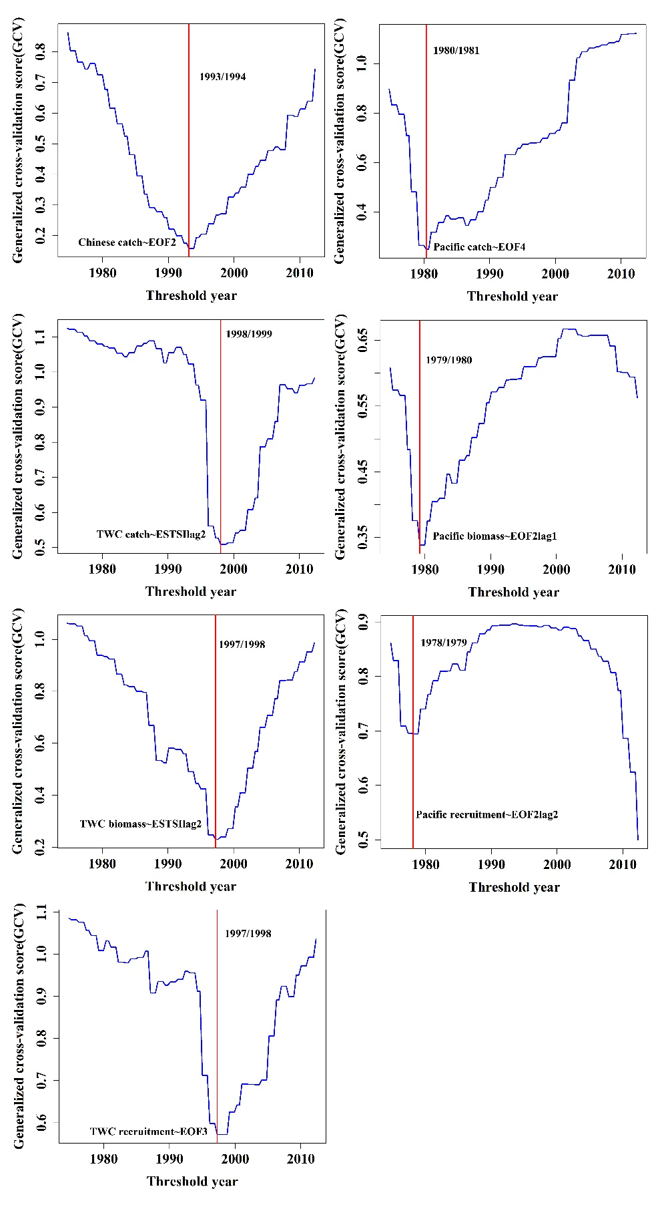
Fig. S8 Generalized cross-validation score (GCV) paths of the best-fitted models in model comparison. Red lines represent threshold years that are characterized by concave GCV paths. Suffixes lag1 and lag2 represent time lags of 1 and 2 years, respectively.
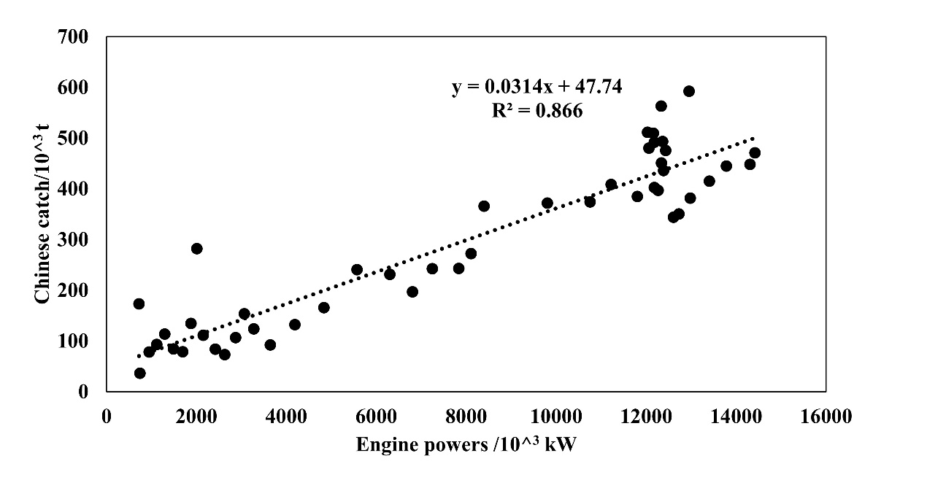
Fig. S9 Correlations of Chinese catch with the engine powers of fishing boats in China seas.

