Supplementary Material
Seasonal gain in body condition of foraging humpback whales along the Western Antarctic Peninsula

KC Bierlich, Joshua Hewitt, Robert Schick, Logan Pallin, Julian Dale, Ari Friedlaender, Fredrik Christiansen, Kate R Sprogis, Allison Dawn, Clara Bird, Gregory D. Larsen, Ross Nichols, Michelle Shero, Jeremy Goldbogen, Andrew Read, David Johnston

Table S1: Field excursions along the Western Antarctic Peninsula 2017 – 2019. NSF = National Science Foundation, LTER = Palmer Long Term Ecological Research Program, OOE = One Ocean Expeditions (tour operators), LMG = Laurence M. Gould, f.l. = focal length of camera on UAS.
Season | Year | Month | Platform | Vessel | UAS Aircraft | f.l.
1 | 2017 | Jan | NSF LTER | R/V LM Gould | FreeFly Alta 6 | 50
1 | 2017 | Nov | OOE | Akademik Ioffe | Mikrokopter LemHex-44 | 50
2 | 2018 | Jan | NSF LTER | R/V LM Gould | FreeFly Alta 6 | 50
2 | 2018 | Feb - Mar | OOE | Akademik Ioffe | DJI Inspire 1 | 25
2 | 2018 | Mar | NSF LMG-03 | R/V LM Gould | Mikrokopter LemHex-44 | 50
2 | 2018 | June | NSF LMG-05 | R/V LM Gould | Mikrokopter LemHex-44 | 50
3 | 2018 | Nov - Dec | OOE | RCGS Resolute | DJI Inspire 1 | 25
3 | 2018 | Dec | OOE | RCGS Resolute | Mikrokopter LemHex-44 | 35
3 | 2019 | Feb - Mar | Palmer Station | Palmer Station | Mikrokopter LemHex-44 | 35
3 | 2019 | Feb - Mar | NSF LMG-03 | R/V LM Gould | FreeFly Alta 6 | 35
3 | 2019 | Mar | OOE | RCGS Resolute | Mikrokopter LemHex-44/FreeFly Alta 6 | 35

Table S2. Summary of uncertainty for total length (TL) and Body Area Index (BAI) for each UAS. Uncertainty is described here as the coefficient of variation (CV%) of the posterior predictive distribution for TL and BAI of each individual. f.l. = focal length
UAS | n | CV%: TL |  |  |  | CV%: BAI
 |  | mean | sd | min | max | mean | sd | min | max
FreeFly Alta 6 w/ 35 mm f.l. | 42 | 6.31 | 5.08 | 1.25 | 19.7 | 0.5 | 0.31 | 0.1 | 1.59
FreeFly Alta 6 w/ 50 mm f.l. | 51 | 3.52 | 2.73 | 1.13 | 14.03 | 0.48 | 0.33 | 0.07 | 1.62
DJI Inspire 1Pro w/ 25 mm f.l. | 52 | 3.95 | 2.56 | 1.1 | 11.88 | 0.44 | 0.25 | 0.07 | 1.26
MikroKopter LemHex-44 w/ 35 mm f.l. | 49 | 5.03 | 3.93 | 1.54 | 19.43 | 0.63 | 0.27 | 0.15 | 1.4
MikroKopter LemHex-44 w/ 50 mm f.l. | 34 | 4.23 | 3.06 | 1.2 | 14.59 | 0.53 | 0.28 | 0.2 | 1.48

Table S3. The slope of the Monte Carlo linear model for each reproductive class with 95% Highest Posterior Density (HPD) intervals. Each HPD interval contains 0, indicating the slope is not significantly different than 0 and therefore that total length does not significantly change over the course of the foraging season for each reproductive class.
Reproductive class | Slope [95% HPD]
Calves | 0.00 [-0.01, 0.01]
Juvenile Females | -0.01 [-0.03, 0.01]
Juvenile Unknown Sex | 0.00 [-0.02, 0.01]
Lactating Females | 0.00 [-0.02, 0.02]
Mature Unknown Sex | 0.00 [-0.01, 0.02]
Non-pregnant Females | 0.00 [-0.01, 0.02]

Table S4. Number of mother-calf pairs per month, n = 28.
Month | n mother-calf pairs
11 | 0
12 | 2
1 | 1
2 | 11
3 | 14
6 | 0

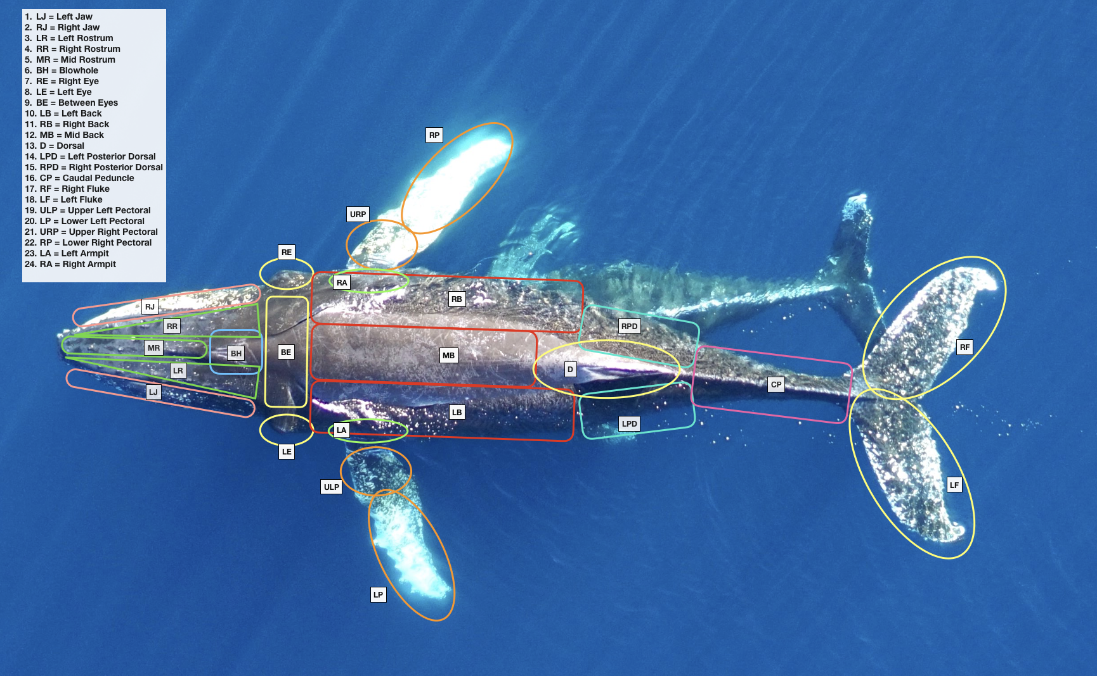
Figure S1: An example of a humpback whale along the Western Antarctic Peninsula segmented into 24 different regions of the body to identify and record unique scarring, markings, and coloration patterns.

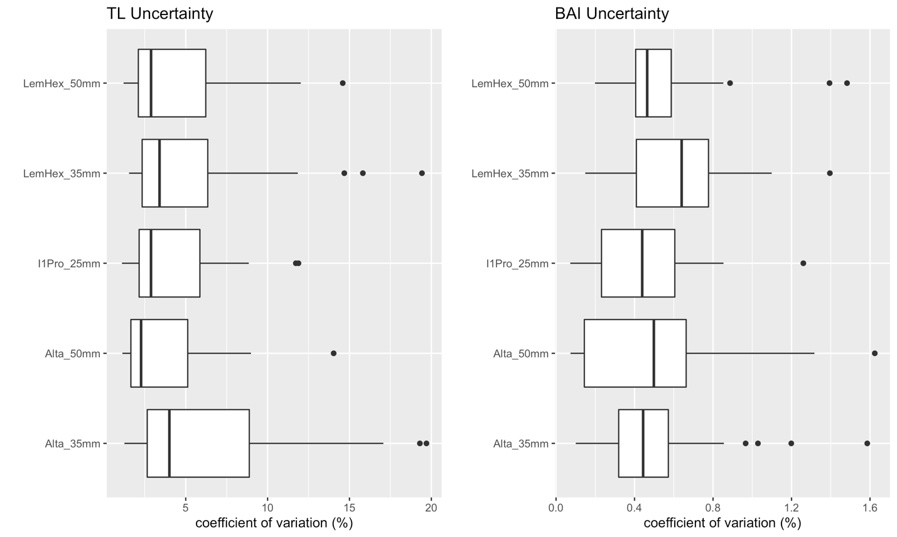
Figure S2. Uncertainty for total length (TL) and Body Area Index (BAI) for each UAS. Uncertainty is described here as the coefficient of variation (CV%) of the posterior predictive distribution for TL and BAI of each individual. I1Pro = DJI Inspire 1 Pro, LemHex = Mikrokopter LemHex-44, Alta = FreeFly Alta 6. Each UAS displayed with the focal length of the camera.

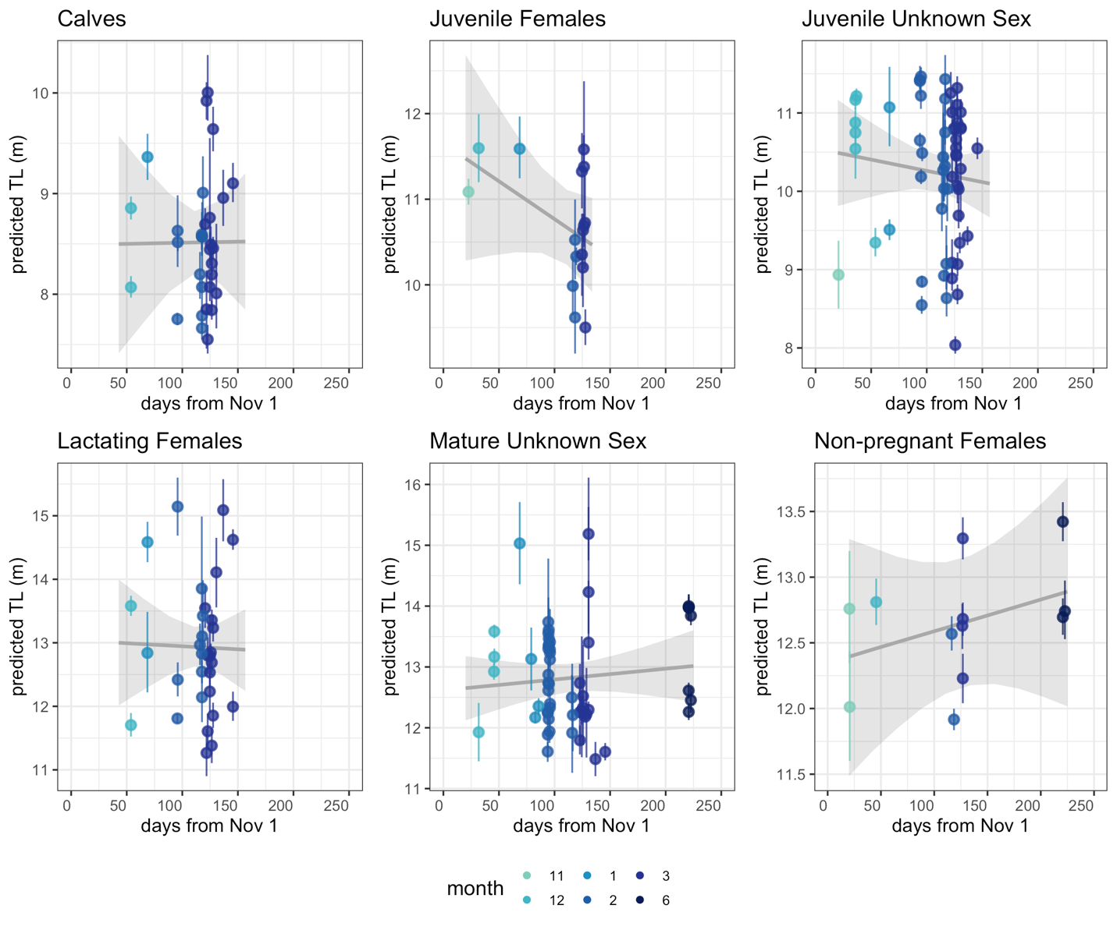
Figure S3. Change in total length (TL) over the course of the austral foraging season for each reproductive class. The slope for each reproductive class was not significantly different than 0 (Table S3), indicating TL does not significantly change over the course of the foraging season for each reproductive class.

