Supplementary Material

Supplementary Figure 1. Comparison between the previous age model (Nielsen and Rasmussen, 2018) and the new age model (this study) for the six sediment cores in eastern Storfjorden. The new age model (red) was applied to the Marine 20 dataset (Heaton et al., 2020) and a regional age difference (ΔR) of -61±37 (Pieńkowski et al., 2021). The figure was taken from Fig. 3 in Nielsen and Rasmussen (2018), and the newly modeled ages were added. Abbreviations: LH, late Holocene; MH, middle Holocene; EH, early Holocene; YD-H, Younger Dryas-Holocene transition; YD, Younger Dryas; AL, Allerød interstadial; BØ, Bølling interstadial.
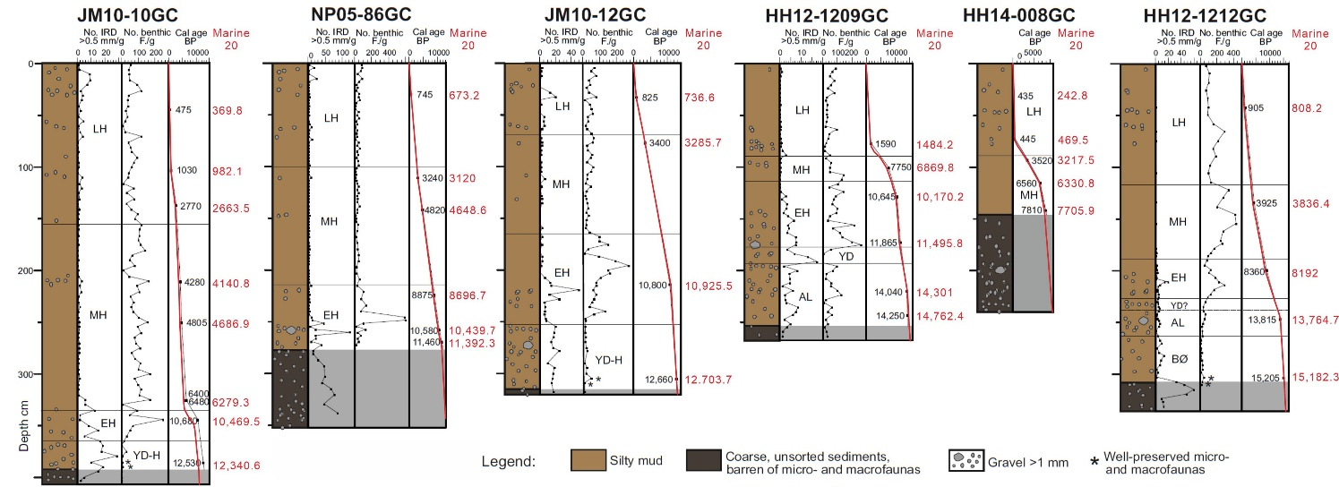

References

Heaton, T.J., Köhler, P., Butzin, M., Bard, E., Reimer, R.W., Austin, W.E., et al. (2020). Marine20—the marine radiocarbon age calibration curve (0–55,000 cal BP). Radiocarbon 62(4), 779-820.
Nielsen, T., and Rasmussen, T.L. (2018). Reconstruction of ice sheet retreat after the Last Glacial maximum in Storfjorden, southern Svalbard. Marine Geology 402, 228-243.
Pieńkowski, A.J., Husum, K., Furze, M.F., Missana, A.F., Irvalı, N., Divine, D.V., et al. (2021). Revised ΔR values for the Barents Sea and its archipelagos as a pre-requisite for accurate and robust marine-based 14C chronologies. Quaternary Geochronology, 101244.

