The transport and fate of microplastic fibres: the role of multiple global processes
Eoghan M. Cunningham^{1,2}*, Nuria Rico Seijo²*, Katye E. Altieri³, Riesna R. Audh³, Jessica M. Burger³, Thomas G. Bornman⁴, Sarah Fawcett^{3,5}, Claire M. B. Gwinnett⁶, Amy O. Osborne⁶, Lucy C. Woodall^{1,2}

¹Department of Zoology, University of Oxford, Zoology Research and Administration Building, 11a Mansfield Road, Oxford OX1 3SZ, United Kingdom
²Nekton Foundation, Begbroke Science Park, Begbroke Hill, Woodstock Road, Begbroke, Oxfordshire OX5 1PF, United Kingdom
³Department of Oceanography, University of Cape Town, Rondebosch 7701, South Africa
⁴SAEON (Elwandle Coastal Node) and Coastal and Marine Research Institute, Nelson Mandela University, Gqeberha, 6031, South Africa
⁵Marine and Antarctic centre for Research and Innovation (MARIS), University of Cape Town, Rondebosch 7701, South Africa
⁶Criminal Justice and Forensic Science Department, Staffordshire University, The Science Centre, Leek Road, Stoke-on-Trent ST4 2DF, England, United Kingdom

Supplementary Material
1. Sample Media

Table S1: Samples collected on board the Research Vessel (R/V) SA Agulhas II during the Weddell Sea Expedition between 8th Dec 2018 and 14th March 2019. Data include Media type (air/sediment (sed)/water (wat)), Category (C), Type (Fibre/fragment (frag)/film), Delusterant presence (Delus.) (No/Low/Medium/High), Cross sectional shape (CS Shape), Length/width (mm), Polymer Type (Poly) - (acrylic (ACR), polyester (PES), polypropylene (PP), acetate (ACE), nylon (NY), unknown synthetic (SYN)). Where data are missing, a cross sectional shape could not be identified. Each microplastic was identified in media sample either south (in) or north (out) of the ACC, and length/width (mm) measurements for each.

Media | C | ACC | Type | Colour | Delus. | CS shape | Poly | Length | Width
Air | 1 | In | Fibre | black | No | Cylindrical | ACR | 100.26 | 4.51
Air | 2 | In | Fibre | black-brown | High | Cylindrical | PES | 504.67 | 26.3
Air | 2 | In | Fibre | black-brown | High | Cylindrical | PES | 459.91 | 29.36
Air | 3 | In | Fibre | black-brown | High | Irregular | PES | 366 | 9.11
Air | 4 | In | Fibre | black-brown | High | Cylindrical | PES | 321.05 | 24.04
Air | 4 | In | Fibre | black-brown | High | Cylindrical | PES | 472.31 | 38.86
Air | 5 | Out | Fibre | black-brown | High | Cylindrical | NY | 377.49 | 35.07
Air | 7 | In | Fibre | black-brown | High | Irregular | SYN | 377.77 | 37.38
Air | 8 | In | Fibre | black-brown | High | Cylindrical | SYN | 643.08 | 19.75
Air | 9 | Out | Fibre | black-brown | High |  | SYN | 923.68 | 25.13
Air | 10 | In | Fibre | blue | Low | Cylindrical | PES | 505.33 | 10.79
Air | 10 | In | Fibre | blue | Low | Cylindrical | PES | 1226.15 | 6.23
Air | 10 | In | Fibre | blue | Low | Cylindrical | PES | 1316.21 | 10.51
Air | 12 | In | Fibre | blue | No | Tape | PES | 441.7 | 15.15
Air | 13 | In | Fibre | blue | No | Cylindrical | NY | 117.34 | 13.78
Air | 14 | Out | Fibre | blue | Med | Cylindrical | PES | 875.02 | 9.41
Air | 16 | In | Fibre | blue-grey | Med | Bilobal | PES | 490.56 | 8.03
Air | 17 | In | Fibre | blue-grey | Med | Cylindrical | PES | 356.3 | 8.22
Air | 18 | In | Fibre | blue-grey | Low | Cylindrical | PES | 1407.12 | 7.2
Air | 18 | In | Fibre | blue-grey | Low | Cylindrical | PES | 675.43 | 8.03
Air | 18 | Out | Fibre | blue-grey | Low | Cylindrical | PES | 2470.47 | 8.07
Air | 18 | In | Fibre | blue-grey | Low | Cylindrical | PES | 398.28 | 8.21
Air | 18 | In | Fibre | blue-grey | Low | Cylindrical | PES | 276.04 | 8.36
Air | 18 | In | Fibre | blue-grey | Low | Cylindrical | PES | 285.18 | 7.89
Air | 18 | In | Fibre | blue-grey | Low | Cylindrical | PES | 130.38 | 9.3
Air | 18 | In | Fibre | blue-grey | Low | Cylindrical | PES | 257.48 | 8.07
Air | 18 | In | Fibre | blue-grey | Low | Cylindrical | PES | 326.87 | 9.48
Air | 18 | In | Fibre | blue-grey | Low | Cylindrical | PES | 397.91 | 4.9
Air | 19 | In | Fibre | blue-grey | Low | Tape | PES | 267.43 | 5.35
Air | 21 | In | Fibre | blue-grey | Low | Cylindrical | NY | 140.62 | 8.1
Air | 23 | Out | Fibre | colourless | High | Cylindrical | PES | 616.2 | 11.12
Air | 24 | In | Fibre | colourless | High | Cylindrical | NY | 1838.37 | 12.76
Air | 25 | In | Fibre | colourless | Med | Cylindrical | PES | 962.6 | 12.22
Air | 27 | Out | Fibre | colourless | Low | Cylindrical | PES | 661.43 | 12.15
Air | 27 | Out | Fibre | colourless | Low | Cylindrical | PES | 1293.46 | 10.16
Air | 27 | In | Fibre | colourless | Low | Cylindrical | PES | 611.85 | 10.28
Air | 28 | In | Fibre | colourless | Low | Bilobal | PES | 1350.69 | 26.57
Air | 29 | In | Fibre | colourless | Low | Tape | PES | 1551.4 | 20.57
Air | 30 | In | Fibre | colourless | Low | Cylindrical | NY | 219.93 | 13.4
Air | 31 | In | Fibre | colourless | Low | Multilobal | NY | 758.54 | 31.93
Air | 34 | In | Fibre | colourless | No | Irregular | PES | 175.2 | 8.14
Air | 34 | In | Fibre | colourless | No | Irregular | PES | 146.55 | 5.89
Air | 35 | Out | Fibre | colourless | No | Delta | PES | 852.97 | 7.04
Air | 37 | Out | Fibre | colourless | No | Cylindrical | PP | 2075.4 | 15.11
Air | 37 | In | Fibre | colourless | No | Cylindrical | PP | 1995.46 | 13.26
Air | 38 | Out | Fibre | colourless | No | Cylindrical | ACR | 3680 | 10
Air | 39 | Out | Fibre | colourless | No | Cylindrical | NY | 229.71 | 6.49
Air | 39 | Out | Fibre | colourless | No | Cylindrical | NY | 284.01 | 5.1
Air | 39 | In | Fibre | colourless | No | Cylindrical | NY | 235.89 | 8.21
Air | 40 | In | Fibre | colourless | No |  | SYN | 610.55 | 5.8
Air | 41 | In | Fibre | purple | No | Cylindrical | ACR | 526.83 | 14.74
Air | 43 | In | Fibre | red | No | Cylindrical | PES | 2215.65 | 7.83
Air | 46 | In | Frag | colourless | No |  | SYN | 143.64 | 79.23
Sed | 6 | In | Fibre | black-brown | High |  | PP | 471.02 | 25.02
Sed | 26 | In | Fibre | colourless | Med | Cylindrical | SYN | 871.86 | 12.63
Sed | 27 | In | Fibre | colourless | Low | Cylindrical | PES | 917.39 | 13.59
Sed | 27 | In | Fibre | colourless | Low | Cylindrical | PES | 949.81 | 13.47
Sed | 27 | In | Fibre | colourless | Low | Cylindrical | PES | 1193.66 | 11.12
Sed | 27 | In | Fibre | colourless | Low | Cylindrical | PES | 1083.22 | 13.02
Sed | 32 | In | Fibre | colourless | Low | Cylindrical | SYN | 726.87 | 10.51
Sed | 32 | In | Fibre | colourless | Low | Cylindrical | SYN | 1066.92 | 9.82
Sed | 33 | In | Fibre | colourless | Low | Irregular | SYN | 195.33 | 10.67
Sed | 42 | In | Fibre | red | Low | Tape | PES | 821.92 | 10.69
Sed | 42 | In | Fibre | red | Low | Tape | PES | 1871.53 | 16.26
Wat | 10 | In | Fibre | blue | Low | Cylindrical | PES | 581.45 | 9.89
Wat | 10 | Out | Fibre | blue | Low | Cylindrical | PES | 1608.17 | 12.44
Wat | 11 | In | Fibre | blue | Low | Tape | NY | 552.89 | 16.82
Wat | 15 | Out | Fibre | blue | Med | Cylindrical | ACR | 1520.12 | 13.42
Wat | 20 | In | Fibre | blue-grey | Low | Irregular | PES | 204.38 | 7.2
Wat | 21 | In | Fibre | blue-grey | Low | Cylindrical | NY | 329.59 | 10.49
Wat | 22 | Out | Fibre | blue-grey | Low | Irregular | NY | 364.25 | 12
Wat | 23 | In | Fibre | colourless | High | Cylindrical | PES | 830.54 | 13.03
Wat | 23 | In | Fibre | colourless | High | Cylindrical | PES | 382.7 | 11.85
Wat | 25 | In | Fibre | colourless | Med | Cylindrical | PES | 694.71 | 17.77
Wat | 25 | In | Fibre | colourless | Med | Cylindrical | PES | 1920.36 | 14.03
Wat | 27 | In | Fibre | colourless | Low | Cylindrical | PES | 554.91 | 12.96
Wat | 36 | In | Fibre | colourless | No | Cylindrical | PES | 1983.13 | 15.01
Wat | 44 | In | Fibre | redish | No | Irregular | PP | 320.46 | 41.28
Wat | 44 | In | Fibre | redish | No | Irregular | PP | 218.94 | 39.39
Wat | 44 | In | Fibre | redish | No | Irregular | PP | 311.53 | 42.07
Wat | 45 | In | Fibre | redish | No | Cylindrical | PP | 472.3 | 44.15
Wat | 47 | In | Film | colourless | No |  | PP | 1047.57 | 293.39

2. Sample locations

  - Air

Table S2: The location of the R/V SA Agulhas II during aerosol sample collection. Data include the deployment/collection date and coordinates for each filter sample. Filter ID are labelled as Early Summer (ES), Weddell Sea (WS), and Late Summer (LS) (see Fig. 4 and S1).

Filter ID | Deployment | Collection | Latitude (S) |  | Longitude (W)
 | date | date | Start | End | Start | End
ES 1 | 07/12/2018 | 08/12/2018 | 34.50059 | 37.00173 | 14.83624 | 12.68983
ES 2 | 08/12/2018 | 09/12/2018 | 37.14729 | 41.84568 | 12.58661 | 8.771073
ES 3 | 09/12/2018 | 10/12/2018 | 41.84568 | 44.10823 | 8.771073 | 6.832197
ES 4 | 10/12/2018 | 12/12/2018 | 44.98146 | 50.79591 | 6.066827 | 0.621242
ES 5 | 14/12/2018 | 16/12/2018 | 59.66499 | 68.2712 | 0.01821 | 0.01445
ES 6 | 16/12/2018 | 19/12/2018 | 68.50327 | 70.13383 | 0.00653 | 2.10808
ES 7 | 19/12/2018 | 21/12/2018 | 70.13382 | 70.16379 | 2.10809 | 2.11897
WS 8 | 04/01/2019 | 06/01/2019 | 67.3534 | 63.9908 | 15.9566 | 37.0147
WS 9 | 06/01/2019 | 08/01/2019 | 63.86314 | 62.53014 | 37.7914 | 49.1964
WS 10 | 08/01/2019 | 10/01/2019 | 62.53014 | 65.68059 | 49.1964 | 60.2237
WS 11 | 10/01/2019 | 12/01/2019 | 65.68059 | 66.60933 | 60.2237 | 59.6395
WS 12 | 12/01/2019 | 14/01/2019 | 66.60933 | 66.0746 | 59.6395 | 60.3686
WS 13 | 14/01/2019 | 16/01/2019 | 66.0746 | 65.79785 | 60.3686 | 60.5488
WS 14 | 16/01/2019 | 18/01/2019 | 65.79785 | 65.81063 | 60.5488 | 60.7096
WS 15 | 18/01/2019 | 20/01/2019 | 65.81011 | 66.44009 | 60.7204 | 60.2522
WS 16 | 20/01/2019 | 22/01/2019 | 66.44009 | 66.4257 | 60.2522 | 59.949
WS 17 | 22/01/2019 | 26/01/2019 | 66.4257 | 64.66171 | 59.949 | 57.2254
WS 18 | 26/01/2019 | 28/01/2019 | 64.66171 | 63.93464 | 57.2254 | 51.9928
WS 19 | 28/01/2019 | 31/01/2019 | 63.93464 | 62.12218 | 51.9928 | 49.924
WS 20 | 31/01/2019 | 01/02/2019 | 62.10363 | 62.20137 | 50.1084 | 58.9498
WS 21 | 01/02/2019 | 06/02/2019 | 62.20137 | 61.9243 | 58.9498 | 48.7476
WS 22 | 06/02/2019 | 09/02/2019 | 61.9908 | 68.95546 | 48.203 | 52.0289
WS 23 | 09/02/2019 | 11/02/2019 | 68.95464 | 68.64156 | 52.0179 | 52.4232
WS 24 | 11/02/2019 | 13/02/2019 | 68.63982 | 68.82849 | 52.4187 | 51.8392
WS 25 | 13/02/2019 | 16/02/2019 | 68.82849 | 68.8528 | 51.8392 | 41.2619
WS 26 | 16/02/2019 | 19/02/2019 | 68.8528 | 69.53058 | 41.2619 | 8.63978
WS 27 | 19/02/2019 | 21/02/2019 | 69.64341 | 70.25737 | 8.16095 | 2.70015
LS 28 | 27/02/2019 | 01/03/2019 | 69.34059 | 59.97974 | 3.9801 | 2.28879
LS 29 | 01/03/2019 | 03/03/2019 | 59.96923 | 59.50047 | 2.84246 | 26.1023
LS 30 | 03/03/2019 | 04/03/2019 | 59.50047 | 55.89431 | 26.1023 | 33.7582
LS 31 | 04/03/2019 | 10/03/2019 | 55.76132 | 49.52903 | 33.9754 | 4.0654
LS 32 | 10/03/2019 | 12/03/2019 | 49.52903 | 43.07011 | 4.0654 | 7.836057
LS 33 | 12/03/2019 | 13/03/2019 | 43.07011 | 36.31568 | 7.836057 | 13.26512
LS 34 | 13/03/2019 | 14/03/2019 | 36.10884 | 34.35332 | 13.42386 | 17.75682

  - Water

Table S3: The location of each underway seawater sampling station occupied during the Weddell Sea Expedition. Data include sampling station ID, latitude, longitude, sample date, local time, and amount of water filtered.

Station ID | Latitude (S) | Longitude (W) | Date | Time | Volume filtered (L)
UW1 | 68.3941 | 7.86285 | 04/01/2019 | 08:00 | 4
UW2 | 68.0806 | 10.5024 | 04/01/2019 | 12:00 | 4
UW14 | 64.1912 | 36.7044 | 06/01/2019 | 12:00 | 10
UW26 | 62.6125 | 48.6936 | 08/01/2019 | 12:00 | 20
UW33 | 65.3389 | 59.5112 | 10/01/2019 | 12:00 | 10
UW38 | 66.0099 | 60.357 | 15/01/2019 | 12:00 | 10
UW39 | 65.7943 | 60.6708 | 18/01/2019 | 08:00 | 10
UW40 | 64.7425 | 58.3395 | 26/01/2019 | 08:00 | 15
UW45 | 63.9743 | 51.4601 | 28/01/2019 | 12:00 | 20
UW58 | 62.3161 | 58.6701 | 01/02/2019 | 06:00 | 15
UW64 | 69.3292 | 49.038 | 08/02/2019 | 12:00 | 15
UW68 | 68.8365 | 42.1404 | 16/02/2019 | 12:00 | 15
UW74 | 69.2805 | 12.1354 | 19/02/2019 | 12:00 | 15
UW80 | 60.0051 | 0.85633 | 01/03/2019 | 14:00 | 15
UW84 | 59.4789 | 26.3421 | 03/03/2019 | 14:00 | 10
UW86 | 56.4757 | 32.7813 | 04/03/2019 | 14:00 | 15
UW97 | 50.1515 | 2.846067 | 10/03/2019 | 14:00 | 15
UW101 | 42.1037 | 8.648467 | 12/03/2019 | 12:00 | 15
UW103 | -37.2353 | 12.55533 | 13/03/2019 | 12:00 | 15
UW104 | -34.9202 | 14.32427 | 14/03/2019 | 00:00 | 15

  - Sediment

Table S4: The location of each of the six sediment core sampling stations in the Weddell Sea. Data include the sampling station ID, location, sample coordinates and seafloor depth (m).
Station ID | Location | Latitude (S) | Longitude (W) | Depth (m)
AM000978 | Jason Trough | 66° 36.297' | 59° 37.636' | 446
AM000979 | Jason Trough | 66° 29.193' | 59° 34.561' | 513
AM000988 | Jason Trough | 66° 46.315' | 59° 55.002' | 323
AM000991 | Jason Trough | 66° 27.454' | 59° 49.392' | 521
AM000992 | Jason Trough | 66° 21.129' | 59° 59.493' | 479
AM000993 | Robertson Trough | 65° 35.335' | 59° 58.975' | 530

  - Sea ice

Table S5: The locations of the sea-ice cores collected in the Weddell Sea. Data include the core identifier, date collected, coordinates, and total length of the core.
Core ID | Date | Latitude (S) | Longitude (W) | Total length (m)
SI-04-MPC-01 | 14/02/2019 | 69.0458 | 50.1713 | 1.28
SI-04-MPC-02 | 14/02/2019 | 69.0458 | 50.1713 | 1.26

3. Controls
Table S6: A description of each control used during the sample processing and procedural stages. Data includes the number assigned to each control (no.), whether contamination was present (Cont.; yes/no), and the subsequent analysis of contamination through Polarised Light Microscopy.

No. | Location / Procedure | Cont. | Analysis
1 | Fume hood - Sediment samples | no
2 | Oven - Sediment samples | no
3 | Fume hood - Sediment samples | no
4 | Lab bench - Sediment samples | no
5 | Fume hood & oven - Sediment samples | no
6 | Fume hood & oven - Sediment samples | no
7 | Fume hood - Mixing chemicals | no
8 | Fume hood - Filtering chemicals | no
9 | Fume hood - Mixing chemicals | yes | natural - PLM
10 | Fume hood - Filtering chemicals | no
11 | Fume hood - Filtering water | no
12 | Centrifuge lab - Sediment samples | no
13 | Lab bench - Checking for airborne contamination | no
14 | Fume hood - Sediment samples | no
15 | Fume hood - Sediment samples | no
16 | Fume hood - Sediment samples | no
17 | Fume hood & oven - Sediment samples | yes | natural - PLM
18 | Fume hood & oven - Sediment samples | no
19 | Lab bench - Checking for airborne contamination | no
20 | Fume hood & oven - Sediment samples | yes | natural - PLM
21 | Fume hood & oven - Sediment samples | yes | natural - PLM
22 | Fume hood - Staining and picking MPs – Sediment samples | no
22_2 | Fume hood - Mixing chemicals | yes | natural - PLM
23 | Fume hood - Filtering chemicals | no
24 | Fume hood & oven - Sediment samples | no
25 | Fume hood & oven - Sediment samples | yes | natural - PLM
26 | Fume hood - Filtering water | no
27 | Centrifuge lab - Sediment samples | no
28 | Fume hood - Sediment samples | no
27_2 | Centrifuge lab - Sediment samples | no
28_2 | Fume hood - Sediment samples | no
29 | Fume hood & oven - Sediment samples | no
30 | Fume hood & oven - Sediment samples | no
31 | Centrifuge lab - Sediment samples | no
32 | Fume hood - Sediment samples | no
31_2 | Centrifuge lab - Sediment samples | no
32_2 | Fume hood - Sediment samples | no
33 | Fume hood - Filtering water | no
33_2 | Fume hood - Staining and picking MPs - Sediment samples | no
34 | Fume hood & oven - Sediment samples | no
35 | Fume hood & oven - Sediment samples | no
36 | Centrifuge lab - Sediment samples | yes | natural - PLM
37 | Fume hood - Sediment samples | yes | natural - PLM
38 | Fume hood - Mixing chemicals & filtering water | no
41 | Fume hood - Filtering chemicals | no
42 | Fume hood - Filtering chemicals | no
39 | Centrifuge lab - Sediment samples | yes | natural - PLM
38_2 | Fume hood - Sediment samples | no
40 | Centrifuge lab - Sediment samples | no
38_3 | Fume hood - Sediment samples | yes | natural - PLM
43 | Centrifuge lab - Sediment samples | no
44 | Fume hood - Sediment samples | no
44_2 | Fume hood - Filtering water | no
45 | Lab bench - Sediment samples | yes | natural - PLM
46 | Lab bench - Sediment samples | no
47 | Fume hood & lab bench - Ice samples | no
47_2 | Fume hood & lab bench - Air samples Dec, Jan, Feb | yes | natural - PLM
48 | Lab bench - Picking MPs - Ice samples | no
48_2 | Fume hood - Filtering & mixing chemicals | no
48_3 | Fume hood - Staining and picking MPs - Sediment samples | no
49 | Fume hood - Staining - Sediment samples | no
50 | Fume hood - Staining - Sediment samples | no
50_2 | Fume hood - Picking MPs - Sediment samples | no
49_2 | Fume hood - Staining and picking MPs - Sediment samples | no
49_3 | Fume hood - Picking MPs - Sediment samples | no
49_4 | Fume hood - Filtering water | no
49_5 | Fume hood - Staining and picking MPs - Sediment samples | yes | natural - PLM
50_3 | Fume hood - Staining - Sediment samples | no
51 | Fume hood - Staining - Sediment samples | no
50_4 | Fume hood - Picking MPs - Sediment samples | yes | natural - PLM
52 | Fume hood - Staining - Sediment samples | no
51_2 | Fume hood - Staining - Sediment samples | no
51_3 | Fume hood - Picking MPs - Sediment samples | yes | natural - PLM
52_2 | Fume hood - Staining - Sediment samples | no
53 | Fume hood - Staining - Sediment samples | no
52_3 | Fume hood - Picking MPs - Sediment samples | yes | natural - PLM
54 | Fume hood - Staining - Sediment samples | no
53_2 | Fume hood - Picking MPs - Sediment samples | no
54_2 | Fume hood - Staining and picking MPs - Sediment samples | no
53_3 | Fume hood - Staining - Sediment samples | no
54_3 | Fume hood - Staining - Sediment samples | no
53_4 | Fume hood - Picking MPs - Sediment samples | yes | natural - PLM
54_4 | Fume hood - Picking MPs - Sediment samples | no
55 | Fume hood - Staining and picking MPs - Sediment samples | yes | natural - PLM
56 | Fume hood - Filtering & mixing chemicals | yes | natural - PLM
57 | Fume hood & lab bench - Ice samples | no
56_2 | Fume hood & lab bench - Air samples March | no
57_2 | Fume hood & lab bench - Air field blanks | no
57_3 | Fume hood & lab bench - Ice samples | no
57_4 | Fume hood - Staining and picking MPs - Sediment samples | yes | natural - PLM
58 | Fume hood - Staining and picking MPs - Sediment samples | no
58_2 | Fume hood & lab bench - Ice samples | no
58_3 | Fume hood & lab bench - Air samples 3rd rep | no
59 | Fume hood - Picking MPs - Water samples & controls | no

4. Supplementary Figures
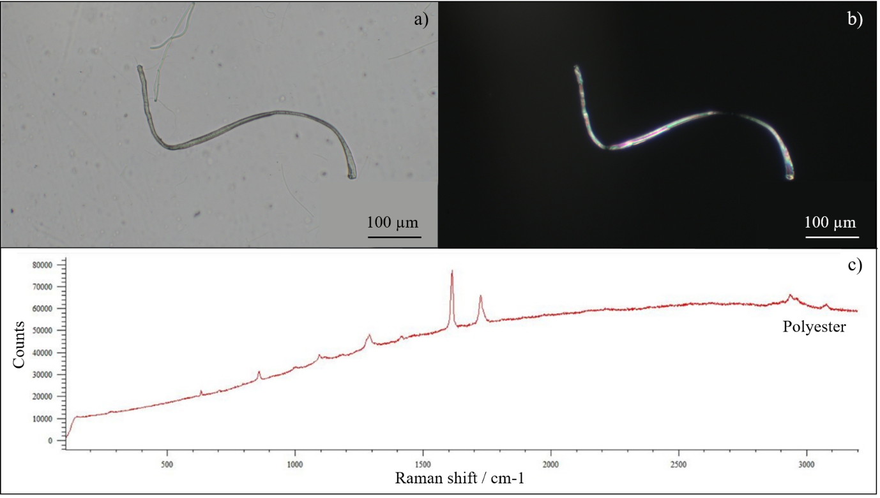
Figure S1: A fibre from category 27 which was found in all three sample media (colourless cylindrical polyester with low amounts of delusterant) photographed under normal (a) and polarised light (b), with a generic Raman polyester spectrum (c).

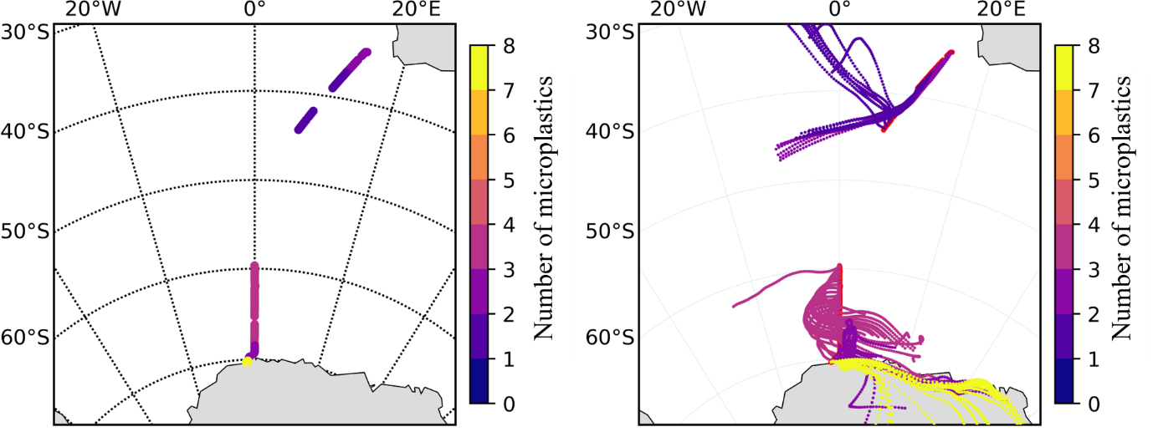
Figure S2: Early Summer (ES) leg, sailing from Cape Town to the Antarctic continent. Cruise track (left) and 72 hr AMBTs (right) are colour coded by the number of microplastics identified in each sample.

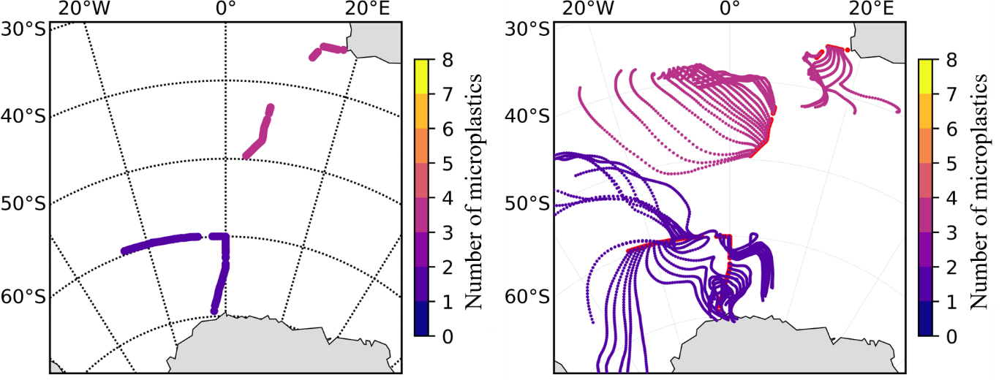
Figure S3: Late Summer (LS) leg, sailing from Antarctica back to Cape Town via South Georgia Island. Cruise track (left) and 72 hr AMBTs (right) are colour coded by the number of microplastics identified in each sample.

5. Additional sample processing information
Subsurface seawater samples – additional methods
Seawater samples were collected every 6 hours from the vessel’s underway system for phytoplankton analyses. The underway intake is located amidships approximately 7 m below the sea surface. The samples were stored in 50 ml polypropylene Greiner centrifuge tubes (T2318) with 20 ml filtered seawater preserved with 10 μL of 25% glutaraldehyde at room temperature in the dark for the duration of the cruise.
Sediment samples - additional methods
The sediment cores were extracted from the corers and the first 5 cm segmented in 1 cm slices. After 5 cm, the slices were sectioned in 5 cm increments. In between coring samplings the corers were cleaned.
The division of the subsamples was done by removing with a spoon-spatula the same amount of liquid mud into a pre-weighted aluminium foil. If the sample had pebbles of larger sediment, those were removed and washed into the glass beaker with the sample and then the subsample division was initiated. After being dried, the sample packages were weighed and transferred into 50 ml centrifuge tubes.
No chemical digestion step was needed because the samples contained very low levels of organic material.
In a modification to the Nile Red staining protocol described by Maes et al. (2017), we used ethanol instead of acetone as a solvent because of the evidence that long-term exposure of plastics to acetone damages them (pers. comm. CMBG).
Sea ice samples – additional methods
Snow cover was cleared from the sea-ice sampling pits with metal shovels, with care taken not to damage or contaminate the surface ice layer. Coring occurred from the outside of the pit using the Kovacs Mark II coring system. Researchers were vigilant at all steps of the sampling process to avoid contamination of the cores and sampling sites with microplastics from clothing and equipment. The corer was cleaned using deionised water prior to coring, and further primed by coring the ice for less sensitive cores before the microplastics cores were extracted. Latex gloves were worn when handling the ice cores.
The sea-ice cores were removed from long term storage in August 2021 and cut at -10 °C in the UCT Mobile Polar Laboratory using a jigsaw and wooden rig. The cores were then segmented along their length into 5 cm segments, starting from the bottom of the core (contact with the seawater) and moving to the top (contact with the snow). The rig and all surfaces were cleaned with ethanol prior to processing, and the jigsaw blade was also cleaned with ethanol and primed using a frozen block of deionised water.

