Supporting Information for
Limited predictability of body length in a fish population
Lin Wang^{1,2*}, Ting Wang¹
*To whom correspondence should be addressed. Email: lwang1253@yeah.net

This file includes:

Figure S1. Changes in body length at age across ages 3–12y from year 1946 to 2004 (original data comes from Eikeset et al. 10.1073/pnas.1525749113).

Figure S2. Chaos detection of time series without noise. (A, D and G) Original data without noise; (B, E and H) Attractor reconstruction; (C, F and I) Lyapunov exponent of body length: D is the neighborhood radius, m is the embedding dimension and C is the correlation integral, which is influenced by both D and m. In each rectangle, m varies from 5 to 12 (from top line to bottom line, m=11 can be obtained for each case when the rate of change of lnC(m, D) with lnD does not change with the increase of m). Body length class I (S₁), class II (S₂) and class III (S₃).

Figure S3. Bifurcation diagrams of the biomass C₁ vary with each ecological parameter. All parameters are presented in table 1 except for V₁=V₂=V₃=V₄=0; the initial value of Eq. (1) is (0.1, 0.1, 0.03, 0.02, 0.03, 0.01, 0.01, 2.2, 2.4, 2.8, 3).

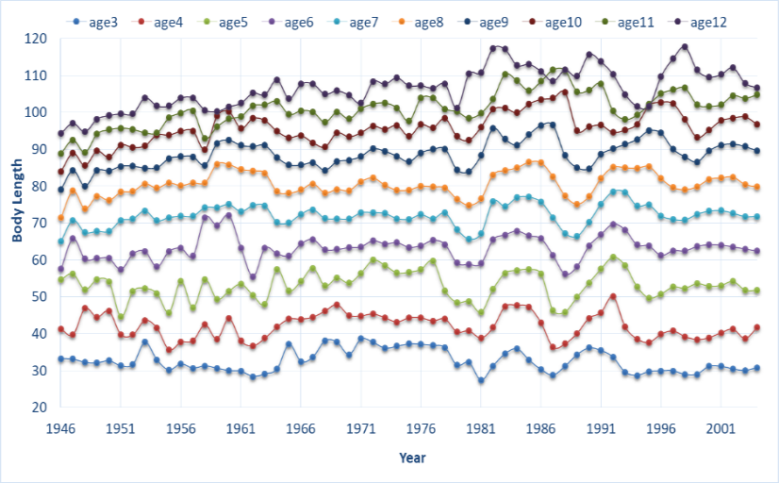
Figure S1. Changes in body length at age across ages 3–12y from year 1946 to 2004 (original data comes from Eikeset et al. 10.1073/pnas.1525749113).

Figure S2. Chaos detection of time series without noise. (A, D and G) Original data without noise; (B, E and H) Attractor reconstruction; (C, F and I) Lyapunov exponent of body length: D is the neighborhood radius, m is the embedding dimension and C is the correlation integral, which is influenced by both D and m. In each rectangle, m varies from 5 to 12 (from top line to bottom line, m=11 can be obtained for each case when the rate of change of lnC(m, D) with lnD does not change with the increase of m). Body length class I (S₁), class II (S₂) and class III (S₃).

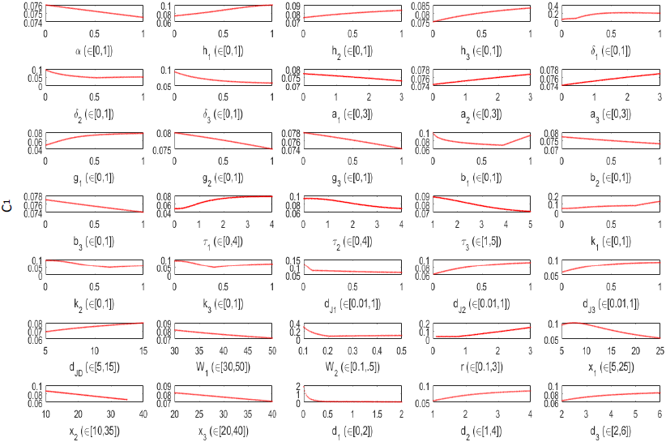
Figure S3. Bifurcation diagrams of the biomass C₁ vary with each ecological parameter. All parameters are presented in table 1 except for V₁=V₂=V₃=V₄=0; the initial value of Eq. (1) is (0.1, 0.1, 0.03, 0.02, 0.03, 0.01, 0.01, 2.2, 2.4, 2.8, 3).

