Supplementary figures
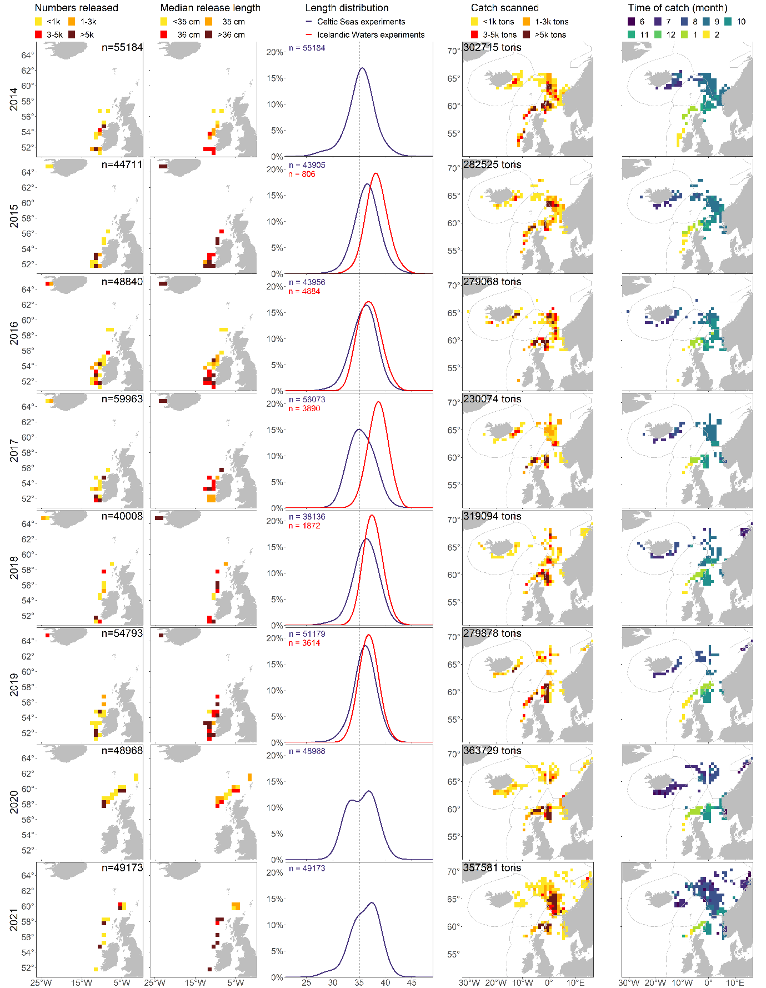
Figure S1. The interannual variation in spatial distribution of numbers of PIT-tagged mackerel in Celtic Waters and Icelandic Waters and the concurrent median body length at release, total relative length distributions, distributions of commercial catches scanned for PIT-tags and the timing of these catches (month). Total numbers tagged and biomass scanned per year are marked.

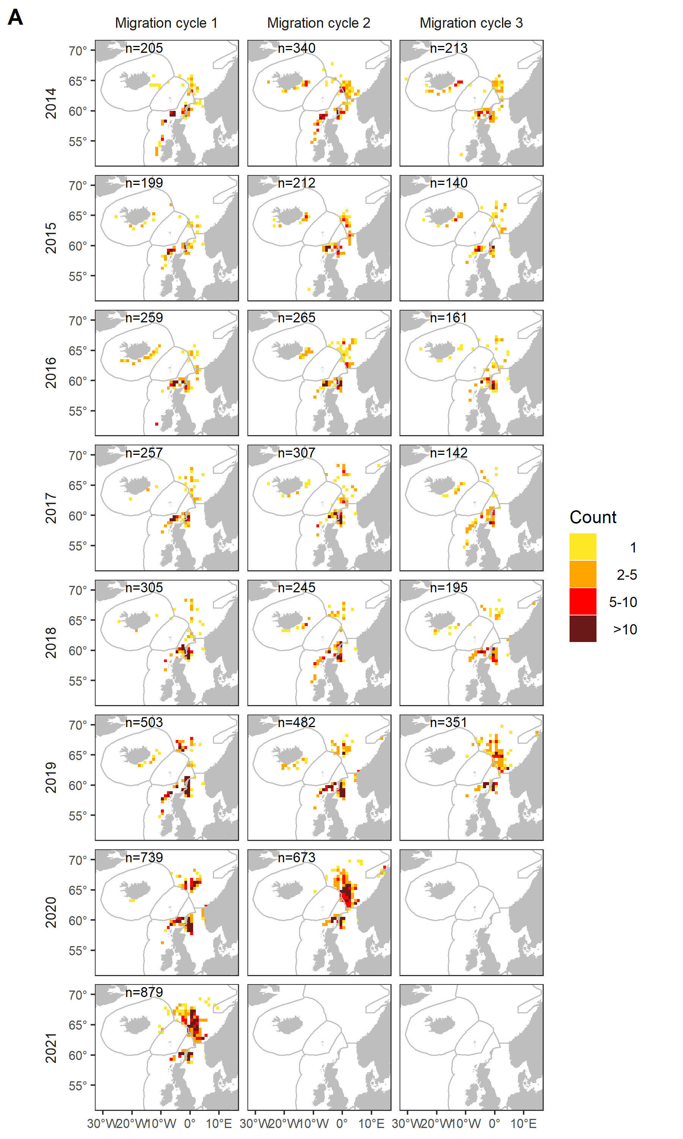
Figure S2. (A) Spatial variation in numbers of recaptures from the Celtic Seas experiments, compared between release years and over migration cycles 1-3.
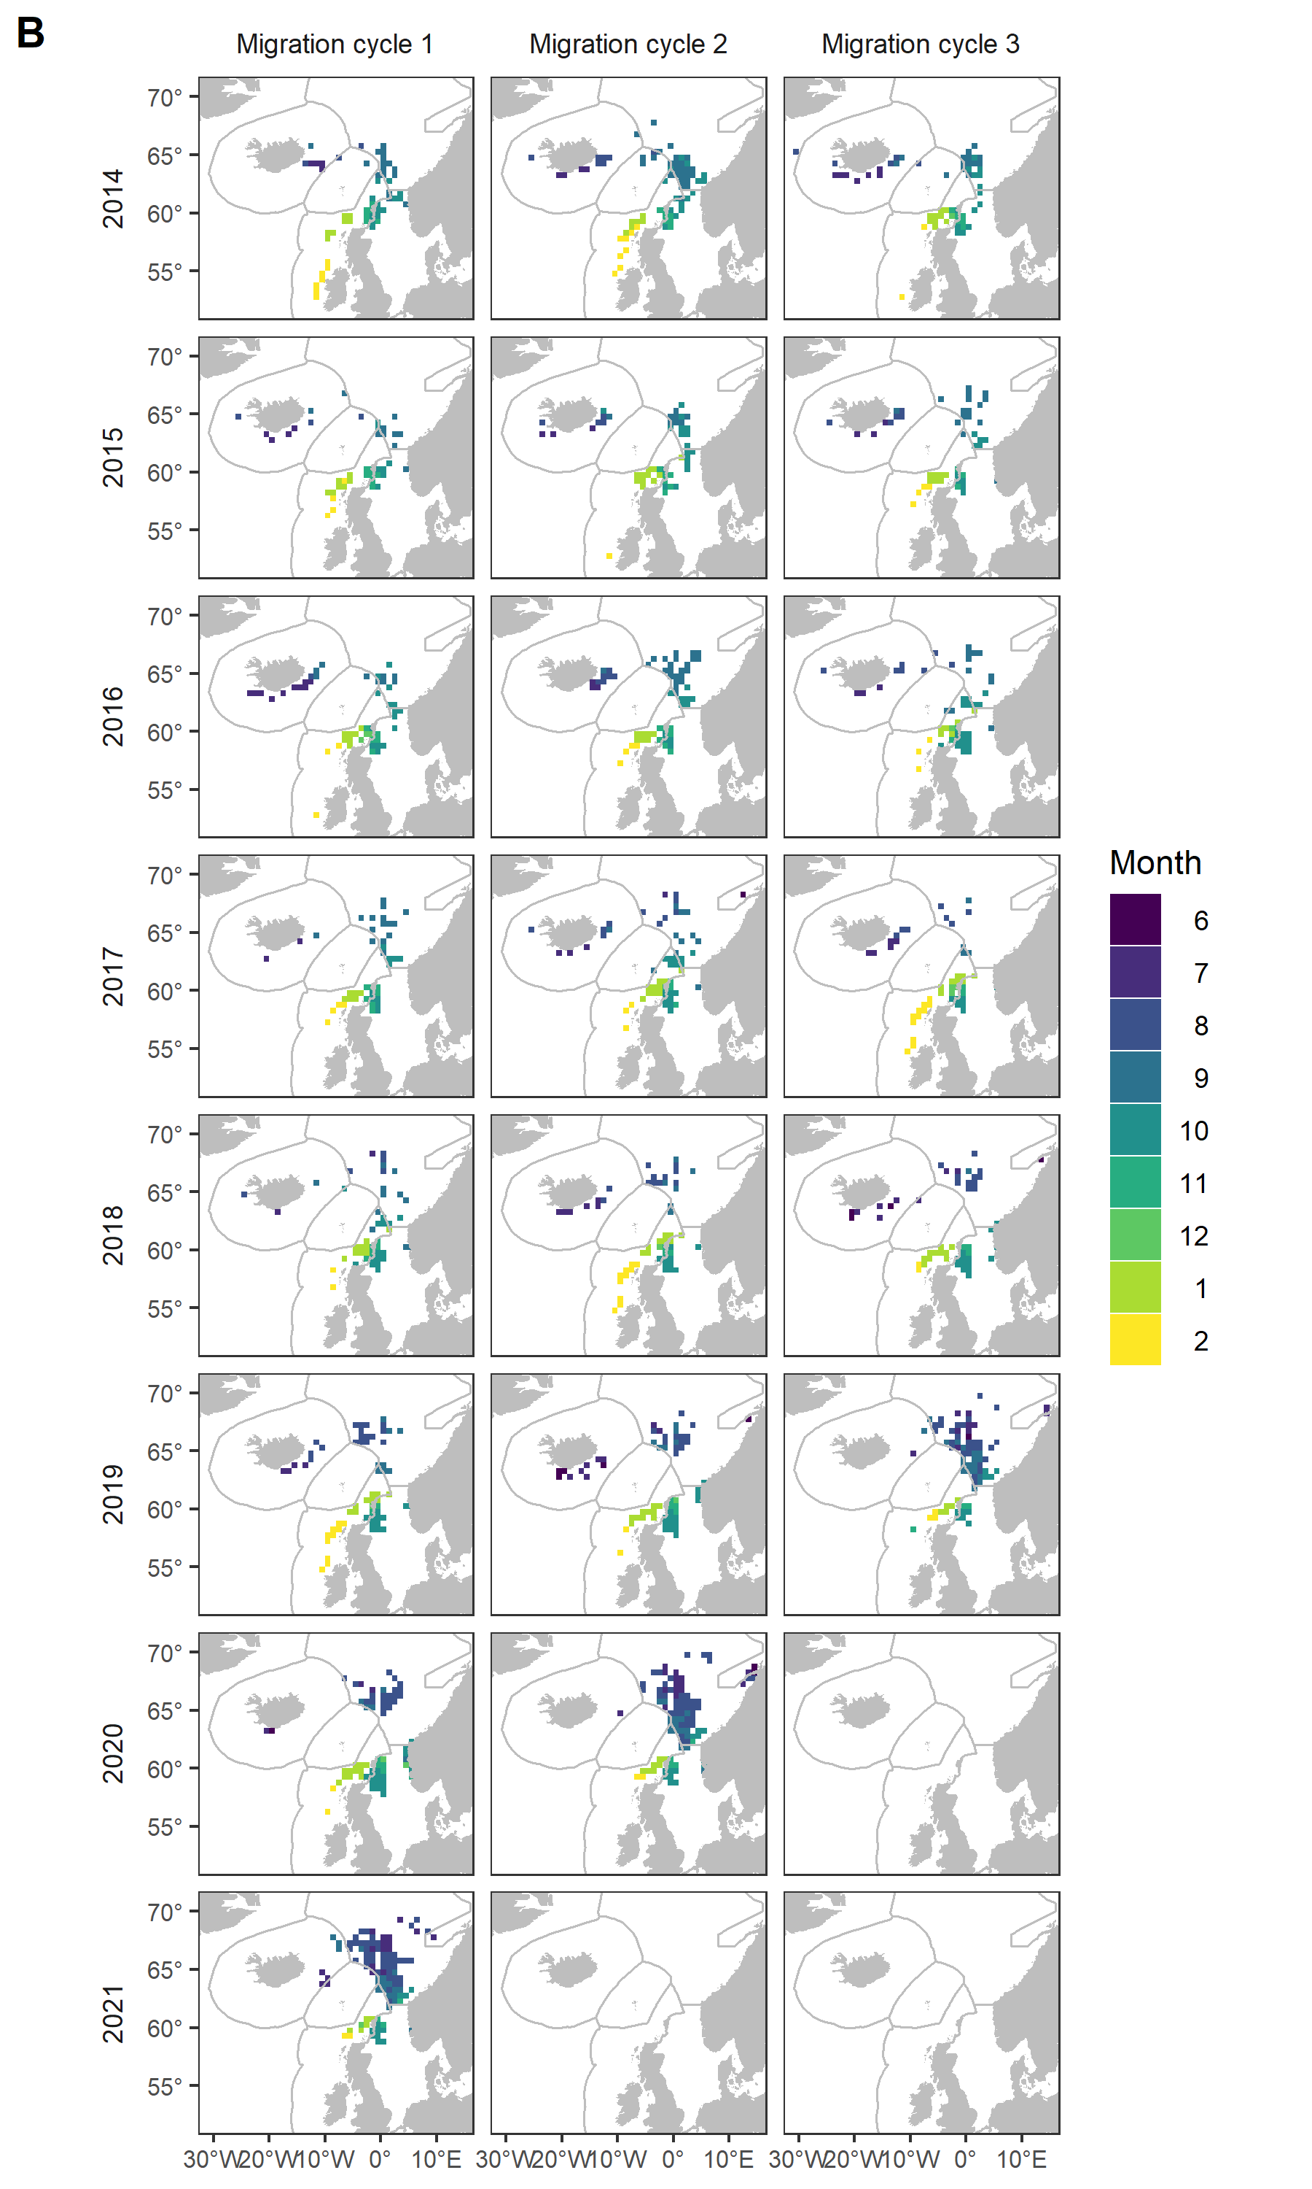
Figure S2. (B) Spatial variation in the timing of recaptures from the Celtic Seas experiments, compared between release years and over migration cycles 1-3.
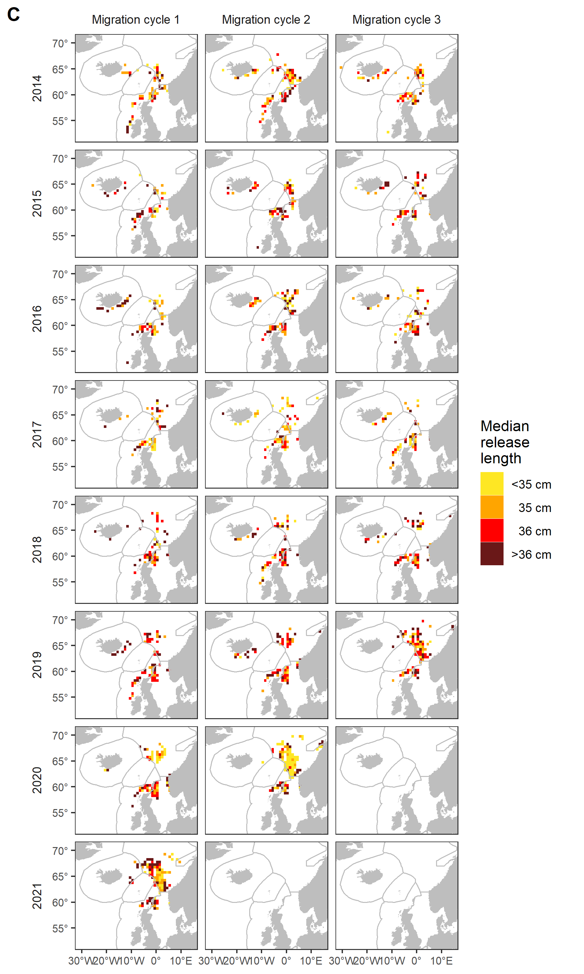
Figure S2. (C) Spatial variation in median release length of recaptured mackerel from the Celtic Seas experiments, compared between release years and over migration cycles 1-3.
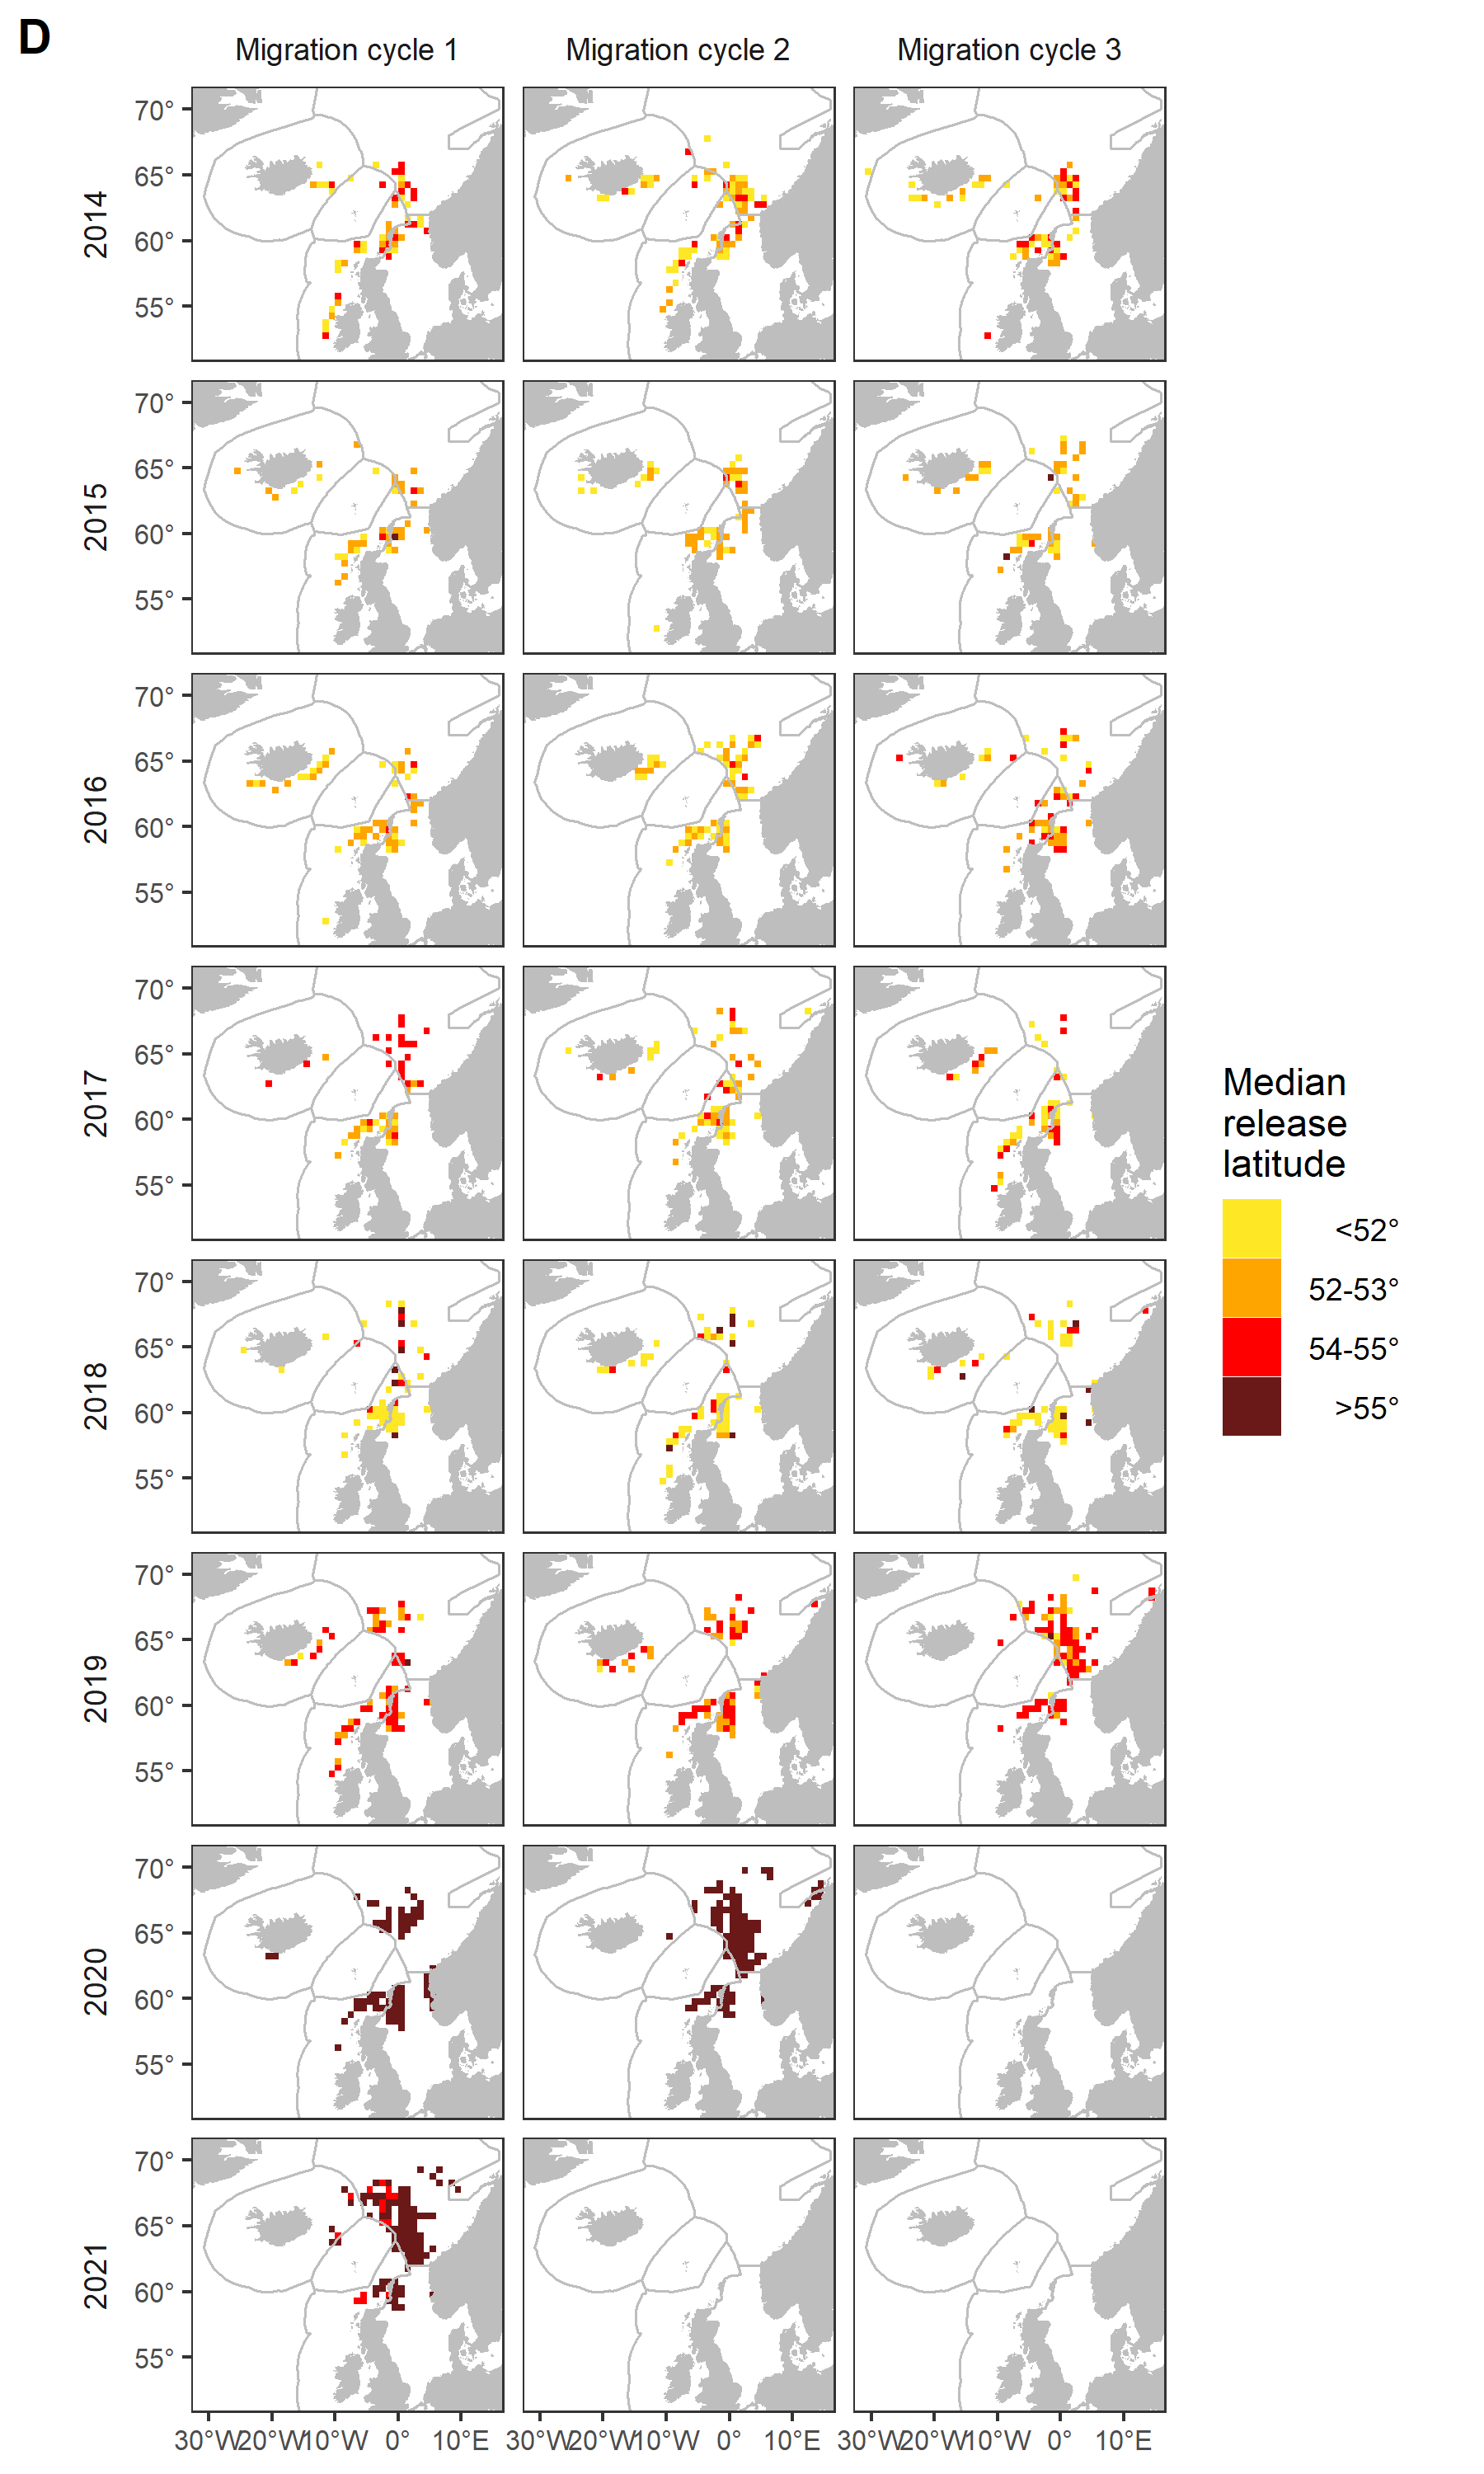
Figure S2. (D) Spatial variation in median release latitude of recaptured mackerel from the Celtic Seas experiments, compared between release years and over migration cycles 1-3.
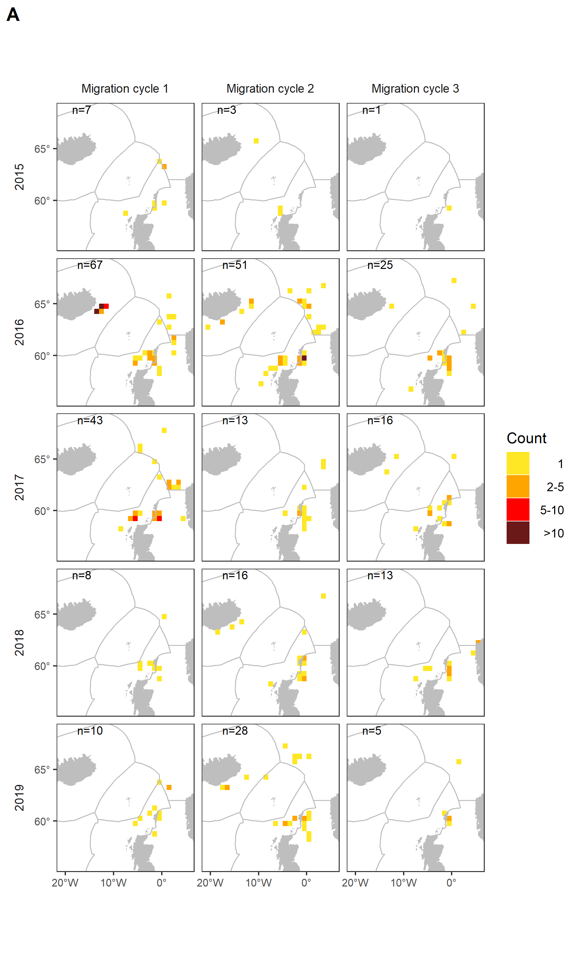
Figure S3. (A) Spatial variations in of numbers of recaptures from the Icelandic Waters experiments, compared between release years and over migration cycles 1-3.
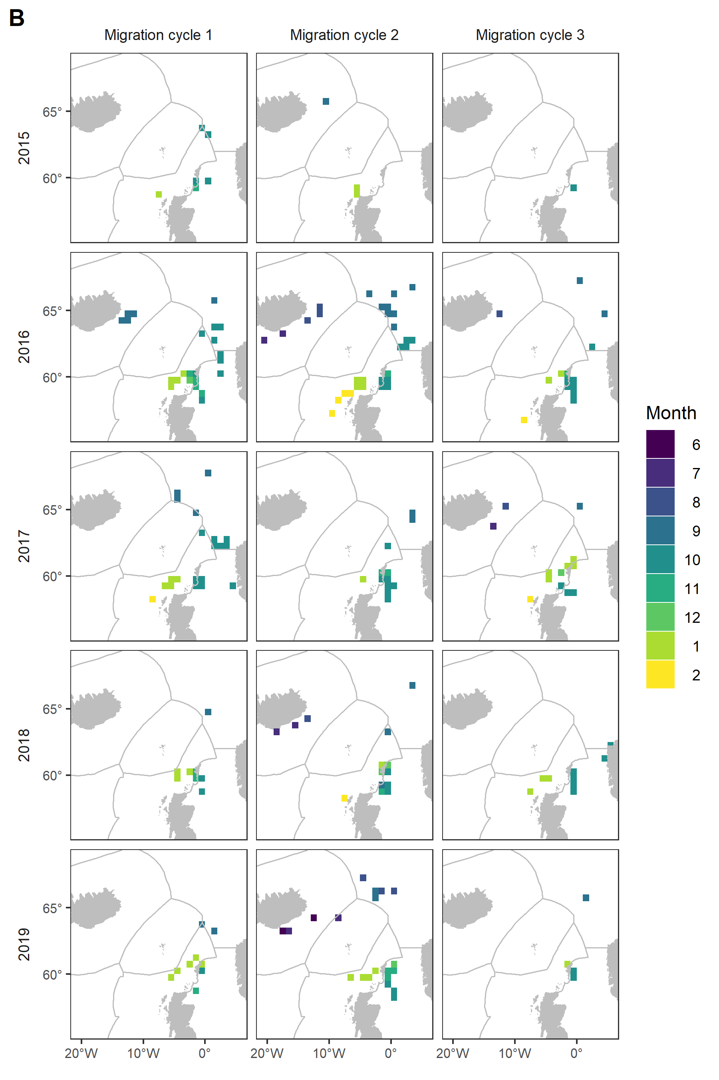
Figure S3. (B) Spatial variations in timing (month) of recaptures from the Icelandic Waters experiments, compared between release years and over migration cycles 1-3.
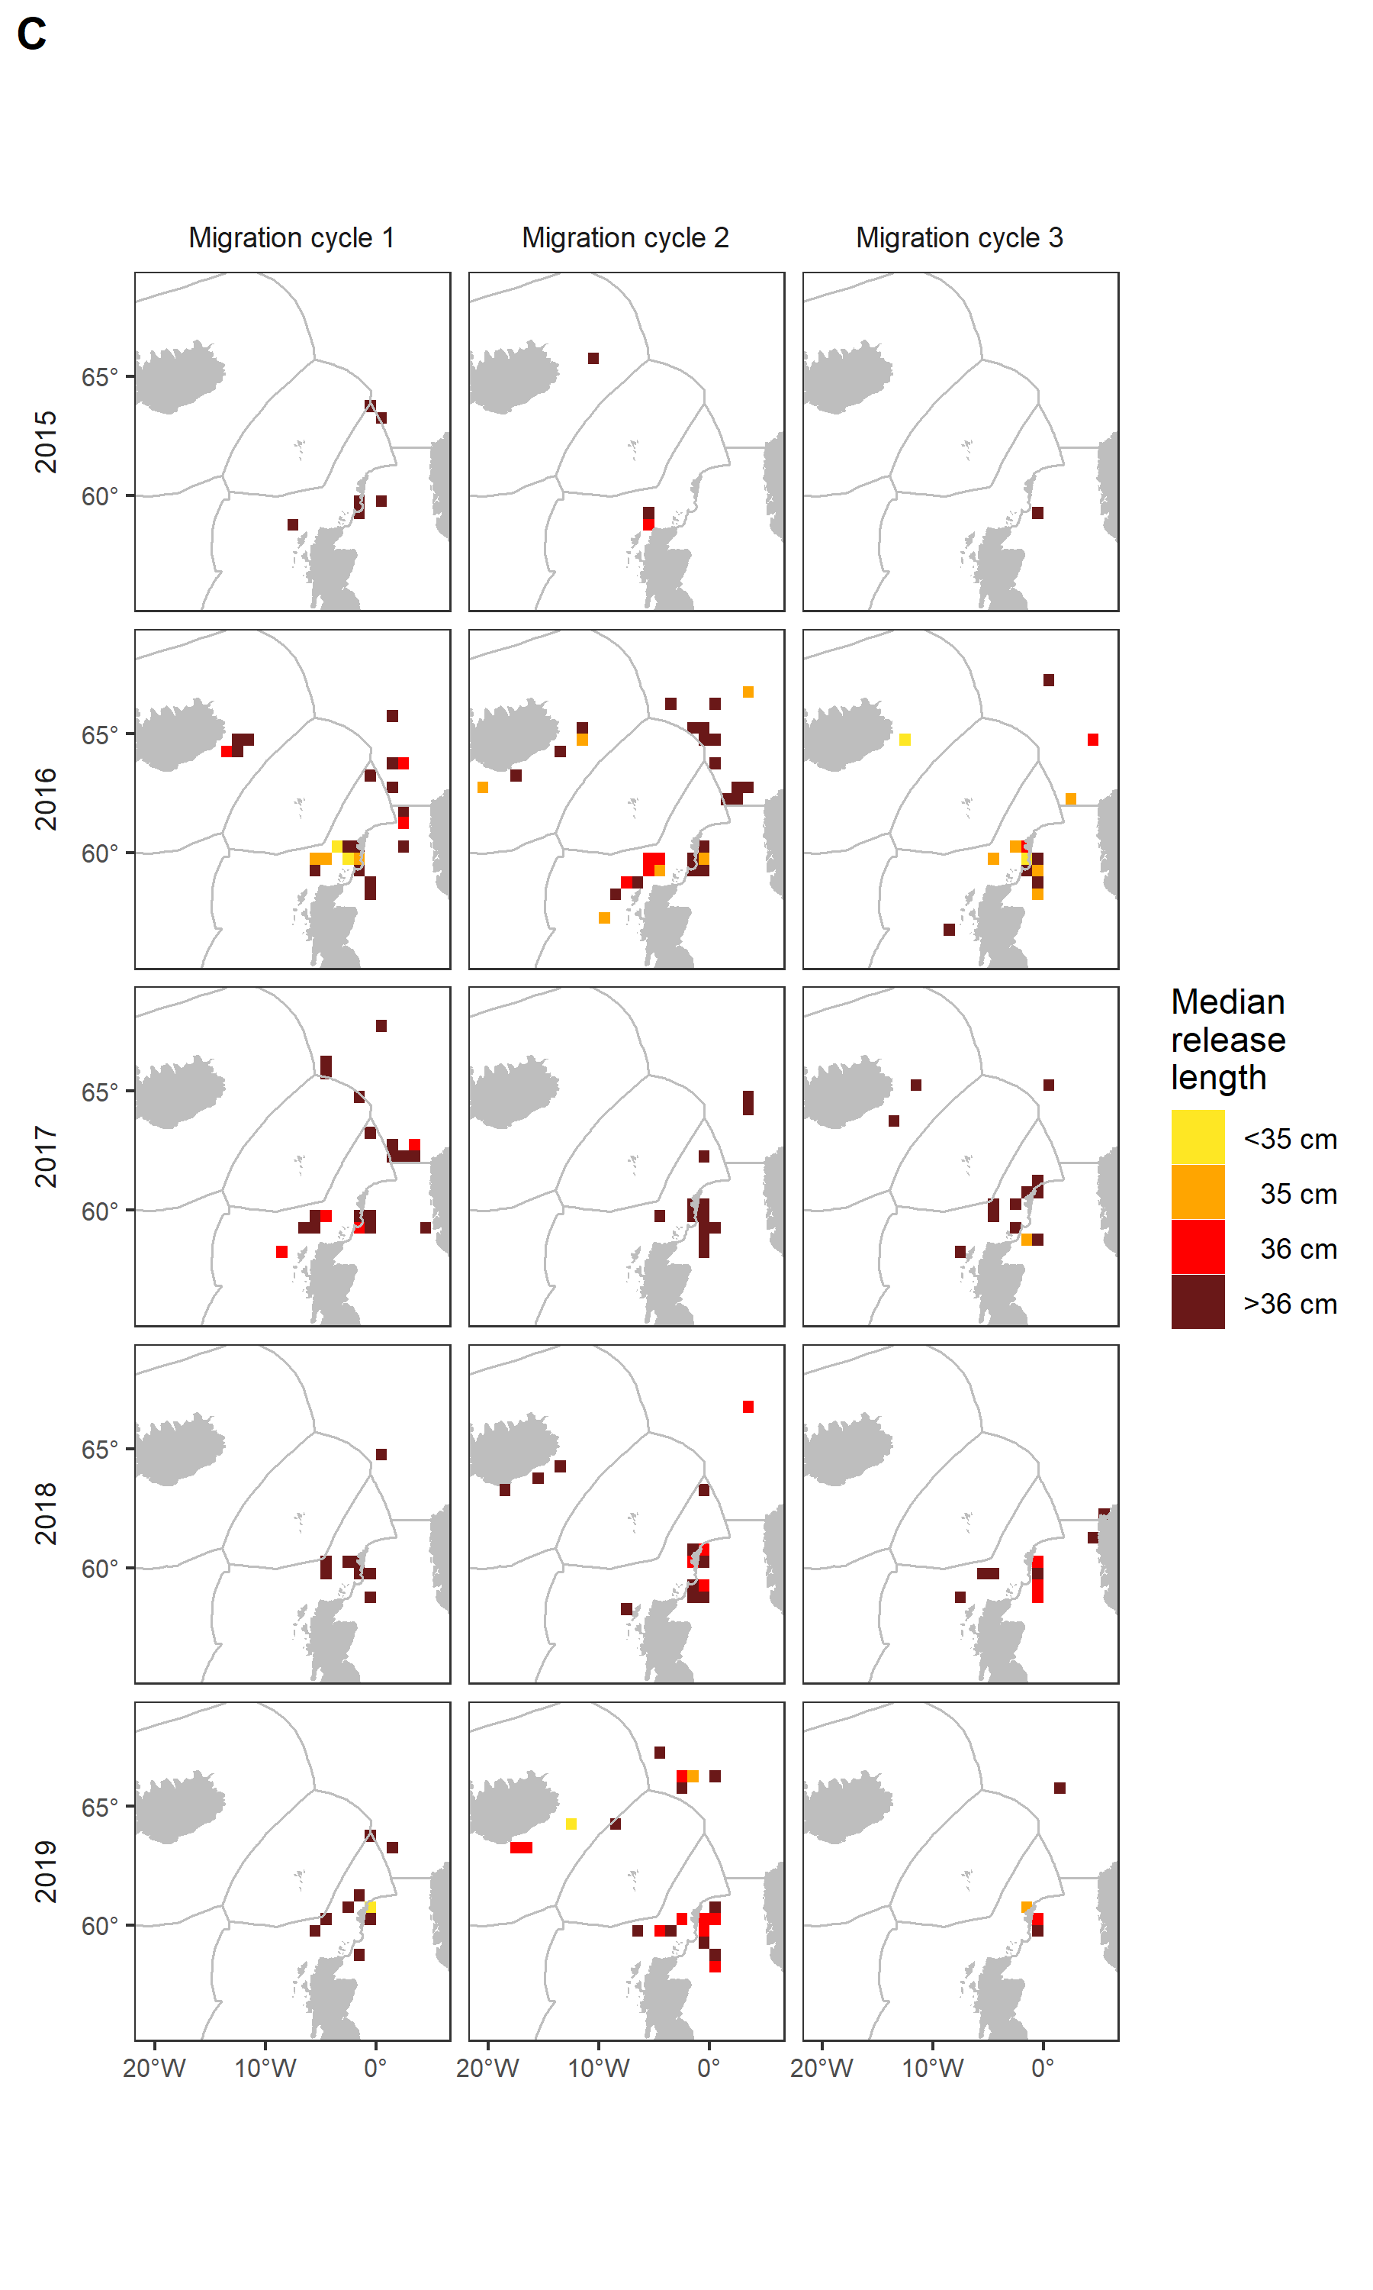
Figure S3. (C) Spatial variation in median release length of recaptured mackerel from the Icelandic Waters experiments, compared between release years and over migration cycles 1-3.
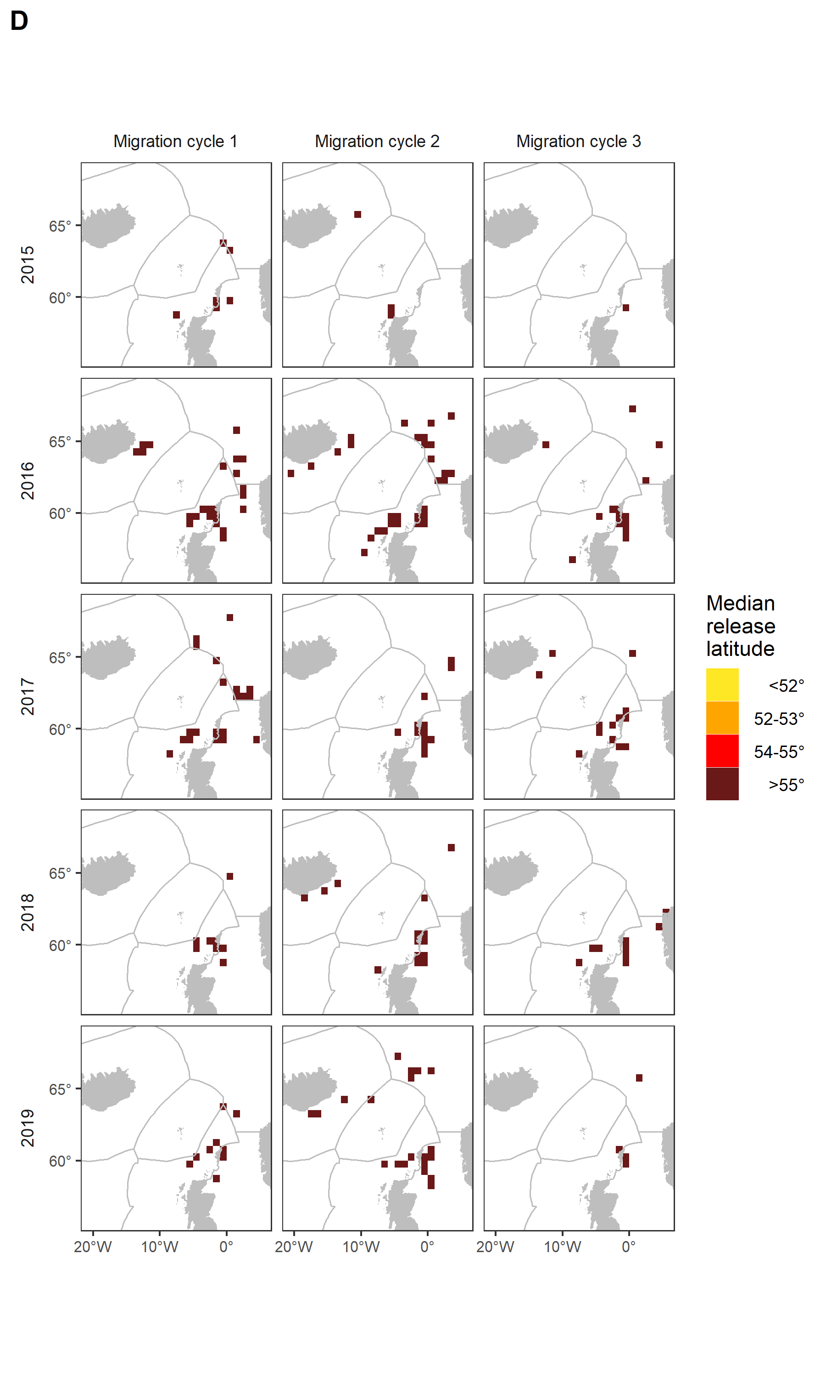
Figure S3. (D) Spatial variation in median release latitude of recaptured mackerel from the Icelandic Waters experiments, compared between release years and over migration cycles 1-3.
Figure S4. Spatial variations in of numbers of recaptures from the North Sea experiment at the Norwegian Coast (red cross) in September 2011 on 1-year olds compared between recapture years 2012-2021. Note that 2012 was the first year with scanning of landings for PIT-tags, but tagging started in 2011(ICES, 2021)
Figure S5. Marginal effects (link scale) of mackerel body size at release, release latitude, recapture date, and release year, by migration cycle on the predicted probability of being recaptured, for each ICES ecoregion when excluding the 2021 data.

