ACTEAST Methodology: Supplemental

- Enrolment Form (3 pages)

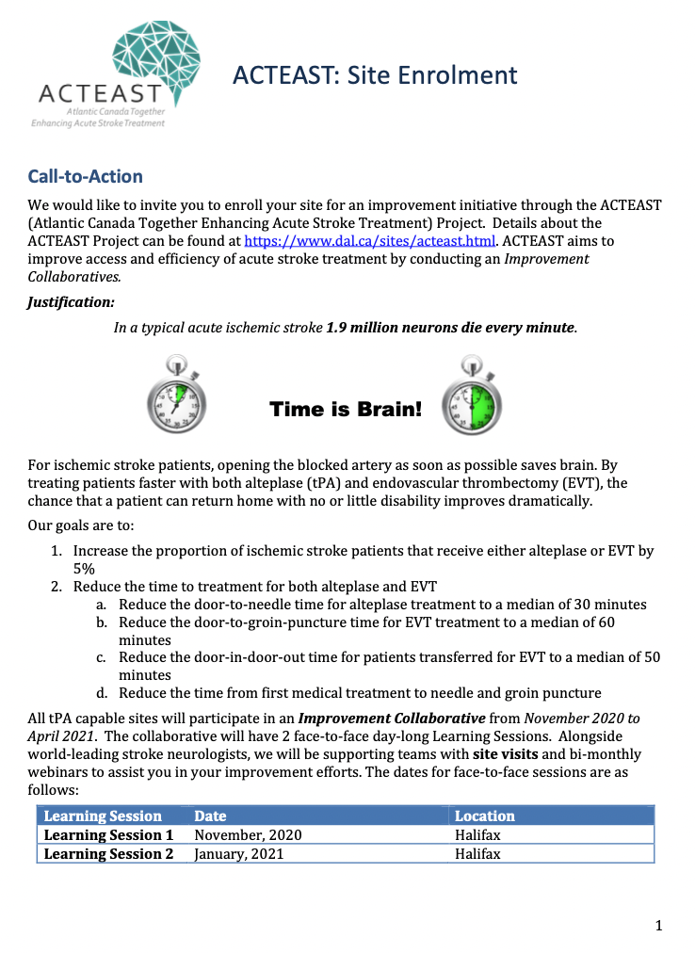
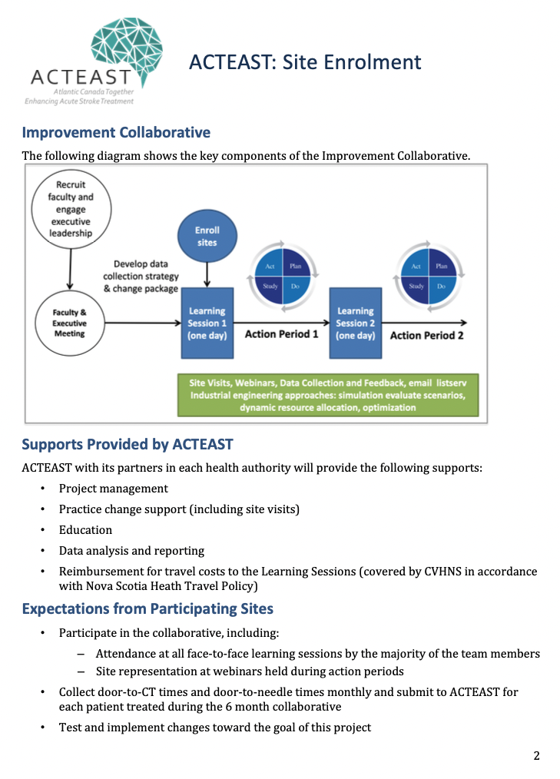
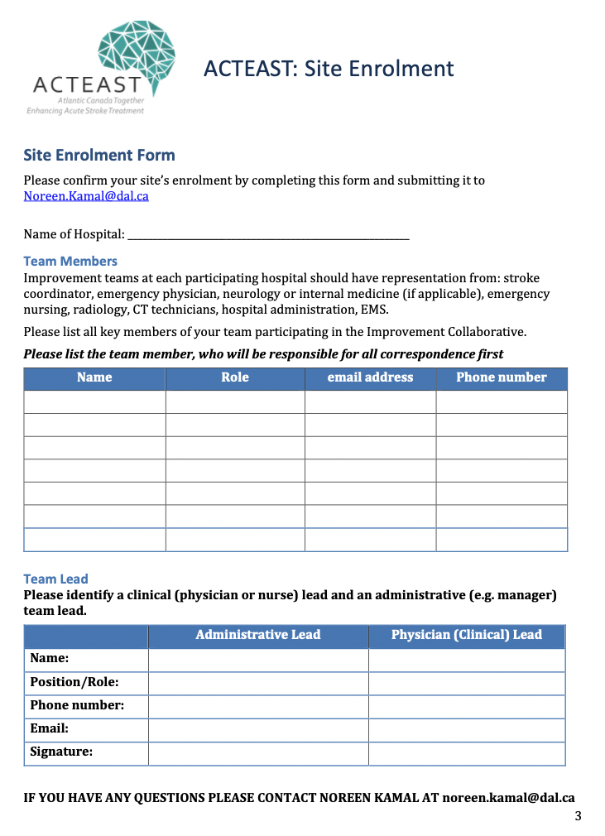

- Nova Scotia Improvement Collaborative – Learning Session 1 Agenda

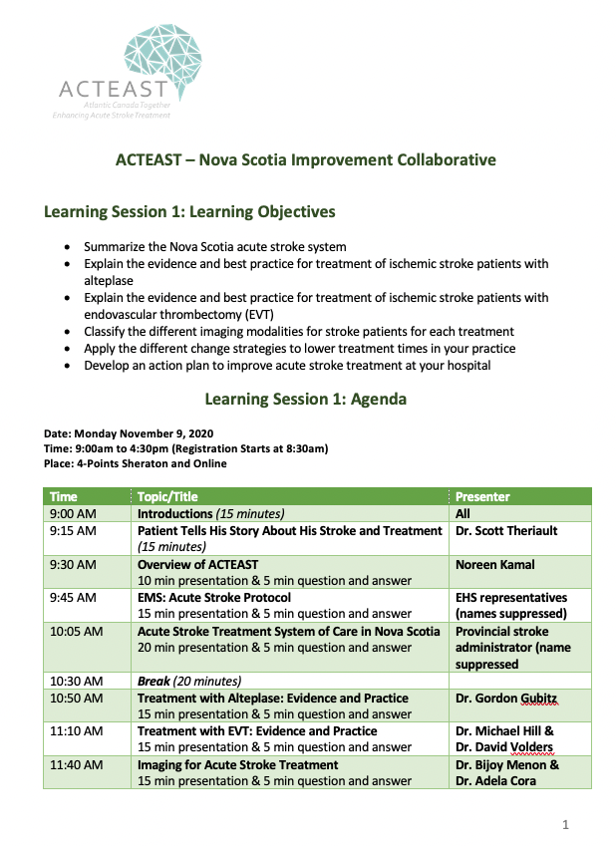

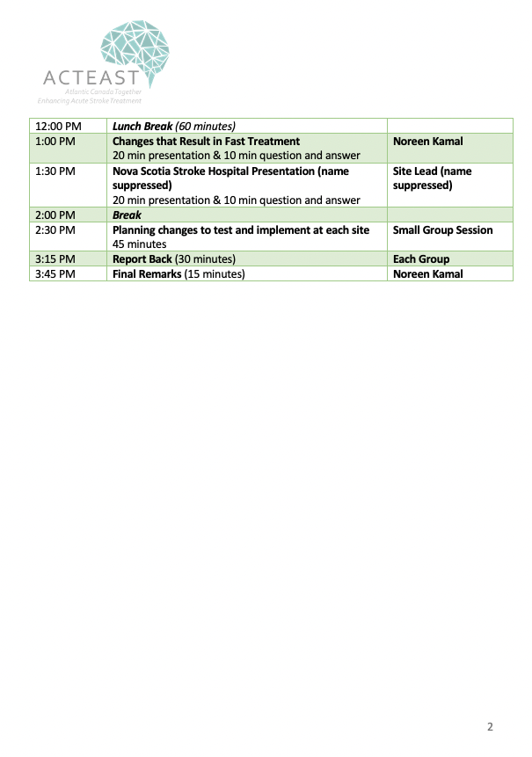

- Nova Scotia Improvement Collaborative – Action Planning Sheet

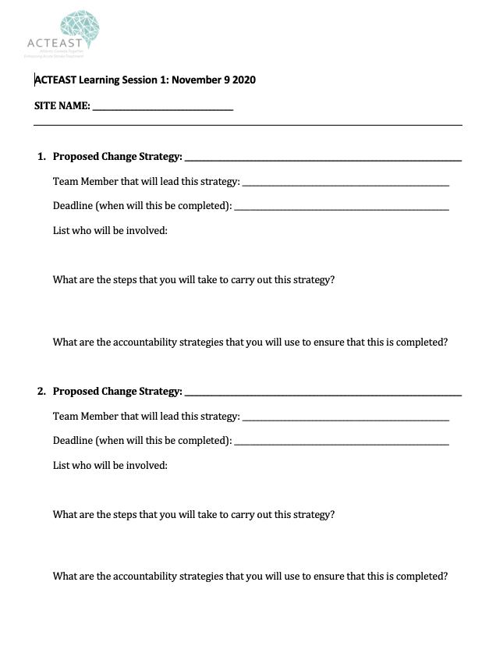

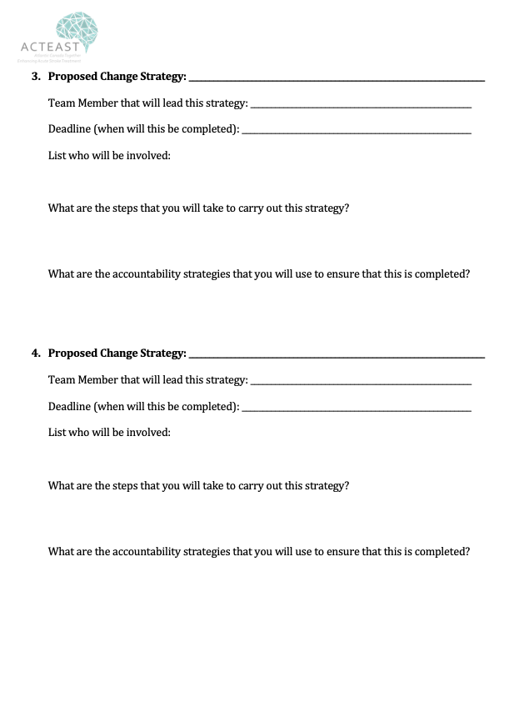

- Nova Scotia Improvement Collaborative – Learning Session 2 Agenda

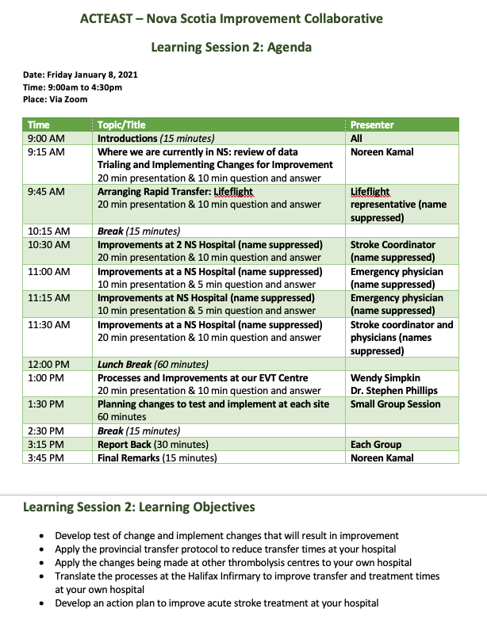’

- NB-PEI Improvement Collaborative – Learning Session 1 Agenda

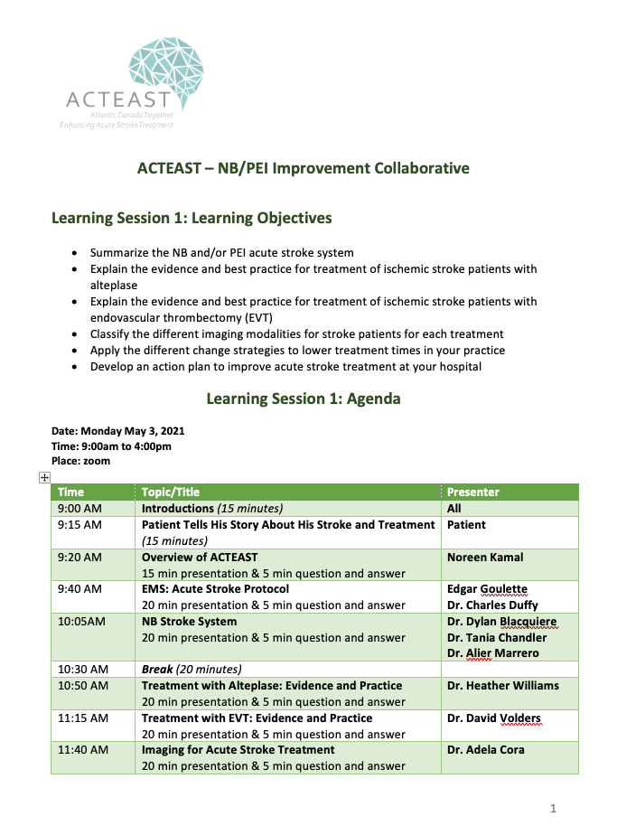

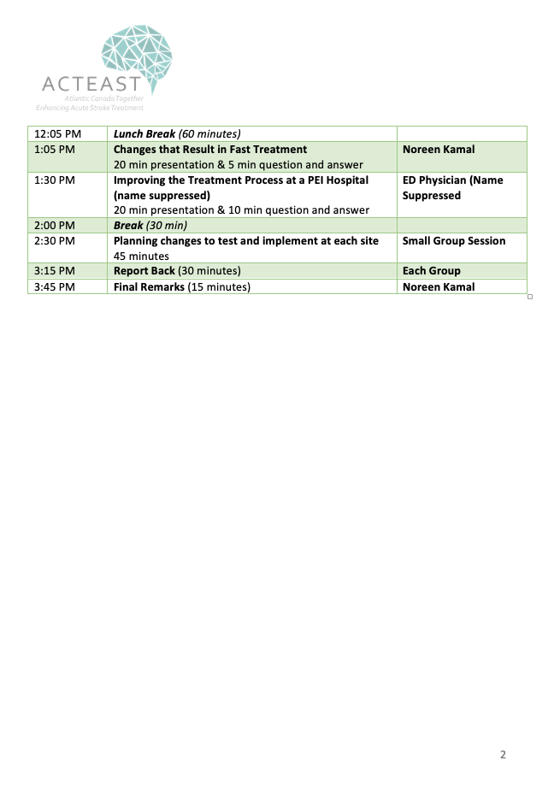

- NB-PEI Improvement Collaborative – Learning Session 2 Agenda

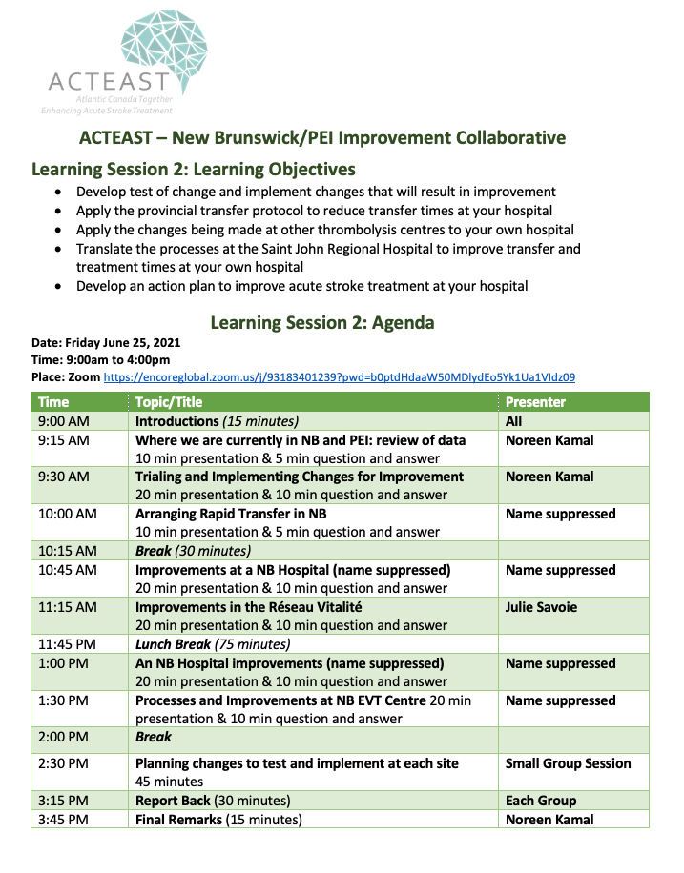

- NL Improvement Collaborative – Learning Session 1 Agenda

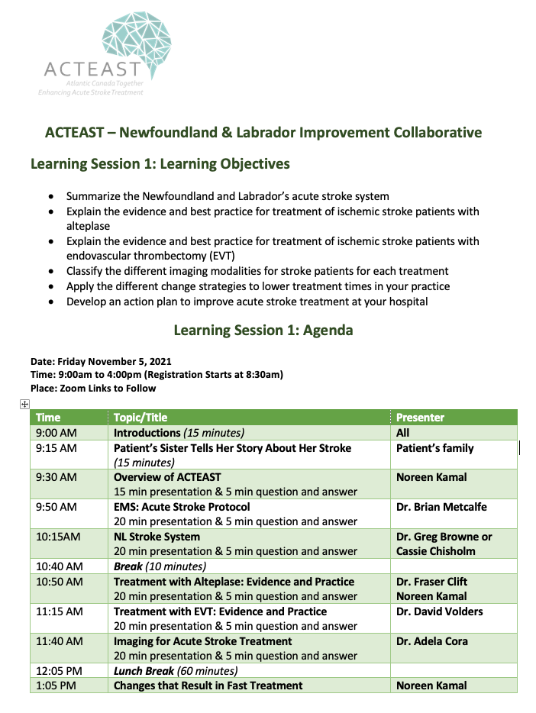
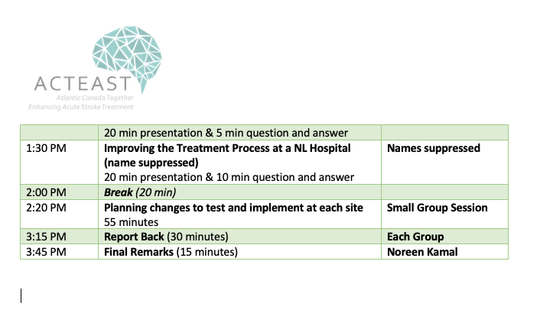

- NL Improvement Collaborative – Learning Session 2 Agenda

