Supplementary Material

Supplementary Figures
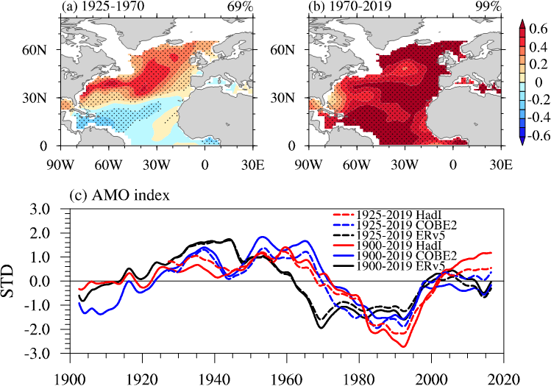
Supplementary Figure 1. Regression pattern of the AMO index in Fig. 1a onto the SSTAs during (a) 1925–1970 and (b) 1970–2019. (c) The AMO indices extracted by LFCA based on 1900–2019 and 1925–2019 SSTA data. The unit in (a, b) is °C.

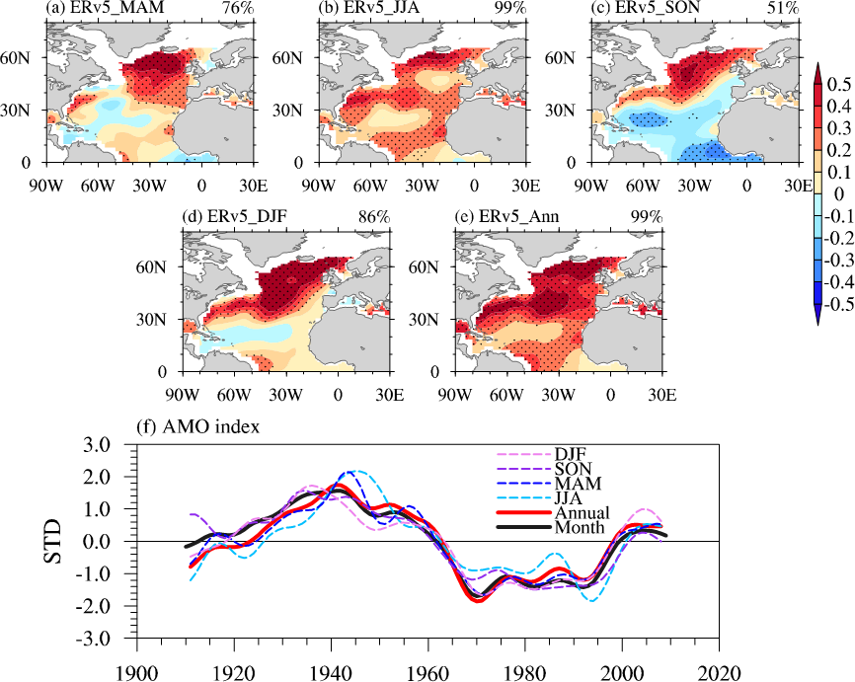
Supplementary Figure 2. The AMO patterns (indices) derived from LFCA based on the seasonal mean (a) MAM, (b) JJA, (c) SON, (d) DJF and (e) annual mean SSTAs in ERv5 over the North Atlantic. The CI is shown in the top right. Dots indicate where values pass the 95% significance level. (f) The corresponding AMO indices. The unit in (a–e) is °C.

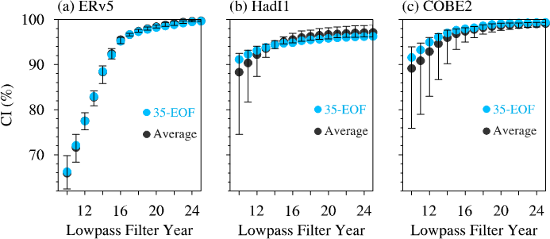
Supplementary Figure 3. The AMO CI in different SST datasets based on different numbers of EOFs and low-pass filter frequencies (1.0/frequency can be expressed as the year numbers) as the input in LFCA: (a) ERv5; (b) HadI1; (c) COBE2. The EOF numbers range from 30 to 40, and low-pass filter year numbers range from 10 to 30. The blue (black) dots denote the (averaged) AMO CI changes with different low-pass filter year numbers when the number of EOFs is fixed at 35 (ranging from 30 to 40 EOFs) in LFCA. When a 10-year low-pass filter is used in LFCA, the averaged AMO CI value for HadI1 and COBE2 is 89%, which is referred to as the threshold CI value for a coherent AMO pattern.

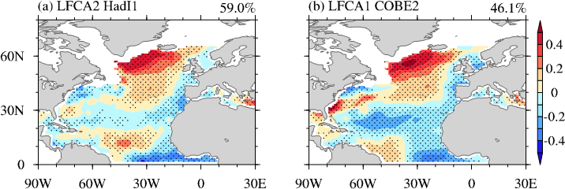
Supplementary Figure 4. The AMO pattern based on LFCA after removing the first leading EOF mode derived from different SST datasets: (a) HadI1; (b) COBE2. The CI is shown in the top right. In (a), the second leading LFCA mode (LFCA2) is the AMO. In (b), the first leading LFCA mode (LFCA1) is the AMO. Unit: °C.
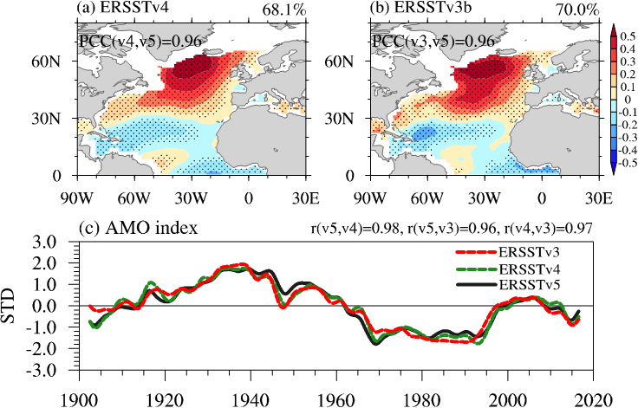
Supplementary Figure 5. The AMO pattern for (a) ERSST.v4 and (b) ERSST.v3b, and corresponding (c) AMO indices. The PCC (TCC) between the AMO pattern (index) with ERv5 is shown. The AMO CI is shown in the top right. Dots indicate where values pass the 95% significance level. The unit in (a, b) is °C.

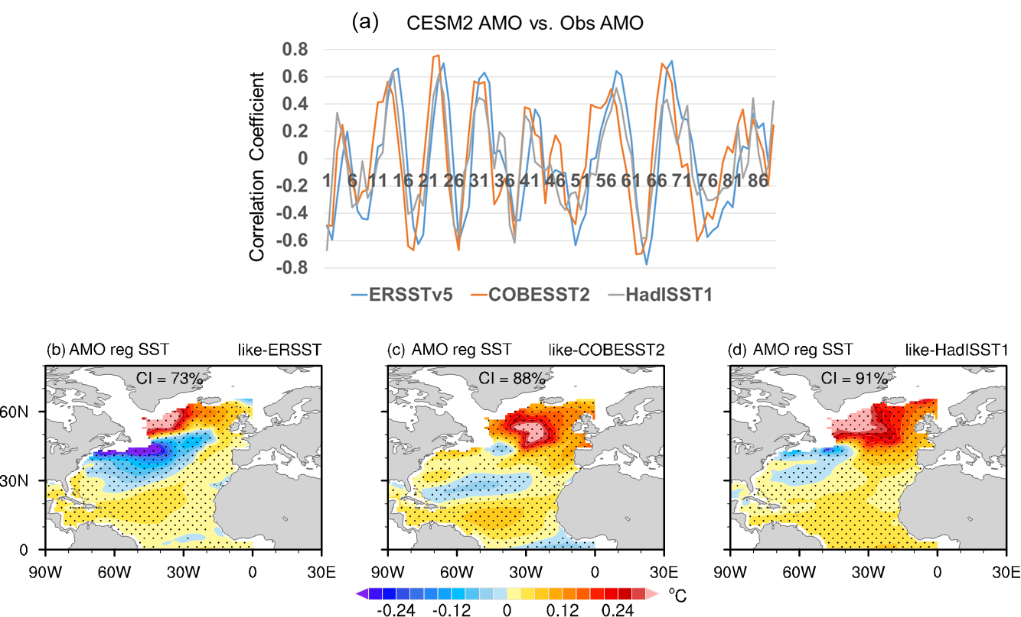
Supplementary Figure 6. (a) The temporal correlation coefficient between AMO index in CESM2 piControl run and that in three observational SST datasets, respectively. The blue line is for ERSSTv5, orange line is for COBESST2, and gray line is for HadISST1. The regression pattern of AMO index into low-pass filtered SST anomalies. The member that is most like the (b) ERSSTv5, (c) COBESST2, and (d) HadISST1. The coherence index (CI) is in the top of the figure.
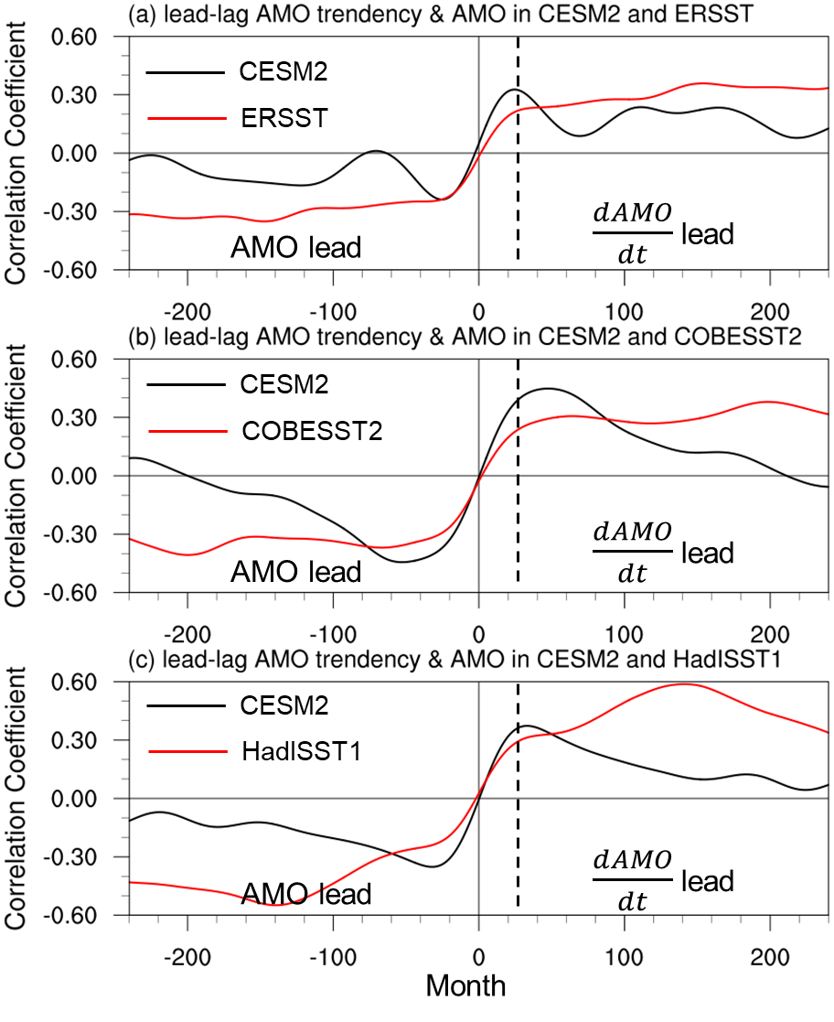
Supplementary Figure 7. The lead-lag correlation between AMO tendency ($\frac{dAMO}{dt}$) and AMO index, black for model member, and red member for observation.

