**Supplementary File: Traditional beliefs, practices and migration: A risk to malaria transmission in rural Nepal**

**Kiran Raj Awasthi 1,*, Jonine Jancey 1, Archie C. A. Clements 1,2,3, Rohit Kumar Sah4, Madan Prasad Koirala4, Binay Chalise5, Justine E. Leavy 1**

*1 Curtin School of Population Health, Curtin University, GPO Box U1987, Perth, WA 6845, Australia*

*2Telethon Kids Institute, Perth, Western Australia, Australia*

*3Peninsula Medical School, University of Plymouth, Plymouth, United Kingdom*

*4 National Malaria Program, Karnali Province Field Office, Nepal*

*5 Graduate School for International Development and Cooperation, Hiroshima University, 739-0043, Hiroshima, Japan*

**\* Correspondence:**

Kiran Raj Awasthi (KRA) : [kiran.awasthi@curtin.edu.au](mailto:kiran.awasthi@curtin.edu.au)

**Figure 1: Qualitative Themes Overview**



**Figure 2: Chhaupadi and Chaugoth**

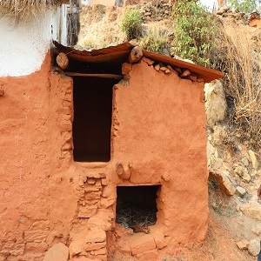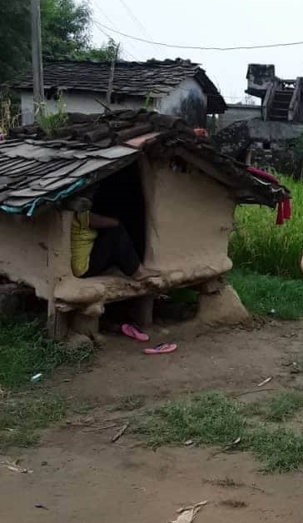

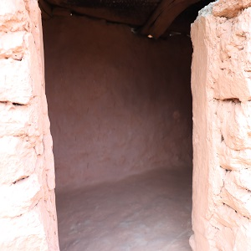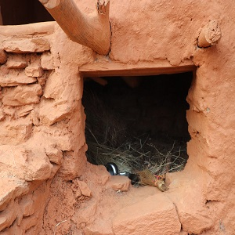

**Source:** KRA, Photos were taken on 16th November (top left) 2018 and 28th October 2021 (remaining three)

**Description:** The first photo (tope left) shows a woman staying in a Chaugoth during her menstruation. The remaining three pictures show a typical Chuagoth in Mugu. As seen in the second picture (top right), there is no door or proper ventilation. The third picture (below left) shows the minimal space to allow the use of LLINs or ITNs. The fourth picture (below right) shows the proximity of the goat shed to the Chaugoth.

**Figure 2: Traditional dwellings in Rigga village, Nepal**

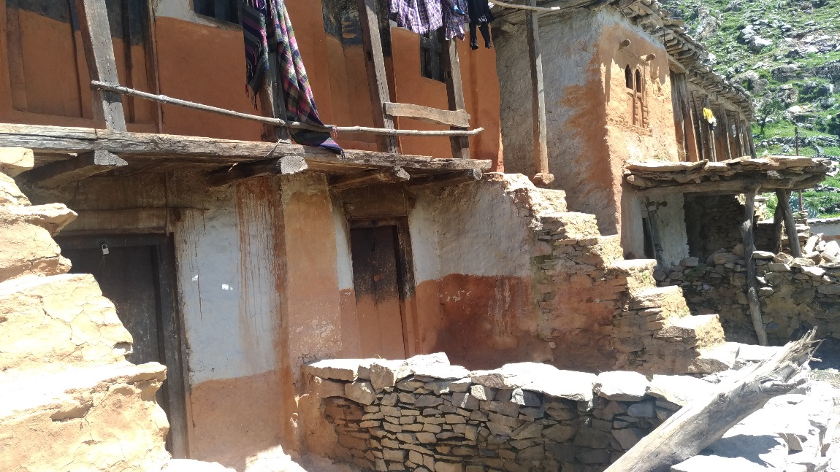

***Source:*** KRA, Photo was taken on 25th April 2018

***Description:*** The above photo shows a typical village house in Rigga village, the study site. The bottom floor is the cow shed whilst people live on the first floor.

**Table1: One-on one interview participants characteristics (n=25)**

|  |  |
| --- | --- |
| **Demographics** | **(n)** |
| **Sex** |  |
| Male | **10** |
| Female | **15** |
| **Type of family** |  |
| Nuclear family (less than two generations in one house) | **10** |
| Extended family (three or more generations in one house) | **15** |
| **Family size** |  |
| Small family (< 5 members) | **5** |
| Large Family (≥ 5 members) | **20** |

**Table 2: Household survey: socio-demographics, beliefs towards malaria treatment, attitude, and sleeping practices (n=218)**

|  |  |
| --- | --- |
| **Demographics** | **n (%)** |
| **Sex** |  |
| Male | 108 (49.5%) |
| Female | 110 (50.5%) |
| **Age (years)** |  |
| 15-30 | 55 (25.2%) |
| 31-40 | 48 (22.0%) |
| 41-50 | 34 (15.6%) |
| >50 | 81 (37.2%) |
| **Occupation** |  |
| Business | 3 (1.4%) |
| Daily wage worker/ migrant worker | 50 (22.9%) |
| Agriculture | 120 (55%) |
| Housewife | 28 (12.8%) |
| Salaried job (govt/private) | 12 (5.5%) |
| Student | 5 (2.3%) |
| Inside | 217 (99.5) |
| Outside  **Education**  Primary school (Grade 5) | 1 (0.05)  24 (11.0%) |
| Secondary school (Grade 10) | 29 (13.3%) |
| Higher Secondary School (Grade 12)  Literate (able to read and write only) | 19 (8.7%)  146 (67%) |
| **Monthly family Income (1 USD= 132 NRs)** |  |
| <10,000 NRs | 185 (84.9%) |
| 10,000-25000 NRs | 27 (12.4%) |
| 25,000-50,000 NRs | 4 (1.8%) |
| >50,000 NRs | 2 (0.9%) |
| **Type of family** |  |
| Nuclear family (less than two generations in the house) | 117 (53.7%) |
| **J**oint family (three or more generations in the house) | 101 (46.3%) |
| **Family Size** |  |
| Small family (<5 members) | 104 (47.7%) |
| Large family (6-10 members) | 98 (45.0%) |
| Very large family (>11 members) | 16 (7.3%) |
| **Key decision makers in the family** |  |
| Father-in-law | 19 (18.7%) |
| Mother-in-law | 8 (3.7%) |
| Husband | 132 (60.6%) |
| Wife | 6 (2.8%) |
| Others | 9 (4.1%) |
| **Beliefs towards malaria treatment** |  |
| **Malaria can be cured?** |  |
| No | 4 (1.80) |
| Yes | 214 (98.2) |
| **The deciding factor when seeking care for malaria?** |  |
| Condition of the patient | 110 (50.5) |
| Condition of the patient, cost involved | 23 (10.5) |
| Condition of the patient, cost involved, availability of time | 1 (0.50) |
| Cost involved | 84 (38.5) |
| **I can treat myself if I get malaria** |  |
| Agree/strongly agree | 33 (15.1) |
| Disagree/strongly disagree | 185 (84.9) |
| **It is dangerous if malaria medication is not completed as prescribed** |  |
| Agree/strongly agree | 202 (92.7) |
| Disagree | 14 (6.4) |
| Neither agree nor disagree | 2 (0.9) |
| **Attitude** |  |
| **I can buy antimalarial drugs from the pharmacy to treat myself.** |  |
| Agree/ strongly agree | 46 (21.1) |
| Disagree/ strongly disagree | 172 (78.9) |
| **I should go for a blood test once suspected of malaria** |  |
| Agree/strongly agree | 217 (99.5) |
| Neither agree nor disagree | 1 (0.50) |
| **Sleeping Practices** |  |
| **Did you sleep inside a LLIN net?** |  |
| No | 181 (83.0) |
| Yes | 37 (17.0) |
| **Where do the women in your household sleep during menstruation? (n = 215)** |  |
| Separate room in the house | 211 (98.1) |
| Shed/ outside | 4 (1.9) |
| **Do women in your household sleep under a LLIN net during menstruation? (n = 215)** |  |
| No | 138 (64.2) |
| Yes | 77 (35.8) |