Supplementary Material

Supplementary Figure

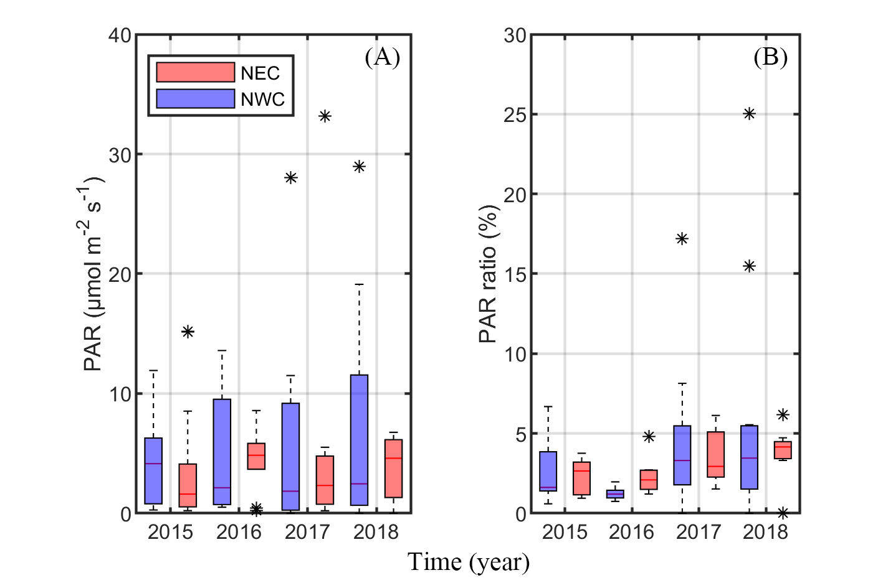
Supplementary Figure 01. Distribution of photosynthetic available radiation (PAR, μmol m⁻² s⁻¹) and the ratio of PAR at the SCM depth to the surface layer (PAR ratio, %) by region. (A) The PAR at the SCM depth by year. (B) The PAR ratio by year. The blue and red boxes represent the northwestern Chukchi Sea (NWC) and the northeastern Chukchi Sea (NEC), respectively.

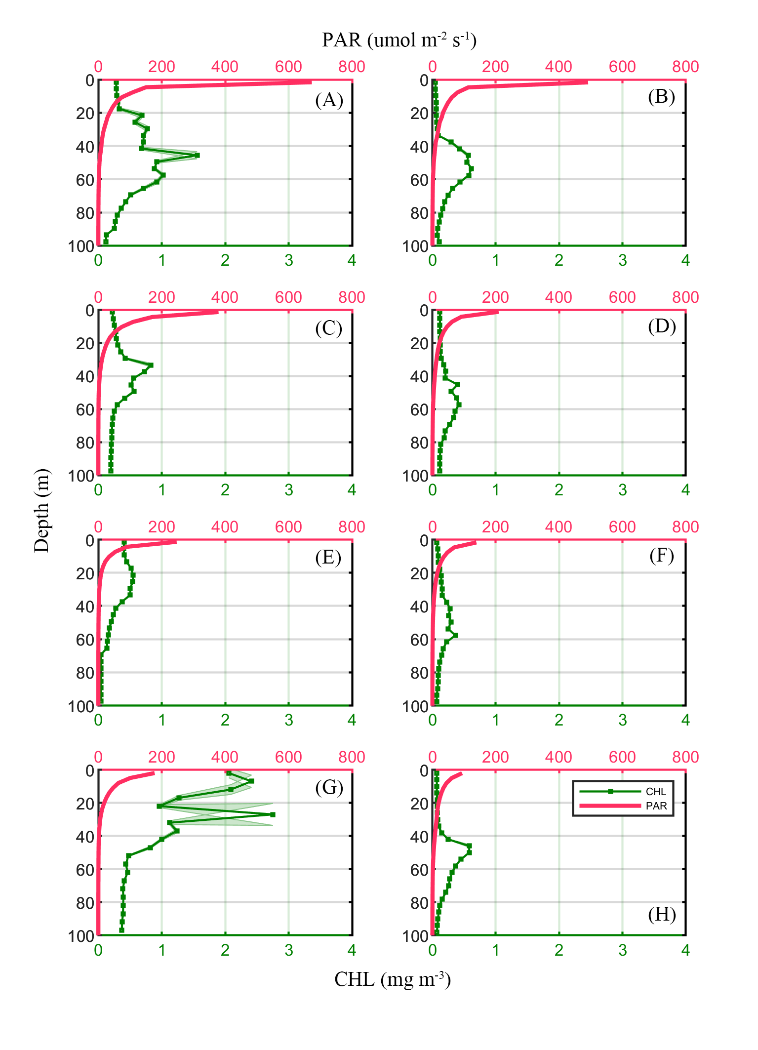
Supplementary Figure 02. Vertical profiles of average chlorophyll-a concentration (CHL, green dotted line) and photosynthetic available radiance (PAR, pink line) by year. in the northwestern Chukchi Sea (NWC, Left panels) and the northeastern Chukchi Sea (NEC, Right panels). (A, B) 2015; (C, D) 2016; (E, F) 2017; (G, H) 2018.

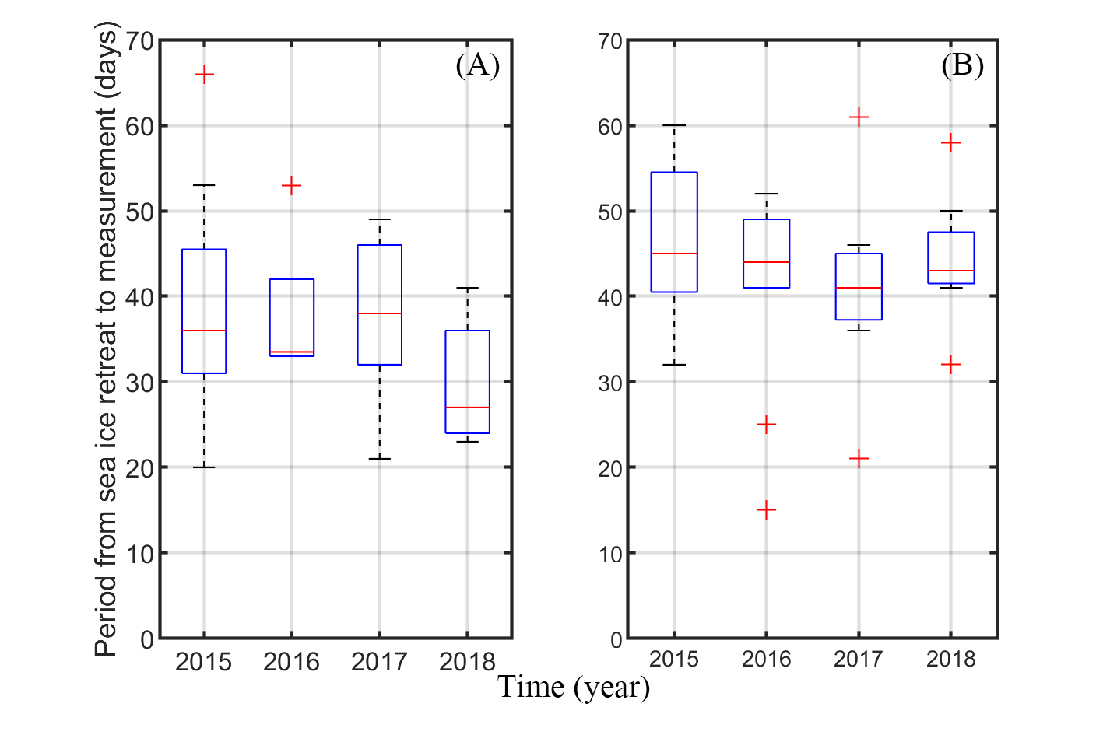
Supplementary Figure 03. The annual distribution of the period from sea ice retreat (below 80% of sea ice concentration) to measurement in the northwestern Chukchi Sea (NWC, Left panels) and the northeastern Chukchi Sea (NEC, Right panels).

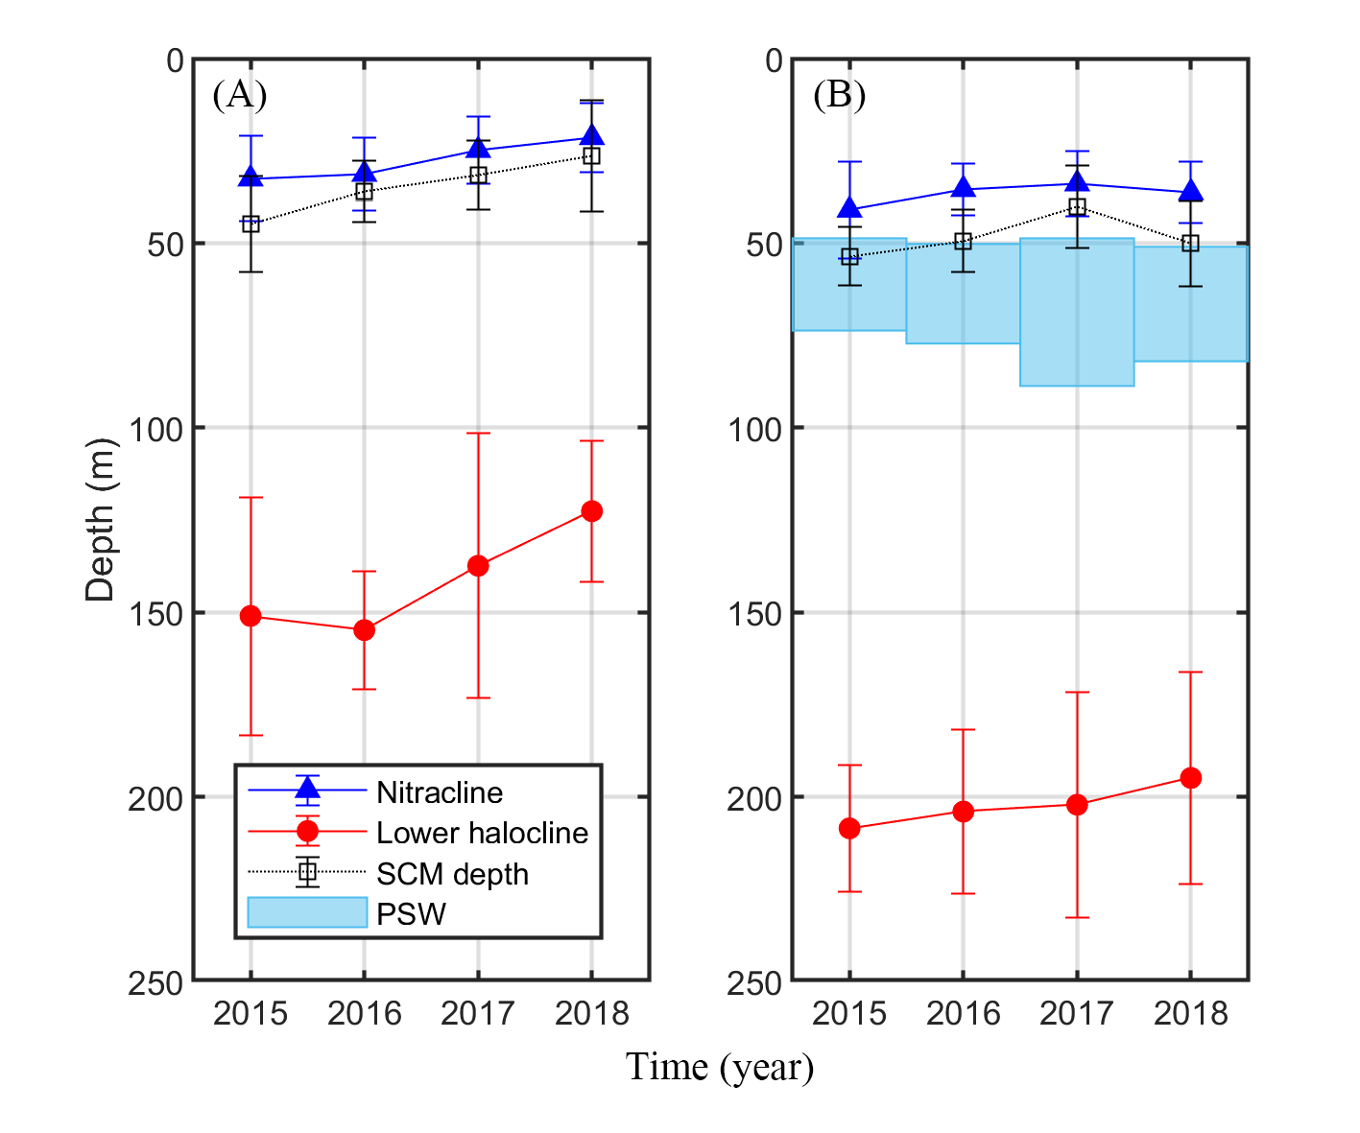
Supplementary Figure 04. Distribution of nitracline (blue triangle), lower halocline (red circle), and the depth of subsurface chlorophyll maximum (SCM, empty square) by year in the northwestern Chukchi Sea (A) and the northeastern Chukchi Sea (B). The sky blue shading represents the Pacific Summer Water (PSW) in the northeastern Chukchi Sea.

