Supplemental Information
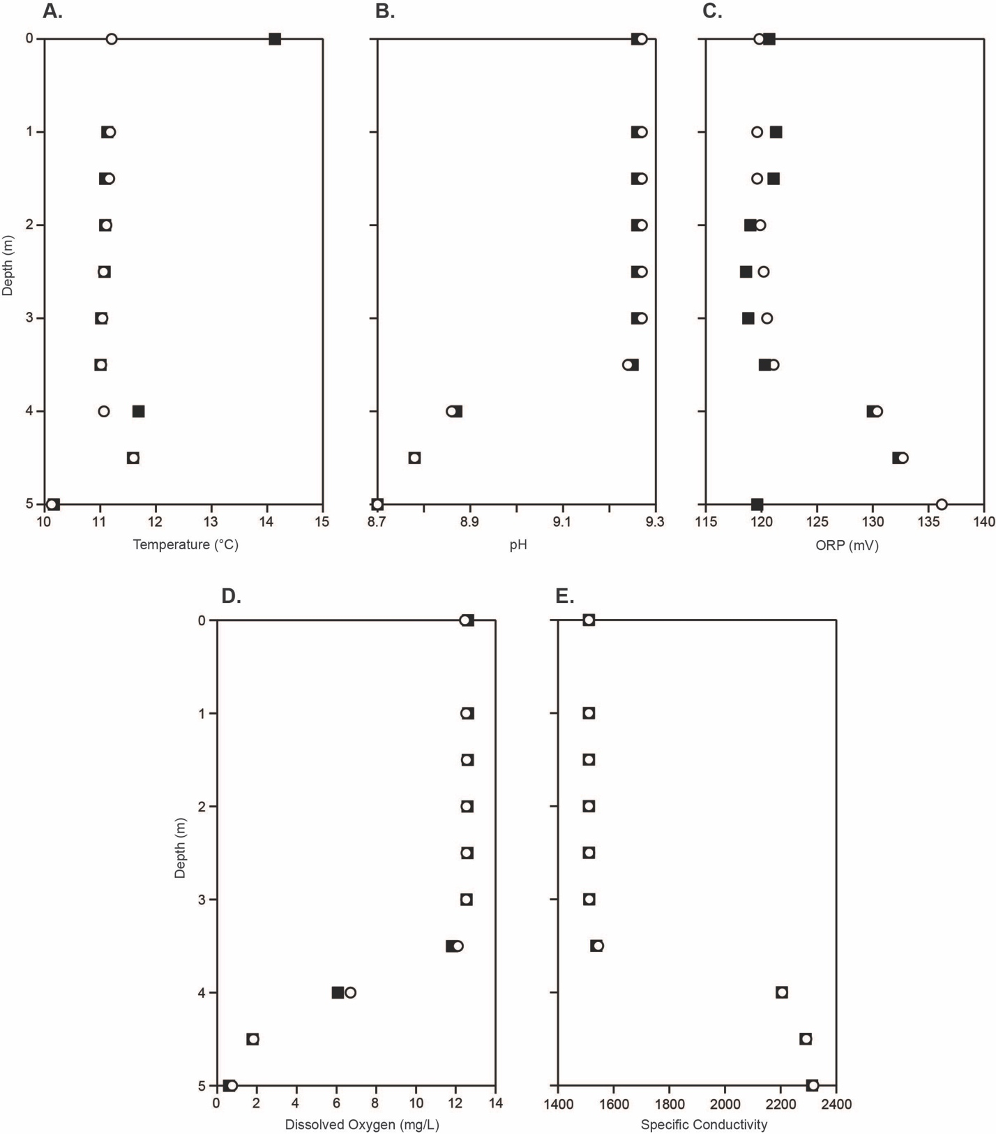
Figure S1: Differences in (A) Temperature, (B) pH, (C) ORP, (D) Dissolved Oxygen and (E) Specific Conductivity between East (open circle) and West (black square) sampling locations. Throughout the water column there is good agreement between trends at both locations

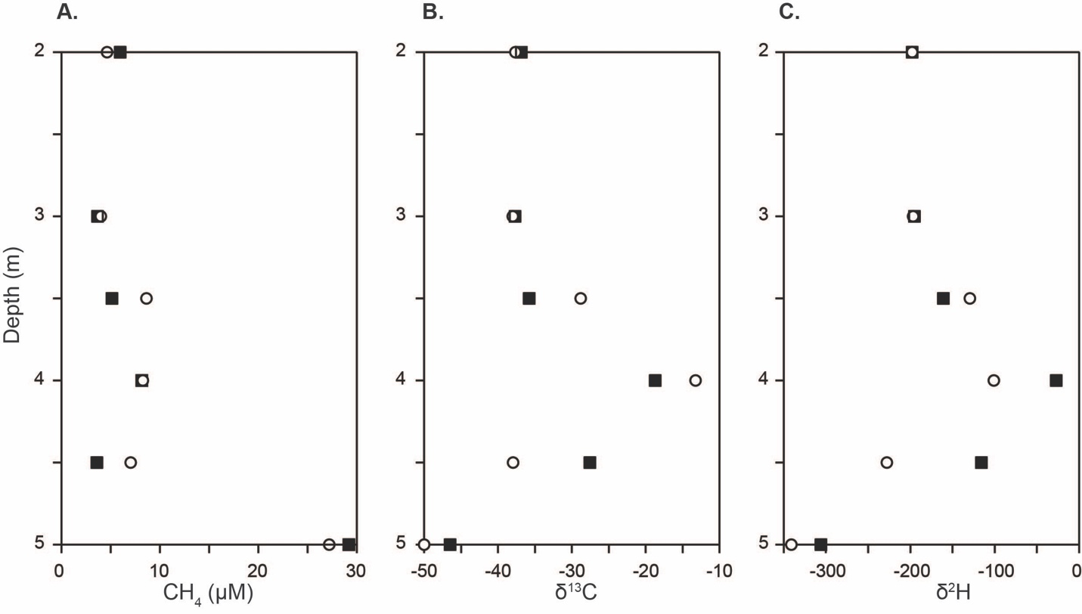
Figure S2: Comparison between East (open circle) and West (black square) sampling locations for (A) methane concentrations, (B) carbon isotopes and (C) hydrogen isotopes. Throughout the water column there is good agreement between trends at both locations.

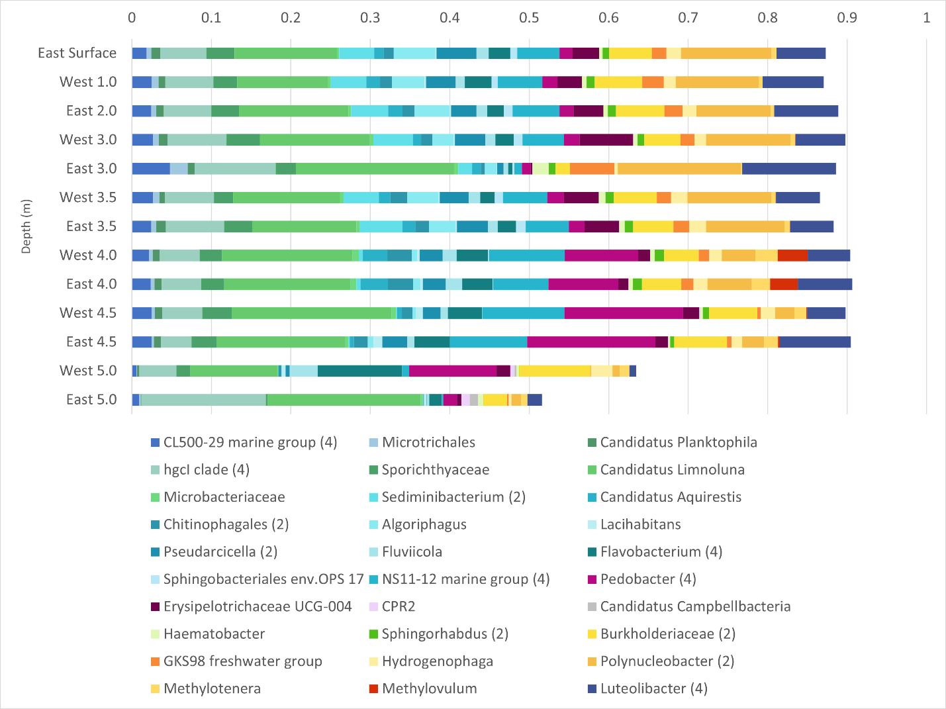
Figure S3: Differences in overall community composition of microbial taxa down the water column at the East and West sampling point based on 16S rRNA genes. Taxonomic groups over 1% relative abundance are shown. The number of ASVs included in each taxonomic group is included with the number given after the taxonomic name. If no number is given, the group only contains one ASV.

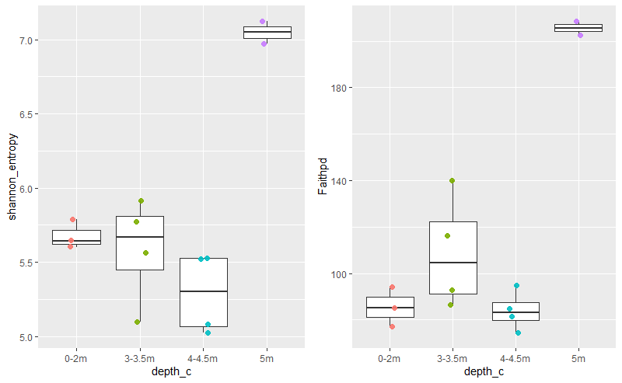
Figure S4. Differences in microbial diversity with depth in Teardrop lake. Shannon entropy and Faith pd were determined across depth intervals and determined diversity was combined for the East and West sampling points.

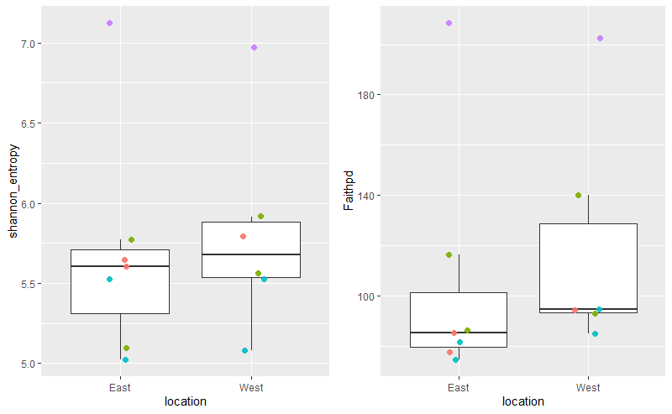
Figure S5. Differences in microbial diversity by sampling location in Teardrop lake. We determined Shannon entropy and Faith pd as measures of microbial diversity.

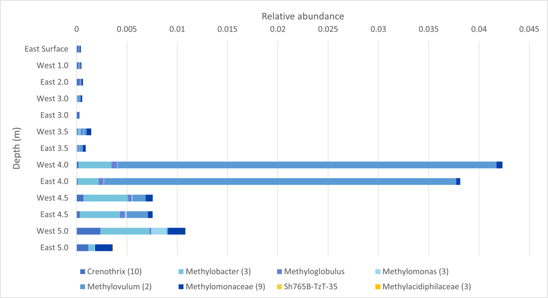
Figure S6: Differences in composition of putative methanotrophs down the water column at the East and West sampling point based on 16S rRNA genes. The number of ASVs included in each taxonomic group is included with the number given after the taxonomic name. If no number is given, the group only contained one ASV.

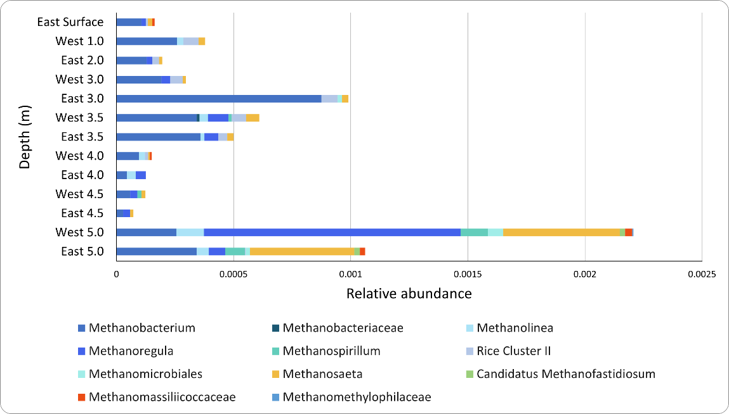
Figure S7: Differences in composition of putative methanogens down the water column at the East and West sampling point based on 16S rRNA genes. The number of ASVs included in each taxonomic group is included with the number given after the taxonomic name. If no number is given, the group only contained one ASV.

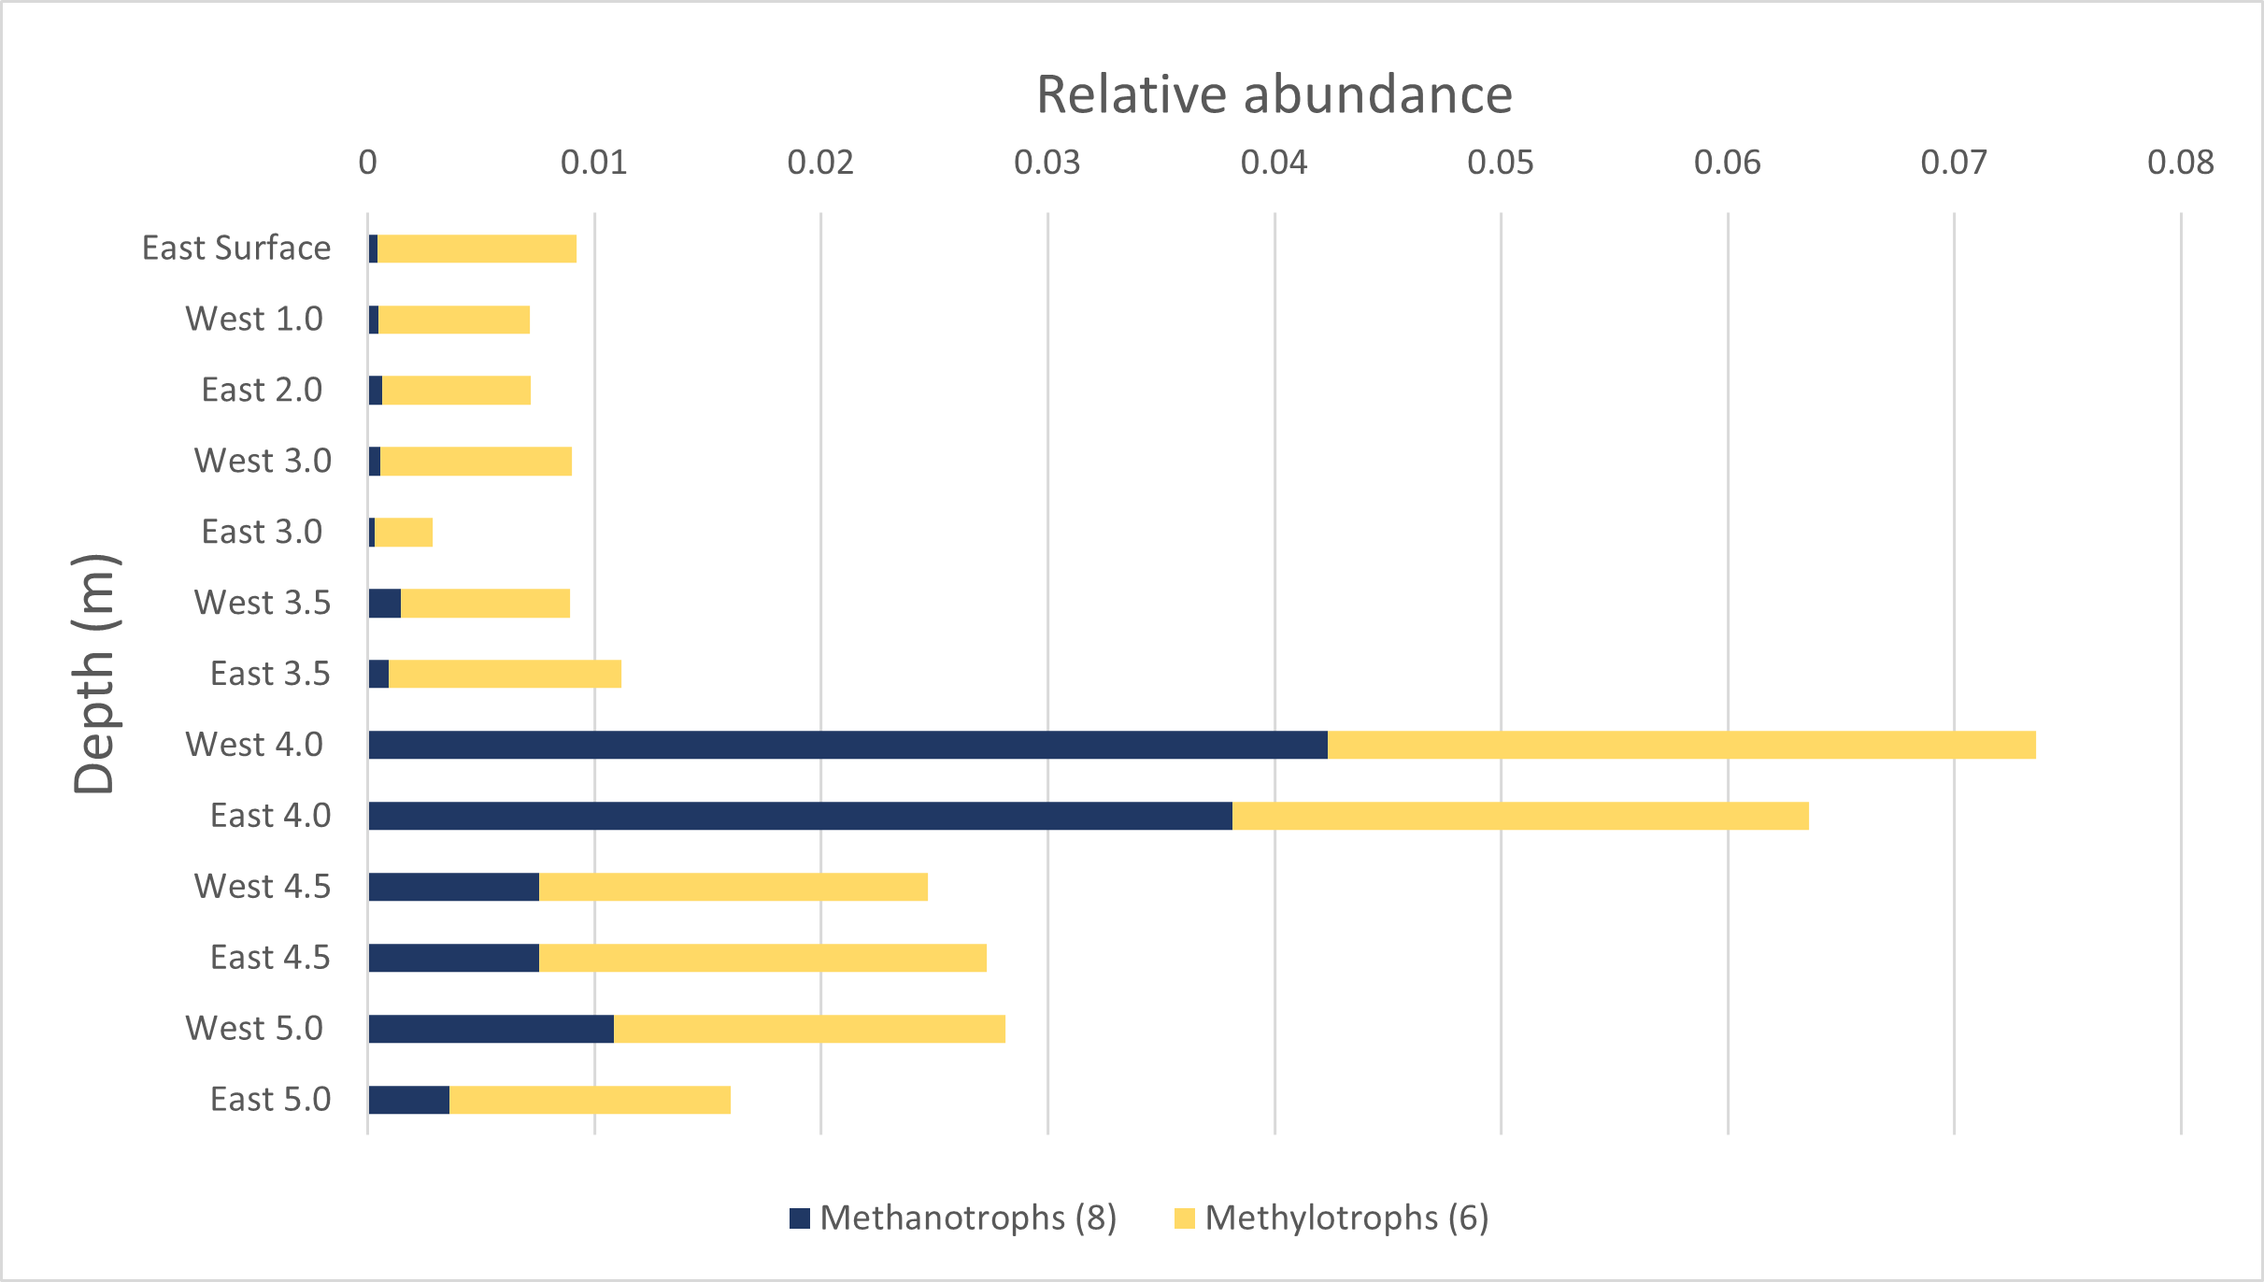
Figure S8: Differences in composition of putative methanotrophs and methylotrophs down the water column at the East and West sampling point based on 16S rRNA genes. We are showing total relative abundance of putative methanotrophs and methylotrophs, respectively.

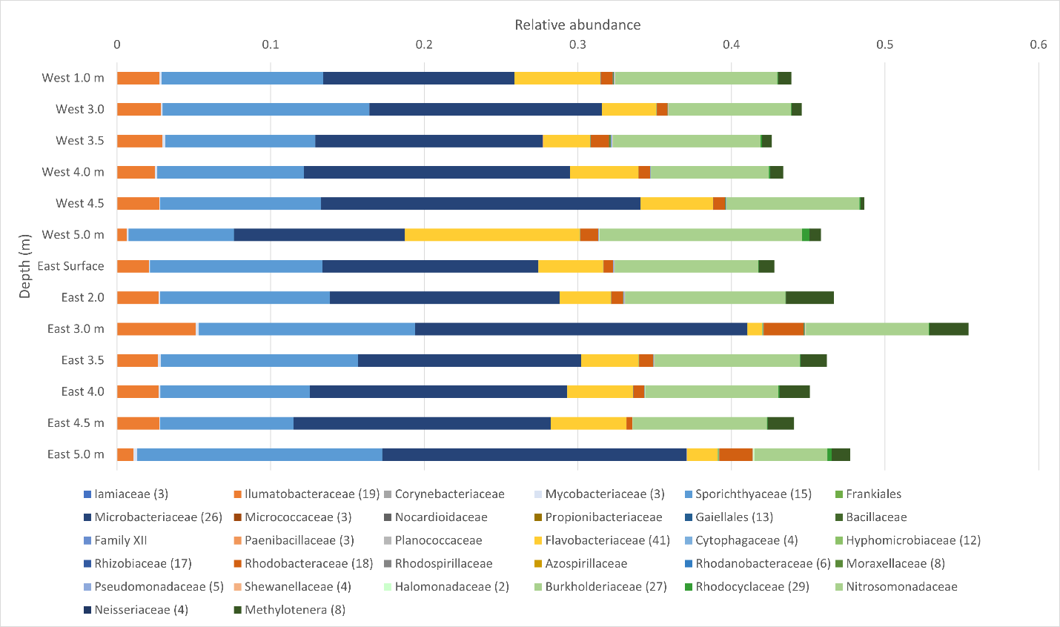
Figure S9: Differences in composition of putative denitrifiers down the water column at the East and West sampling point based on 16S rRNA genes. The number of ASVs included in each taxonomic group is included with the number given after the taxonomic name. If no number is given, the group only contained one ASV.

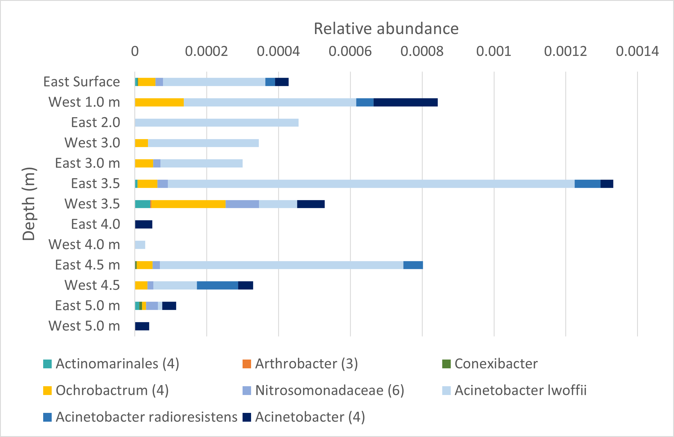
Figure S10: Differences in composition of putative ammonia oxidizers down the water column at the East and West sampling point based on 16S rRNA genes. The number of ASVs included in each taxonomic group is included with the number given after the taxonomic name. If no number is given, the group only contained one ASV.

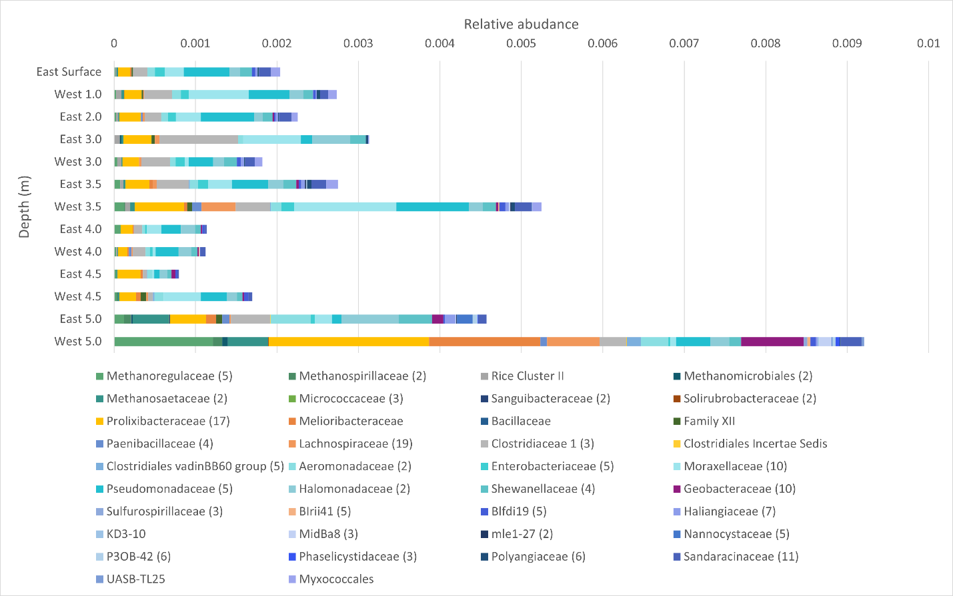
Figure S11: Differences in composition of putative dissimilatory nitrate reducers to ammonium (DNRA) down the water column at the East and West sampling point based on 16S rRNA genes. The number of ASVs included in each taxonomic group is included with the number given after the taxonomic name. If no number is given, the group only contained one ASV.

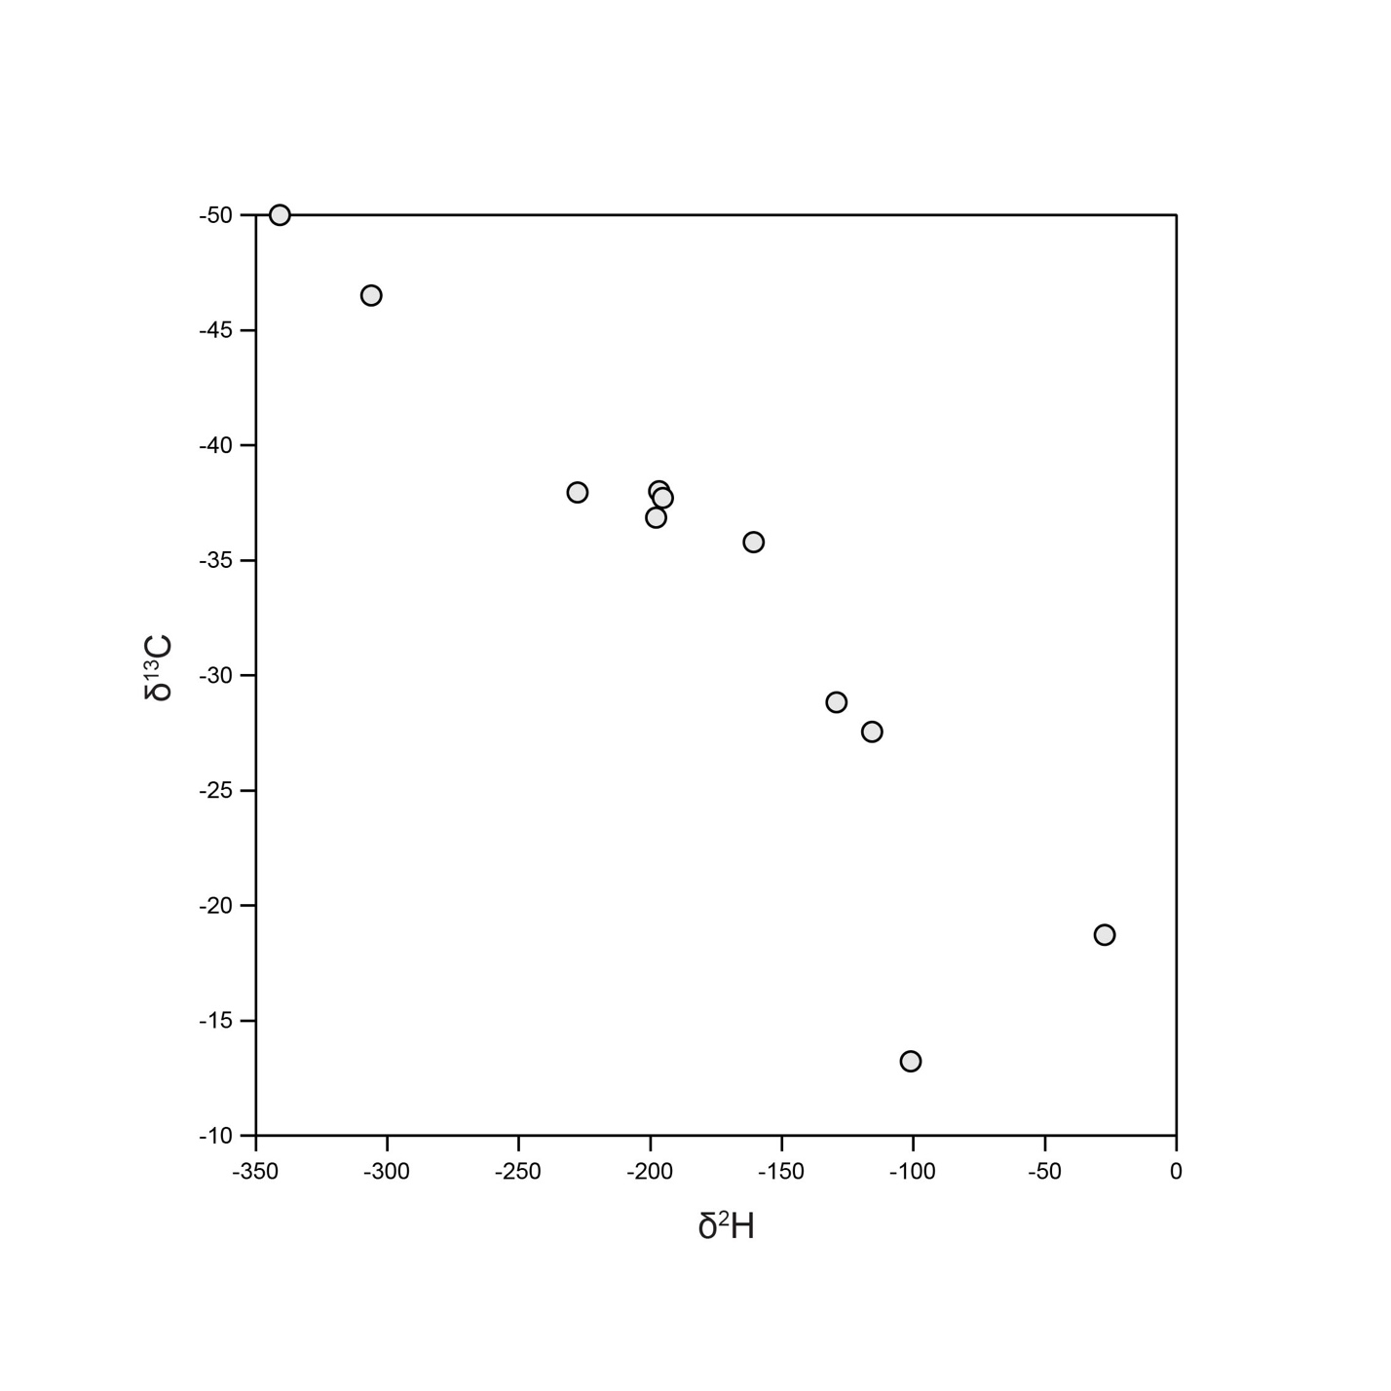
Figure S12: Relationship between δ¹³C and δ²H of dissolved methane in Teardrop Lake. A positive correlation was observed between δ¹³C and δ²H (n=12, R = 0.93, p < 0.001). Regression (δ¹³C =0.1121*δ²H - 13.364)

