Supplementary Materials for

Temporal dynamics in zooplankton δ¹³C and δ¹⁵N isoscapes for the North Atlantic Ocean: Decadal cycles, seasonality and implications for predator ecology

Boris Espinasse^{1*}, Anthony Sturbois², Sünnje L. Basedow¹, Pierre Hélaouët³, David G. Johns³, Jason Newton⁴ and Clive N. Trueman⁵

Contents of this file
7 Figures and 3 Tables

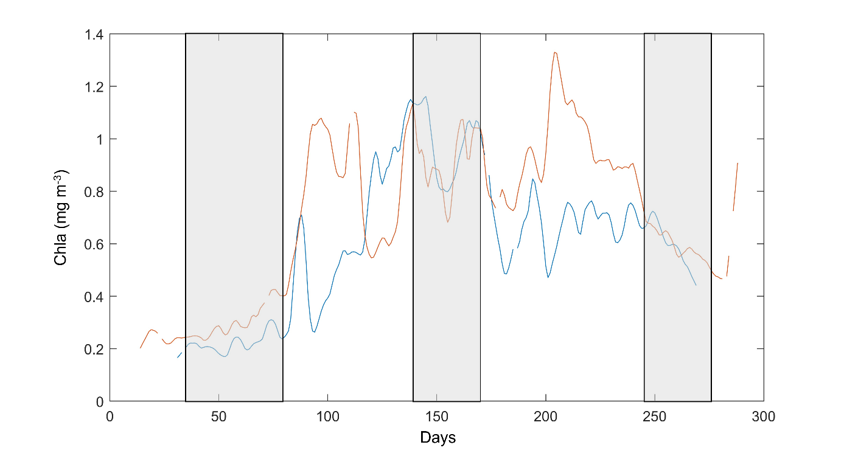
Figure S1. Daily climatology of chlorophyll a concentrations inferred from ocean colour measured by MODIS-AQUA satellite for the geographical points 60°N / 38°W (blue line) and 54°N / 20°W (red line), being located in the sub-polar and westerly biomes, respectively. Light grey boxes represent the season as defined in this study (minus 10 days for tissue turnover rates), during which the ecosystems are assumed to be relatively stable.

Figure S2. Delaunay triangulation mesh for the North Atlantic Ocean (> 40°N; n= 4306).

Figure S3. Scatter plots + linear regressions of seasonal observational stable isotope data vs modelled data (A) using season as a random effect and (B) doing prediction with the yearly models using seasonal predictors.

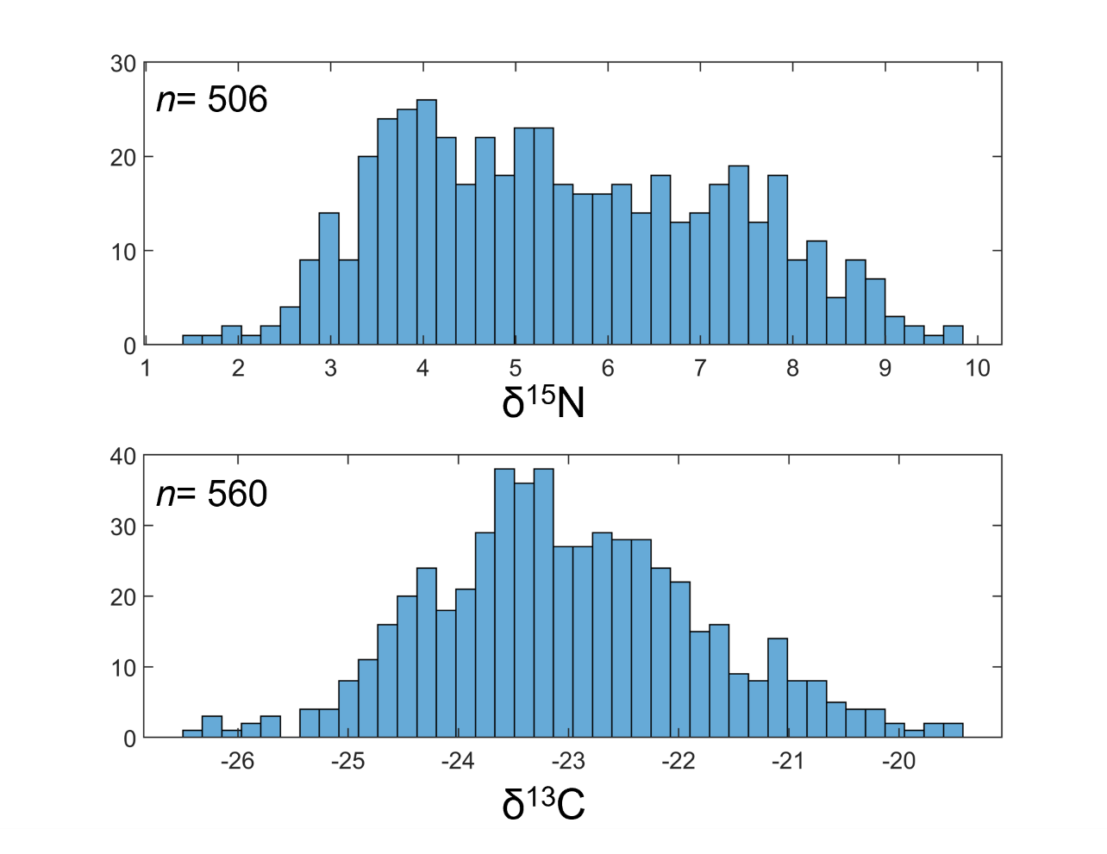
Figure S4. Histograms of δ¹⁵N and δ¹³C values measured in Calanus copepods.

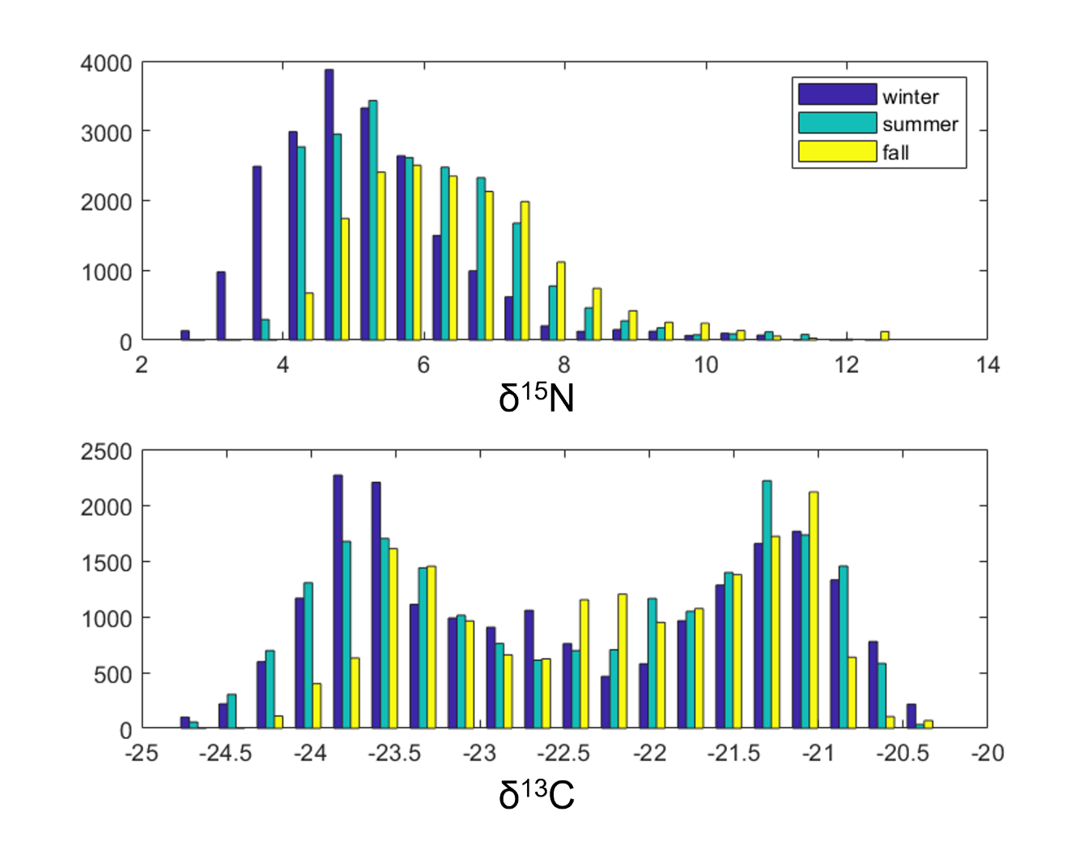Figure S5. Histograms of modelled δ¹⁵N and δ¹³C values for three seasons.

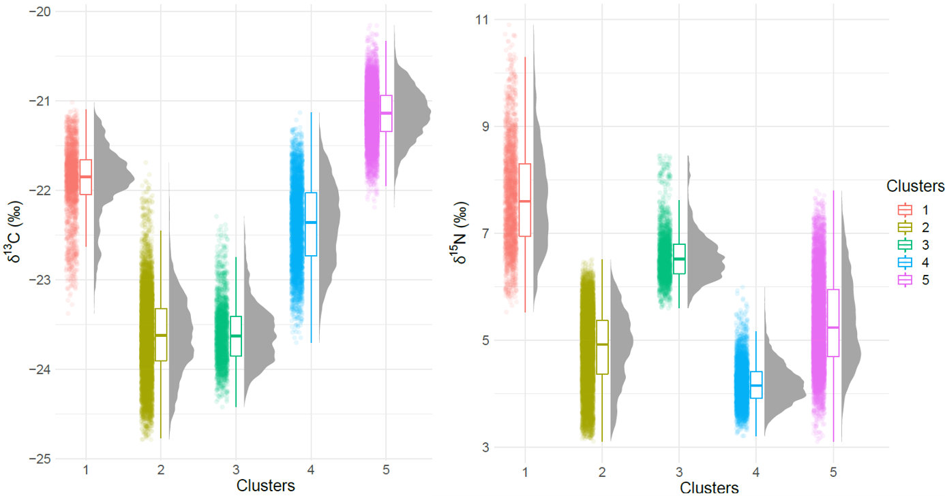

Figure S6. Boxplots of modelled δ¹⁵N and δ¹³C values for each cluster.

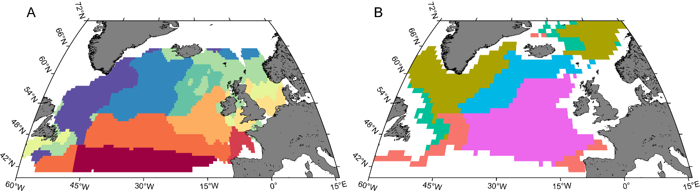
Figure S7. A) ecoregions defined in Beaugrand et al., 2019, based on zooplankton community composition and environmental variables and B) clusters defined in this study based on isotopic trajectory path.

Table S1. Description of the parameters used in the isoscape modelling.
Parameter | Value range | Spatial resolution | Transformation | Notation | Data source
Sea surface temperature (°C) | 0.93 – 16.04 | 0.05° |  | SST | marine.copernicus.eu/
Chla concentrations (mg m⁻³) | 0.2 – 3.05 | 25 km | Logged; capped at [0.2 ; -] | chla | globcolour.info/
Net primary productivity (mgC m⁻² d⁻¹⁾ | 9.48 – 1947.63 | 0.25° |  | NPP | http://sites.science.oregonstate.edu/ocean.productivity/
Wind speed (m s⁻¹) | 5.77 – 14.41 | 0.25° |  | Wind | marine.copernicus.eu/
Mixed layer depth (m) | 10.61 – 150 | 0.083° | Logged; capped at [- ; 150] m | MLD | marine.copernicus.eu/
Distance to 200 m isobath (km) | 50.01 – 700 | 2 km | Capped at [50 ; 700] km | dist | ETOPO1, NOAA

Table S2. Description of some of the model formulas tested. The main idea behind the model selection process was to keep the models as simple as possible to be able to interpret the smoother shape and to do not overfit the observations data. In order to achieve that, only a few interaction terms were tried and the number of knots controlling the wiggliness of the smoother was kept low. All the models were described here were developed using the frequentist GAM package ‘mgcv’.
Model formula | AIC | Deviance explained | Total edf
δ¹³C ~ s(sst) + ti(chla,wind) + s(dist) | 1582.8 | 44.9% | 17.82
δ¹³C ~ s(sst) + ti(mld,wind) + s(dist) | 1588.4 | 42.9% | 22.09
δ¹³C ~ s(sst) + ti(mld,chla) + s(dist) | 1582.5 | 43% | 20.41
δ¹³C ~ ti(mld, chla, k=4) + s(sst, k=5) + s(dist, k=3) | 1552.9 | 43.8% | 16
*δ¹³C ~ s(chla, k=5) + s(sst, k=5) + s(dist, k=3) + wind | 1496.2 | 46.7% | 12
δ¹⁵N ~ ti(chla,mld) + s(wind) + s(sst) + s(dist) | 1794.1 | 43.6% | 29.37
δ¹⁵N ~ ti(chla,wind) + s(mld) + s(sst) + s(dist) | 1791.1 | 43.9% | 23.81
δ¹⁵N ~ ti(chla, wind, k=4) + s(mld, k=5) + s(sst, k=5) + dist | 1697.9 | 48.9% | 19
δ¹⁵N ~ s(chla, k=4) + s(mld, k=5) + s(sst, k=5) + s(wind, k=6) + dist | 1706.7 | 47.8% | 18
*δ¹⁵N ~ chla + s(mld, k=3) + s(sst, k=5) + s(wind, k=5) + dist | 1703.5 | 47.1% | 13

Table S3. Results of Watson's two-sample test of homogeneity performed on SI data between clusters.
 | Cluster #1 | Cluster #2 | Cluster #3 | Cluster #4
Cluster #1 | -
Cluster #2 | 6.48*** | -
Cluster #3 | 4.27*** | 0.43*** | -
Cluster #4 | 9.75*** | 2.36*** | 0.89*** | -
Cluster #5 | 0.90*** | 9.23*** | 4.35*** | 13.08***

