Supplementary Material

Supplementary material 1
Minimum, mean and maximum sea water temperature layers of each sampling location were assessed using R software environment (R Development Core Team, 2016) and Bio-Oracle (http://www.bio-oracle) (Assis et al, 2017). The 3 nearest cells from each sampling sites were selected.
Bio-Oracle temperature layers used for Roscoff, Galicia and Morocco: BO2_tempmax_ss Maximum sea surface temperature
BO2_tempmin_ss: Minimum sea surface temperature
BO2_tempmean_ss: Mean sea surface temperature
For Italy, a deep population (50m depth), the following layers were used: BO_bathymax: Maximum depth of the seafloor (depth constrained between -39 to -56 m)
BO2_tempmax_bdmax: Maximum sea water temperature at the bottom at maximum bottom depth
BO2_tempmin_bdmax: Minimum sea water temperature at the bottom at maximum bottom depth
BO2_tempmean_bdmax: Mean sea water temperature at the bottom at maximum bottom depth

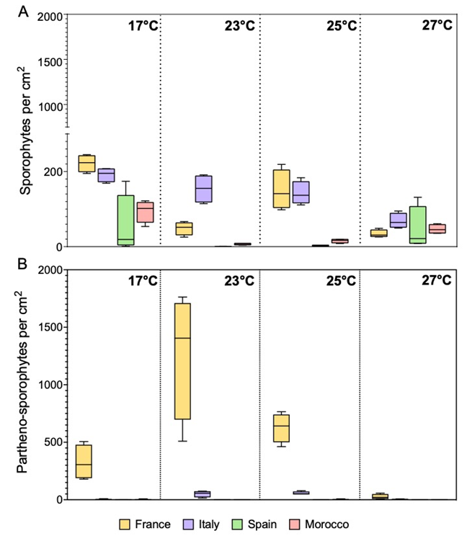
Supplementary Figure S2. Average density (cm²) of sexual (A) and asexually (B) formed sporophytes of different populations of Laminaria ochroleuca after recovery from different thermal treatments (17°C, 23°C, 25°C, and 27°C). Box plots with median, boxes for 25th and 75th percentiles and whiskers indicating min and max values (n = 4).

