Supplementary Figures
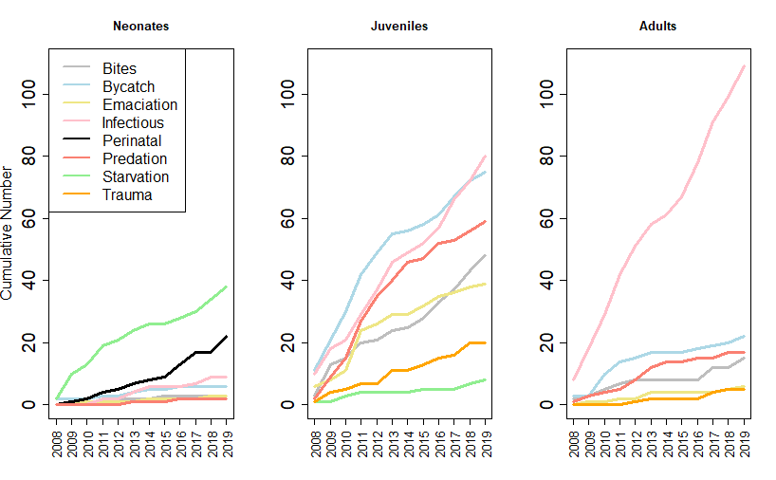
Figure S1. Cumulative number of causes of death per year, framed per age class

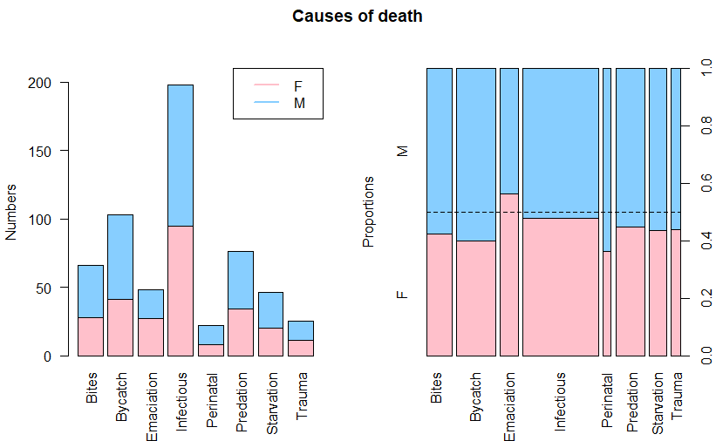
Figure S2. Sex per cause of death category. Left: stacked absolute numbers. Right: proportions with the width of the bars representative of sample size and dotted horizontal line at 0.5. Blue is males. Pink is females. 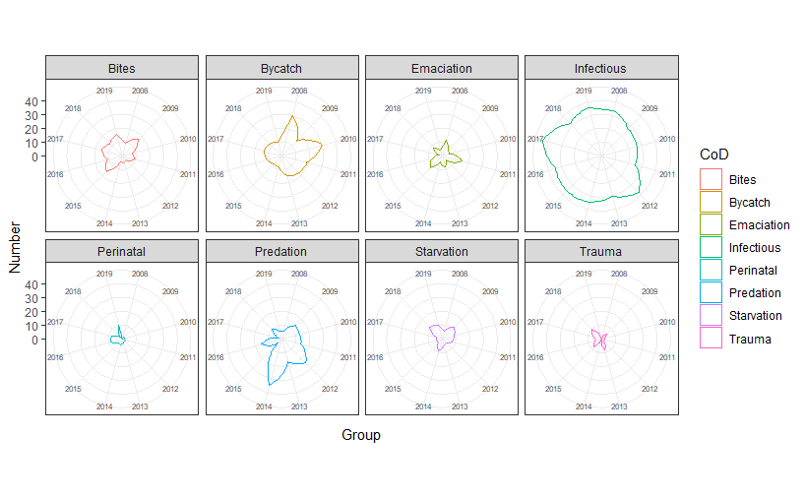
Figure S3. Radar plots of causes of death categories per year (2009-2019) corrected for n/year
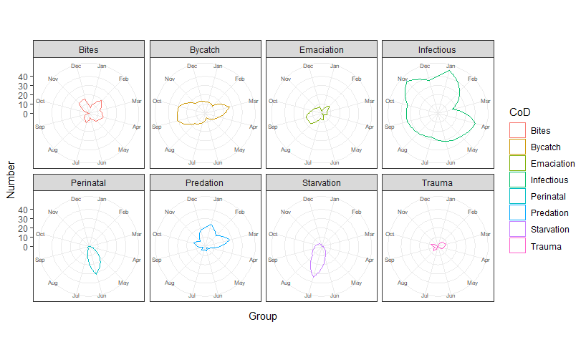
Figure S4. Radar plots of causes of death categories per month corrected for n/month

