Supplemental Materials and Methods
1. Animals and sensitization model design
A total of 32 female inbred high IgE-responder Brown Norway (BN) rats (aged 4 weeks) were purchased from Charles River (Beijing, China; Permission number “SYXK (Jing) 2016-0006”). All experiments were performed in strict accordance with the NCH guidelines from China for the care and use of laboratory animals (NHC Publication No.11, Rev. 2016) and approved by the Animal Care Committee of Nanchang University (Nanchang, China). The animal sensitization protocol was performed according to previous studies (Knippels & Penninks, 2003) with some modifications. The rats were housed in cages (four rats/cage) at 22 ± 2 ℃, relative humidity was 55 ± 5 %, and a light/dark cycle of 12/12 h. Rats were randomly distributed into four groups (Control, PM, UHTM and DSM group) and each group consisted of eight rats. After a week of acclimatization, BN rats were administered by oral gavage each day for 55 days with 0.5 mL of either cow’s milk (10 mg protein, treated groups) or purified water (control group). On the 56th day, each rat was dosed by gavage with 1 mL of either cow’s milk (30 mg protein, treated groups) or purified water (control group), and 30 min later, blood and intestine were collected. For serum separation, blood was clotted overnight at 4 ℃ and serum was separated with centrifugation at 3500 rpm for 10 minutes at 4 °C and stored at -80 ℃ for further analysis. Figure S1 is an overview of the animal experimental design.
2. The detection of specific antibody by indirect ELISA
Specific IgE, IgG, IgG1, and IgG2a responses to cow’s milk proteins were performed by indirect ELISAs. Microtitre plates (96-well, Corning, NY, USA) were coated with 2 μg/mL of allergen (100 μL/well) diluted in 0.05 M carbonate buffer (15 mmol/mL Na₂CO₃, 35 mmol/mL NaHCO₃, pH 9.6) and incubated overnight at 4 °C. Plates were washed three times by PBS with 0.01% Tween 20 (PBS-T). Those plates were blocked with 250 μL/well of 3% gelatin in PBS for 1 h at 37 °C. Dilutions of serum was 1:10, 1:40,000, 1:8,000, and 1:8,000 for testing IgE, IgG, IgG1 and IgG2a, respectively. The diluted sera (100 μL/well) were added and incubated for 1 h at 37℃. For detection IgG, IgG1, and IgG2a, 100 μL of HRP-labelled mouse-anti-rat IgG, IgG1, and IgG2a (Southern Biotech, Birmingham, AL, USA) diluted 1: 5,000 (v:v) in PBS was added to each well and incubated for 1 h at 37℃, respectively. For the IgE binding experiments, 100 μL of biotin-labelled mouse-anti-rat IgE (Bio-Rad, California, USA) diluted 1: 5,000 (v:v) in PBS was added to each well and incubated for 1 h at 37℃, and after washing, streptavidin-HRP (NeoBioscience, Shanghai, China) diluted 1:60 (v:v) in PBS was added to each well. The step for visualization of the specific antibody response was same as the above.

Table S1. Formulation of simulated gastric fluid (SGF) and simulated intestinal fluid (SIF)
 | Constituent (mol/L)
 | KCl (0.5) | KH₂PO₄ (0.5) | NaHCO₃ (1) | NaCl (2) | MgCl₂ (0.15) | (NH₄)₂CO₃ (0.5)
gastric stock electrolyte solution (mL) | 6.9 | 0.9 | 12.5 | 11.8 | 0.4 | 0.5
 | Added water to 400mL
intestinal stock electrolyte solution (mL) | 6.8 | 0.8 | 42.5 | 9.6 | 1.1
 | Added water to 500mL

Table S2. Clinical data of 10 individuals with cow’s milk allergy
Number | Sex | Age | Clinical symptoms | Specific IgE level (KUA/L)
1 | Female | 10 months old | Asthmatic Bronchial Pneumonia | 3.5
2 | Male | 4 months old | ND* | 2.7
3 | Male | 1 months old | Bronchial Asthma | 2.9
4 | Female | 13 months old | Pneumonia | 1.0
5 | Female | 4 years old | Allergic Rhinitis | 3.2
6 | Male | 4 months old | Urticaria | 5.9
7 | Male | 9 months old | Urticaria | 56.8
8 | Male | 11 months old | ND* | 18.0
9 | Male | 1 year old | Leukocytosis | 43,7
10 | Male | 3 years old | Allergic Rhinitis | 3.7
ND*—Not Done

Table S3. Formulation of Kreb’s solution
 | Constituent (mol/L)
 | KCl (0.47) | KH₂PO₄ (120) | NaHCO₃ (0.248) | NaCl (1.17) | MgCl₂ (0.1) | CaCl₂(0.256) (0.256CO₃ (0.5) | Glucose
Kreb’s solution (mL) | 10 | 10 | 100 | 100 | 12 | 10 | 2g
 | Added water to 1L

Table S4. The amino acid sequence information of synthetic peptides.
Peptide | Amino acid sequence | Purity
P1(β- LG -AA₄₁₋₆₀) | VYVEELKPTPEGDLEILLQK | 95%
P2(β-LG -AA₆₁₋₆₉) | WENGECAQK | 95%
P3(β-LG -AA₇₆₋₈₃) | TKIPAVFK | 95%
P4(β-LG -AA₈₄₋₉₁) | IDALNENK | 95%
P5(β-LG -AA₉₂₋₁₀₀) | VLVLDTDYK | 95%
P6(β-LG -AA₁₂₅₋₁₃₅) | TPEVDDEALEK | 95%
P7(β-LG -AA₁₂₅₋₁₃₈) | TPEVDDEALEKFDK | 95%
P8(β-LG -AA₁₄₂₋₁₄₈) | ALPMHIR | 95%
P9(α-LA -AA₆₃₋₇₉) | DDQNPHSSNICNISCDK | 95%
P10(α-LA -AA₈₀₋₉₃) | FLDDDLTDDIMCVK | 95%
P11(α-LA -AA₉₉₋₁₀₈) | VGINYWLAHK | 95%
P12(α-LA -AA₁₁₅₋₁₂₂) | LDQWLCEK | 95%
P13(αS1-casein -AA₈₄₋₉₀) | EDVPSER | 95%
P14(αS1-casein -AA₁₂₅₋₁₃₂) | EGIHAQQK | 95%
P15(αS2-casein -AA₂₅₋₃₂) | NMAINPSK | 95%
P16(αs2-casein -AA₇₁₋₇₆) | ITVDDK | 95%

Table S5. The remaining peptides derived from the pasteurized milk (PM), ultra-heat-treated milk (UHTM) and dried skim milk (DSM) after simulating gastrointestinal digestion were identified by nano-LC-QE.
Measured MW (MH+) | Identification | Sequence
PM group
2707.37 | β-LG (15-40) | VAGTWYSLAMAASDISLLDAQSAPLR
2313.25 | β-LG (41-60) | VYVEELKPTPEGDLEILLQK
903.56 | β-LG (76-83) | TKIPAVFK
916.47 | β-LG (84-91) | IDALNENK
1065.58 | β-LG (92-100) | VLVLDTDYK
1193.67 | β-LG (92-101) | VLVLDTDYKK
1635.77 | β-LG (125-138) | TPEVDDEALEKFDK
837.47 | β-LG (142-148) | ALPMHIR
1699.94 | α-LA (95-108) | ILDKVGINYWLAHK
1200.65 | α-LA (99-108) | VGINYWLAHK
1759.94 | αS1-casein (8-22) | HQGLPQEVLNENLLR
1337.67 | αS1-casein (80-90) | HIQKEDVPSER
1267.70 | αS1-casein (91-101) | YLGYLEQLLR
946.52 | αS1-casein (35-42) | EKVNELSK
223.23 | αS1-casein (4-22) | HPIKHQGLPQEVLNENLLR
1384.72 | αS1-casein (23-34) | FFVAPFPEVFGK
1237.66 | αS1-casein (24-34) | FVAPFPEVFGK
875.53 | αS1-casein (103-109) | KYKVPQL
910.47 | αS1-casein (125-132) | EGIHAQQK
874.44 | αS2-casein (25-32) | NMAINPSK
1367.9 | αS2-casein (81-91) | ALNEINQFYQK
1246.64 | αS2-casein (71-80) | ITVDDKHYQK
1195.67 | αS2-casein (115-125) | NAVPITPTLNR
1247.66 | αS2-casein (151-160) | TKLTEEEKNR
979.56 | αS2-casein (174-181) | FALPQYLK
1137.55 | β-casein (114-122) | YPVEPFTER
1151.69 | β-casein (199-209) | GPVRGPFPIIV
1013.52 | β-casein (106-113) | HKEMPFPK
780.49 | β-casein (170-176) | VLPVPQK
1512.78 | β-casein (46-58) | QDKIHPFAQTQSL
1242.68 | κ-casein (76-86) | WQVLSNTVPAK
1269.61 | κ-casein (1-10) | QEQNQEQPIR
UHTM group
2707.37 | β-LG (15-40) | VAGTWYSLAMAASDISLLDAQSAPLR
2313.25 | β-LG (41-60) | VYVEELKPTPEGDLEILLQK
903.56 | β-LG (76-83) | TKIPAVFK
1256.72 | β-LG (83-93) | KIDALNENKVL
916.47 | β-LG (84-91) | IDALNENK
1193.67 | β-LG (92-101) | VLVLDTDYKK
1065.58 | β-LG (92-100) | VLVLDTDYK
1245.58 | β-LG (125-135) | TPEVDDEALEK
1635.77 | β-LG (125-138) | TPEVDDEALEKFDK
1699.94 | α-LA (95-108) | ILDKVGINYWLAHK
1200.65 | α-LA (99-108) | VGINYWLAHK
1759.94 | αS1-casein (8-22) | HQGLPQEVLNENLLR
1237.66 | αS1-casein (24-34) | FVAPFPEVFGK
1337.67 | αS1-casein (80-90) | HIQKEDVPSER
946.52 | αS1-casein (35-42) | EKVNELSK
1267.70 | αS1-casein (91-101) | YLGYLEQLLR
910.47 | αS1-casein (125-132) | EGIHAQQK
1506.77 | αS1-casein (120-132) | LHSMKEGIHAQQK
1386.64 | αS2-casein (138-149) | TVDMESTEVFTK
1247.65 | αS2-casein (151-160) | TKLTEEEKNR
979.56 | αS2-casein (174-181) | FALPQYLK
1246.64 | αS2-casein (71-80) | ITVDDKHYQK
1195.67 | αS2-casein (115-125) | NAVPITPTLNR
1351.78 | αS2-casein (114-125) | RNAVPITPTLNR
1137.55 | β-casein (114-122) | YPVEPFTER
1981.86 | β-casein (33-48) | FQSEEQQQTEDELQDK
1591.93 | β-casein (170-183) | VLPVPQKAVPYPQR
1458.77 | β-casein (193-205) | YQEPVLGPVRGPF
2682.32 | β-casein (141-163) | QSWMHQPHQPLPPTVMFPPQSVL
1242.68 | κ-casein (76-86) | WQVLSNTVPAK
DSM group
2313.25 | β-LG (41-60) | VYVEELKPTPEGDLEILLQK
903.56 | β-LG (76-83) | TKIPAVFK
1256.72 | β-LG (83-93) | KIDALNENKVL
1193.67 | β-LG (92-101) | VLVLDTDYKK
1065.58 | β-LG (92-100) | VLVLDTDYK
1243.61 | β-LG (123-132) | VRTPEVDDEAL
1245.58 | β-LG (125-135) | TPEVDDEALEK
1635.77 | β-LG (125-138) | TPEVDDEALEKFDK
1759.94 | αS1-casein (8-22) | HQGLPQEVLNENLLR
1384.72 | αS1-casein (23-34) | FFVAPFPEVFGK
1337.67 | αS1-casein (80-90) | HIQKEDVPSER
1267.70 | αS1-casein (91-101) | YLGYLEQLLR
946.52 | αS1-casein (35-42) | EKVNELSK
2021.01 | αS1-casein (125-142) | EGIHAQQKEPMIGVNQEL
690.36 | αS2-casein (71-76) | ITVDDK
1246.64 | αS2-casein (71-80) | ITVDDKHYQK
1367.69 | αS2-casein (81-91) | ALNEINQFYQK
1379.66 | αS2-casein (126-137) | EQLSTSEENSKK
1251.57 | αS2-casein (126-136) | EQLSTSEENSK
1386.64 | αS2-casein (138-149) | TVDMESTEVFTK
1247.65 | αS2-casein (151-160) | TKLTEEEKNR
979.56 | αS2-casein (174-181) | FALPQYLK
1195.67 | αS2-casein (115-125) | NAVPITPTLNR
1351.78 | αS2-casein (114-125) | RNAVPITPTLNR
874.44 | αS2-casein (40-47) | NMAINPSK
1137.55 | β-casein (114-122) | YPVEPFTER
1981.86 | β-casein (33-48) | FQSEEQQQTEDELQDK
1013.52 | β-casein (106-113) | HKEMPFPK
1591.92 | β-casein (170-183) | VLPVPQKAVPYPQR
889.48 | β-casein (98-105) | VKEAmAPK
1512.78 | β-casein (46-58) | QDKIHPFAQTQSL
1242.68 | κ-casein (76-86) | WQVLSNTVPAK

Table S6. Identification by nanoESI-MSMS of pasteurized milk (PM), ultra-heat-treated milk (UHTM) and dried skim milk (DSM) derived peptides surviving in vitro transepithelial transport by sensitized rats’ intestines.
Measured MW (MH+) | Identification |  | Sequence
PM group
2313.25 | β-LG (41-60) |  | VYVEELKPTPEGDLEILLQK
1179.47 | β-LG (61-69) |  | WENGECAQK
701.45 | β-LG (70-75) |  | KIIAEK
674.42 | β-LG (76-83) |  | TKIPAVFK
916.47 | β-LG (84-91) |  | IDALNENK
1065.58 | β-LG (92-100) |  | VLVLDTDYK
1193.67 | β-LG (92-101) |  | VLVLDTDYKK
1635.77 | β-LG (125-138) |  | TPEVDDEALEKFDK
837.47 | β-LG (142-148) |  | ALPMHIR
1715.80 | β-LG (149-162) |  | LSFNPTQLEEQCHI
1699.75 | α-LA (80-93) |  | FLDDDLTDDIMCVK
1200.65 |  | α-LA (99-108) | VGINYWLAHK
1091.51 |  | α-LA (115-122) | LDQWLCEK
831.38 |  | αS1-casein (84-90) | EDVPSER
874.44 |  | αS2-casein (25-32) | NMAINPSK
UHTM group
1179.47 | β-LG (61-69) |  | WENGECAQK
674.42 | β-LG (78-83) |  | IPAVFK
1065.58 | β-LG (92-100) |  | VLVLDTDYK
1193.67 | β-LG (92-101) |  | VLVLDTDYKK
1245.58 | β-LG (125-135) |  | TPEVDDEALEK
1635.77 | β-LG (125-138) |  | TPEVDDEALEKFDK
837.47 | β-LG (142-148) |  | ALPMHIR
1715.80 | β-LG (149-162) |  | LSFNPTQLEEQCHI
2003.81 |  | α-LA (63-79) | DDQNPHSSNICNISCDK
1200.65 |  | α-LA (99-108) | VGINYWLAHK
1699.75 |  | α-LA (80-93) | FLDDDLTDDIMCVK
1091.51 |  | α-LA (115-122) | LDQWLCEK
831.38 | αS1-casein (84-90) |  | EDVPSER
9910.47 | αS1-casein (125-132) |  | EGIHAQQK
874.44 | αS2-casein (25-32) |  | NMAINPSK
690.36 | αS2-casein (71-76) |  | ITVDDK
DSM group
674.42 | β-LG (78-83) |  | IPAVFK
1065.58 | β-LG (92-100) |  | VLVLDTDYK

Table S7. Identification by nanoESI-MSMS of the pasteurized milk (PM), ultra-heat-treated milk (UHTM) and dried skim milk (DSM) derived peptides surviving in vitro transepithelial transport by rat’s intestine from the control group
Measured MW (MH+) | Identification | Sequence
PM group
2313.25 | β-LG (41-60) | VYVEELKPTPEGDLEILLQK
1179.47 | β-LG (61-69) | WENGECAQK
674.42 | β-LG (78-83) | IPAVFK
916.47 | β-LG (84-91) | IDALNENK
1245.58 | β-LG (125-135) | TPEVDDEALEK
1715.80 | β-LG (149-162) | LSFNPTQLEEQCHI
UHTM group
674.42 | β-LG (78-83) | IPAVFK
1384.73 | αS1- casein (23-34) | FFVAPFPEVFGK
DSM group
674.42 | β-LG (78-83) | IPAVFK

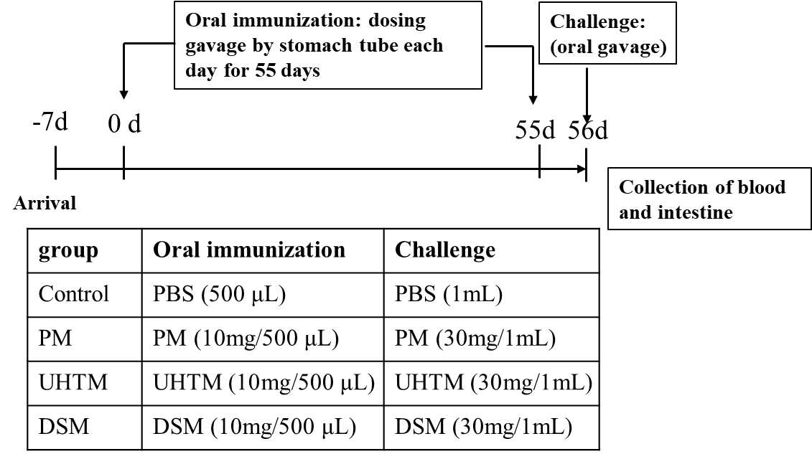
Figure S1. Sensitization experiments. Treatment project: Brown Norway rats were administered by oral gavage each day for 56 days with PBS, pasteurized milk (PM), ultra-heat-treated milk (UHTM) and dried skim milk (DSM), respectively. The experimental setup with n=8 rats per group is shown in the insert: Control group, PM group, UHTM group, DSM group.

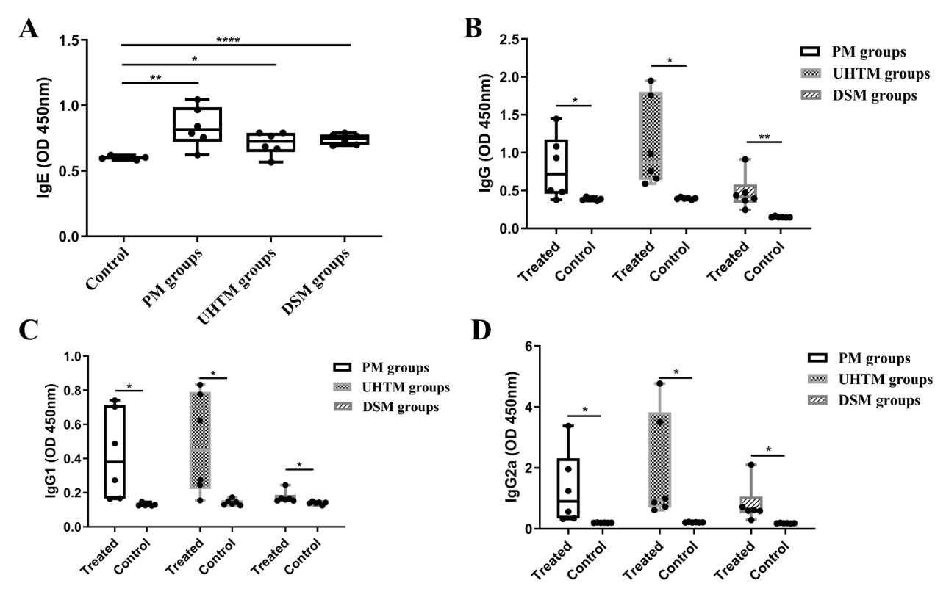
Figure S2. The levels of specific IgE/IgG/ IgG2a/IgG1 in sera from rat immunized by different cow’s milk sample including pasteurized milk (PM), ultra-heat-treated milk (UHTM) and dried skim milk (DSM). *p < 0.05, **p < 0.01, ***p < 0.001, ****p < 0.0001 indicate significant difference as compared to that of control group.

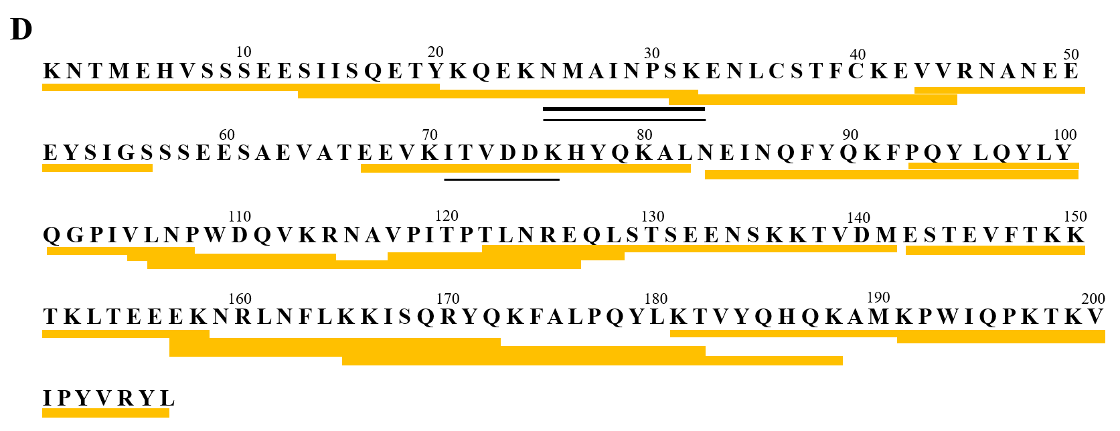
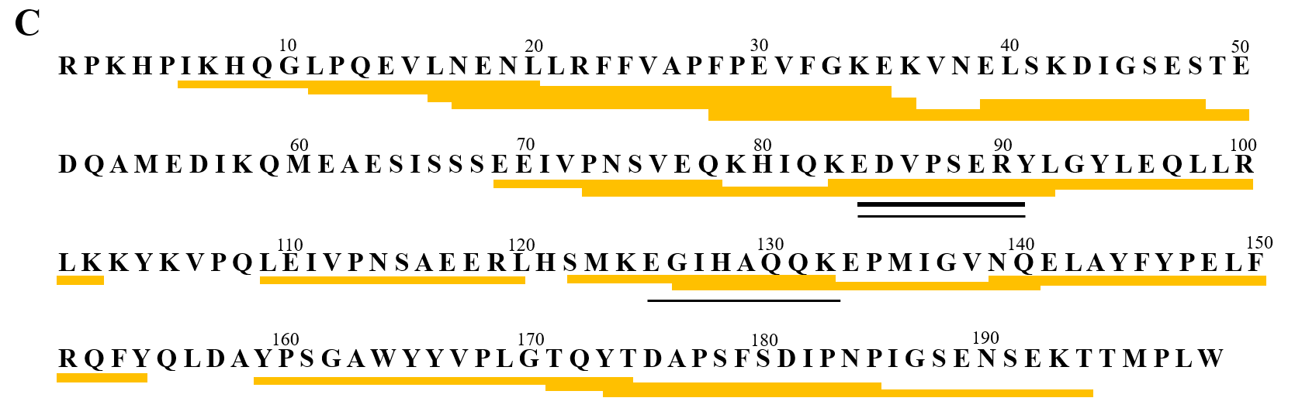
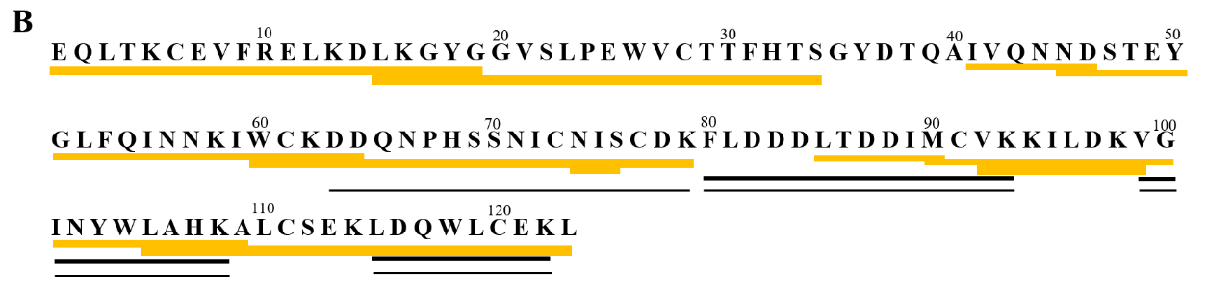
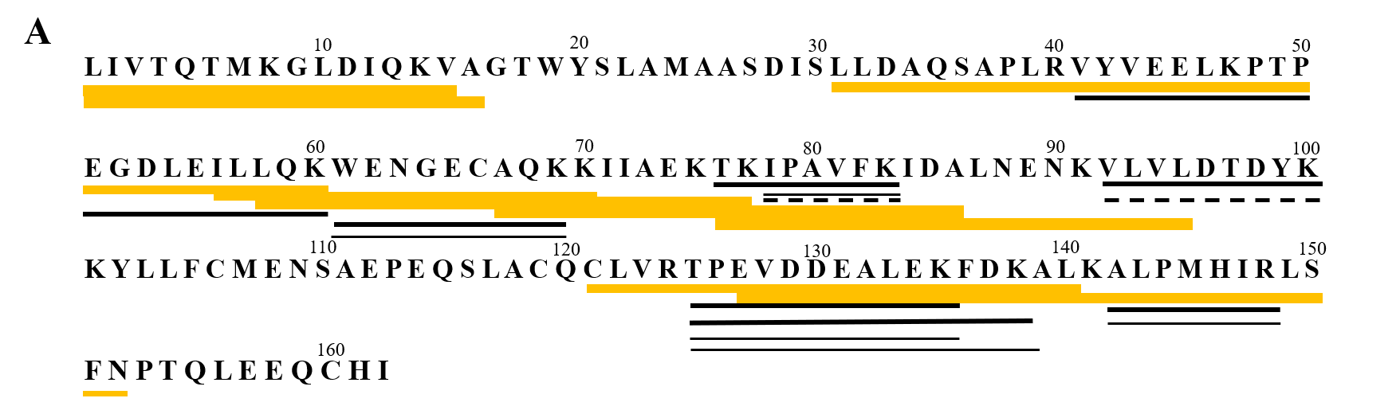
Figure S3. The peptides were identified by LC-MS/MS at the end of β-LG (A), α-LA (B), αS1-casein (C), and αS2-casein (D) gastrointestinal digestion followed by intestinal transportation. The reported IgE linear epitopes were represented as the yellow bars. Peptides found in pasteurized milk (PM), ultra-heat-treated milk (UHTM) and dried skim milk (DSM) were represented as thick black bars, thin black bars and dashed lines, respectively.

Reference
Knippels, L. M., & Penninks, A. H. (2003). Assessment of the allergic potential of food protein extracts and proteins on oral application using the brown Norway rat model. Environ Health Perspect, 111 (2), 233-238.

