Supplementary Material

Comparative biology of the grenadiers Macrourus caml and M. whitsoni in the Ross Sea region, Antarctica
- Bradley R. Moore^{1,2*}, Steven J. Parker¹, Peter M. Marriott³, Colin Sutton¹, Matthew H. Pinkerton³
¹National Institute of Water and Atmospheric Research Ltd, Nelson, New Zealand
²Institute for Marine and Antarctic Studies, University of Tasmania, Hobart, TAS, Australia
³National Institute of Water and Atmospheric Research Ltd, Wellington, New Zealand
* Correspondence: Bradley Moore: bradley.moore@niwa.co.nz

Supplementary Data
This document reports the supplementary tables and figures cited in the paper.

Supplementary Tables

Supplementary Table S1. Results of Kolmogorov-Smirnov tests of length and age distributions between Macrourus caml and M. whitsoni from the Ross Sea region. Longline includes all fish sampled by longlines, including those collected during the winter surveys.
Parameter | Test | D | p
Total length | M. caml vs. M. whitsoni | 0.41 | < 0.01
 | M. caml male vs. M. caml female | 0.23 | < 0.01
 | M. whitsoni male vs. M. whitsoni female | 0.31 | < 0.01
 | M. caml longline vs. research trawl | 0.09 | <0.01
 | M. whitsoni longline vs. research trawl | 0.61 | <0.01
Age | M. caml vs. M. whitsoni | 0.22 | < 0.01
 | M. caml male vs. M. caml female | 0.06 | 0.69
 | M. whitsoni male vs. M. whitsoni female | 0.09 | 0.41
 | M. caml longline vs. research trawl | 0.16 | < 0.01
 | M. whitsoni longline vs. research trawl | 0.58 | < 0.01

Supplementary Table S2. Sex-aggregated von Bertalanffy growth function (VBGF) parameter estimates ± standard error for unconstrained and constrained (t₀ = 0) models for Macrourus caml and M. whitsoni in the Ross Sea region.
Species | Model | VBGF parameter
 |  | L∞ (TL, cm) | k | t₀
M. caml | Unconstrained | 82.85 ± 1.85 | 0.056 ± 0.005 | -1.098 ± 0.882
 | Constrained | 81.21 ± 1.18 | 0.062 ± 0.002 | -
M. whitsoni | Unconstrained | 65.82 ± 1.73 | 0.075 ± 0.007 | -0.822 ± 0.614
 | Constrained | 64.17 ± 1.09 | 0.084 ± 0.004 | -

Supplementary Figures

Supplementary Figure S1. Histogram of differences in annuli counts (left) and age bias plot (right) comparing annuli estimates from thin sections between the reader of the current study (PMM re-read) and the reference set. Error bars indicate the coefficient of variation (CV) for each age.

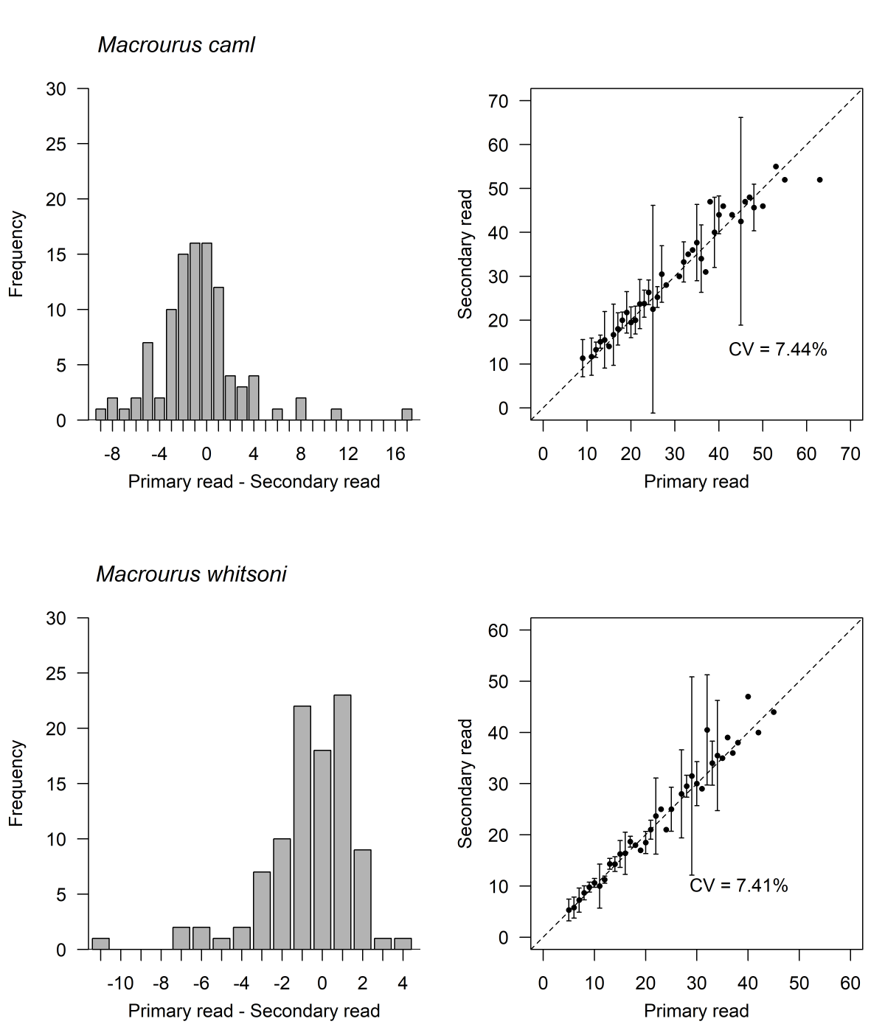
Supplementary Figure S2. Histogram of differences in annuli counts (left) and age bias plot (right) comparing annuli estimates from primary and secondary reads by the reader of the current study (PMM) for Macrourus caml (top) and M. whitsoni (bottom). Error bars indicate the coefficient of variation (CV) for each age.

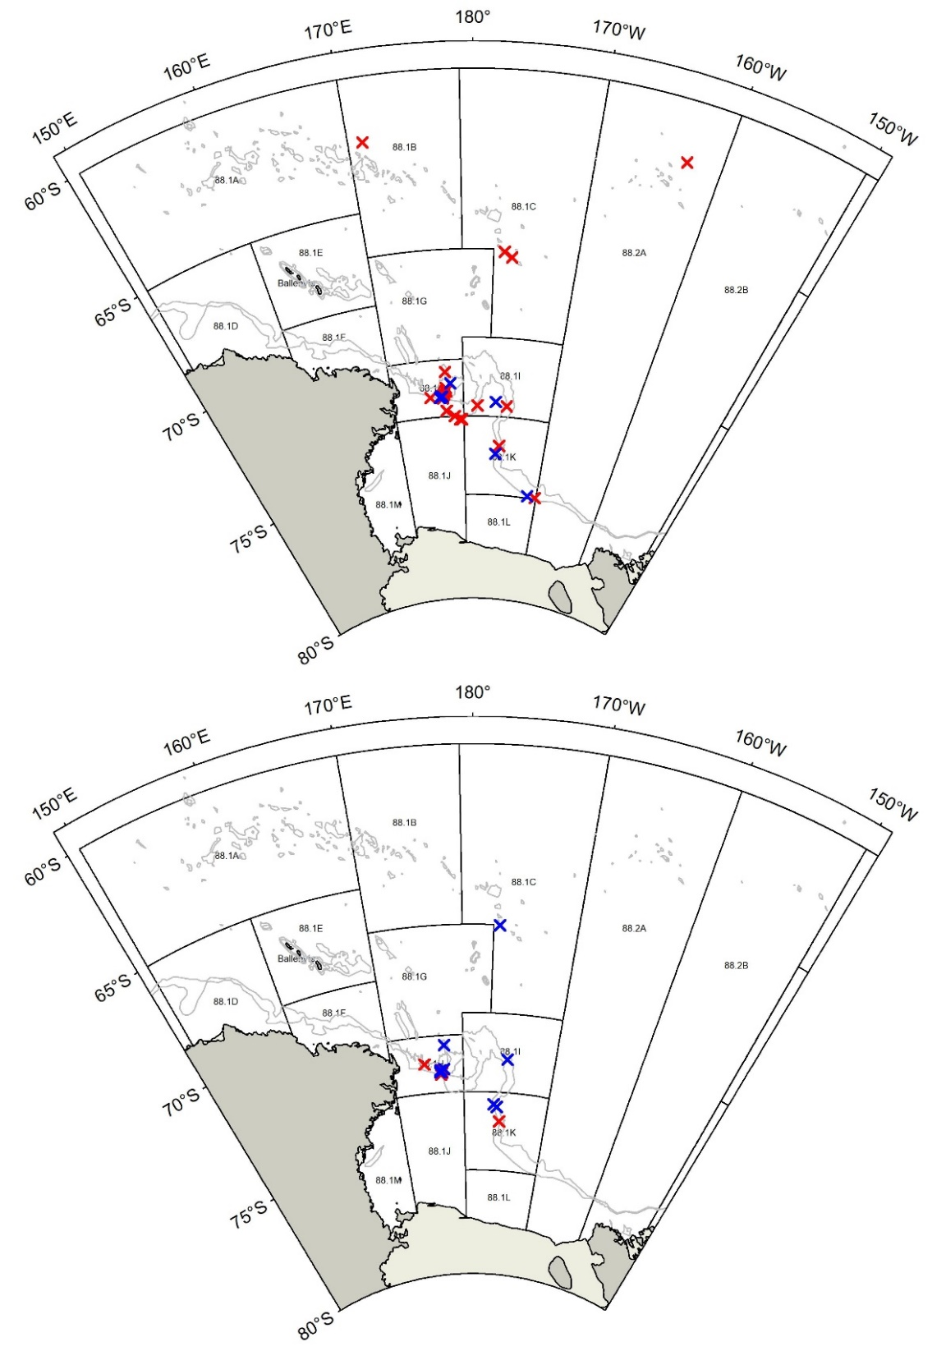
Supplementary Figure S3. Locations where ripe/running ripe (red crosses) and spent (blue crosses) female Macrourus caml (top) and M. whitsoni (bottom) were sampled in the Ross Sea region.

