Supplementary Material S1. Pipeline for analysis of multi-locus amplicon sequencing data of bacteria in gill tissues of Bathymodiolus mussels of the Central Indian Ridge (CIR) and the eastern Pacific. The software used on each step is indicated on the left.
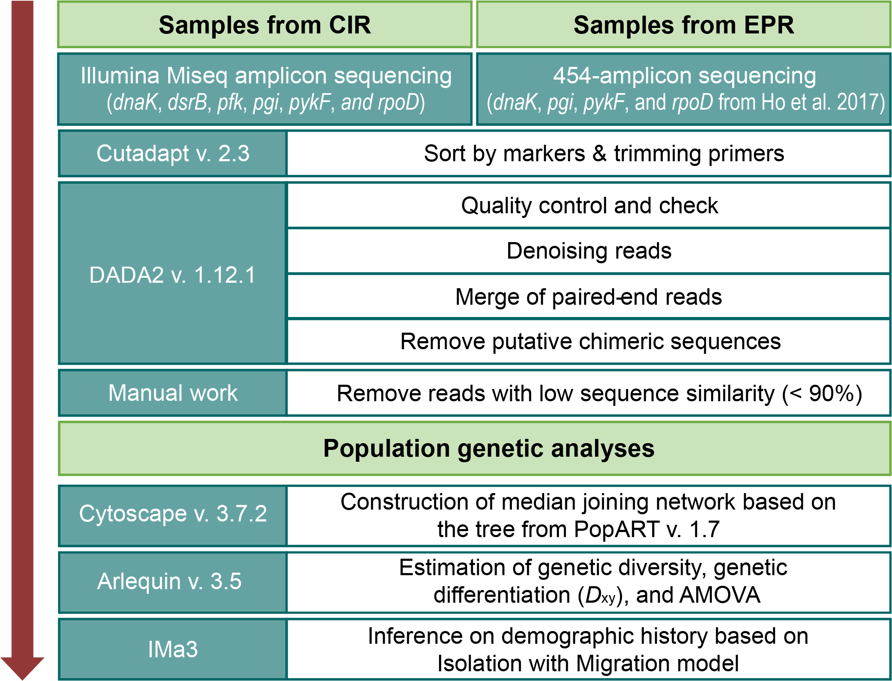

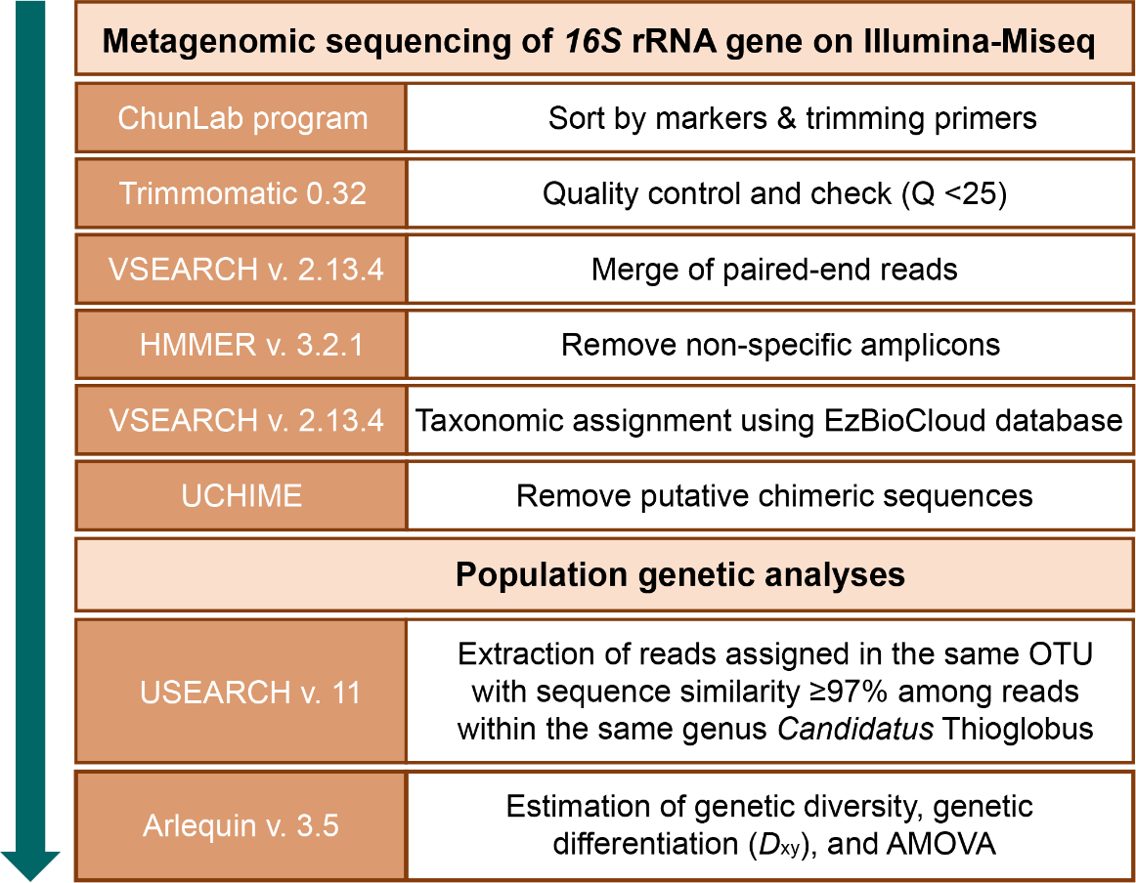
Supplementary Material S2. Pipeline for analysis of 16S rRNA amplicon sequencing data of bacteria in gill tissues of Bathymodiolus marisindicus of the CIR. The software used on each step is indicated on the left.
Supplementary Material S3. Command options used for IMa3 analyses.
In step 1, we estimated topologies using specific options for symbiont and host populations. IMa3 run used the hyperprior distribution with upper bounds of 0.05 and 0.044 for population size parameters of symbiont bacterial and host mussels, respectively. The exponential hyperprior distribution was used for migration rate parameters with the mean of the prior distribution, 60 and 180 for symbiotic bacteria and host mussels, respectively. The uniform prior distribution was used for splitting time parameters with upper bounds of 0.08 and 0.016 symbiotic bacteria and host mussels, respectively. Multiple metropolis-coupled chains, 40 chains on 20 processors (heating curve shape parameter, ha: 0.98, lower heating value, hb: 0.7) for symbiotic bacteria and 60 chains on 30 processors (ha: 0.985, hb: 0.7) for host mussels, were mixed using the geometric heating model.
In step 2, we estimated demographic parameters based on the topology estimated from step 1 using specific options for the symbiont and host populations (Table 4). The uniform prior distribution for population size and splitting time parameters were used with upper bounds, 0.05 and 0.02 for symbiotic bacteria; and 0.022 and 0.008 for host mussels. The exponential prior distributions were used for migration rate parameters with the mean of the prior distribution, 40 for both symbiotic bacteria and host mussels. The multiple metropolis-coupled chains were used with the same heating schemes as in step 1 for symbiotic bacteria and host mussels.

Supplementary Material S4. MCMC convergence diagnostics for IMa3 results.
Step 1. Estimation of a population topology.
First, we visually inspected the mixing of the MCMC simulation based on trace plots of loglikelihoods, priors, posteriors, and sampled phylogenies. For symbiotic bacteria, 4,091 genealogies were sampled after additional processes including discarding the first 10% and applying a thinning interval of 200 iterations. For host mussels, 1,644 genealogies were sampled after additional processes including discarding the first 40% and applying a thinning interval of 1,200 iterations. After burn-in and thinning, we conducted Pearson’s chi-square tests to compare the distributions of potential phylogenies between the initial 10% and final 50% and between the initial 50% and last 50% of the total sampled values. Finally, non-mixing and non-convergence were detected from the MCMC simulations. The related files were uploaded to Figshare (https://doi.org/10.6084/m9.figshare.17701754.v5).
Step 2. Estimation of demographic parameters.
In step 1, for each run, we visually inspected the mixing of an MCMC simulation based on trace plots of loglikelihoods, priors, posteriors, and two splitting times. The density plots of two splitting times from multiple runs were compared to ensure convergence. For symbiotic bacteria, 39,646 genealogies were sampled after discarding the first 10,000 and applying a thinning interval of 25 iterations in addition to the initial setting of 1,000,000 burn-in and 400 thinning intervals. For host mussels, 143,430 genealogies were sampled after discarding the first 3,000,000 and applying a thinning interval of 400 iterations. The stationary distribution of the MCMC simulations with non-patterned trend plots was examined through several diagnostics, including Geweke’s, Raftery and Lewis’s, and Heidelberg and Welch’s diagnostics. Furthermore, we assessed the convergence between two independent runs using t-tests for two splitting times. The related files were uploaded to Figshare (https://doi.org/10.6084/m9.figshare.17701754.v5).

