I - Correlation between the two dependent variables
Figure A.
Scatterplot and marginal histograms of the relation between dwell time and number of enters in the AOI.
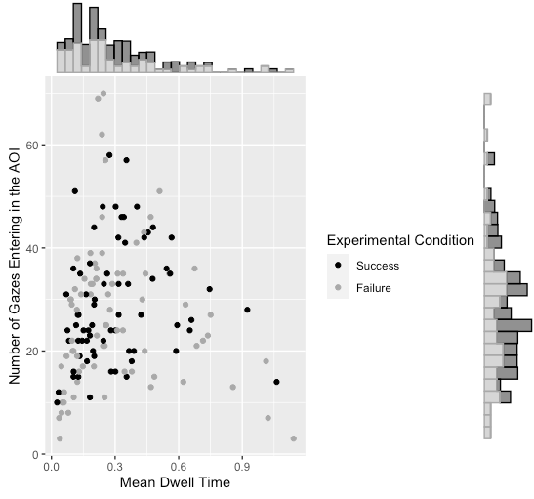

II - Details regarding the Motivation Hypothesis test

Testing increased motivation to perform the test
The manuscript reports an interaction effect between guilt proneness and failure manipulation on the number of gazes entering the zone of interest reflecting the participant’s face. Given the registered interpretation of such an effect, this would reflect self-focus avoidance following failure for guilt-prone individuals. However, an alternative account would be that guilt proneness, being associated to approach-motivation in the literature, could increase participant’s motivation to perform the task (in contrast to looking at oneself) which should be reflected in a larger number of gazes towards the zones in which the targets are expected to appear, and shorter latencies to correctly categorize targets. If this is true, it can be hypothesized that a) guilt proneness should be associated to an increased motivation to perform the task (main effect of guilt proneness), and b) strongly guilt-prone individuals should be more motivated to perform the task than weakly guilt-prone individuals in the failure rather than in the success condition (interaction effect).
In order to test whether guilt proneness predicted increased motivation to perform the task, we conducted additional analyses. We investigated the effect of guilt proneness and failure manipulation (using a similar set of predictors as the ones used in the main results section of the manuscript) on 1) number of entries in the screen zones where targets are expected to appear during the inter-trial period (see manuscript), and 2) latencies taken to accurately detect whether the target is a word or a non-word. Codes describing how these variables were computed are available on the OSF.

- Number of gazes entering target AOI
Entries in the four different potential target locations (i.e., screen corners) were computed (see Additional file “AOI details” and Figure 1 below). We used a computation of the number of entries in these AOI that was similar to the one used for computing the main dependent variable (i.e., number of gazes entering the zone of the screen reflecting the participant’s face).

Figure 1.
Computed AOI to assess the effect of guilt proneness on motivation to perform the task
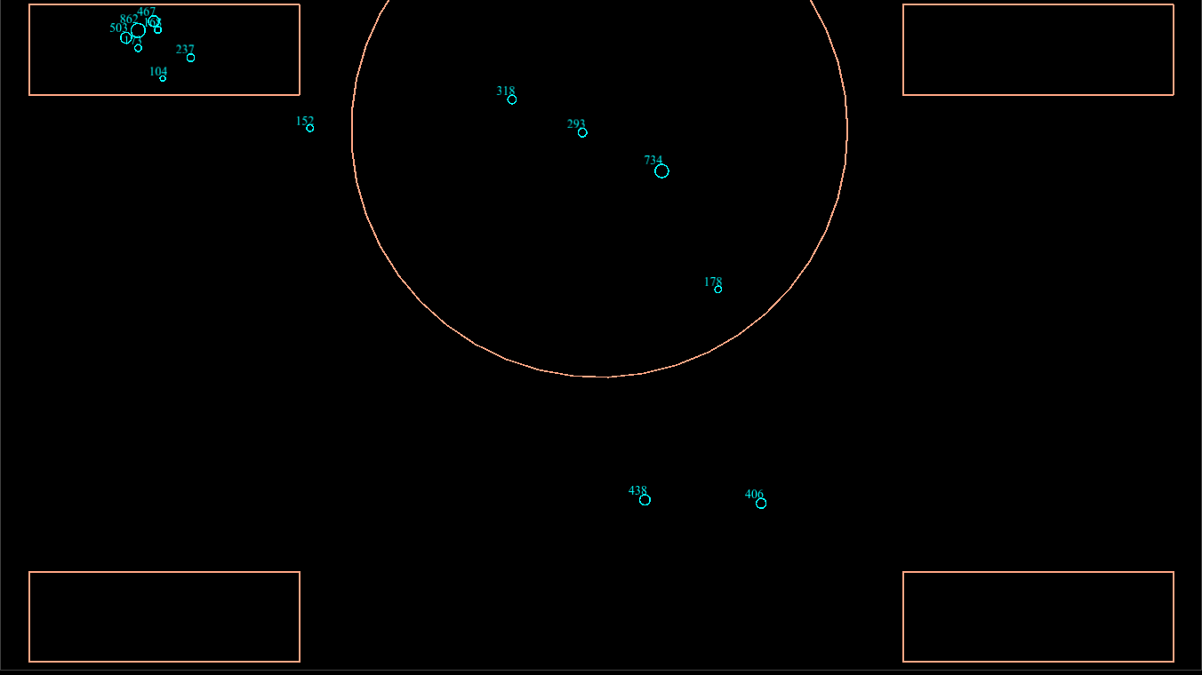

Results did not lend support for the hypothesis that guilt proneness moderated the number of gazes entering the target zones. Failure manipulation did not influence the number of gazes entering the target zones, nor did it interact with guilt proneness scores to predict enters in the target zones (Table 1).

Table 1. Results of the linear regression model performed on Target AOI
Predictor | Degree of Freedom | beta | t-value | p-value
Failure | 133 | -1.837 | -0.718 | .47
Shame proneness |  | -0.063 | -0.042 | .97
Guilt proneness |  | -.202 | 0.134 | .89
Shame proneness x Failure |  | 1.674 | 0.555 | .58
Guilt proneness x Failure |  | -2.894 | -0.961 | .34

- Recognition latencies associated to correct answers
We next analyzed latencies associated to correct answers in the lexical decision task. Codes describing how latencies associated to correct answers were computed are available on the OSF webpage. Once again, results did not support the motivation hypothesis. We failed to detect an effect of guilt proneness on latencies, nor did we observe an interaction between guilt proneness scores and failure manipulation. Moreover, failure manipulation did not significantly influence latencies to accurately detect targets (Table 2).

Table 2. Results of the linear regression model performed on latencies
Predictor | Degree of Freedom | beta | t-value | p-value
Failure | 133 | 19.05 | 0.687 | .49
Shame proneness |  | -1.712 | -0.105 | .92
Guilt proneness |  | 6.118 | 0.375 | .71
Shame proneness x Failure |  | 14.65 | 0.448 | .66
Guilt proneness x Failure |  | 10.98 | 0.337 | .74

Conclusion
Taken together, these analyses do not yield support for the motivation hypotheses. Hence, the effects reported in the manuscript are unlikely to be related to an effect of guilt proneness and failure manipulation on motivation to perform the task.

