Supplementary Material
Contents of this file
Text S1. Process of improving the F-J spectrum.
Figure S1. The reference model and initial models for inversion.
Figure S2. Ambient noise cross­correlation functions in the time domain.
Figure S3. F-J spectra affected by some stations.
Figure S4. Locations of the stations discussed in Figure S3.
Table S1. The travel time of the primary wave for each ray path.

Introduction
The supporting information mainly contains some text, four figures, and a table. The text S1 gives a detailed account of the process of improving the F-J spectrum of the average model. Figure S1 shows the reference model and initial models used in inversion to obtain the average S-wave velocity structure of Iceland. Figure S2 shows ambient noise cross­correlation functions of the average model in the time domain as well as the signal and noise windows used to control quality. Figure S3 reveals the F-J spectra affected by some stations whose locations are shown in Figure S4. Table S1 lists the travel time of the primary wave calculated from different models and the travel time observed from the station records for each ray path.
Text S1
The F-J method (Wang-Wu-Chen, 2019) is based on the prerequisite that the underground velocity structure is horizontally layered with little transverse heterogeneity and the high-quality F-J spectrum will be obtained when the investigated area is closer to the prerequisite. In fact, the initial F-J spectrum of the average model obtained in this study is not very ideal, and the high-frequency part of its fundamental mode energy is greatly destroyed (Figure S3a). It has been found that the XD-HOT03 station from the XD Array (Nolet, 1996) is suspended by the sea with a strong heterogeneity around it, which may incorporate many disturbances into the noise cross-correlation functions between it and other stations, thus, deteriorating the F-J spectrum. After removing the cross-correlation functions related to XD-HOT03, the F-J spectrum shows a significant improvement, especially in the high-frequency parts of the fundamental mode (Figure S3b). To find potential contaminants, we have checked 30 stations of the XD Array one by one as follows: remove one station at a time and observe changes in the F-J spectrum; following this, remove two stations and three stations at a time, with a total of 4525 results. Besides, some stations are necessary to maintain the completeness of the F-J spectrum and their absence will damage the F-J spectrum seriously, as shown in Figure S3c following the removal of stations XD-HOT10 and XD-HOT19. Finally, we select the best F-J spectrum from all results by eliminating XD-HOT03, XD-HOT04, and XD-HOT18 stations, as shown in Figure S3d. Furthermore, the locations of the mentioned stations are shown in Figure S4.

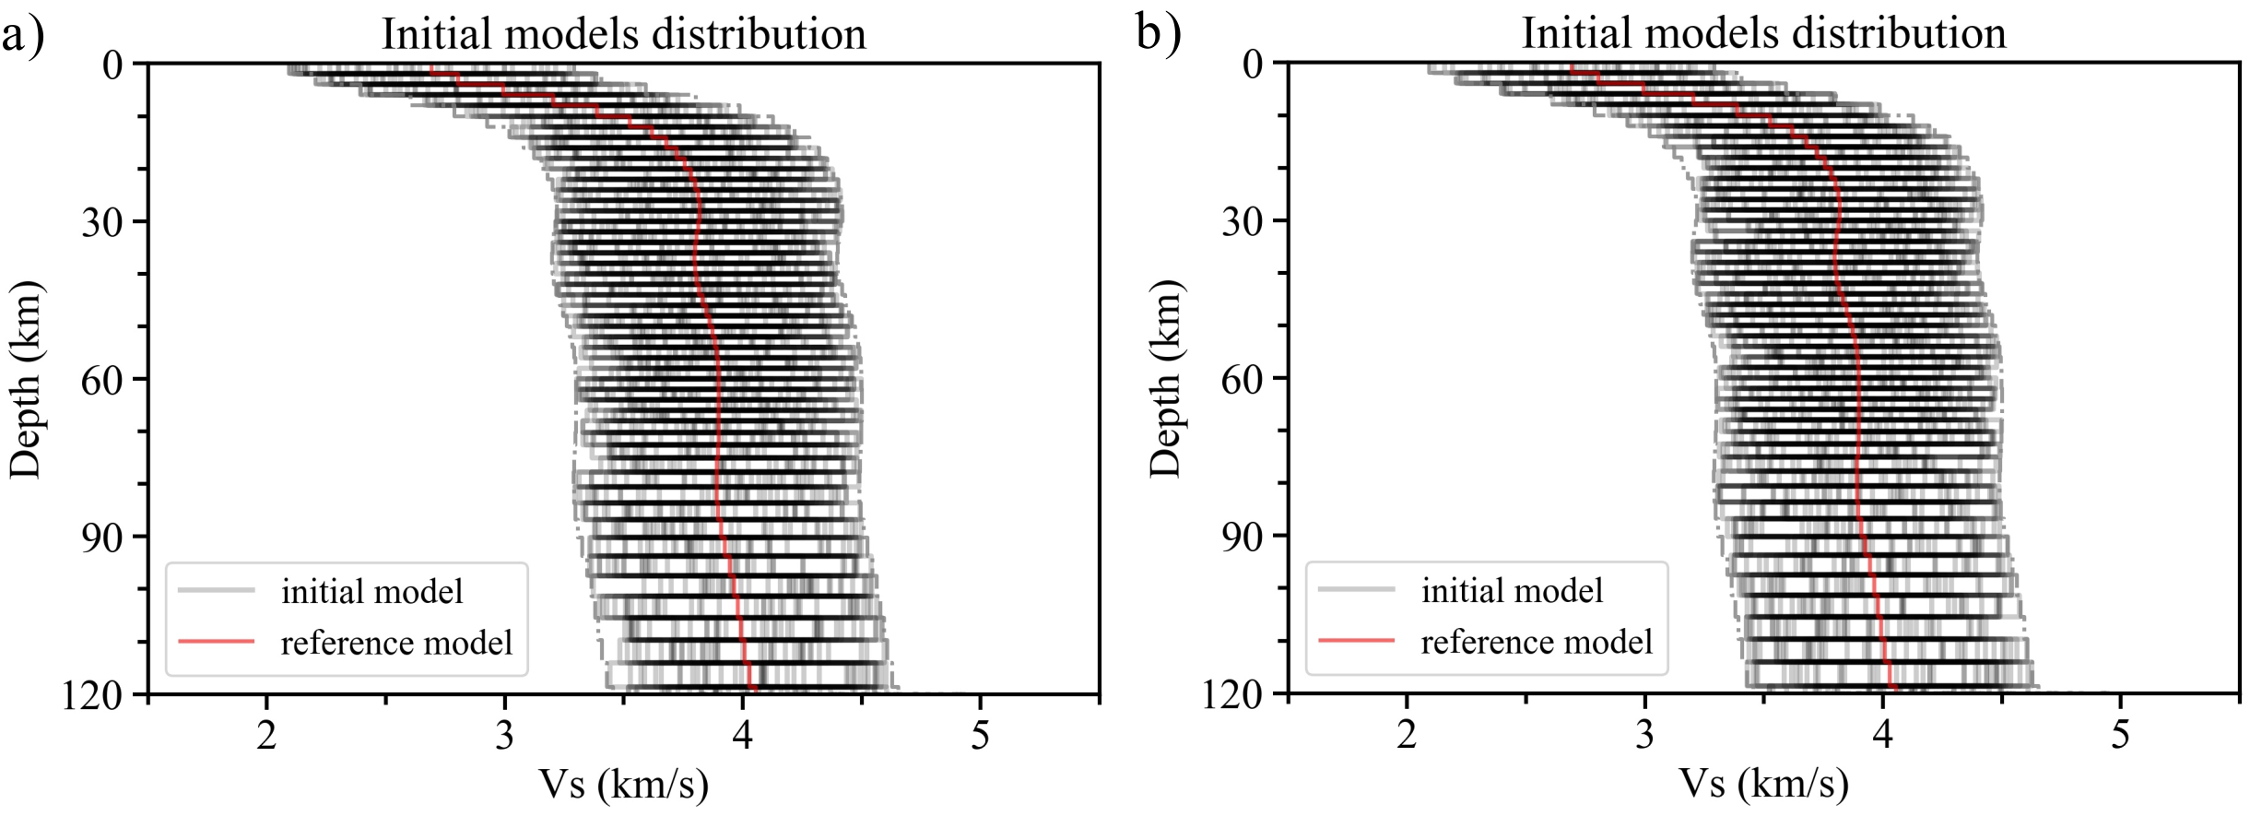
Supplementary Figures

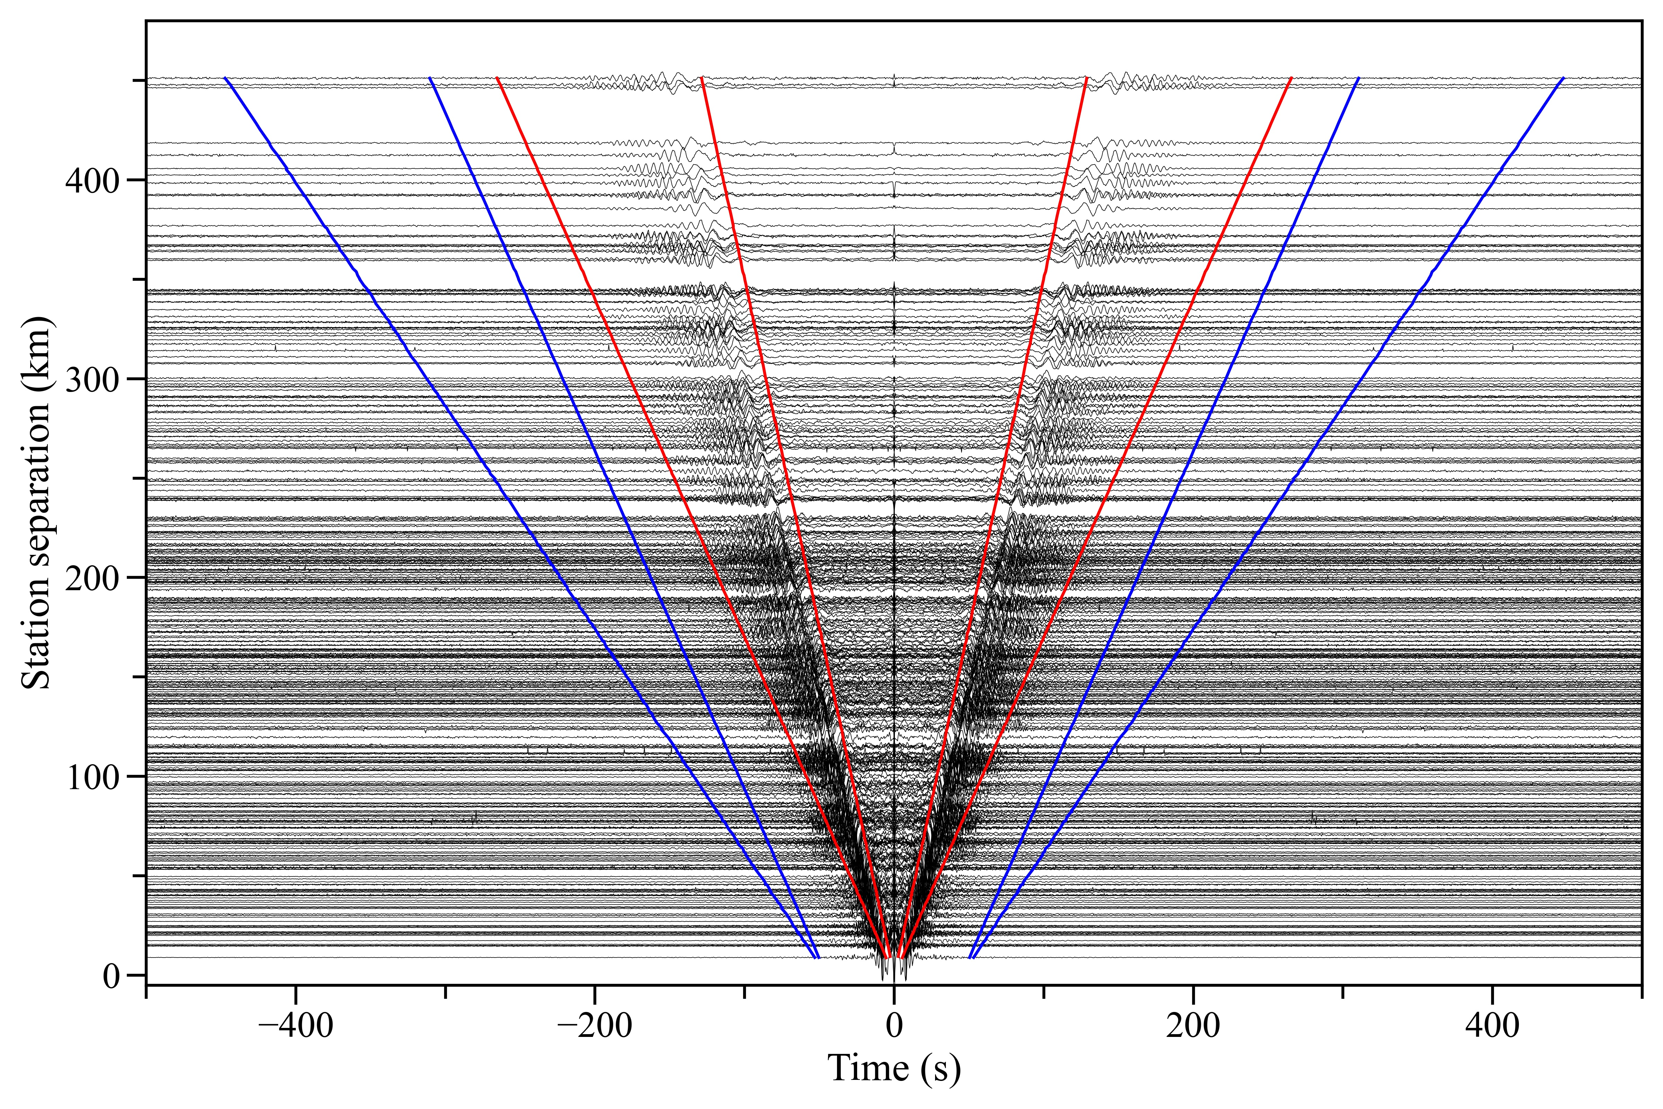
Supplementary Figure S1. The reference model (red line) and 80 initial models (gray lines) randomly generated by perturbation with ±0.6 km/s for inversion to get the average S-wave velocity structure of Iceland. The dashed gray lines are the ranges of initial models. (a) Models for inversion using the fundamental mode dispersion curve. (b) Models for inversion using the first two mode dispersion curves.

Supplementary Figure S2. Ambient noise cross­correlation functions (NCFs) of three different time periods in the time domain are ordered by the separations of station pairs. Red and blue lines are signal and noise windows, respectively, which are used to calculate the signal-to-noise ratio (SNR) to obtain reliable data.

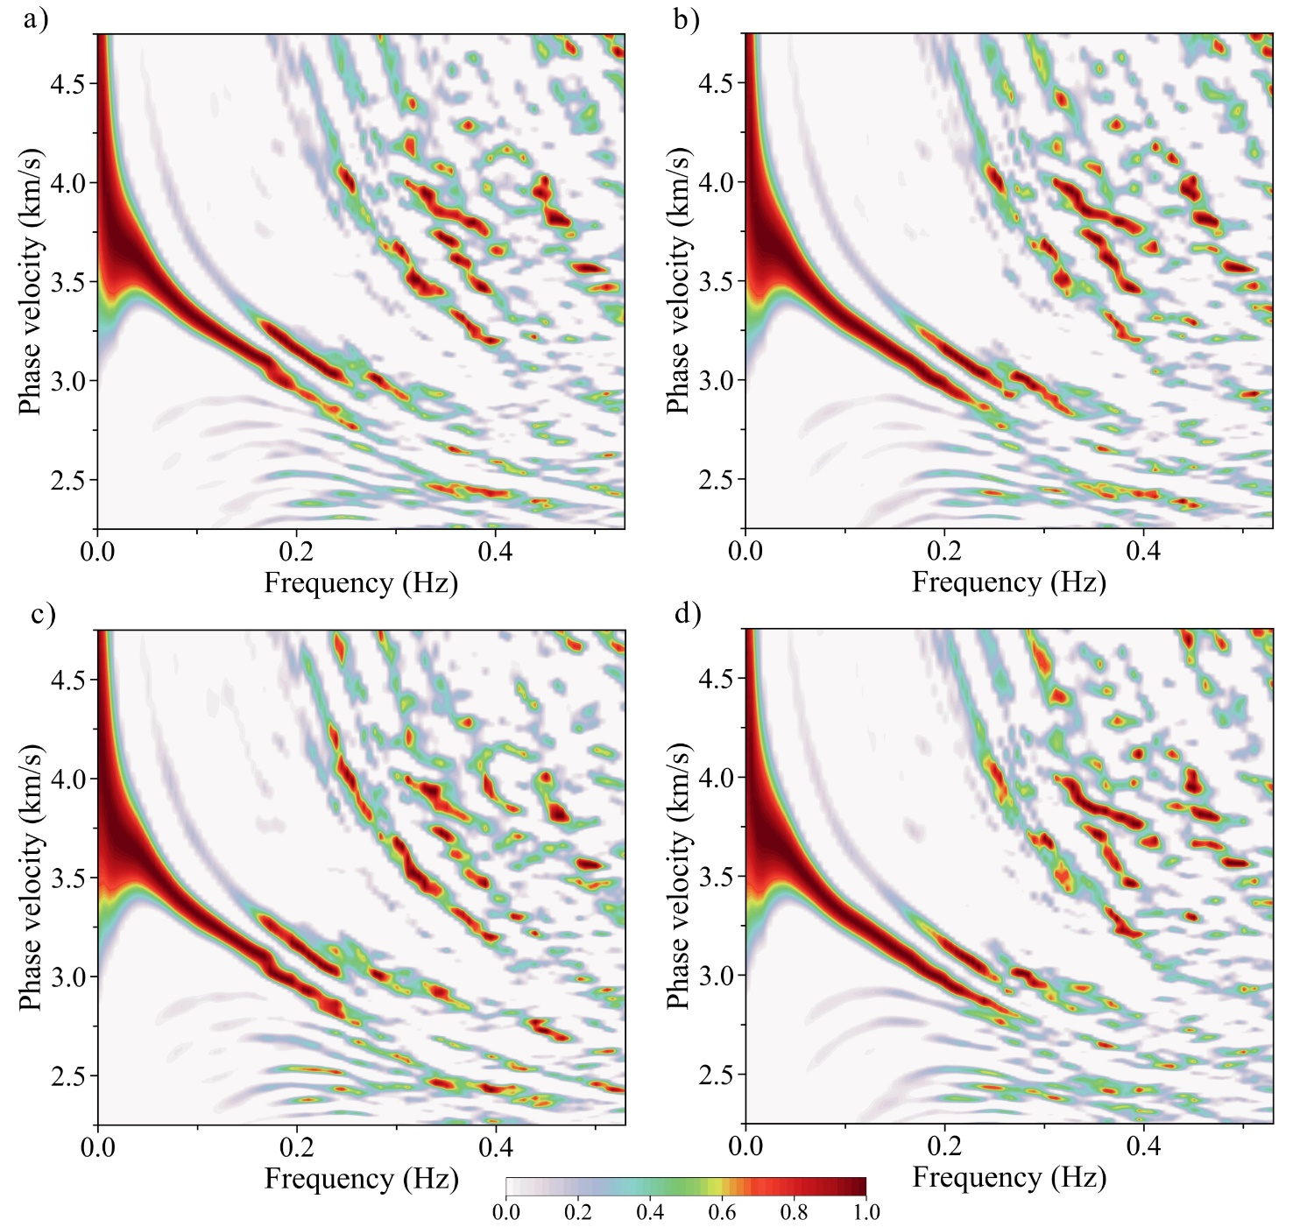

Supplementary Figure S3. F-J Spectra affected by some stations. (a) F-J spectrum obtained by all stations. (b) F-J spectrum obtained by eliminating station XD-HOT03. (c) F-J spectrum obtained by eliminating stations XD-HOT10 and XD-HOT19. (d) F-J spectrum obtained by eliminating stations XD-HOT03, XD-HOT04, and XD-HOT18.

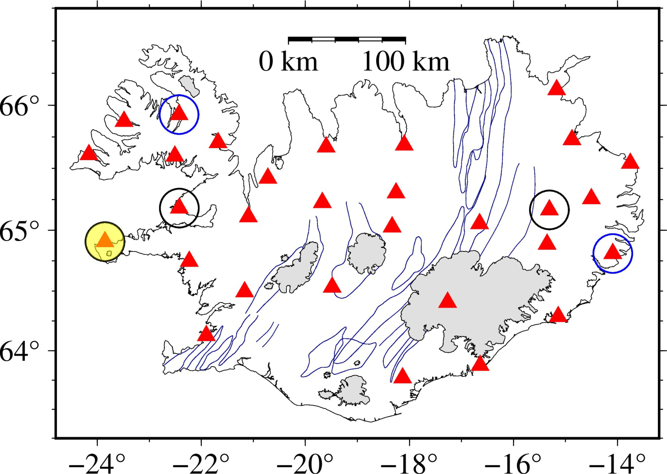

Supplementary Figure S4. Coverage of broadband seismic stations of the XD Array. Stations trapped with black circles are XD-HOT03, XD-HOT04, and XD-HOT18; stations trapped with blue circles are XD-HOT10 and XD-HOT19. The triangle covered by a yellow area is station XD-HOT03.

Supplementary Table

Supplementary Table S1. Calculated for different models and observed travel time in 20 ray paths
Path number | Event code | Station | Distance (degree) | AK135 (s) | Li and Detrick (2006) (s) | Average (s) | Observation (s)
1 | C | XD-HOT22 | 1.40 | 25.57 | 25.18 | 23.97 | 24.80
2 | A | XD-HOT11 | 1.43 | 25.99 | 25.63 | 24.43 | 23.62
3 | B | XD-HOT25 | 1.45 | 26.12 | 25.78 | 24.58 | 23.60
4 | D | XD-HOT29 | 1.50 | 26.95 | 26.68 | 25.49 | 24.90
5 | C | XD-HOT06 | 1.77 | 30.66 | 30.74 | 29.58 | 28.30
6 | B | XD-HOT28 | 1.83 | 31.49 | 31.64 | 30.47 | 29.90
7 | C | XD-HOT12 | 1.87 | 32.04 | 32.24 | 31.07 | 30.10
8 | B | XD-HOT17 | 1.91 | 32.59 | 32.84 | 31.67 | 32.20
9 | C | XD-HOT10 | 2.04 | 34.38 | 34.79 | 33.61 | 32.30
10 | C | XD-HOT09 | 2.14 | 35.75 | 36.30 | 35.10 | 33.40
11 | B | XD-HOT01 | 2.15 | 35.89 | 36.45 | 35.25 | 34.55
12 | A | XD-HOT13 | 2.17 | 36.16 | 36.75 | 35.55 | 35.15
13 | D | XD-HOT02 | 2.20 | 36.71 | 37.35 | 36.14 | 36.60
14 | B | XD-HOT19 | 2.33 | 38.37 | 39.15 | 37.93 | 38.70
15 | B | XD-HOT20 | 2.44 | 39.88 | 40.80 | 39.57 | 38.45
16 | D | XD-HOT21 | 2.48 | 40.43 | 41.40 | 40.16 | 40.70
17 | B | XD-HOT22 | 2.54 | 41.25 | 42.30 | 41.05 | 41.25
18 | C | XD-HOT18 | 2.85 | 45.52 | 46.96 | 45.65 | 46.25
19 | C | XD-HOT19 | 3.23 | 50.74 | 52.67 | 51.29 | 53.20
20 | C | XD-HOT29 | 3.26 | 51.15 | 53.12 | 51.73 | 52.90

Reference
Li, A., and Detrick, R.S. (2006). Seismic structure of Iceland from Rayleigh wave inversions and geodynamic implications. Earth Planet. Sci. Lett. 241(3), 901-912. doi: 10.1016/j.epsl.2005.10.031
Nolet, G. (1996). Data from: Seismic study of the Iceland hotspot. International Federation of Digital Seismograph Networks. doi:10.7914/SN/XD_1996
Wang, J., Wu, G., and Chen, X. (2019). Frequency-Bessel transform method for effective imaging of higher-mode Rayleigh dispersion curves from ambient seismic noise data. J. Geophys. Res. Solid Earth 124(4), 3708-3723. doi: 10.1029/2018JB016595

