Supplementary Material
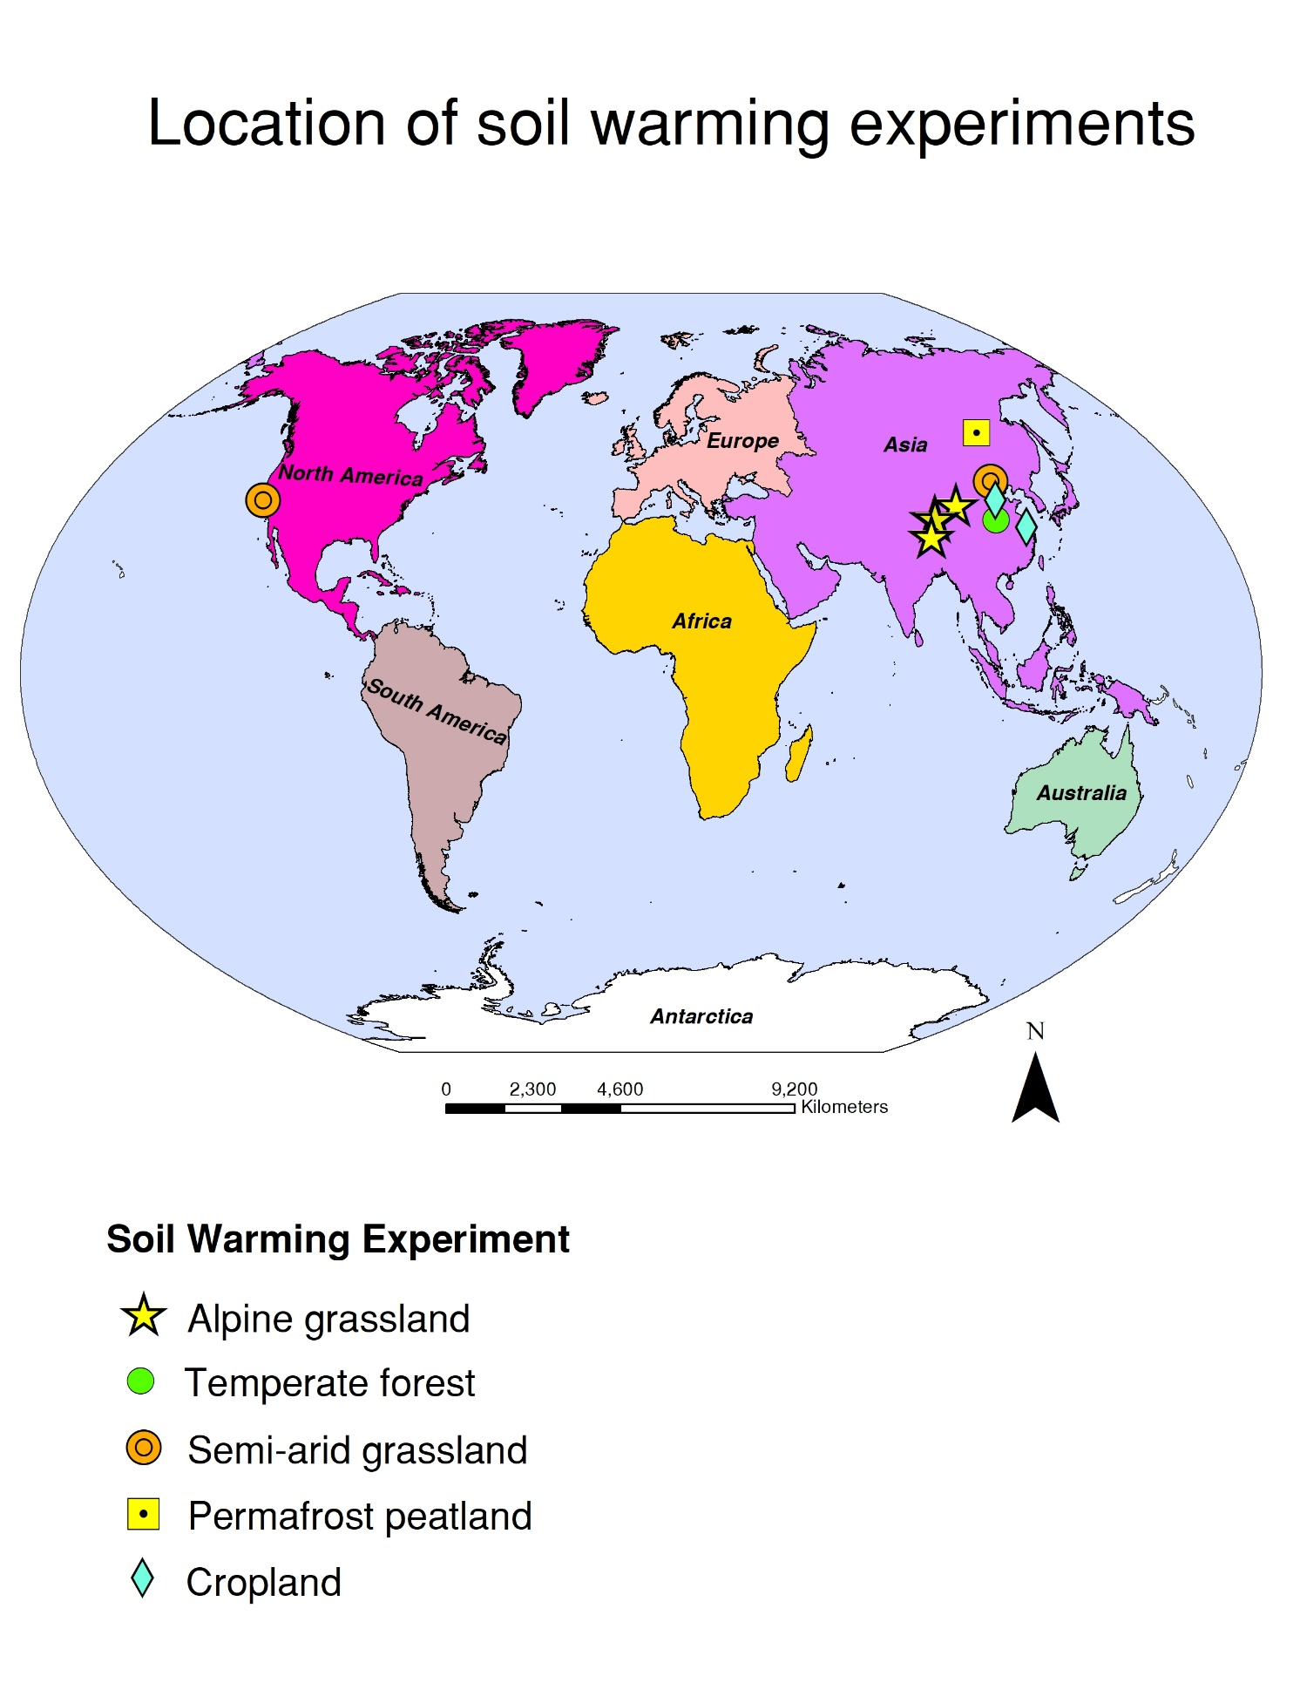

Supplementary Figure S1. Map showing the locations of in situ soil warming experiments that measured microbial necromass via amino sugar analysis (n = 12). Map symbols indicate the biome were soil warming experiments were conducted. Biomes included alpine and semi-arid grasslands, temperate forest, permafrost peatlands, and cropland. This map was generated using ArcMap software version 10.8.1.

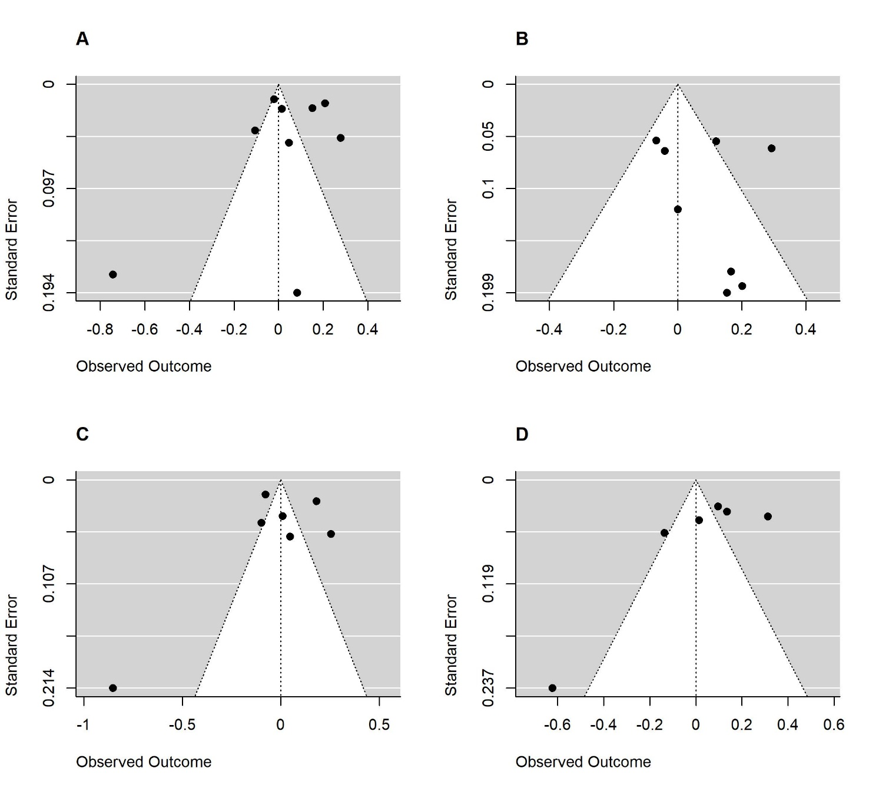
Supplementary Figure S2. Funnel plots showing distribution of effect size estimates across total amino sugars (A), muramic acid (B), glucosamine (C), and galactosamine (D). The shape of these funnel plots indicates the absence of publication bias. Egger’s regression test for funnel plot asymmetry indicated no publication bias (p-value > 0.05).

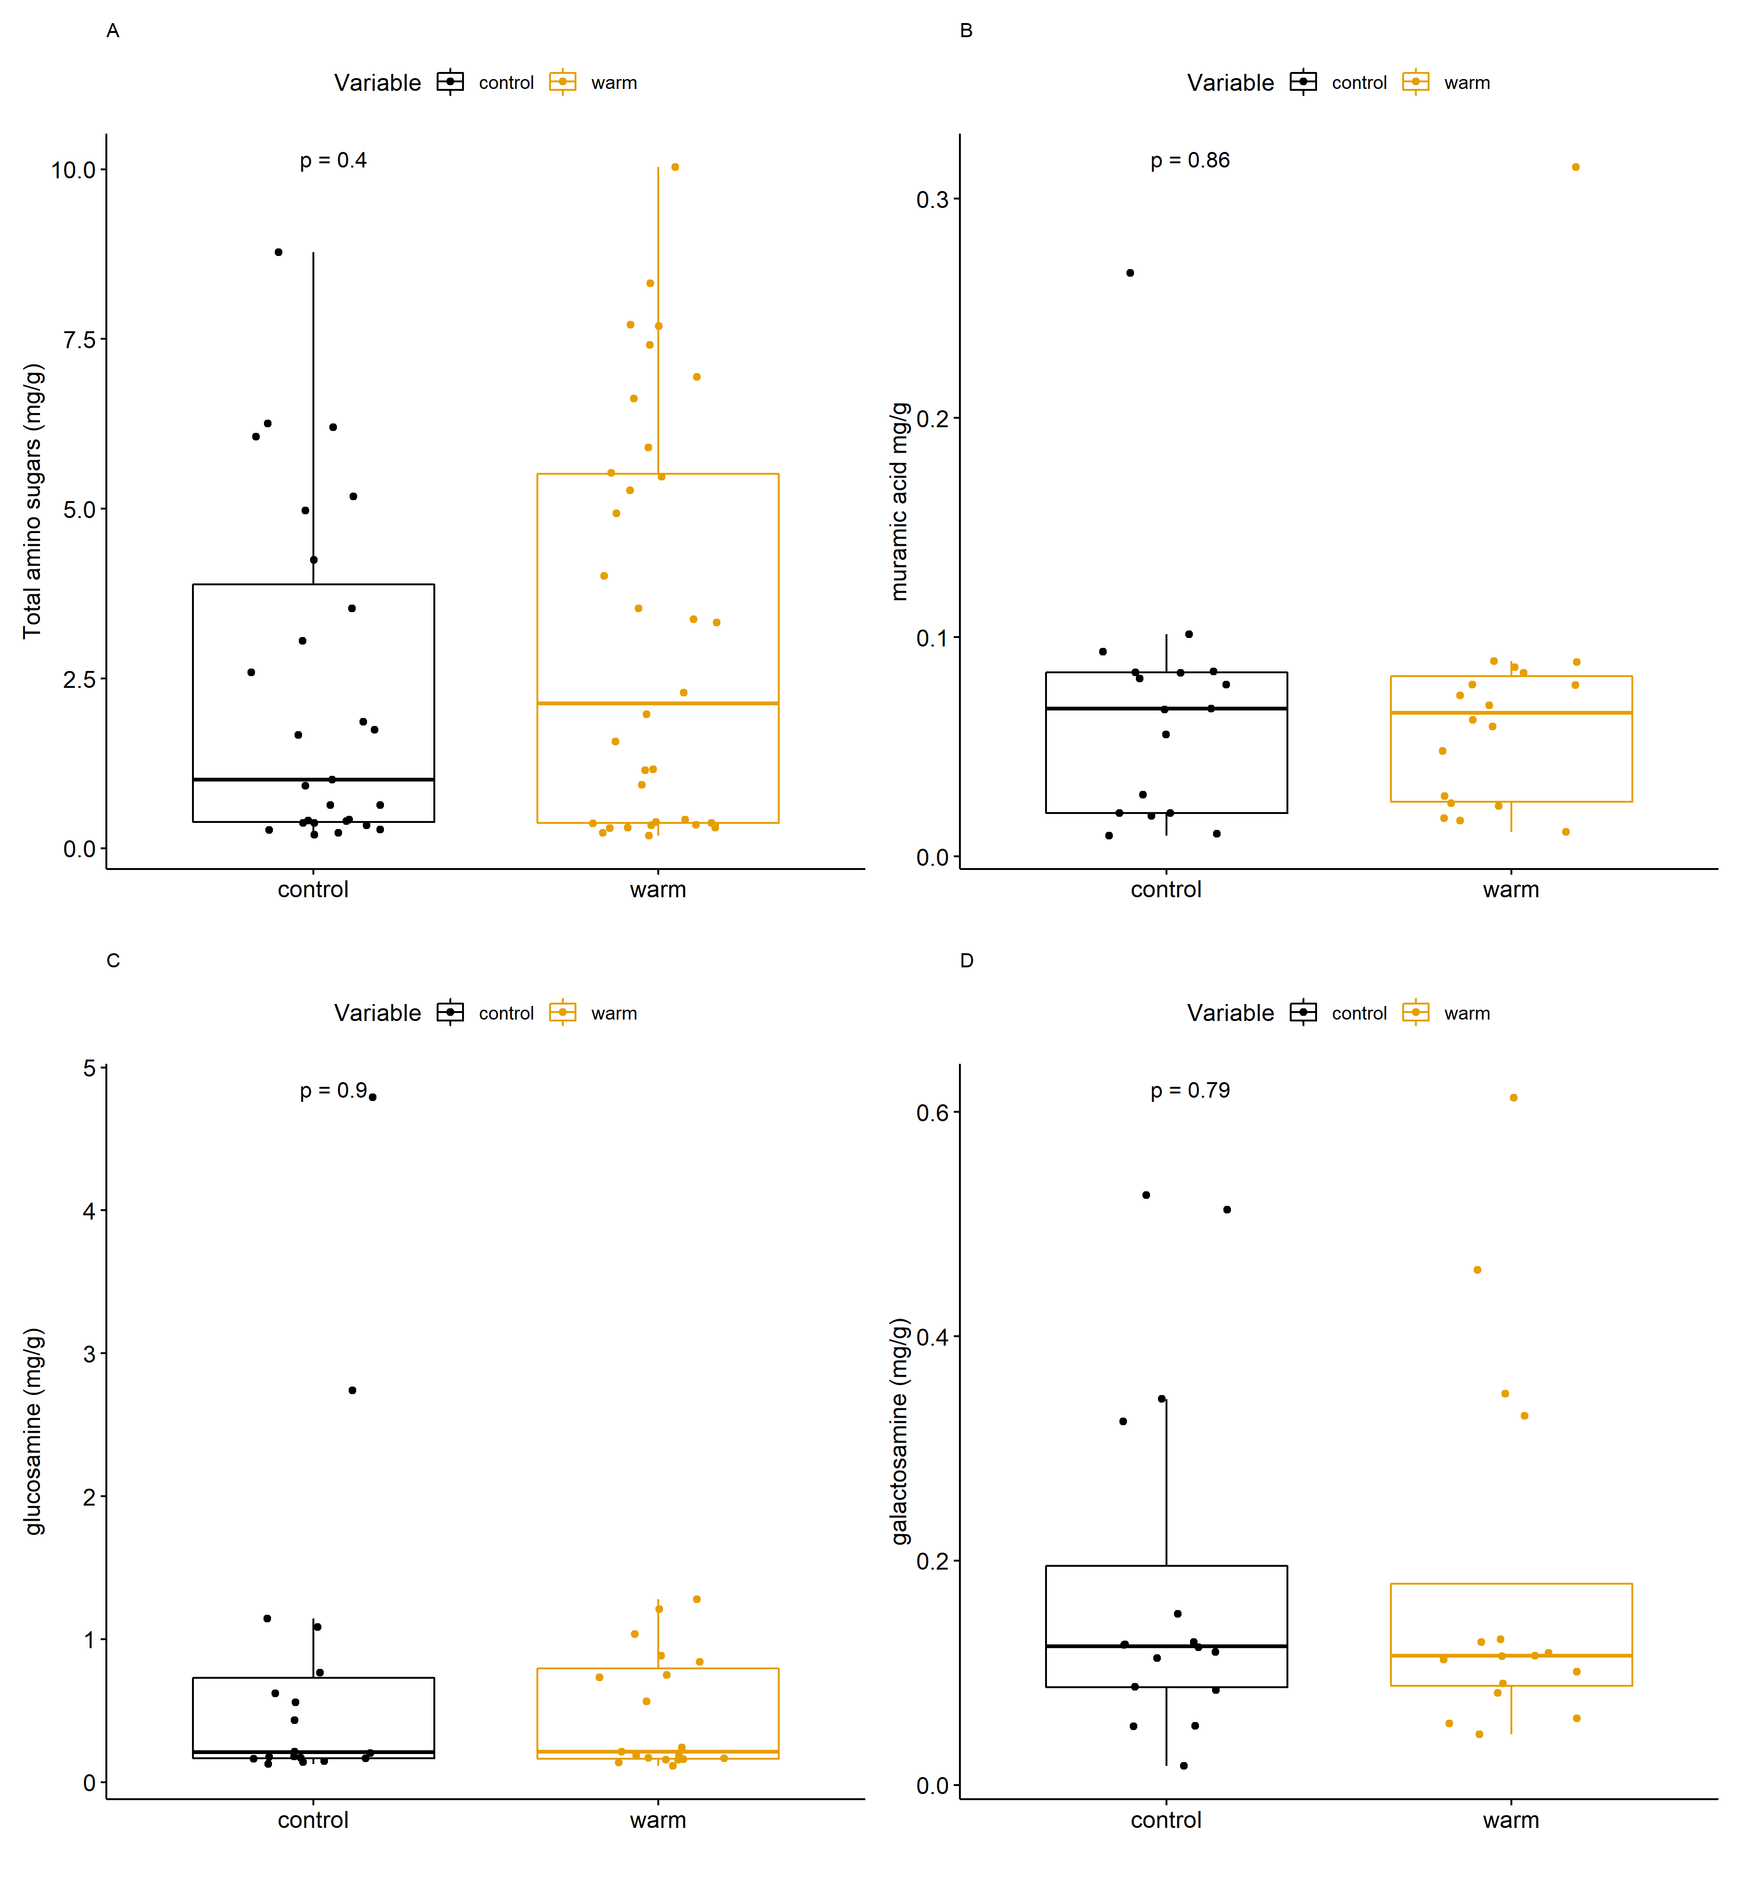
Supplementary Figure S3. Boxplots showing (A) total amino sugars (mg/g), (B) muramic acid, (C) glucosamine, and (D) galactosamine between treatment groups (control and warm). Necromass did not significantly differ between treatment groups, as determined by the Kruskal Wallis test (alpha level 0.05).

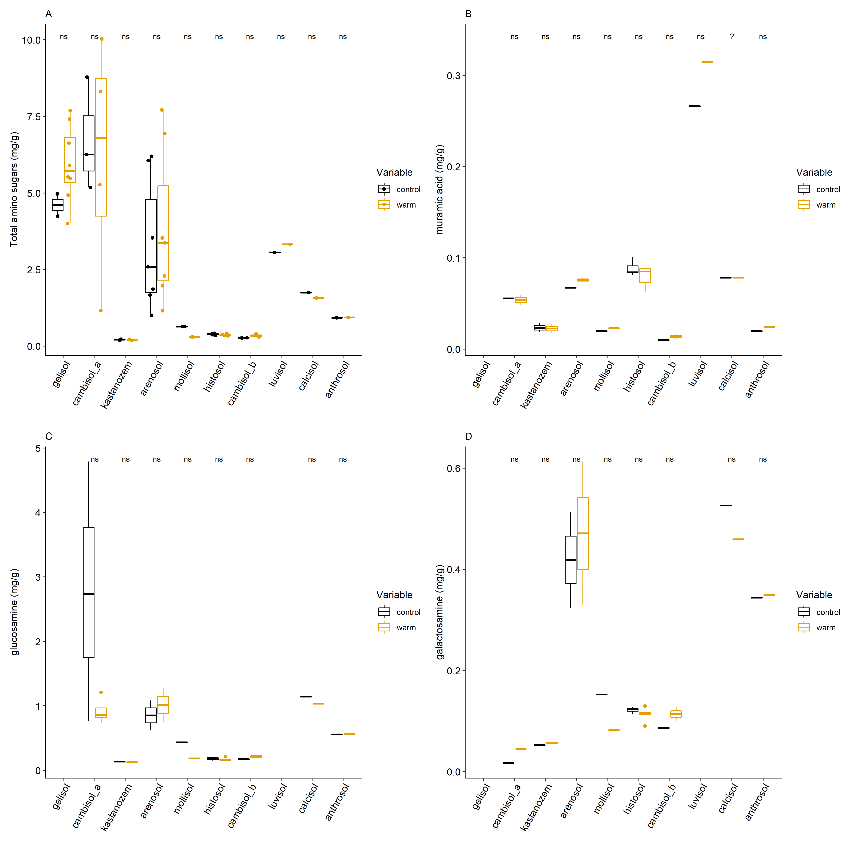
Supplementary Figure S4. Boxplots showing (A) total amino sugars (mg/g), (B) muramic acid, (C) glucosamine, and (D) galactosamine between treatment groups (control and warm) across reference soil groups. Necromass did not significantly differ between treatment groups, as determined by the Kruskal Wallis test (alpha level 0.05).

Supplementary Table S1. Pairwise comparisons of total amino sugar (mg/g) estimated marginal means (EMM) across reference soil groups. EMM were extracted from the GLM that predicts total amino sugars (mg/g) with reference soil group. This table shows the contrast between soil groups, standard error (SE), and p-values. Bold p-values indicate that the EMM of total amino sugars (mg/g) significantly differ between reference soil groups at alpha level 0.05.
Contrast | EMM | SE | P-value
anthrosol - arenosol | 1.0774 | 0.4118 | 0.2097
anthrosol - calcisol | 0.7922 | 0.4461 | 0.7507
anthrosol - cambisol_a | 1.1320 | 0.4114 | 0.1535
anthrosol - cambisol_b | -9.3137 | 1.5728 | 0.0000
anthrosol - gelisol | 1.1252 | 0.4114 | 0.1597
anthrosol - histosol | -5.9175 | 0.7718 | 0.0000
anthrosol - kastanozem | -21.6824 | 2.7556 | 0.0000
anthrosol - luvisol | 1.0580 | 0.4163 | 0.2463
anthrosol - mollisol | -3.3831 | 0.9094 | 0.0076
arenosol - calcisol | -0.2852 | 0.1741 | 0.8293
arenosol - cambisol_a | 0.0546 | 0.0240 | 0.4061
arenosol - cambisol_b | -10.3911 | 1.5182 | 0.0000
arenosol - gelisol | 0.0478 | 0.0240 | 0.6087
arenosol - histosol | -6.9949 | 0.6535 | 0.0000
arenosol - kastanozem | -22.7598 | 2.7248 | 0.0000
arenosol - luvisol | -0.0194 | 0.0679 | 1.0000
arenosol - mollisol | -4.4606 | 0.8114 | 0.0000
calcisol - cambisol_a | 0.3398 | 0.1733 | 0.6266
calcisol - cambisol_b | -10.1059 | 1.5279 | 0.0000
calcisol - gelisol | 0.3330 | 0.1733 | 0.6542
calcisol - histosol | -6.7097 | 0.6756 | 0.0000
calcisol - kastanozem | -22.4746 | 2.7302 | 0.0000
calcisol - luvisol | 0.2658 | 0.1846 | 0.9146
calcisol - mollisol | -4.1753 | 0.8293 | 0.0000
cambisol_a - cambisol_b | -10.4457 | 1.5181 | 0.0000
cambisol_a - gelisol | -0.0068 | 0.0172 | 1.0000
cambisol_a - histosol | -7.0495 | 0.6532 | 0.0000
cambisol_a - kastanozem | -22.8144 | 2.7248 | 0.0000
cambisol_a - luvisol | -0.0740 | 0.0658 | 0.9824
cambisol_a - mollisol | -4.5151 | 0.8112 | 0.0000
cambisol_b - gelisol | 10.4389 | 1.5181 | 0.0000
cambisol_b - histosol | 3.3962 | 1.6526 | 0.5596
cambisol_b - kastanozem | -12.3687 | 3.1191 | 0.0029
cambisol_b - luvisol | 10.3717 | 1.5194 | 0.0000
cambisol_b - mollisol | 5.9306 | 1.7211 | 0.0203
gelisol - histosol | -7.0427 | 0.6532 | 0.0000
gelisol - kastanozem | -22.8076 | 2.7248 | 0.0000
gelisol - luvisol | -0.0672 | 0.0658 | 0.9911
gelisol - mollisol | -4.5083 | 0.8112 | 0.0000
histosol - kastanozem | -15.7649 | 2.8019 | 0.0000
histosol - luvisol | 6.9755 | 0.6563 | 0.0000
histosol - mollisol | 2.5343 | 1.0414 | 0.3056
kastanozem - luvisol | 22.7404 | 2.7255 | 0.0000
kastanozem - mollisol | 18.2992 | 2.8429 | 0.0000
luvisol - mollisol | -4.4412 | 0.8137 | 0.0000

Supplementary Table S2. Pairwise comparisons of muramic acid (mg/g) estimated marginal means (EMM) across reference soil groups. EMM were extracted from the GLM that predicts muramic acid (mg/g) with reference soil group. This table shows the contrast between soil groups, standard error (SE), and p-values. Bold p-values indicate that the EMM of muramic acid (mg/g) significantly differ between reference soil groups at alpha level 0.05
Contrast | EMM | SE | P-value
anthrosol - arenosol | 31.4636 | 5.1419 | 0.0000
anthrosol - calcisol | 32.6832 | 5.2188 | 0.0000
anthrosol - cambisol_a | 27.0259 | 5.2924 | 0.0000
anthrosol - cambisol_b | -38.9336 | 8.2913 | 0.0001
anthrosol - histosol | 33.5335 | 5.0529 | 0.0000
anthrosol - kastanozem | 1.6909 | 6.0781 | 1.0000
anthrosol - luvisol | 42.0097 | 5.0386 | 0.0000
anthrosol - mollisol | -1.3072 | 7.2082 | 1.0000
arenosol - calcisol | 1.2195 | 1.7857 | 0.9990
arenosol - cambisol_a | -4.4377 | 1.9905 | 0.3863
arenosol - cambisol_b | -70.3973 | 6.6857 | 0.0000
arenosol - histosol | 2.0698 | 1.2187 | 0.7478
arenosol - kastanozem | -29.7728 | 3.5910 | 0.0000
arenosol - luvisol | 10.5460 | 1.1579 | 0.0000
arenosol - mollisol | -32.7708 | 5.2831 | 0.0000
calcisol - cambisol_a | -5.6573 | 2.1815 | 0.1892
calcisol - cambisol_b | -71.6168 | 6.7450 | 0.0000
calcisol - histosol | 0.8503 | 1.5107 | 0.9998
calcisol - kastanozem | -30.9923 | 3.7004 | 0.0000
calcisol - luvisol | 9.3265 | 1.4621 | 0.0000
calcisol - mollisol | -33.9904 | 5.3580 | 0.0000
cambisol_a - cambisol_b | -65.9595 | 6.8021 | 0.0000
cambisol_a - histosol | 6.5076 | 1.7480 | 0.0061
cambisol_a - kastanozem | -25.3350 | 3.8034 | 0.0000
cambisol_a - luvisol | 14.9838 | 1.7062 | 0.0000
cambisol_a - mollisol | -28.3331 | 5.4297 | 0.0000
cambisol_b - histosol | 72.4671 | 6.6175 | 0.0000
cambisol_b - kastanozem | 40.6245 | 7.4298 | 0.0000
cambisol_b - luvisol | 80.9433 | 6.6066 | 0.0000
cambisol_b - mollisol | 37.6264 | 8.3796 | 0.0002
histosol - kastanozem | -31.8426 | 3.4625 | 0.0000
histosol - luvisol | 8.4762 | 0.6591 | 0.0000
histosol - mollisol | -34.8407 | 5.1966 | 0.0000
kastanozem - luvisol | 40.3188 | 3.4416 | 0.0000
kastanozem - mollisol | -2.9981 | 6.1980 | 0.9999
luvisol - mollisol | -43.3169 | 5.1827 | 0.0000

