Supplementary Files
An Integrative Reverse Vaccinology, Immunoinformatic, Docking and Simulation Approaches Towards Designing of Multi-epitopes Based Vaccine Against Monkeypox Virus

Asad Ullah¹, Farah Shahid², Mahboob Ul Haq^{1, 3}, Muhammad Tahir ul Qamar², Muhammad Irfan^{4,} Bilal Shaker⁵. Sajjad Ahmad^{1, *}, Faris Alrumaihi ⁶, Khaled S. Allemailem ⁶, Ahmad Almatroudi ⁶

¹Department of Health and Biological Sciences, Abasyn University, Peshawar 25000, Pakistan
asad.ullah@abasyn.edu.pk, mahboob.haq@abasyn.edu.pk. sajjad.ahmad@abasyn.edu.pk
²Department of Bioinformatics and Biotechnology, Government College University Faisalabad, Faisalabad 38000, Pakistan; farah.shahid.209@gmail.com (F.S.); tahirulqamar@gcuf.edu.pk (M.T.Q.)
³Department of Pharmacy, Abasyn University, Peshawar 25000, Pakistan.
⁴Department of Oral Biology, College of Dentistry, University of Florida, Gainesville, FL 32611, USA.irfanmuhammad@ufl.edu.
⁵Department of biomedical engineering, Chung-Ang University, Seoul, South Korea. Ch.bilal321@outlook.com.
⁶ Department of Medical Laboratories, College of Applied Medical Sciences, Qassim University, Buraydah 51452, Saudi Arabia; f_alrumaihi@qu.edu.sa (F.A.); k.allemailem@qu.edu.sa (K.S.A.); aamtrody@qu.edu.sa (A.A.)

*Correspondence author: sajjad.ahmad@abasyn.edu.pk

Table S1. Accession no of proteomes used in the study.
Serial number | Accession number
1 | ASM645832v1_protein
2 | ASM645838v1_protein
3 | ASM645866v1_protein
4 | ASM645886v1_protein
5 | ASM645888v1_protein
6 | ASM646512v1_protein
7 | ASM646514v1_protein
8 | ASM646516v1_protein
9 | ASM646526v1_protein
10 | ASM646528v1_protein
11 | ASM646530v1_protein
12 | ASM646536v1_protein
13 | ASM646542v1_protein
14 | ASM646570v1_protein
15 | ASM646572v1_protein
16 | ASM646574v1_protein
17 | ASM646582v1_protein
18 | ASM646584v1_protein
19 | ASM646590v1_protein
20 | ASM647196v1_protein
21 | ASM1433735v1_protein
22 | ASM1433736v1_protein
23 | ASM1433737v1_protein
24 | ASM1433738v1_protein
25 | ASM1433738v1_protein
26 | ASM1433739v1_protein
27 | ASM1433740v1_protein
28 | ASM1433741v1_protein
28 | ASM1433742v1_protein
30 | ASM1433743v1_protein
31 | ASM1433743v1_protein
32 | ASM1433744v1_protein
33 | ASM1462154v1_protein
34 | ASM1462155v1_protein
35 | ASM1462155v1_protein
36 | ASM1462157v1_protein
37 | ASM1462158v1_protein
38 | ASM1462159v1_protein
39 | ASM646592v1_protein

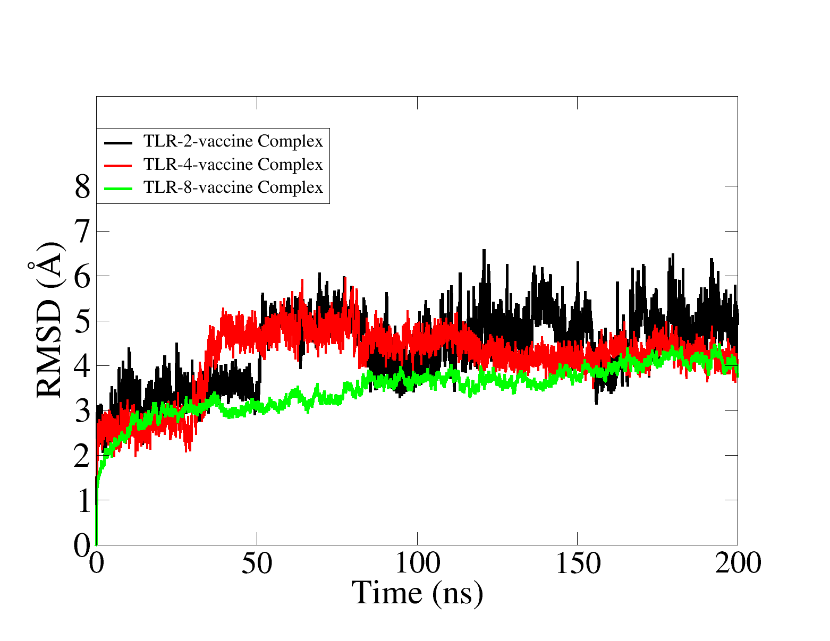
S-Fig.1. Duplicate simulation of complexes using different initial velocity.

