Supplementary Materials for
Multi-year acoustic tracking reveals transient movements, site fidelity, and apparent seasonality in the coastal-offshore presence of Greenland sharks (Somniosus microcephalus)
Edwards, Jena E.¹, Kevin J. Hedges², Steven T. Kessel³, and Nigel E. Hussey¹
¹ University of Windsor, Department of Integrative Biology, Windsor, ON, Canada N9B 3P4
² Fisheries and Oceans Canada, Arctic Aquatic Research Division, Winnipeg, MB, Canada R3T 2N6
³ Daniel P. Haerther Center for Conservation and Research, John G. Shedd Aquarium, Chicago, IL, United States, 60605

This document contains:
- Further evidence of coastal-offshore seasonality
- Potential roles of sex and size in the seasonality of Greenland shark movements
- References
- Figure S1
- Figure S2
- Table S1

Further evidence of coastal-offshore seasonality
A distinct seasonal pattern in the coastal-offshore occurrence of tagged Greenland sharks was observed across four coastal acoustic receiver arrays and 3 offshore arrays situated in Baffin Bay (Eastern Canadian Artic). This large-scale trend was exemplified at a smaller scale by the repeated coastal-offshore transitions of sharks detected in the coastal trough off Qikiqtarjuaq and the offshore arrays (ABO, DST, and QIK) over a 3-y period (Nov 2015 to Aug 2018) (Fig. S1). In this region, peak monthly (detection-based) shark abundance was recorded by offshore receivers during the ice-covered period from January to June (mean ± SD = 2.62 ± 3.16 individuals/month [range = 1-21]). Sharks were primarily detected by offshore receivers in the eastern portion of ABO (gates Nar01-Nar04) and central DST (C6) (Fig. S1a). During the ice-free summer months between July and October, 73% of detected individuals (n = 15) were recorded on receivers in Qikiqtarjuaq’s coastal trough, resulting in a detection rate of 1.07 ± 0.27 individuals/month (range = 1-2) for the entire 4-month period (Fig. S1b). In November and December, shark detections were concentrated in the offshore along Baffin Bay’s eastern shelf in the vicinity of the fishery closure (frequency of detected individuals increased to an average of 1.85 ± 1.87 individuals/month: range = 1-9) (Fig. S1c). This trend in shark movements observed supports the general seasonal pattern observed for all tagged sharks throughout Baffin Bay.
Potential roles of sex and size in the seasonality of Greenland shark movements
Sex and size class are known drivers of differences in movement behaviour and habitat use among sharks, for example, resulting in sexual or size-dependent segregation or homogenous aggregations (Springer, 1967; Ketchum et al., 2013). Sexual segregation may serve to reduce intra-specific aggression, but can also result from differing dietary prefences and reproductive requirements (e.g., suitable pupping grounds for gravid females) (Springer, 1967; Sims, 2005). For Greenland sharks, baited remote underwater video (BRUV) surveys and acoustic tracking studies conducted in coastal Arctic waters found no evidence for sex-driven differences in localised abundance (Devine et al., 2018) or in the timing and duration of temporary coastal residency in eastern Canadian Arctic waters (Edwards et al., 2021). In the published literature, there are no reports regarding sex-specific feeding ecology, and little is known about their reproductive requirements (Edwards et al., 2019). It should be noted, that females were less represented in the current study, however, it is unclear whether this represents the sex ratio present in the local population.
There are, however, some indications that body size might play a role in Greenland shark distribution. Size-dependant segregation in sharks may result from ontogenetic differences in diet and environmental preference and can also reduce risk of cannibalism for smaller individuals (Morrissey & Gruber, 1993). Importantly, immature sharks were found to make up the majority of all sharks examined in coastal Canadian Artic waters both by BRUV surveys (mean L_{T =} 2.48 ± 0.40 m, n = 93; Devine et al., 2018) and by the current and previous acoustic tracking studies (mean L_{T} = 2.48 ± 0.50 m; Edwards et al., 2021). Extensive scientific catch data also suggest that regional differences in size classes occur at an even broader scale, with no records of adult females (> 4 m L_{T}) recorded in waters around the Canadian Arctic and Svalbard (N = 362 individuals; Skomal and Benz, 2004; Fisk et al., 2002, 2012; Leclerc et al., 2012; Lydersen et al., 2016; Hussey et al., 2015, 2018; Devine et al., 2018) and a relatively high proportion of juveniles, including potential neonates (0.4–1 m; MacNeil et al., 2012), captured in one of the sites included in the current study – Scott Inlet, Nunavut (Hussey et al., 2015). Telemetry studies conducted since showed that juvenile sharks (< 2 m L_{T}) remained in Scott Inlet longer than subadults (> 2 m L_{T}), corroborating the earlier indications that the system may serve as a nursery (Hussey et al., 2015). The tagged population in the current study is also representative of the apparent regional size-class distribution, with individuals ranging from 0.93–3.5 m L_{T}.
Stomach content analysis indicates that Greenland shark diet shifts from a greater proportion of lower trophic level prey (predominantly squid) among smaller individuals (< 2 m L_{T}) to an increasing importance of larger fish and marine mammals in individuals > 2 m L_{T} (Nielsen et al. 2019). While slight regional differences in Greenland shark diet have also been observed in the relative importance of pelagic prey items, it is still unclear whether this is a true reflection of dietary variations rather than differences in sampling method (Fisk et al., 2002; MacNiel et al., 2012; Edwards et al., 2019). Further examination of spatial variation in diet and the distribution of preferred prey items will be essential to determine the role of diet in age-class distrubution.

References:
Devine, B. M., Wheeland, L. J., and Fisher, J. A. D. (2018). First estimates of Greenland shark (Somniosus microcephalus) local abundances in Arctic waters. Sci. Rep. 8 (1), 1–10. doi: 10.1038/s41598-017-19115-x

Edwards, J. E., Hedges, K. J., and Hussey, N. E. (2021). Seasonal residency, activity space, and use of deep-water channels by Greenland sharks (Somniosus microcephalus) in an Arctic fjord system. Can. J. Fish. Aquat. Sci. doi: 10.1139/cjfas-2021-0009

Edwards, J. E., Hiltz, E., Broell, F., Bushnell, P. G., Campana, S. E., Christiansen, J. S., and Hussey, N.E. (2019). Advancing research for the management of longlived species: A case study on the Greenland shark. Front. Mar. Sci. 6 (APR). doi: 10.3389/fmars.2019.00087

Fisk, A. T., Lydersen, C., and Kovacs, K. M. (2012). Archival pop-off tag tracking of Greenland sharks somniosus microcephalus in the high Arctic waters of Svalbard, Norway. Mar. Ecol. Prog. Ser. 468 (September 2017), 255–265. doi: 10.3354/meps09962

Fisk, A. T., Tittlemier, S. A., Pranschke, J. L., and Norstrom, R. J. (2002). Using anthropogenic contaminants and stable isotopes to assess the feeding ecology of Greenland sharks. Ecology 83 (8), 2162–2172. doi: 10.1890/0012-9658(2002)083[2162:UACASI]2.0.CO;2

Hussey, N. E., Cosandey-Godin, A., Walter, R. P., Hedges, K. J., VanGerwen-Toyne, M., Barkley, A. N., et al. (2015). Juvenile Greenland sharks somniosus microcephalus (Bloch & schneide) in the Canadian Arctic. Polar Biol. 38 (4), 493–504. doi: 10.1007/s00300-014-1610-y

Hussey, N. E., Orr, J., Fisk, A. T., Hedges, K. J., Ferguson, S. H., and Barkley, A. N. (2018). Mark report satellite tags (mrPATs) to detail large-scale horizontalmovements of deep water species: First results for the Greenland shark (Somniosus microcephalus). Deep-Sea Res. Part I: Oceanogr. Res. Pap. 134 (March), 32–40. doi: 10.1016/j.dsr.2018.03.002

Leclerc, L. M. E., Lydersen, C., Haug, T., Bachmann, L., Fisk, A. T., & Kovacs, K. M. (2012). A missing piece in the Arctic food web puzzle? Stomach contents of Greenland sharks sampled in Svalbard, Norway. Polar biology, 35(8), 1197-1208.

Lydersen, C., Fisk, A. T., and Kovacs, K. M. (2016). A review of Greenland shark (Somniosus microcephalus) studies in the kongsfjorden area, Svalbard Norway. Polar Biol. 39 (11), 2169–2178. doi: 10.1007/s00300-016-1949-3

MacNeil, M. A., McMeans, B. C., Hussey, N. E., Vecsei, P., Svavarsson, J., Kovacs, K. M., et al. (2012). Biology of the Greenland shark somniosus microcephalus. J. Fish Biol. 80 (5), 991–1018. doi: 10.1111/j.1095- 8649.2012.03257.x

Morrissey, J. F., and Gruber, S. H. (1993). Habitat selection by juvenile lemon sharks, negaprion brevirostris. Environ. Biol. Fishes 38 (4), 311–319. doi: 10.1007/BF00007524

Nielsen, J., Christiansen, J. S., Grønkjær, P., Bushnell, P., Steffensen, J. F., Kiilerich, H. O., et al. (2019). Greenland Shark (Somniosus microcephalus) stomach contents and stable isotope values reveal an ontogenetic dietary shift. Front. Mar. Sci. 6 (APR). doi: 10.3389/fmars.2019.00125

Skomal, G. B., and Benz, G. W. (2004). Ultrasonic tracking of Greenland sharks, somniosus microcephalus, under Arctic ice. Mar. Biol. 145 (3), 489–498.doi: 10.1007/s00227-004-1332-8

Sims, D. W. (2005). Differences in habitat selection and reproductive strategies of Q29 male and female sharks. Sexual Segregation in Vertebrates. Cambridge University Press, Cambridge, UK. p. 127.

Springer, S. (1967). “Social organization of shark populations,” in Sharks, skates and rays. Eds. P. W. Gilbert, R. F. Mathewson and D. P. Rall (Baltimore: John Hopkins), 149–174.

Ketchum, J. T., Galván-Magaña, F., and Klimley, A. P. (2013). Segregation and foraging ecology of whale sharks, rhincodon typus, in the southwestern gulf of California. Environ. Biol. Fish 96, 779–795. doi: 10.1007/s10641-012-0071-9

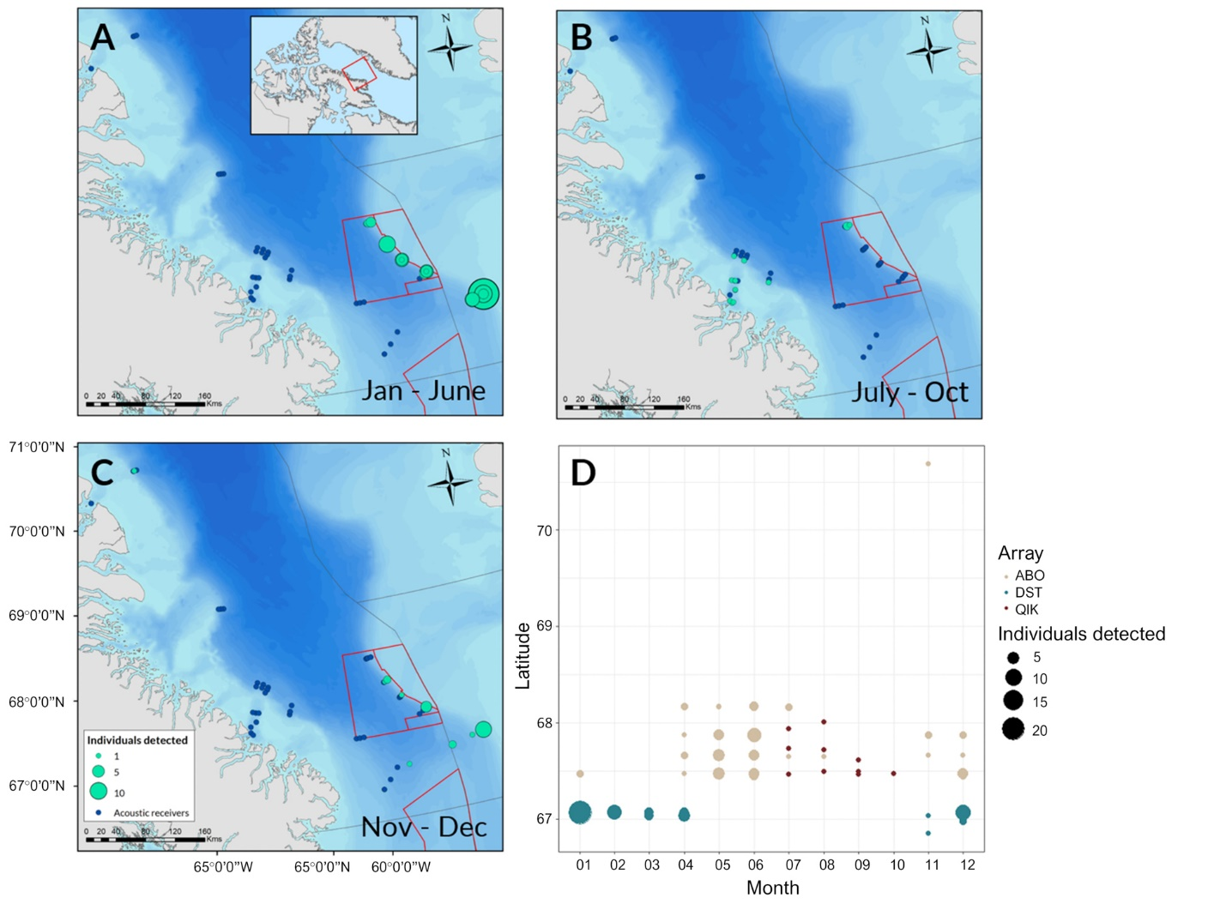
Figure S1 | Seasonality in coastal and offshore acoustic detections of Greenland sharks in southern Baffin Bay (NAFO subarea 0A). Panels A-C show detections recorded from Nov 2015 to Aug 2018 where points are scaled by the number of unique individuals recorded within each time period (January-June, July-October, and November-December) at each receiver location. Panel D shows detections from the same 3-year period grouped by month and latitude with points scaled by the number of individuals detected and coloured by array. Array abbreviations are as follows: Arctic Baffin Offshore (ABO), Davis Strait (DST), Qikiqtarjuaq (QIK). [Colour online.]

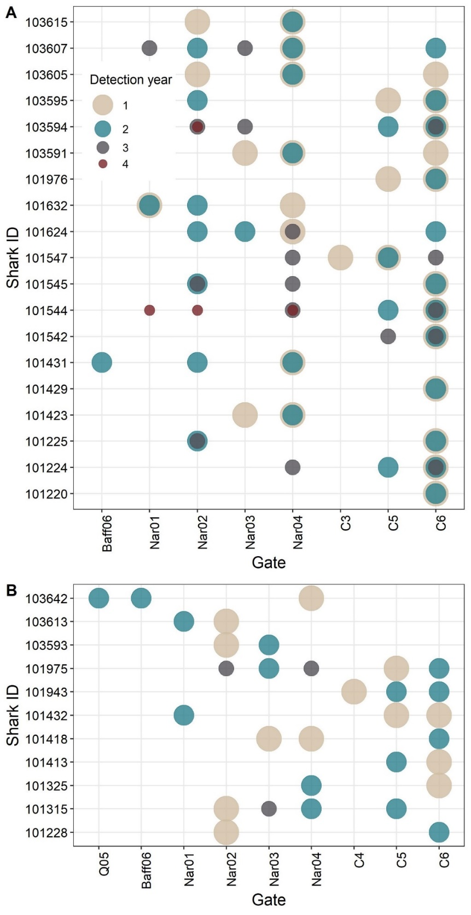
Figure S2 | Greenland shark detections recorded by acoustic receiver stations in offshore Baffin Bay (ABO, DST, and QIK arrays) across multiple study years, listed by the identification number of tagged sharks and by receiver gate. A) Sharks demonstrating spatial overlap in detection locations (i.e., receiver gates) across years. B) sharks for which no spatial overlap across years was observed. Points are coloured by the sequential year during which each individual was detected, where year 1 represents the first year in which an individual was detected. [Colour online.]

Table S1 | Mean duration, standard deviation, and range of Greenland shark detection events (hours and seconds) recorded by receiver gates in offshore Baffin Bay and listed in descending order based on mean event duration. Standard deviation is listed as NA where only single detection events were recorded. Total detection events and total detections refer to total values associated with all receivers in each gate, as recorded throughout the entire study period.
Gate | Mean event duration (h) | Mean event duration (sec) | SD (sec) | Range (sec) | Total detection events | Total detections
Nar04 | 18.19 | 65,469 | 182,617.67 | 0-798,900 | 40 | 931
Nar02 | 9.32 | 33,548.28 | 86,356.65 | 0-347,880 | 29 | 359
C6 | 8.46 | 30,473.46 | 87,040.39 | 0-476,880 | 55 | 1,260
Nar03 | 3.47 | 12,477.14 | 28,613.17 | 0-101,760 | 21 | 404
Nar01 | 3.28 | 11,813.33 | 37,193.66 | 0-160,080 | 18 | 162
C5 | 2.46 | 8,851.58 | 10,050.08 | 0-35,880 | 19 | 454
Baff06 | 2.20 | 7,920 | 8,909.55 | 1620-14,220 | 1 | 39
C4 | 0.80 | 2,880 | 593.97 | 2,460-3,300 | 2 | 33
C3 | 0.48 | 1,740 | NA | 1,740 | 1 | 7
Baff03 | 0 | 0 | NA | 0 | 1 | 1
Q02 | 0 | 0 | NA | 0 | 1 | 1
Q05 | 0 | 0 | NA | 0 | 1 | 1

Correspondence: Jena E. Edwards, email: edwar11n@uwindsor.ca (alternate email: edwardsj67@gmail.com)

