Supplementary Materials
Supplementary Table 1 - The composition and biomass of the microplankton across the Fram Strait (initial carbon), and the clearance rate and ingestion rate of the Calanus finmarchicus females. Water samples were taken at the chlorophyll maximum using 20L Niskin bottles in May – June 2018. Clearance rates and ingestion rates were calculated by particle removal experiments and grazing equations (Frost, 1972). Ind represents individual females. Mean averages are shown ± standard deviation.

Ex | Day | Station | Type | Initial carbon | Clearance rate | Ingestion rate
 |  |  |  | (µmol C L⁻¹) | (mL ind⁻¹ day⁻¹) | (µmol C ind⁻¹ day⁻¹)
3 | 1 | F17 | Small diatoms | 37.8 ± 10.2 | 474.65 ± 63.01 | 4.1 ± 0.2
 |  |  | Large diatoms | 14.3 ± 8.9 | 382.33 ± 150.52 | 1.6 ± 0.4
 |  |  | Pennate diatoms | 0.2 ± 0.1 | 14.33 ± 24.81 | 0.0 ± 0.0
 |  |  | Dinoflagellates | 12.9 ± 6.6 | 118.38 ± 150.89 | 0.6 ± 0.7
 |  |  | Ciliates | 1.7 ± 0.4 | 110 ± 95.57 | 0.1 ± 0.1
 |  |  | Flagellates | 2.7 ± 2.2 | 0.00 ± 0.00 | 0.0 ± 0.0
 |  |  | Total | 69.5 ± 2.6 |  | 6.5 ± 0.8
3 | 2 | F15 | Small diatoms | 13.8 ± 1.2 | 468.96 ± 185.20 | 2.0 ± 0.3
 |  |  | Large diatoms | 4.6 ± 1.4 | 660.46 ± 131.64 | 0.6 ± 0.0
 |  |  | Pennate diatoms | 0.1 ± 0.0 | 13.79 ± 23.89 | 0.0 ± 0.0
 |  |  | Dinoflagellates | 10.2 ± 2.5 | 120.39 ± 103.95 | 0.5 ± 0.4
 |  |  | Ciliates | 0.7 ± 0.0 | 31.47 ± 18.17 | 0.0 ± 0.0
 |  |  | Flagellates | 0.5 ± 0.1 | 214.14 ± 94.18 | 0.1 ± 0.0
 |  |  | Total | 30.0 ± 2.1 |  | 3.3 ± 0.5
3 | 3 | F13 | Small diatoms | 82.7 ± 15.3 | 273.02 ± 105.76 | 3.0 ± 1.5
 |  |  | Large diatoms | 31.0 ± 1.9 | 87.40 ± 59.32 | 1.5 ± 0.7
 |  |  | Pennate diatoms | 0.3 ± 0.1 | 134.07 ± 122.95 | 0.0 ± 0.0
 |  |  | Dinoflagellates | 22.7 ± 10.4 | 247.75 ± 141.00 | 2.6 ± 1.2
 |  |  | Ciliates | 5.6 ± 1.1 | 199.73 ± 176.88 | 0.6 ± 0.5
 |  |  | Flagellates | 0.7 ± 0.1 | 130.53 ± 67.86 | 0.1 ± 0.0
 |  |  | Total | 143.0 ± 8.0 |  | 7.8 ± 2.3
3 | 4 | F10 | Small diatoms | 41.8 ± 20.8 | 296.20 ± 7.38 | 2.7 ± 1.1
 |  |  | Large diatoms | 16.8 ± 0.7 | 257.63 ± 11.51 | 3.0 ± 0.1
 |  |  | Pennate diatoms | 0.2 ± 0.0 | 32.86 ± 29.53 | 0.0 ± 0.0
 |  |  | Dinoflagellates | 27.7 ± 7.1 | 371.18 ± 44.98 | 3.7 ± 0.4
 |  |  | Ciliates | 5.0 ± 1.0 | 230.79 ± 165.97 | 0.7 ± 0.5
 |  |  | Flagellates | 0.5 ± 0.1 | 222.42 ± 36.93 | 0.1 ± 0.0
 |  |  | Total | 92.1 ± 29.7 |  | 10.1 ± 0.3
3 | 5 | FS1 | Small diatoms | 17.3 ± 3.2 | 355.63 ± 103.79 | 1.2 ± 0.4
 |  |  | Large diatoms | 21.5 ± 3.5 | 59.24 ± 41.64 | 0.6 ± 0.4
 |  |  | Pennate diatoms | 0.6 ± 0.4 | 80.61 ± 78.34 | 0.0 ± 0.0
 |  |  | Dinoflagellates | 15.9 ± 0.3 | 118.33 ± 55.82 | 1.0 ± 0.4
 |  |  | Ciliates | 7.2 ± 2.4 | 264.88 ± 137.14 | 0.8 ± 0.2
 |  |  | Flagellates | 0.6 ± 0.0 | 179.27 ± 9.81 | 0.1 ± 0.0
 |  |  | Total | 63.2 ± 2.5 |  | 3.7 ± 1.4
4 | 1 | F8 | Small diatoms | 38.1 ± 14.4 | 306.80 ± 422.81 | 4.1 ± 3.5
 |  |  | Large diatoms | 22.8 ± 2.1 | 205.47 ± 178.49 | 1.8 ± 0.9
 |  |  | Pennate diatoms | 0.4 ± 0.1 | 143.37 ± 83.42 | 0.0 ± 0.0
 |  |  | Dinoflagellates | 21.6 ± 2.3 | 322.60 ± 42.10 | 2.9 ± 0.2
 |  |  | Ciliates | 1.2 ± 0.3 | 311.88 ± 28.34 | 0.2 ± 0.1
 |  |  | Flagellates | 0.3 ± 0.1 | 117.12 ± 101.52 | 0.0 ± 0.0
 |  |  | Total | 84.4 ± 14.9 |  | 9.0 ± 4.5
4 | 2 | HGIV | Small diatoms | 6.6 ± 0.1 | 27.31 ± 285.25 | 0.3 ± 0.3
 |  |  | Large diatoms | 2.3 ± 2.2 | 483.41 ± 200.19 | 0.4 ± 0.1
 |  |  | Pennate diatoms | 0.7 ± 0.3 | 138.50 ± 66.39 | 0.1 ± 0.0
 |  |  | Dinoflagellates | 10.8 ± 0.0 | 157.82 ± 117.78 | 0.8 ± 0.5
 |  |  | Ciliates | 6.9 ± 1.8 | 161.75 ± 207.06 | 0.3 ± 0.3
 |  |  | Flagellates | 1.2 ± 0.5 | 29.29 ± 35.95 | 0.0 ± 0.0
 |  |  | Total | 28.6 ± 0.3 |  | 1.9 ± 0.9
4 | 3 | F4 | Small diatoms | 4.9 ± 0.9 | 378.30 ± 459.08 | 0.4 ± 0.3
 |  |  | Large diatoms | 0.2 ± 0.3 | 147.76 ± 139.54 | 0.0 ± 0.0
 |  |  | Pennate diatoms | 0.5 ± 0.0 | 135.93 ± 107.15 | 0.0 ± 0.0
 |  |  | Dinoflagellates | 11.1 ± 0.1 | 0.00 ± 0.00 | 0.0 ± 0.0
 |  |  | Ciliates | 6.7 ± 3.4 | 108.69 ± 153.18 | 0.7 ± 0.6
 |  |  | Flagellates | 0.8 ± 0.3 | 9.24 ± 16.01 | 0.0 ± 0.0
 |  |  | Total | 24.1 ± 1.8 |  | 1.2 ± 0.7
4 | 4 | F2 | Small diatoms | 8.6 ± 3.0 | 82.75 ± 206.74 | 0.3 ± 0.2
 |  |  | Large diatoms | 0.5 ± 0.4 | 551.60 ± 51.50 | 0.1 ± 0.0
 |  |  | Pennate diatoms | 1.5 ± 0.5 | 56.03 ± 23.91 | 0.1 ± 0.0
 |  |  | Dinoflagellates | 14.8 ± 0.6 | 21.23 ± 36.77 | 0.2 ± 0.3
 |  |  | Ciliates | 13.2 ± 4.5 | 233.06 ± 167.89 | 1.3 ± 1.3
 |  |  | Flagellates | 1.0 ± 0.6 | 94.89 ± 66.41 | 0.1 ± 0.0
 |  |  | Total | 39.6 ± 0.2 |  | 2.0 ± 1.6
4 | 5 | KB0 | Small diatoms | 4.9 ± 1.6 | 0.00 ± 169.60 | 0.0 ± 0.0
 |  |  | Large diatoms | 0.0 ± 0.0 | 0.00 ± 0.00 | 0.0 ± 0.0
 |  |  | Pennate diatoms | 3.0 ± 1.0 | 68.77 ± 22.89 | 0.2 ± 0.1
 |  |  | Dinoflagellates | 22.5 ± 7.7 | 0.00 ± 0.00 | 0.1 ± 0.1
 |  |  | Ciliates | 3.5 ± 1.8 | 19.52 ± 33.81 | 0.0 ± 0.0
 |  |  | Flagellates | 0.4 ± 0.1 | 58.09 ± 50.65 | 0.0 ± 0.0
 |  |  | Total | 34.4 ± 12.0 |  | 0.3 ± 0.1
5 | 1 | ST1 | Small diatoms | 28.6 ± 2.1 | 486.53 ± 172.45 | 3.0 ± 0.9
 |  |  | Large diatoms | 4.1 ± 2.9 | 402.92 ± 170.92 | 0.4 ± 0.1
 |  |  | Pennate diatoms | 0.2 ± 0.0 | 3.46 ± 6.00 | 0.0 ± 0.0
 |  |  | Dinoflagellates | 11.9 ± 3.0 | 115.33 ± 112.47 | 0.8 ± 0.3
 |  |  | Ciliates | 10.5 ± 13.9 | 2171.55 ± 139.54 | 2.2 ± 0.1
 |  |  | Flagellates | 0.1 ± 0.0 | 77.28 ± 67.88 | 0.0 ± 0.0
 |  |  | Total | 55.4 ± 16.2 |  | 6.3 ± 0.8

Supplementary Figure 1. The change in ratio of carbon (C) to nitrogen (N) in C. finmarchicus individuals. The C and N content of the experimental females did not vary significantly between the start and end of the incubations. Ex represents experiment.
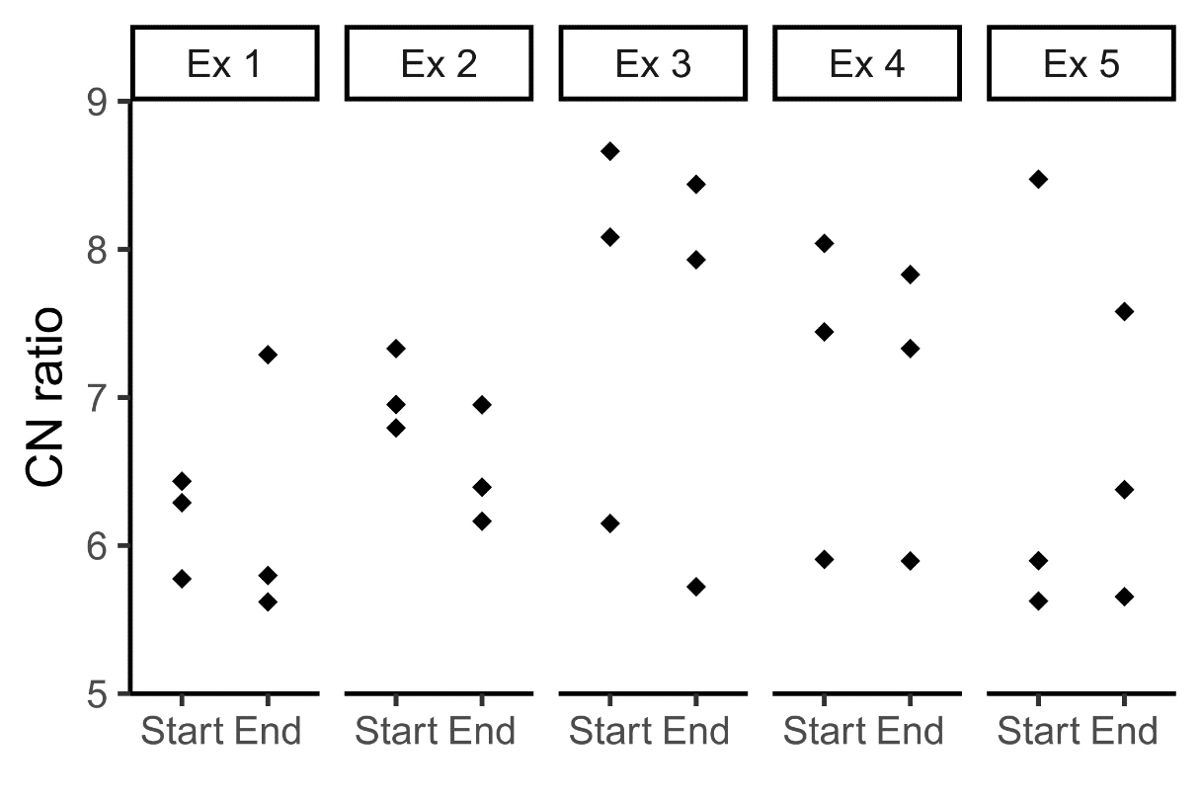
Supplementary Table 2. The carbon (C) and nitrogen (N) content of the experimental female C. finmarchicus caught in the Fram Strait in May to June 2018. Start denotes animals that were preserved immediately after catch and identification. End denotes animals that were caught at the same time as those in Start, but then underwent bottle incubations. Ind represents individual female.
Ex | Length | Timepoint | C content | N content | C:N
 | (days) |  | (µmol C ind⁻¹) | (µmol N ind⁻¹)
1 | 4 | Start | 12.57 | 2.00 | 6.29
 |  |  | 13.32 | 2.07 | 6.43
 |  |  | 17.32 | 3.00 | 5.78
 |  | End | 13.24 | 2.36 | 5.62
 |  |  | 14.49 | 2.50 | 5.80
 |  |  | 12.49 | 1.71 | 7.29
2 | 4 | Start | 14.65 | 2.00 | 7.33
 |  |  | 11.16 | 1.64 | 6.79
 |  |  | 12.91 | 1.86 | 6.95
 |  | End | 12.32 | 2.00 | 6.16
 |  |  | 13.24 | 2.07 | 6.39
 |  |  | 12.41 | 1.78 | 6.95
3 | 5 | Start | 16.74 | 2.07 | 8.08
 |  |  | 14.49 | 2.36 | 6.15
 |  |  | 12.99 | 1.50 | 8.66
 |  | End | 14.15 | 1.78 | 7.93
 |  |  | 22.90 | 2.71 | 8.44
 |  |  | 13.07 | 2.28 | 5.72
4 | 5 | Start | 13.07 | 2.21 | 5.91
 |  |  | 21.81 | 2.71 | 8.04
 |  |  | 18.07 | 2.43 | 7.44
 |  | End | 15.65 | 2.00 | 7.83
 |  |  | 15.15 | 2.57 | 5.90
 |  |  | 18.32 | 2.50 | 7.33
5 | 2 | Start | 18.15 | 2.14 | 8.47
 |  |  | 13.65 | 2.43 | 5.63
 |  |  | 14.74 | 2.50 | 5.90
 |  | End | 14.57 | 2.28 | 6.38
 |  |  | 19.48 | 2.57 | 7.58
 |  |  | 13.32 | 2.36 | 5.65

Supplementary Figure 2. The relationships between the quantity of available food and the ingestion (A, B, C & D) and egg production rate (E, F & G, H) of C. finmarchicus in bottle-incubation experiments in May and June 2018. The quantity of available food is estimated from using the chlorophyll a concentration as a proxy (A & E), and calculated using inverted microscopy for all cell types (B & F), for small (S) and large (L) diatoms (C & G), and for dinoflagellates (D & H). Shaded areas show 95 % confidence intervals. R is spearman’s ρ.
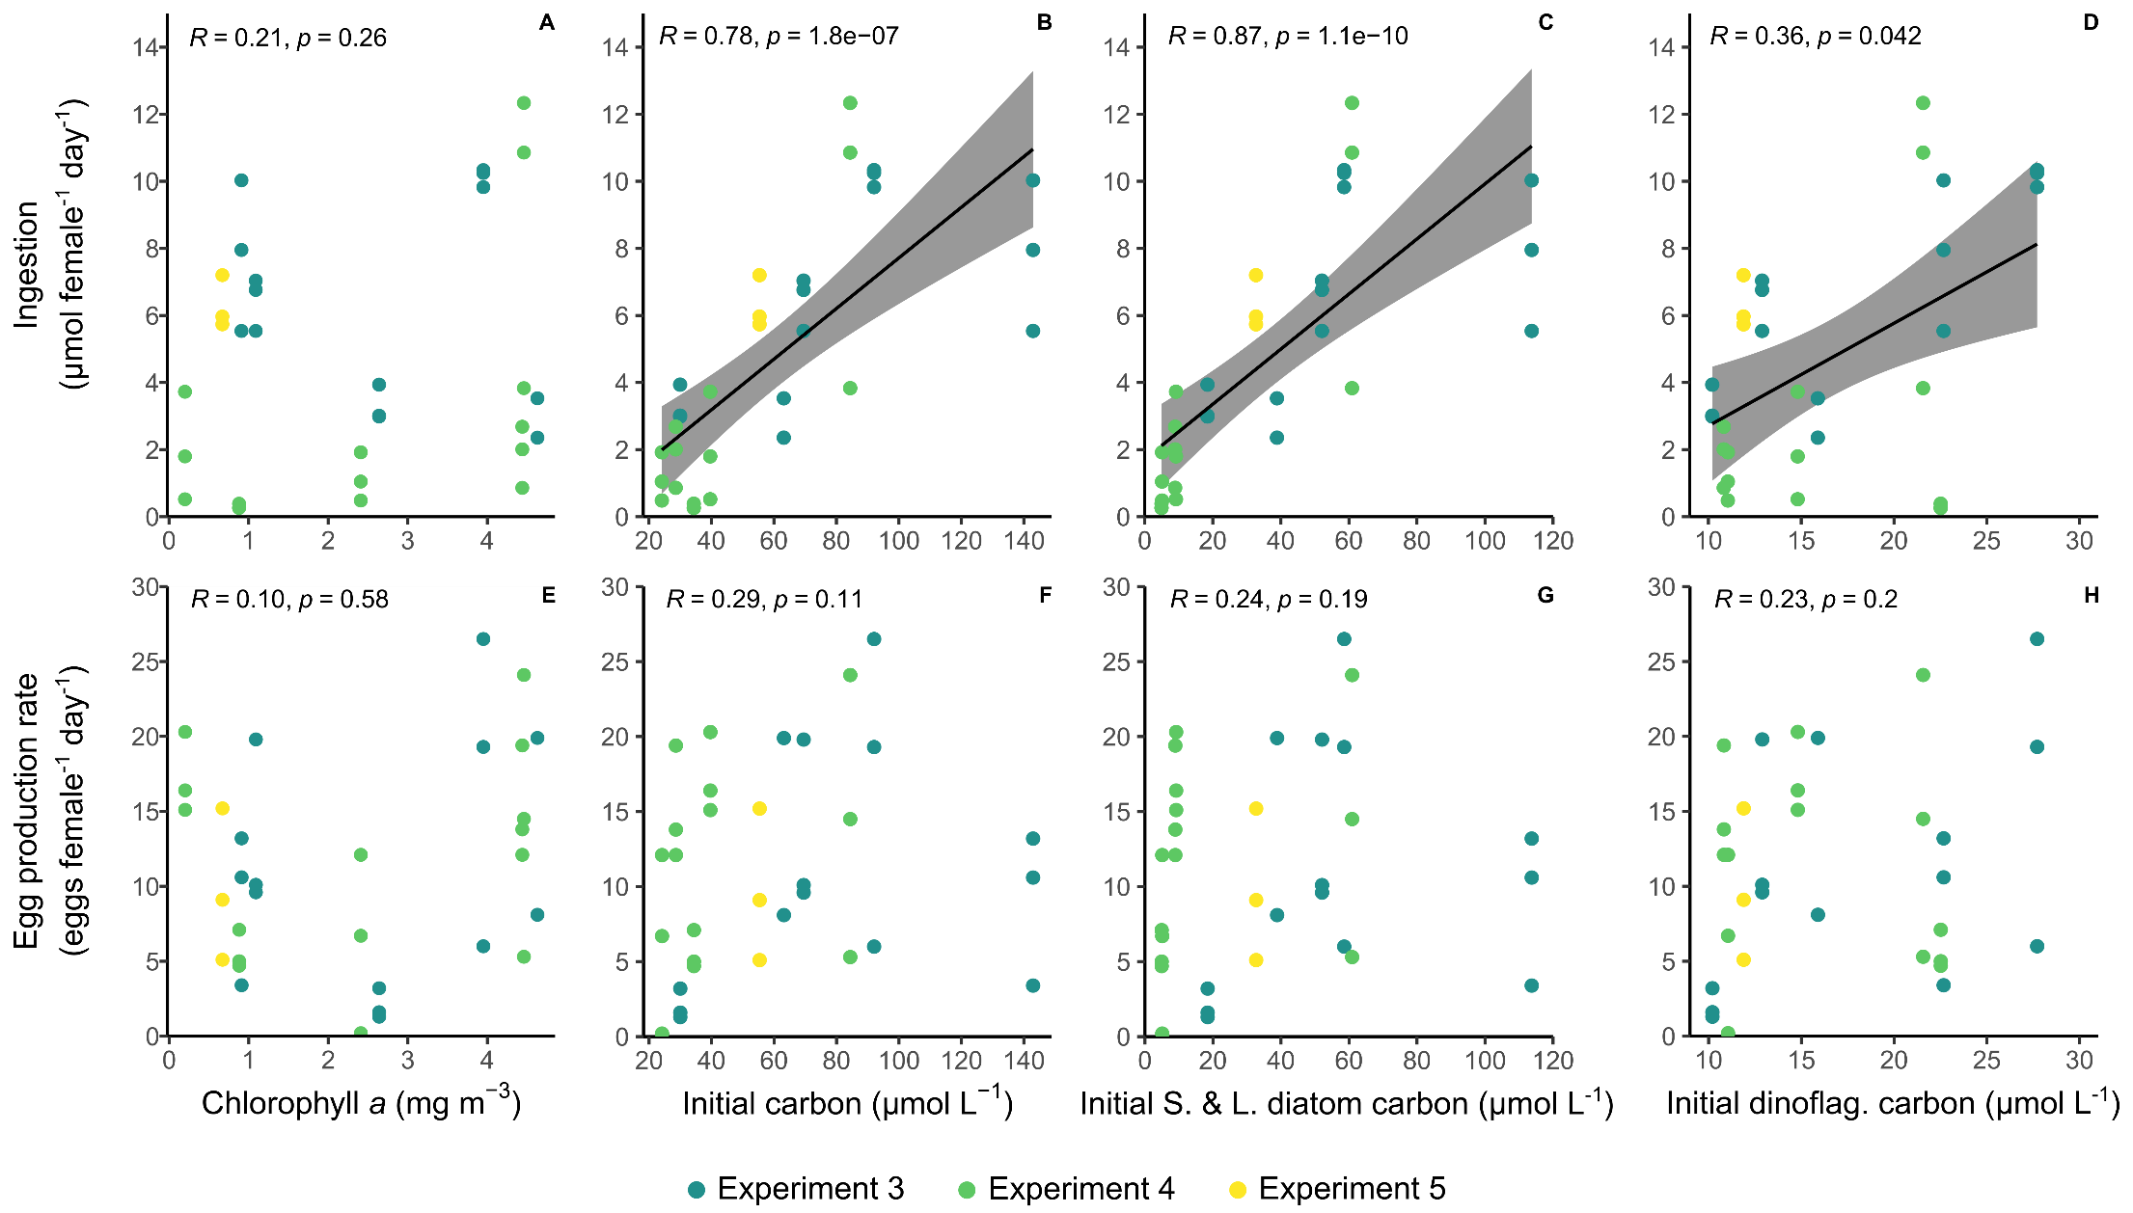

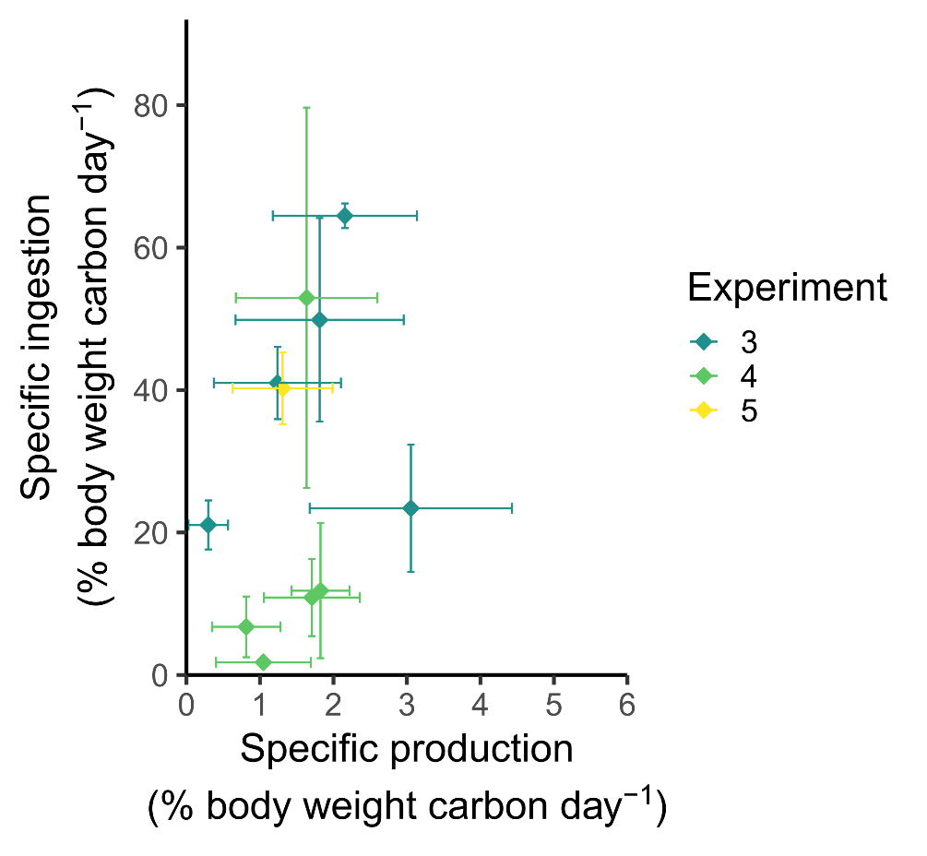Supplementary Figure 3. Specific ingestion and specific production by C. finmarchicus females in bottle incubation experiments in May to June 2018. The relationship between specific ingestion and specific production is insignificant (ρ = 0.21, p = 0.24).

Supplementary Figure 4 – the significant positive correlation between specific egg production and the percentage of females that were spawning in experiments run alongside the experiments detailed here.
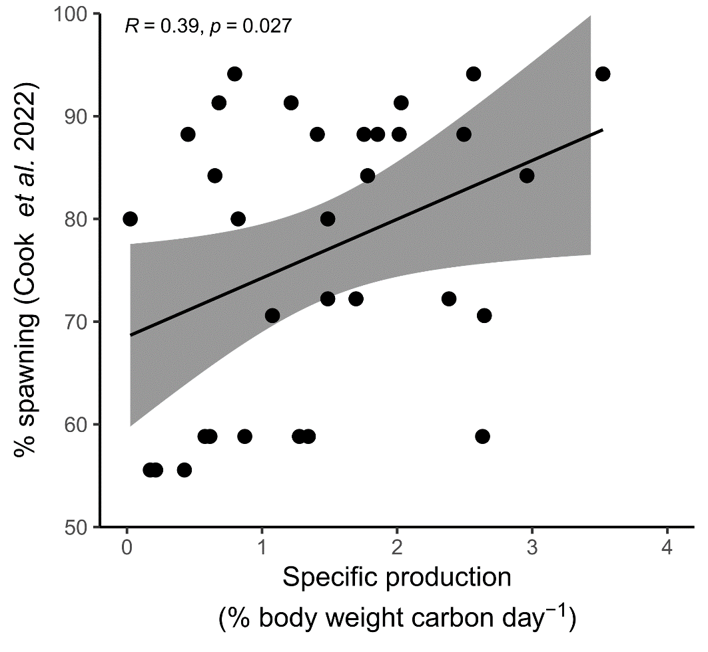

Supplementary Figure 5. Photographs taken of experimental female C. finmarchicus on 21/5/18, showing the lipid sac and gonopore but no obvious ovaries or eggs.
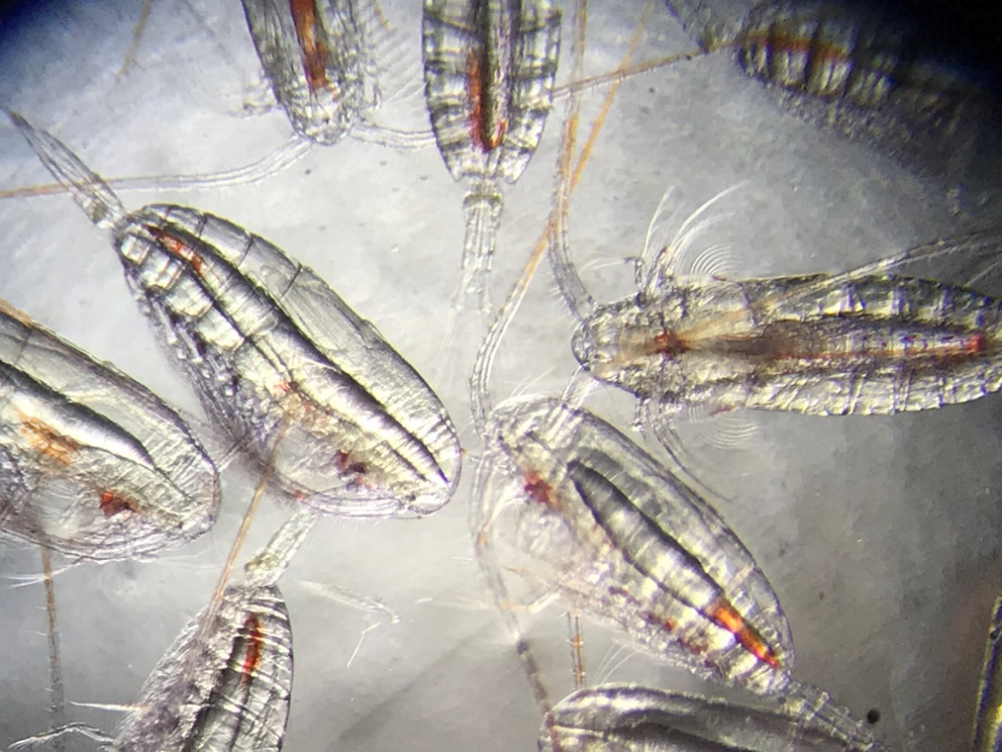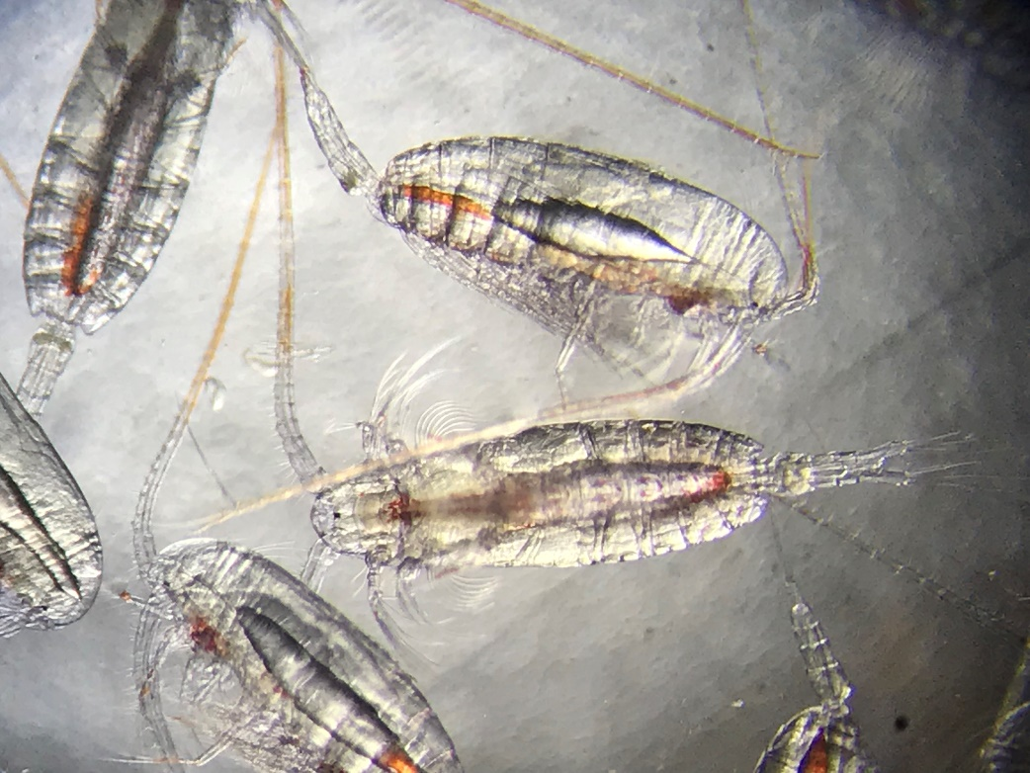

Supplementary Table 3. Egg production rates (EPR) of Calanus finmarchicus in the Arctic. The Arctic Ocean here excludes the Norwegian Sea. Temp. is the ocean temperature at surface/animal sampling depth. False-bottom includes any container that allows eggs to pass but not adults, including those with mesh bottoms and those with narrow elongated ends. Literature search using terms: “Calanus finmarchicus” & “egg production rate” & Arctic giving 624 results.
Area | Year | Temp. | Season | Exp. type | EPR | Error | EPR | Error | Notes | Reference
 |  | °C |  |  | (eggs female⁻¹ day⁻¹) | SD  (* = SE) | (% body carbon day⁻¹) | SD  (* = SE)
North Svalbard | 1987 | -1 to -1.5 | Summer | False-bottom incubations | 0.3 | NA | NA | NA | Eggs from only one station | (Hirche & Mumm, 1992)
East Greenland Shelf | 1988 | 0 | Summer | False-bottom incubations | 19.9 | 5.7 | 4.5 | 1.3 | Mean | (Hirche, 1990)
East Greenland Shelf | 1988 | 0 | Summer | False-bottom incubations | 34 | NA | NA | NA | Maximum | (Hirche, 1990)
Central Greenland Sea | 1989 | 0 to 2 | Summer | False-bottom incubations | 4.3 | NA | NA | NA |  | (Hirche & Kosobokova, 2007)
Barents Sea | 1989 | -1 to -0.5 | Spring | False-bottom incubations | 0 | 0 | NA | NA | Prebloom – all had immature gonads | (Hirche & Kattner, 1993)
Disko Bay | 2005 | 0 | Spring | Bottle incubations | 4 | 0.7* | NA | NA | Average | (Madsen et al., 2008)
Disko Bay | 2005 | 0 | Spring | Bottle incubations | 44 | 7* | NA | NA | Maximum | (Madsen et al., 2008)
Disko Bay | 2008 | -1.3 | Early spring | Bottle incubations | 0.03 |  | 0.01 |  | Pre-bloom | (Swalethorp et al., 2011)
Disko Bay | 2008 | 1 | Spring | Bottle incubations | 9.7 |  | 1.7 |  | Bloom | (Swalethorp et al., 2011)
Disko Bay | 2008 | 1 | Summer | Bottle incubations | 7.0 |  | 1.0 |  | Post-bloom | (Swalethorp et al., 2011)
Barents Sea | 2010 | 0, 2.5, 5, 7.5, 10 | Spring | False-bottom incubation | 6.3 – 14.5 |  | NA | NA |  | (Pasternak et al., 2013)
Disko Bay | 2012 | 0 | Spring | Bottle incubations | 36 |  | 0.05 |  | Maximum | (Møller et al., 2016)

References
Frost, B.W. (1972) Effect of size and concentration of food particles on the feeding behaviour of the marine planktonic copepod Calanus pacificus. Limnology and Oceanography. 1972 (17), 805–815. doi:10.4319/lo.1972.17.6.0805.
Hirche, H.J. (1990) Egg production of Calanus finmarchicus at low temperature. Marine Biology. 106 (1), 53–58. doi:10.1007/BF02114674.
Hirche, H.J. & Kattner, G. (1993) Egg production and lipid content of Calanus glacialis in spring: indication of a food-dependent and food-independent reproductive mode. Marine Biology. 117 (4), 615–622. doi:10.1007/BF00349773.
Hirche, H.J. & Kosobokova, K. (2007) Distribution of Calanus finmarchicus in the northern North Atlantic and Arctic Ocean-Expatriation and potential colonization. Deep-Sea Research Part II: Topical Studies in Oceanography. 54 (23–26), 2729–2747. doi:10.1016/j.dsr2.2007.08.006.
Hirche, H.J. & Mumm, N. (1992) Distribution of dominant copepods in the Nansen Basin, Arctic Ocean, in summer. Deep Sea Research Part A, Oceanographic Research Papers. 39 (2 PART 1), 485–505. doi:10.1016/S0198-0149(06)80017-8.
Madsen, S.J., Nielsen, T.G., Tervo, O.M. & Söderkvist, J. (2008) Importance of feeding for egg production in Calanus finmarchicus and C. glacialis during the Arctic spring. Marine Ecology Progress Series. 353, 177–190. doi:10.3354/meps07129.
Møller, E.F., Bohr, M., Kjellerup, S., Maar, M., Møhl, M., Swalethorp, R. & Nielsen, T.G. (2016) Calanus finmarchicus egg production at its northern border. Journal of Plankton Research. 38 (5), 1206–1214. doi:10.1093/plankt/fbw048.
Pasternak, A.F., Arashkevich, E.G., Grothe, U., Nikishina, A.B. & Solovyev, K.A. (2013) Different effects of increased water temperature on egg production of Calanus finmarchicus and C. glacialis. Marine Biology. 53 (5), 547–553. doi:10.1134/S0001437013040085.
Swalethorp, R., Kjellerup, S., Dünweber, M., Nielsen, T.G., Møller, E.F., Rysgaard, S. & Hansen, B.W. (2011) Grazing, egg production, and biochemical evidence of differences in the life strategies of Calanus finmarchicus, C. glacialis and C. hyperboreus in Disko Bay, Western Greenland. Marine Ecology Progress Series. 429 (August 2014), 125–144. doi:10.3354/meps09065.
Frost, B.W. (1972) Effect of size and concentration of food particles on the feeding behaviour of the marine planktonic copepod Calanus pacificus. Limnology and Oceanography. 1972 (17), 805–815. doi:10.4319/lo.1972.17.6.0805.
Hirche, H.J. (1990) Egg production of Calanus finmarchicus at low temperature. Marine Biology. 106 (1), 53–58. doi:10.1007/BF02114674.
Hirche, H.J. & Kattner, G. (1993) Egg production and lipid content of Calanus glacialis in spring: indication of a food-dependent and food-independent reproductive mode. Marine Biology. 117 (4), 615–622. doi:10.1007/BF00349773.
Hirche, H.J. & Kosobokova, K. (2007) Distribution of Calanus finmarchicus in the northern North Atlantic and Arctic Ocean-Expatriation and potential colonization. Deep-Sea Research Part II: Topical Studies in Oceanography. 54 (23–26), 2729–2747. doi:10.1016/j.dsr2.2007.08.006.
Hirche, H.J. & Mumm, N. (1992) Distribution of dominant copepods in the Nansen Basin, Arctic Ocean, in summer. Deep Sea Research Part A, Oceanographic Research Papers. 39 (2 PART 1), 485–505. doi:10.1016/S0198-0149(06)80017-8.
Madsen, S.J., Nielsen, T.G., Tervo, O.M. & Söderkvist, J. (2008) Importance of feeding for egg production in Calanus finmarchicus and C. glacialis during the Arctic spring. Marine Ecology Progress Series. 353, 177–190. doi:10.3354/meps07129.
Møller, E.F., Bohr, M., Kjellerup, S., Maar, M., Møhl, M., Swalethorp, R. & Nielsen, T.G. (2016) Calanus finmarchicus egg production at its northern border. Journal of Plankton Research. 38 (5), 1206–1214. doi:10.1093/plankt/fbw048.
Pasternak, A.F., Arashkevich, E.G., Grothe, U., Nikishina, A.B. & Solovyev, K.A. (2013) Different effects of increased water temperature on egg production of Calanus finmarchicus and C. glacialis. Marine Biology. 53 (5), 547–553. doi:10.1134/S0001437013040085.
Swalethorp, R., Kjellerup, S., Dünweber, M., Nielsen, T.G., Møller, E.F., Rysgaard, S. & Hansen, B.W. (2011) Grazing, egg production, and biochemical evidence of differences in the life strategies of Calanus finmarchicus, C. glacialis and C. hyperboreus in Disko Bay, Western Greenland. Marine Ecology Progress Series. 429 (August 2014), 125–144. doi:10.3354/meps09065.

