Sphagnum capillifolium holobiont from a subarctic palsa bog aggravates the potential of nitrous oxide emissions

Yanxia Nie^{1,2,5,}*, Sharon Yu Ling Lau^{3,5}, Xiangping Tan¹, Xiankai Lu¹, Suping Liu¹, Teemu Tahvanainen⁴, Reika Isoda⁵, Qing Ye^{1,2}, Yasuyuki Hashidoko^{5※}
¹Key Laboratory of Vegetation Restoration and Management of Degraded Ecosystems, South China Botanical Garden, Chinese Academy of Sciences, Guangzhou 510650, China.
²Southern Marine Science and Engineering Guangdong Laboratory, Guangzhou 511458, China.
³Sarawak Tropical Peat Research Institute, Kuching-Samarahan Expressway, Kota Samarahan, 94300, Malaysia.
⁴Department of Environmental and Biological Sciences, University of Eastern Finland, Joensuu FI-80100, Finland.
⁵Graduate School of Agriculture, Hokkaido University, Sapporo 060-0808, Japan.
※Deceased
* Correspondence:
Corresponding Author: Dr. Yanxia Nie
Email: nieyanx@scbg.ac.cn
South China Botanical Garden, Chinese Academy of Sciences, Xingke Road 723, Tianhe District, Guangzhou, 510650, China.

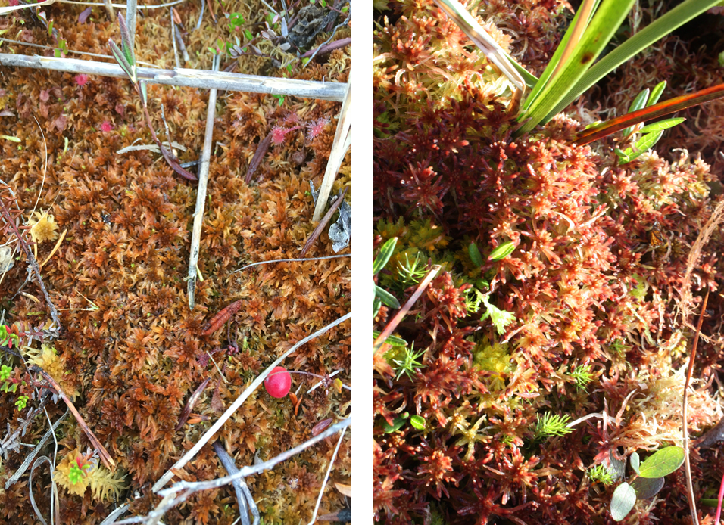
Sphagnum fuscum Sphagnum capillifolium

Fig. S1 Vegetation of Sphagnum mosses in a plateau of a permafrost mound of a palsa mire near Kilpisjärvi (68° 52’ 45; 21° 4’ 40), Finland. Two characteristic species including Sphagnum fuscum and Sphagnum capillifolium were collected.
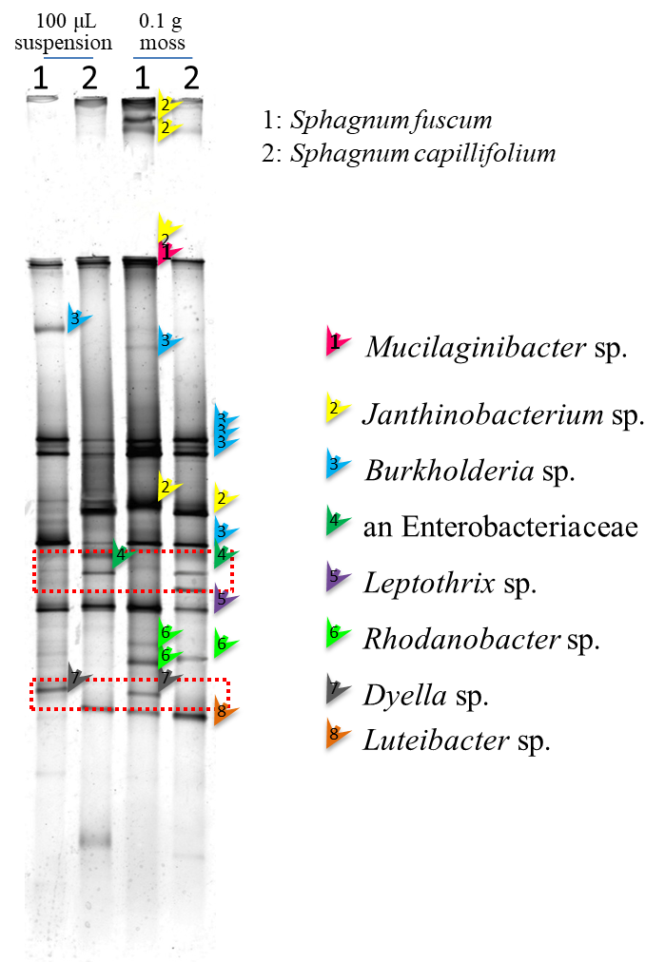
Fig. S2. The profile of DGGE of the two Sphagnum species

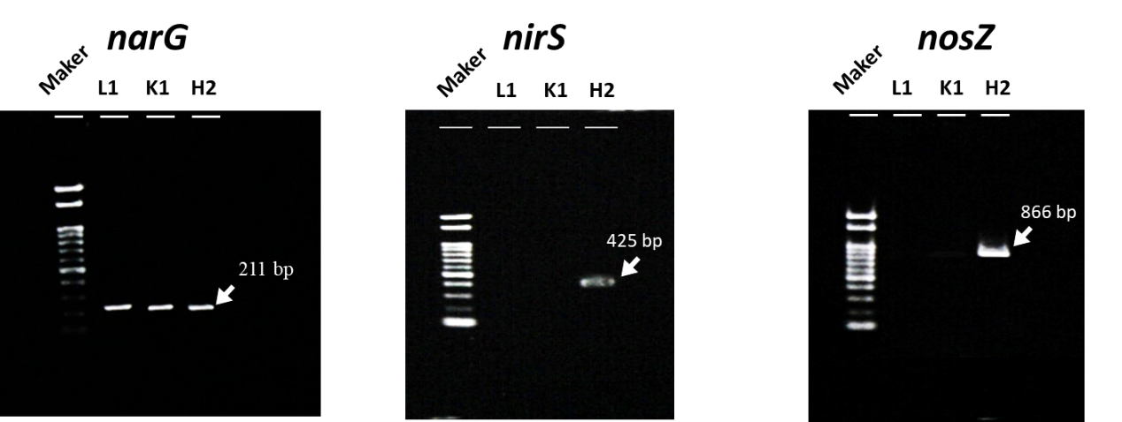
Fig. S3. Detection of narG, nirS, and nosZ genes of the three active N₂O emitters.
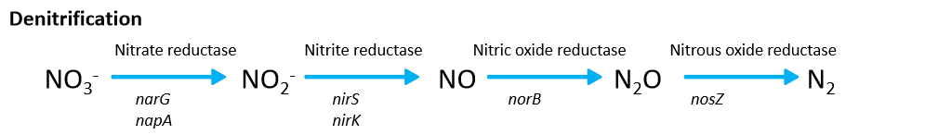
Fig. S4. Functional genes in the process of denitrification.

Target  gene | Primer set | Sequence (5'–3') | Thermal profile | Reference
narG | 2168F  2391R | 5‘-TCG GGC AAG GGC CAC GAA TAC-3‘  5‘-TTC TCG TAC CAC GTC GCG GTC-3‘ | 95˚C 10 min, 30 cycles of 52˚C 1 min, 72˚C 1 min, 72˚C 10 min | This study
nirS | cd3AF  R3cd | 5‘-GTSAACGTSAAGGARACSGG-3‘  5‘-GASTTCGGRTGSGTCTTGA-3‘ | 95˚C 10 min, 30 cycles of 52˚C 1 min, 72˚C 1 min, 72˚C 10 min | Throbäck et al., 2004
nosZ | 661F  1527R | 5‘-CGG CTG GGG GCT GAC CAA-3‘  5‘-CTG RCT GTC GAD GAA CAG-3‘ | 95˚C 10 min, 30 cycles of 55˚C 1 min, 72˚C 1 min, 72˚C 10 min | Scala and Kerkhof, 1998
Table S1 The detail reaction conditions of PCR amplifications of narG, nirS, nosZ genes.

Table S2 Screening of the N₂O emitters isolated from the surface of Sphagnum mosses leaves. Incubation conditions of these isolated pure strains: pH=5, incubated at 15˚C, 5 days, n=3, with 0.05% sucrose. (-) indicated inactive N₂O emitters, (+) indicated active emitters.

Sphagnum species | Bacterium | Most aligned sequences | N₂O (ng vial⁻¹ d⁻¹) | N₂O emitters
SF | SF-B1 | Burkholderia sp. | 62.12 | -
 | SF-D2 | Burkholderia sp. | 54.02 | -
SC | SC-L1 | Enterobacteriaceae. | 338.49 | +
 | SC-K1 | Serratia sp. | 186.22 | +
 | SC-H2 | Pseudomonas sp. | 427.35 | +
 | SC-M1 | Burkholderia sp. | 51.90 | -

