Supplementary Material
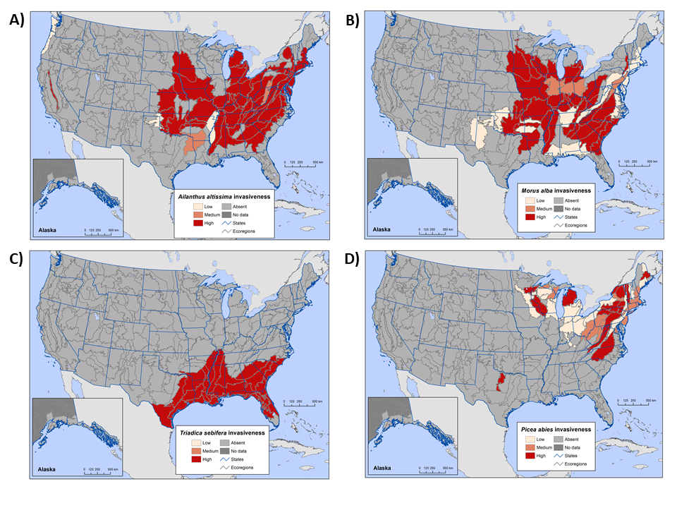
Supplementary Figure 1: The invasive impact classification for (A) Ailanthus altissima, (B) Morus alba, (C) Triadica sebifera, and (D) Picea abies in each ecoregion section of the conterminous United States and coastal Alaska using Forest Inventory and Analysis (FIA) tree occurrence data.
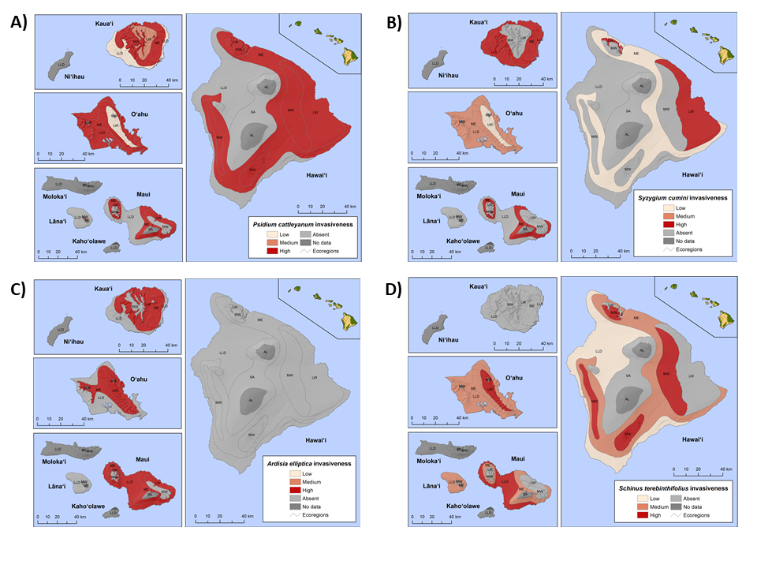
Supplementary Figure 2: The invasiveness classification for (A) Psidium cattleyanum, (B) Syzygium cumini, (C) Ardisia elliptica, and (D) Schinus terebinthifolius in each Hawaiian ecoregion, by island, using Forest Inventory and Analysis (FIA) tree occurrence data.

