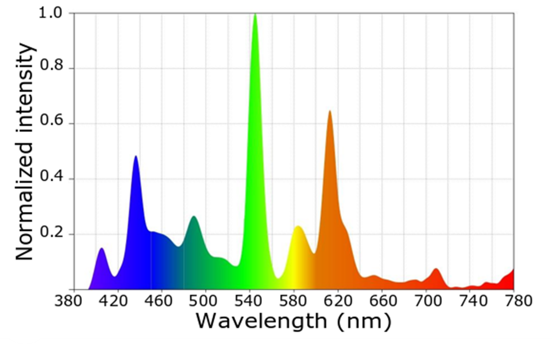
Figure S1: Spectrograms of the light bulb used for the acclimation and for the experiment. The light spectrum was recorded using the Sekonic Sprectromaster C-700 (North White Plans, NY, USA).

