Supplementary information: Succession of protistan functional traits is influenced by bloom timing
Bérangère Péquin^{1, 2*}, Richard LaBrie^{1, 3*†}, Nicolas Fortin St-Gelais¹, Roxane Maranger¹
*These authors have contributed equally to this work and share first authorship
†Corresponding author, richard.labrie90@gmail.com

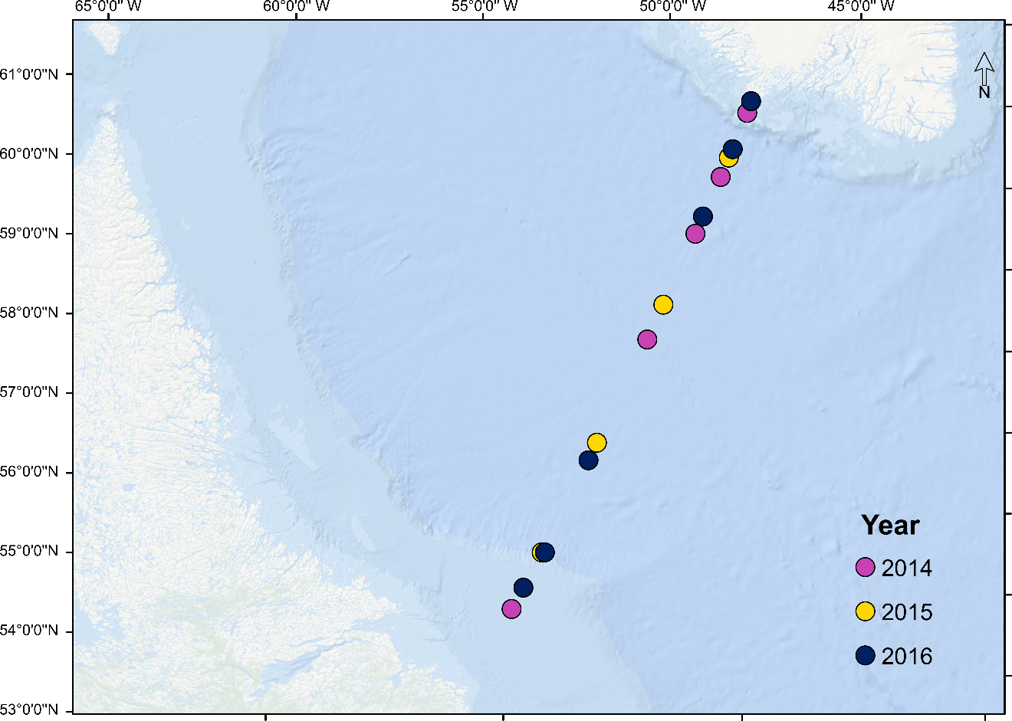
Figure S1. Map of the studied region. Colors indicate years. Note that station 8.5 (3rd from bottom) was sampled in 2015 and 2016.

Table S1: Location, type of identification, sampling day and day of the peak chlorophyll-a for all stations
Id | Station | Lat (°N) | Long (°E) | Year | Identification | Sampling (DOY) | Peak (DOY) | Days before peak | Onset of bloom (DOY)
400804 | L3_05 | 54.49 | -54.75 | 2014 | Both | 133 | 164 | 31 | 157
400889 | L3_9.5 | 55.34 | -53.9 | 2014 | Microscopy | 134 | 156 | 22 | 142
400563 | L3_16.5 | 57.59 | -51.57 | 2014 | Microscopy | 131 | 148 | 17 | 133
400149 | L3_17 | 57.8 | -51.33 | 2014 | Sequencing | 127 | 148 | 21 | 133
400244 | L3_20 | 59.07 | -49.94 | 2014 | Both | 128 | 140 | 12 | 111
400467 | L3_22 | 59.75 | -49.16 | 2014 | Both | 130 | 148 | 18 | 123
400365 | L3_27.5 | 60.51 | -48.29 | 2014 | Both | 129 | 148 | 19 | 102
408395 | L3_8.5 | 55.19 | -54.05 | 2015 | Both | 135 | 156 | 21 | 143
408491 | L3_11.5 | 55.73 | -53.49 | 2015 | Microscopy | 136 | 132 | 4 | 125
407871 | L3_14 | 56.54 | -52.68 | 2015 | Both | 129 | 140 | 11 | 117
408276 | L3_15.5 | 57.18 | -52.01 | 2015 | Microscopy | 134 | 140 | 6 | 119
408231 | L3_18 | 58.22 | -50.88 | 2015 | Both | 133 | 140 | 7 | 97
407968 | L3_19.5 | 58.85 | -50.19 | 2015 | Microscopy | 130 | 140 | 10 | 111
408041 | L3_23 | 59.98 | -48.9 | 2015 | Both | 131 | 140 | 9 | 82
408063 | L3_28 | 60.57 | -48.23 | 2015 | Microscopy | 131 | 132 | 1 | 109
433946 | L3_06 | 54.75 | -54.48 | 2016 | Sequencing | 136 | 172 | 36 | 131
433246 | L3_8.5 | 55.19 | -53.97 | 2016 | Sequencing | 128 | 180 | 52 | 127
433318 | L3_13.5 | 56.33 | -52.89 | 2016 | Sequencing | 129 | 172 | 43 | 126
433442 | L3_20.5 | 59.28 | -49.71 | 2016 | Sequencing | 131 | 172 | 41 | 141
433643 | L3_23.5 | 60.08 | -48.78 | 2016 | Sequencing | 133 | 180 | 47 | 141
433569 | L3_28.5 | 60.65 | -48.15 | 2016 | Sequencing | 132 | 132 | 0 | 124
Note: DOY is day of year
Note 2: All stations were sampled at 2 m and 30 m deep
Figure S2. Total number of reads (a) and relative abundance (b) of the main protistan phyla detected at each station and for each year using 18SrRNA gene Illumina sequencing.

Figure S3. Total abundance of the main protistan phyla detected by microscopy at each station for 2014 (top) and 2015 (bottom).

Higher Rank | class | validName | No. Stations | Note
Cercozoa | Incertae_Sedis | Quadricilia | 1 | Classified as Cercozoa in 2018¹
Chlorophyta | Chlorophyceae | Pachysphaera | 2
Choanoflagellatea | Acanthoecida | Crucispina | 1
Choanoflagellatea | Acanthoecida | Monosiga | 8 | Different species
Choanoflagellatea | Acanthoecida | Monosiga | 5
Choanoflagellatea | Acanthoecida | Parvicorbicula | 1 | Different species
Choanoflagellatea | Acanthoecida | Parvicorbicula | 11
Ciliophora | Intramacronucleata | Lohmanniella | 8
Ciliophora | Intramacronucleata | Mesodinium | 4
Ciliophora | Intramacronucleata | Uronema | 1
Cryptophyta | Cryptomonadales_cl | Hemiselmis | 2
Cryptophyta | Cryptomonadales_cl | Plagioselmis | 12 | Haploid stage of Teleaulax (found in 18S)²
Dynophyta | Dinophyceae | Amphidinium | 14 | Different species
Dynophyta | Dinophyceae | Amphidinium | 3
Dynophyta | Dinophyceae | Peridiniella | 4 | Different species
Dynophyta | Dinophyceae | Peridiniella | 1
Dynophyta | Dinophyceae | Proterythropsis | 5
Dynophyta | Dinophyceae | Torodinium | 1
Euglenozoa | Euglenoidea | Eutreptiella | 1
Haptophyta | Prymnesiales | Corymbellus | 9 | Colonial form of Chrysochromulina (found in 18S)³
Haptophyta | Prymnesiophyceae_cl | Phaeocystis_haploid | 3 | Can't be differentiated from diploid stage using 18S
Ochrophyta | Dictyochophyceae | Apedinella | 3
Ochrophyta | Diatomea | Arcocellulus | 6
Ochrophyta | Raphidophyceae | Chattonella | 1
Ochrophyta | Diatomea | Cylindrotheca | 1
Ochrophyta | Dictyochophyceae | Dictyocha | 4
Ochrophyta | Chrysophyceae | Dinobryon | 2
Ochrophyta | Raphidophyceae | Heterosigma | 14
Ochrophyta | Diatomea | Lennoxia | 2
Ochrophyta | Diatomea | Membraneis | 1
Ochrophyta | Xanthophyceaea | Meringosphaera | 6 | First sequenced in 2021⁴
Ochrophyta | Dictyochophyceae | Pseudopedinella | 6 | Different species
Ochrophyta | Dictyochophyceae | Pseudopedinella | 7
Stramenopiles | Incertae_Sedis | Commation | 6 | Classified as "MAST" in sequencing
Telonemia | Telonemea | Telonema | 6 | Different species; unique in this phylum
Telonemia | Telonemea | Telonema | 12

Table S2: Taxa only found in microscopy
Note. 1. Yabuki and Ishida (2018); 2. Altenburger et al. (2020); 3. Estep and MacIntyre (1989); 4. Zlatogursky et al. (2021)

Some taxa identified in microscopy had other names in our sequencing database. For example, Phaeocystis was identified in both haploid and diploid stages which can’t be discriminated using 18S; Corymbellus (microscopy) is the colonial form of Chrysochromulina (18S) and Plagioselmis (microscopy) is the haploid form of Teleaulax (18S). Other taxa were first sequenced (Zlatogursky et al., 2021) or taxonomically classified (Yabuki and Ishida, 2018) after our sequencing database was made (SILVA v128, 2016).

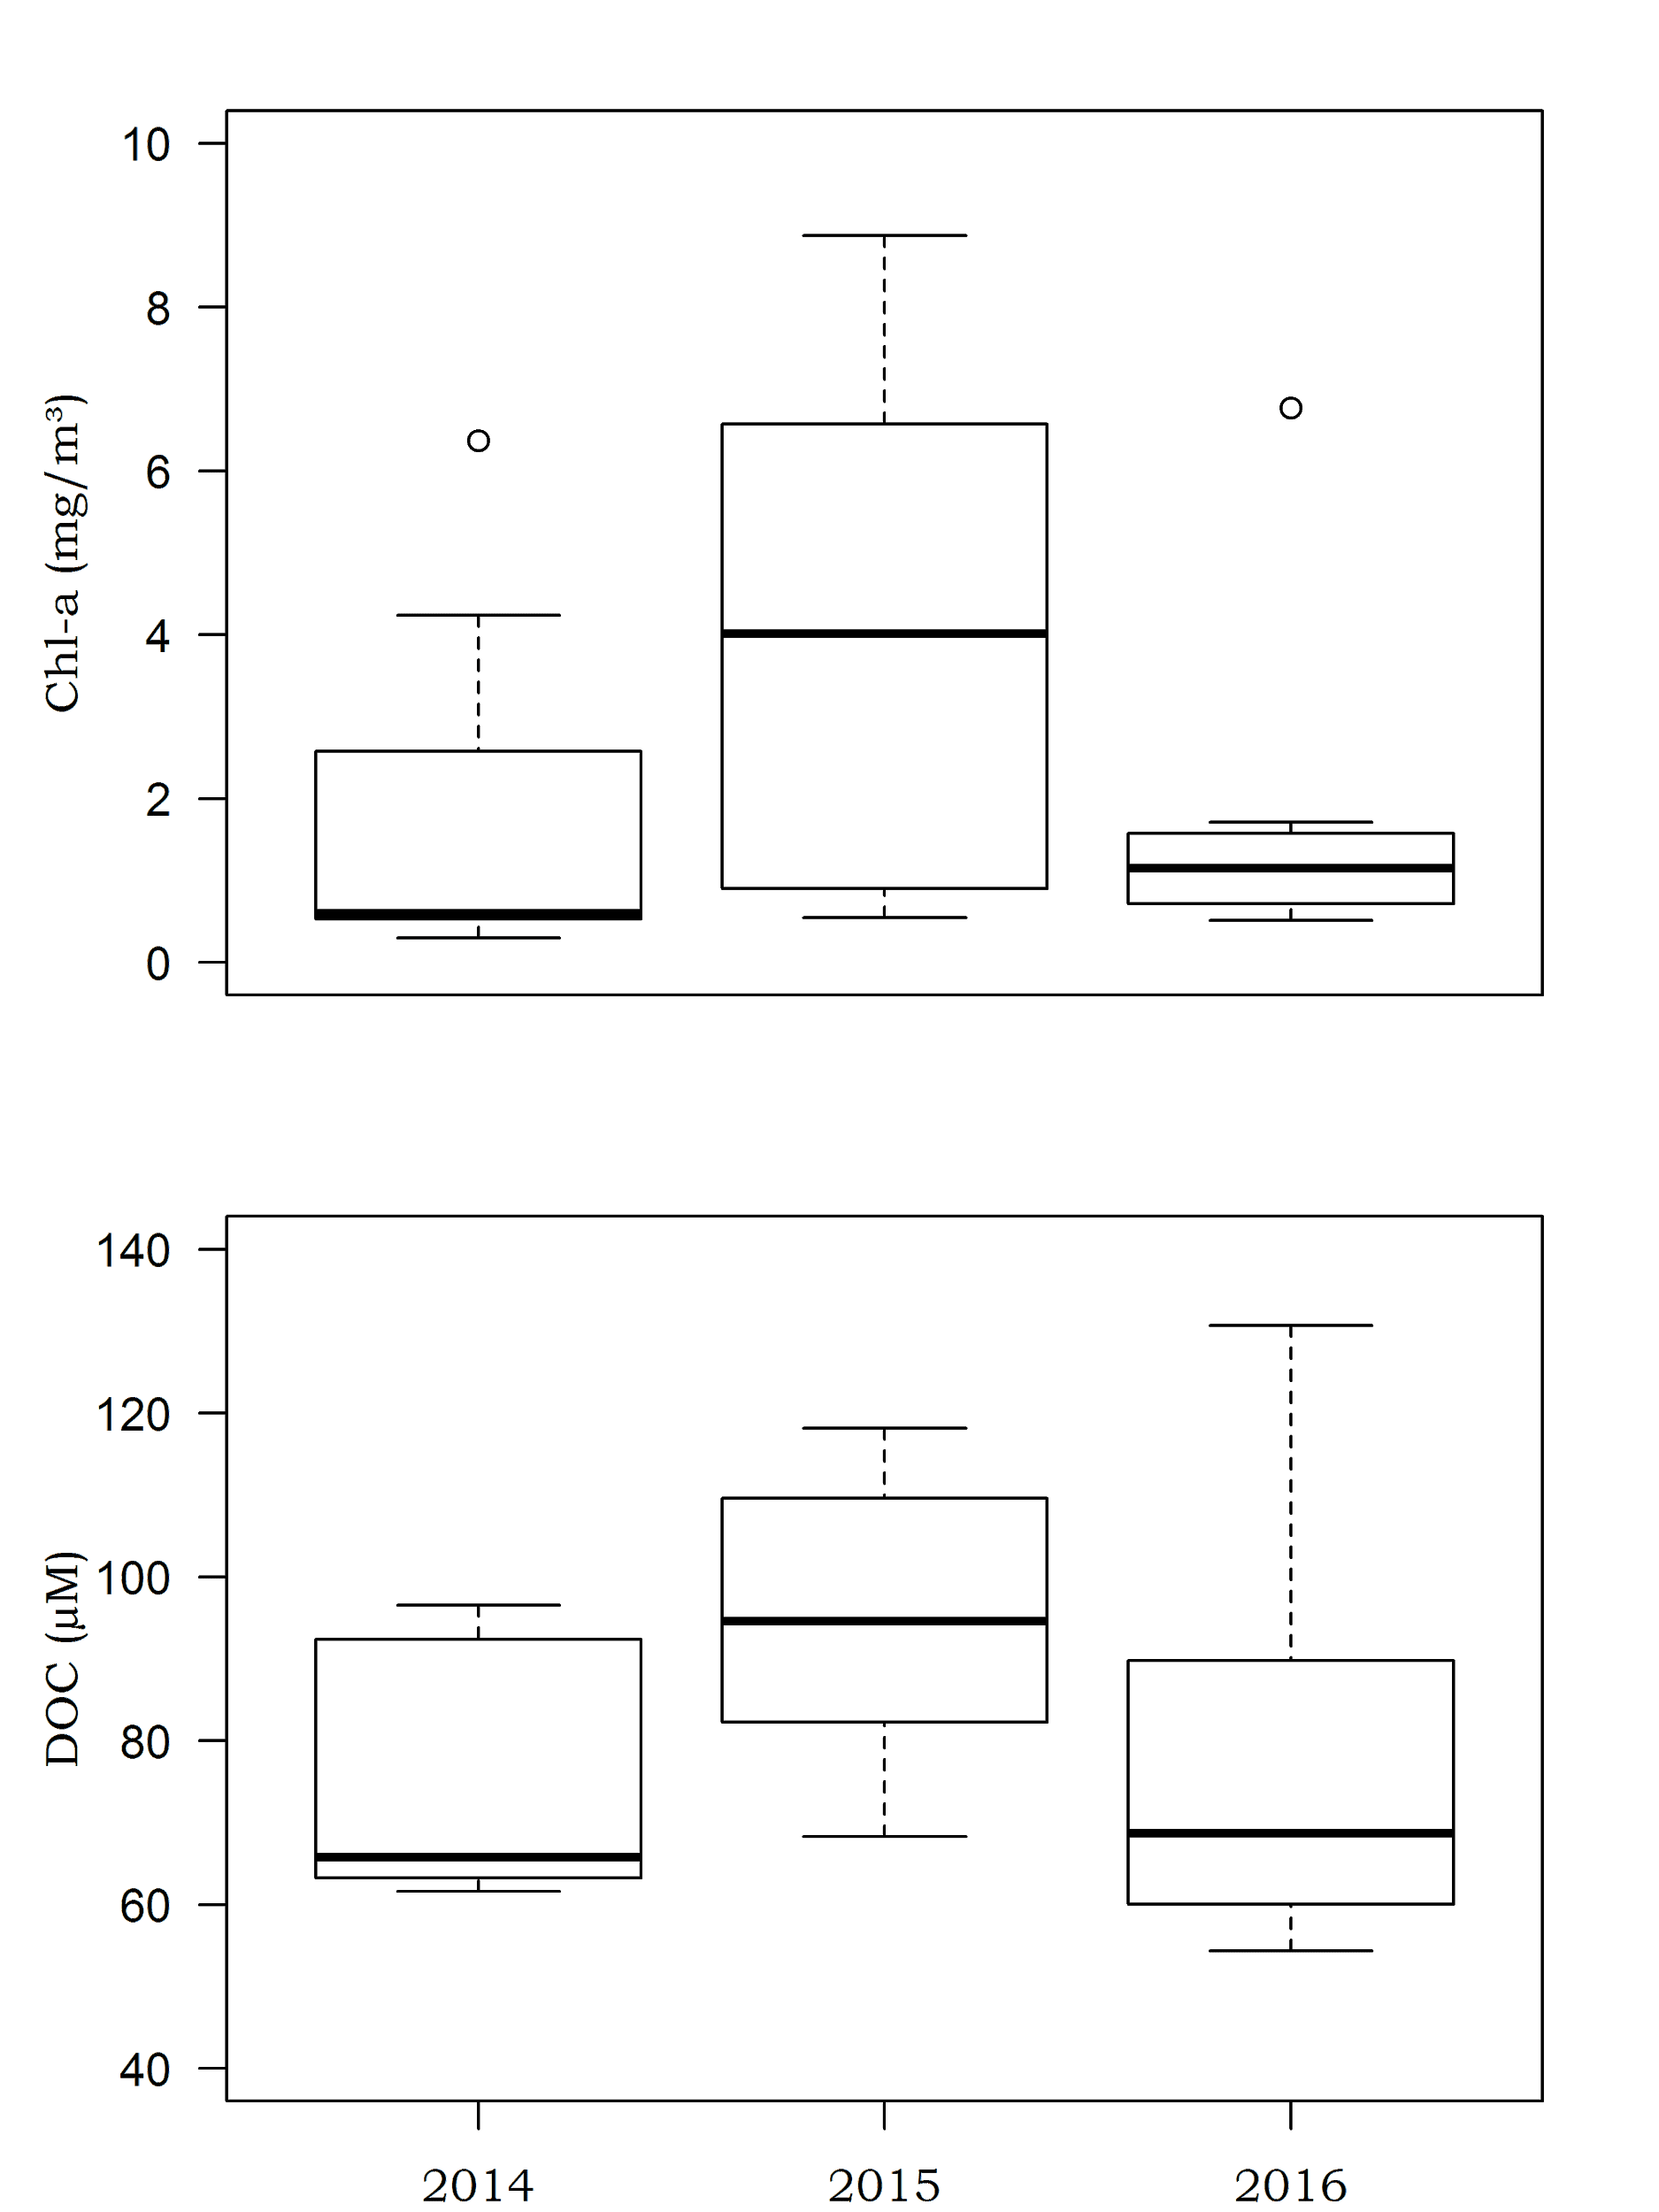
Figure S4. Box and whiskers plot of 5% and 95% (whiskers), 25% and 75% (box) and median (bold line) chlorophyll-a and DOC concentrations among years across all stations of the Atlantic Repeat Hydrography Line 7 west (AR7W) sampling line in the Labrador Sea.

Table S3: Adjusted R² values from the variance partitioning on taxonomic composition and selected functional traits shown as percentages for each fraction.
 | Water mass (WM) | Year | Days before peak | WM+Year | DBP+WM | DBP+Year | DBP+Year+WM | Total
 |  |  | (DBP)
Taxonomic composition | 8%* | 4%* | 0% | 1% | 9% | 8% | 0% | 30%
Trophic strategy | 10%* | 14%* | 0% | 0% | 27% | 11% | 0% | 62%
Size (5 classes) | 16%*** | 9%* | 0% | 0% | 13% | 17% | 0% | 55%
Motility | 18%* | 13%* | 0% | 0% | 23% | 19% | 0% | 73%
DMS | 0% | 31%** | 0% | 4% | 5% | 14% | 0% | 54%

Note: DMS represent dimethylsulfoxide or dimethylsulfoniopropionate producers. *, ** and *** represent partial RDA p-values of ≤ 0.05, ≤ 0.01 and ≤ 0.001, respectively.

Figure S5. The smoothed (LOWESS function, stats core R package, 60% span) relationship between the proportion of motile protists and the number of days before peak.

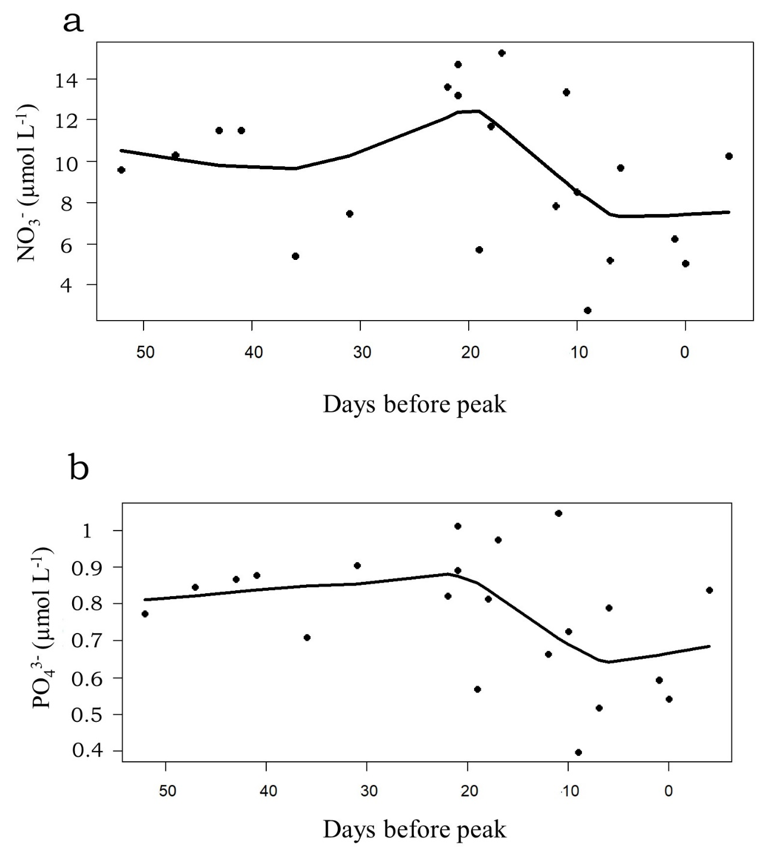
Figure S6. The smoothed (LOWESS function, stats core R package, 60% span) relationship between nitrate (a) and phosphate (b) concentrations the number of days before peak.
Figure S7. The smoothed (LOWESS function, stats core R package, 60% span) relationship between bacterial biomass production and the number of days before peak.

References
Altenburger, A., Blossom, H.E., Garcia-Cuetos, L., Jakobsen, H.H., Carstensen, J., Lundholm, N., et al. (2020). Dimorphism in cryptophytes—The case of Teleaulax amphioxeia/Plagioselmis prolonga and its ecological implications. Science Advances 6(37), eabb1611. doi: 10.1126/sciadv.abb1611.
Estep, K.W., and MacIntyre, F. (1989). Taxonomy, life cycle, distribution and dasmotrophy of Chrysochromulina: a theory accounting for scales, haptonema, muciferous bodies and toxicity. Marine Ecology Progress Series 57(1), 11-21.
Yabuki, A., and Ishida, K.-i. (2018). An Orphan Protist Quadricilia rotundata Finally Finds Its Phylogenetic Home in Cercozoa. Journal of Eukaryotic Microbiology 65(5), 729-732. doi: https://doi.org/10.1111/jeu.12502.
Zlatogursky, V.V., Shɨshkin, Y., Drachko, D., and Burki, F. (2021). The long-time orphan protist Meringosphaera mediterranea Lohmann, 1902 [1903] is a centrohelid heliozoan. The Journal of Eukaryotic Microbiology 68(5), e12860. doi: 10.1111/jeu.12860.

