Supplementary Material

Table S1 – Radiocarbon measurement data and dates
Site | Mean sample depth [cm bs] | material | ¹⁴C age [yr BP] | ± [yr] | F¹⁴C | ± [abs] | Calibrated ages (2σ)*  [cal yr BP] | Mean age [cal yr BP] | AWI no.
B3 | 27.75 | plant/wood | 141 | 16 | 0.9826 | 0.002 | 58 – 118 | 111 | 6742.1.1
 | 45.5 | plant/wood | 899 | 18 | 0.8941 | 0.002 | 733 – 801 | 789 | 6743.1.1
 | 64 | plant/wood | 3157 | 18 | 0.675 | 0.0015 | 3350 – 3412 | 3384 | 6744.1.1
 | 106 | plant/wood | 9356 | 24 | 0.312 | 0.0009 | 10499 – 10609 | 10568 | 6745.1.1
B2 | 21.25 | plant/wood | 2081 | 17 | 0.7717 | 0.0017 | 1993 – 2110 | 2038 | 6746.1.1
 | 64 | plant/wood | 2300 | 17 | 0.751 | 0.0016 | 2311 – 2351 | 2338 | 6747.1.1
 | 77 | plant/wood | 2765 | 18 | 0.7088 | 0.0016 | 2782 – 2886 | 2854 | 6748.1.1
 | 106 | plant/wood | 3382 | 18 | 0.6564 | 0.0014 | 3569 – 3664 | 3616 | 6749.1.1
B1 | 26.25 | plant/wood | modern |  | 1.0263 | 0.002 |  |  | 6750.1.1
 | 76 | plant/wood | 3487 | 18 | 0.6479 | 0.0014 | 3695 – 3781 | 3761 | 6751.1.1
 | 112.5 | plant/wood | 3879 | 18 | 0.617 | 0.0014 | 4242 – 4407 | 4327 | 6752.1.1
 | 124 | plant/wood | 4533 | 20 | 0.5688 | 0.0014 | 552 – 5188 | 5154 | 6753.1.1
U3 | 26.25 | plant/wood | modern |  | 1.0262 | 0.002 |  |  | 6754.1.1
 | 58.5 | plant/wood | 8643 | 23 | 0.341 | 0.001 | 9539 – 9633 | 9588 | 6755.1.1
 | 82.5 | bulk | 27748 | 417 | 0.0316 | 0.0016 | 31105 – 32971 | 31779 | 6756.1.1
 | 112 | bulk | 30099 | 563 | 0.0236 | 0.0017 | 33267 – 35673 | 34564 | 6757.1.1
U1 | 27 | plant/wood | 191 | 16 | 0.9766 | 0.0019 | 162 – 218 | 183 | 6758.1.1
 | 71 | plant/wood | 6355 | 21 | 0.4533 | 0.0012 | 7251 - 7323 | 7278 | 6759.1.1
*calibrated using Calib 8.2 (Stuiver et al., 2021) equipped with IntCal20 (Reimer et al., 2020)

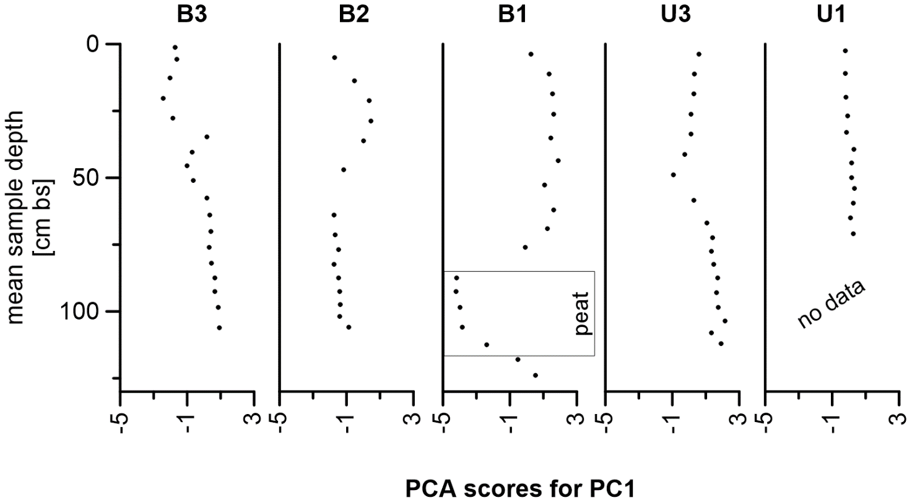
Supplementary Figure S1. PCA scores (PC1) for all five sampling sites plotted over depth; the peat layer in B1 is marked to underline the strong differences in score values for this core section.

Table S2 - PCA scores of all samples for PC1, PC2 and PC3
Sample | PC1 | PC2 | PC3
B3 0 - 2.5 cm | -1.72828936822952 | 0.79456126167141 | -0.61482725290452
B3 2.5 - 9 cm | -1.61378417246138 | 0.836613877279835 | -0.460232049621469
B3 9 - 16.5 cm | -2.02584215117961 | 0.484916847416413 | -0.408520198467624
B3 16.5 - 24 cm | -2.43468671841201 | 0.360133437721508 | -0.182853221506374
B3 24 - 31.5 cm | -1.85797896541634 | 0.586104578654619 | 0.0297473834549391
B3 31.5 - 38 cm | 0.164611578748646 | -1.26416459186833 | -0.159666354741859
B3 38 - 43 cm | -0.703894321779553 | -0.617433511767476 | -0.36363440711776
B3 43 - 48 cm | -0.99578554193291 | -0.479524510773411 | -0.446574157450325
B3 48 - 54 cm | -0.641363436186067 | -0.427401531216055 | -0.366574393341726
B3 54 - 61 cm | 0.185884511833234 | -0.962729545593494 | -0.192424664678638
B3 61 - 67 cm | 0.355426430987167 | -0.714847292891141 | -0.018408454962224
B3 67 - 73 cm | 0.429112041353264 | -0.936623045473872 | -0.10401930408524
B3 73 - 79 cm | 0.307608019729899 | -0.832450805588648 | -0.120188574399396
B3 79 - 85 cm | 0.459362568752285 | -0.181038028611709 | -0.178746260767103
B3 85 - 90 cm | 0.63793931760529 | 1.53566392195926 | -0.538563646706518
B3 90 - 95 cm | 0.641733865886682 | 1.63558097293812 | -0.552565321875372
B3 95 - 102 cm | 0.849147307721511 | 1.40945744441639 | -0.359610680433202
B3 102 - 110 cm | 0.924561472069458 | 1.27711042771241 | -0.199862869999766
B2 0 - 10 cm | -1.72762316025062 | 0.390676828058753 | 0.297209904020113
B2 10 - 17.5 cm | -0.53819655312725 | -0.581711069453459 | -0.701840319118469
B2 17.5 - 25 cm | 0.350673788342737 | -0.66628617482599 | -0.107534641361183
B2 25 - 32.5 cm | 0.450272628084469 | -0.299805406658183 | 0.0534447836235677
B2 32.5 - 40 cm | 0.0198590420979712 | -0.0760137345866076 | -0.0873251220091136
B2 43 - 51 cm | -1.17353471363093 | 0.191288603769064 | 0.0391197112132075
B2 59 - 69 cm | -1.74232931899253 | 0.0781975224372 | 0.867226685807276
B2 69 - 74 cm | -1.66144771812034 | 0.282643184151303 | -0.0544025140929912
B2 74 - 80 cm | -1.46125612498465 | 0.278792377486865 | -0.560629050457609
B2 80 - 85 cm | -1.7383131145873 | 0.249213647145052 | -0.528605161092288
B2 85 - 90 cm | -1.45756920175365 | 0.201278245454611 | -0.57323916622093
B2 90 - 95 cm | -1.39559390729031 | 0.215245091344257 | -0.707091355941216
B2 95 - 100 cm | -1.35954009338321 | 0.0940292736766472 | -0.448091246315404
B2 100 - 104 cm | -1.41570413047677 | 0.220282504139758 | -0.645202273858343
B2 104 - 108 cm | -0.86791286475283 | -0.200144811836961 | -0.583093400796626
B1 0 - 7.5 cm | 0.271191995263323 | 0.1116022739381 | 0.24721001304744
B1 7.5 - 15 cm | 1.35823964620241 | -0.24985296102967 | 0.350571453641561
B1 15 - 22.5 cm | 1.53823060930171 | -0.116225987934259 | 0.446758112296384
B1 22.5 - 30 cm | 1.61721067149005 | -0.330255037299748 | 0.405292357865951
B1 31.5 - 39 cm | 1.44184358336806 | -0.595279417693444 | 0.297877675702354
B1 40 - 47.5 cm | 1.88269301331624 | 0.0785621673086083 | 0.570397430619768
B1 47.5 - 58 cm | 1.07729181556172 | -0.982049357621838 | 0.0855606476439327
B1 58 - 66 cm | 1.60382518090042 | -0.145085247672119 | 0.45960579195335
B1 66 - 72 cm | 1.22653863363841 | -0.465379468151475 | 0.269677984166531
B1 72 - 80 cm | -0.0876267751171507 | -0.899492602046968 | -0.116425503609968
B1 85 - 90 cm | -4.19253237028427 | -0.34259657133402 | 1.28448942061627
B1 90 - 95 cm | -4.22061991065372 | -0.380821987059903 | 1.41709531144882
B1 95 - 102 cm | -3.986318924247 | -0.518552919675533 | 1.34933137634462
B1 102 - 110 cm | -3.84721155104831 | -0.0686628123322466 | 0.0999809540727091
B1 110 - 115 cm | -2.39152503189249 | 1.96229184821575 | 0.827343538088331
B1 115 - 121 cm | -0.512355979270665 | 0.572181840552919 | -0.530468506753881
B1 121 - 127 cm | 0.519180870204634 | -0.176361252223538 | -0.398142957558924
U3 0 - 7.5 cm | 0.581270466420169 | -1.13685115968999 | 0.0900988431775815
U3 7.5 - 15 cm | 0.332624869558444 | -0.835526318737297 | -0.248548826301236
U3 15 - 22.5 cm | 0.280785462423725 | -1.28203982724231 | -0.19504449577392
U3 22.5 - 30 cm | 0.116041280221733 | -1.14058402162561 | -0.303268194100373
U3 30 - 37.5 cm | 0.131581545975197 | -1.01479664660951 | -0.254708106829293
U3 37.5 - 45 cm | -0.263301152106179 | -0.846955543702143 | -0.45712094543485
U3 45 - 53 cm | -0.936104657574038 | -0.382671479680713 | -0.585476638750803
U3 53 - 64 cm | 0.285526110933803 | -0.171023993251327 | -0.457959694085462
U3 64 - 70 cm | 1.07241301714104 | -0.0557197077818492 | 0.0396872028329865
U3 70 - 75 cm | 1.41416169896124 | 0.111198995078279 | 0.254857411542177
U3 75 - 80 cm | 1.32534689627241 | -0.255492113495384 | 0.221697583455245
U3 80 - 85 cm | 1.48746929544828 | -0.366853225977491 | 0.333920001529216
U3 85 - 90 cm | 1.71068315222418 | -0.316640114615832 | 0.502477501562614
U3 90 - 96 cm | 1.63343219618652 | -0.248005711594269 | 0.439227112733296
U3 96 - 101 cm | 1.74210268355141 | 0.234884519857074 | 0.459035954943547
U3 101 - 106 cm | 2.16218539485719 | 1.19051534784052 | 0.671268571114924
U3 106 - 110 cm | 1.33518986869115 | 0.335344189733196 | 0.133115786202302
U3 110 - 114 cm | 1.9116241492708 | 1.18138469808452 | 0.495705147857055
U1 0 - 5 cm | 0.803971303920385 | 0.52865626398542 | -0.209705539744404
U1 7 - 15 cm | 0.811072882040621 | 0.255210299617119 | -0.201173882672043
U1 17 - 23 cm | 0.800601202496243 | 0.580422989782014 | -0.170521832386132
U1 23 - 31 cm | 0.85270437931884 | 0.17985457311159 | -0.0686505950979235
U1 31 - 35 cm | 0.922791296544158 | 0.0589824232203635 | -0.138482685886514
U1 37 - 42 cm | 1.49299239008226 | 0.145700297207129 | 0.311740062987035
U1 42 - 47 cm | 1.24443876058526 | -0.196806371334027 | 0.152275276659587
U1 47 - 53 cm | 1.29170760757515 | 0.209982440856021 | 0.170979270812145
U1 53 - 55 cm | 1.51250325642168 | 0.28437487218781 | 0.321257500444112
U1 57 - 62 cm | 1.35019081717204 | 0.705325339266223 | 0.25784362193826
U1 62 - 68 cm | 0.869939211008574 | 0.593246979757409 | 0.0769617970198236
U1 70 - 72 cm | 1.19045214137952 | 1.31924351152433 | 0.269935286869985

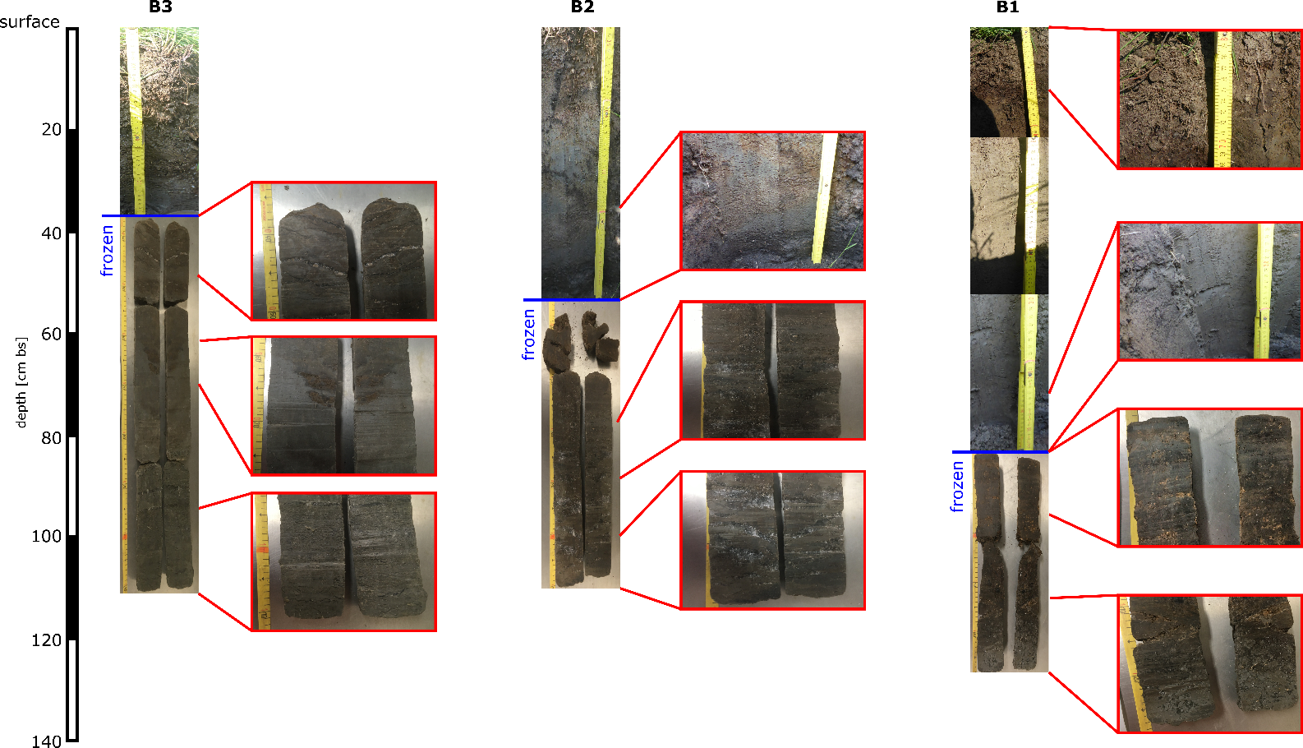
Supplementary Figure S2. Cores obtained from the partially drained thermokarst basin.

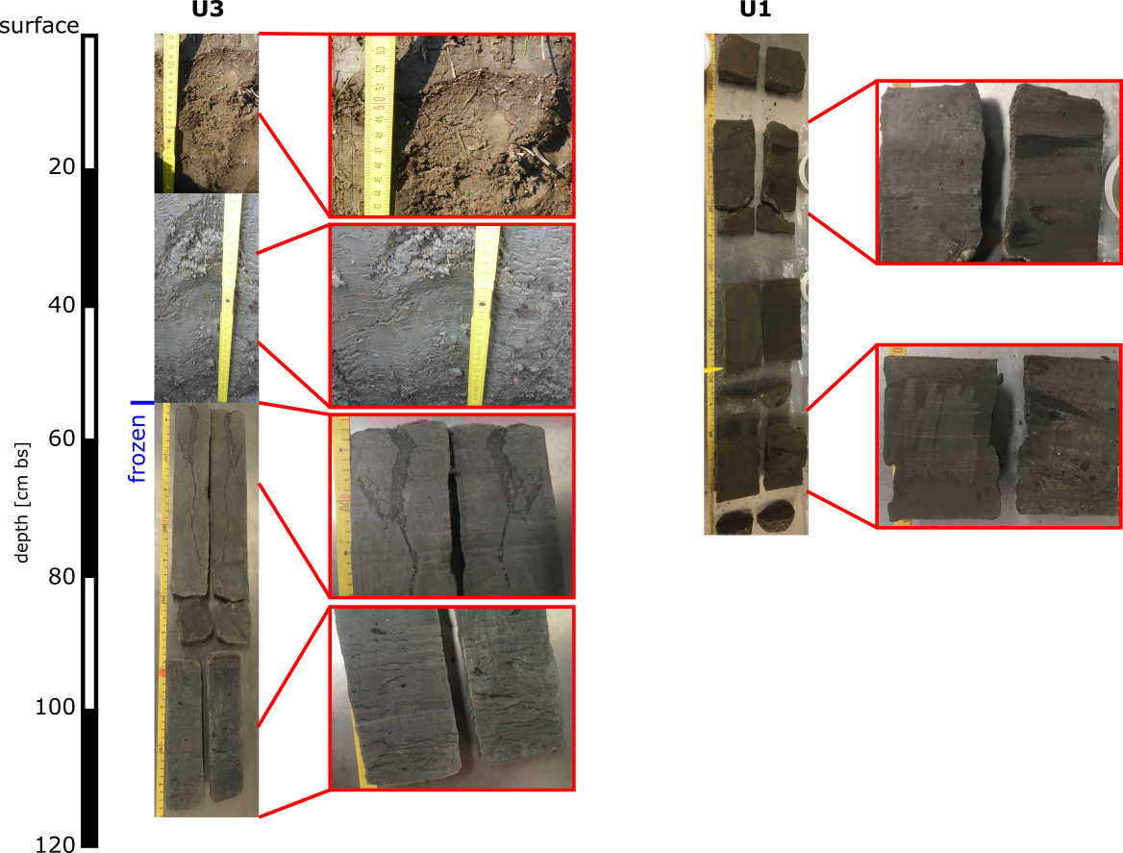
Supplementary Figure S3. Cores obtained from the Yedoma upland.

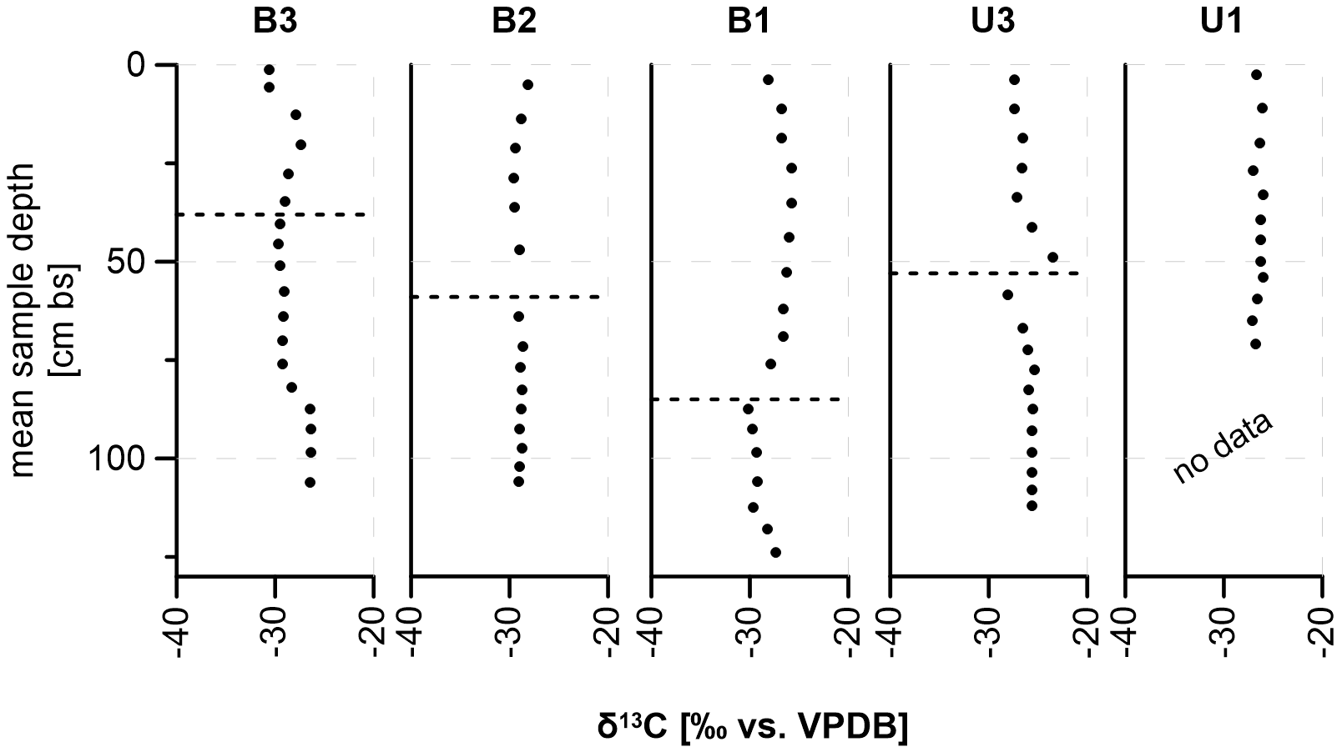
Supplementary Figure S4. δ¹³C values, given in ‰ vs. VPDB, plotted over depth for all sampling sites; higher values indicate a less degraded state of the organic material; dashed lines mark the thaw depth found in July 2019.

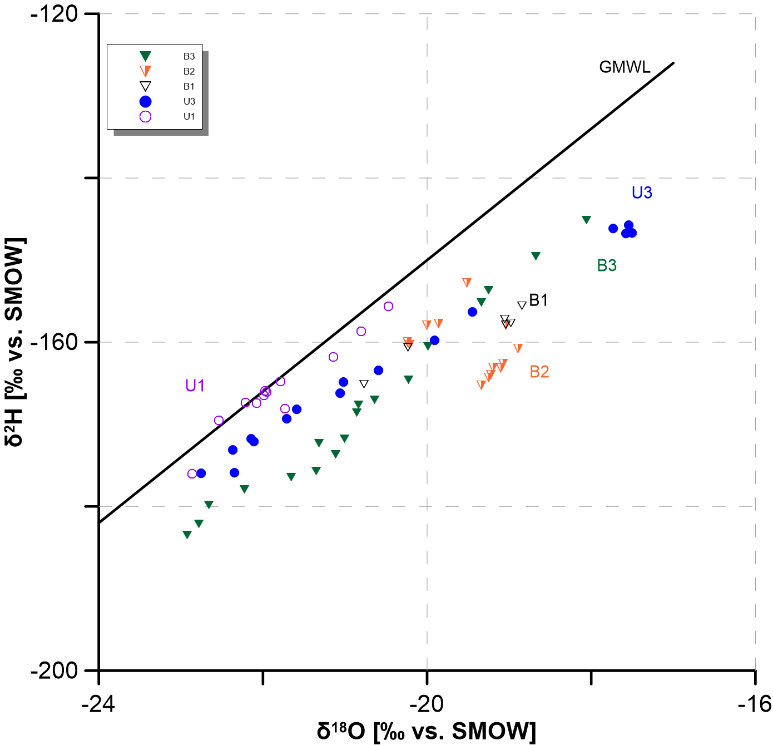
Supplementary Figure S5. δ¹⁸O (stable oxygen isotopes) plotted versus δ²H (stable hydrogen isotopes) along the global meteoric water line (GMWL, δ²H=8*δ¹⁸O+10); these measurements derive from pore water that was extracted from the samples using artificial plant roots (Rhizones) with a pore size of 0.15 µm and applied vacuum; not all samples could be analysed due to low water content.

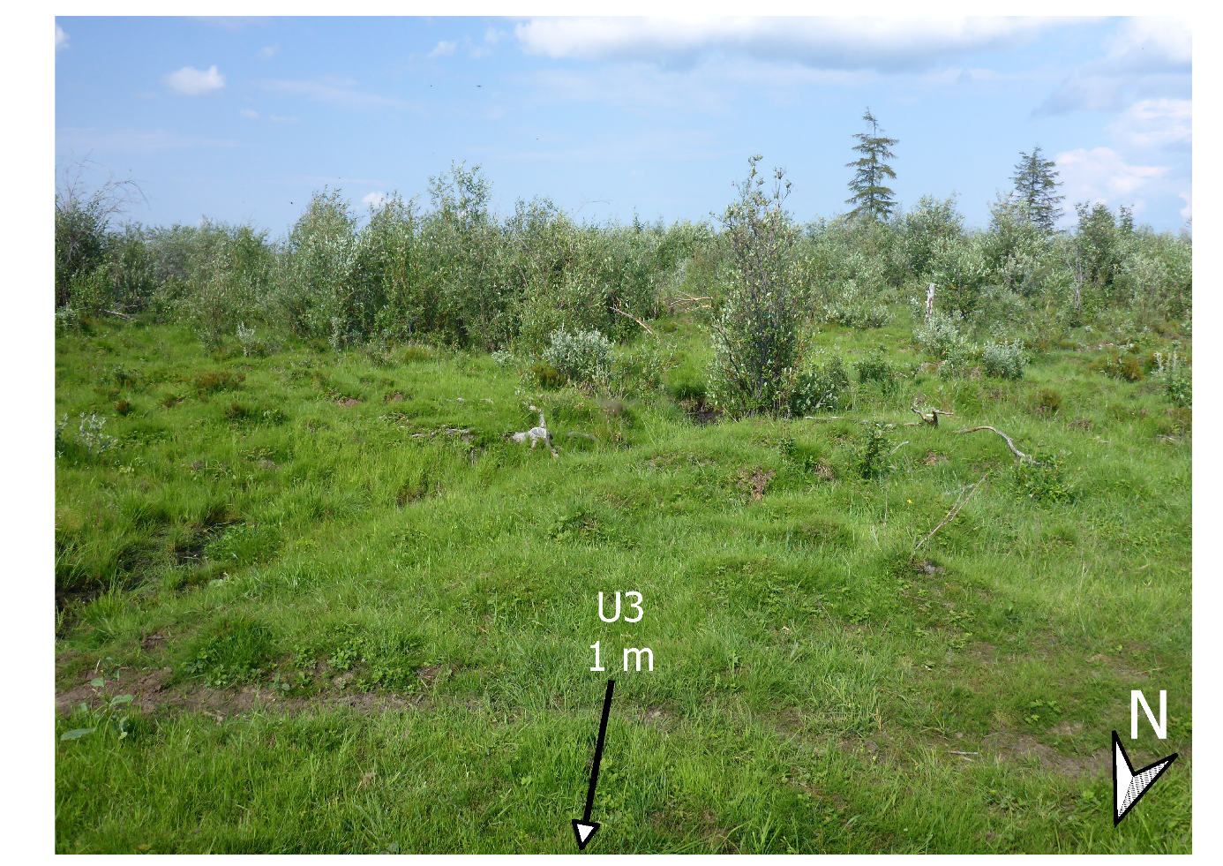
Supplementary Figure S6. Photograph of the surrounding landscape, taken from site U3; view direction is SSE; foreground: grasses and other short vegetation along with an animal path; background: willow shrubs with up to 2.5 m in height in the occasionally grazed neighborhood of the intensively grazed site U3.

