Supplementary material

Supplemental Animation: Hourly movements over several days of a blue whale that was tagged off the coast of Southern California in 2017. Feeding behavior (green and blue markers) was determined from the stereotypical kinematic signature of blue whale lunge feeding derived from the tag’s high-resolution sensors (e.g. pressure, accelerometer). Whale foraging locations are overlaid with Lagrangian features (i.e. Finite-Time Lyapunov Exponents, FTLE) at hourly increments using data from coastal High-Frequency Radar stations (Black and white diamond markers). FTLE was calculated by integrating a grid of evenly-spaced tracers backward in time over a 48-hour period for each time-step.

Model | Slope | P-Value
Blue Whales | 0.448 | 0.002
Random Site Selection Model (CRW Tracks) | -0.066 | 0.156
Temporal (+ 24 hours) | 0.491 | 0.007
Temporal (+ 48 hours) | 0.229 | 0.175
Temporal (+ 96 hours) | 0.157 | 0.384
Temporal (+192 hours) | -0.371 | 0.034
Supplemental Table 1: GLMM Model results for Null Models used in this study.

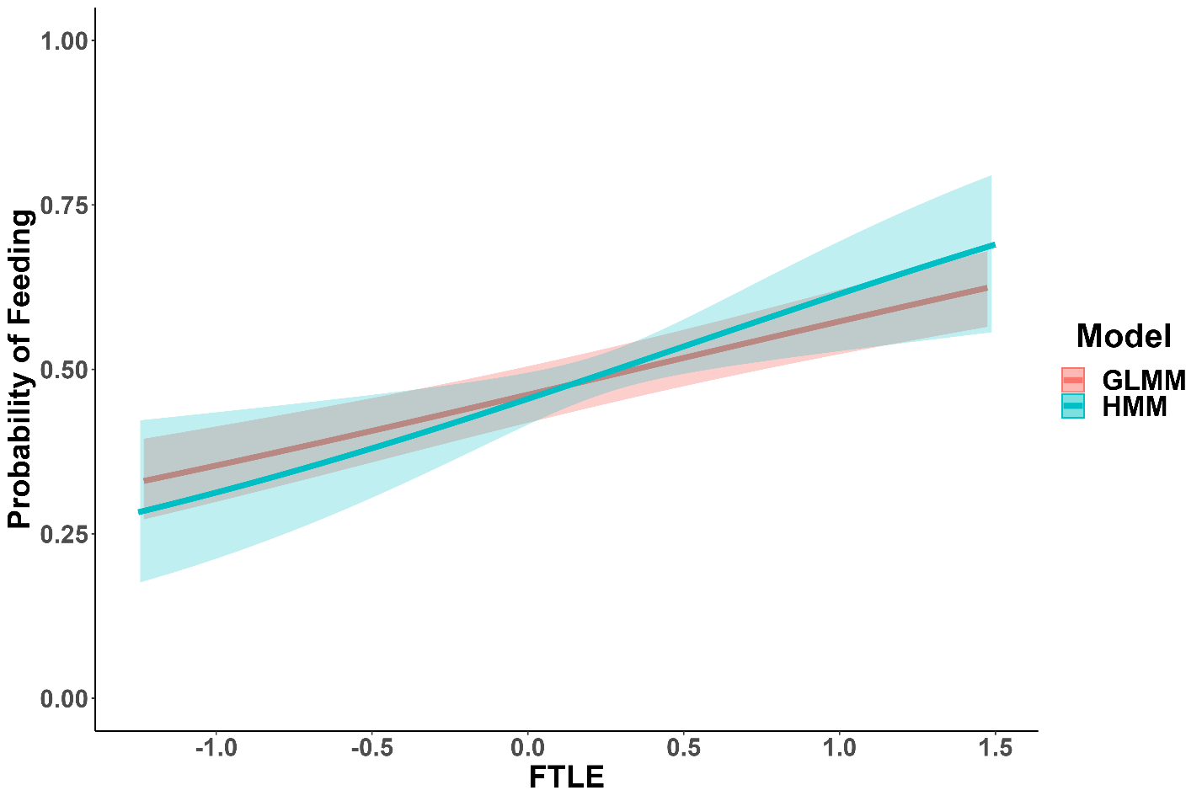
Supplemental Figure 1: Comparison of HMM and GLMM Results; HMM model had a slope of 0.618 while the GLMM had a slope of 0.446 and models had overlapping confidence intervals.

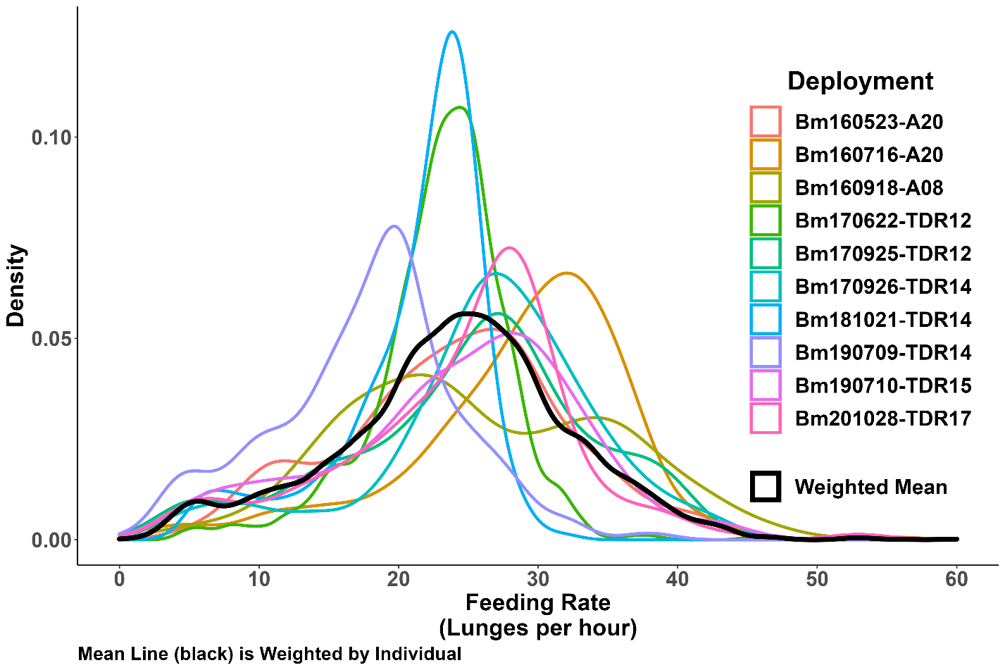
Supplemental Figure 2: Density distribution of feeding rates by dive for each deployment. Weighted mean for all animals shown in black.

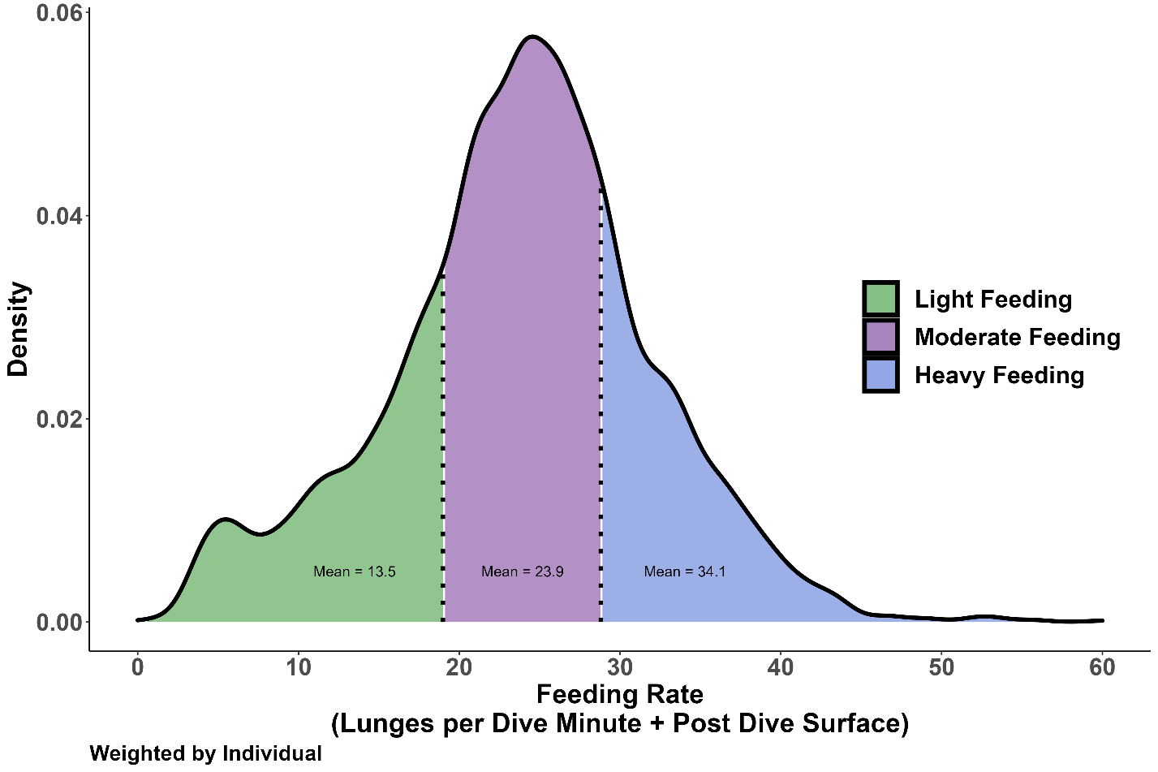
Supplemental Figure 3: Density distribution of feeding rates (weighted by individual to control for varying deployment rates). Dashed vertical lines delineate the 25th and 75th percentiles, separating the weighted distribution into the 3 feeding states used in feeding performance estimates. The light feeding state (green) has a mean feeding rate of 13.5 lunges per hour; the moderate feeding state (purple) has a mean feeding rate of 23.9 lunges per hour; and the heavy feeding state (blue) has a mean feeding rate of 34.1 lunges per hour.

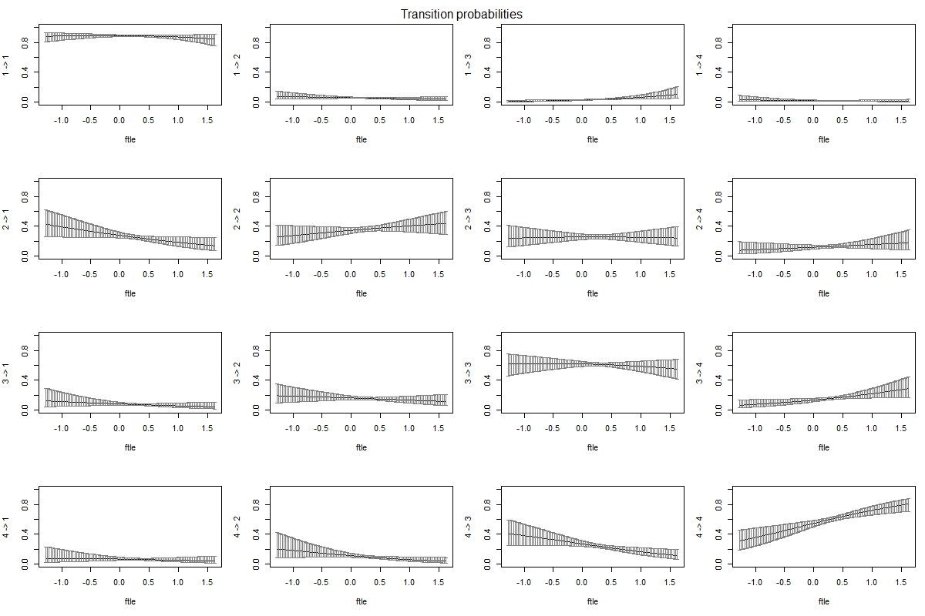
Supplemental Figure 4: Transition probabilities for the 4-State Feeding Rate HMM.

