Figure S1

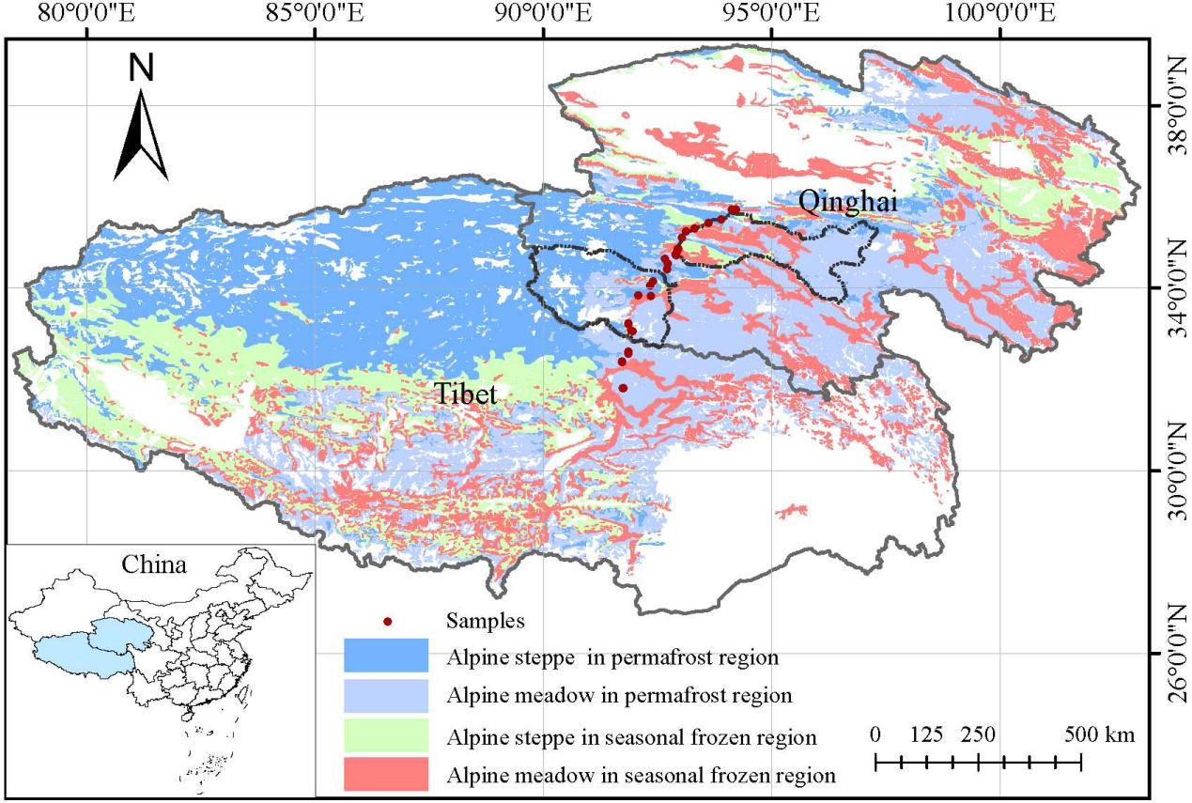

Fig. S1 spatial distributions of the 36 resampling sites (red dots) and major grassland types in the permafrost region of the Tibetan Plateau. Areas inside the black dotted lines are Qumalai county (northernmost) and Tanggulashan town (southernmost).

Figure S2
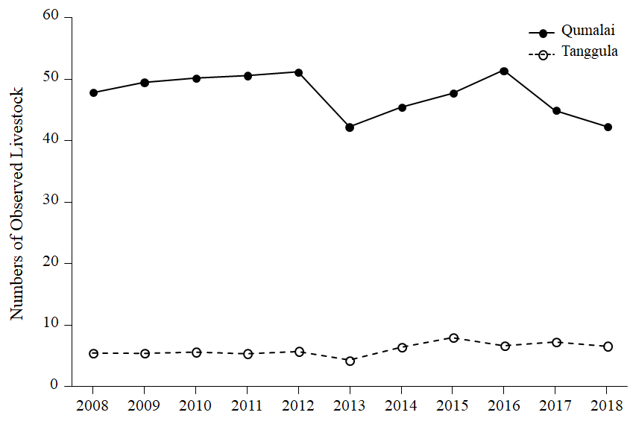

Fig. S2 Livestock numbers recorded in Tanggulashan and Qumalai counties of the permafrost region from 2008 to 2018.

Table S1 Change in number of species per family between 2008 and 2018 in the permafrost region of the Tibetan Plateau. Δ Species number is change in total number of species, % is relative rate of change in number of species (ΔSpecies numbers/species numbers in 2008) in all sites. P values were conducted by t test of difference in species numbers between 2008 and 2018. *, p < 0.05; **, p < 0.01; ***, p < 0.001.

Families | Δ Species number | （%） | P value
Forbs
Asteraceae | +28 | +32 | < 0.001***
Scrophulariaceae | +19 | +83 | 0.005**
Gentianaceae | +18 | +257 | < 0.001***
Umbelliferae | +14 | +93 | < 0.001***
Crassulaceae | +11 | +367 | 0.001**
Papaveraceae | +10 | +500 | 0.003**
Ranunculaceae | +9 | +56 | 0.027*
Primulaceae | +8 | +30 | 0.088
Brassicaceae | +6 | +22 | 0.245
Liliaceae | +5 | +63 | 0.023*
Caryophyllaceae | +5 | +42 | 0.134
Rosaceae | +4 | +11 | 0.441
Commelinaceae | +2 | +200 | 0.160
Chenopodiaceae | +1 | - | 0.324
Labiatae | +1 | +33 | 0.571
Boraginaceae | 0 | 0 | 1.000
Euphorbiaceae | 0 | 0 | -
Polygonaceae | -1 | -13 | 0.661
Saxifragaceae | -1 | -33 | 0.324
Campanulaceae | -1 | -100 | 0.324
Legumes
Leguminosae | -7 | -10 | 0.070
Sedges
Cyperaceae | +11 | +11 | 0.176
Grass
Gramineae | +9 | +9 | 0.278

