Electronic supplementary material
1-hour averaged traces of operative and air temperature measurements

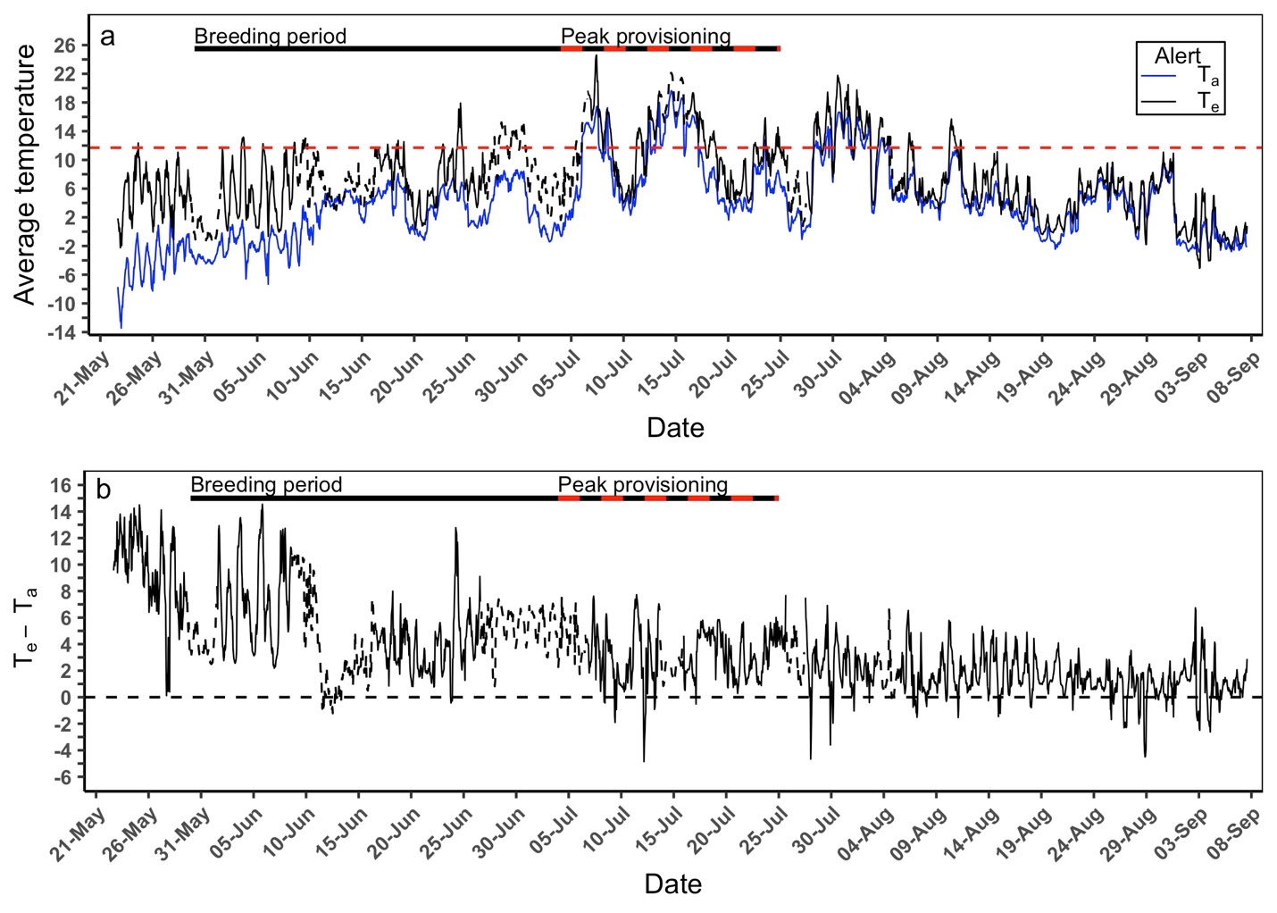
Figure S1. (a) Average hourly operative (T_{e}) and air (T_{a}) temperature and (b) differences between hourly recordings of T_{e} and T_{a} measured from 22 May to 07 September 2019 at Alert, Nunavut Canada. The combined solid black and red/black dashed bar represents the typical breeding period range (30 May to 25 July) while the red/black dashed bar represents the typical peak provisioning period (4 July to 25 July). The horizontal red dashed line in panel (a) represents the 11.7°C operative temperature threshold for birds to maintain thermal balance and sustain an optimal performance ≥ 4x basal metabolic rate. The dashed operative temperature traces represent the predicted operative temperature values from the artificial neural network.

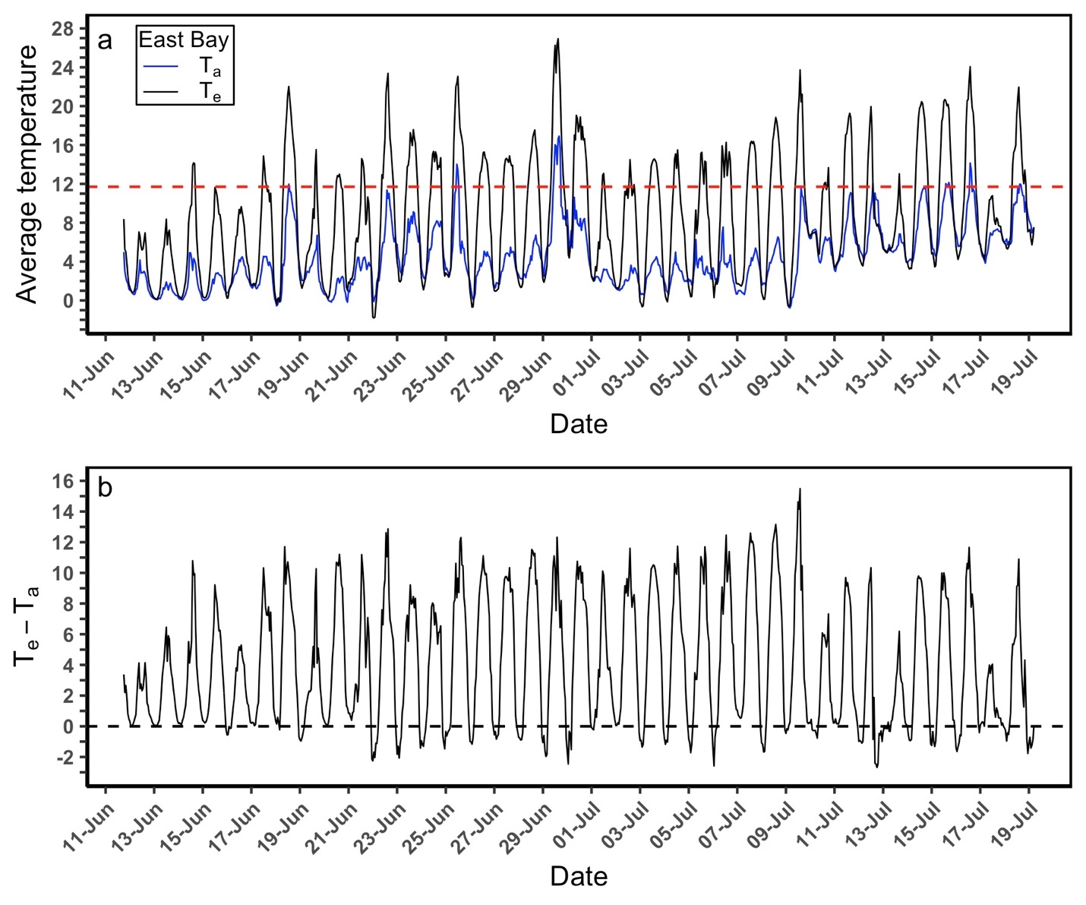
Figure S2. (a) Average hourly operative (T_{e}) and air (T_{a}) temperature values and (b) differences between hourly recordings of T_{e} and T_{a} measured from 11 June to 19 July 2019 at East Bay, Nunavut Canada. The horizontal red dashed line in panel (a) represents the 11.7°C operative temperature threshold for birds to maintain thermal balance and sustain an optimal performance ≥ 4x basal metabolic rate.

