Supplementary material

Multi-scale satellite observation of the Arctic sea ice: a new insight into the life cycle of floe size distribution
Byongjun Hwang*, Yanan Wang**
*Corresponding author : B.Hwang@hud.ac.uk
**E-mail : Yanan.Wang@hud.ac.uk
Supplementary Table 1 : Summary of the range of the floe size distribution derived from previous observations.
Supplementary Table 2 : Summary of satellite data used in this study and power-law parameters
Supplementary Figure 1 : Floe number histograms derived from MEDEA imagery data.
Supplementary Figure 2 : Sub-sections of the MEDEA images for fracturing.
Supplementary Figure 3 : Sub-sections of the MEDEA images for transition.
Supplementary Figure 4 : Sub-sections of the MEDEA images for melt/wave fragmentation.
Supplementary Figure 5 : Sub-sections of the TX images for scaling.

SUPPLEMENTARY TABLE 1 – Summary of the range of the floe size distribution derived from previous observations.
Floe size range (d) | Observation | Reference
1 to 100 m | Aerial photograph mosaic (δ* ≈ centimetres) | Rothrock and Thorndike (1984); Paget et al. (2001); Inoue et al. (2004); Lu et al. (2008); Steer et al. (2008); Toyota et al. (2006); Toyota et al. (2011); Perovich and Jones (2014); Toyota et al. (2016)
5-10 to 1,000 m | MEDEA images (δ = 1 m) | Wang et al. (2016); Stern et al. (2018); Denton and Timmermans (2022)
100 to 1,000 m | Landsat images (δ = 30 m) | Rothrock and Thorndike (1984); Toyota et al. (2006); Gherardi and Lagomarsino (2015); Wang et al. (2016)
200 to 3,000 m | TX SM images (δ = 1.2-3.3 m) | Hwang et al. (2017); Stern et al. (2018).
900 to 10,000 m | ERS-1 SAR images (δ = 100 m) | Holt and Martin (2001)
2,000 to 20,000 m | MODIS images (δ = 250 m) | Toyota et al. (2016); Stern et al. (2018)
*image resolution

SUPPLEMENTARY TABLE 2 – Summary of satellite data used in this study and power-law parameters.
Image name and date | Image type | Image size (m) | location | Total number of floes | Power-law range (m) | Power-law exponent α | Number of floes within power-law range | p-value
Fracturing
TX_SL_20200526 | TX SL | 5,256×6,516 | MOSAiC¹ | 943 | 27 – 1,000 | 1.97 | 523 | 0.01
TX_SL_20200612 | TX SL | n/a* | MOSAiC² | n/a | n/a | n/a | n/a | n/a
fram_20000607 | MEDEA | 14,472×12,552 | Fram Strait¹ | 2,264 | 24 – 3,000 | 2.07 | 1,074 | 0.84
fram_20010615 | MEDEA | 16,416×7,440 | Fram Strait¹ | 1,962 | 26 – 3,000 | 1.99 | 870 | 0.53
fram_20100629 | MEDEA | 10,608×5,040 | Fram Strait¹ | 1,824 | 31 – 3,000 | 2.05 | 759 | 0.12
Transition
fram_20140707 | MEDEA | 12,388×13,343 | Fram Strait¹ | 3,910 | 288 – 3,000 | 2.56 | 147 | 0.16
chukchi_20060604 | MEDEA | 13,486×17,557 | Chukchi Sea | 5,558 | 172 – 3,000 | 2.54 | 343 | 0.65
chukchi_20100530 | MEDEA | 7,080×10,944 | Chukchi Sea | 4,101 | 240 – 3,000 | 2.71 | 125 | 0.35
fram_20100820 | MEDEA | 9,528×10,944 | Fram Strait¹ | 4,909 | 252 – 3,000 | 2.78 | 197 | 0.86
chukchi_20130610 | MEDEA | 8,352×12,960 | Chukchi Sea | 14,537 | 310 – 3,000 | 3.46 | 203 | 0.76
chukchi_20140610 | MEDEA | 13,008×6,144 | Chukchi Sea | 7,431 | 261 – 3,000 | 3.15 | 183 | 0.34
TX_SC_20120624 | TX_SC | 53,856×48,114 | Chukchi Sea | 2,407 | 300 – 10,000 | 2.44 | 920 | 0.46
TX_SM_20180731 | TX_SM | 16,552x8,327 | Fram Strait² | 948 | 405-3,500 | 2.66 | 160 | 0.44
Melt/Wave
miz02_20140718 | MEDEA | 6,720×9,168 | MIZ¹ | 4,144 | 70 – 2,000 | 2.48 | 776 | 0.21
miz02_20140730 | MEDEA | 10,352×9,392 | MIZ² | 6,954 | 69 – 2,000 | 2.42 | 601 | 0.10
miz02_20140814 | MEDEA | 10,944×7,728 | MIZ³ | 6,682 | 70 – 1,000 | 3.45 | 1,597 | 0.14
TX_SM_20140731 | TX_SM | 30,360×23,232 | MIZ⁴ | 9,262 | 204 – 6,000 | 2.77 | 1,543 | 0.57
TX_SM_20140812 | TX_SM | 29,832×26,796 | MIZ⁵ | 11,579 | 298 – 2,000 | 3.82 | 1,373 | 0.14
WV3_20210428 | WV3 | 2,282×2,354 | Bering Sea | 4,996 | 39 - 400 | 3.29 | 773 | 0.33
miz02_20140808 | MEDEA | n/a | MIZ⁶ | n/a | n/a | n/a | n/a | n/a
miz02_20140830 | MEDEA | n/a | MIZ⁷ | n/a | n/a | n/a | n/a | n/a
miz02_20140913 | MEDEA | n/a | MIZ⁸ | n/a | n/a | n/a | n/a | n/a
TX_SM_20140729 | TX_SM | n/a | MIZ⁹ | n/a | n/a | n/a | n/a | n/a
miz04_20140802 | MEDEA | n/a | MIZ¹⁰ | n/a | n/a | n/a | n/a | n/a
miz04_20140814 | MEDEA | n/a | MIZ¹¹ | n/a | n/a | n/a | n/a | n/a
Image type & resolution: TX_SL = 1.25 m; MEDEA = 1 m; TX_SC = 8.25 m; TX_SM = 2.75 m; WV3 = 0.3 m
Power-law range: the low cut and high cut to determine the power-law regime using the method by Clauset et al. (2009); p-value: a goodness-of-fit to test whether the data in question represent a power-law distribution (typically considered as power-law when p-value > 0.1); the power-law program obtained from the website https://aaronclauset.github.io/powerlaws/
MOSAiC¹: 83.40°N, 8.93°E; MOSAiC²: 82.71°N, 7.95°E; Fram Strait¹: 85.00°N, 0.05°E; Fram Strait²: 84.87°N, 6.75°E; Chukchi Sea: 70.00°N, 170.00°W; MIZ¹: 74.12N, 150.20W; MIZ²: 74.22N, 149.44W; MIZ³: 74.05N, 153.41W; MIZ⁴: 74.34N, 149.07W; MIZ⁵: 74.32N, 151.52W; MIZ⁶: 74.35N, 150.99W; MIZ⁷: 74.93N, 153.66W; MIZ⁸: 75.14N, 150.83W; MIZ⁹: 74.29N, 149.28W; MIZ¹⁰: 74.59N, 149.48W; MIZ¹¹: 74.59N, 149.58W; Bering Sea: 61.98N, 169.93W
* n/a - not used to derive the floe size distribution

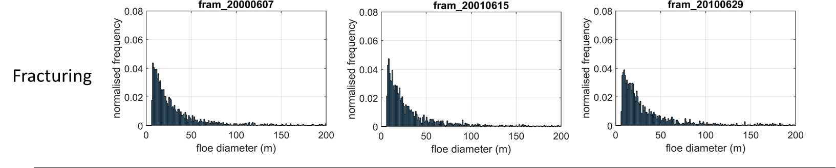
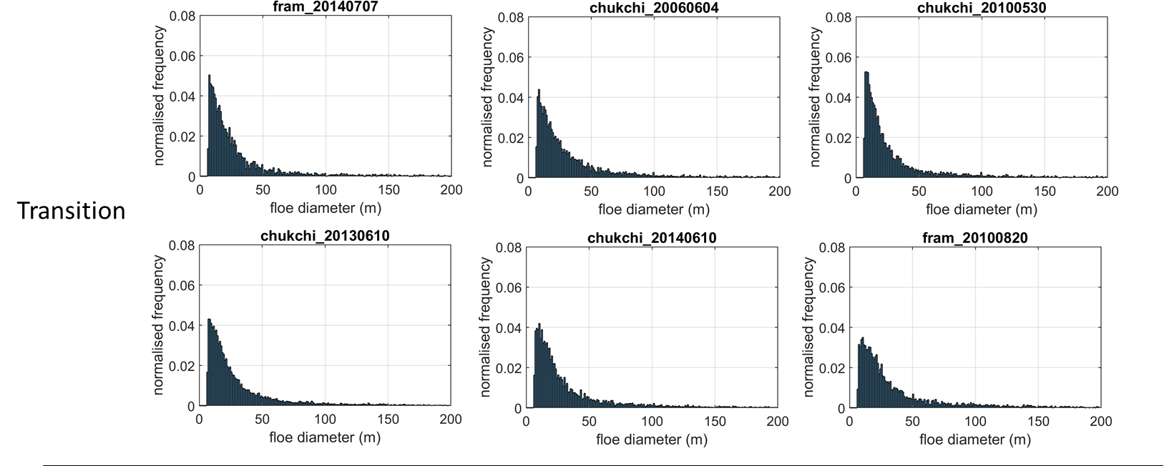
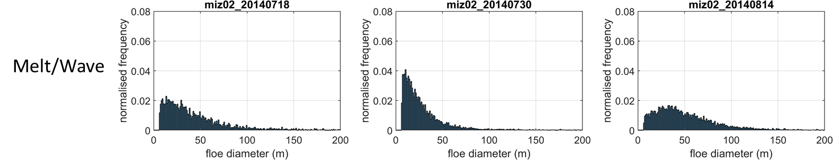

SUPPLEMENTARY FIGURE 1 – Floe number histograms derived from MEDEA imagery data. The histograms are shown for three different stages of the life cycle: fracturing, transition and melt/wave.

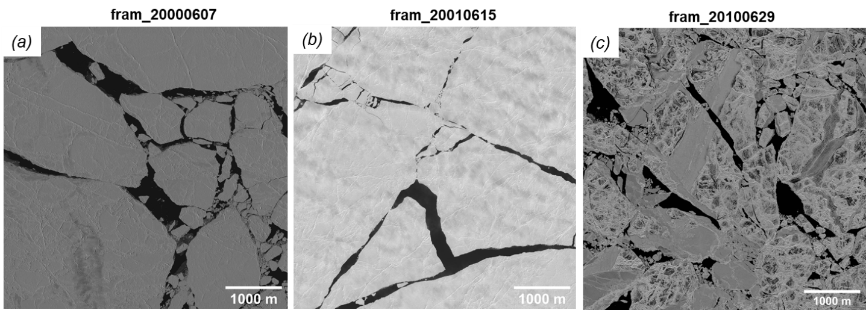

SUPPLEMENTARY FIGURE 2 – Sub-sections of the MEDEA images for fracturing. These images represent the ice floe conditions right after the spring breakup (“fracturing”).

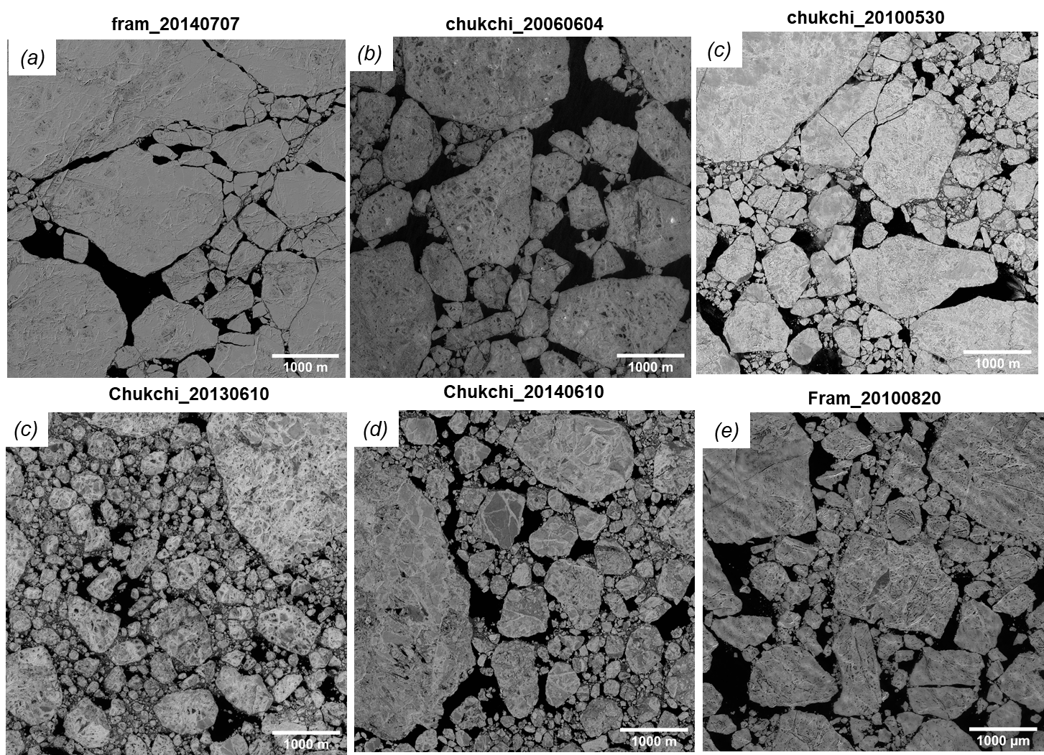

SUPPLEMENTARY FIGURE 3 – Sub-sections of the MEDEA images for transition. These images represent the ice floe conditions in transition from fracturing to summer melt. Dynamic ice conditions can cause further floe fragmentation from the initial floe size distribution.

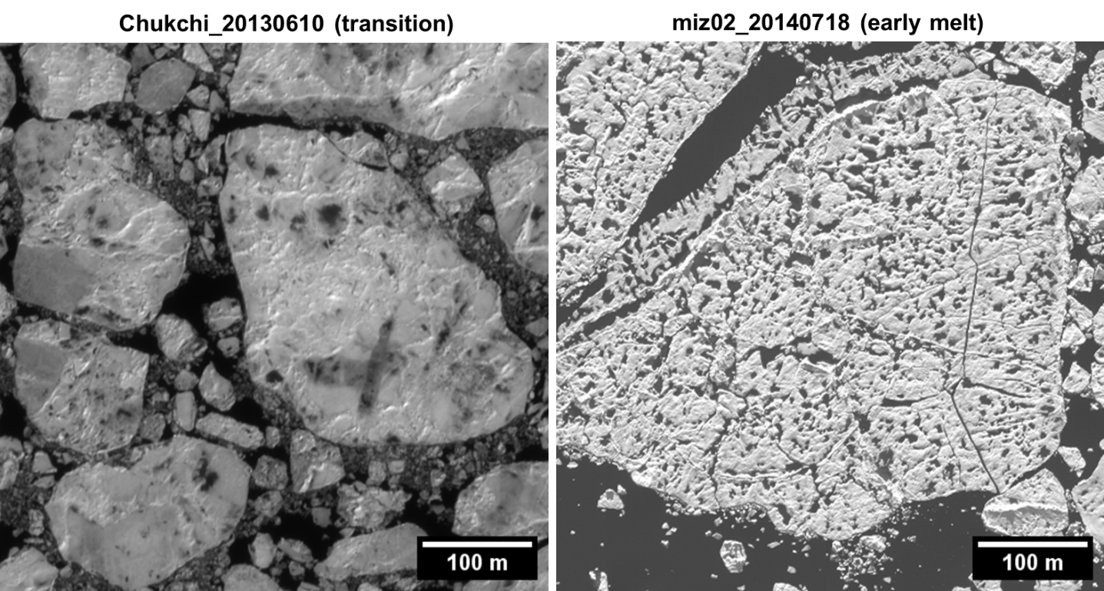

SUPPLEMENTARY FIGURE 4 – Close-up images showing the difference in surface melt between (left) transition and (right) melt/wave fragmentation. The melt ponds in the Chukchi_20130610 image (transition) were not well developed, compared to the miz02_20140718 image (melt/wave), although the power-law exponent of the former is larger. (The floe size distribution from the Chukchi_20130610 image shows the power-law regime with the largest exponent (α = 3.46) over the floe size range of 310-3,000 m, while the distribution from the miz02_20140718 image shows the power-law regime a smaller exponent (α = 2.48) over the floe size range of 70-2,000 m.)

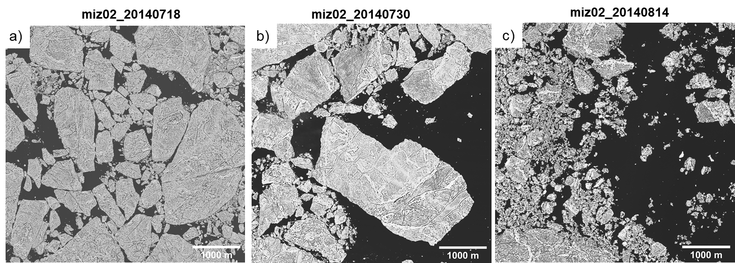

SUPPLEMENTARY FIGURE 5 – Sub-sections of the MEDEA images for melt/waves fragmentation. These images represent the ice floe conditions during the summer melt.

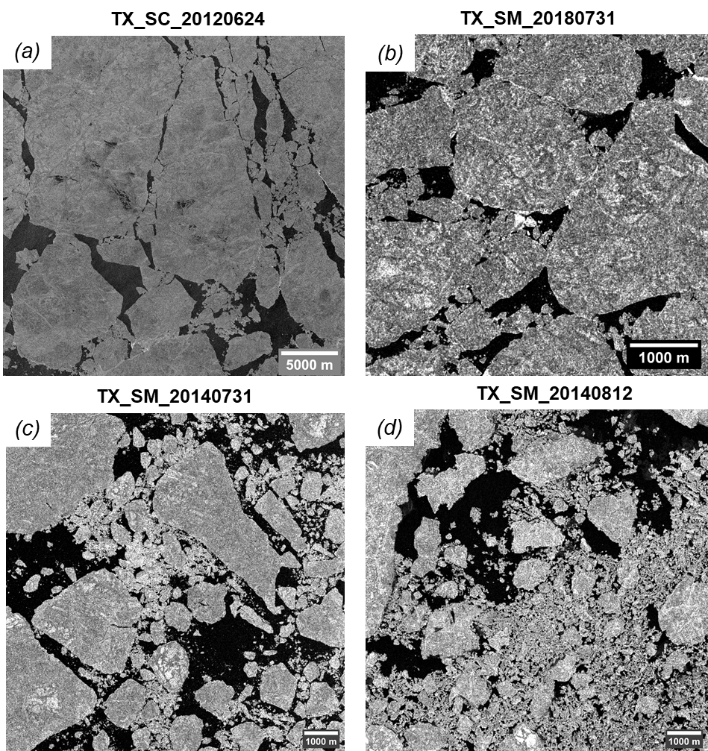

SUPPLEMENTARY FIGURE 6 – Sub-sections of the TX images used for scaling.

Supplementary references
- Rothrock DA, Thorndike AS. 1984 Measuring the sea ice floe size distribution. J. Geophys. Res. 89, 6477. (doi:10.1029/JC089iC04p06477)
- Paget MJ, Worby AP, Michael KJ. 2001 Determining the floe-size distribution of East Antartic sea ice from digital aerial photographs. Ann. Glaciol. 33, 94–100. (doi:10.3189/172756401781818473)
- Inoue J, Masaaki Wakatsuchi, Yasushi Fujiyoshi. 2004 Ice floe distribution in the Sea of Okhotsk in the period when sea-ice extent is advancing. Geophys. Res. Lett. 31, L20303. (doi:10.1029/2004GL020809)
- Lu P, Li ZJ, Zhang ZH, Dong XL. 2008 Aerial observations of floe size distribution in the marginal ice zone of summer Prydz Bay. J. Geophys. Res. Ocean. 113, 1–11. (doi:10.1029/2006JC003965)
- Steer A, Worby A, Heil P. 2008 Observed changes in sea-ice floe size distribution during early summer in the western Weddell Sea. Deep. Res. Part II Top. Stud. Oceanogr. 55, 933–942. (doi:10.1016/j.dsr2.2007.12.016)
- Toyota T, Takatsuji S, Nakayama M. 2006 Characteristics of sea ice floe size distribution in the seasonal ice zone. Geophys. Res. Lett. 33, L02616. (doi:10.1029/2005GL024556)
- Toyota T, Haas C, Tamura T. 2011 Size distribution and shape properties of relatively small sea-ice floes in the Antarctic marginal ice zone in late winter. Deep Sea Res. Part II Top. Stud. Oceanogr. 58, 1182–1193. (doi:10.1016/j.dsr2.2010.10.034)
- Perovich DK, Jones KF. 2014 The seasonal evolution of sea ice floe size distribution. J. Geophys. Res. Ocean. 119, 8767–8777. (doi:10.1002/2014JC010136)
- Toyota T, Kohout A, Fraser AD. 2016 Formation processes of sea ice fl oe size distribution in the interior pack and its relationship to the marginal ice zone off East Antarctica. Deep. Res. Part II 131, 28–40. (doi:10.1016/j.dsr2.2015.10.003)
- Wang Y, Holt B, Erick Rogers W, Thomson J, Shen HH. 2016 Wind and wave influences on sea ice floe size and leads in the Beaufort and Chukchi Seas during the summer-fall transition 2014. J. Geophys. Res. Ocean. 121, 1502–1525. (doi:10.1002/2015JC011349)
- Stern HL, Schweiger AJ, Stark M, Zhang J, Steele M, Hwang B. 2018 Seasonal evolution of the sea-ice floe size distribution in the Beaufort and Chukchi seas. Elem. Sci. Anthr. 6, 1–15. (doi:10.1525/elementa.305)
- Denton AA, Timmermans M. 2022 Characterizing the Sea-Ice Floe Size Distribution in the Canada Basin from High-Resolution Optical Satellite Imagery. The Cryosphere 16 (doi:10.5194/tc-16-1563-2022)
- Gherardi M, Lagomarsino MC. 2015 Characterizing the size and shape of sea ice floes. Sci. Rep. 5, 1–11. (doi:10.1038/srep10226)
- Holt B, Martin S. 2001 The effect of a storm on the 1992 summer sea ice cover of the Beaufort, Chukchi, and East Siberian Seas. J. Geophys. Res. Ocean. 106, 1017–1032. (doi:10.1029/1999JC000110)
- Clauset A, Shalizi CR, Newman MEJ. 2009 Power-law distributions in empirical data. SIAM Review 51, 4. (doi:10.1137/070710111)

