Supplementary Informations
Rapid warming over East Antarctica since 1940s caused by increasing influence of ENSO and SAM
Tariq Ejaz*^{1, 2}, Waliur Rahaman¹, C.M Laluraj¹, K. Mahalinganathan¹, and Meloth Thamban¹
¹National Centre for Polar and Ocean Research, Ministry of Earth Sciences, Goa, India
²School of Earth Ocean and Atmospheric Sciences, Goa University, Goa, India

*Corresponding author
Tariq Ejaz (tariq@ncpor.res.in, tariqejaz94@gmail.com)
Running title: Rapid warming of East Antarctica since 1940s
Content of this file
Figures S1 to S3
Table S1 and S3
Reference

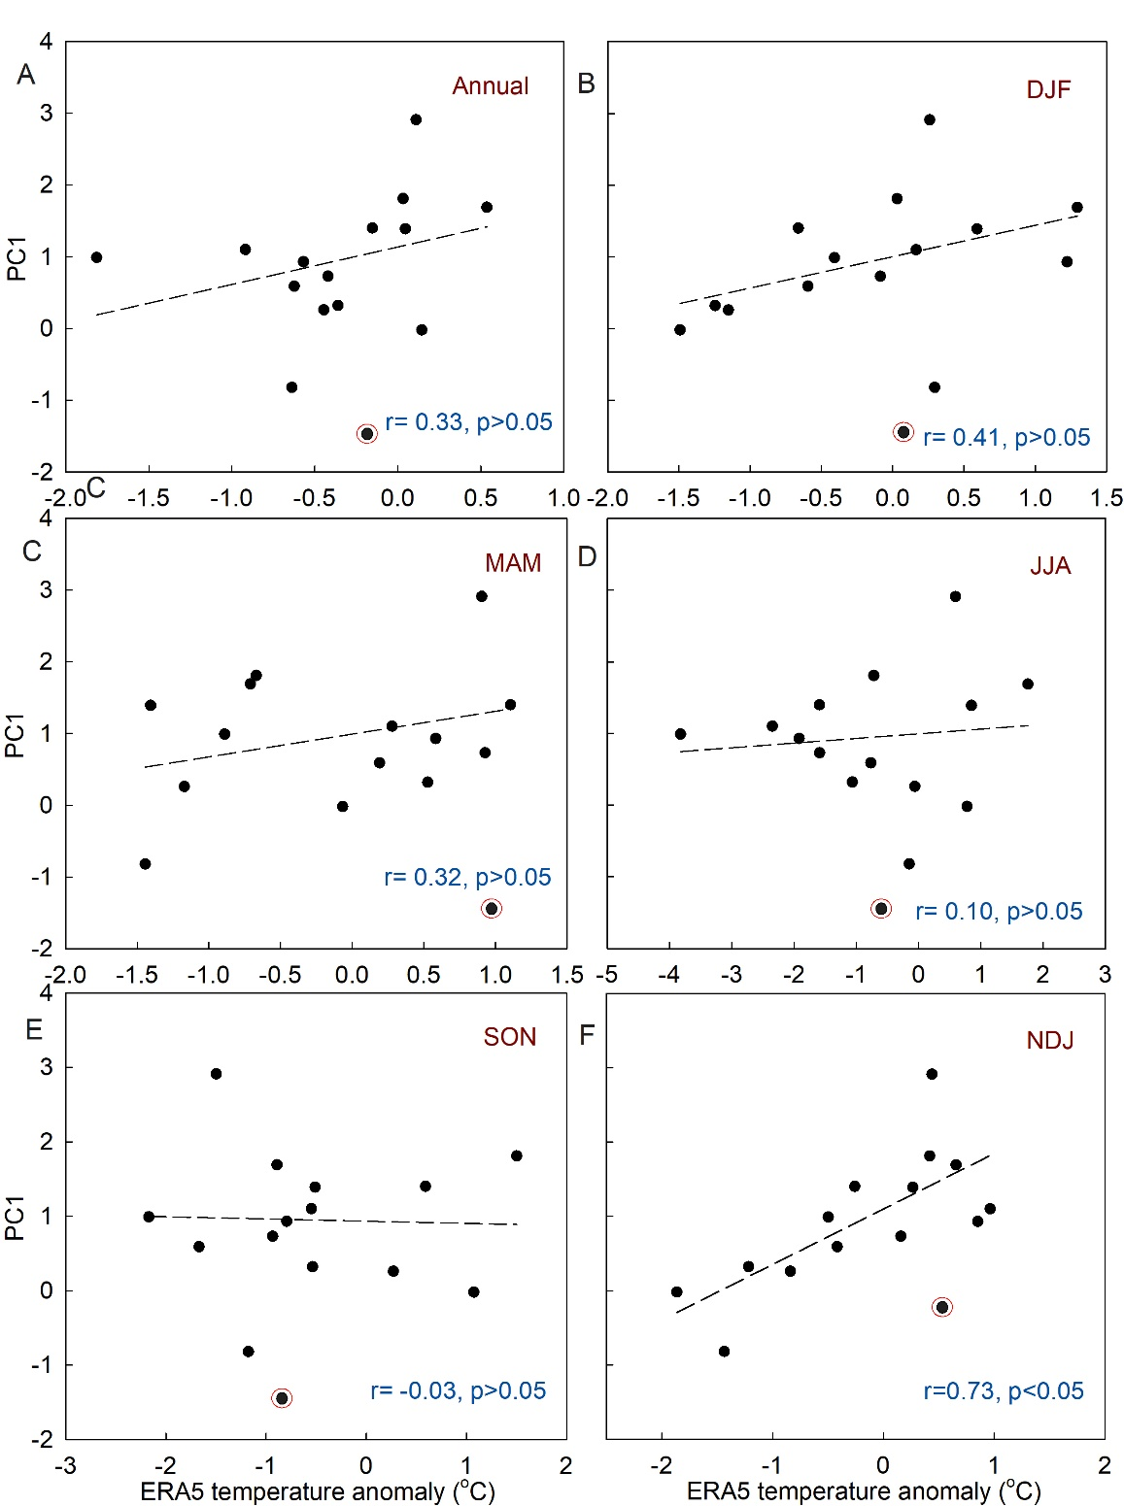
FIGURE S1. (A) PC1 correlation with ERA5 annual surface air temperature anomaly averaged over the DML region (71.5°S to 75.5°S; 11.0°E to 5°W). PC1 correlation with ERA5 surface air temperature anomaly averaged over the DML region during (B) Summer (DJF), (C) Autumn (MAM), (D) Winter (JJA), (E) Spring (SON), and (F) Late-spring to summer (NDJ). Strong correlation between PC1 and ERA5 surface air temperature (r=0.73, p<0.05, 1979-1993 CE, lag=1year) is observed during late spring to summer (NDJ).

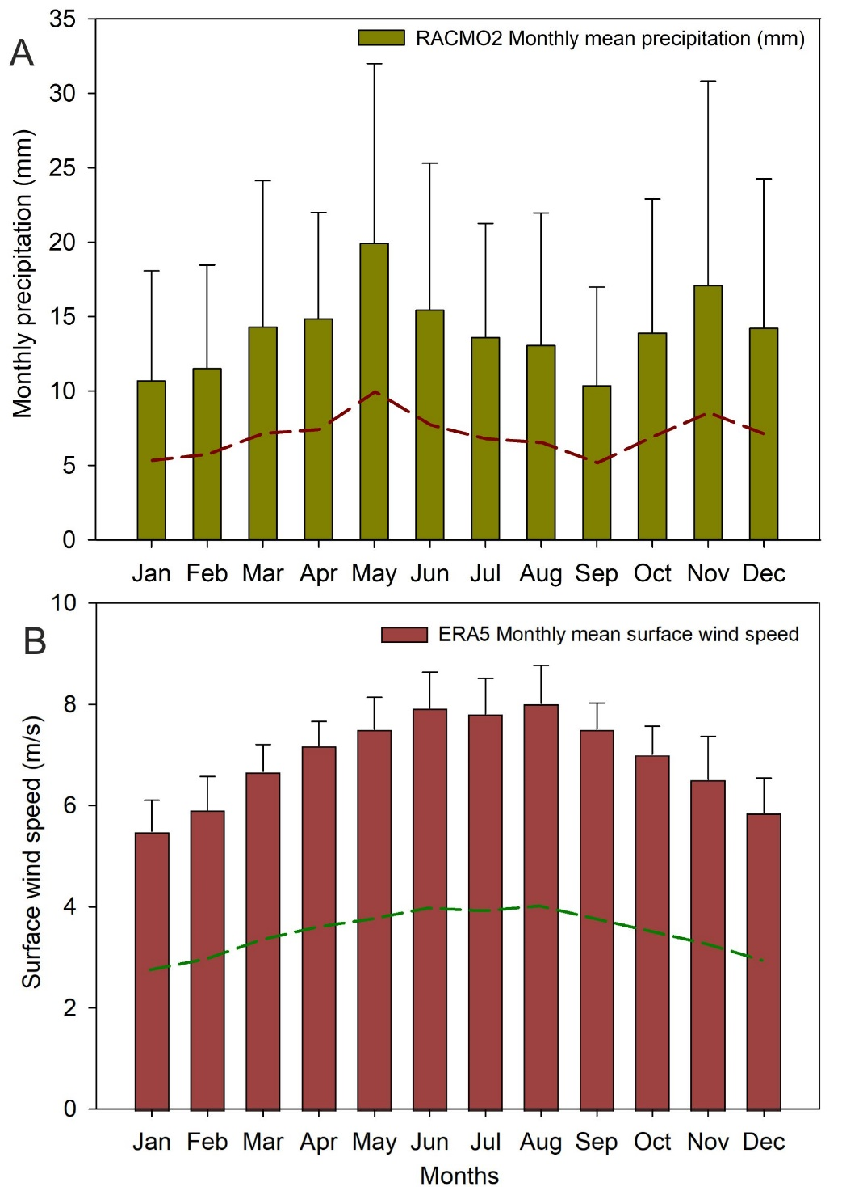
FIGURE S2. (A) RACMO2 (van Wessem et al., 2018) model aggregate monthly precipitation over the DML region (71.5°S to 75.5°S; 11.0°E to 5°W) from 1979–2013 CE. (B) ERA5 monthly averaged surface wind speed (m/s) over the DML region (71.5°S to 75.5°S; 11.0°E to 5°W) from 1979–2013 CE. Error bar (1σ) represents precipitation and wind speed fluctuations during the representative month for the due period. Red and green dotted lines are drawn from the centre of the bar plot to show precipitation and wind patterns during the different seasons. During April-May-June and October-November-December, the DML region is experiencing periods of high precipitation. In the case of surface wind patterns over the DML region, a high-speed wind during the winter caused freshly deposited snow to be reworked, but a low-speed wind during the summer resulted in less snow reworking.

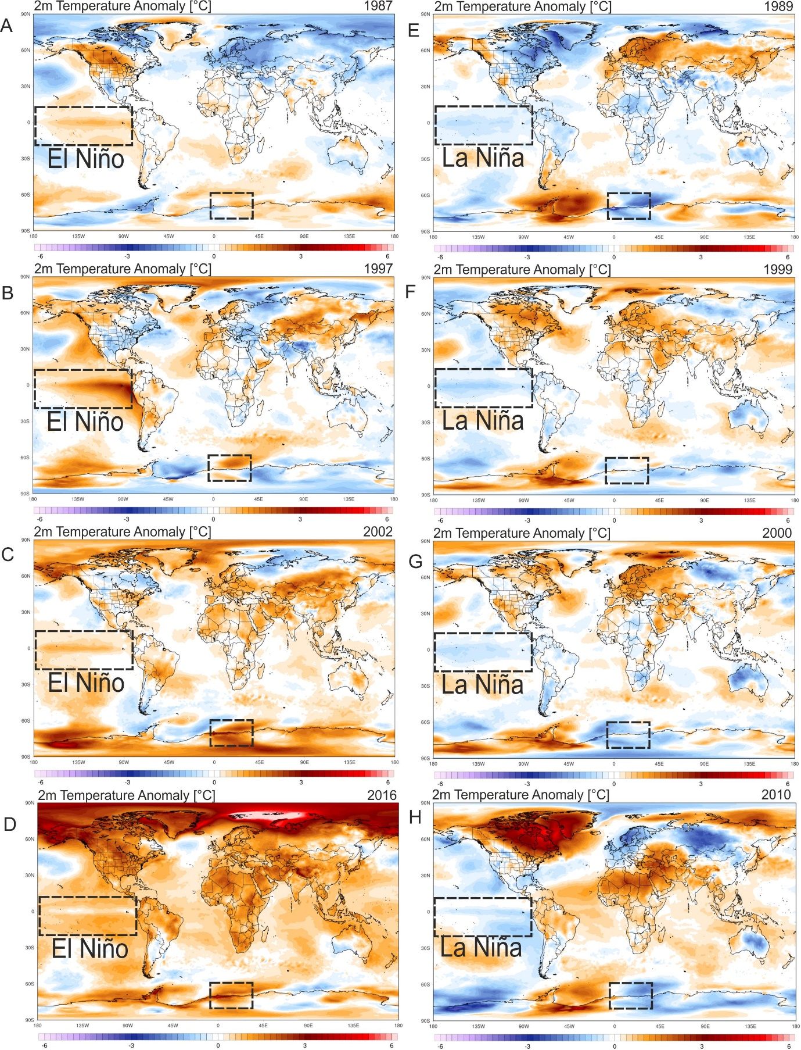
FIGURE S3. Spatial anomaly plots of ERA5 2m temperature during strong El Niño events (1987, 1997, 2002, and 2016) (A-D) and La Niña events (1989, 1999, 2000, and 2010) (E-H). During El Niño events (A-D), the anomaly plots show an increase in 2m temperature, whereas the La Niña events (E-H) highlight decreasing 2m temperature over the DML region of east Antarctica.

Supplementary Table S1: Correlation matrix of ice cores used in the present study
Correlation matrix (Pearson (n))
Variables | DML07 | DML17 | DML05 | IND33
DML07 | 1 | 0.0696 | 0.1872 | -0.0447
DML17 | 0.0696 | 1 | 0.1127 | -0.1209
DML05 | 0.1872 | 0.1127 | 1 | 0.0505
IND33 | -0.0447 | -0.1209 | 0.0505 | 1

Supplementary Table S2: Ice core records used in principal component analysis within common time window 1809-1993 CE.
 |  | δ¹⁸O (per mil)
Ice core | Time interval (CE) | Minimum | Maximum | Mean | Std. deviation
DML07 | 1809-1993 | -47.85 | -41.69 | -45.02 | 1.28
DML17 | 1809-1993 | -50.42 | -42.76 | -46.66 | 1.32
DML05 | 1809-1993 | -49.68 | -40.64 | -45.12 | 1.54
IND33 | 1809-1993 | -32.70 | -27.68 | -30.47 | 0.91

Supplementary Table S3: Variability and Eigenvalue for principal components derived from principal component analysis.
 | PC1 | PC2 | PC3 | PC4
Eigenvalue | 1.26 | 1.08 | 0.89 | 0.76
Variability (%) | 31.61 | 26.95 | 22.37 | 19.06

REFERENCE
van Wessem, J. M., van de Berg, W. J., Noël, B. P. Y., van Meijgaard, E., Amory, C., Birnbaum, G., et al. (2018). Modelling the climate and surface mass balance of polar ice sheets using RACMO2 – Part 2: Antarctica (1979–2016). The Cryosphere, 12(4), 1479-1498. https://tc.copernicus.org/articles/12/1479/2018/

