Supplementary Material
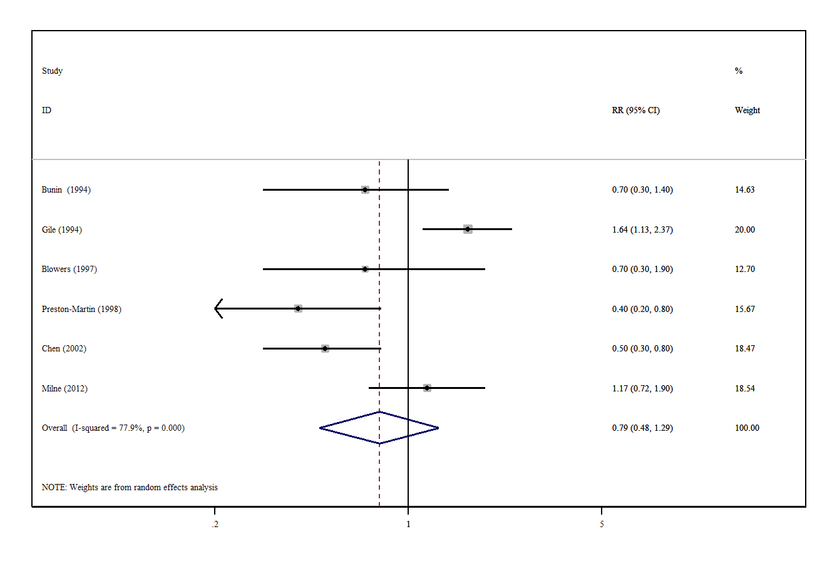
Supplementary Figure 1 | A forest plot showing risk estimates of the association between vitamin A intake and brain tumors.

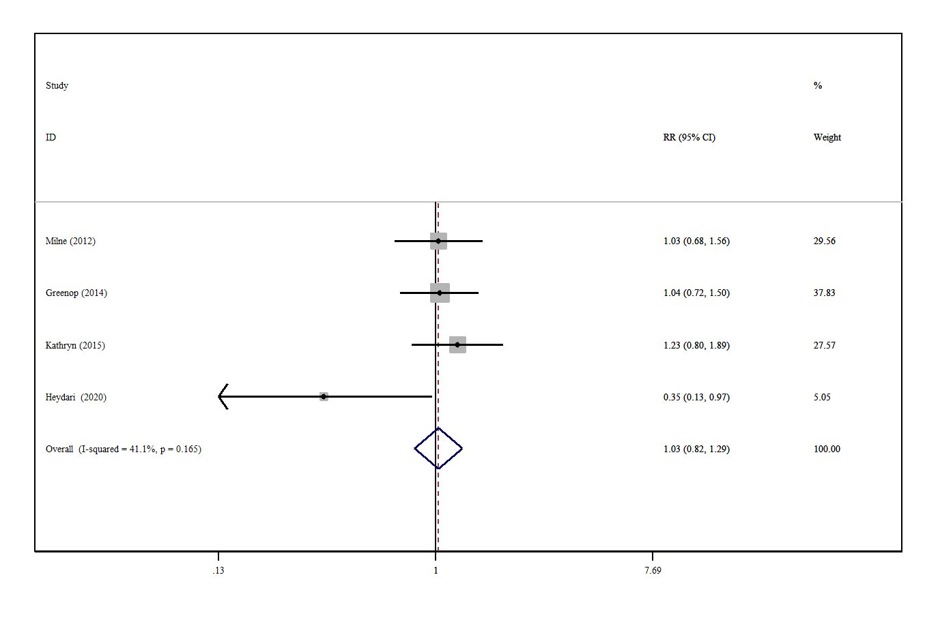
Supplementary Figure 2 | A forest plot showing risk estimates of the association between vitamin B intake and brain tumors.

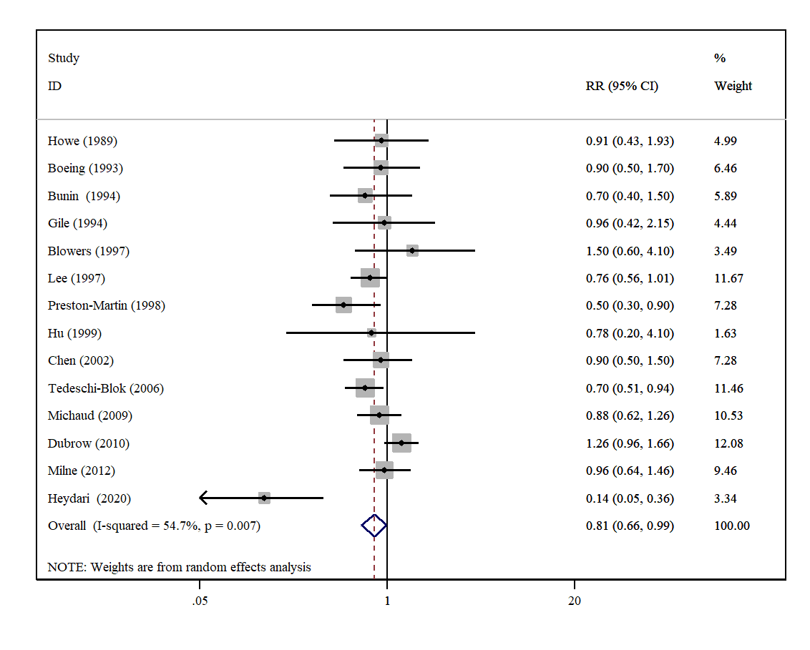
Supplementary Figure 3 | A forest plot showing risk estimates of the association between vitamin C intake and brain tumors.
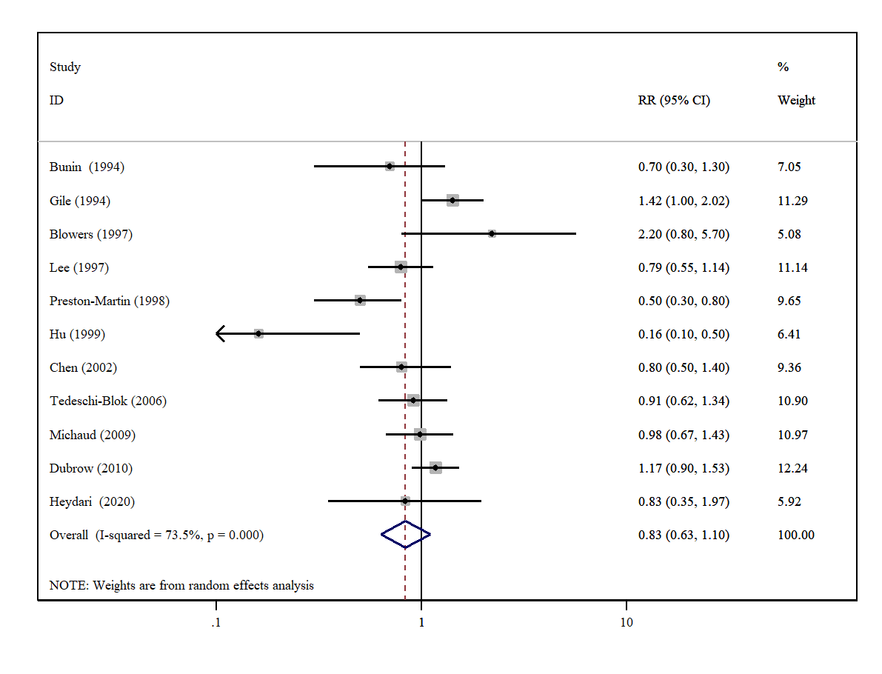
Supplementary Figure 4 | A forest plot showing risk estimates of the association between vitamin E intake and brain tumors.

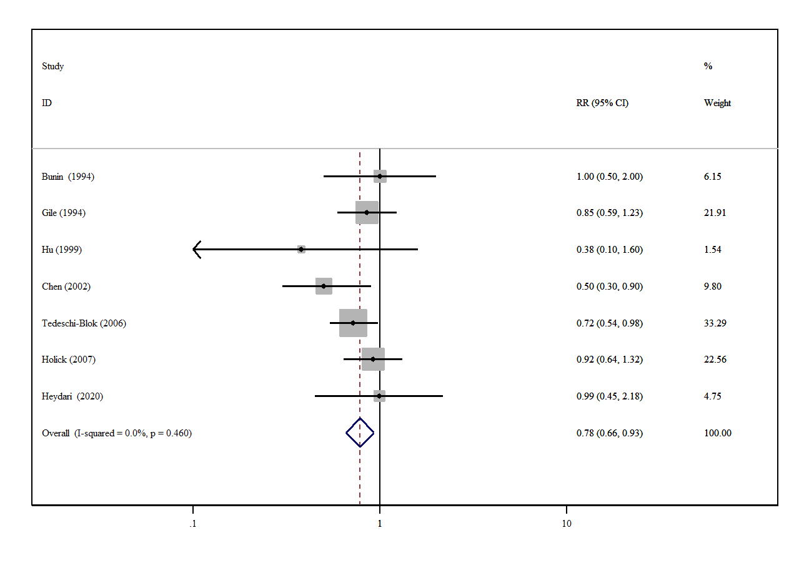
Supplementary Figure 5 | A forest plot showing risk estimates of the association between β-carotene intake and brain tumors.

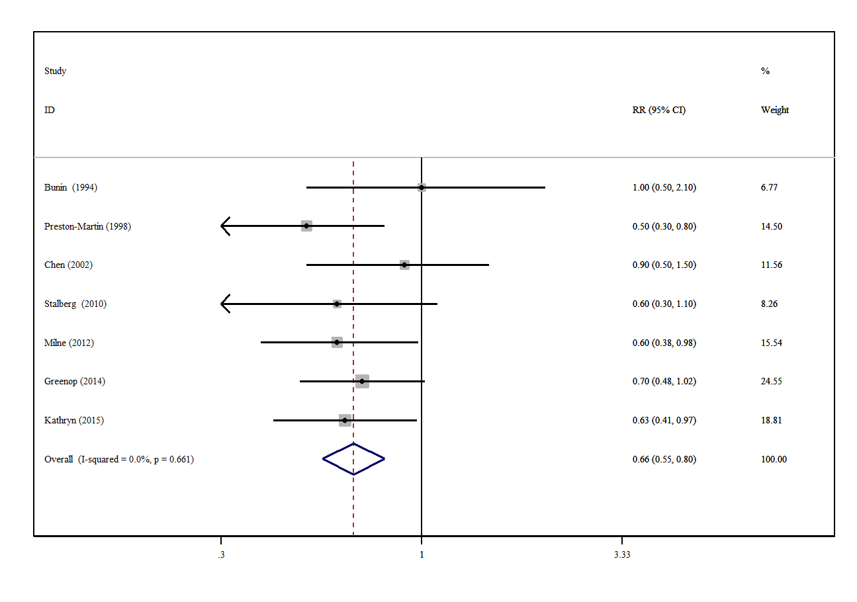
Supplementary Figure 6 | A forest plot showing risk estimates of the association between folate intake and brain tumors.

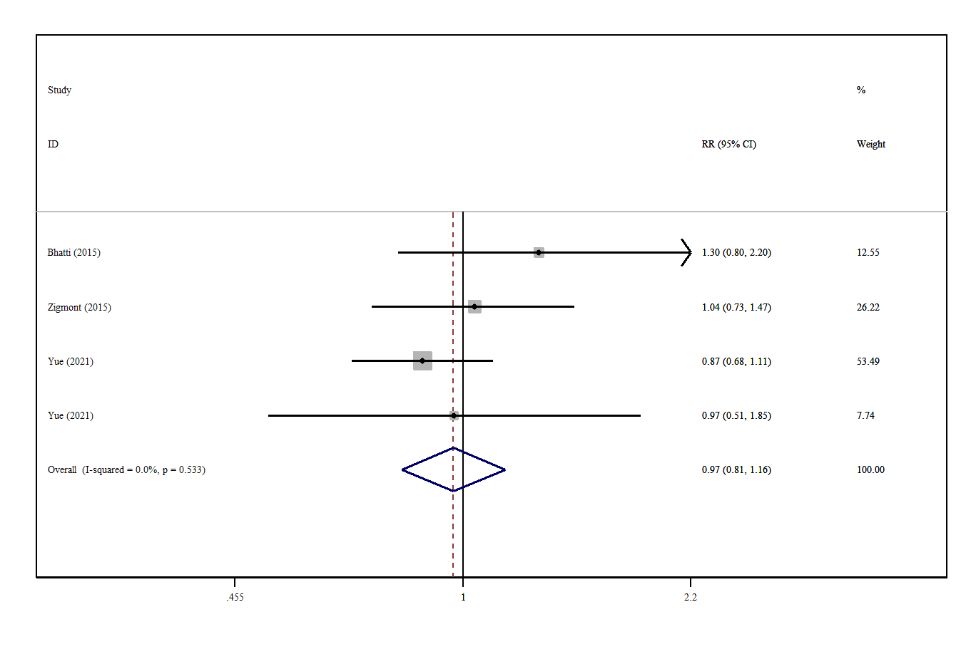
Supplementary Figure 7 | A forest plot showing risk estimates of the association between serum 25-hydroxyvitamin D concentration and brain tumors.

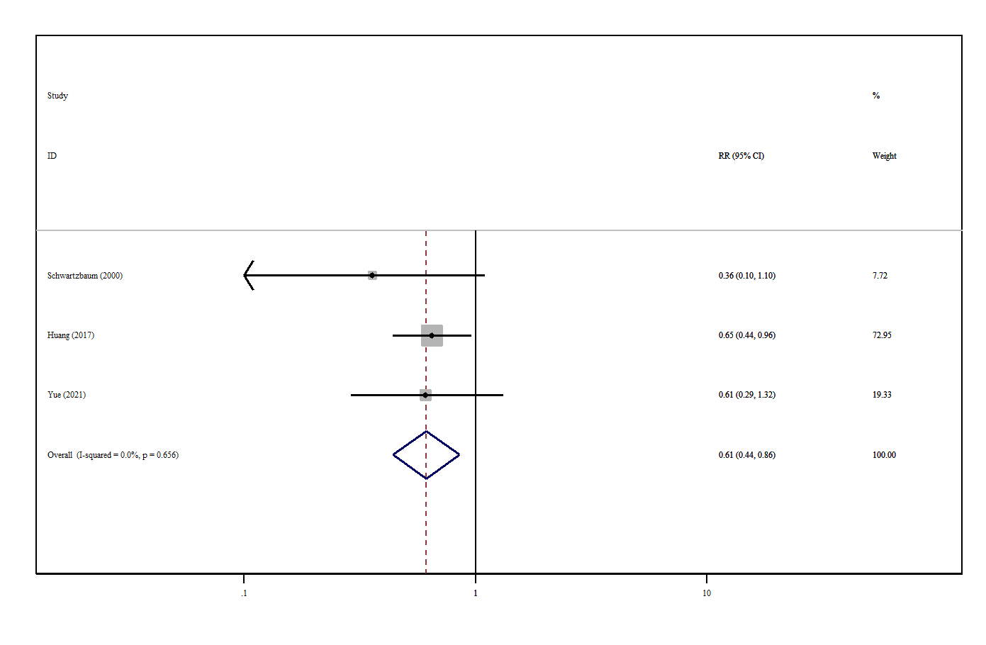
Supplementary Figure 8 | A forest plot showing risk estimates of the association between serum α-tocopherol concentration and brain tumors.

